Component 3 Project

Pathifnder Maze game

Jaivir Sohal

Year 23/24

Contents

Section 1 - Analysis 5

Problem Identification 5

The problem 5

The Computational Approach 6

My Stakeholder 8

Identifying Stakeholder 8

How the stakeholder will use the proposed solution 8

Suitability of the proposed solution 8

Problem Research 9

Possible Non-Computational Methods 9

Computational Methods 17

Maze Generation 36

Online Products 42

Features 49

Essential Features 49

Other potential Features 51

Limitations 53

Features 53

Java Swing 53

User Requirements 54

Success Criteria 55

Section 2 - Design 58

Decomposition 58

Overall Structure 58

Hierarchy Charts 63

UML diagram 67

ERD 67

Solution Description 69

Flowcharts & algorithms 69

Variable tables 76

Validation 77

Usability features 78

Testing 80

Final Testing 80

Section 3 - Development 86

Cycle 1 - Login & Register GUI Design 86

Design 86

Coding and Testing 87

Review & Evaluation 92

Cycle 2 – Login Form GUI 93

Design 93

Coding and Testing 98

Review 121

Cycle 3 – Register Form GUI 136

Design 136

Coding and Testing 145

Review 160

Cycle 4 – Standard Functions Class 178

Design 178

Coding and Testing 179

Review 184

Cycle #5 – Revising the Login Form 189

Design 189

Coding and Testing 194

Review 222

Cycle #6 – Revising the Register From 241

Design 241

Coding and Testing 248

Review 270

Cycle #7 – Developing the Maze Class 278

Design 278

Coding and Testing 283

Review 301

Cycle #8 – Developing the Visualiser 306

Design 306

Coding and Testing 315

Review 394

Cycle #9 - Developing the Main Menu 403

Design 403

Coding and Testing 405

Review 410

Cycle #10 – Developing the Play mode 412

Design 412

Coding and Testing 417

Review 459

Conclusion 464

Cycle #11 Developing the Statistics 465

Design 465

Coding and Testing 467

Review 485

Conclusion 491

Section 4 – Evaluation 492

Final Testing 492

Function Testing 492

Robustness Testing 540

Usability Testing 550

Success of the solution 561

Concluding Success Criteria 561

Assessing Success Criteria 563

Describe the final product 576

Evaluating functionality 576

Evaluating usability 580

Maintenance and Development 594

Evaluating maintenance 594

Evaluating limitations 595

Conclusion 596

Further features 596

Evaluation Summary 597

Bibliography 598

# Section 1 - Analysis

## Problem Identification

### The problem

**Problem-solving** is a skill that is used in every aspect of life. It is critical to recognise the issue of deteriorating **mental skills** during breaks and the subsequent slow transition back to work. This issue impacts people of all ages, from primary school to university, as well as teachers who take time off from their daily duties.

Essential skills that are developed from enhancing problem-solving:

* Analytical Skills
* Collaboration
* Creativity
* Decision Making
* Critical thinking
* Prioritisation
* Planning
* Leadership
* Spatial Reasoning
* Etc.

**Puzzle games** are a great way to exercise and improve mental agility and critical thinking skills, ultimately promoting the development of a healthy mind. They provide an upside in that they not only provide valuable **mental stimulation** for individuals who are experiencing a gradual decline in mental abilities over time, but they also serve as an enjoyable **alternative to monotonous tasks**, assisting individuals in maintaining a strong work ethic while keeping their problem-solving skills sharp and up to date.

In the study of Neuro psychobiology, Mazes tend to be the ideal test for pure cog**nitive activation**. “Mazes as well as pseudo-mazes, activated a large network from visual to parietal regions, reflecting the dorsal stream of visual information processing.” [1]. This study outlines the impact of maze solving on **neural activity** and the positive impact it creates. Maze solving boosts memory and recall skills. Solvers must recollect previously explored paths, recall unsuccessful routes to avoid backtracking steps, and keep mental maps of the maze structure. Regular maze solving exercises can help to **strengthen** short-term memory, spatial memory, and the capacity to retain and recall information.

Making a game that simulates mazes and calculates a score depending on your solution is ideal for honing mental skills. To raise your score, you must **generate mazes indefinitely and randomly**, one after the other, with time constraints to stimulate pressure. Visualising pathfinding algorithms will be very helpful to anyone learning computer science because it will help to solidify information. This is the basic description of what the final product should include to solve the problem.

### The Computational Approach

Mazes have existed and been practically used for thousands of years, dating back all the way to Egyptian times where labyrinths were often constructed for entertainment. Over time, there has been many solutions manufactured with the sole purpose of **getting from point A to point B** in a maze. Only recently has the widespread use of computational power revolutionised the art of solving a maze. Nature can also surprisingly offer extremely efficient and practical solutions to maze.

List of natural solutions to mazes:

* Electricity
* Water
* Slime mould.
* Self-assembling wires
* Wave propagation
* Fatty acids + Acidic hydrogel
* Rats
* Ant colony pheromones

Each solution will have an in-depth analysis within the problem research stage but as a short overview; the quickest and most efficient solution would be using electricity to solve mazes. Not only does it find the **shortest and most efficie**nt solution to a maze but also delivers the solution instantly if viewed in a thermal camera. However, resorting to these natural solutions may be interesting but not practical at all.

For each experiment, a **large amount of time** must be consumed to construct the physical maze. For the electrical solution, a laser cut aluminium sheet must be cut, 3d printed walls for a water solution and all components must be joined together. Cost of materials such as acidic hydrogel or the slime mould (Physarum polycephalum) is also a huge factor as a lot of these natural solutions have expensive setups. Despite the lengthy procedure, the results do show practicality as electricity can find the shortest path instantly whilst water can also show the effectiveness of an algorithm that **exhausts each path** before moving on.

Nevertheless, these solutions **would never be the ideal** **method** for maze solving. Generally, these experiments help outline the behaviour of natural occurrences such as the way electricity or a piece of mould behaves/interacts with objects to carry out a scientific study. This is why a **computational method** would be an ideal way to simulate maze solving.

#### Features that make a computational approach amenable

Fundamentally, the **speed** of a computer and its CPU allows for complex mazes of any size to be instantly solved with graphical analysis, visualisation and algorithms which are far more rapid and beneficial than any solution proposed in a real-life situation. **Efficiency** is clear as mathematical and computational techniques all offer systematic exploration of paths until an optimal path is found which is what allows the solving of larger mazes. This allows for the implementation of **infinite generation** within the product so that with a simple click, a newly randomly generated maze is displayed in front of the user with minimal processing power used.

The program is highly **scalable** algorithms can handle dynamic maze structures where there are thousands of interconnected paths. There is a great deal of **flexibility** in an algorithmic approach as there are no physical limitations such as size, environments, or the type of material in a maze which in turn allows for complete customisation. With this feature, the user can choose the size and difficulty of the maze on a graphical user interface without having to go through the extra hassle of ordering/making a physical maze when wanting a change.

A new maze can be instantly created with randomised generation if programmed to do so on a computer; this can maximise time spent solving mazes instead of physically making a maze. These methods are **precise** and determine exact/intended solutions to a maze e.g., the shortest solution can be found or the solution where all dead ends are filled first. With minimal change, a computational method can provide a vast number of customisable solutions. Such bespoke software allows **algorithmic exploration** where different algorithms can be run side by side to make comparisons with modularity allowing the simple addition of a new way to solve a maze without having to recreate an entirely different scientific setup to achieve the same result in real life.

**Visualisation** is a key advantage to this method as users can view a step-by-step process of the algorithm that is currently solving the maze. Users can reinforce and build understanding on the concept of solving a maze this way due to the constant engagement. Problem-solving with mazes that can be instantly generated one after another offer substantial **educational value** as there is a constant involvement with the user that will train computational thinking and will help learn about the theory behind pathfinding.

The concept of **abstraction** can be utilised in a digital way as it allows the complete removal of irrelevant features. Furthermore, the physical aspects of a maze such as the walls and corridors can be disregarded and instead viewed as arrays or matrices with the heights of the walls being ignored due to the 2d representation using 2d arrays with numbers ‘0’ and ‘1’ representing paths and walls. After abstraction, this problem can be decomposed using decomposition where a hierarch of tasks is made to ensure that this project is manageable and easier to solve.

A computational approach to developing a maze solver provides numerous advantages, including efficient and precise solutions, scalability to handle varying maze complexities, adaptability for customisation, educational value in teaching computer science concepts, and the ability to explore and innovate with different algorithms. It is an excellent choice for maze-solving applications since it provides a powerful and **diverse** tool for solving mazes with a digital interface for users.

## My Stakeholder

### Identifying Stakeholder

My Stakeholder is **Mr C Murray** - the head of **Computer Science** at Thomas Telford School. He has knowledge on algorithms with a **clear** and **logical** mindset of how he prefers a solution to be carried out, giving straightforward requirements and good **feedback** along the way. Using this, I imagined Mr Murray to be a great choice of client for a product that is heavily **computational** that employs many different algorithms with a few being in the very A level specification that he teaches to his students.

### How the stakeholder will use the proposed solution

The solution to the problem allows the stakeholder to **interact** with a GUI (powered by Swing in Java) and will offer the option to choose between visualising pathfinding algorithms in randomly generated mazes or solve mazes as an infinite minigame. Mr Murray will be able to demonstrate how Breadth First Search (**BFS**), Depth First Search (**DFS**) and variations such as **Dijkstra** or **A\*** algorithms work to his students to help teach part of the year 2 A-level OCR content on pathfinding algorithms.

When teaching graph traversals and shortest path algorithms, Mr. Murray can use the product to teach the students the steps of these algorithms. For example, clicking the slowest visualisation setting to visualise Breadth First Search can help display its radial manner where all neighbours are checked periodically before moving onto the next cycle / level. This can be repeated with all algorithms to show these standard algorithms and the use of heuristics.

In addition to its educational application, the proposed method appeals to Mr. Murray's other intended use: completing mazes during holidays to keep up mental agility. Recognising that mental skills may deteriorate during breaks from academic routines, Mr. Murray can use the solution's maze-solving feature to engage in a satisfying and intellectually engaging pastime. By challenging himself with mazes, he keeps his mind occupied and stimulates cognitive development.

### Suitability of the proposed solution

The solution to the problem is vastly suitable for Mr Murray and is heavily advantageous for the for not only **lesson planning** but passing time between lessons/at home. As previously mentioned, creating a product that uses algorithms in the A-level OCR specification and **visualises** the algorithm is essential for ensuring that students understand how the algorithm works and how the different versions compare to each other.

The maze-solving project's visual and interactive aspect captures students' attention and draws their interest. Important principles of computational thinking are brought to life as users view the maze being formed, explore alternate paths, and observe the algorithm's decision-making process. Students may see the direct application of the algorithms and data structures they learnt in class through this project.

Mr Murray often spends his **holidays**, much like every teacher, away from work. As an OCR marker, he usually marks many papers repeatedly one after another for an extended period. Performing the same task constantly encourages **boredom**, **chronic stress**, and damages **creativity**. This is why this maze simulator is vital for Mr Murray in his strive for always maintaining cognitive aptitude.

Mr Murray is inherently tied to the world of computers as a computer science teacher, which allows him continual access to the maze-solving programme. This access to the programme serves as an excellent teaching aid, enhancing his teaching methods and increasing his students' learning experiences.

## Problem Research

### Possible Non-Computational Methods

#### Electricity

Electricity can show **lightning-fast solutions** to a maze of **any complexity**. This is how to set up the apparatus:

1. A simple starting point is to cut out the desired maze with any conducting material e.g., aluminium and ensure a thin slice is used (preferably foil form) to speed up the heating of the metal.
2. Using spray paint, spray the foil black to create a high emissivity surface so heat is dissipated easier.
3. Connect a circuit to the start and end of the maze with clips to allow current to flow through the maze.

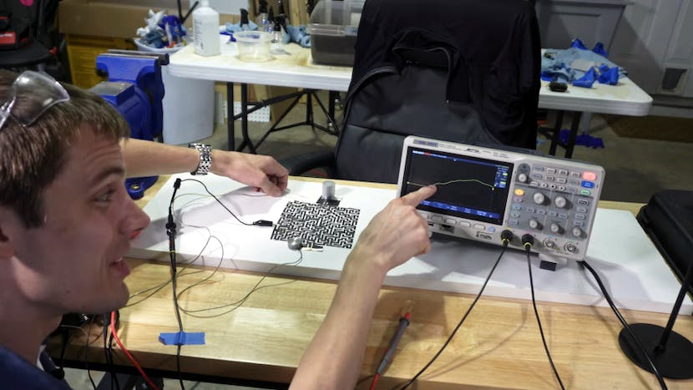

[2]

The maze can be viewed **much like wires**, there can be many paths leading to different locations and the stream of electrons will flow through every path, but the majority will take the shortest path of “**least resistance**”. The human eye cannot see the electrons flowing so will not see the path right away but **there is a change in temperature**.

The path the electrons are mostly taking will heat up much faster than the other paths. This is where the black spray paint and thin thickness help; the path is presented almost immediately. A **thermal camera** can be used to show this path created and highlights how the electricity succeeds in creating a perfect, shortest solution to the maze.

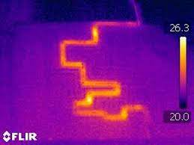

[2]

**Electron density** at each junction shows that each patch is still being considered as there are electrons flowing through that point. Almost instantly, the current **considers all paths**, providing an efficient solution to solving a maze. At each junction, a dead-end path connecting to the main path will have the **same electron density** as that point on the main path.

A maze may have **multiple solution**s, but electricity/current will aways take the shortest path. If there are two solutions that are in similar size electrons will simply take both paths. This is where the electrical approach differs from any other approach as it is possible to go through two solutions at the same time.

“**Memristors–resistors with “memory**”–a couple of researchers have created a memristor processor that solves mazes in a massively parallel way” [3]. These memristors allow parallel processing and simultaneous solving of a maze. Solutions will be remembered by the memristor as the amount of **current flowing is stored**. This allows for mazes to be solved at a much quicker rate with the initial concept of using electricity.

#### Water

Solving a maze with water behaves surprisingly **similarly to electricity** in many ways. In theory, without the effects of natural forces such as surface tension or **air pressure**, filling a maze with water should exhaust a path until it is filled with water and then continues onto the **next possible path**. Within this simulation, even if the path is found and is emptying water, the **entire maze should fill** up.

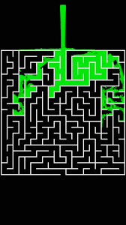

[4]

In this simulated world, a solution may have to **exhaust the entire** maze before reaching a solution **unlike electricity** where the ideal path is found instantly and efficiently.

When testing this concept in real life, a typical setup consists of **3D printed polymer parts** forming a maze-like structure, with a tank allowing water to flow through. Surprisingly, the behaviour seen during real-world testing improves from the simulated scenario, as natural factors are at work.

The behaviour of the water **resembles the simulation** when the tank fills with water and the flow begins. It exhausts many paths as it travels the maze's channels. A large shift happens once the solution has been found. As the water begins to flow through the exit, factors such as air pressure and surface tension come into play as it **blocks any previous dead ends** from filling up any further.



[5]

Unlike the electrical solution, after the solution path is found, it is the only path that allows water to flow through it. In the figure above you can clearly see how n**ew water flows through** the maze and does not flow through previously explored paths that lead to dead ends.

Junctions just like the electrical junctions hold levels if the maze is horizontal and not vertical with a water pump pushing through any water. A path leading to the main path will hold the **same level of water as the level of the junction**.

#### The human body

The human body is a great model of a maze – ions, protein and water navigate through the maze to find the optimal path to the intended destination. However, in the body, the destination is always **changing to supply an area of low concentration** with the intended products. Despite this, the body is a very practical example of how water and any other **molecules solve mazes** within our very bodies as membranes constrict, relax, change permeability, and redirect the flow of blood to maintain equilibrium withing the body.

|  |  |
| --- | --- |
| [6] | [7] |

The **brain itself is a complex maze** full of paths that neurons can travel through and much like the memristors mentioned above, once a neuron creates a path – the solution is remembered and a connection between the two points are established. **Cells and neurons** posses’ spatial awareness. “All of the neurons acted independently, firing randomly to mark off places in the maze. But some neurons had a greater propensity to mark off space than others” [8].

These messengers behave almost **exactly like electricity** where all paths are exhausted, and every solution is tested but only the shortest/most efficient solution contains the highest density of neurons. This neuron activation simulated by a maze helps educate **scientists** on how humans and the brain can make sense of new places by **monitoring neuron activity.**

As well as the nervous and digestive system, the respiratory system can be modelled as a maze. Air passes into tiny air sacs called alveoli within the maze-like structure of the bronchioles. These tiny chambers mimic the maze's **countless interconnecting sections**. Describing the respiratory system as a maze allows us to better grasp its complex structure and the importance of each component. It emphasises the importance of an **organised network of airways** for efficient gas exchange and oxygen delivery to our bodies' cells.[9]

#### Fungi

Physarum polycephalum, also known as **slime mould**, is a fascinating organism with unusual behaviours. One of Physarum polycephalum’ amazing abilities is its ability to explore and solve maze-like constructions. This makes it a good topic to investigate in for maze-solving algorithms and computational problem-solving. Scientists can gain insights into the fungi’s maze-solving ability by **studying its features and behaviours**, which means that we can **use these insights to design efficient algorithms** for solving mazes.



[10]

The slime mould Physarum polycephalum uses a unique technique known as "**gradient-following**" to solve mazes and navigate complex surroundings. This method of pathfinding allows the organism to locate the most efficient paths to its food sources.

Pathfinding is shown by the fungi with **adaptive behaviour** and communication across its interconnected network of protoplasmic veins. When presented with a maze-like structure, the slime mould **stretches its veins in all directions**, investigating all possible paths. As the creature moves around, it leaves a network of trails of cytoplasm, a viscous fluid. This **network serves as an archive** for its previous movements like a small memory unit [11].

Physarum polycephalum naturally tends towards the most optimal paths that lead to its food sources by frequently modifying its growth patterns. This adaptability enables the slime mould to choose the **shortest and most efficient path** through the maze.

The slime mould's gradient-following technique **is like conventional pathfinding** algorithms such as the gradient descent algorithm, in which a system seeks to follow the route of greatest descent. The slime mould, for example, changes its growth to follow the gradient, leading it to **the ideal path**.

#### Self-assembling wires

Electricity and electrodes are used by self-assembling wires to support the self-assembly nature. The **interaction of electrical impulses and physical interactions** allows the units to coordinate their movements, communicate with one another, and **construct complex networks** inside mazes.

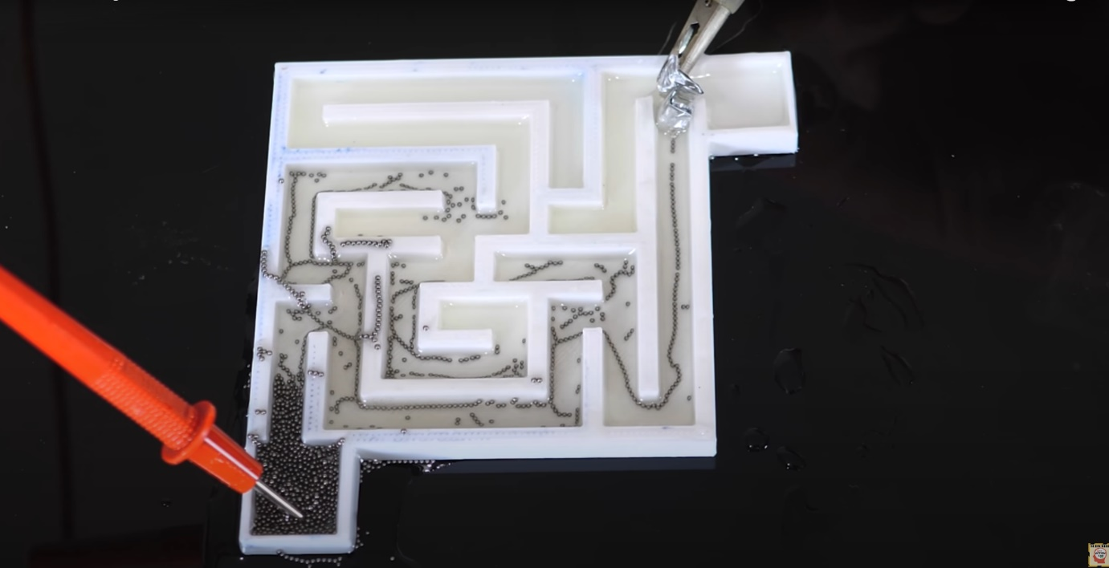

[12]

To begin the process, the units are spread across the maze in **castor o**il. Each unit can detect what's around it, including whether there are of obstructions or other units nearby. The units work together to create a path across the maze by **exchanging information and controlling their actions**. [12]

As the units move through the maze, they constantly adjust their configurations to avoid obstacles and choose the most efficient path. This adaptability enables them to change the **course dynamically** depending on current events, **minimising dead ends** and optimising overall journey length. This technology is the fundamental idea behind automatons and self-repairing circuitry in electronics.

#### Wave propagation

When considering wave propagation to solve mazes physically (rather than computationally), one strategy involves building a physical maze with **interconnected pathways** and navigating it with real waves or signals. The maze can be made using walls, hallways, or even physical barriers to form a system of paths. Materials like as marbles, balls, or even water can be used to **simulate waves**.

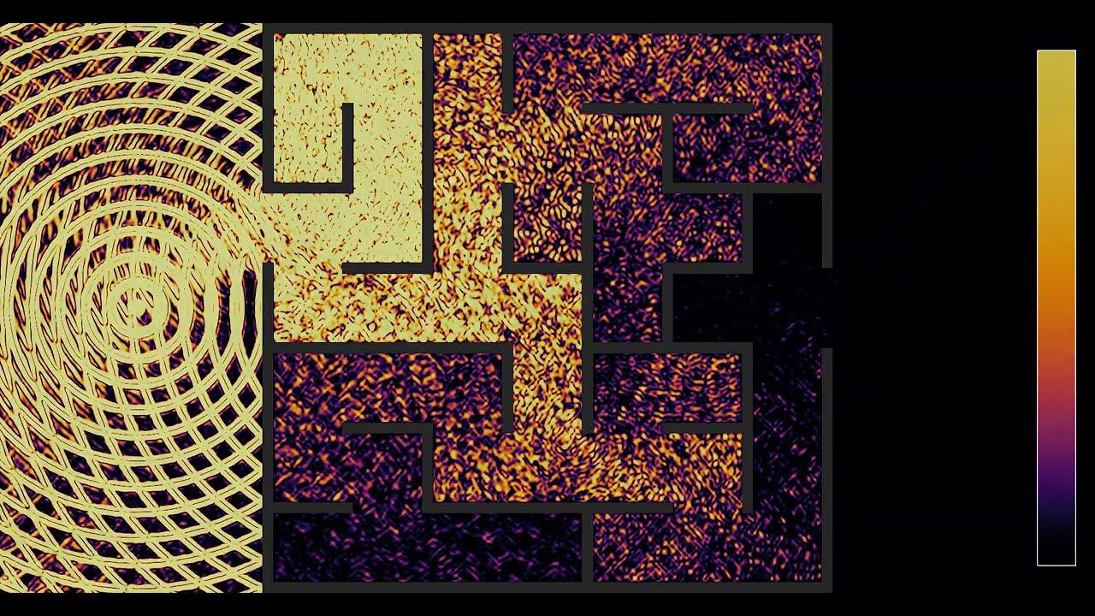

[13]

**A starting point** within the maze is chosen to start the wave propagation. After that, the waves or signals are released from that starting position propagate across the interconnected routes. The direction that the waves take is decided by their behaviour when they approach intersections.

For example, if the **waves come to a fork in the maze**, they can be led down various paths, each demonstrating a distinct option. As the waves travel further, they investigate the **various** **passageways**, progressively covering more of the maze.

### Computational Methods

Computational solutions to mazes and the algorithms created are **used by numerous applications** other than solving mazes from satellite navigation to internet packet routing. These algorithms even be applied to find the length of the shortest wire that will connect pins on a circuit board.

#### DiJkstra’s algorithm

One famous solution that appears in the **OCR A-Level specification** is the Dijkstra algorithm that generates the shortest path to a maze. It was created by Dutch physicist Edsger Dijkstra in 1956 as he thought about how to calculate the shortest route between 2 places in the Netherlands.

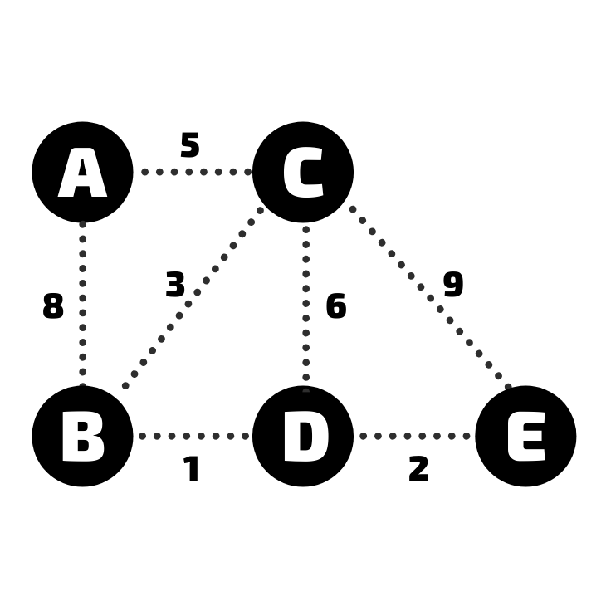

A weighted graph – [14]

The main features of Dijkstra’s algorithm:

* Nodes – (known as vertices) are the circles in the diagram above. Each node holds data that is relevant to the situation e.g., each node is a city or an IP address.
* Edges – Connections between nodes are known as edges and they each have a weight associated with them. This could be distance or time between two points in real life or connections between devices on a network.

In this algorithm, the optimal path would be the path that ‘costs’ the least and the solution is a series of edges of from node to node. Dijkstra’s algorithm is widely used for many complex problems and is generally represented as the weighted graph.

##### **Explanation**

The only goal is to find the shortest paths from a starting node to every other node.

* Cost of a path between two nodes is calculated by adding the weights of all edges along that path.
* Shortest path is the sequence of nodes in the order they are visited, resulting in the cost to travel from start to end node.

When the algorithm is completed, it will produce a list containing:

* The node label.
* Cost of shortest path to that node (from the start)
* The label of the previous node in the path

With this information in the list – it is easy to backtrack every node to the start and give you the shortest path with all the associated costs.

##### **Implementation**

In the weighted graph in Figure 10 there are 5 locations: A, B, C, D and E and the weights represent time between each node.

1. Initialise costs of all the nodes to a very large number to show cost is not calculated yet.
2. Create the unvisited list with headings: ‘node’, ‘cost from start’ and ‘previous’ – in the node column list all the nodes starting with the first (A). In the cost column write a large number(infinity) for each node. In the previous column write none/null. Set cost of the start node (A) to 0

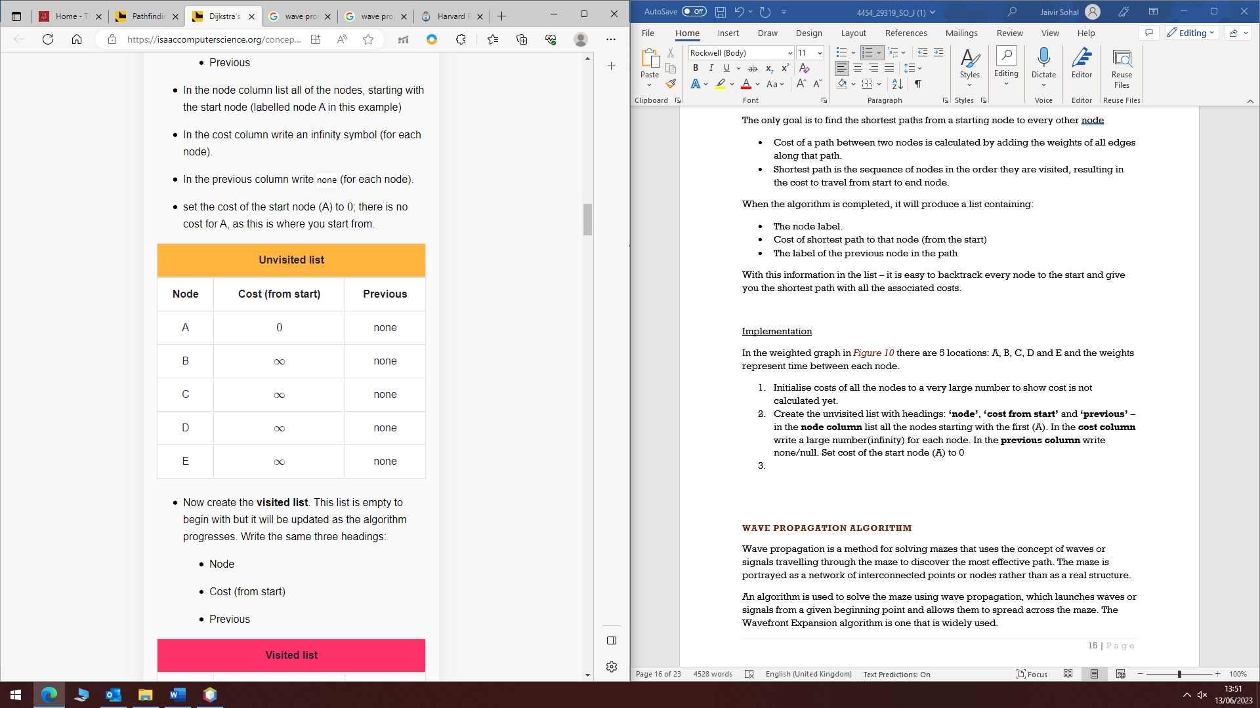

Unvisited list – [13]

1. Create the visited list (starts empty) and will be updated as the algorithm progresses. This list will have the same headings.

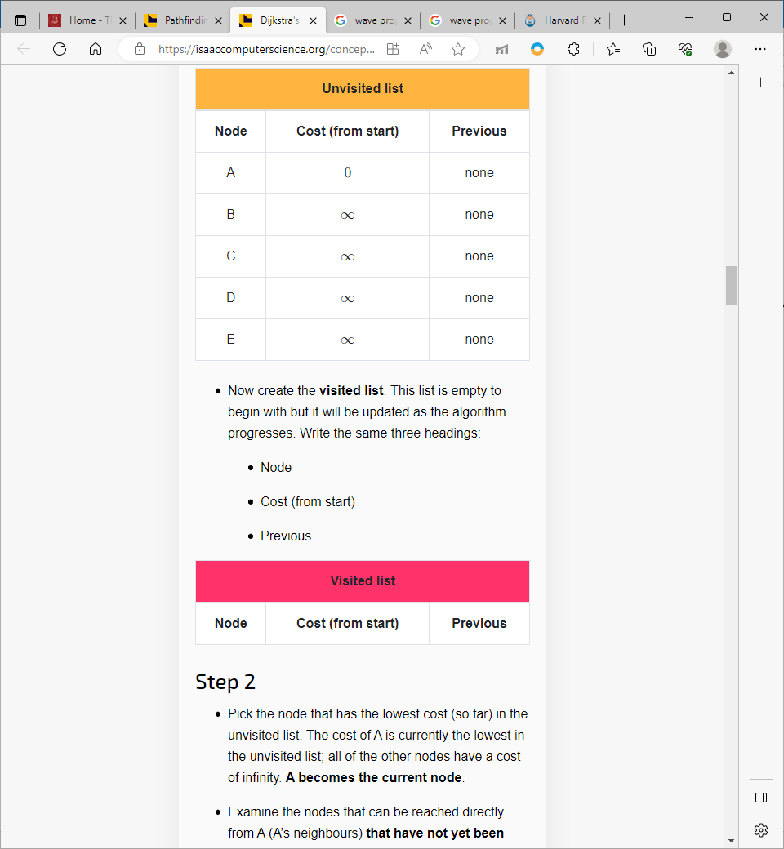

[13]

1. Pick the node that has the lowest cost (now) in the unvisited list. Cost of the first one is 0 (A) as all the other nodes are infinity – A is the current node.
2. Examine all nodes that can be reached directly from the current node that have not yet been visited.
   1. The edge from A to B has a cost of 8.
   2. Cost currently recorded in unvisited list is infinity. A cost of 8 is less that infinity so you overwrite that with 8 and record the previous node as A.
   3. Edge from A to C has a cost of 5. Cost currently recorded is infinity – Cist of 5 is less than infinity so that is overwritten, and A is previous node.
3. Now all neighbours of the current node have been evaluated. Remove A from the unvisited list and add it to the visited list with its cost (0) and its previous node (none)

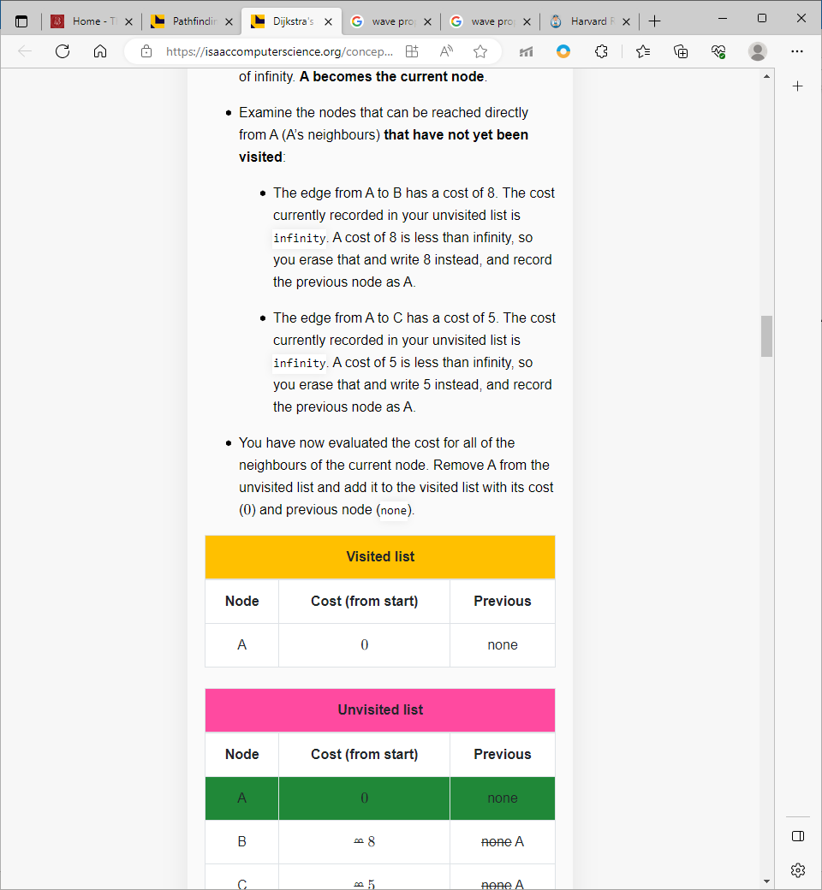

[13]

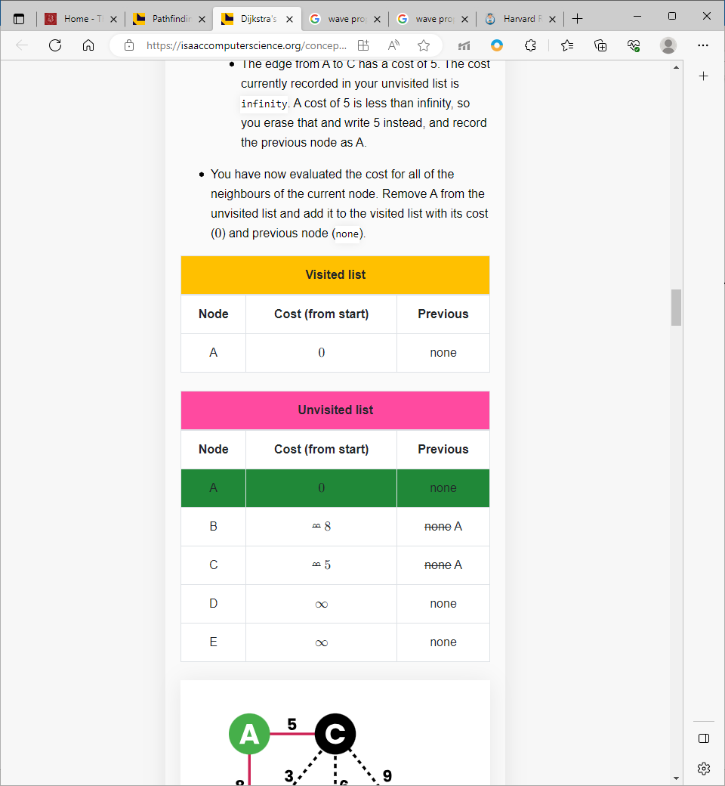

[13]

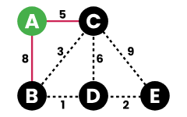

[13]

1. Next you pick the node that has the shortest path (so far) from the start as the next node to look at. The cost of the path from A to C is currently the lowest in the unvisited list; therefore, C is the current node.
2. Examine the nodes that can be reached directly from C (C’s neighbours) that have not yet been visited.
   1. Edge C to B has cost 3. Cost A to C is 5, so you add 3 and 5 to produce the total cost of using that path (A to B through C), which is 8. This is not lower than the current cost from A to B, so you leave the entry in the unvisited list as it is.
   2. Edge C to D has cost 6. Cost A to C is 5, so you add 6 and 5 to produce the total cost of using that path (A to D through C), which is 11. The cost currently recorded in the unvisited list for D is infinity, so it is overwritten with 11, with a previous node of C.
   3. Edge C to E has cost 9. Cost A to C is 5, so you add 9 and 5 to produce the total cost of using that path (A to E through C), which is 14. The cost currently recorded in the unvisited list for E is infinity, so it is overwritten with 14 instead, with a previous node of C.

By following this method, you will get the lowest cost for each path in the unvisited list which will help find the shortest path.

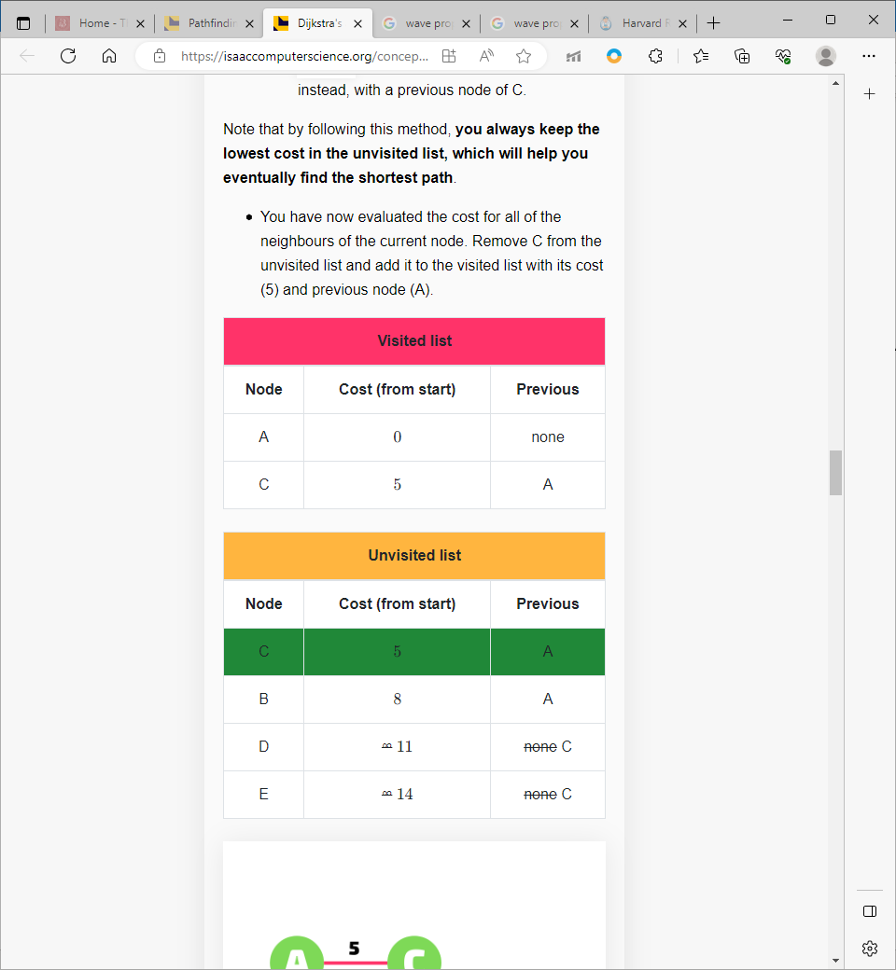

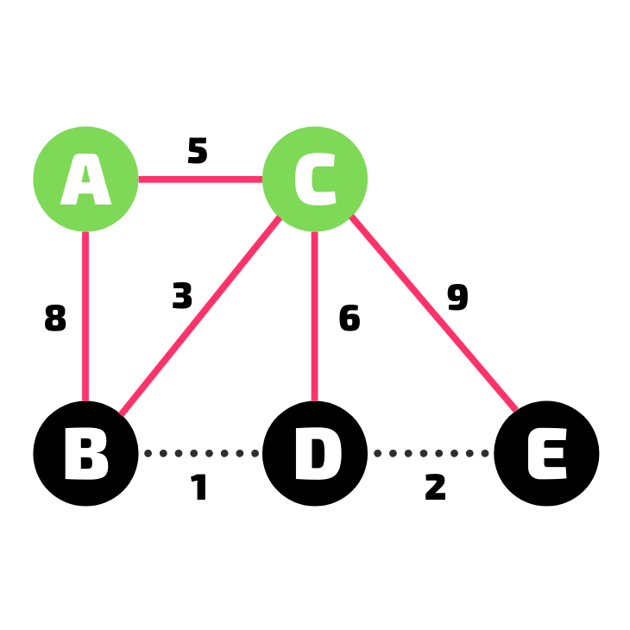

C has been visited – [13]

1. You **repeat this for B as it becomes the curreent node**. Check all neighbours and calulate the cost of all possible paths – if shorter than A-B then update the cost from start. Lowest cost is always in visited list. **At the end B has been visited** and all connections evaluated for B so add to visited list with cost and previous node.

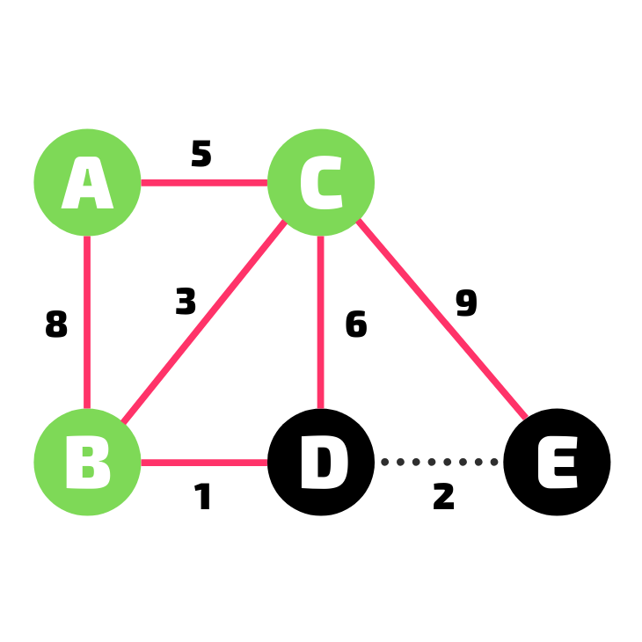

[13]

1. **Repeat process for D and E.** After this all nodes will be in the visited list and the algorithm will end

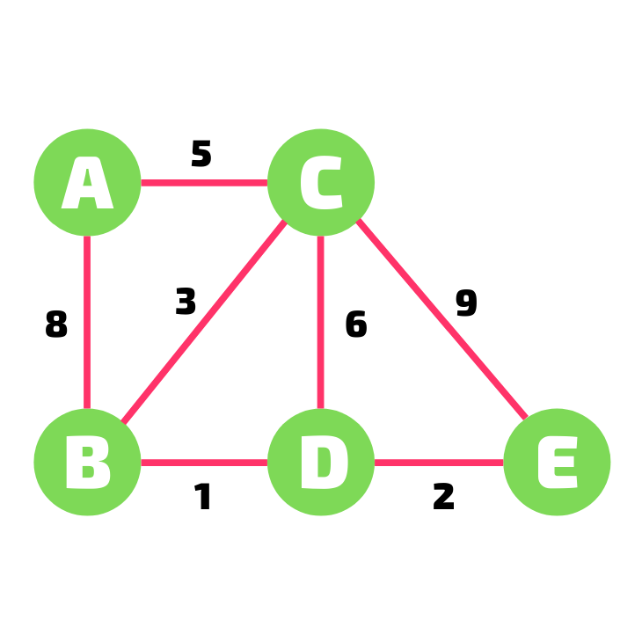

[13]

1. To find the shortest path from a node – Choose a node. For example if E is chose, the previous node is looked at in the list and then the previous to that node etc. A list of nodes will be produced.

**Dijkstra’s** pathfindingalgorithm **works well for a whole set of nodes** but when trying to find the shortest path to one sepcific target – it can be inefficient.

The algorithm’s goal is to **always follow the shortest path** from the unvisited list regardless of the direction or how close the target is. The algorithm may be edited to add an additional check each time it takes a node from the unvisited list (Statement: if this is the target node, then stop processing and return information needed).

**Compared to the A* algorithm, it is less efficient** in finding the shortest path to a specific node but is great at handling whole sets of nodes.

#### A* Algorithm

The A* pathfinding algorithm builds upon the previously discussed Dijkstra’s algorithm to provide a faster solution to find the shortest path between 2 specific nodes. This is with the implementation of heuristics that essentially adds further decision-making processes when choosing the next node to consider.

##### **What are heuristics?**

Computational problems, such as searching, sorting, pathfinding, etc., are classified into two categories: tractable and intractable.

* Tractable – Manageable and solvable in a reasonable time frame. A problem is defined as tractable if an algorithm exists to solve it and is executed in polynomial time.
* Intractable – problems that grow exponentially worse.
* The time complexity is usually notated using Big O Notation.

To tackle an intractable problem, heuristic methods are applied. Heuristic methods are approaches that are ‘best fit’ and return solutions that are not always accurate, optimal or complete but are created to allow achievable results in a time frame. These methods should be considered within the design phase of the product.

##### **How heuristics are used in the A* algorithm**

A* algorithm will find a short solution that may not be the best but will be good enough and within a reasonable time limit with the use of heuristics. The A* algorithm uses heuristic functions to help decide which path to consider next. This function provides an estimate of the minimum cost between a given node and the target node.

The algorithm combines the actual cost from the start node - referred to as g(n) - with the estimated cost to the target node - referred to as h(n). These results are used to select the next node to evaluate.

Common heuristics can be used to create a straight line between nodes or circular paths, but the context and application are different for every method. Three common heuristics used for A*:

* Euclidian distance

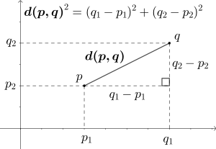

[14]

* Manhattan distance

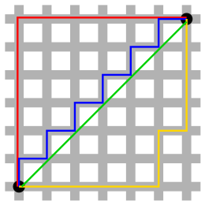

[15]

* Great circle distance

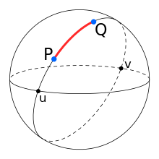

[16]

The weights on a graph do not always represent distance. It is vital that the heuristic function does not overestimate costs. If the heuristic function provides an estimate that is less than or equal to the actual cost, A* will always find an optimal path and will generally find it much faster than Dijkstra’s algorithm.

##### **Step by step implementation**

Example: find the shortest path from A to F.

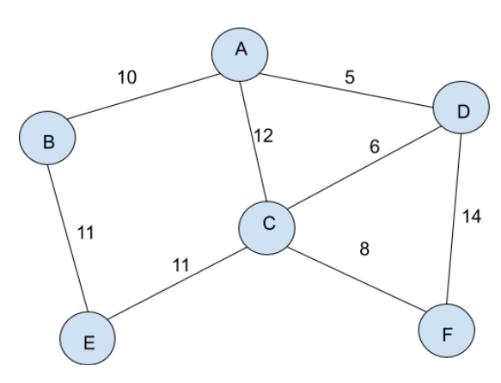

[17]

A common heuristic function that is used is black box (algorithm is not seen and the detail Is abstracted). The function will return the estimated distance between two specific nodes.

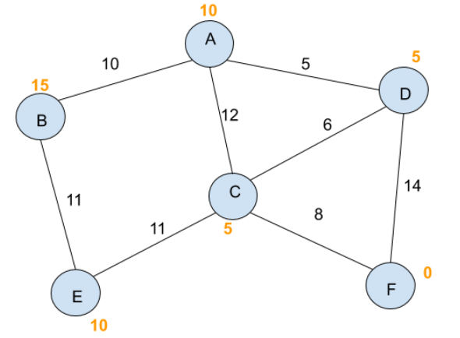

[17]

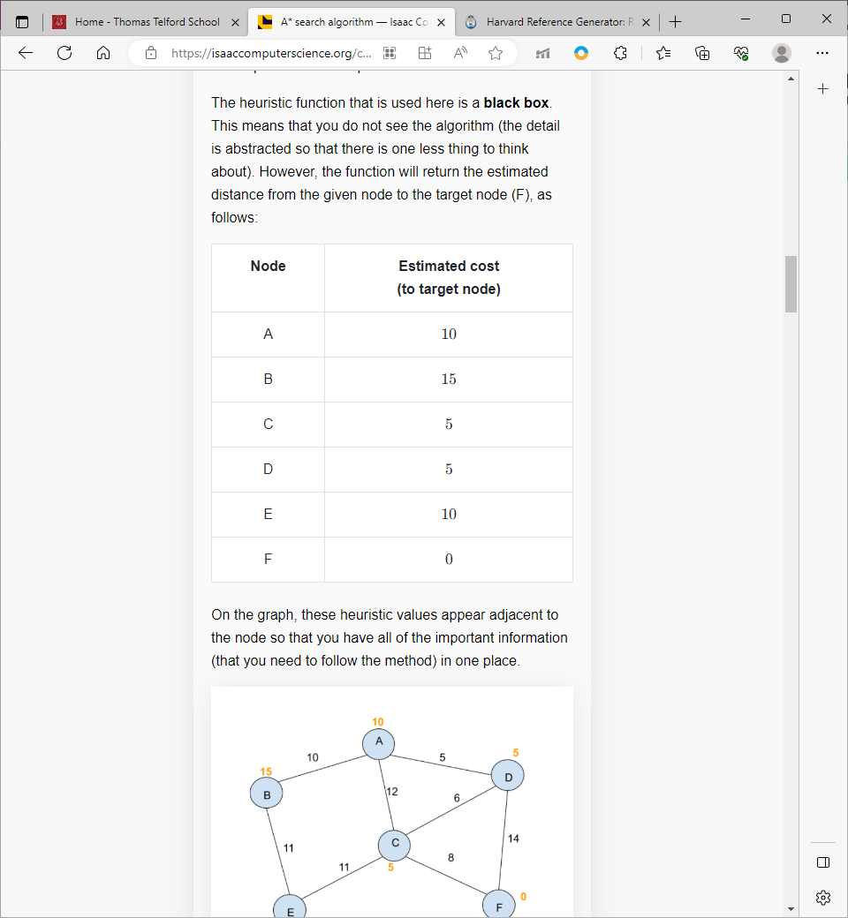

[17]

In Dijkstra’s, the cost of each path is kept track of as all routes are evaluated and cost of previous node is constantly updated.

In A*, cost of route from start node is calculated, stored, and updated in a similar way but is referred to as g-score (cost from start) and f-score (cost from start + heuristic), which is cost of path (so far) + heuristic cost. F-score is used to select the next current node. All figures below under [17].

* 1. G-score of every node is initialised to infinity.
  2. Create unvisited list with headings (node, g-score, f-score, previous)
  3. Select the start node (A), set g-score to 0 and f-score to heuristic score (10)

For all other nodes, g-score = infinity and f-score = none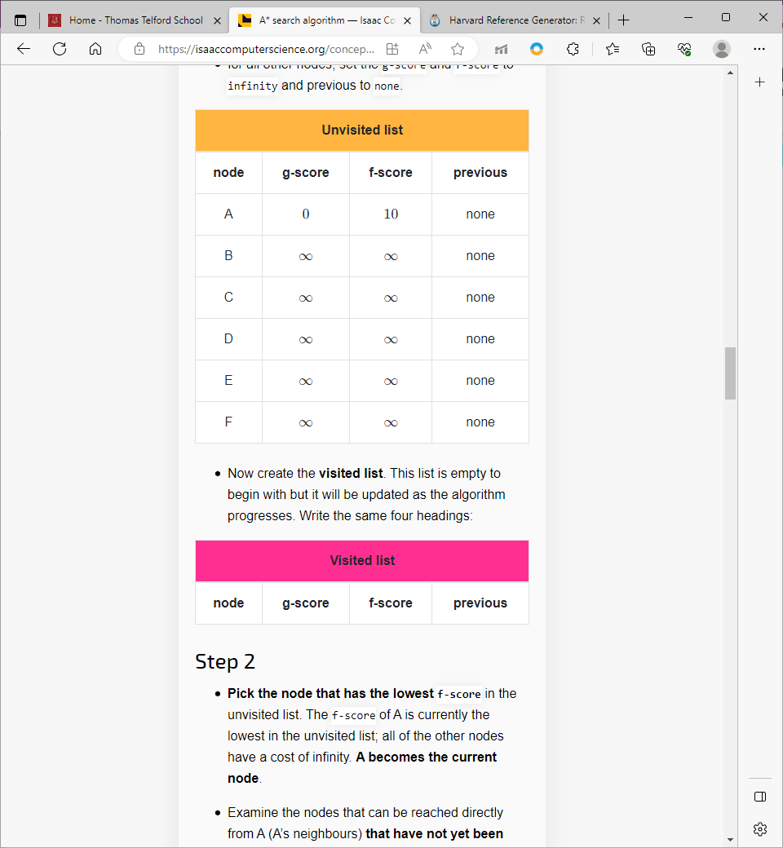

* 1. Create visited list which is empty to begin with
  2. Pick node with lowest f-score in the unvisited list, in our case, the current is node A
  3. Examine nodes that can be reached directly from our current node.
  4. Edge A-B has weight 10. Current g-score for B is infinity but 10 < infinity so set that to 10 instead, calculate f-score by doing g-score + heuristic of (B) which is 10 + 15 = 25. This is recorded in the unvisited list.
  5. Repeat for all other adjacent nodes (A-C and A-D)
  6. Node A has been visited after all adjacent nodes have been visited.

. 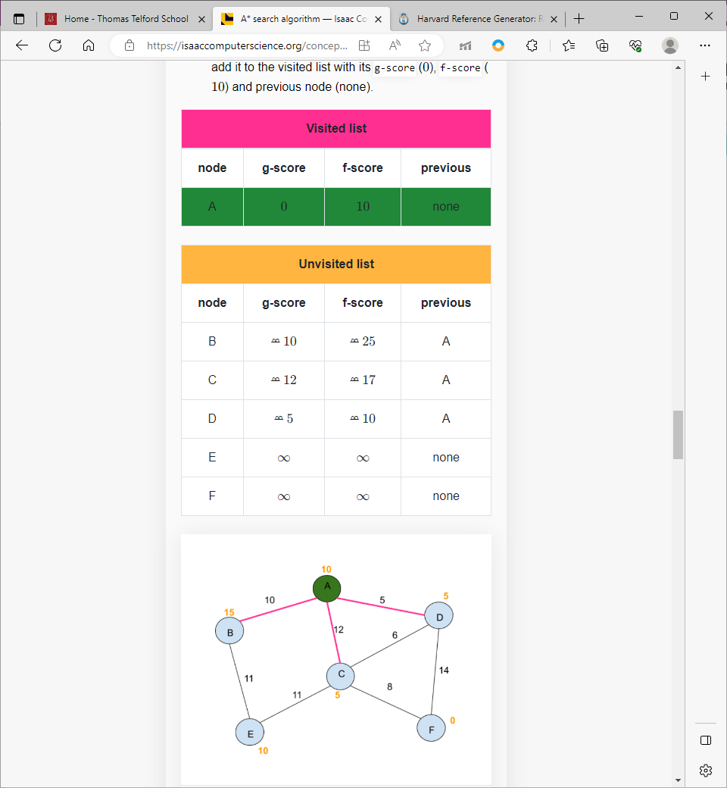

* 1. Lowest f-score chosen (D)
  2. Examine neighbours that have not been visited.
  3. Edge D-C has weight 6, g-score for D is 5 so new g-score = 5+ 6 + 11 to get A to C via D. This is lower than current score for C (12) so g-score is updated in the unvisited list where D is now set to the previous node. H(C) = 5 so f-score = 11+5 = 16.
  4. Repeat for remaining neighbours (D-F)
  5. Following this method, lowest values for each node’s g-score and f-score are maintained which will help find the shorted path.

. 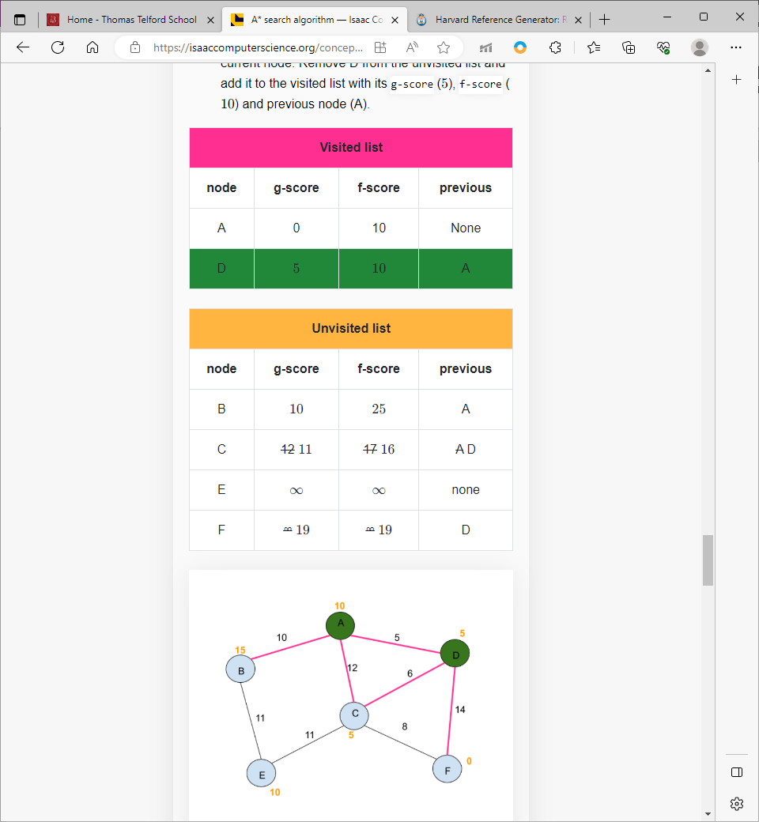

* 1. Keep repeating this until the current node becomes the target node. When F is the target node, the search is complete, and the shortest path (g-score) Is returned.

. 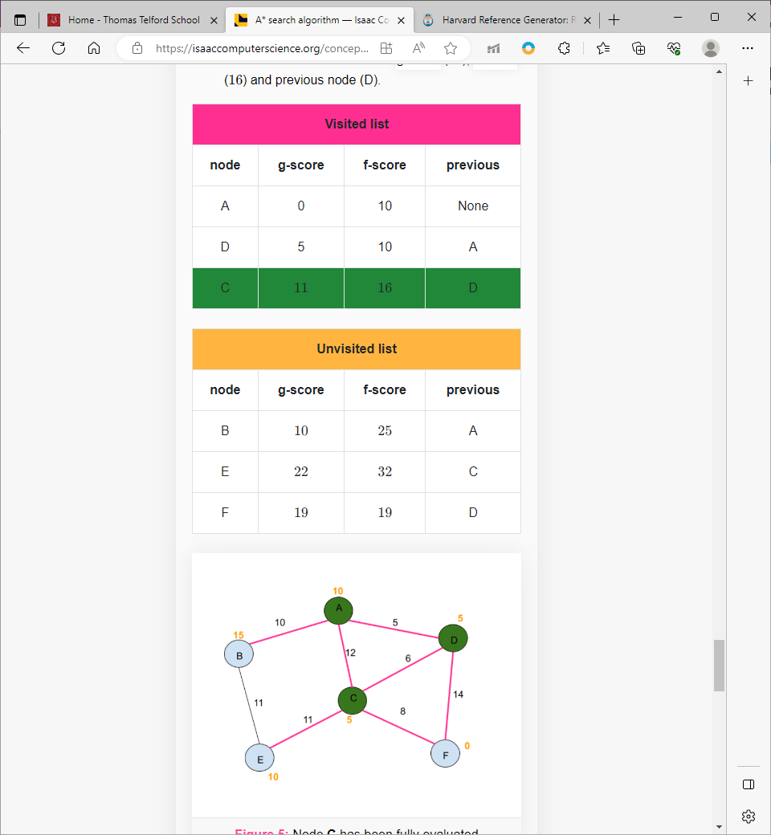

* 1. F would be the next node chosen

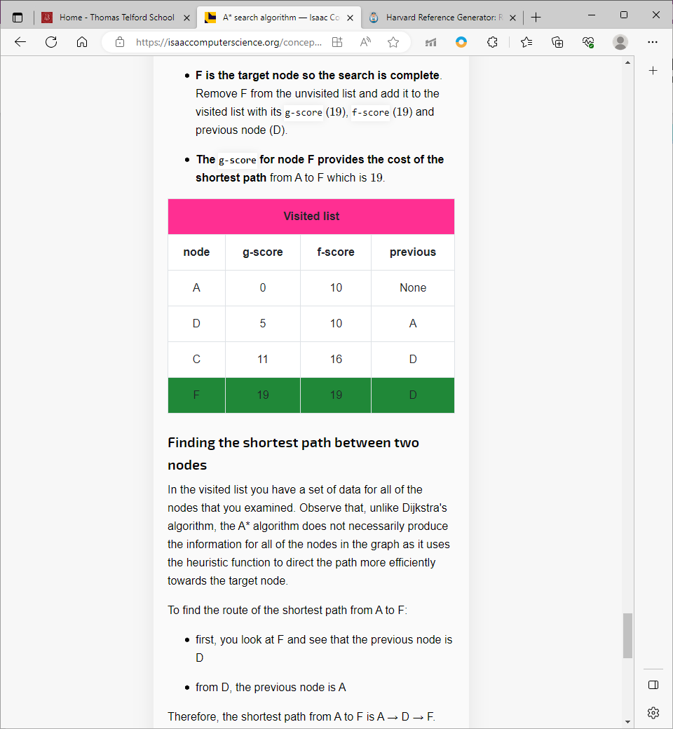

Finished list.

#### Comparing A* and Dijkstra

Dijkstra’s pathfinder will never evaluate paths that won’t find the shortest solution. Heuristics show that the trade-off between speed and accuracy is important. Dijkstra will find the shortest path between a start node and every other node no matter how long it takes so it will find the best solution but not the quickest solution that is ‘good enough’ like A* does. However, the **algorithm can be inefficient as it will waste time** as it will continue evaluating routes even if the target node is found.

The A**\* algorithm is much more efficient than Dijkstra’s algorithm**. A heuristic function provides an estimate of the costs between paths and can make more intelligent decisions. The greatest challenge is choosing an adequate heuristic function as the time it takes to provide a heuristic must not cancel out any saved time in the pathfinding process. Furthermore, the **heuristic** **must not overestimate** as if h(n) is always lower than or equal to the cost of moving from n to the target node, then a solution will always be found.

#### Other Algorithms

##### **Wave propagation algorithm**

Wave propagation is a method for **solving mazes that uses the concept of waves** or signals travelling through the maze to discover the most effective path. The maze is portrayed as a network of interconnected points or nodes rather than as a real structure.

An algorithm is used to solve the maze using wave propagation, which launches waves or signals from a given beginning point and allows them to spread across the maze. The **Wavefront Expansion algorithm** is one that is widely used.

The Wavefront Expansion algorithm begins by **designating the starting location** as the source of the initial wave. From there, the wave gradually grows, visiting neighbouring spots or nodes as it moves through the maze. During the propagation, each node keeps note of its distance from the source node.

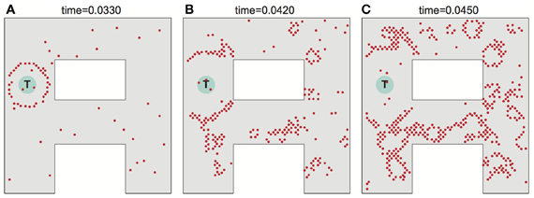

[18]

The algorithm ensures that all possible paths are considered by carefully passing through the maze using wave propagation. This method ensures that the **shortest path is found by the time the wave reaches the destination** or covers the entire maze.

The use of wave propagation in labyrinth solution has the advantage of being precise and efficient. It **avoids repetitive path exploration**, quickly discovers the shortest path, and responds smoothly to complex maze setups. This makes it a **great strategy** not only for maze-solving problems, but also for robot navigation and network routing.

##### **RIPA algorithm**

* Widely viewed as the **simplest** and **fastest** out of the pathfinding methods
* Utilises branching from a central corridor to other connected paths.
* Calculates the optimal path without any distance checks.
* As it spreads out, it uses **pre-configured paths** to make checks between every step until a final connection is generated.
* Open paths can be added to **2 separate arrays**, one for fast checks and the other one for names of nodes.

##### **Sample algorithm**

* **Starts off with a map**, a start co-ordinate, and a destination co-ordinate.

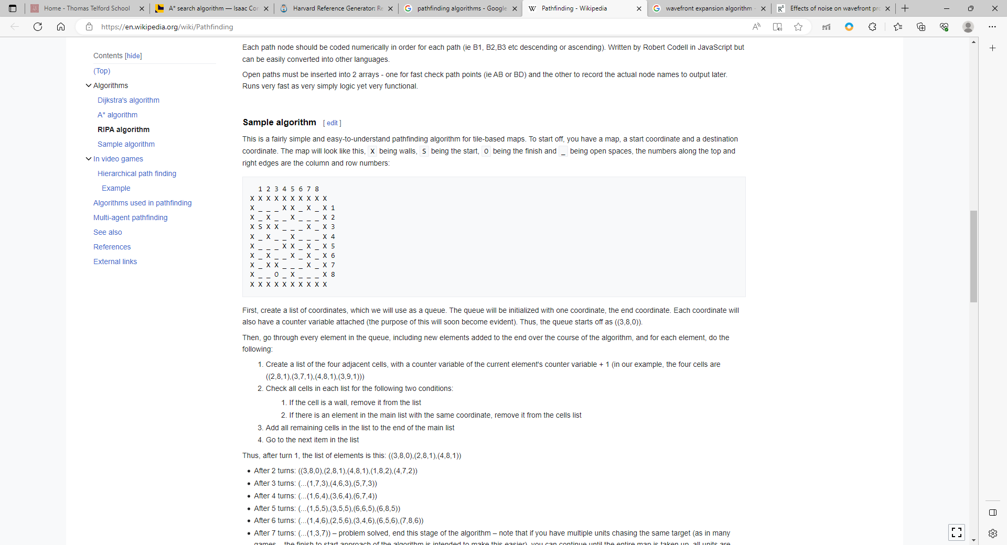

[19]

* Use a **queue structure** to create a list of co-ordinates.
* Each co-ordinate has a counter variable as the 3rd item in the list.
* The queue will be initialised with the end co-ordinate. The queue starts at (3, 8, 0)
* Go through every element in the queue, including the new elements added to the end as the algorithm progresses.
* For each element:
  + Create a **sub list of four adjacent cells**, each with a counter variable of +1
  + Check all cells for 2 conditions:
    - If the cell is a wall, remove from the list.
    - If there is an element in the main list with the same co-ordinate, remove it from the cells list.
  + **Add all remaining cells** in the list to the end of the main list.
  + Go to the next item in the list and the counter variable is incremented each time.
* **Map the counters onto the map**, start at the start and go to the next cell with the lowest number.

.

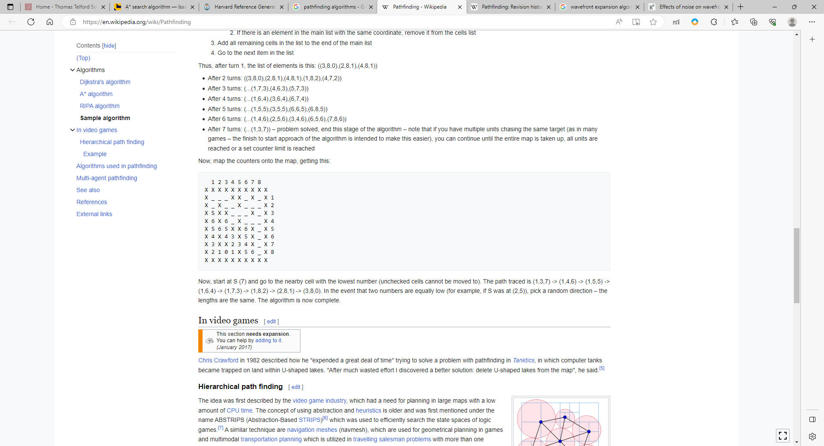

[19]

Despite being simple, this algorithm proves to be quite inefficient in a larger scale and time is favoured when generating a fast paced maze generation game.

My main focus is to implement **Dijkstra’s algorithm** to solve a maze and if there is availability to simulate a wide variety of these researched solutions, they will also be added to the product and displayed visually.

### Maze Generation

##### **Randomised Depth-First Search**

Also known as the ‘**recursive backtracker’** is an application of the depth-first search algorithm, where a branch is explored as far as possible before needing to backtrack but randomised. This approach is viewed as one of the simplest methods to generate a maze using a computer and is frequently implemented using a **stack data structure.**

The space is a large grid (2D Array) much like a chess board where the algorithm will begin to randomly create squares off itself and each cell starting off with four walls.

1. **Starting from a random cell**, the computer selects a random neighbouring cell that has not yet been visited.
2. The computer removes the walls between the two cells and marks this cell as visited and **adds it to the stack to facilitate backtracking**.
3. The computer continues this process with a cell that has no unvisited neighbours being considered a dead end.
4. When at a dead-end, it **backtracks through the path** until it visits a cell with an unvisited neighbour.

This repeats until all cells are visited and the beginning stack is traced all the way back (empty stack).

Short visual of the maze generation algorithm below: [20]

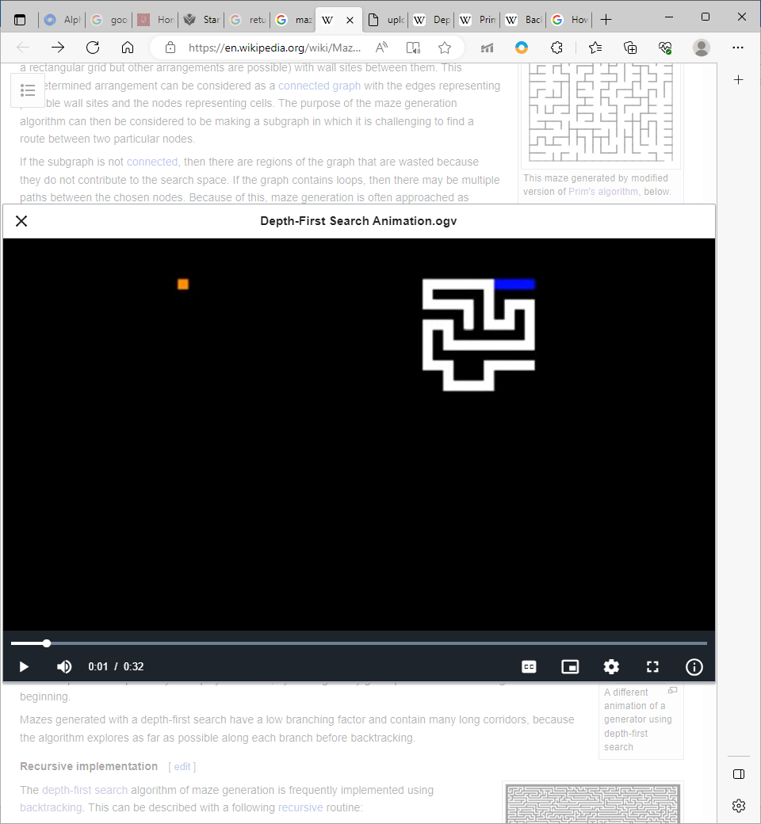

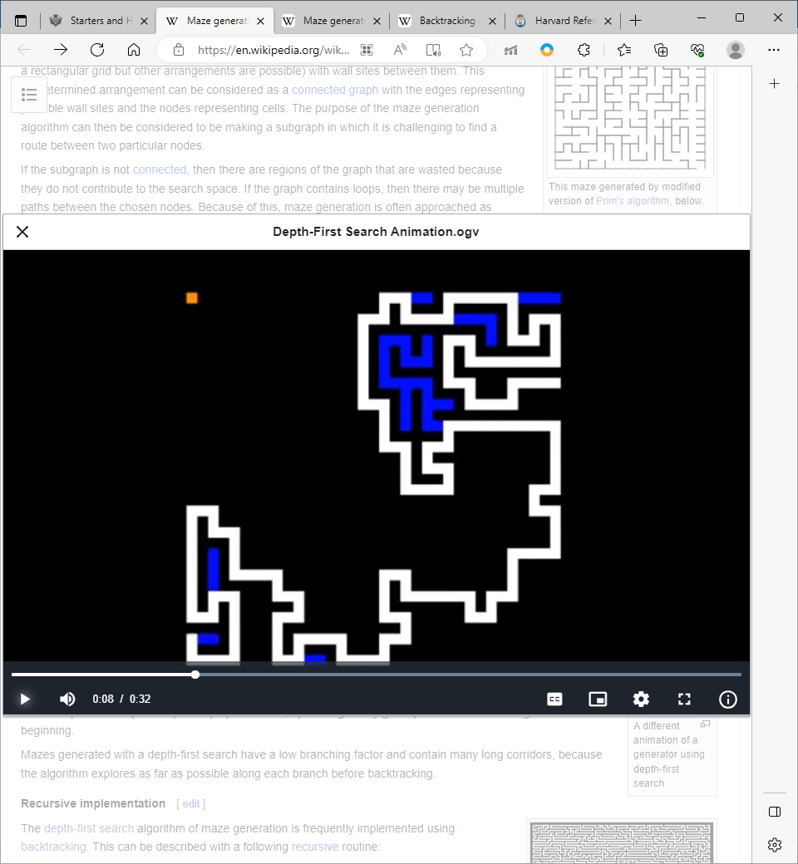

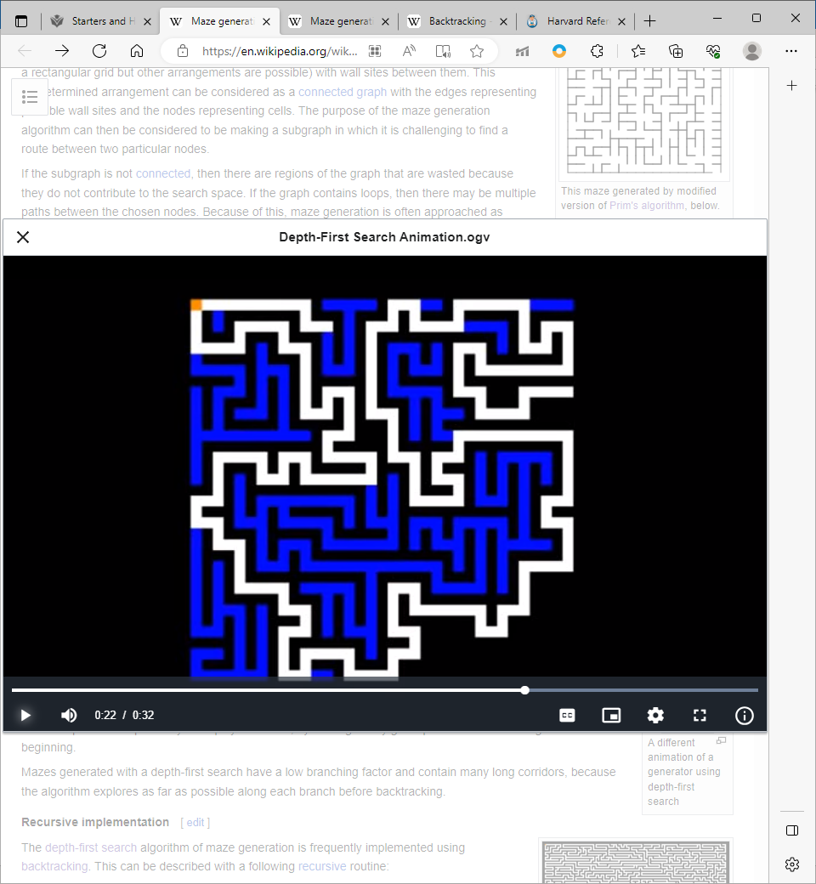

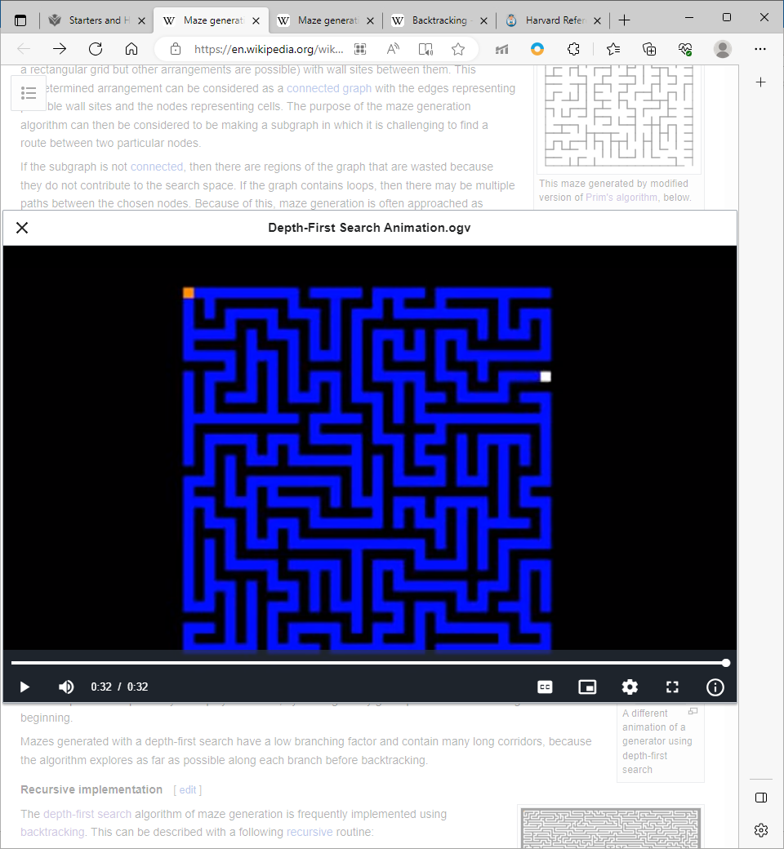

However, as this **algorithm uses deep recursion**, there may be an issue of stack overflow errors on certain computer architectures. The algorithm may be edited into a loop by storing backtracking information in the maze itself. This provides a quick way to a solution by **starting at any point and backtracking to the beginning**. Mazes generated by this algorithm can share similarities where there is a low branching factor with large corridors as the entire branch is explored as far as possible before backtracking.

**Recursive implementation**

The depth-first search algorithm is often implemented using **backtracking** which is also described as a recursive method.

1. Current cell is a parameter.
2. Mark the current cell as visited.
3. While current cell has any unvisited neighbours.
   1. Choose one unvisited neighbour.
   2. Remove the wall between current and chosen cell.
   3. Invoke recursive routine for the current cell.

This is invoked once for any starting cell in the area.

**Iterative implementation**

The first approach has a few negatives with the **main drawback being the large depth of recursion** where a worst case will have the routine recurring on every single cell in the area which can exceed maximum stack depth in some integrated development environments and especially Apache NetBeans where the product will be constructed.

In accordance with this drawback, the same backtracking method may be **implemented with an explicit stack** which allows large growth with relatively no harm.

1. Pop a cell from the stack and make it the current cell.
2. Choose a neighbouring cell.
3. Remove walls between the cells.
4. Mark the chosen cell as visited and push it to the top of the stack.

##### **Randomised Kruskal’s algorithm**

Kruskal’s algorithm [21] utilises a **minimum spanning** forests and weighted edges to find a minimum spanning tree between nodes where the sum of weights of edges is minimised. This algorithm is applied randomly to a stack of nodes.

1. **Create a list of all walls**, and create a set for each cell, containing just that one cell.
2. In a random order for each cell, if the cells divided by this wall belong to distinct (unique) sets:
   1. Remove the current wall.
   2. Join sets of the divided cells.

If an **efficient data structure** such as the disjoint-set/ merge-set is used for non-overlapping items them the running time of the algorithm will be proportional to the number of walls available in the maze

##### **Randomised Prim’s algorithm**

Just like the previous algorithm a standard algorithm, in this case Prim’s algorithm, is randomised. Prim’s algorithm [22] is a greedy algorithm (**heuristic optimisation**) that is very similar to Kruskal’s algorithm in a sense that it will find a **minimum spanning tree** but **instead builds a tree one vertex at a time**, creating the cheapest tree.

1. Start with a grid of walls.
2. Choose a random cell and mark it as part of the maze, add the walls of the cell to the wall list.
3. Whilst there are walls in the list:
   1. Pick a random wall, if only one of the cells that the walls divides is visited then:
      1. Remove the wall between the cells and mark the unvisited cell as part of the maze.
      2. Add the neighbouring walls of the cell to the existing wall list.
   2. Remove the wall from the list.

This algorithm creates walls that area **visually very similar to Kruskal’s** algorithm as they are both using minimal spanning tree algorithms.

##### **Wilsons algorithm**

**All** previously discussed algorithms **contain bias** such as **depth-first having bias** towards **long corridors** and Prim’s/Kruskal’s are biased towards many short dead ends. An unbiased sample from the uniform (symmetrical equal probability) distribution will generate a completely unbiased maze using loop-erased random walks.

The maze is initialised by a one cell chosen arbitrarily. Starting at this cell, perform a random walk until we reach a cell already in the maze – however if the random walk reached its own generated path, it would erase the loop and start again. This repeats until all cells are filled.

This **procedure remains unbiased throughout the entire process** no matter what cell is chosen.

##### **Tessellation algorithm**

This is the simplest and quickest way to generate a maze. Iterations are used where a maze is created by **copying itself 3 times to** create a maze that is double the size each iteration. At the end of each iteration, 3 paths are opened between the 4 smaller mazes.

Despite being extremely simple and fast, It isn’t possible to get a maze of a chosen size and often doesn’t look like a generic maze. Shown below [20]:

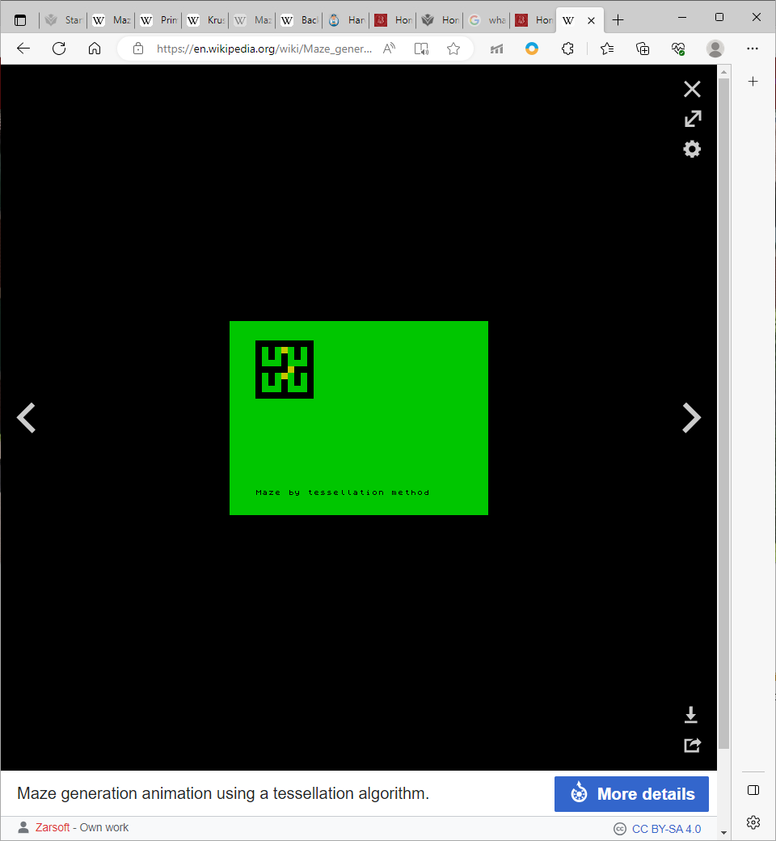

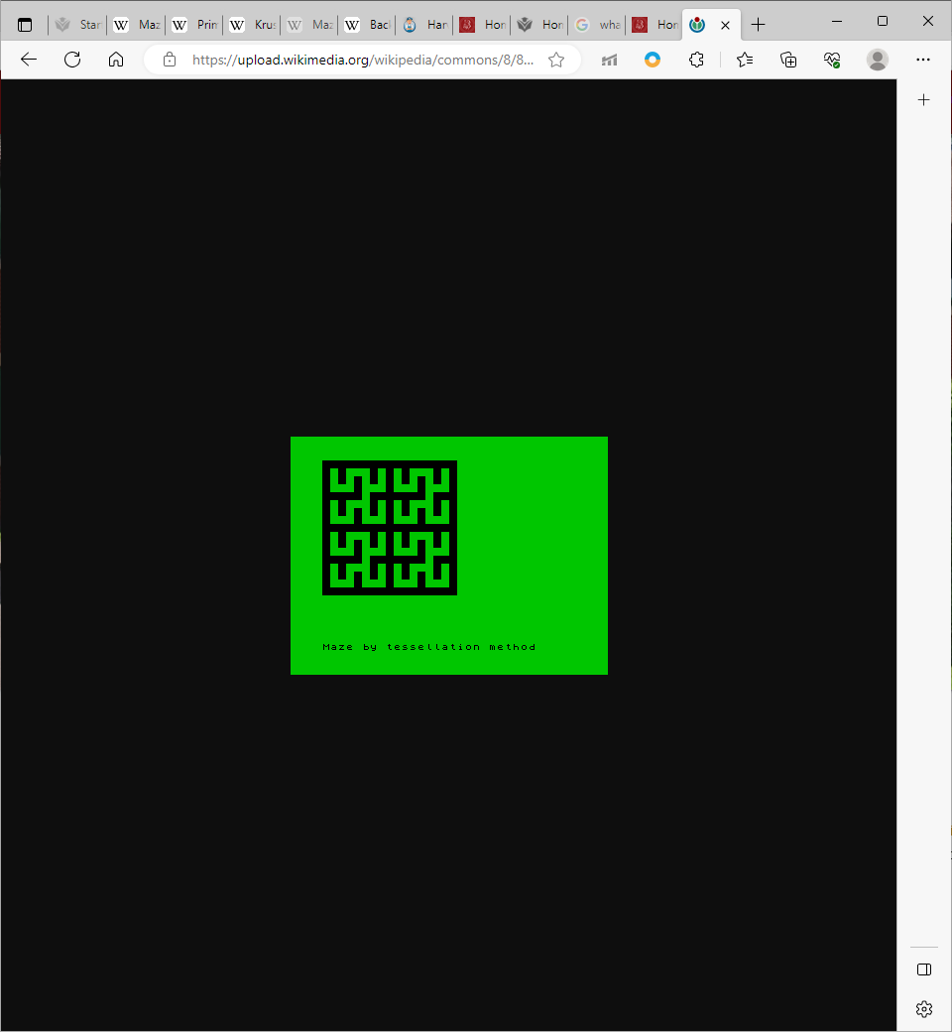

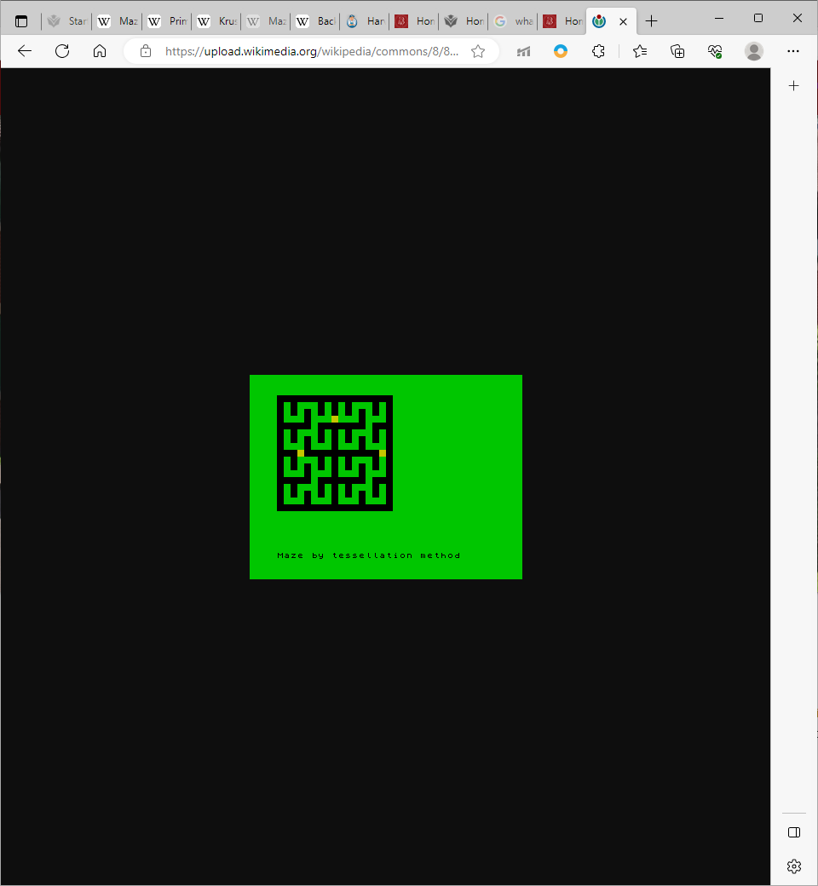

##### **Comparisons**

The **depth-first search** is unarguably the **number one choice** when it comes to developing an algorithm to generate mazes as it harnesses the characteristics of an algorithm that is greatly familiar to all computer scientists with the implementation giving a standard, quick and accurate result. However, the product that will be created will need to include visualisation of pathfinding on large mazes but with this algorithm, there **can be bias towards long paths** as shown in the image below.

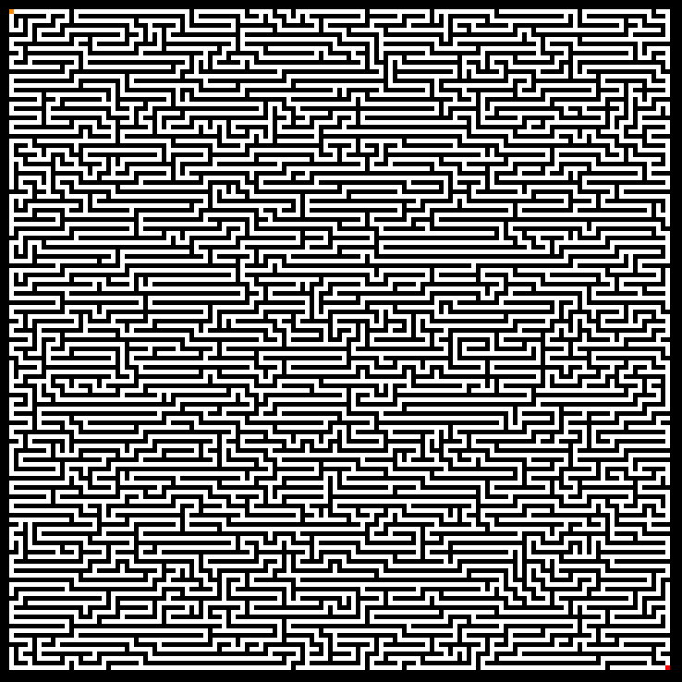

[21]

As Kruskal’s and Prim’s algorithm both make use of minimum spanning trees, they can be regarded in the same sense. Despite generation functional mazes, **many short dead ends are generated** whilst generation is generally slower than other methods. Implementation of this technique **may be seen as unnecessary** as it requires the addition of existing algorithms such as Prim’s algorithm with their dedicated heuristics and can sway focus from the main intention of the product. **Prim’s algorithm will generate more dead ends than Kruskal’s** and considerable resources are wasted on redundant tasks.

The **tessellation algorithm** is great for a **short simple solution**, but it **lacks complexity** and functionality as one of the main features of the product will be variable maze size which is impossible with this form of algorithm. Wilson’s algorithm on the other hand has very interesting visuals when creating the maze and not only does it generate a maze that looks truly random, but it is also allows dynamic maze size. This may be restricted by the algorithms **initial lengthy stage of locating the first square** without looping back on itself. The main two choice’s I could use for generating mazes would be Wilson’s algorithm or **randomised depth-first** **search** as they are most beneficial to my requirements.

### Online Products

##### **Mazes – Maths is Fun**

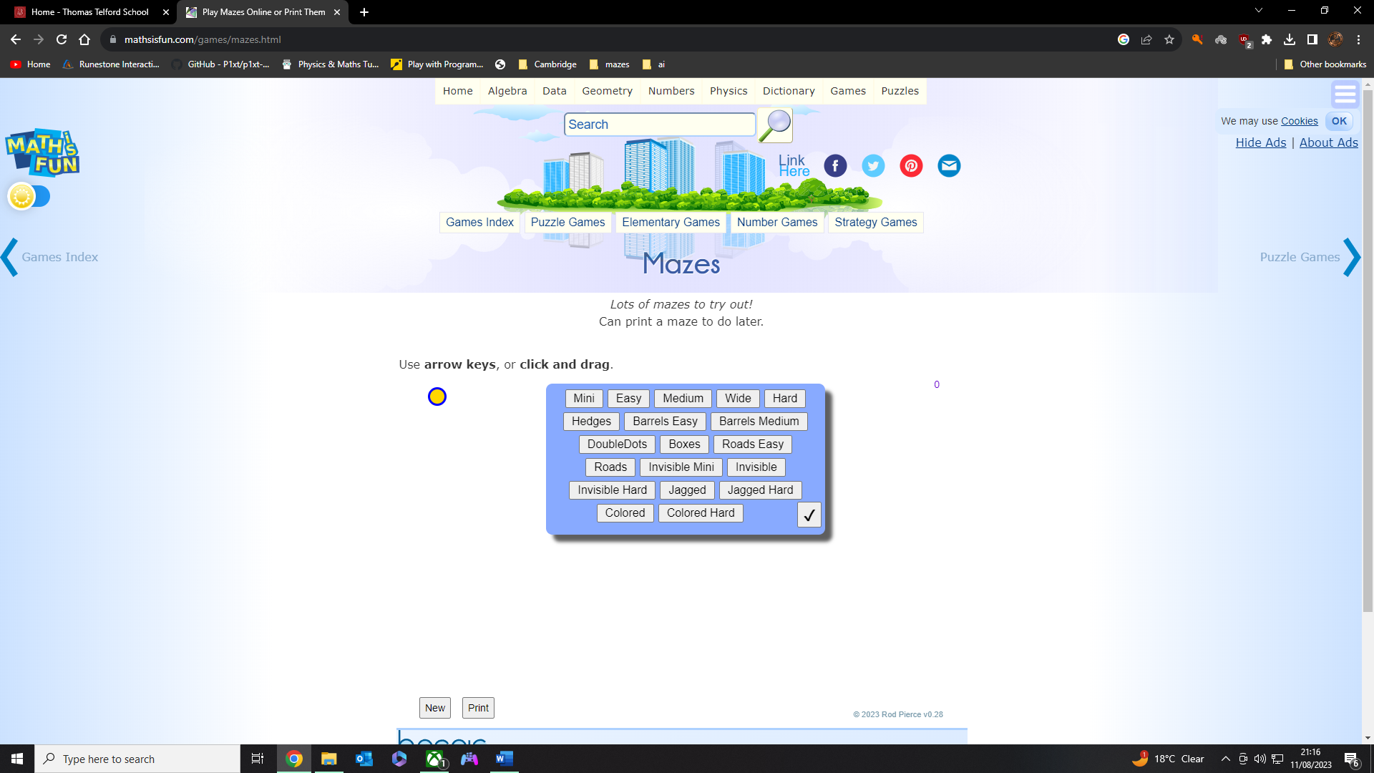

[23]

Upon entering the maze subsection on this website there is an **immediate selection of 19 different types of game modes** with a simple set of instructions located above. The interface is clean, uncluttered, and straightforward with the focus being on how to use the website before selecting a mode. There is a **clear confirm button** and the buttons are highlighted once pressed to show which one was selected.

Despite the **straightforward layout**, it would be useful to preview how the certain game mode works/ looks before clicking it. Furthermore, although the website is clean, it **does** **not show too much creativity** within the graphics and many users may find this aspect boring.

However, this website is not specialised solely for mazes but **offers many different classic puzzle games** with **easy navigation** as shown in the image where the shortcut bar includes a game index to every game and different categories of games that saves time searching through the game index. As **the product** I am creating is **focused on mazes**, we can ignore this shortcut bar, but a selection of game modes adds a new and fun way to play mazes that will aid in **engaging the user’s attention**. The short how to play instructions is very subtle but essential for the final product.

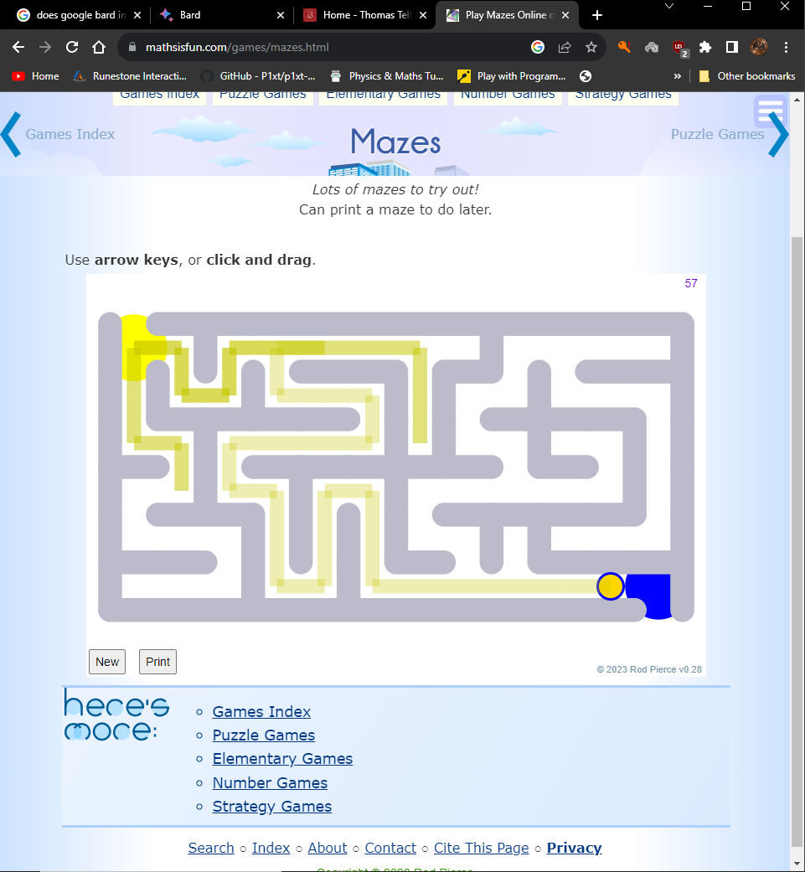

[23]

The transition from the selection menu to the actual game itself is **satisfying and smooth**, where there is no refresh or redirect to another web page but rather on the same page where a simple substitution is made. The controls are extremely user friendly with each arrow click corresponding with one tile move followed by a **light-yellow trail** to show the path taken so far. A useful technique that can be used to **warn users of backtracking** and a decreasing score is deployed here and its where every backtracked tile becomes a shade darker.

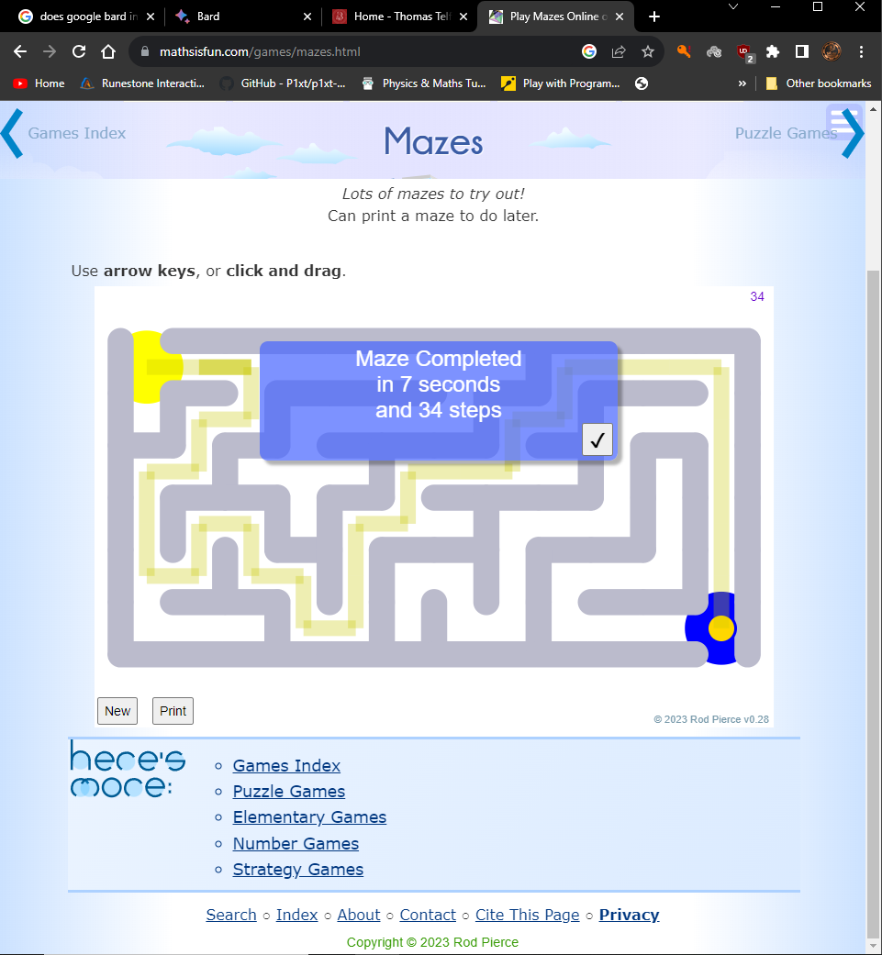

[23]

After reaching the finish line there is a **simple statistics screen**; this tells you the maze is completed, how many **seconds** it took to complete and the total **number of steps**. A statistics screen can be quite helpful for a user but is quite simple on this website and other stats could be useful such as mean time taken between all puzzles, leaderboards and high scores stored on the account.

A new maze can be selected mid game or after the game where it calls a function to overlay the starting menu onto the current screen to **prompt the user to select a mode**. Although it is a useful button, a user must go through the entire process of selecting a mode when they may just want to **replay the same mode indefinitely**. This is why it may be useful to leave out overlaying this menu and just re invoke the same game mode and if a user wants to select a new game mode, have them navigate back to the menu or create a new button for this command.

The mazes are randomly generated each time and the website allows you **to export the maze as a jpg file** and print it out which can be useful when wanting to work on it in real life or within a group. At the bottom of the page there is also a short bar like the shortcut bar that contains privacy/ legislation documents and more links to other genres of games. Overall, **the GUI is simple**, easy to use and contains a **minimal** **amount of** **complexity** to allow a relaxed user experience. The final product will be heavily focused on algorithmic capability before graphical design so this website can be a great source of inspiration for a base UI with great potential for improvement.

##### **My Steinbach Maze Game**

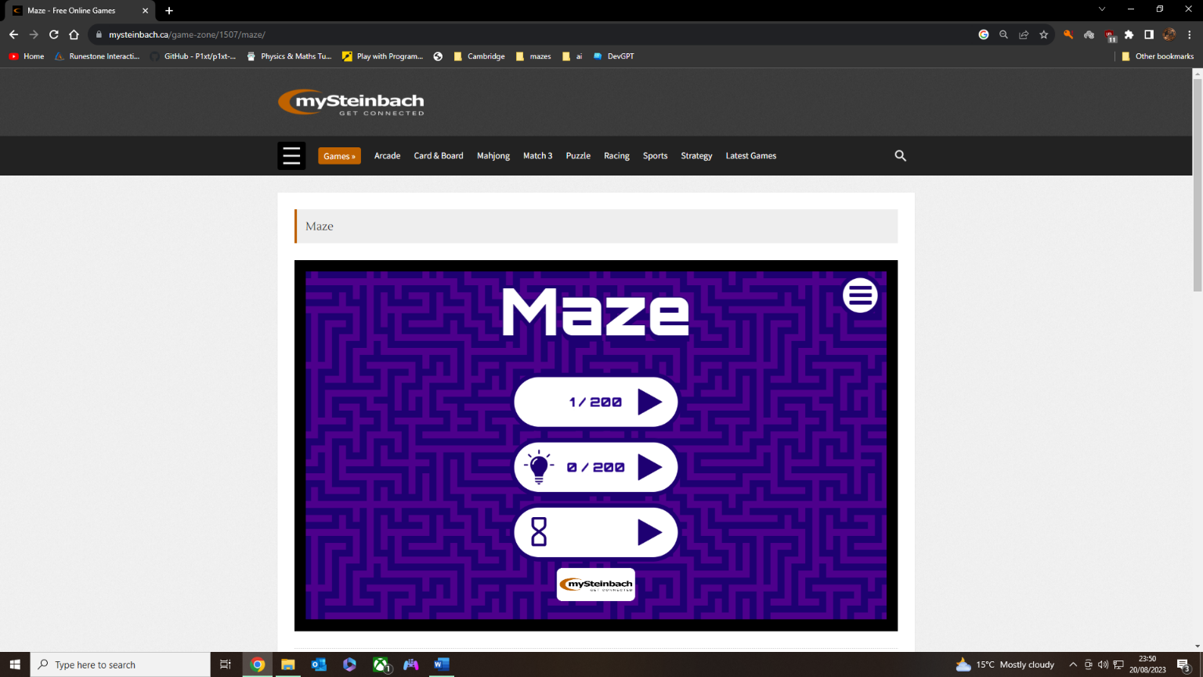

[24]

Unlike the previous website, the immediate impression from this website is derived from the **graphical appeal to the user**. The contrast between the solid colours purple, black and white gives a clear distinction between parts of the user interface. Despite being aesthetic, it is also minimalistic showing how better visuals may not necessarily result in higher complexity and in turn easier to use.

The menu present three option; the first option is a level **selection of 200 levels** that get progressively harder to complete. The second option is another 200 levels, but you have limited visibility, adding a fun twist that is unique to any other competitor online. The final option is a time-based game mode with a predetermined maze size, and you try to navigate to the end point in the shortest possible time.

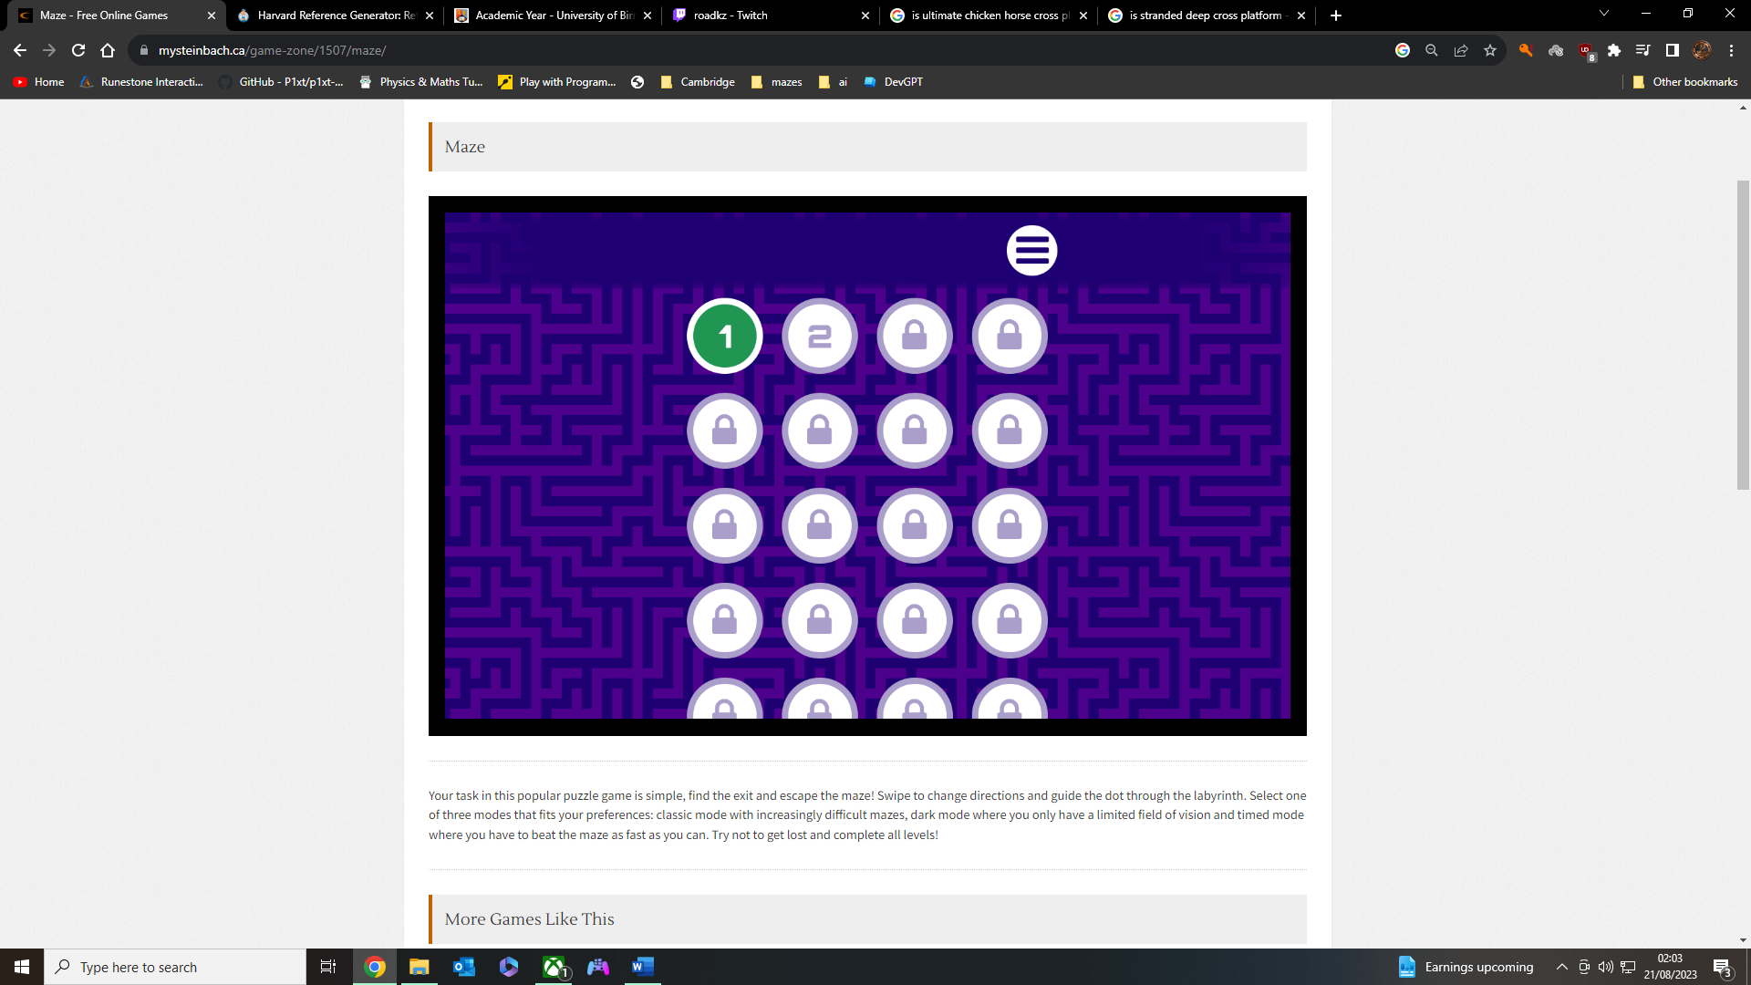

[24]

After choosing the first option, you are redirected to another menu where it shows completed levels and **levels that are locke**d. Here you have the option to readily see what level you are up to and provides the option to replay any level previously completed. The users IP address is used to **save data and keep track of the level** you are on even after you close the website as it stores this information inside a dedicated database for the site. You have the option to click the menu button top right where it allows you to toggle volume or return to the main menu. This **menu button is persistent** and remains in the top right of the screen regardless of the game mode.

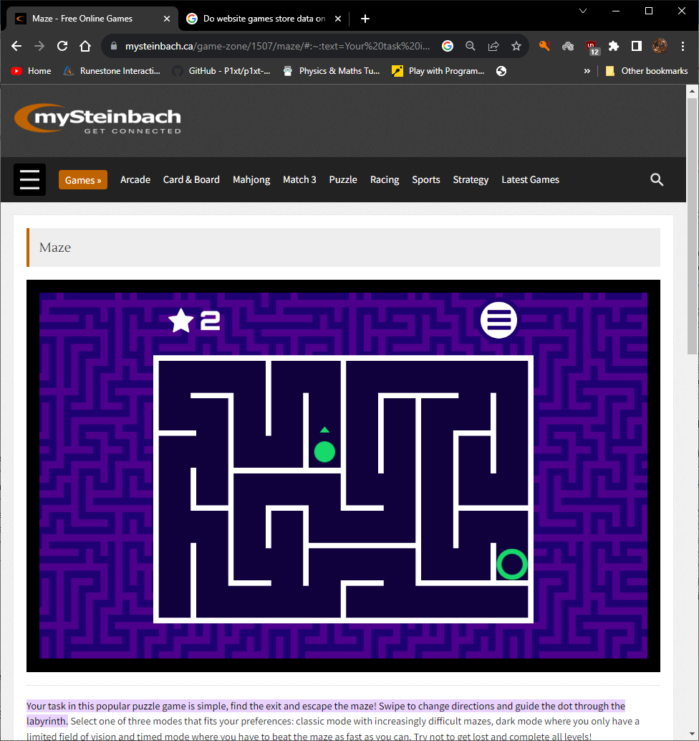

[24]

This first option has **200 predefined levels so** they will **always be the same**, but it is safe to assume that they were all randomly generated beforehand as another mode offers infinite randomised generation. Playing the game has a greatly smooth experience as when you click a button in the intended direction the **cursor smoothly glides** to the next possible decision/junction. Although removing the option to backtrack mid-way through the journey between junctions, a new playstyle is introduced that isn’t necessarily worse than other examples.

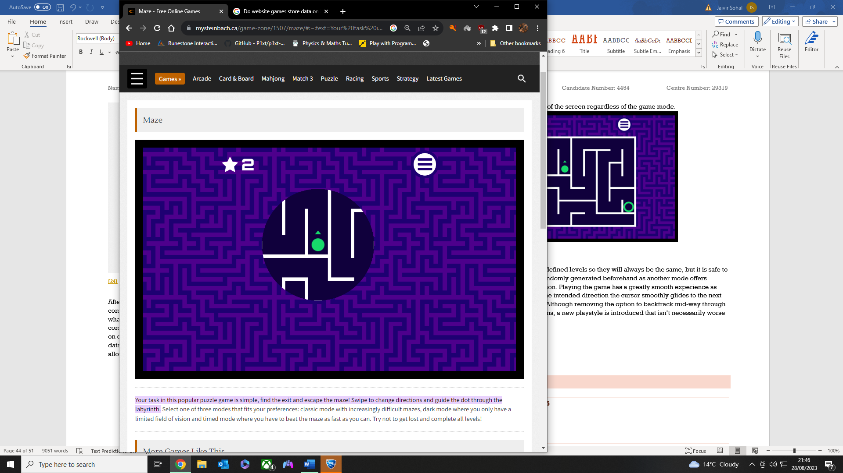

[24]

Moving on to the second option, it’s a maze with **limited visibility** with the main purpose of not knowing where the finish line is. This introduces another **creative** **twist** that is unique to this website and **isn’t often seen elsewhere**. The game is almost identical to the previous option with the only expansion being the change in field of view, even the **same levels are used** and **not randomly generated**. Users may see the level repeat as negative, but many will not notice the repetition due to the decreased visibility.

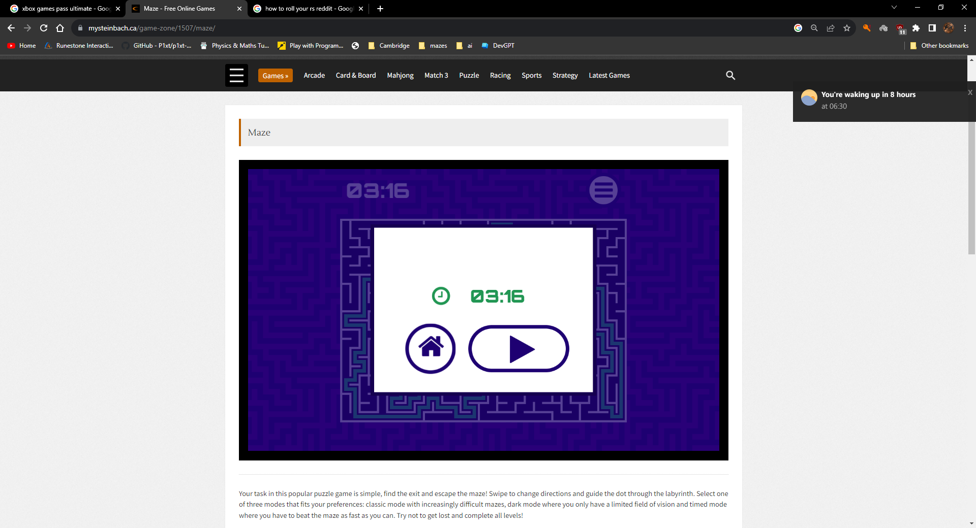

[24]

The final game mode consists of a traditional randomly generated maze that puts you against the clock to try and **achieve a high score time**. The length and width of the maze will always be constant the finish and start marker is randomly placed on the grid. This game mode will be most like the final product’s game functionality except from the **lack of customisation such as leaderboards** and different maze sizes. The animation is smooth but seems unnecessary and leading you automatically to the next junction removes the joyous aspect of navigating tile by tile through the maze.

**Aspects that can be transferred** to the final product are features such as the last game mode, **persistent menu** icons and the visually **pleasing colour palette**. The automatic locking to junctions is unique but it removes the classic maze navigation feeling as well as the limited visibility where luck is the prominent factor.

## Features

### Essential Features

Having a **meeting with the client**, a variety of features were **reviewed**, **declared as essential** and some that would be **ideal** to have. These features would be the mandatory implementations to have a working solution to the proposed computational solution.

##### **Interface**

Login

A login form is inevitably the first screen a user would see on a loaded application. Not only does it add a sense of security on the application where all **local data** is held on one account, there is also a **customised** experience as user profiles **will always be unique** to one another.

Simple layout:

Register here!

Enter Password…

Enter Username…

The vital layout would consist **of 2 text boxes prompting the user** to enter a login for the first box and then a password on the second box. A small link to another form would be present above both boxes to allow the user to register if not already registered before. The purpose of the layout is to have the main subject on the login as **people are more often logging in rather than registering an account**.

When registering a new password, there **must be validation** that indicates a strong password. The requirements that have been decided are **at least 8 characters, 1 special character and 1 number.** Furthermore, there must be validation that checks whether a username and password exist within the saved data. Users will have 3 attempts to enter the correct details before being locked out for 30 seconds.

Menus

* **Main menu:**

Upon completion of the login phase, the screen the user will be met with is a selection of two options; the first will be a ‘visualise’ button and the second button will be a ‘play’ button. There will be a small red ‘X’ in the bottom right corner of the menu to allow the user to exit the application.

* **Visualise:**

After discussing with the client, we decided that both maze generation and maze solving visualisers should be functions on the same panel. Once the maze has been slowly generated and the visual is complete, you will be able to choose a maze solving algorithm to visualise on the maze that was just generated where a coloured trail will reveal the path. The statistics of how well the maze solving algorithm was and the relative time taken for it to solve will be displayed for reference.

* **Play:**

The purpose of the ‘play’ section is to allow the player to choose a maze size with the sole purpose of trying to solve it as quickly as possible. After pressing the button, the user will be prompted to select a maze size out of 3 set options for example: 10x10, 20x20, 30x30. This allows for less procrastination on maze sizes, and it is very easy for a user to just select a size and play with minimal decision making.

* **Maze completion menu:**

After completing a maze in ‘play’ mode there will be a pop up that will inform the user of statistical information and options to play again or return the main menu. Information the client would like to view after completion are values such as time taken to solve and total steps taken. Like the play menu is the visual completion menu, this is not a pop up and is simply a collection of buttons alongside the main maze panel. This will consist of a re-generate button, a button with the pathfinding algorithm name and a re-solve button.

* **Transition Menu:**

At all times there will be a small button in the top right-hand corner of the screen that prompts a little pop-up menu that is like the maze completion interface but only has two buttons: resume and return to menu.

##### **Algorithms**

There will be one primary way to generate mazes with the implementation of at least one pathfinding algorithm to visualise. A form of the depth first search will be handy as it is not only simple but avoids long corridor bias when working with smaller mazes as the client will be doing. Whilst handy to have at least two pathfinding algorithms to compare, it is essential the final product has at least **one generation and one solving technique** to ensure full functionality.

The first pathfinder will be made **using randomised depth first search** as it will be simple to expand upon the generation technique and manipulate in a way that will solve the maze whilst displaying an interesting visual representation.

There must also be an algorithm to appropriately generate a **starting square** and a **finishing square** at moderate distances to each other so that they are not too close or not too far apart from each other. The starting square would usually be in the upper quarter of the maze whereas the finish square would be in the lower quarter.

##### **Aesthetics**

The primary font requested by client was “Courier New “as this would add a **retro fe**el to the game and would fit in with the old maze theme. Each aspect of the main maze will have a green hue; the **border of the maze will be a forest green**, the st**arting point light green** and the **ending point dark green**. To contrast with the green colour, The background will be black with walls being white in colour which is different from regular maze games where the inverted is true.

### Other potential Features

##### **Interface**

Login – Lost Password

An extra addition to add complexity to the login form is to add an option **to recover passwords**. This allows users to go through an extended process to alter stored data and **re-enter the password once reset** provided they give the correct verification to be allowed access to do so. Not only can the password be reset but after passing the verification e.g., phone or email verification, you will be **able to view your username** if you have forgotten that.

Register here!

Forgot Password? Password?

Enter Password…

Enter Username…

An advancement on the login section would be **storing the associated login details in a private relational database** on where the program would call and retrieve information for verification and storage.

Visualiser – on played maze

After completing a maze and the pop-up menu appears, there will be an option where it can **run the visualiser function on top of the played maze** as an overlay, to show the optimal and shortest path to the finish so you can visually compare this to your solution.

The visualiser function will be a **different path colour** and will be at **50% opacity** over double traced lines (lines that pass over the original player lines). This function will also run at a slower speed than the original visualisers as it should allow for users to compare the path at each step taken therefore **increasing the time**. This can be easily achieved by **adding a parameter to the function** that accepts time for each step.

Extended Statistics

This extended statistical overview **offers an overhaul on the previous statistics** tab; an entire new main menu option titled ‘**Statistics’** will be present underneath the play button. Users can access the leaderboard where it holds the name of users who have **completed mazes in the shortest time** (resolution of milli seconds).

On top this global leaderboard, there will be a **local leaderboard** specific to the user where it **displays maze times** that have been saved by the user so that they can see how they have been **improving over time.**

Extending on the visualiser, after completing the maze, all maze times will be saved locally onto the user profile so that they can be viewed later. A new statistical comparison is output to the user where it displays a % on how close their solution was to the pathfinder’s solution, with **100% being a perfect score.**

##### **Algorithms**

On the visualise menu, it would be beneficial to have other pathfinding algorithms such as Dijkstra’s or the A* algorithm to **effectively compare them against each other** and show the user the comparison. There would be an extra button labelled ‘compare’ and that would allow you to select **2 algorithms that would run against each other**. They would run sequentially (one after another) instead of at the same time as a threaded application would be necessary for such a procedure.

After each run, the algorithms would solve the maze almost instantly. This is why we purposefully **slow down the time taken so that it can be perceived by the user’s eye** but in relative time. This way the ratio between times would be correct but slowed down significantly.

Exclusively to the visualise tab, when a maze is generated, the user will have the option to **select which generation algorithm** would be used to create the maze and this too will be slowed down so that the user can view the entire process. After researching the problem, it became obvious the first 2 algorithms to be added on the extension should be iterative implementation and randomised Prim’s algorithm. This is so that the user can see the difference between complete random behaviour and structed random behaviour that is displayed by Prim’s algorithm.

## Limitations

### Features

After carrying out extensive research for the product, **analysing algorithms**, **reviewing** web products, and focusing on the client’s needs, several features that were initially brainstormed **have been removed from** the list of possible features.

##### **Difficulties**

Within the ‘play’ mode of the product, there was the idea of **adding difficulties** in the form of better pathfinding algorithms to compare the user’s path. If selecting a harder mode, the **algorithm would have a quicker relative time** and follow an even shorter path thus giving the user a lower score. There was also **an idea of a ‘pass score’** that had to be achieved before you complete the maze.

With these additions **arose several problems**. One of these problems would be due to the maze generation algorithm; **many mazes would only have one solution** so a better pathfinding algorithm would **likely find the same path** as all the competitors and render the whole idea useless. Also, it adds multiple purposes to one game mode and too much complexity can not only be confusing but also adds obscurity to the true objective. This addition is limited by the need to make the product have one sole purpose.

It is **better to stick to just completing a maze** and competing with your **own score** rather than having to compete with a perfect AI that would only deplete morale. To fix the problem, there would be a second function that traverses over the maze to create a **second path**, but this would **create an unnatural look** and obscure the visualiser for the generation algorithm.

##### **Mini Games**

It would be best to **steer clear of adding extra functionality** to the product that goes outside of the client’s needs as it is unnecessary and falls out of place with the client’s specification. For example, adding enemy circles/ players that would chase the player removes the classical and retro feel of a classic maze game. It would **create** **pressure** that may not allow the user to locate the best solution in that run. **Different shapes** of the mazes such as hexagonal mazes would be interesting but is **entirely redundant** and would serve no purpose than purely for aesthetics.

**If released commercially,** every unique and fun mini game **would be implemented** to try and provide the best user experience. However, the product being developed is **tailored to the client’s needs** and over complicating **extra features removes the purpose of being a simple tool** to interact with. Therefore, providing a functional and easy product to use is far more effective and suitable in the given context.

### Java Swing

The final product will be coded using Java and the Java Swing libraries for the graphical user interface. Whilst being able to produce adequate visuals, Jav**a Swing is not suited for game development** and offers substantially **less documentation** or **customisability** regarding creating and implementing a GUI for a game that creates mazes. An entire subsection of the product is visually based and using a tool that isn’t specialised for game development will **put more stress under a timed condition** that only allows for less total features to be included.

Speed is a major limitation as Java Swing can cause vital performance issues when migrating the code to other platforms such as Android or IOS in the form of a mobile application. A great commercial feature that would be unprecedented in a maze game would be a **multiplayer race function**. This is where 2 or more individuals race against each other to complete several mazes e.g., 5 mazes and the person to complete them all with the shortest time wins.

Unfortunately, there is **no inbuilt networking support** within Java Swing which would require generating compatible networking code to create connections between codes which would be quite unproductive due to this feature already being present on game engines such as Unreal Engine. Not only does networking need to be added but **synchronisation of data** between players must be handled alongside accounting for latency variation. Generating code that is compatible with Java Swing to handle all these tasks would be very laborious.

## User Requirements

##### **Hardware requirements**

* Keyboard – Without a keyboard, you can not only not navigate using the arrow keys but also the operating system will not load without a keyboard present
* Mouse – essential when navigating through login forms and menus by clicking a box to type or selecting a button to advance.
* Processor (CPU) - 1GHz or faster as the instructions from the product must be processed before execution but the application is not too complex and will only require one thread.
* Storage – A minimum of 250mb free space is required for the application – with the user’s files and operating system accounted for – a storage device such as SSD or HDD of 128gb or more is optimal.
* Router–provides an internet connection that allows the download of files such as Java Development Kits.
* Monitor– A display of at least 800x600 pixels is required but a regular display is usually 1980 x 1080 pixels and is recommended.

##### **Software requirements**

* Operating System– an up-to-date version of the operating system is necessary for downloading compatible integrated development such as Apache NetBeans. Older versions can be exploited which leads to security vulnerabilities that can jeopardise the system used to run the application.
* Java Development Kit– A recently updated JDK is necessary to run Java applications and includes the Java Runtime Environment (JRE) which is the software used to run the application/ product. The JRE contains the Java Virtual Machine and many other essential libraries that the code references.

## Success Criteria

1. Log in
   1. Users will be able to interact with a login screen and type their existing username and password to access the application.
   2. This ensures that only authorised users are permitted to use the application and can have all local data stored on one account. This allows the separation of data and provides the user with a personalised experience.
2. Register
   1. Users that do not have existing details to sign up with should be able to interact with a form that allows them to register a unique username and a strong password. The register form should be easy to locate.
   2. An option to register allows a new user to create a way to securely access the application and have relevant data stored locally A registration form that is easy to locate will enhance user friendliness.
3. Register validation
   1. User passwords must meet a specific criterion when registering. The password must at least 8 characters, have 1 special character and have 1 number.
   2. Password validation enhances security by forcing users to have a complex password. This reduces the possibility of passwords and account details being breached and unauthorised access.
4. Maze generation
   1. The application must generate solvable mazes that have at least one path for the user or pathfinding algorithm to navigate through. A maze is defined as solvable if you can navigate to the finish from any point in the maze.
   2. Having solvable mazes adds functionality to the game and allows users to interact with a working product. Pathfinding algorithms can only be applied to mazes that are solvable therefore this feature is mandatory.
5. Start and finish squares
   1. Every maze in ‘play’ mode must have a starting square that the player starts on and a finish square that the player must reach. These must be randomly generated by an appropriate algorithm.
   2. Clear starting and finishing points are essential for creating a structured and solvable maze. Random generation ensures diversity in maze layouts and provides the user with a different experience each time. A maze without starting or finishing squares cannot be played.
6. Interaction and playability
   1. Users must be able to interact with the maze and complete it by displaying an appropriate completion screen upon reaching the finishing square.
   2. This creates the base functionality for the product and adds clarity so the user can understand what their actions lead to and can identify when they have successfully completed a maze.
7. Maze size selection
   1. The user must be able to choose between three predetermined maze sizes when choosing to play.
   2. This removes the user not being able to decide what size is best and instead gives them a pointer to difficulty. E.g., 10x10 is the easiest, 20x20 is medium difficulty and 30x30 is the hardest.
8. Win Detection
   1. There must be detection in place to recognise when a user completes a maze.
   2. The detection makes sure there is no game that lasts for ever and allows users to play mazes one after another.
9. Maze generation algorithm
   1. The product must have at least one maze generation algorithm for the user to select in ‘visualise’ mode.
   2. There should be at least one way for a maze to be generated as this is the primary function of the product. Before pathfinding, a maze must be generated visually.
10. Maze generation visualiser
    1. A gradual creation of a maze must be displayed visually that highlights each step of the maze generation algorithm.
    2. Maze generation visualisation provides users with insights into how mazes are created. It is an educational and entertaining aspect of the application which in turn enhances the entre experience.
11. Maze pathfinding algorithm
    1. There must be at least one choice and code for a pathfinding algorithm to apply onto the generated maze in ‘visualise mode’.
    2. Having at least one algorithm is the bare minimum for the visualise section to be functional. It can be called and applied to generated mazes.
12. Maze pathfinding visualiser
    1. Once a choice is selected, the maze must display every step of the pathfinding algorithm with a coloured path that traces through the maze until the end point is reached.
    2. Allowing the user to see the path being traced and visually seeing the algorithms decisions can be insightful and develops greater understanding for how the algorithm functions.
13. Working main menu
    1. The menu should offer options to choose between playing mazes, visualising solutions to mazes and exiting the form.
    2. A well-structured main menu improves user navigation and experience. It provides clear choices for users and makes sure they can easily access the intended features.
14. Transition Menu
    1. A perpetual menu will be located top right during all game modes and allows the user to pause, resume and return to main menu.
    2. The transition menu adds convenience to the user experience by allowing easy access back to the main menu and can be resumed at any time.
15. Win Menu
    1. After the user navigates to the final square, a menu should appear to inform the user of the win and present the options associated with a win.
    2. This removes ambiguity after a win and gives users a clear blueprint on what to do after a win.
16. Solve statistics.
    1. After a maze is completed, the time taken to solve the maze should be displayed to the user.
    2. The user can compare previous scores to current scores to monitor progress and improvement.
17. Visualise statistics.
    1. The relative data after solving a maze with the selected pathfinding algorithm should be output to the user on the screen.
    2. The chosen pathfinding algorithm is compared against other algorithms to outline the efficiency when compared against similar algorithms.
18. Leaderboard
    1. Users should be able to open a leaderboard and see their local data compared against other statistics.
    2. After completing a maze, the user should see their local stats to track progression and monitor improvement.

# Section 2 - Design

## Decomposition

### Overall Structure

Before developing the product there must be a clear design and subset of tasks to help create a clear outline of what needs to be added to the product. To do this, the problem must be decomposed; the two main menus present will be the initial login and the main menu after being permitted access into the application.

* Log in / Register.
* Main Menu
  + Visualise
  + Play
  + Statistics

Within the main menu there will be three vital modes that are visualise, play and statistics. Such separation allows the analysis of each feature and can set a structure for the functions that will be included within the product.

#### Login

The login menu is designed to allow **existing users** to submit their details into form so that they can gain access into the main program. This wall of **security** is designed to keep unauthorised users out but will allow them to **register** onto the system with dedicated details that are authorised by the application. When registering you must **confirm the password** by typing it into a secondary box – this ensures that any syntax errors will be corrected so that registration is not done with an incorrect password. Upon registration, the user will receive a **unique recovery code** that can be used to restore any lost passwords.

* loginUser – After typing in details into the text boxes, there will be two outcomes: access **granted**, or access **denied**. If denied, a suitable **error message** will be output stating either the username or password is incorrect. Username and password that is grabbed from the text box will be passed through these parameters.
  + submitDetails – Allows the **submission** of details on the click of a button.
  + validateUser – **Two parameters** will be passed through the login which are the username and password. A condition needs to be met for this function to return true; **both** password and username much match stored values **and** password must be of the correct format. The user’s password is **compared** to the actual password linked to the username and if there is an incorrect username or password then the error message will **not** specify which one is incorrect, only that one of them is wrong.
    - getPassword – with the username provided by the user, the value of the associated password is fetched from the **stored location** to be compared with entered password in validateUser.
    - validatePassword – the password received before submission should fit a correct format of **at least 8 characters, 1 special character and 1 number**. A Boolean statement is returned and if the condition is not met then the user cannot be validated in validateUser.
    - idleValidation – a great addition is to run a live check with a traffic light system based upon the **strength of the password**. The details are **constantly checked** and will update the text field below the password box to show if it is in correct format.

#### Register

* registerUser – users that are **new** to the application will not have login details so the details must be added onto the system. The username, password and **confirmed password** are passed through where the data will be **validated** and then approved if successful.
  + validateRegister – this checks that the username is **unique**, both passwords are equal and of correct format – idleValidation will also be used for running live format checks.
    - checkPassword – this takes two parameters which are the first and second password and simply checks if they are **equal**. Within this function, **validatePassword** is called to check the password is of correct format and an additional check to verify **if** **both are equal**.
    - uniqueCheck – on registration, the user must have a **unique username** so the data entered by the user must **be compared to a list** of all usernames to check if they can register with that identity. A Boolean value is returned.
    - idleValidation
  + generateCode – with a successful registry, the user should be given a **code of length 12** of a **random** mixture of **letters and numbers**, with dashes separating the code into **3 sets of 4 characters**. This is what can be used to recover forgotten passwords.

#### Recovery

* recoverPassword (not essential) – if a user has lost their password, they can input their **recovery code** and provided the details are correct, the password and the username can both be changed, a **new code is generated** at the end. This section has similarities to registerUser but has the option to view username as well as declare a new password.
  + submitDetails
  + isUser – returns a **Boolean** value that considers whether the **username** wishes to be **viewed**.
  + isPassword – returns a Boolean that considers whether the **password** wishes to be **changed**.
    - checkPassword
    - idleValidation
  + generateCode – A new code will **always** be **generated** even after viewing the username.
  + updateDetails – **updates** the **stored** **values** for example a data item in a database that was holding the original password associated with a specific username is edited as well as the recovery code and/or the username if changed.

#### Visualise

* visualiseMenu – Upon clicking the visualise button on the main menu, a function will call a form that will prompt a user to generate a maze, solve a maze and display statistics.
  + genChoice – the first interface the user will see is the option to select an algorithm that will generate the maze and represented visually, this returns a string that corresponds to the choice. This will be achieved using buttons for the user to interact with.
  + buildMaze – taking the genChoice, time to build and Boolean play as its parameter, the algorithm to generate a maze is called and slowly generated using components such as buttons. Each step of the generation algorithm will be displayed visually, and the speed is determined by the passed parameter. The Boolean at the end ‘play’ indicates whether the maze is to be played. If it is played the function genSquares is called (start and finish squares).
  + solveChoice – once the maze is generated, this subroutine is involved and prompts the user to select a pathfinding algorithm to visualise. A string of the chosen algorithm is returned.
  + solveMaze – taking the solveChoice as the parameter, the maze is allocated a pathfinding algorithm that procedurally creates a coloured path over the maze to represent the solution it finds.
  + displayStatistics – outputs relative and related statistics on time taken, number of steps and total comparisons against other algorithms.
  + topMenu – there is a menu in the top right corner that can be called upon click and will allow the user to return to main menu or resume after pause.

#### Play

* playMenu – Upon clicking the visualise button on the main menu, a function will call a form that will prompt a user to generate a maze, solve a maze and display statistics.
  + sizeChoice – the user is asked to select between 3 size options that increment in a constant amount e.g., 10x10, 20x20, 30x30. This is input into buildMaze.
  + genChoice – this is called but no user input is taken, this is predetermined and can be any algorithm to generate mazes e.g., depth-first generation.
  + buildMaze –genChoice, time to build and Boolean play and size as its parameter. The time to solve will be a very short time so the user can play instantly. The Boolean play will be set to true, so the starting and finish square are generated.
    - genSquares – An algorithm will randomly generate a starting square in the first quartile and a finishing square in the fourth quartile. The algorithm must make sure there is always a path between the two squares, but the paths will usually be handled when the maze and its walls are generated.
  + winDetection – this validates and constantly checks if the user has reached the final square and if true the maze is locked, and the win menu is displayed.
    - legalCheck – Constantly check if a move can be carried out by evaluation all options.
  + winMenu – Upon detection of a win using winDetection, a menu is called to the screen and informs the user of their win and displays any associated statistics.
    - displayStatistics – Once a maze has been completed, the menu to display statistics should be displayed. The tracked variables such as total number of steps/moves and time taken to complete the maze will be displayed on this called menu.
      * saveStatistics – the associated statistics will be stored and can be accessed in the statistics menu.
    - returnMain – this will be a function that is called on the click of the main menu button once a game is completed to return to the main menu.
    - playAnother – another option will be the ability to generate and play another game back-to-back. This will re initialise the maze window and refresh it.
  + topMenu

#### Statistics

* statisticsMenu – This calls the form that displays statistics. Here, there are options between seeing **local statistics and global statistics**.
  + localStatistics – here is the data stored locally and is associated with the profile. Improvement can be monitored as data is reviewed. There will be three different statistic types (one for each maze size).
    - displayData – outputs the individual data passed through the parameter in the form of a table onto the screen.
    - plotData – this function allows the past n data items of the user to be plotted on a graph which will show the progression much easier than reading numbers off a table.
  + globalStatistics – comprised of high scores and the usernames of the people who achieved the scores on the leaderboard.
    - displayLeaderboard – pulls saved data and displays it in a table. The top 10 people are displayed and anytime someone plays a maze, the score they get is first compared to the 10th score.
    - displayData

### Hierarchy Charts

#### Overall chart

#### Login Chart

#### Visualise Chart

#### Play Chart

#### Win Menu chart

#### Statistics chart

### UML diagram

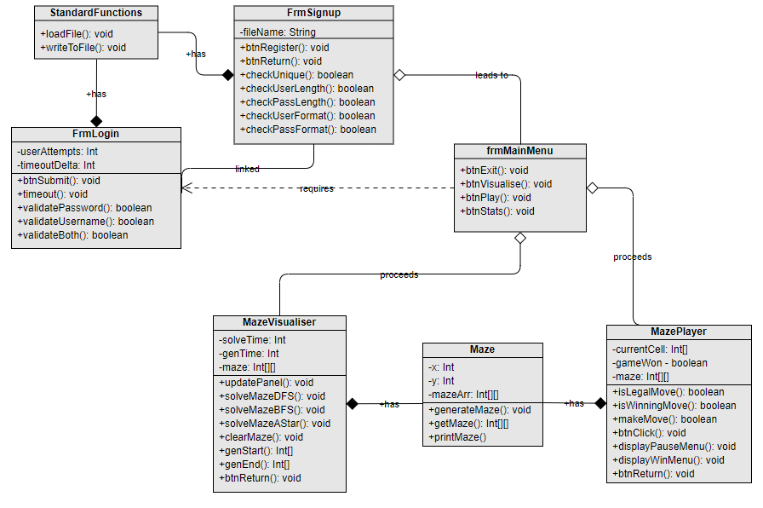

Here the **general** **classes** have been outlined and their **relative connections** to other classes. For example, the **standard functions** only have a composite bond to the login and sign-up form as these are **dependent** on this class. This is similar between the maze class and the visualiser/ play game.

### ERD

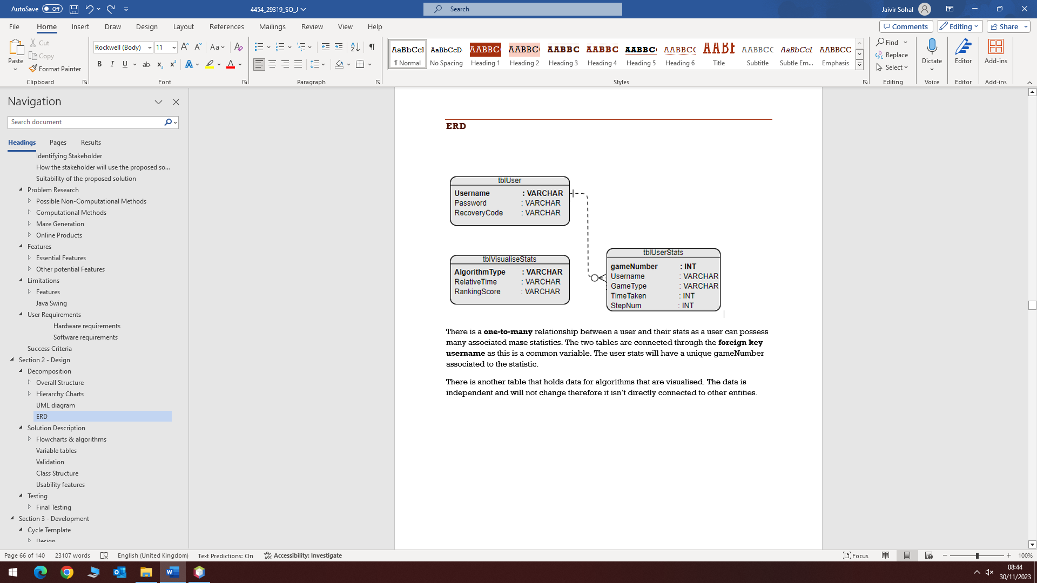

There is a **one-to-many** relationship between a user and their stats as a user can possess many associated maze statistics. The two tables are connected through the **foreign key username** as this is a common variable. The user stats will have a unique gameNumber associated to the statistic.

There is another table that holds data for algorithms that are **visualised**. The data is independent and will not change therefore it **isn’t directly connected** to other entities.

## Solution Description

### ****Flowcharts & algorithms****

#### Login

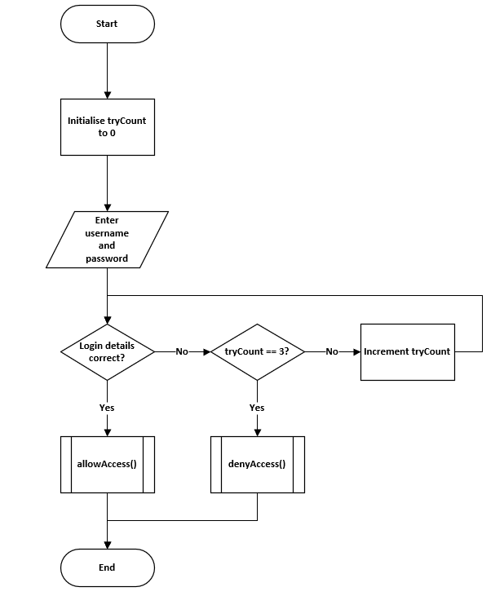

#### Register

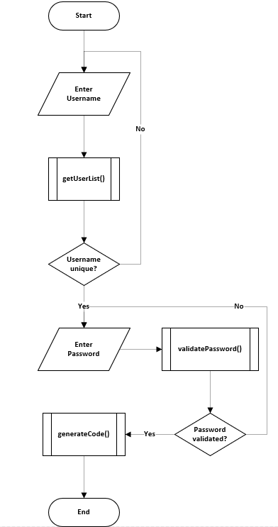

#### ****Main Menu****

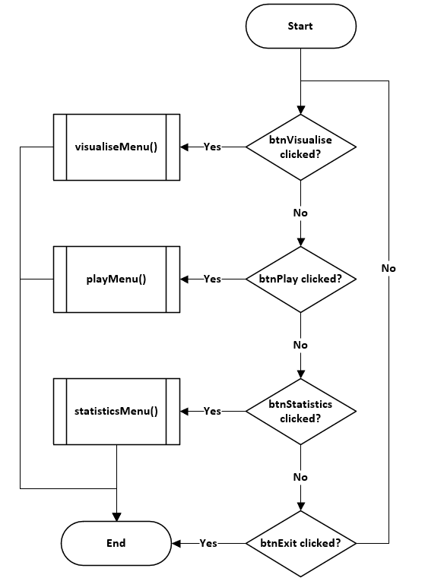

#### ****Visualise Pathfinder****

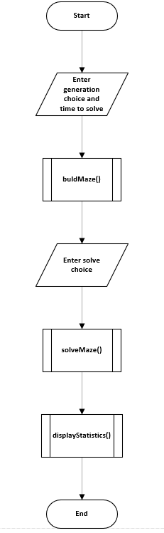

#### ****Win condition****

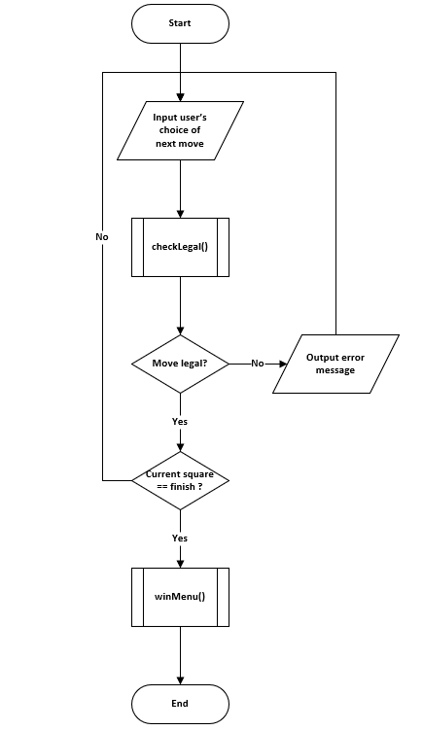

#### ****Statistics****

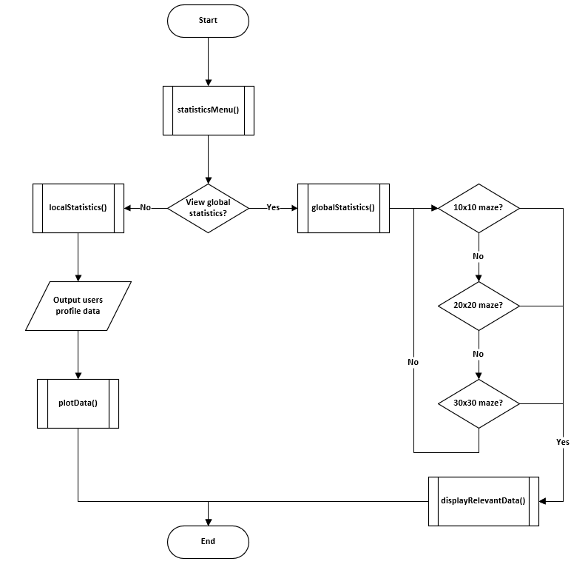

#### **Pseudocode**

Win detection:

**//repeat while game not finished**

**while (current!=finish)**

**//Get legal user input**

**do**

**choice = input(“Enter next square”)**

**if NOT checkLegal(choice) then**

**print(“Move is not legal”)**

**endif**

**until checkLegal(choice)**

**//Make move on the maze**

**current = currentMove(choice)**

**endwhile**

**winMenu()**

Visualise

**genChoice = input (“Enter generation choice: ”)**

**time = int(input(“Enter time to solve: “))**

**buildMaze(choice, time)**

**solveChoice = input((“Enter solve choice: “)**

**solveMaze(solveChoice)**

**displayStatistics()**

### Variable tables

Many variables that will be located through the coded solution are described below where the data type and the explanation of the variable is presented.

|  |  |  |
| --- | --- | --- |
| Key Variables | Data Type | Justification |
| inputUsername | String | The name the user inputs when registering or when logging in is stored as a string |
| inputPassword | String | When entering a password, the data will be stored as a string as it is a series of characters |
| userValidated | Boolean | In the validateUser function, a true or false value will be returned that determines whether the user has been successfully validated. |
| storedUsername | String | This is the actual value of the username that the inputted username is compared to |
| storedPassword | String | This is the actual value of the password the inputted password is compared to |
| isStrong | Boolean | True or false value that is returned from a function that determines whether a password being registered onto the system is of the correct format |
| isEqual | Boolean | True or false value that determines whether the first password and the confirmed password are equal |
| recoveryCode | String | String that is 3 sets of 4 characters separated by hyphens and is a mixture of letters and numbers. This is generated upon registry or when the password is changed |
| choice | String | This is a local variable that appears in multiple functions such as genChoice and solveChoice. This string is the value that is returned and identifies the user’s choice |
| play | Boolean | This Boolean value is used as a parameter for the function that builds the maze, it signifies whether the maze is played. If true, then the finishing square is generated |
| timeToBuild | Integer | This integer is a value in seconds of how quickly the maze should be built; slowly if visualised and quickly if being played |
| startingSquare | JButton | Single button in a 2D array of JButtons. This is the square the user will start on and will usually be at the top left of the screen. |
| finishingSquare | JButton | The final square the player or algorithm must reach and is usually towards the end of the 2D array |
| stepNum | Integer | The total number of steps the player took throughout the entire game is stored as an integer and then output to the screen. This is tracked after every step is taken |
| timeToSolve | Integer | Integer second value of how long the entire solve took to complete |
| mazeSize | Integer | Determines the side length of the maze. As the maze is a square, the size is a single integer that is used to initialise the size of 2D maze array |
| isMoveLegal | Boolean | After every move, this true or false value is returned and determines whether a move is possible |
| isSolved | Boolean | This variable determines whether the current square is equal to the final square after each individual move. If true, then the maze is solved |

### Validation

Within every algorithm, a **set of rules to regulate** a step in the algorithmic process is present and ensures the program executes in the correct order with the correct responses. Validation can be in the form of **data sanitisation** or only allowing branching of the program once a **certain condition** is met.

Login

The first validation the user is met with is in the **login form.** As the user inputs their username and password the two parameters will be passed through a validateUser function. The condition that needs to be met is that both username and password match the associated stored values. Upon failed verification, the **error message will not specify** if the one of the values was incorrect and instead output an **ambiguous** message to provide security.

Register

Registration is **stricter** than a login as here a new username and password is being registered onto the system. The product must ensure that the username is **unique**, and the password is of the **correct format** before being entered onto the system. There will be two boxes to enter a password: enter and confirm. On the first password box, there is a form of idle validation where the **live format** is assessed and output as soon as a character is entered. This allows the user to amend the password before a submission that would receive an error message. For a registry to be legal, the username must be unique, the password must be of correct format, and both entered passwords must be equal.

Legal Move

After each move, a series of conditions must be met before the move is verified and carried out. A move is defined as legal if the square you are **requesting to move to is not a wall**. Therefore, only **one comparison** needs to be made and that is calculating the index of the next square and seeing if it is marked as a wall. If it is, then the user’s input will not do anything – no error message will be displayed, and it will just simply **ignore** the input.

Win-detection

A win should **only** be registered if the move is legal, and the current square is equal to the final square. A win should not be validated or evaluated any other way, and this is the only way to reach the win menu.

### Usability features

* Login form layout– the user will be greeted with a login form that does not hold any ambiguity. It will have a clear outline of **how to interact** with prompts such as ‘enter your username here’ guiding the user. This allows the product to **be easy to learn** and the systematic layout will provide the user with a straightforward experience. If the user wants to create an account, there will simply be a button that prompts the user to do so. **No extra functionality** other than logging in or signing up will present on this screen. The buttons and text areas will be laid out in an efficient manner such that buttons that the user is most likely to click are placed in proximity.
* Login form aesthetic – This screen will have a house font of **courier new** to provide a retro feel as per the client’s request. The colours of the screen will be in **harmony** with each other with **no conflict** so that there is an engaging form in front of the user. Font size is important and should be large enough to fill the boxes and be visible to the user so that there is **no discomfort when trying to read** any text on the screen.
* Login form error handling – If the username or password is not correct, the product will output a **suitable message** and inform the user of the problem. This way, the user is not left to guess what the problem is and allows the problem to be resolved quickly.
* Register form error handling - When registering, the user **does not want to wait** until clicking the submit button before finding out the two passwords do not match, or they are not of the correct format. This is why there will **be live validation** by adding action listeners onto the text box to constantly provide the user with feedback on the password. They will be **told instantly** on the screen if passwords are weak or do not match. Passwords should also be hidden when typing it into the text so that no one can see what you have entered if there are people viewing your screen.
* Main menu layout – When thinking about how a menu should be presented you must think about **how a user interacts** with a product and plan for efficiency and ability for user engagement. Before playing, the user will want to see how the mazes are generated and solved – for inspiration. After seeing the visualisation, the **mazes will be played** and then the stats will be viewed. This is why the three buttons will be in the **order of visualise, play and statistics from top to bottom**. The design will also be larger than usual as there are only four buttons (including exit) so to minimise white space, the buttons will be **large** and **easy to read**.
* Visualise (learning) – When the generation or pathfinding algorithm is being displayed visually, the steps are shown at a **rate that can be analysed by a human**. This way, it is **easy to learn** how certain algorithms can navigate or build mazes and makes algorithms such as depth-first generation that appear in **the OCR specification** easy to learn.
* Visualise (engagement) – This section is designed around **engaging the user**; every step along the process requires a **user prompt**. This can be selecting the pathfinding algorithm, solving algorithm, or choosing whether to save statistics. The **speed of the visualisation** is also tailored towards the user being fully engaged – not too slow or not too fast.
* Play experience – After selecting the size of the maze, the user **will know how** to **navigate** through the maze instantly, this is because the controls will be located on the screen with a description just before starting the game. There will only be one goal during this; use the controls to navigate form the starting square to the finishing square. Too many **different functions will obscure** the objective so keeping **one goal** will allow the user to easily use the product.
* Play layout – The layout would consist of a **simple grid** (for the maze) and a button in the top right to navigate through the menus. It is best to stick to one feature which would be playing the maze. Each aspect would involve a **green hue**: the **border is a forest green**, starting square a **light green** and ending square a **dark green**. This is because this arrangement showcases a harmony of colours and is **aesthetically pleasing.**
* Statistics – Accessing stored statistics should be an easy task with **little confusion**. To tackle this, the user is first **prompted between the choice** of viewing **global** statistics and **local** statistics. This is because instead of being left to guess what buttons to clicked, the **user is forced to decide**. This way the user is not overloaded with statistics and the process is broken up into smaller steps.

## Testing

### Final Testing

Creating the **blueprint and criteria** for how the final product should run is **necessary** in developing a solution that fits all user needs and provides structure when **iteratively developing** the application. Having a criterion to meet throughout each cycle ensures maximal functionality is obtained.

#### Final Test Table

|  |  |  |  |  |  |
| --- | --- | --- | --- | --- | --- |
| Test | Test description | Input | Expected outcome | Type of test | Relative Success Criteria |
| 1 | Test for the user’s ability to interact with the login form and enter details | Any username and password (both strings) | Data should be evaluated and an appropriate response output | Normal | 1 |
| 2 | Test to see the outcome of inputting the correct username and the correct password | Correct username and password both of type String | User is allowed access and is redirected to the main menu form | Normal | 1 |
| 3 | Test for inputting the incorrect username, correct password | Incorrect username, correct password | User is denied access but is only told that the details are incorrect, not specifically the username | Normal | 1 |
| 4 | Test for inputting the correct username, incorrect password | Correct username, incorrect password | User is denied access but is only told that the details are incorrect, not specifically the password | Normal | 1 |
| 5 | Test for inputting the incorrect username, incorrect password | Incorrect username, incorrect password | User is denied access and is told that the details are not correct, not specifically that both are incorrect | Normal | 1 |
| 6 | Test for entering a username that contains characters other than letters or numbers | Invalid username with characters other than letters or numbers | The user is told that the username must only contain letters and numbers and is not allowed to register | Erroneous | 2 |
| 7 | Test for entering a username that contains only letters but is not unique | A valid username that has already been registered | User is informed that the username is taken, and the account cannot be created | Normal | 2 |
| 8 | Test for entering a username that isn’t in the accepted length range | Username with a length of less than 4 letters | User is told that the username must be inclusively between 4 and 10 characters. | Boundary | 2 |
| Username with a length of more than 10 characters |
| 9 | Test for a password that isn’t at least 8 characters | Password with a length less than 8 characters | Password is not accepted, and the user should be told the password must be at least 8 characters in length | Boundary | 3 |
| 10 | Test for a password that does not have at least one special character | Password not containing any special characters | Password is not accepted, and the user is told that the password should contain at least one special character | Erroneous | 3 |
| 11 | Test for a password that does not have at least one number | Password not containing any numbers | Password is not accepted; user is informed that there should be at least one number within the password | Erroneous | 3 |
| 12 | Test for entering a correctly formatted first password but a different confirmed password | Formatted correct password, incorrect confirmed password | User is told before submission that the two passwords are not matching and should not be allowed access | Erroneous | 3 |
| 13 | Test for entering an incorrectly formatted first password and a different confirmed password | Incorrectly formatted password and non-matching passwords. | User should only be told that the password is of incorrect format before any other warning, so this is what is corrected first | Erroneous | 3 |
| 14 | Test the input of a correctly formatted password and a correctly confirmed password, non-unique username | Correctly formatted password and correct confirmed password, non-unique username | User can not submit their details and is notified once again that their password should be unique | Erroneous | 3. |
| 15 | Test the input of a correctly formatted password and a correctly confirmed password, unique username | Correctly formatted password and correct confirmed password, unique username | User passes all validation checks and is allowed access onto the system | Normal | 3. |
| 16 | Test when all inputs are left blank | No input | User cannot submit their details and is informed that text fields must be | Erroneous | 3. |
| 17 | Test when at least one input is left blank |
| 18 | Test for generating a maze in the visualise section | User clicks button | Click the generate maze should generate the maze slowly at a speed that the user can follow | Normal | 9, 10 |
| 19 | Test for generating a solvable maze in the visualise section | Users click – algorithmic process called upon click | Once the maze is generated, there must be a path from the start of the square to the finish | Normal | 4. |
| 20 | Test to check whether pathfinder correctly identifies the solution | User selects the pathfinding mode | Once the algorithmic process has ended, the maze should be solved with the pathfinder marker on the final square | Normal | 11, 12 |
| 21 | Test to see if the pathfinder displays each step of the process on the screen | User confirms pathfinding choice | Each step of the solver will be overlayed onto the maze and the steps until completion are displayed gradually | Normal | 12 |
| 22 | Test for a 10x10 generated maze | User selects 10x10 maze | A maze that has 100 cells (10 by 10) is generated | Normal | 7 |
| 23 | Test for a 20x20 generated maze | User selects 20x20 maze | A maze that has 400 cells (20 by 20) is created | Normal | 7 |
| 24 | Test for a 30x30 generated maze | User selects 30x30 maze | A maze that has 900 cells (30x30) is created | Normal | 7 |
| 25 | Test to check if the maze on ‘play’ mode generates a solvable maze | User selects the size of the maze | After the size is selected, a complete maze should be created with that dedicated size | Normal | 4 |
| 26 | Test for starting square generation on 10x10 | No input | User should start on a square located bias to the top left of the first maze quadrant | Boundary | 5 |
| 27 | Test for starting square generation on 20x20 |
| 28 | Test for starting square generation on 30x30 |
| 29 | Test for target square generation | No input | A square should be generated bias to the bottom right of the fourth quadrant | Boundary | 5 |
| 30 | Test for starting square random generation | Re generated maze | Starting square should generate randomly but with little deviation | Normal | 5 |
| 31 | Test for target square random generation | Re generated maze | Final square should generate randomly but with noticeable deviation | Normal | 5 |
| 32 | Test for intractability /playability | User clicks a cell on the grid or arrow key pressed adjacent to current square | Button should be able to be clicked or accessed if it is adjacent to the current square and is then highlighted | Normal | 6 |
| 33 | Test for selecting non-current cells that have not been highlighted previously | User clicks or tries to access a cell that is not the current cell and has not been highlighted before | Nothing happens, the square is not highlighted, and the input is ignored | Erroneous | 6 |
| 34 | Test for deselecting non-current cells that have been highlighted previously | User clicks or accesses a highlighted button that isn’t the current button | The cell is not deselected, and the input is ignored as only the current square can be deselected | Erroneous | 6 |
| 35 | Test for deselecting a current cell | User clicks on the current cell | The input is accepted, and the square is deselected. The previous square now becomes the current square. | Normal | 6 |
| 36 | Test for menu after win detection | User navigates to the final square | As soon as the final square is reached, a menu is displayed after the win is detected | Normal | 8, 15 |
| 37 | Test for returning to main menu after playing a game on the win menu | Button click | Upon clicking return to main menu, the old form is removed, and the main menu is now displayed | Normal | 13, 15 |
| 38 | Test for the ability to play another game on the win menu | Button click | User can successfully play a game one after another. Game loads after click and removes the previous game | Normal | 15 |
| 39 | Test for the game pausing after transition menu selected | Transition menu selected in the game menu | Once the menu is clicked, the user should not be able to interact with the game and only the menu | Normal | 14 |
| 40 | Test for returning to menu after transition menu selected | Visualise section | After selecting return to main menu on the transition menu, the menu should close as well as the form currently open and then display the main menu | Normal | 14 |
| Play section |
| Statistics section |
| 41 | Test for resuming after transition menu selected | Visualise section | After selecting the transition menu, if resume is collected, the transition menu is closed, and everything returns to normal | Normal | 14 |
| Play section |
| Statistics section |
| 42 | Test for displaying correct stats after a win is called | User completes a maze and reaches the finish | Upon winning a game, the user should be shown the total time taken to solve and the total number of steps taken | Normal | 8, 16 |
| 43 | Test for displaying top 10 scores for a 10x10 maze with at least 10 pieces of total data | Selection of the 10x10 statistics | Top 10 scores of all time for the 10x10 game mode will be recalled and output on the screen to see | Normal | 17, 18 |
| 44 | Test for displaying top 10 scores for a 10x10 maze with less than 10 pieces of data | All scores recorded for the 10x10 will be output onto the screen as there cannot be a ranking if there are less than 10 total items of data |
| 45 | Test for displaying top 10 scores for a 20x20 maze with at least 10 pieces of total data | Selection of the 20x20 statistics | Top 10 scores of all time for the 20x20 game mode will be recalled and output on the screen to see | Normal | 17, 18 |
| 46 | Test for displaying top 10 scores for a 20x20 maze with less than 10 pieces of data | All scores recorded for the 20x20 will be output onto the screen as there cannot be a ranking if there are less than 10 total items of data |
| 47 | Test for displaying top 10 scores for a 30x30 maze with at least 10 pieces of total data | Selection of the 30x30 statistics | Top 10 scores of all time for the 30x30 game mode will be recalled and output on the screen to see | Normal | 17, 18 |
| 48 | Test for displaying top 10 scores for a 30x30 maze with less than 10 pieces of data | All scores recorded for the 30x30 will be output onto the screen as there cannot be a ranking if there are less than 10 total items of data |

# Section 3 - Development

## Cycle 1 - Login & Register GUI Design

### Design

#### Decomposition & Overview

Before creating a functional **login-menu** there must first be a **blueprint** design of how the form should be developed and the target **aesthetic** needed. It is mandatory that the design will give off a **retro** feel whilst also feeling **professional**. As well as the main login form, the sign-up form will be of similar style but with the added functionality to register onto the **system**.

The login menu will be comprised of **two main text fields**: the username and password text boxes. A confirm choice and a prompt to redirect the user to sign up via a separate form. The sign-up page will include a username, password and confirm password box all with associated **validation**.

#### Usability Features

Form Layout

Statistically, most uses of the menu will be logins rather than sign ups therefore it would be more **beneficial** to start the user on a login screen rather than ask them whether they want to log in or sign up. If needing to sign up, there will be a **button** on the screen of **appropriate visibility** to allow them to register onto the system.

House Style

The font of the entire program will **be courier new** as the client requested so that it manufactures a retro style that is fitting with the topic of **classical** mazes. The font will also be of **reasonable size** to ensure there is **no difficulty** trying to read any text.

The colours will consist of simple block colours such as black, white, and green to create a clean feel.

Hint Text

Before typing a username or password there will be **greyed out text** that informs the user of what they need to do, this removes any **ambiguity**. The text should **disappear** once clicking into the box to remove any **unnecessary** hassle for the user.

Security

The **password** will also appear as dots as it is typed into the box to **increase security** just in case anyone in proximity is watching the user type in a password. This can be **negated** by selecting an option to view the password in **plaintext**.

### Coding and Testing

#### Iterative Development of Prototype

##### Prototype #1

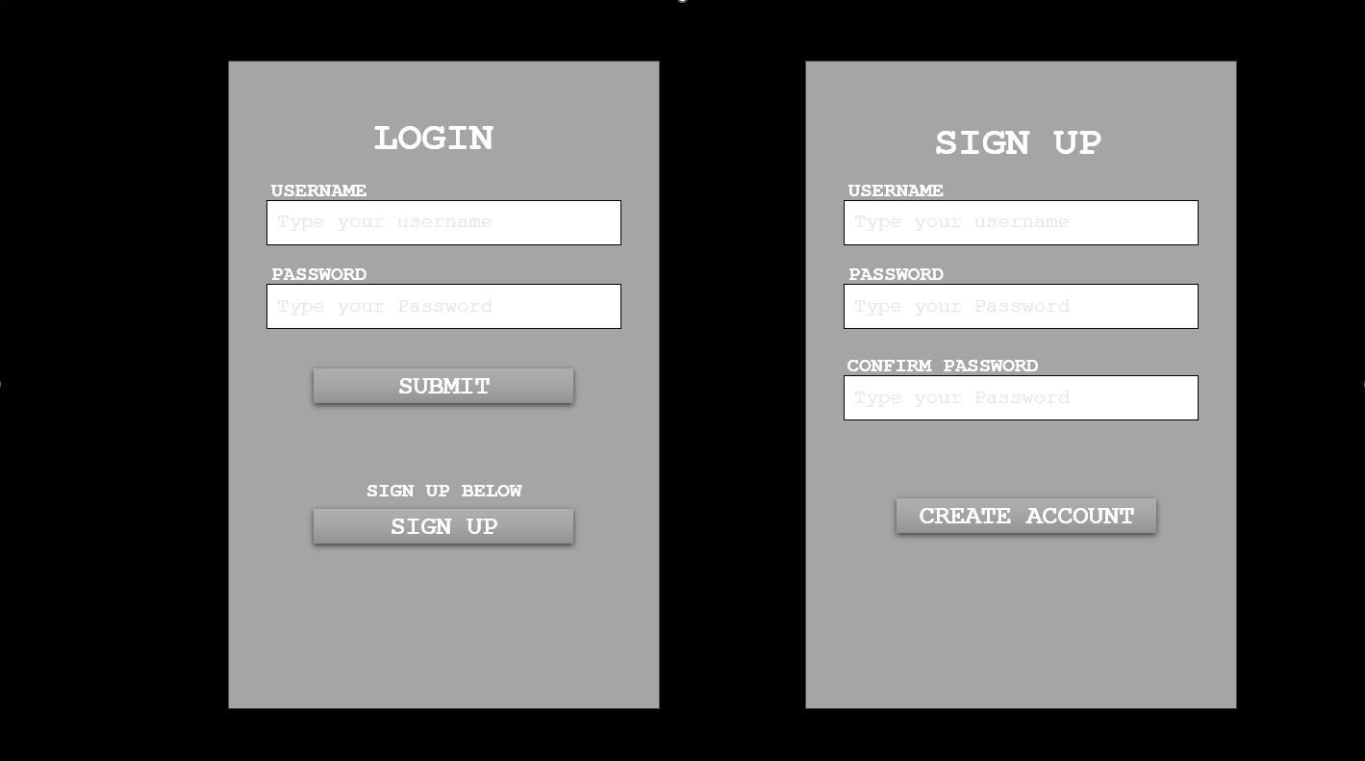

This first iteration is rough design of what is necessary within a login form. The form on the right is the first window the user is met with and the sign-up form on the right is only displayed if the user selects the sign-up button. As previously discussed, most users will be logging in rather than signing up therefore it is important to include a title at the top to inform the user of what should be completed. Capital letters were chosen rather than camel case due to the nature of the font Courier New. This font may come across as relaxed when not capitalised and keeping the emphasis adds to the retro style of the game.

##### Prototype #2

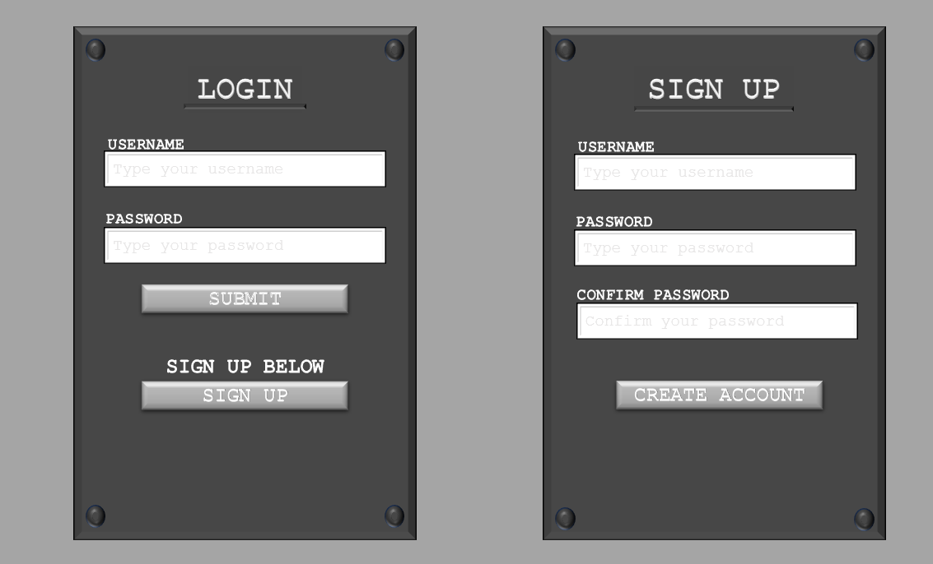

The main purpose of the second iteration was to review the aesthetics and make the entire form more visually pleasing. Adding bevelled rivets to each corner gives a metallic feel much like the plating on old arcade machines. To start off simple, a dark grey background with white text/ text boxes was used as a basis for future iterations. Keeping the greyed-out text allows a subtle hint to suggest what the user should do without affecting the overall aesthetic. A bevelled underline was also included underneath the title to emphasise the purpose of the form. Adding to this, the text was bevelled to add visual complexity but overall, the colours are dull and do not stand out.

##### Prototype #3

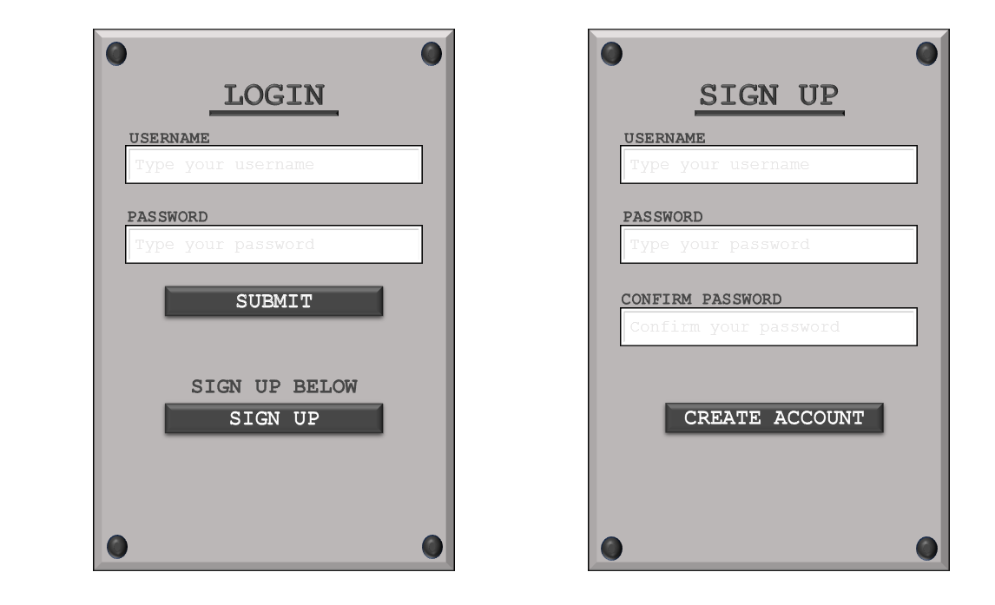

To bring out the bevelled shadows, a lighter grey background was used and the raw text on the background change to the previous dark grey colour. The buttons were also converted to this colour with text being made white. This colour palette adds much more unified contrast than the previous iteration and stands out to a higher degree. With this lighter background, the shadows on the text field have more defined shadows and it is easier to notice the indentation into the form. Whilst having contrasting details, the colour palette remains dull, and the client had requested green hues onto the menus.

##### Prototype #4

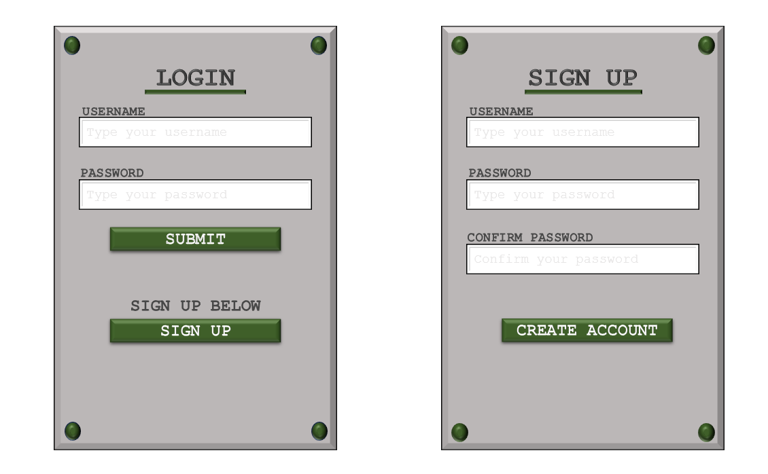

Editing the previous iteration, the buttons were modified to hold a forest green background and adds a slight contrast to the dull grey backdrop. Paired with the green underline and rivets, a clean form with contrasting block colours is created through this iteration. This design matches the clients specified request for a green hue with Courier New font and reflects the initial desire to have a contrasting, but engaging screen as mentioned at the beginning of the cycle.

##### Prototype #5

|  |  |
| --- | --- |
|  |  |

A login and sign-up form should contain an option to view the password that is being hidden when typed to verify the correct password is entered if the user wishes to do so. An eye symbol is a common way to represent a function to reveal the password and it was added to both designs in black and green. This allows the presentation of multiple styles so that a range of choices/ features are available for my client to pick and choose from

#### Final Design Prototype

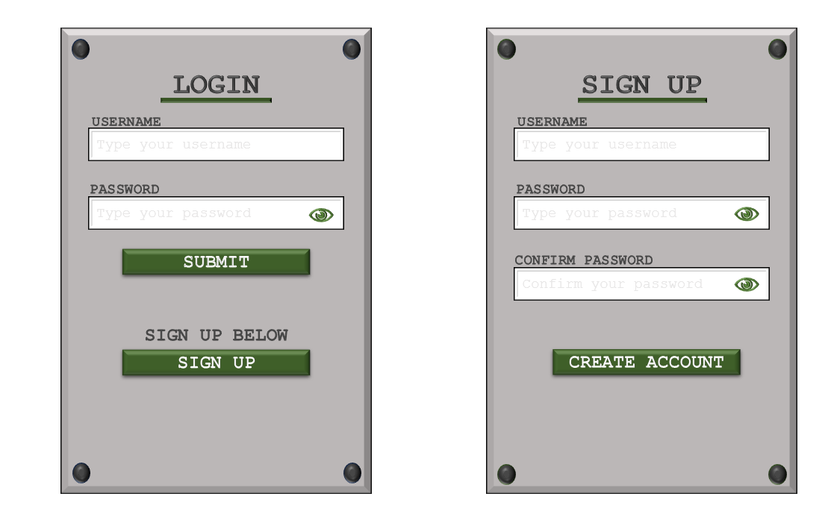

After presenting my selection of designs to my client, the grey background was the preferred option due to the bevel shadow visibility. To stick with the proposed green colour palette, the client had chosen to keep the forest green buttons and underlines for the title. However, the client had requested that the 4 rivets in each corner remain black instead of green to keep the metal plating feel as it is unnatural in real life to have rivets that are forest green in colour. The client also did not prefer the colour of the eye symbols and proposed either colour is fine, so the green colour was chosen.

### Review & Evaluation

The initial decomposed solution stated that the menu should be clean and simple with block colours such as green and black. This **clean aesthetic** was created, and the final form consists of the colour palette that the client had requested. Using this design, the coding and development of the GUI in Java will be much simpler as there is a blueprint to follow. When developing the code, the design and **placement of the buttons does not need to be re-developed**, and the full commitment can be applied to creating a secure, functional login form.

## Cycle 2 – Login Form GUI

### Design

#### Decomposition & Overview

A login form is the **first screen** a user would see on the application. When considering a login form, there are **two main outcomes** that the program should display after a conclusion: access granted, or access denied. This menu is solely designed for **existing users** to enter their registered details to then gain access onto the application. This form of security is necessary for the application so that statistics can be tracked and **unauthorised user are kept off the system**.

This frame would consist of 2 text boxes that prompt the user to enter a login for the first box and then a password in the second box. The password will have a corresponding button to allow **visibility to be toggled back and forth.** The username and password entered by the user will be grabbed by the program and compared against an external file to check whether the login details exist on the system and ensures validity. There will be **3 possible attempts** to enter the correct details onto the system before being locked out for **30 seconds**. The username and password should be passed through parameters in a validation function that will return a **Boolean value** based on the outcome of the code.

#### Validation

The initial form of verification is located as details are **submitted**. The user inputs their username and password as **two parameters** that will be passed through a **validation** function and the outcome is based on the **returned Boolean value**. The associated condition is that the username and password match the stored values in the external files. If the verification fails, the user is told that that the username or password is incorrect but **will not specify** which one to **tighten security**.

After developing the main body and functionality of the login frame, the design prototype from cycle 1 will be applied to **boost aesthetics** and apply the usability features previously discussed.

#### Pseudocode

//global attempts variable

attempts = 3

//validate submitted details

procedure btnSubmit()

//get text box values

userEnter = ""

passEnter = ""

userEnter = tfUser.getText()

passEnter = tfPass.getText()

//validate details

isValid = validateDetails(userEnter, passEnter)

if isValid then

//close login and allow access into menus

frmLogin.close()

frmMainMenu menu = new frmMainMenu()

else

if attempts > 0 then

attempts = attempts - 1

tfOutput.setText("Username or Password incorrect - " + attempts + " attempts remaining")

else

//timeout user for 30 seconds if 0 attempts

tfOutput.setText("You have been timed out for 30 seconds")

Timer timer = new Timer(30000)

timer.start()

attempts = 3

endif

endif

endprocedure

//consider choice of register

procedure btnRegister()

FrmLogin.close()

frmRegister register = new FrmRegister()

endprocedure

//validate user and password

function validateDetails(user, pass)

//retrieve stored values

array storedDetails = loadDetails()

//validate user

for i=0 to storedDetails.length

//split details into user AND password

splits = storedDetails[i].split(",")

//compare stored values

if (user == splits[0] and pass == splits[1]) then

return true

endif

return false

endfunction

function loadDetails()

//open file in read mode

myFile = openRead("login_details.txt")

lineNum = 0

//get number of lines

while NOT myFile.endOfFile()

lineNum = lineNum + 1

endwhile

//store all lines in an array

array details[lineNum]

index = 0

while NOT myFile.endOfFile()

details[index] = myFile.readLine()

index = index + 1

endwhile

return details

endfunction

#### Variable Table

|  |  |  |
| --- | --- | --- |
| Key Variables | Data Type | Justification |
| userEnter | String | This is the temporary variable within a button function that fetches the string from the user text box and stores the username. |
| passEnter | String | This is the temporary variable within a button function that fetches the string from the user text box and stores the password. |
| isValid | Boolean | The validateDetails() function is called and the return value is stored in this Boolean. |
| attempts | Integer | Integer that stores a maximum value of 3 and once the count has depleted, the number is reset. This signifies how many tries the user has before timing out. |
| storedDetails | Array | All comma separated details are stored in this array with a new index representing a new login/ line in the external file. |
| splits | Array | A sub array of stored details that temporarily stores the split values from a certain index in the array. These splits contain values such as username and password. |
| myFile | File | This is the file that has all login details stored. This file is read from in the login stage. In the registration section, the file is written to and read from. |

The new variables introduced at this stage are mainly temporary variables with a local scope specific to the related function. These variables will be re written and discarded after each function cycle.

The attempts variable is an exception as this would be a global variable where the value is simply changed depending on the outcomes of the user input.

#### Test Table

|  |  |  |  |  |
| --- | --- | --- | --- | --- |
| Test | Test description | Input | Expected outcome | Type of test |
| 1 | Test for the user’s ability to interact with the login form and enter details | Any username and password (both strings) | Data should be evaluated and an appropriate response output | Normal |
| 2 | Test to see the outcome of inputting the correct username and the correct password | Correct username and password both of type String | User is allowed access and is redirected to the main menu form (dummy form as main menu not developed) | Normal |
| 3 | Test for inputting the incorrect username, correct password | Incorrect username, correct password | User is denied access but is only told that the details are incorrect, not specifically the username | Normal |
| 4 | Test for inputting the correct username, incorrect password | Correct username, incorrect password | User is denied access but is only told that the details are incorrect, not specifically the password | Normal |
| 5 | Test for inputting the incorrect username, incorrect password | Incorrect username, incorrect password | User is denied access and is told that the details are not correct, not specifically that both are incorrect | Normal |
| 6 | Test for clicking the associated sign-up button | Button click with the intent to sign up | User is redirected to the sign-up page | Normal |
| 7 | Test for clicking into a text box | Button click onto a text box | The text hint should disappear once the user clicks onto the box for the first time | Normal |
| 8 | Test for entering blank details | No input into the text box | The user should be told that either the username or password is blank, and an attempt is not used | Normal |
| 9 | Test for attempts correctly going down | Incorrect login details | User should be told they have an x number of attempts remaining. Maximum is 3 and once all are gone, the user is timed out for 30 seconds where the attempts are reset after the time is up | Normal |

#### Usability Features

Hint text

Before typing onto a box, the text displayed should be a hint of grey colour to subtly inform the user of what details should be input into the box. This allows for less ambiguity and once the box is clicked, the text will disappear without the user having to manually deselect the text.

Password security

The password will also appear as dots as it is typed into the box to increase security just in case anyone in proximity is watching the user type in a password. This can be negated by selecting an option to view the password in plaintext.

### Coding and Testing

#### Iterative Development and Testing

##### Prototype #1

Initial design of the buttons, text fields and labels using Java Swing’s drag and drop functionality:

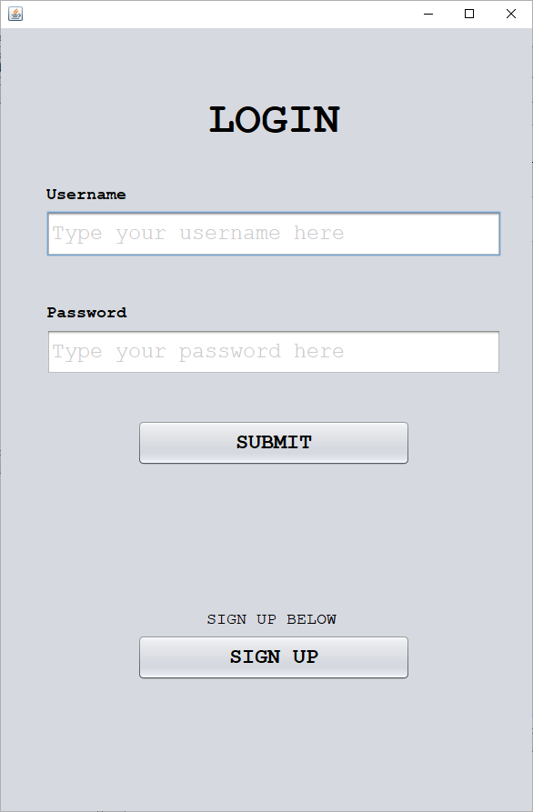

This is a very simple recreation of the final GUI design from the end of Cycle #1. Before implementing the graphics, I believe the best approach to take would be adding full functionality. This is because it is mandatory for the login form to be working and would be beneficial to have a working prototype before the graphics are upgraded.

##### Prototype #2

Development of login functionality:

The initial plan is to write the code responsible for the submit button. The body of the code will be developed by adapting the previous pseudocode where any functions that are called will be written after the submit code is written.

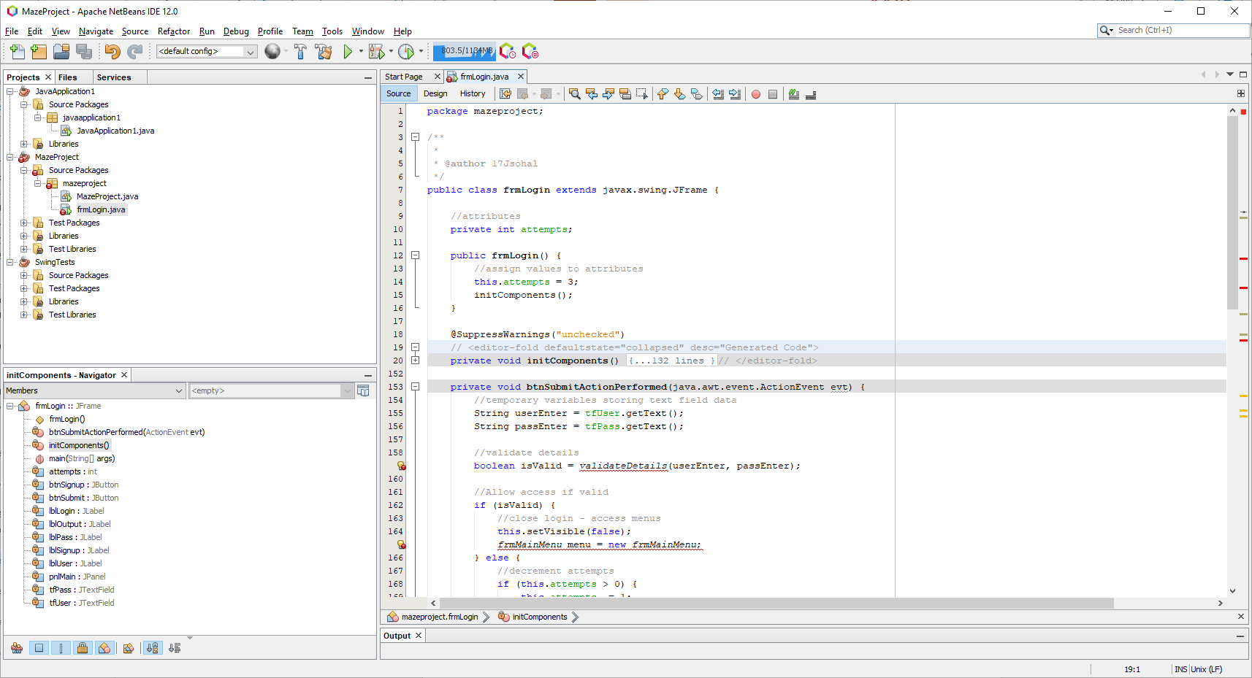

The variable ‘attempts’ is defined as a global variable as it will continuously be changed, reset and decremented across the entire class. The value is initialised to 3 within the constructor as this is how many attempts the user will start with.

Submit button:

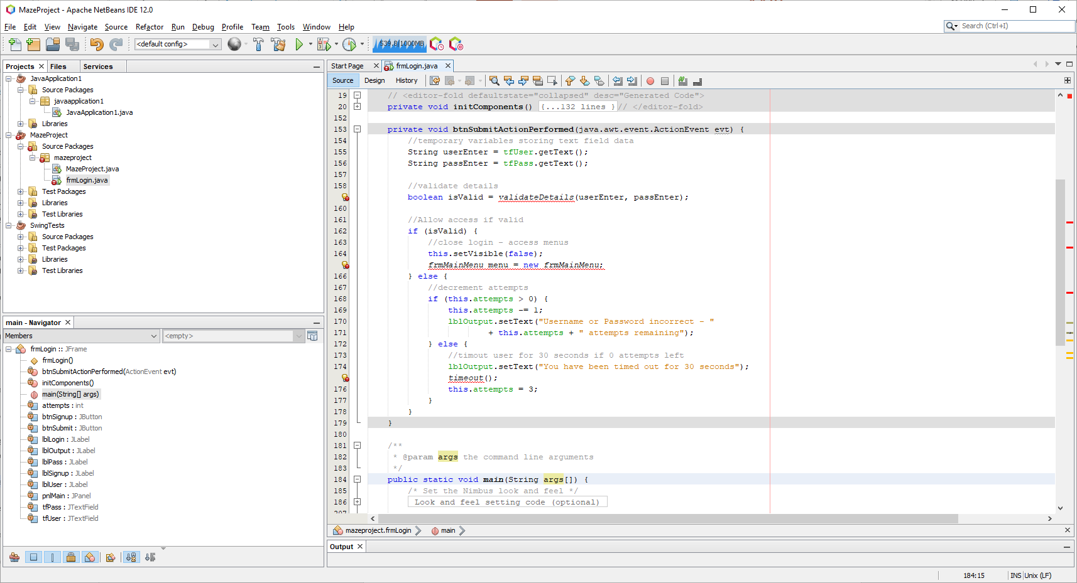

Within this function, the layout of the pseudocode was recreated, and a global attempts variable is manipulated. At this point, the functions validateDetails and timeout are not yet defined and will be developed next. The main menu form for now will be a blank placeholder form so that no errors are encountered. A missing set of semi colons needs to be added to the end of the main menu to correctly call the class.

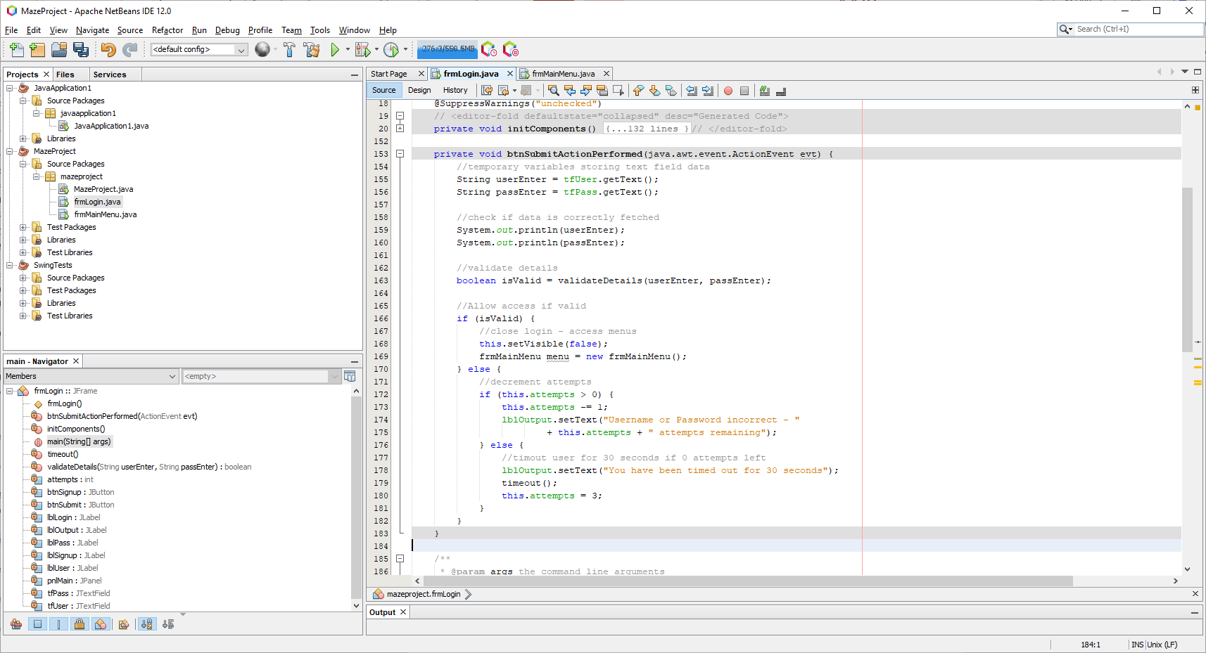

Testing fetching data:

The entered text entered the box is still greyed out like the hints, but this will be fixed once the graphical aspect is developed. The simple text Jaivir and Sohal are entered for the username and password and the output text should repeat these values.

This prototype now contains the foundation for creating the intended functionality.

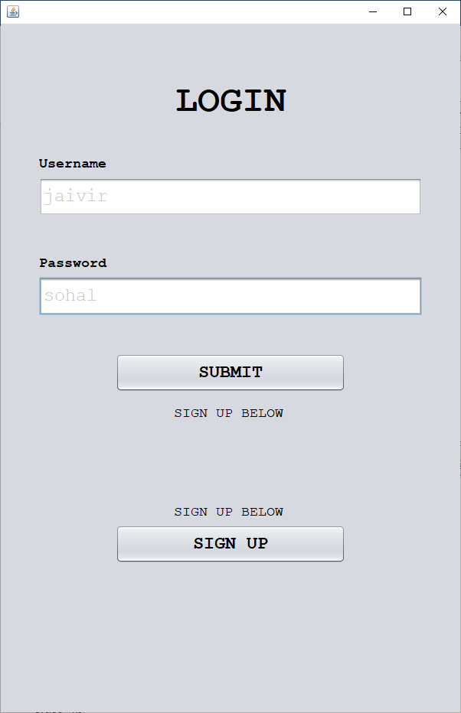

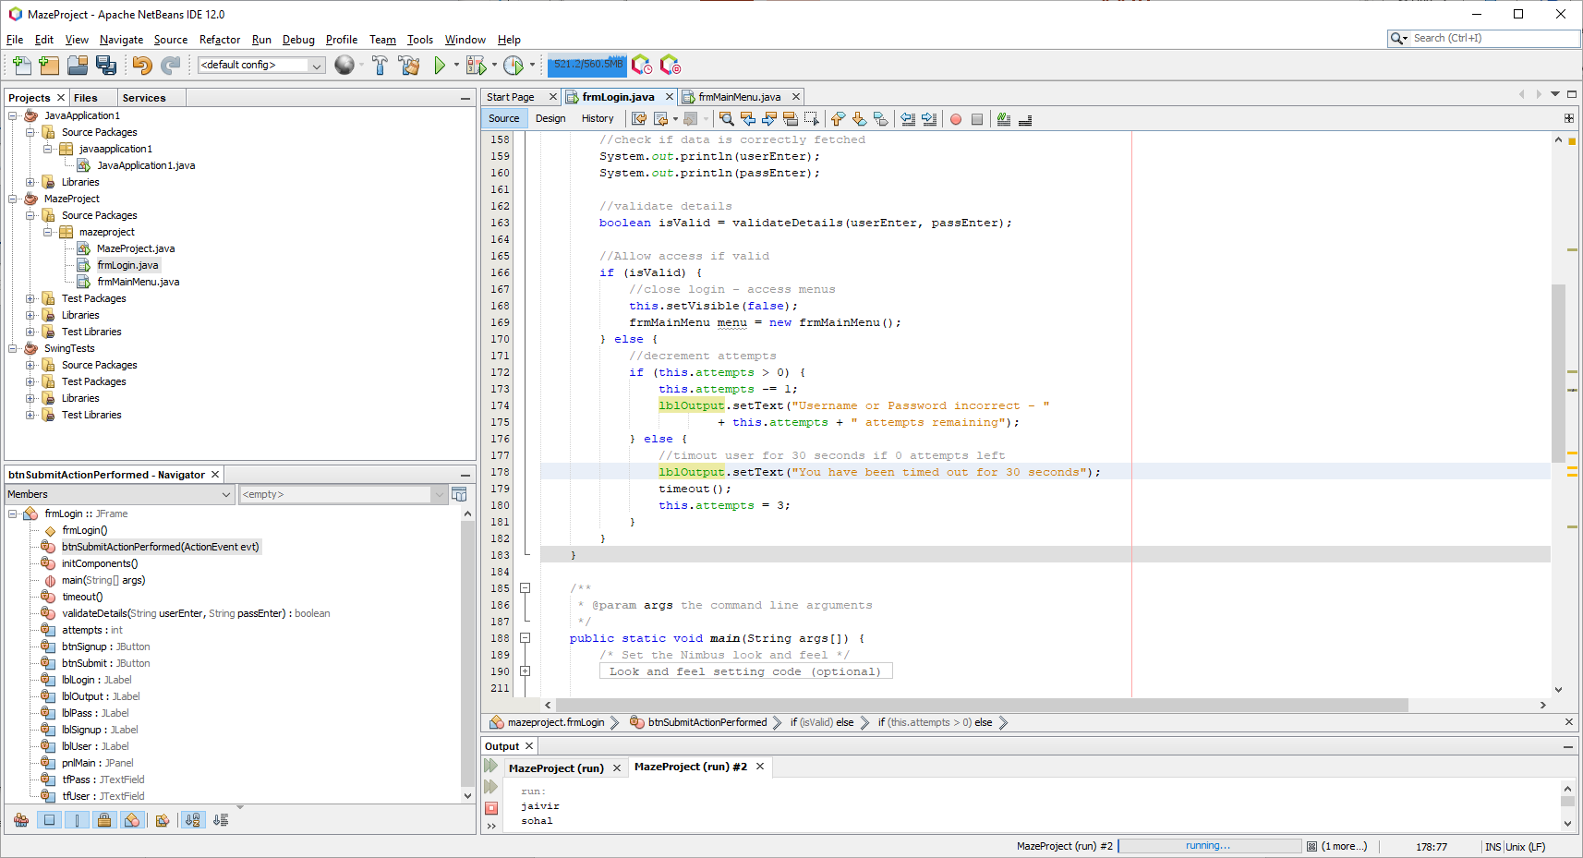

Here the values are correctly passed and now the validation/ file functions can be created.

##### Prototype #3

Validation function

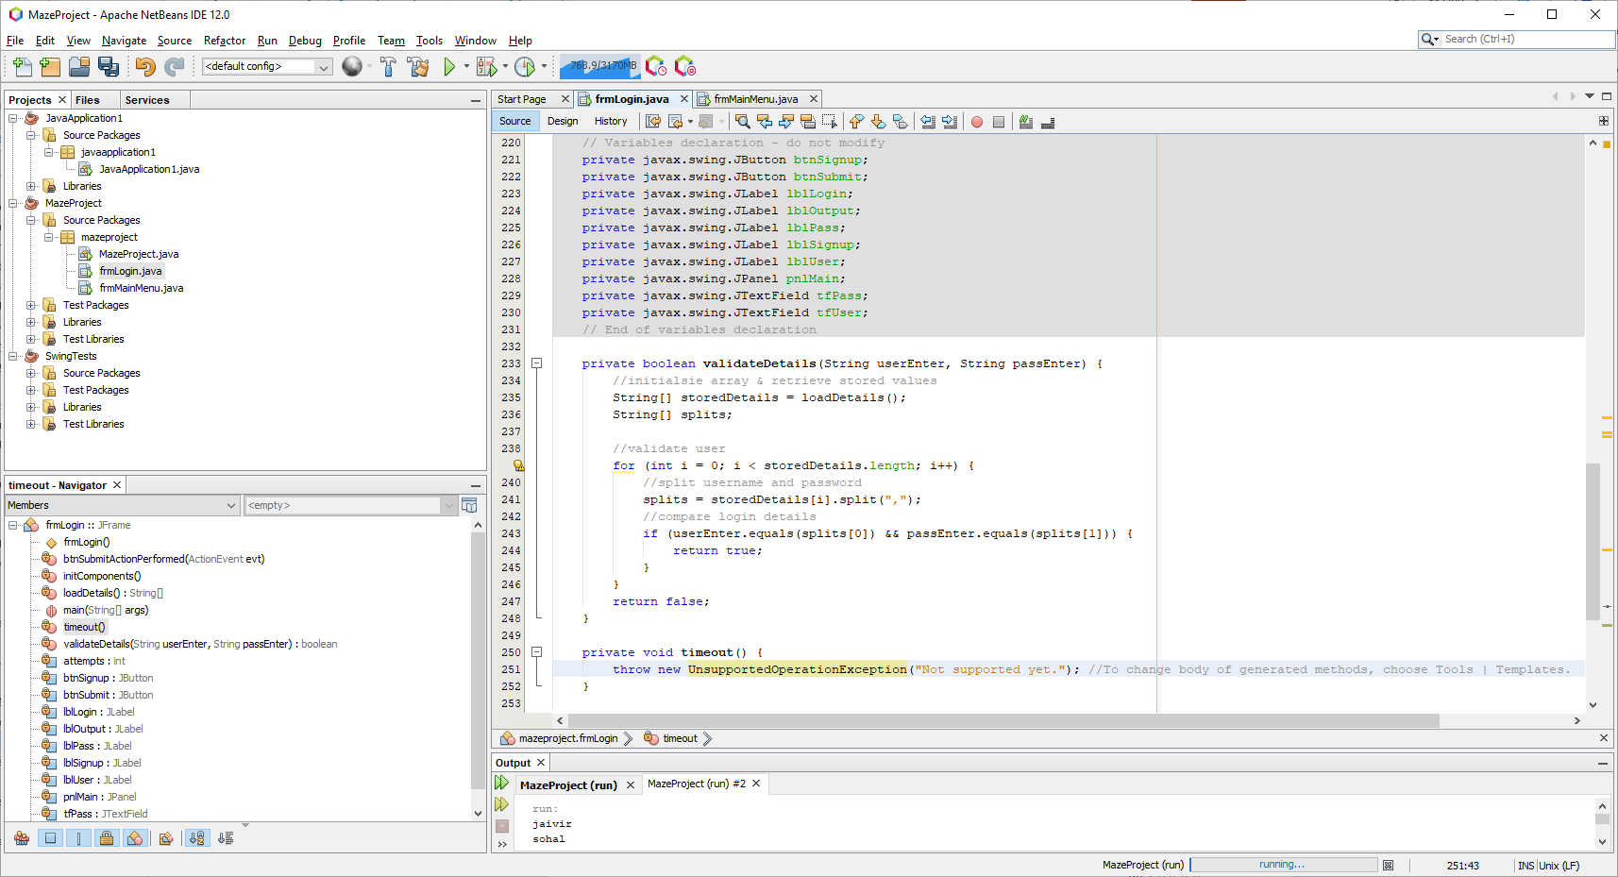

This function simply calls a function that stores all lines of a text file in an array. This array holds all details, and each username and password pair are compared until either a match is found, or no match is found.

The loadDetails function is not yet created and an empty array is being returned. Before creating the load detail’s function, it is best to make sure this validation function work first. To do this, we can have the loadDetails function return a pre generated string array.

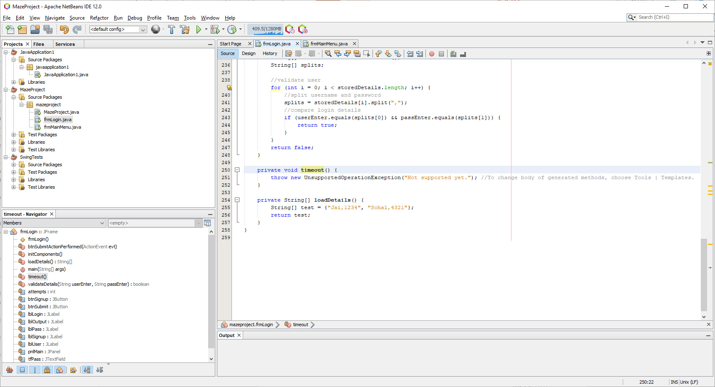

For testing purposes, I will comment out the code that closes the frame and instead output to the text field saying ‘approved’. I have also reduced the height of the login form by 100 pixels from 900 to 800 so that there is less blank space on the screen.

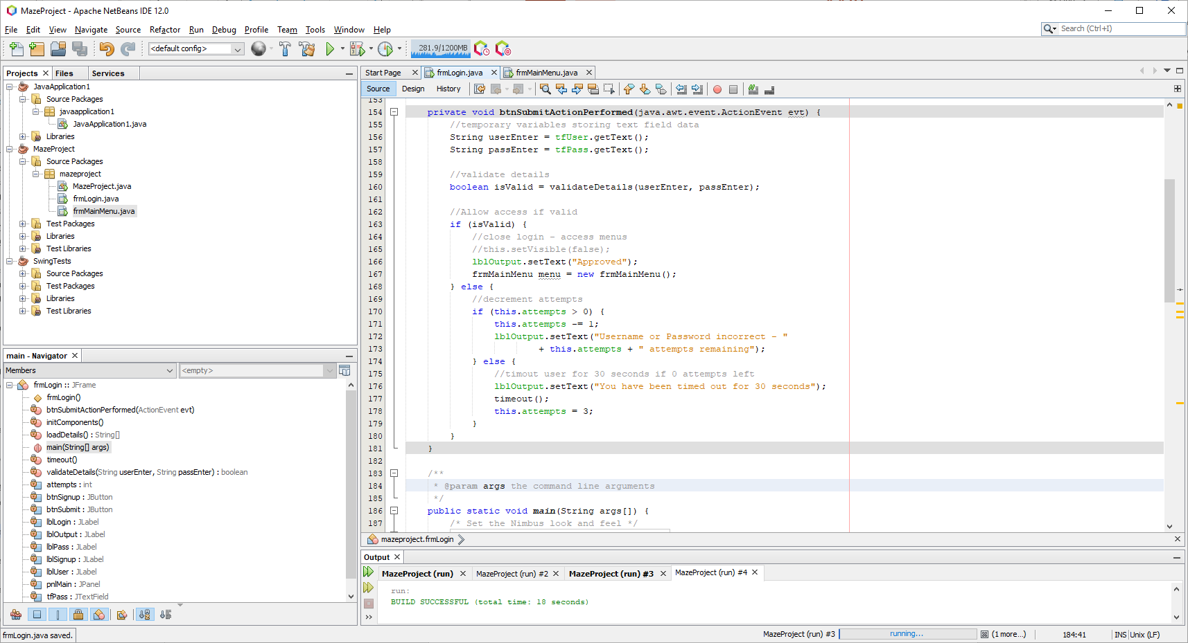

Testing the correct details:

Inputting username ‘Jai’ and password ‘1234’:

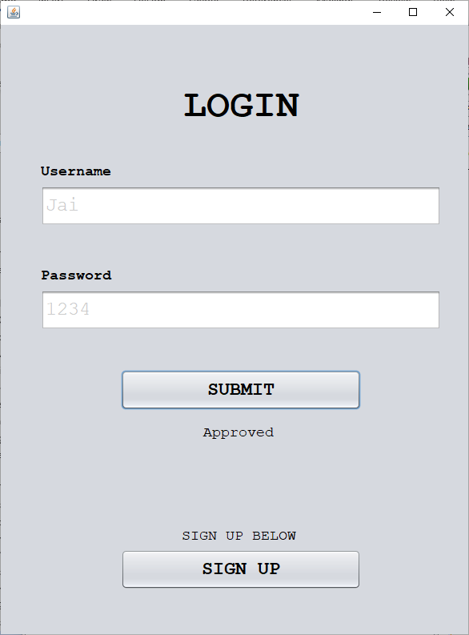

Here the password and username were approved as they matched the stored values however no main menu was brought up.

Fixing menu visibility issue

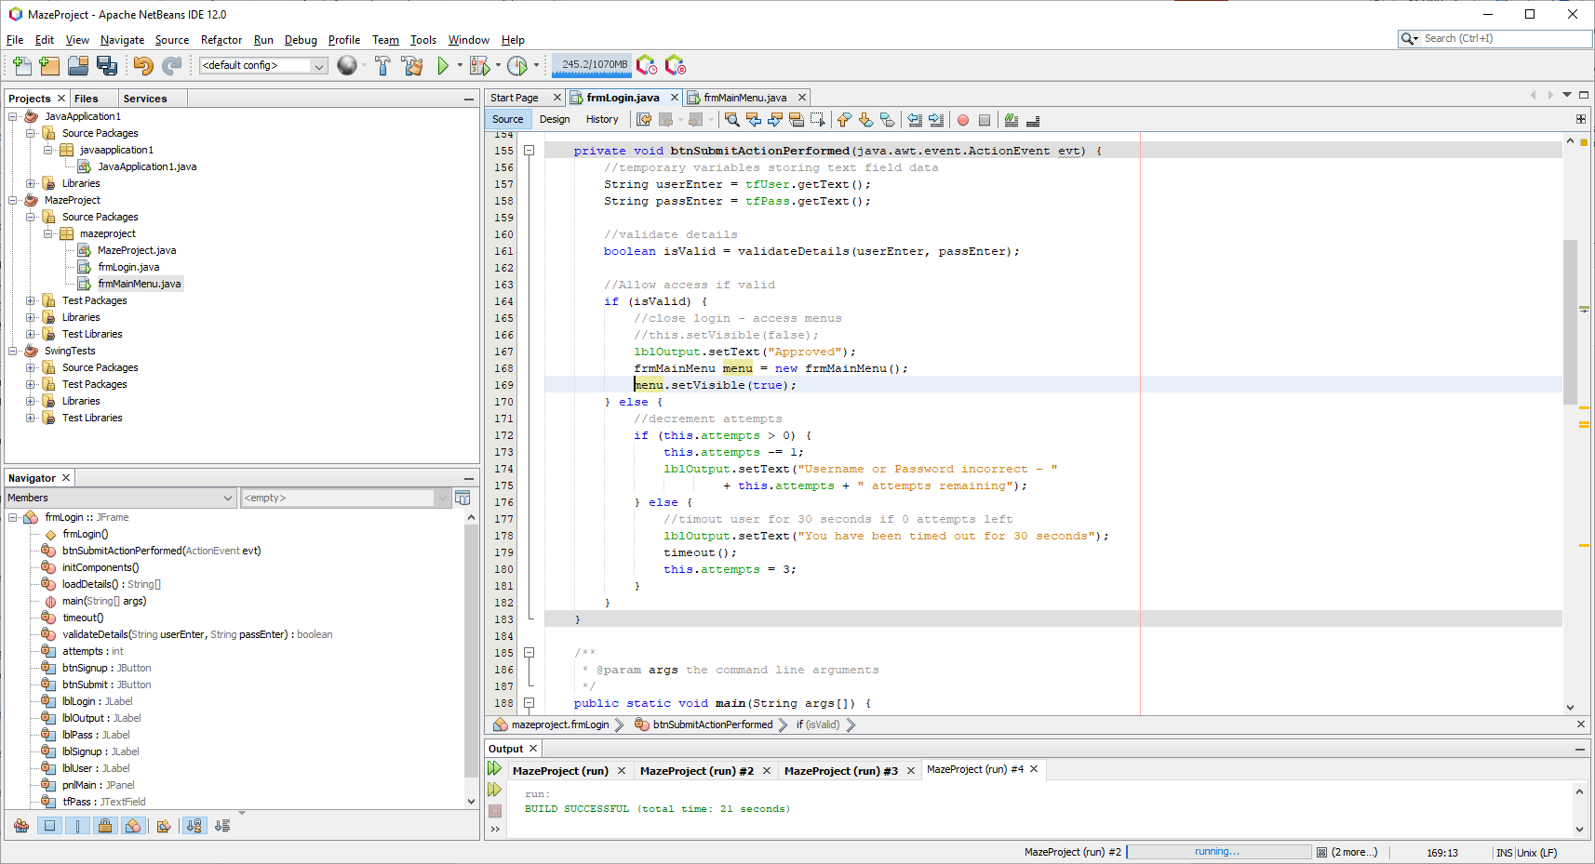

The issue was that once the menu object was being created, it was simply not set to visible, and the fix was to call a function to change this:

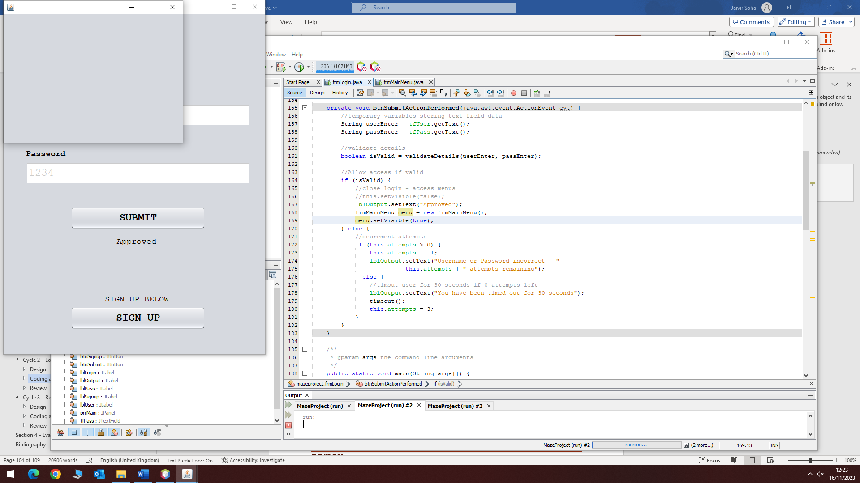

Now that the blank menu pops up on correct validation, the code that hides the login form can be uncommented so that the login form disappears.

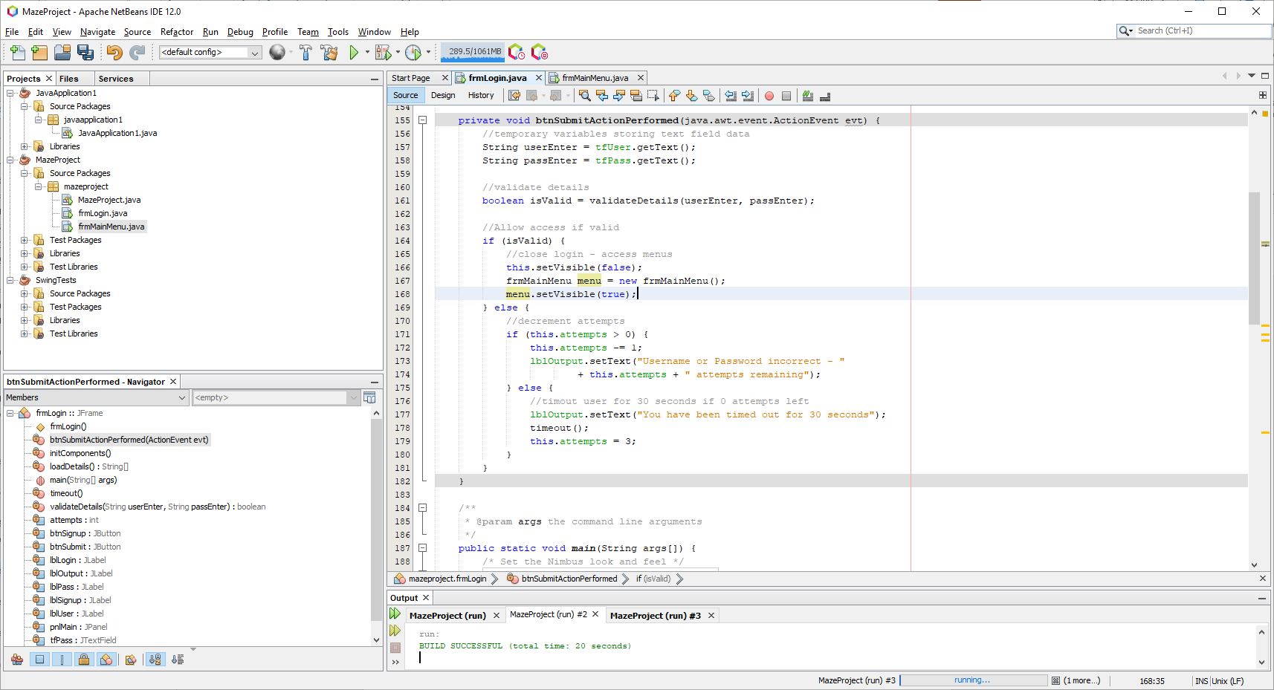

Testing for incorrect details + 3 attempts

When inputting incorrect details:

|  |  |
| --- | --- |
|  |  |
|  |  |

Here as you can see the user has had 4 attempts when in reality, they should only be receiving 3 total attempts before being locked out. Apart from this logic issue, the validation is working and correctly identifies incorrect details. Furthermore, the user isn’t actually timed out as right now there is a placeholder function that throws an error message when called.

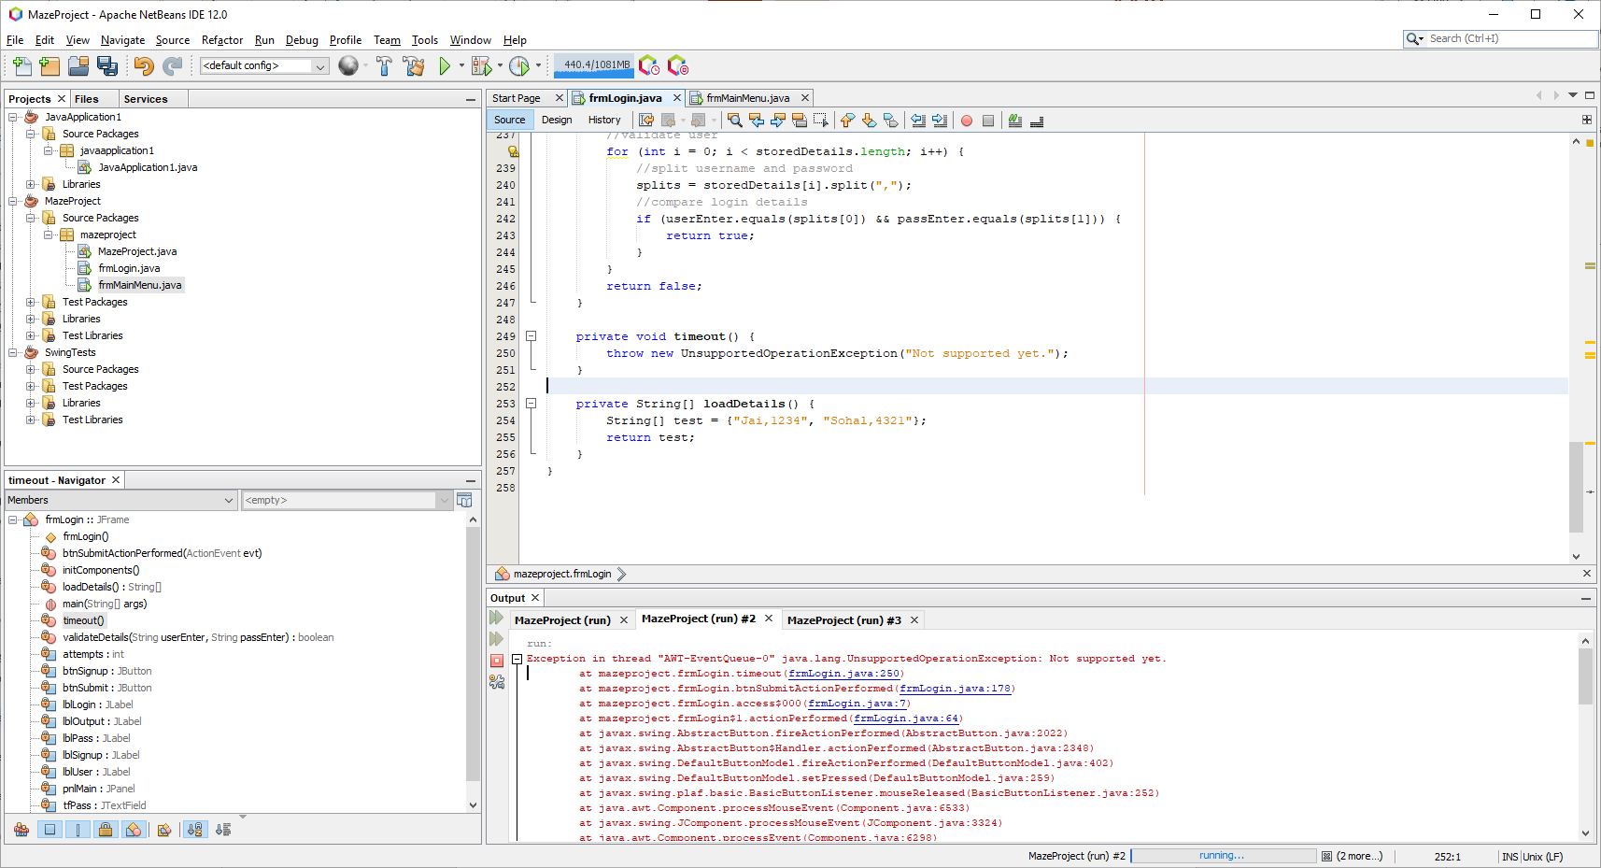

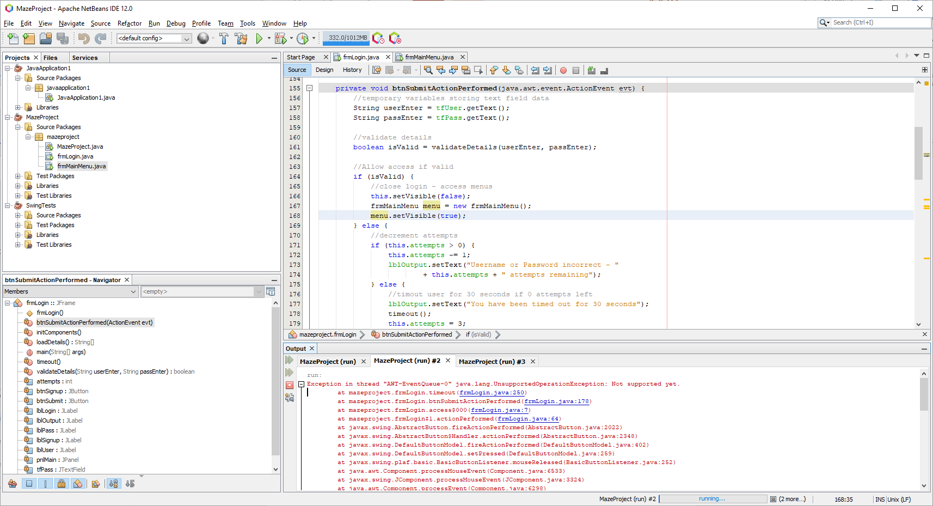

Fixing the attempts logic

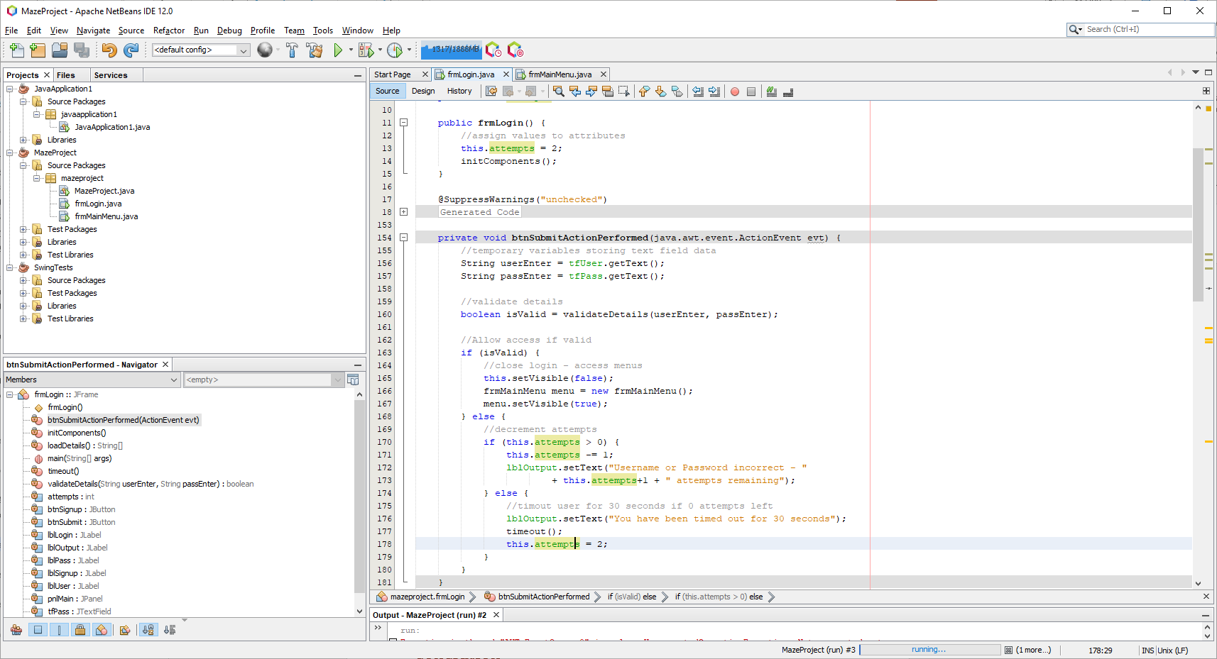

As there was an extra attempt each iteration, I simply started the attempts variable at 2 rather than 3 to tackle this. On line 173 I also needed to make sure the displayed number is incremented by one so that there is no point where it displays ‘0 attempts remaining’.

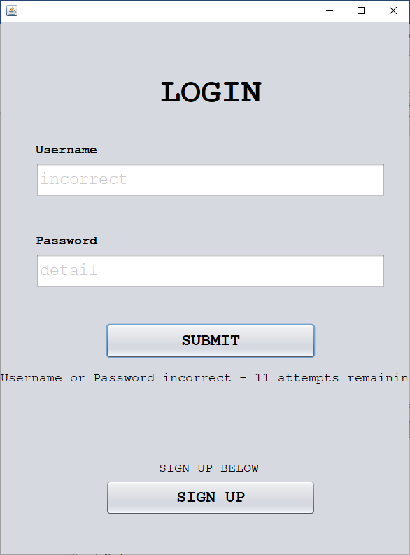

Instead of incrementing the count by 1, a 1 is concatenated onto the end of the attempts number. The error lies on line 173 where the statement is not encased by brackets to indicate integer addition rather than string concatenation.

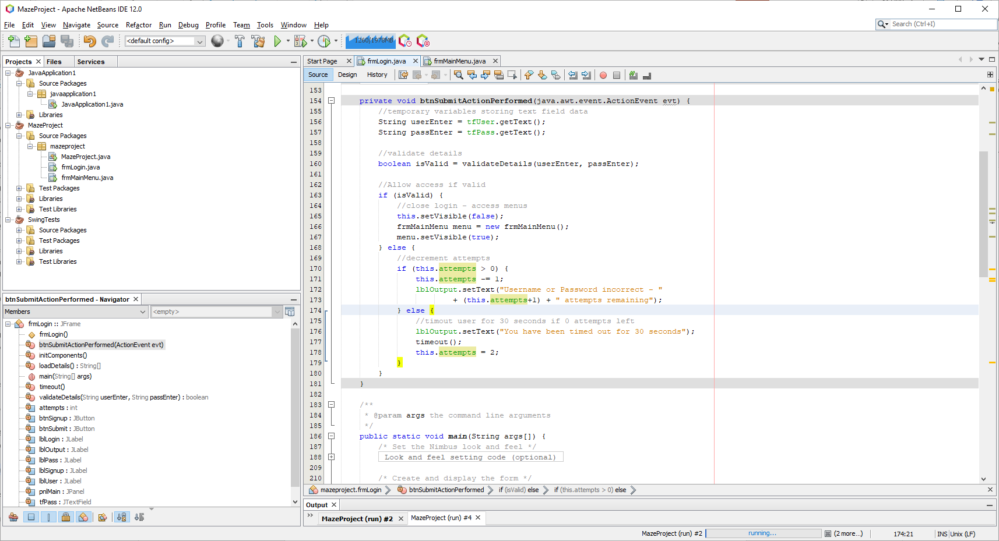

This encasing of brackets now indicates integer addition.

|  |  |
| --- | --- |
|  |  |

Correct display of 1 attempt remaining after 2 attempts.

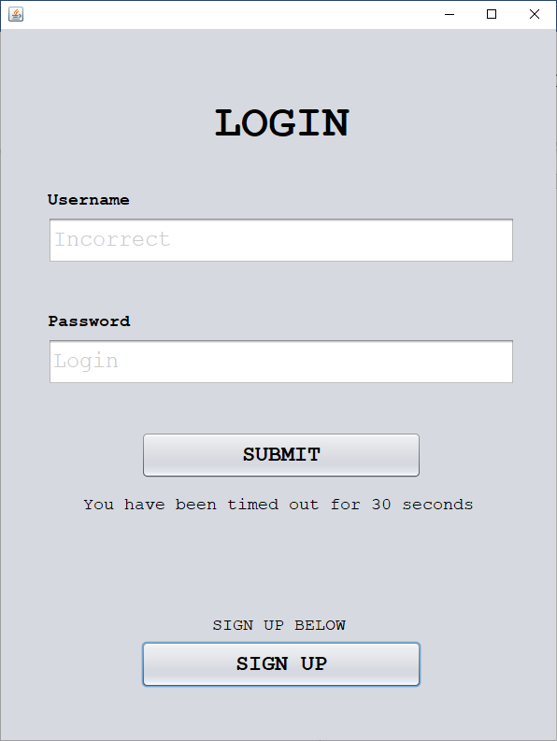

On the third attempt the user is told they are timed out but there is no function implemented yet – for this prototype, working validation is implemented.

##### Prototype #4

Developing the load DETAIL’S function

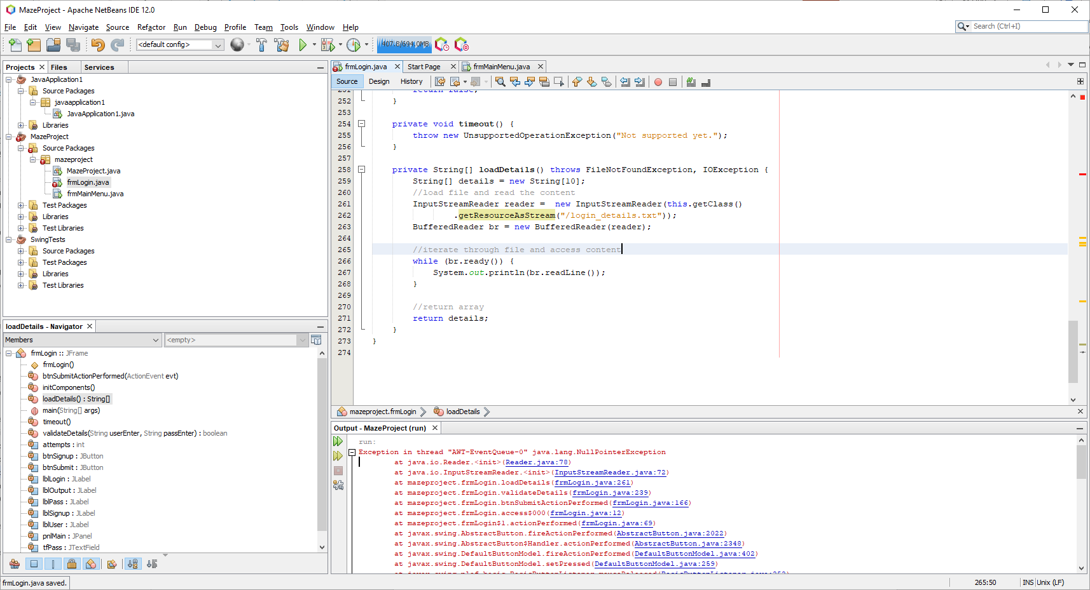

This code contains a placeholder string array as the file reading system is being developed. Here the file reads from a relative path to access the login details text file and then iterates through each line to access the content.

Fixing the null error

When running this code an error is reached:

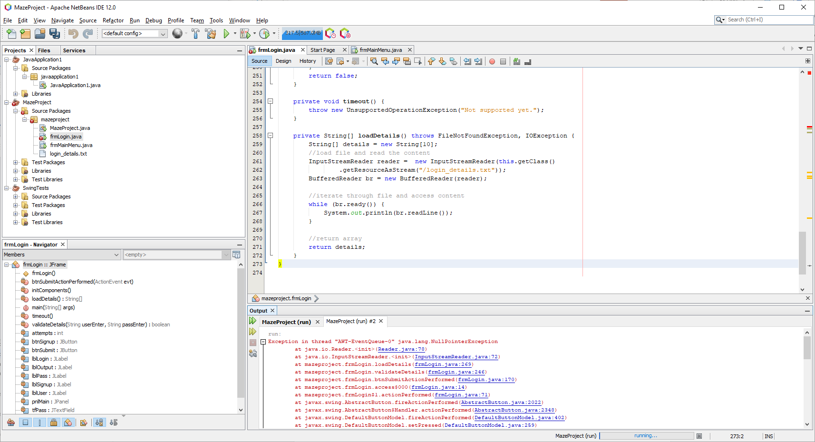

To combat this, I decided to stick to a single buffered reader with a relative path to the project file.

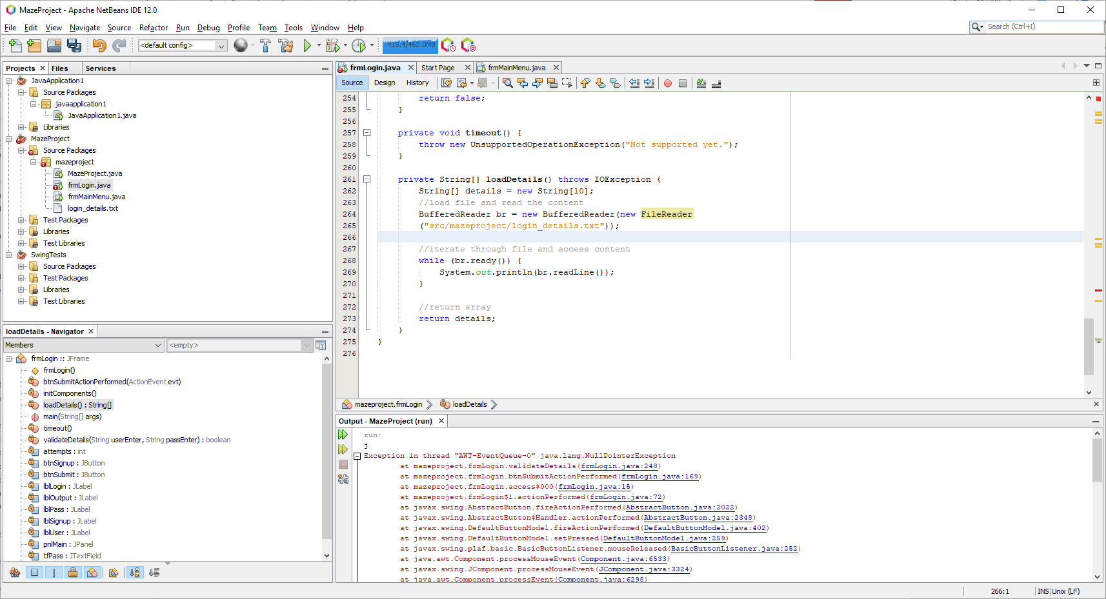

Having this correction, my file that contains a few sample logins is correctly displaying the content in the console. However, I do not have any detection for when the line reaches the end.

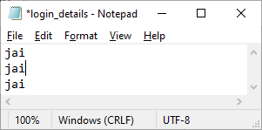

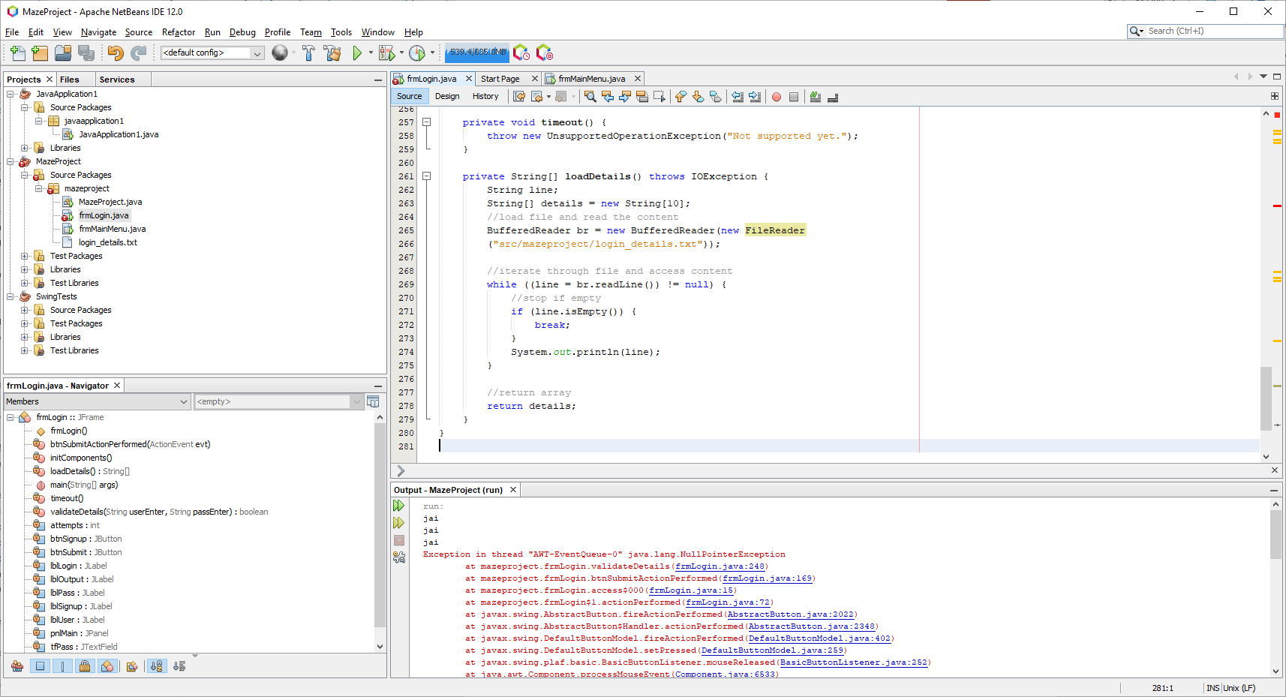

Now that I have made this fix, the null pointer exception still occurs:

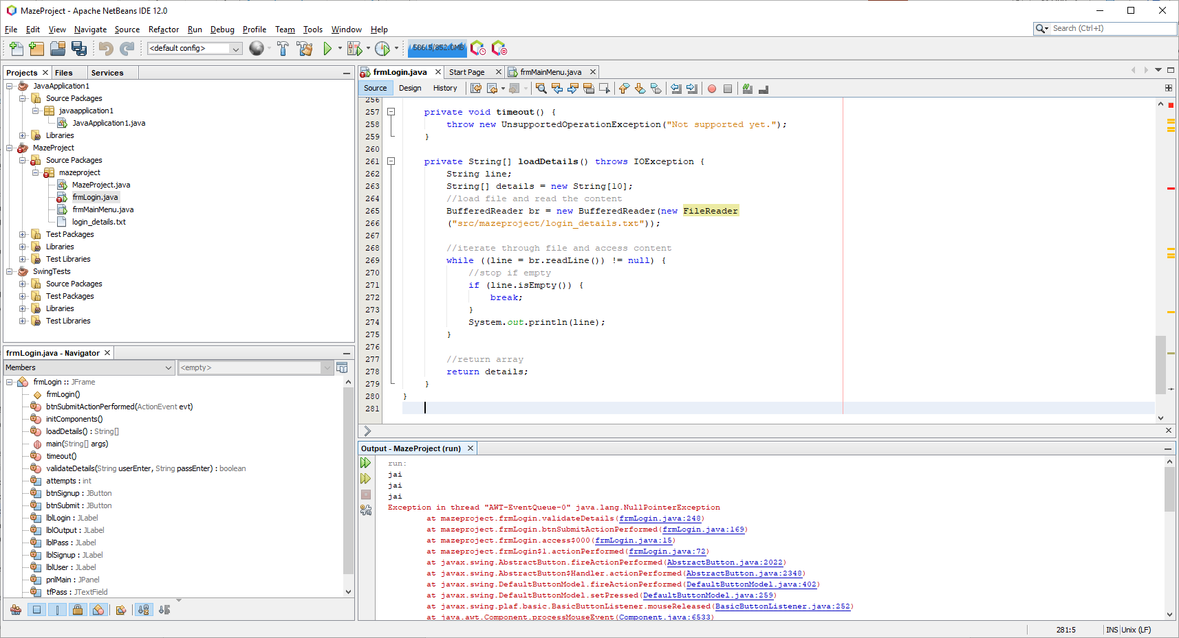

This is due to the login details in the file being of incorrect format. Instead of ‘jai’ it should be ‘jai,1234’ so that when the details are split by the program at the comma, no error occurs.

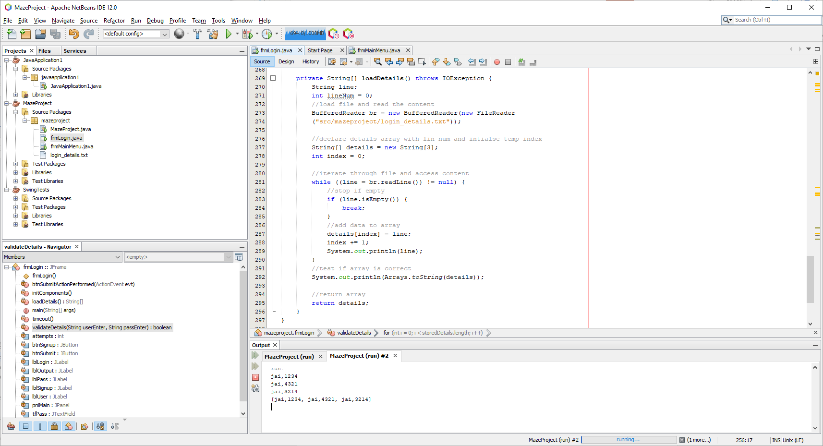

Before worrying about getting the number of lines to declare the array the correct size, I decided to make sure the code correctly accesses the data by setting the size to 3 manually.

Now that the code correctly detects null values and the text is of correct format, the code should work:

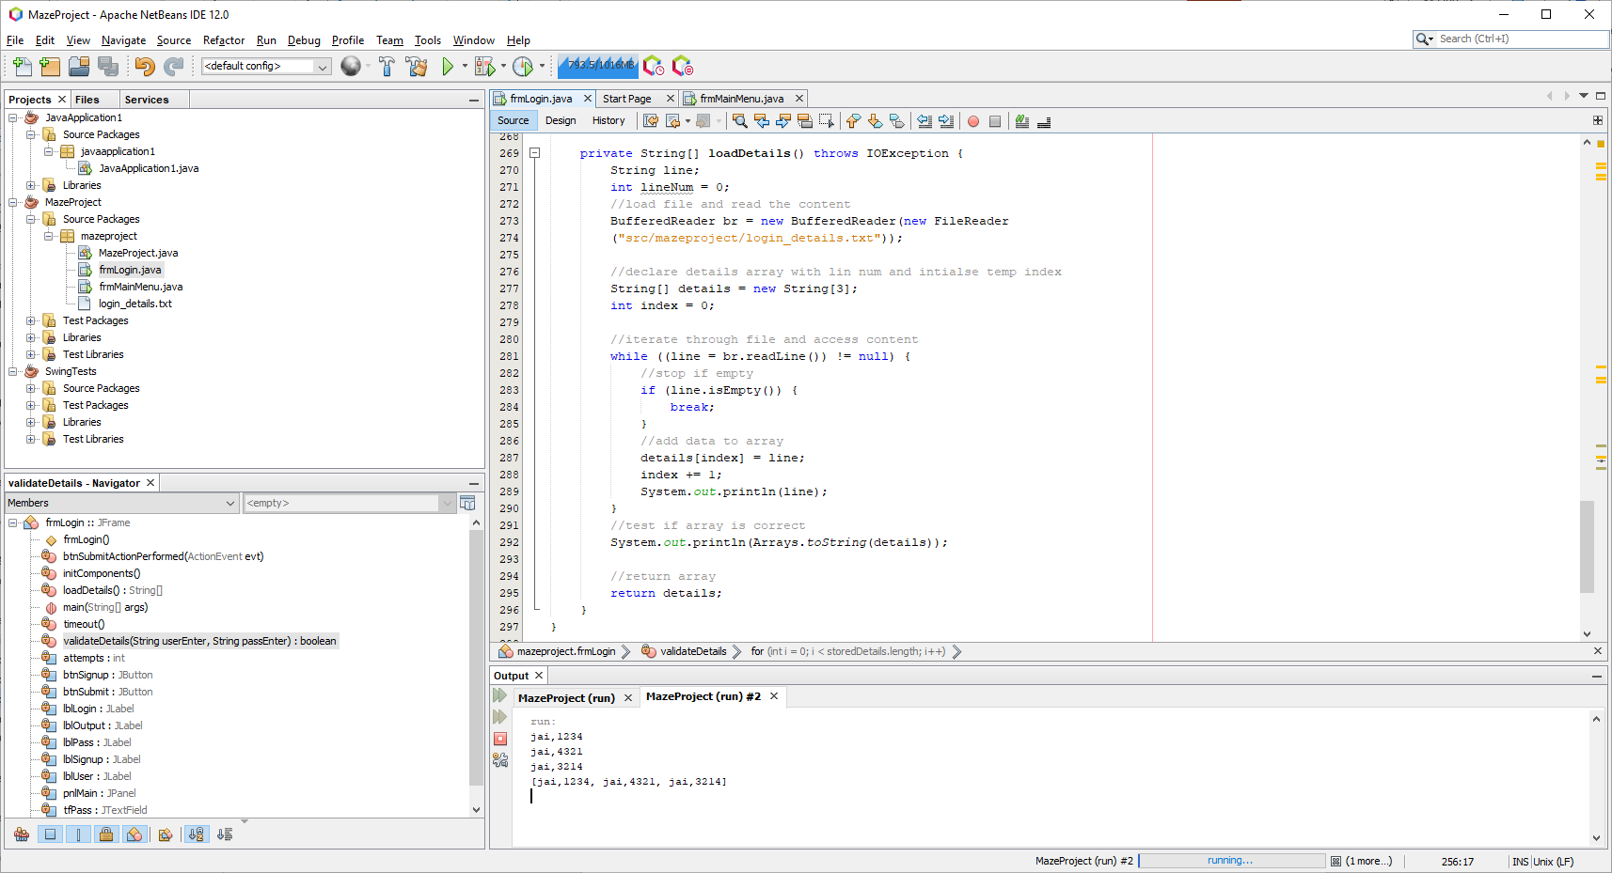

The input is correctly read, and the correct array is being returned.

Adding detection for line numbers

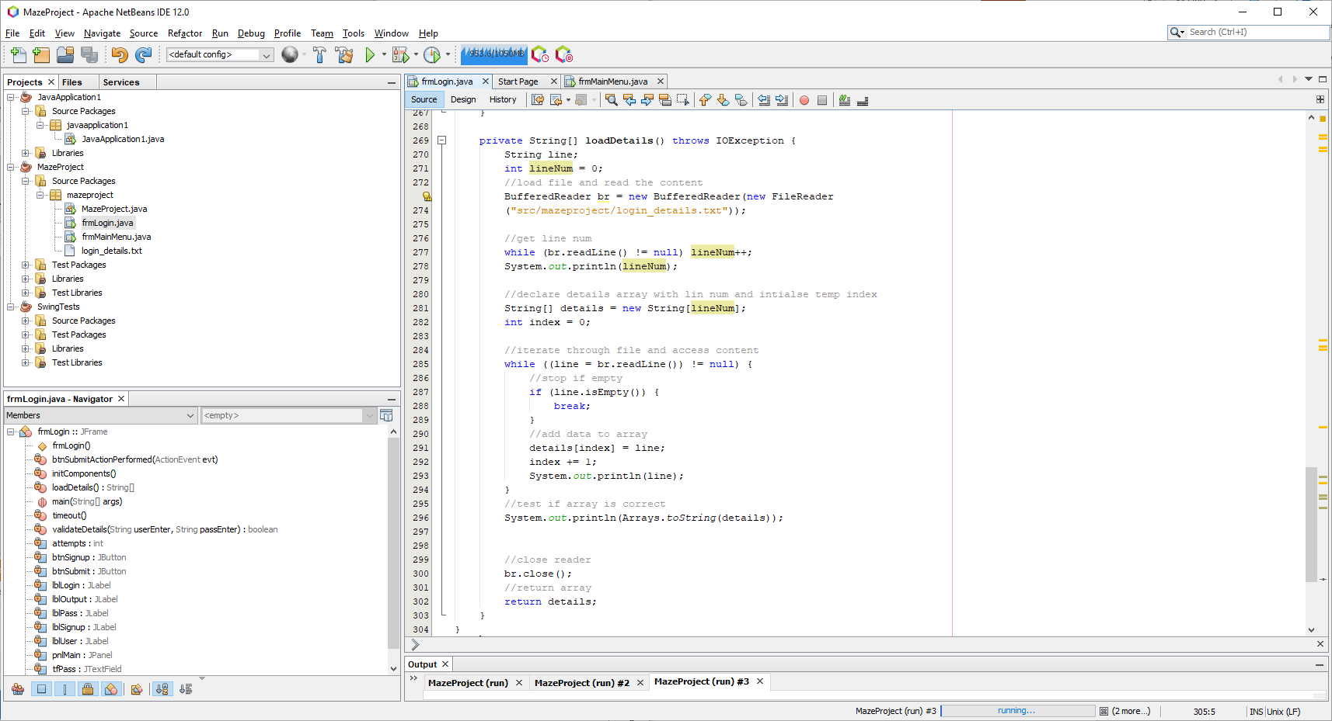

From lines 276-278, I added another reader loop to get the line number – however, a null pointer exception is present again.

Analysing the error, it seems that a reader cannot be read twice as it has already reached the end of the file.

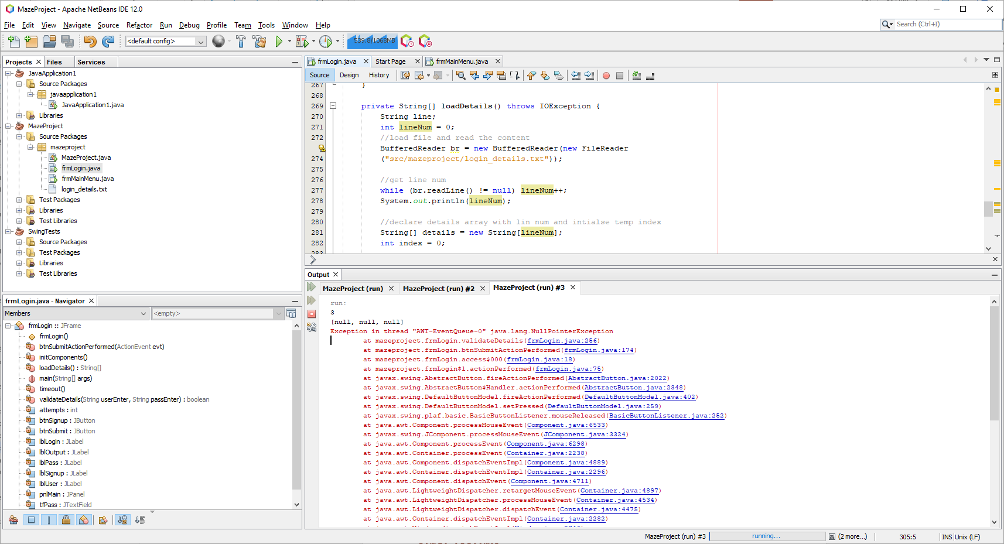

Fixing the line number detection

To resolve this issue, another reader must be instantiated and is solely responsible for retrieving the line number.

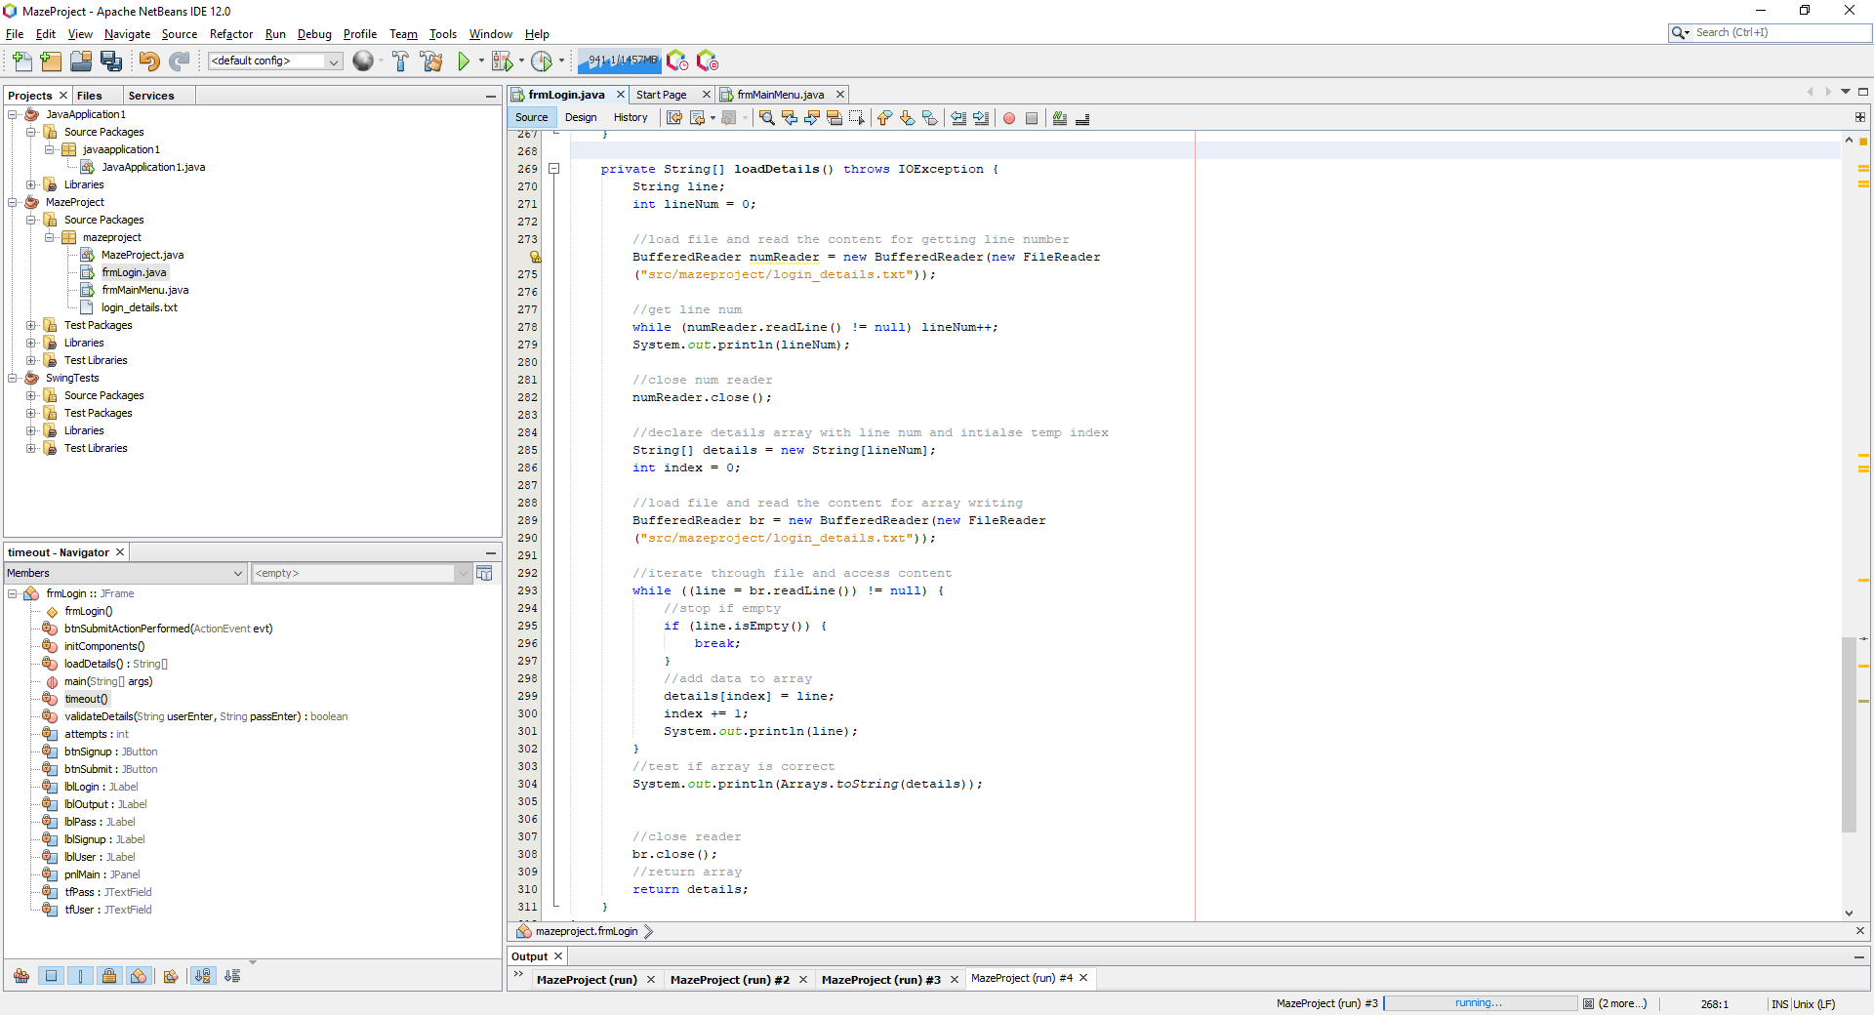

Now there are two separate readers, the issue is resolved, and the readers are closed after use.

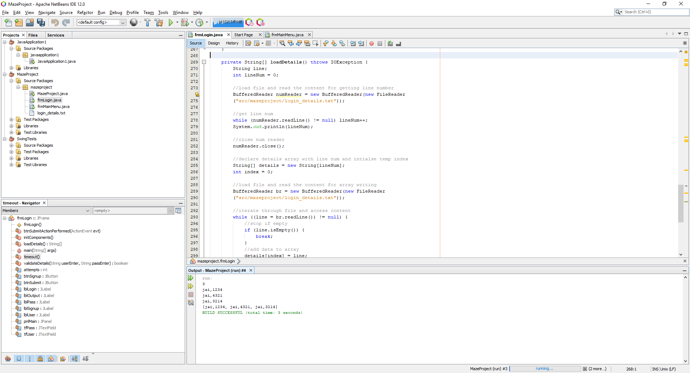

Fixing validation function

In my validateDetails function, this code must have an IOException thrown due to data accessed from the file. However, this is a drag and drop form and the button function cannot be edited.

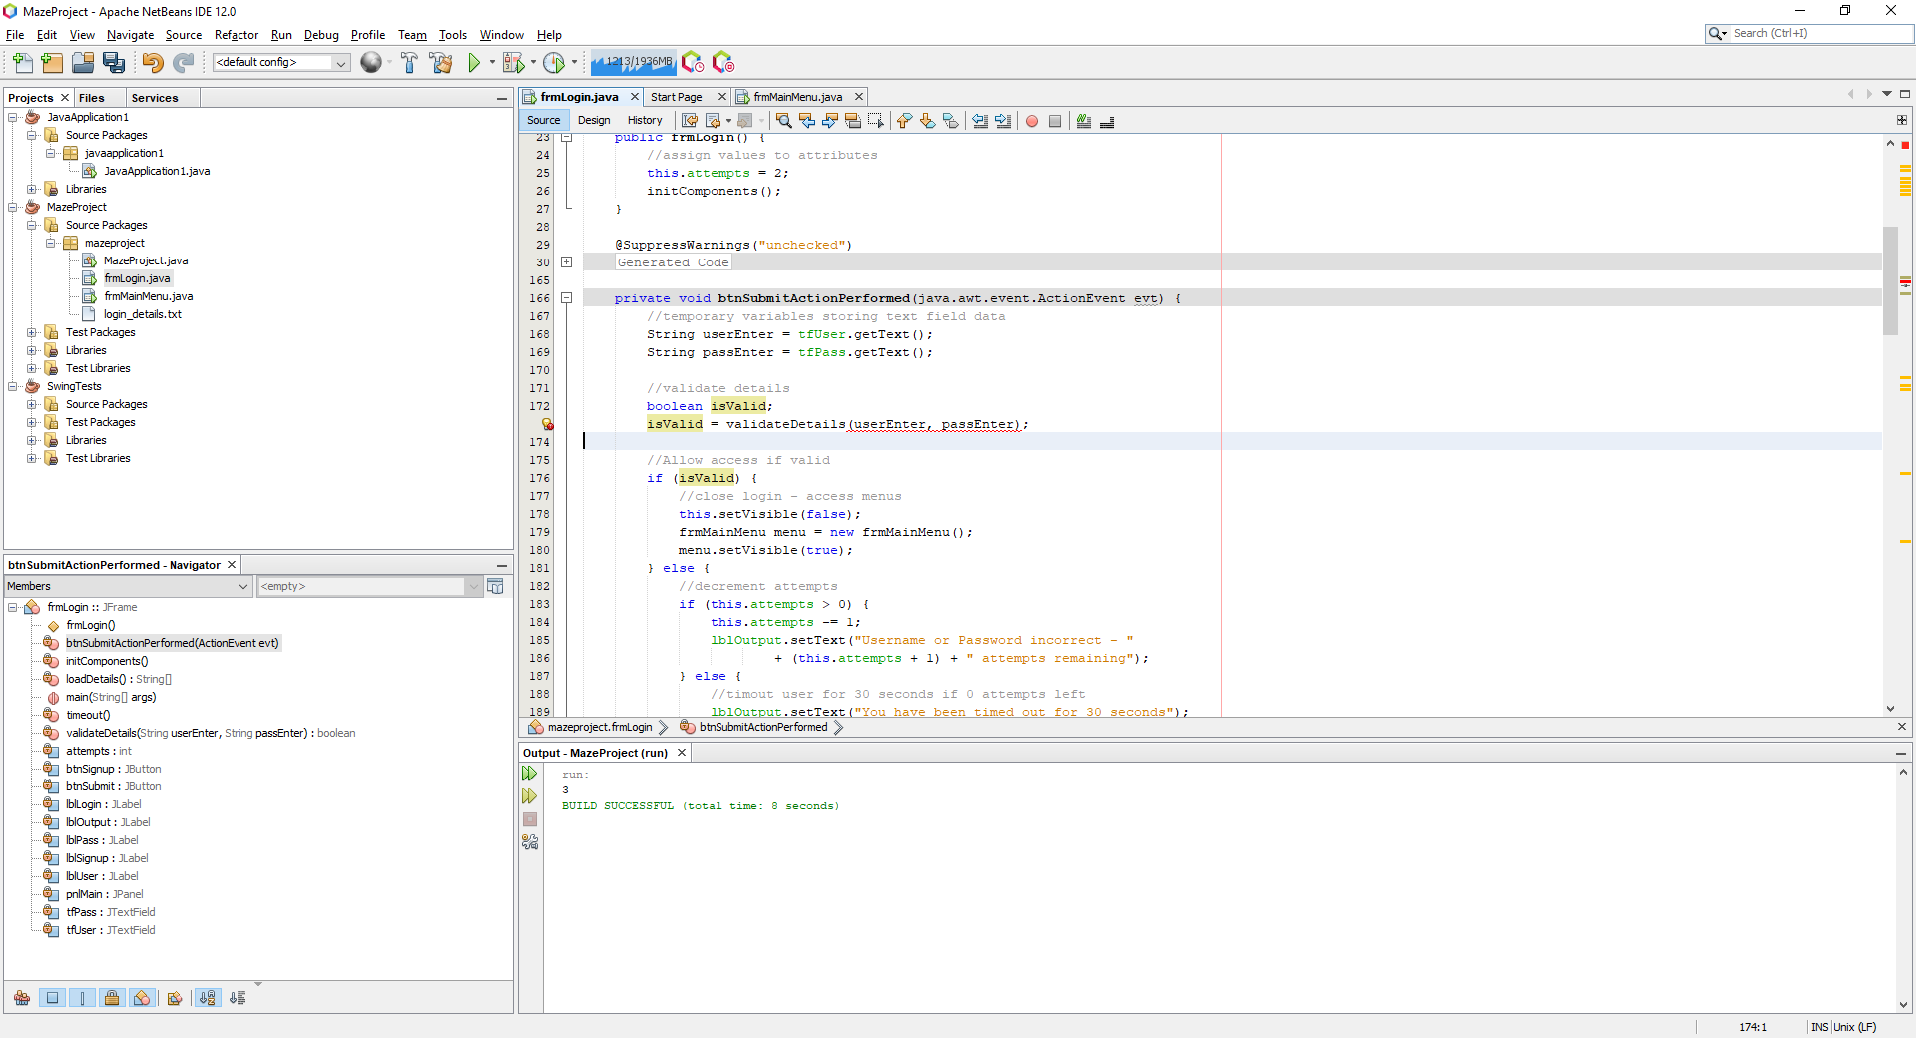

To fix this, a try catch clause is thrown within the actual function for the IOException and the variable isValid must be set to false as it must be initialised first.

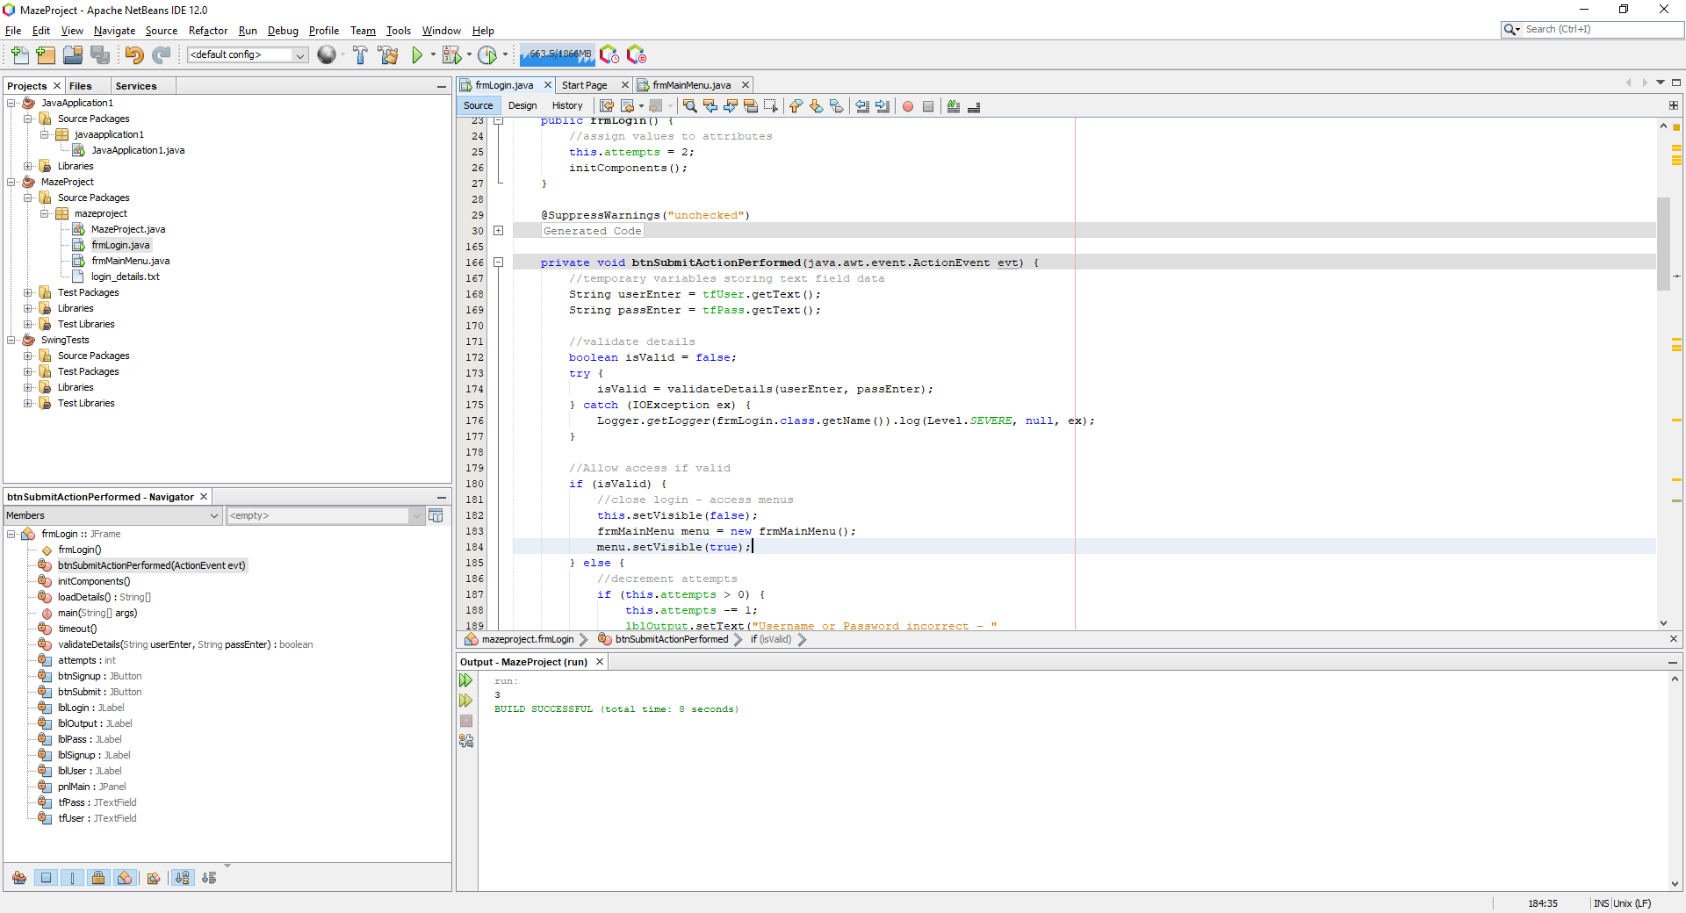

Testing no file found error:

If clicking submit but no file is found, an error will be thrown:

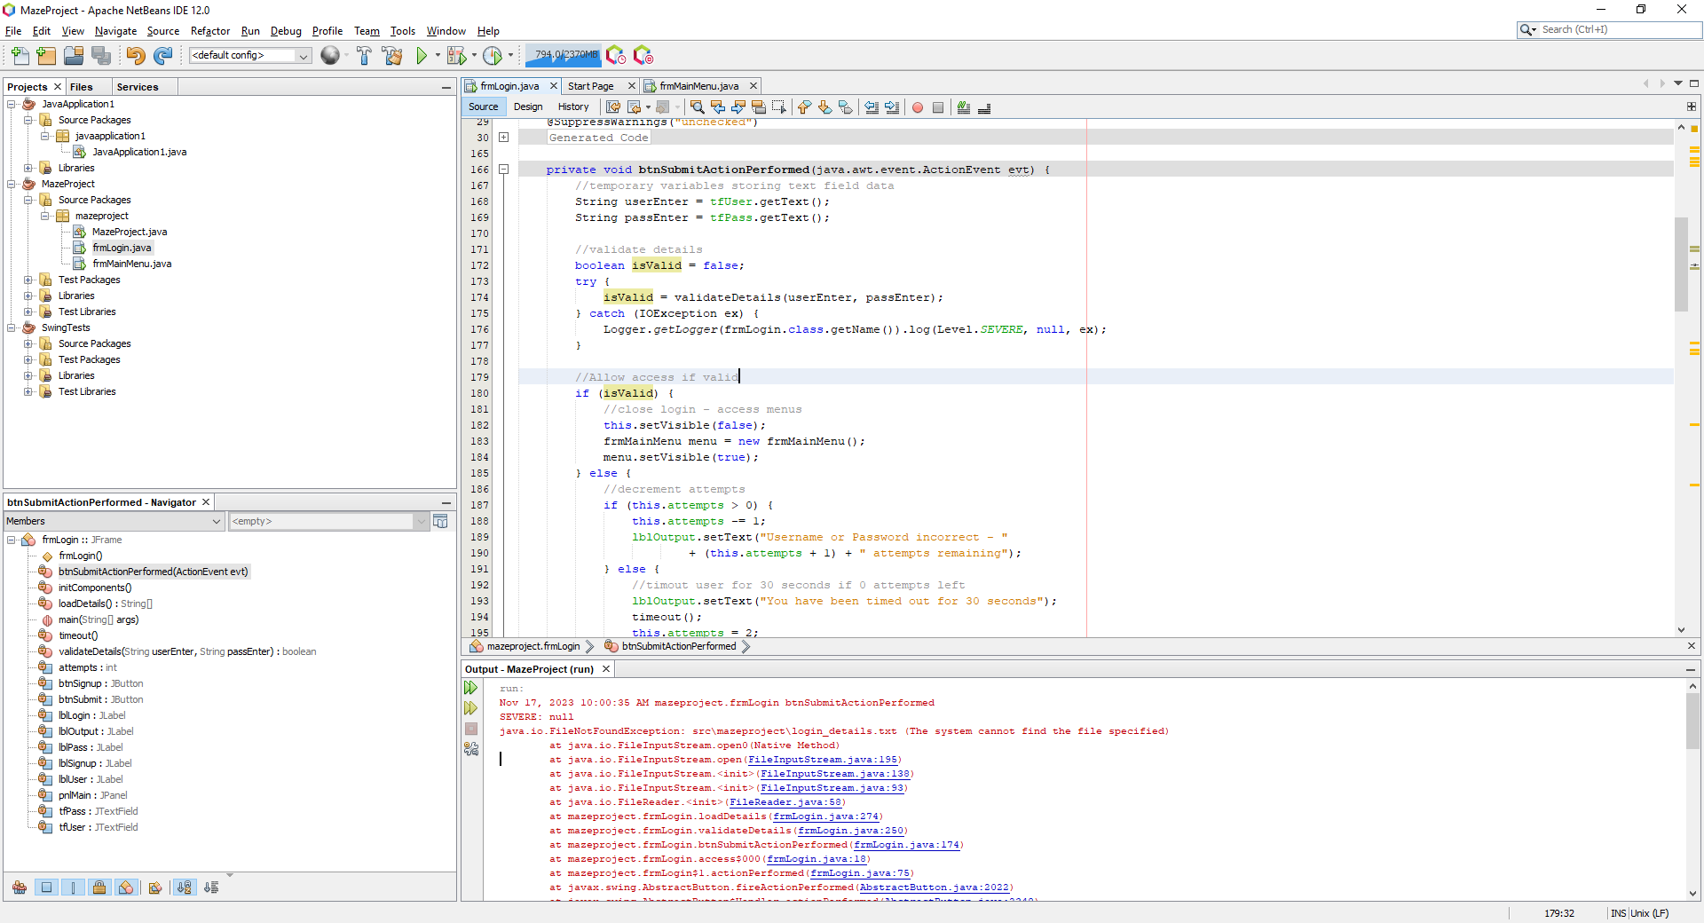

A simple fix would be catching this error and if the error is found, return an array of size 1. This array must have 2 blank spaces separated by a comma so that the future split function works.

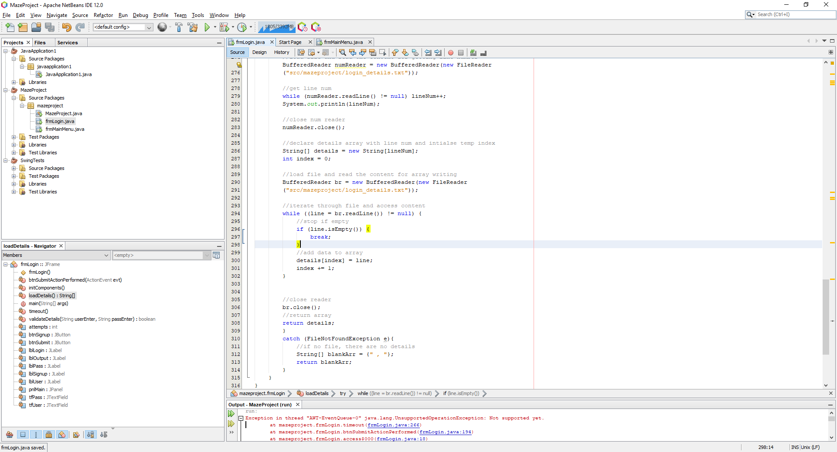

This statement is added at the end of the loadDetails function to resolve this issue. After this implementation, the code now runs smoothly and correctly. When blank input detection is added, this result will be impossible as blank data cannot pass through validation.

Developing the time out function

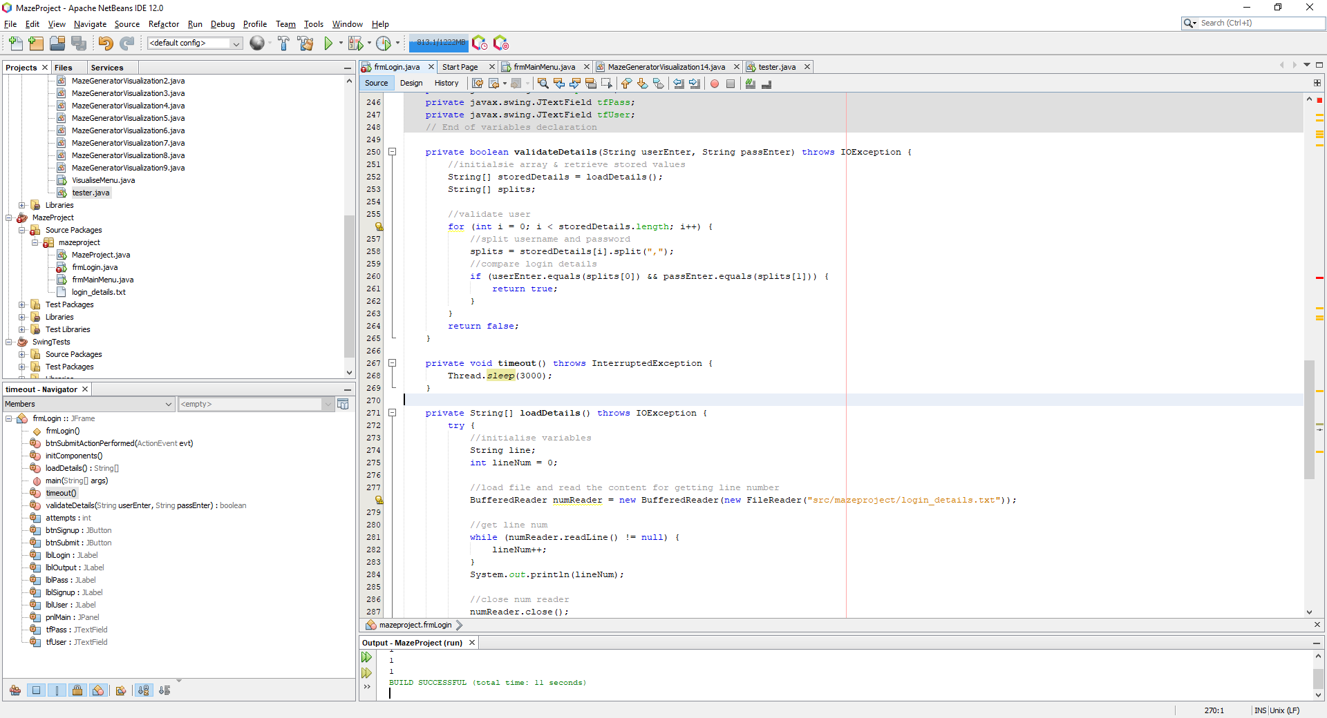

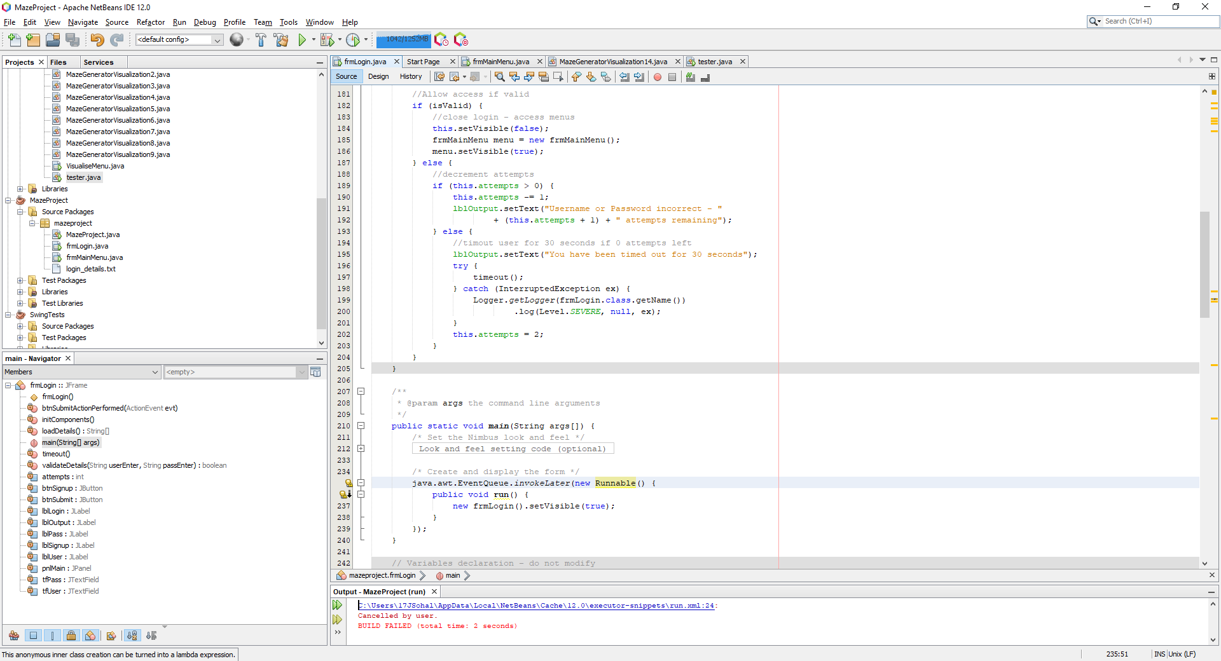

I have called a function to sleep the thread within the timeout function and for testing purposes I have chosen 3 seconds, so I do not have to wait the full 30 seconds.

This code successfully adds a delay of three seconds, but threads behave differently than Java Swing Timers and require manipulation to get the intended result.

Right now after the third attempt, when the button is clicked, the button stays pressed down for 3 seconds and then displays the timeout text after these 3 seconds are finished as shown in the image below despite the code for the label being before the timeout function

|  |  |
| --- | --- |
|  |  |
|  |  |

To fix this, Swing Worker functions can be implemented to allow threads to correctly sleep when a button is pressed.

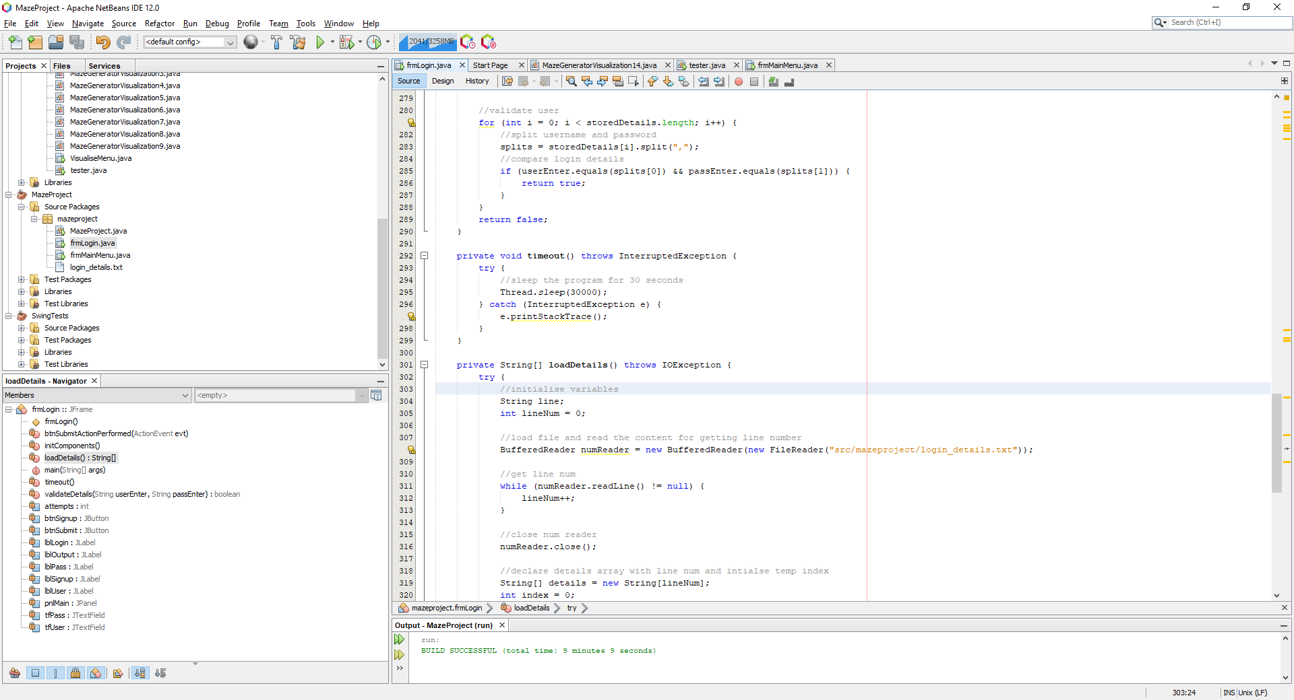

Here I have a sleeper function for 30 seconds and have an error catcher here rather than inside the button function.

With this Swing worker function, the code first disables the menu and then times the user out. After the 30 seconds are complete, the menus are then re enabled by iterating through the components

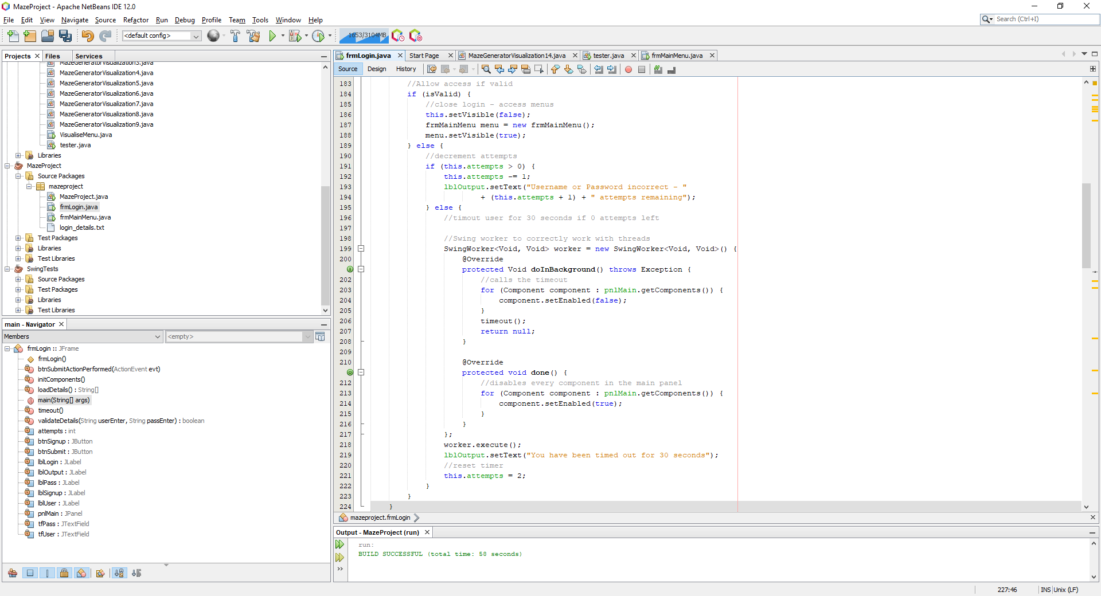

#### Final Cycle Code

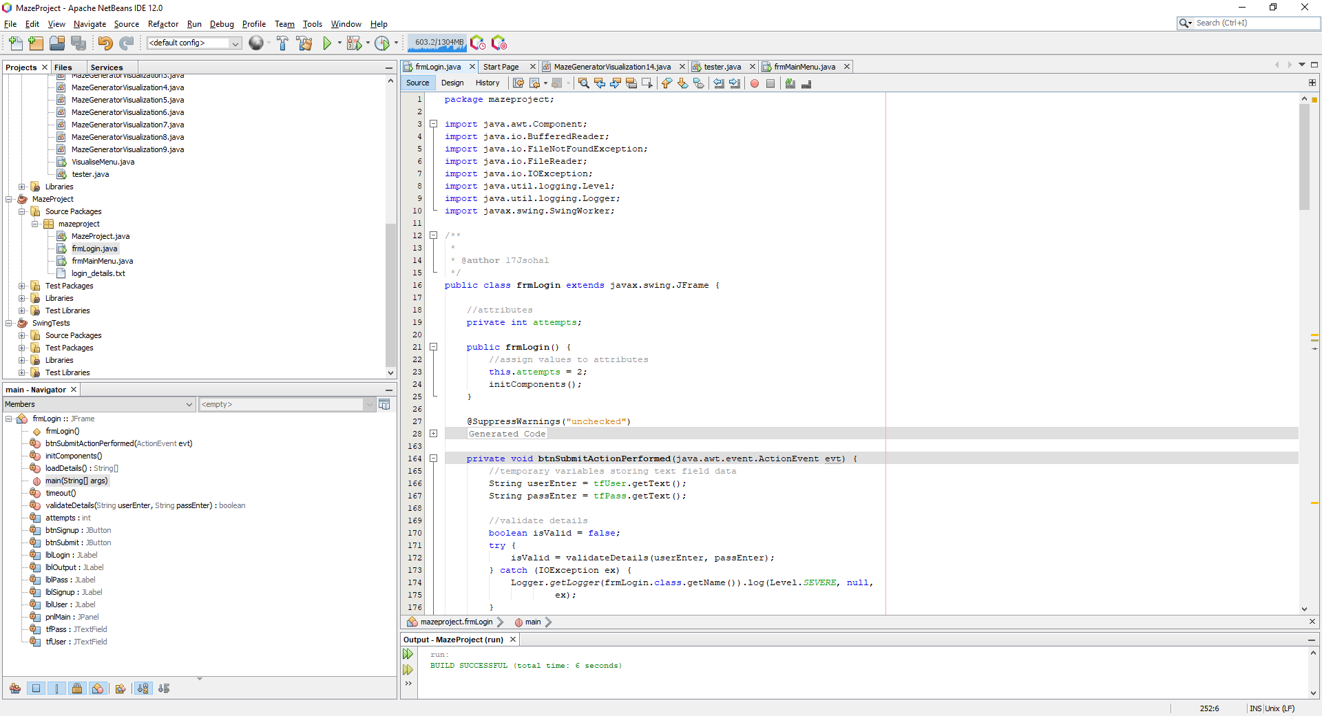

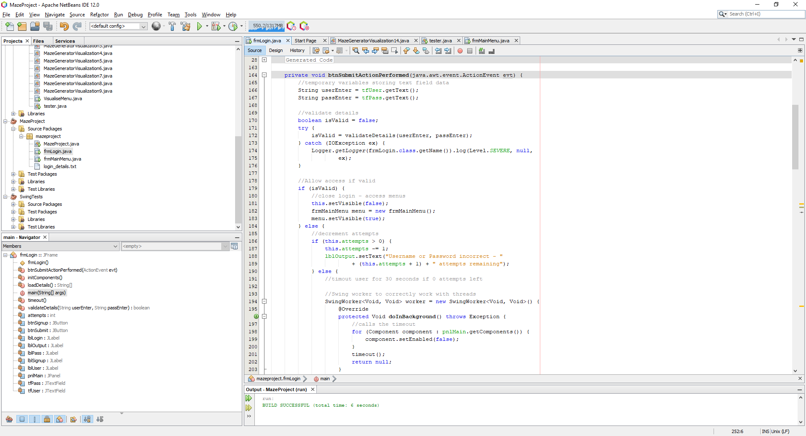

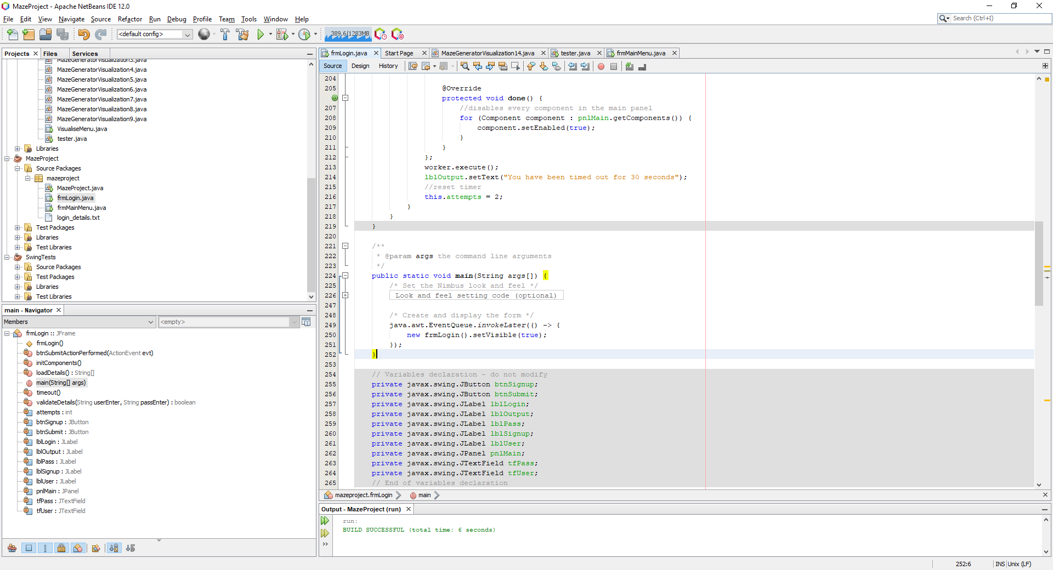

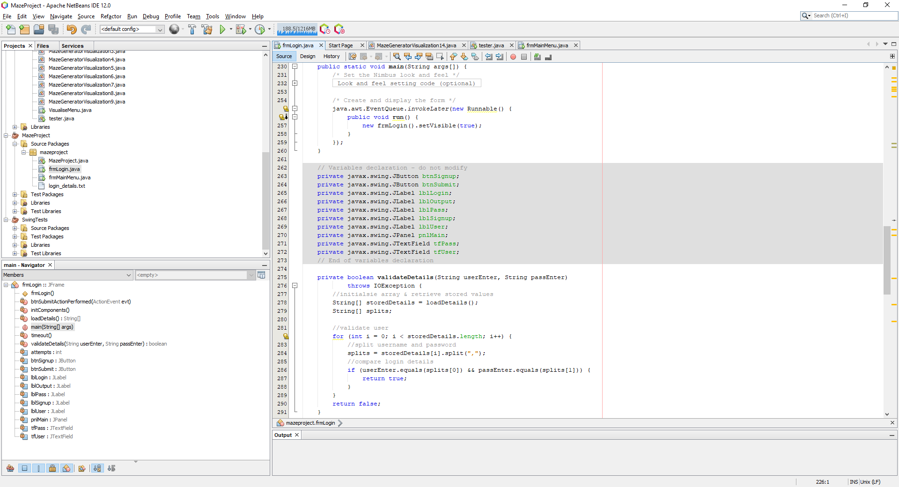

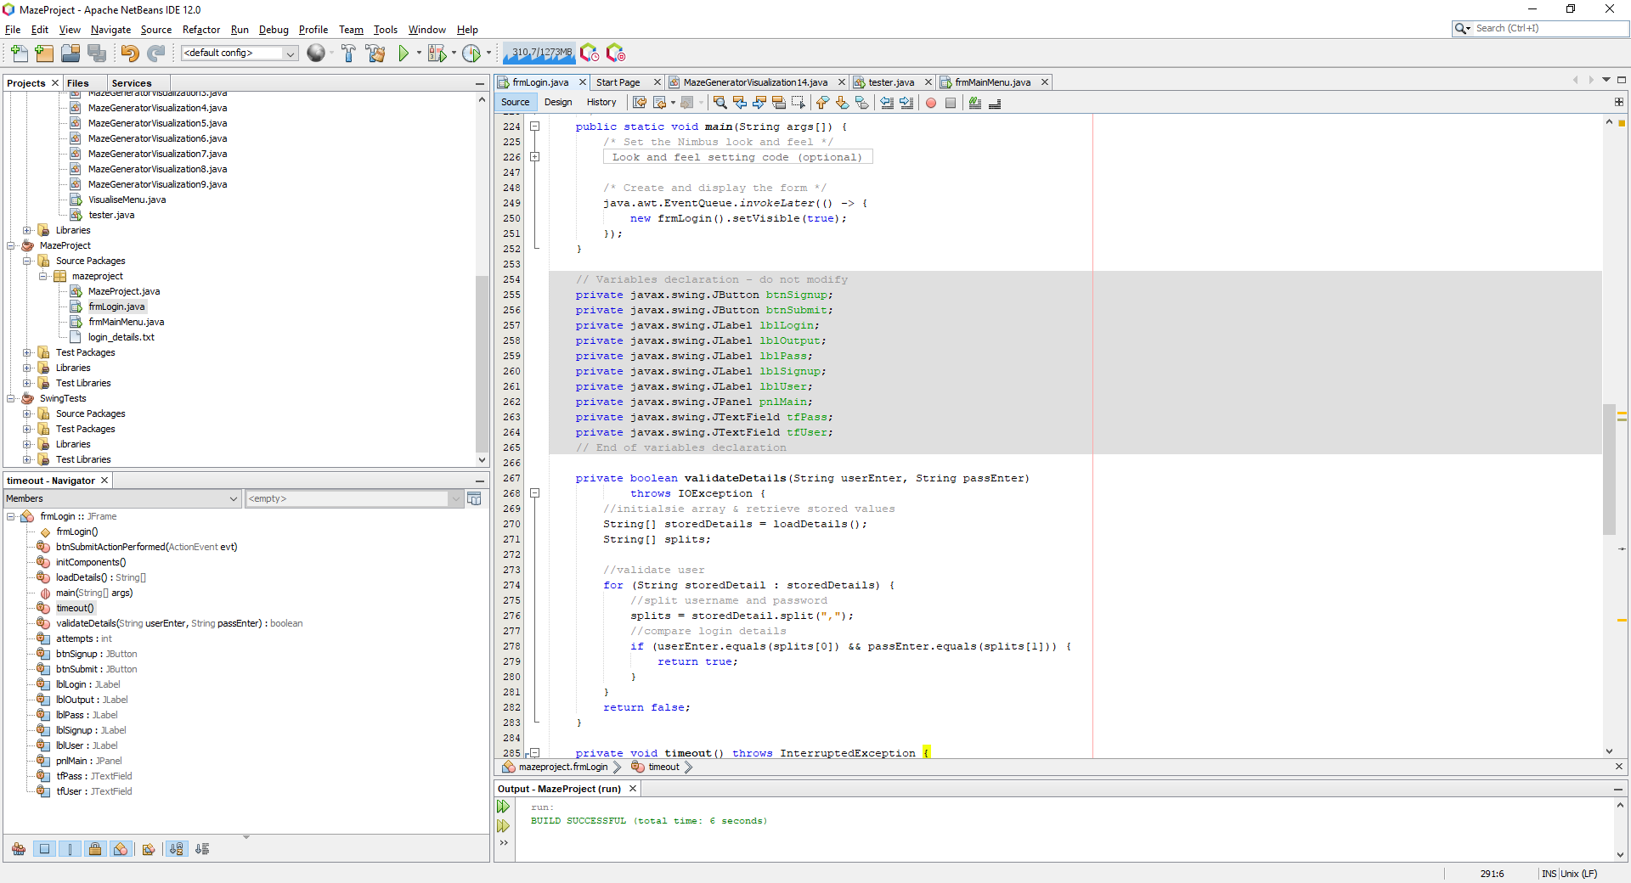

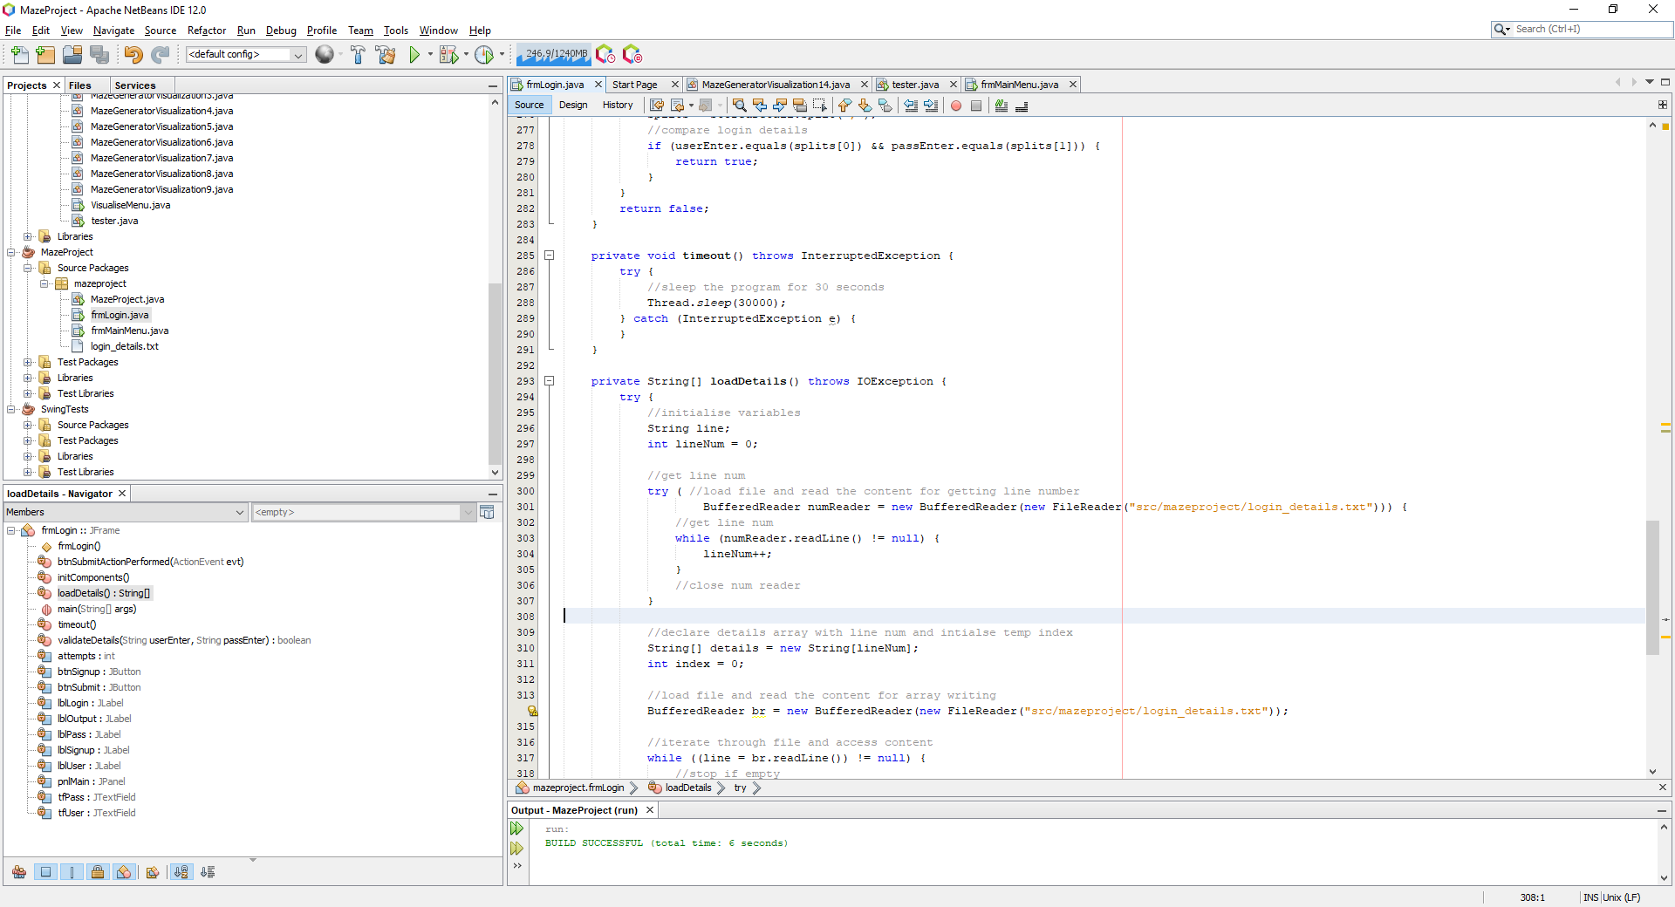

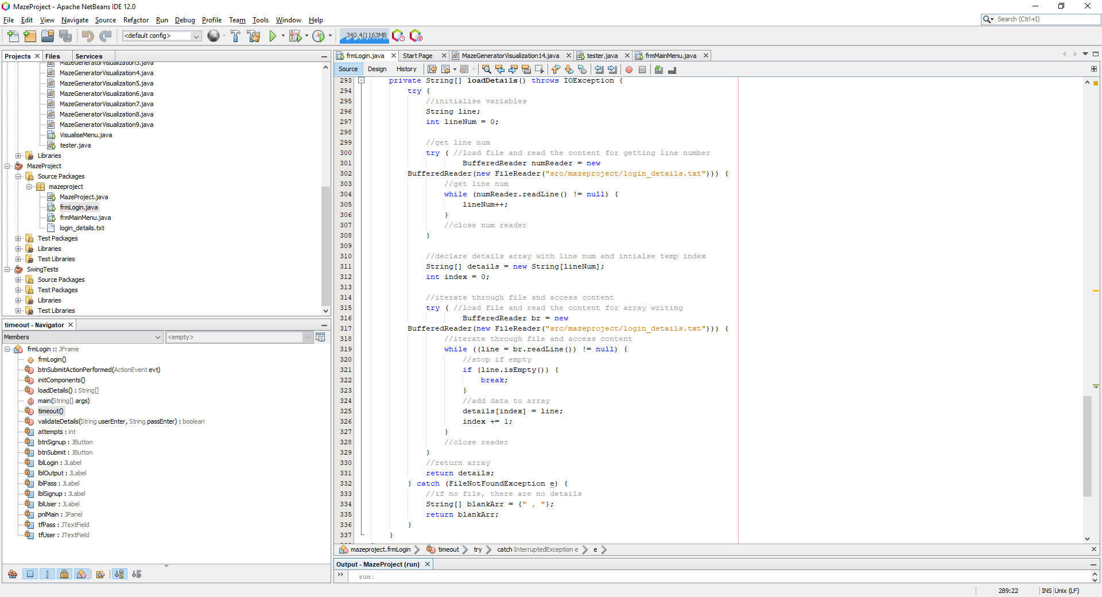

### Review

#### Final testing

|  |  |  |  |  |  |
| --- | --- | --- | --- | --- | --- |
| Test | Test description | Input | Expected outcome | Type of test | Passed Test? |
| 1 | Test for the user’s ability to interact with the login form and enter details | Any username and password (both strings) | Data should be evaluated and an appropriate response output | Normal |  |
| 2 | Test to see the outcome of inputting the correct username and the correct password | Correct username and password both of type String | User is allowed access and is redirected to the main menu form (dummy form as main menu not developed) | Normal |  |
| 3 | Test for inputting the incorrect username, correct password | Incorrect username, correct password | User is denied access but is only told that the details are incorrect, not specifically the username | Normal |  |
| 4 | Test for inputting the correct username, incorrect password | Correct username, incorrect password | User is denied access but is only told that the details are incorrect, not specifically the password | Normal |  |
| 5 | Test for inputting the incorrect username, incorrect password | Incorrect username, incorrect password | User is denied access and is told that the details are not correct, not specifically that both are incorrect | Normal |  |
| 6 | Test for clicking the associated sign-up button | Button click with the intent to sign up | User is redirected to the sign-up page | Normal |  |
| 7 | Test for clicking into a text box | Button click onto a text box | The text hint should disappear once the user clicks onto the box for the first time | Normal |  |
| 8 | Test for entering blank details | No input into the text box | The user should be told that either the username or password is blank, and an attempt is not used | Normal |  |
| 9 | Test for attempts correctly going down | Incorrect login details | User should be told they have an x number of attempts remaining. Maximum is 3 and once all are gone, the user is timed out for 30 seconds where the attempts are reset after the time is up | Normal |  |

##### Test #1

|  |  |  |  |  |  |
| --- | --- | --- | --- | --- | --- |
| Test | Test description | Input | Expected outcome | Type of test | Passed Test? |
| 1 | Test for the user’s ability to interact with the login form and enter details | Any username and password (both strings) | Data should be evaluated and an appropriate response output | Normal |  |

The program passes the test if a user can correctly interact with the boxes, type into the text box, and highlight text so that the login form can be used.

This login form, despite not being finished in the graphics sense, has the capability to perform all of these tasks.

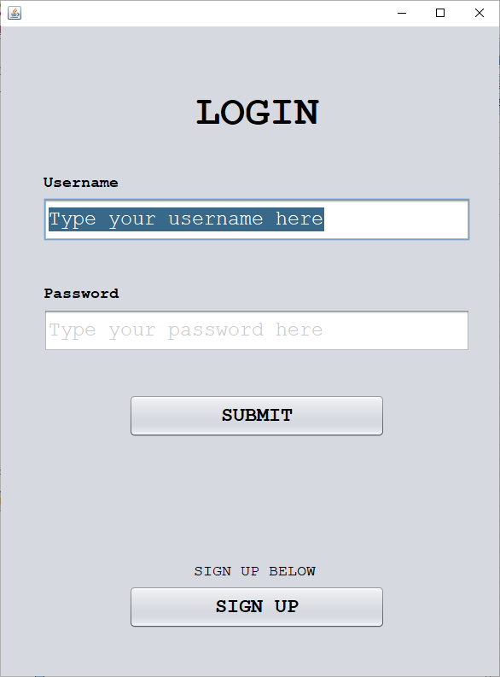

##### Test #2

|  |  |  |  |  |  |
| --- | --- | --- | --- | --- | --- |
| Test | Test description | Input | Expected outcome | Type of test | Passed Test? |
| 2 | Test to see the outcome of inputting the correct username and the correct password | Correct username and password both of type String | User is allowed access and is redirected to the main menu form (dummy form as main menu not developed) | Normal |  |

Inputting correct username and correct password:

|  |  |
| --- | --- |
|  |  |

Putting in test usernames of ‘jai’ and ‘1234’ which is in the details text file, correctly opens the dummy main menu.

##### Test #3

|  |  |  |  |  |  |
| --- | --- | --- | --- | --- | --- |
| Test | Test description | Input | Expected outcome | Type of test | Passed Test? |
| 3 | Test for inputting the incorrect username, correct password | Incorrect username, correct password | User is denied access but is only told that the details are incorrect, not specifically the username | Normal |  |

Here we can see that an incorrect password correctly informs the user that either the password or username is incorrect. It does not specify which is incorrect and access is denied.

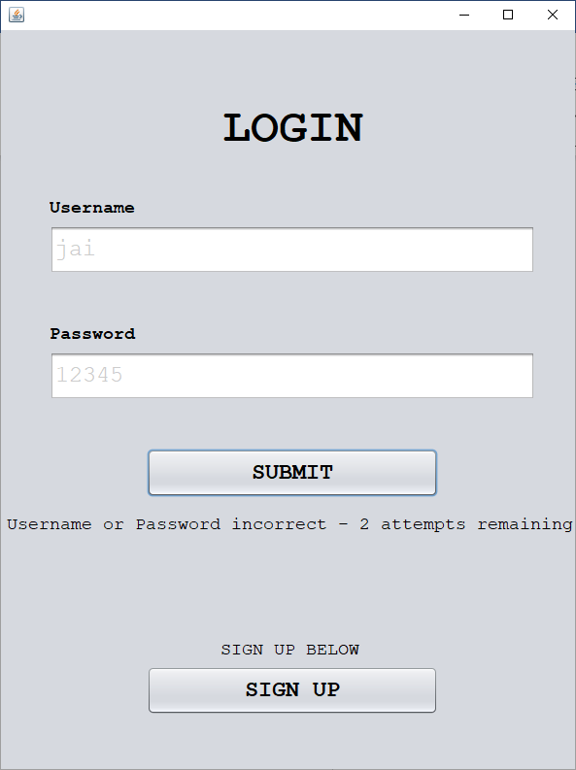

##### Test #4

|  |  |  |  |  |  |
| --- | --- | --- | --- | --- | --- |
| Test | Test description | Input | Expected outcome | Type of test | Passed Test? |
| 4 | Test for inputting the correct username, incorrect password | Correct username, incorrect password | User is denied access but is only told that the details are incorrect, not specifically the password | Normal |  |

Inputting the inverse of test #3 with an incorrect username but a correct password outputs the same result where it displays an error to the user but not specifically what the error was.

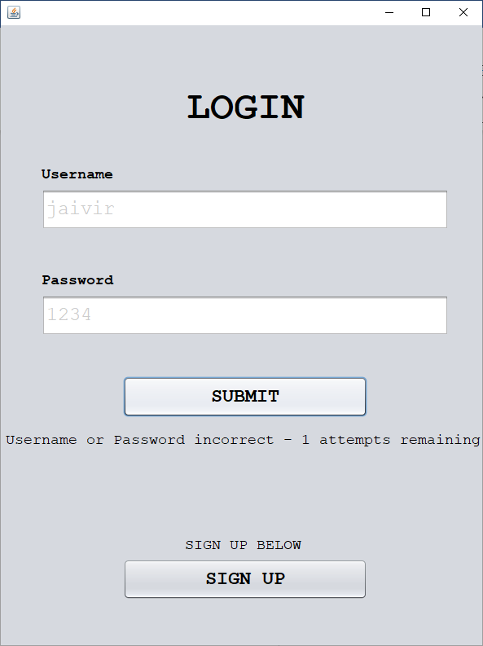

##### Test #5

|  |  |  |  |  |  |
| --- | --- | --- | --- | --- | --- |
| Test | Test description | Input | Expected outcome | Type of test | Passed Test? |
| 5 | Test for inputting the incorrect username, incorrect password | Incorrect username, incorrect password | User is denied access and is told that the details are not correct, not specifically that both are incorrect | Normal |  |

Now combining test #3 and test #4, when having both details incorrect, the user should also output the same result and **not inform** the user that **both** details are incorrect.

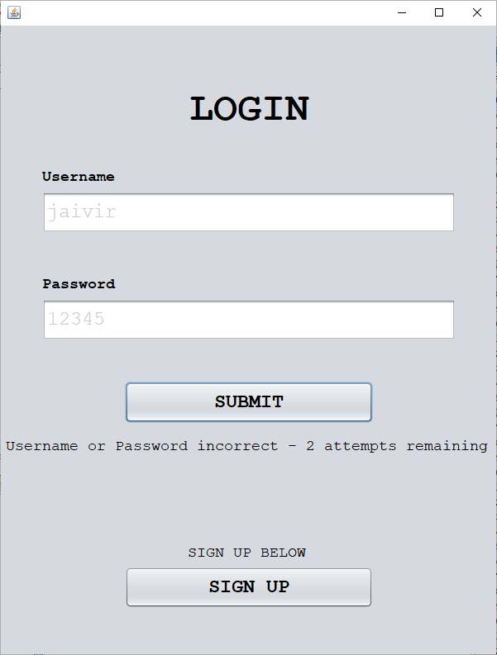

##### Test #6

|  |  |  |  |  |  |
| --- | --- | --- | --- | --- | --- |
| Test | Test description | Input | Expected outcome | Type of test | Passed Test? |
| 6 | Test for clicking the associated sign-up button | Button click with the intent to sign up | User is redirected to the sign-up page | Normal |  |

When the sign-up button is clicked, the user is not redirected to the sign-up form simply because it does not yet exist. Even though it does not exist yet, a dummy form should be created so that the code has functionality.

##### Test #7

|  |  |  |  |  |  |
| --- | --- | --- | --- | --- | --- |
| Test | Test description | Input | Expected outcome | Type of test | Passed Test? |
| 7 | Test for clicking into a text box | Button click onto a text box | The text hint should disappear once the user clicks onto the box for the first time | Normal |  |

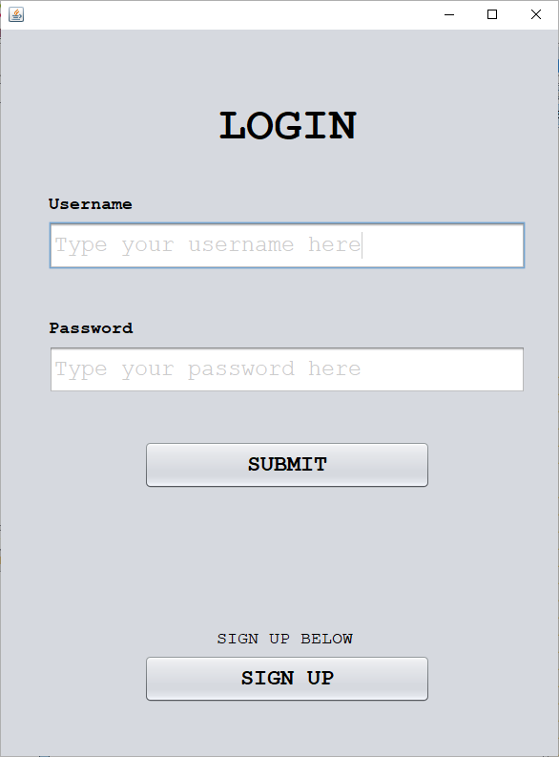

When clicking onto the text box, the cursor points to the end of the text as shown in the username text box above

The purpose of this cycle was to have a functional login form at the minimal level so that a base program can be developed before implementing extra quality of life features.

##### Test #8

|  |  |  |  |  |  |
| --- | --- | --- | --- | --- | --- |
| Test | Test description | Input | Expected outcome | Type of test | Passed Test? |
| 8 | Test for entering blank details | No input into the text box | The user should be told that either the username or password is blank, and an attempt is not used | Normal |  |

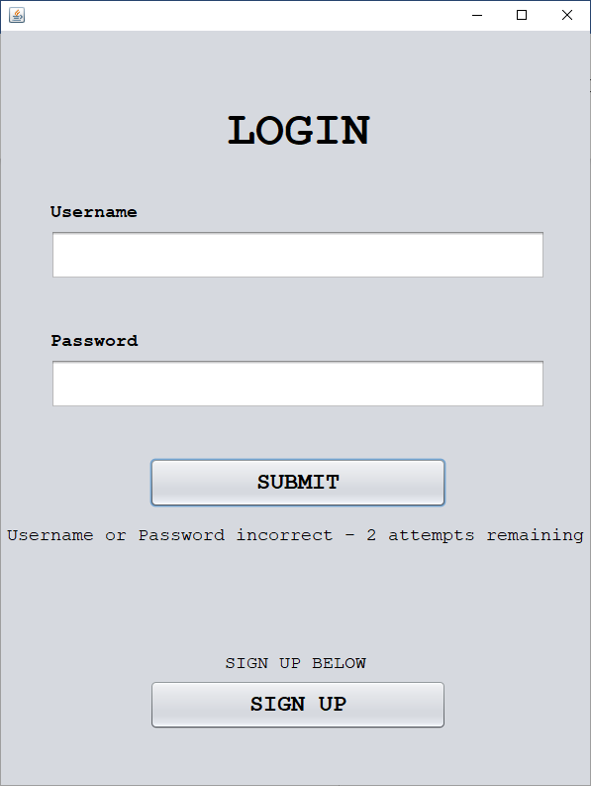

When the blank fields are entered, an attempt is used which should not be the case and this code must be altered to accommodate for blank fields. If either of the fields are blank, the program must detect this and not use an attempt whilst appropriately informing the user of the issue.

##### Test #9

|  |  |  |  |  |  |
| --- | --- | --- | --- | --- | --- |
| Test | Test description | Input | Expected outcome | Type of test | Passed Test? |
| 9 | Test for attempts correctly going down | Incorrect login details | User should be told they have an x number of attempts remaining. Maximum is 3 and once all are gone, the user is timed out for 30 seconds where the attempts are reset after the time is up | Normal |  |

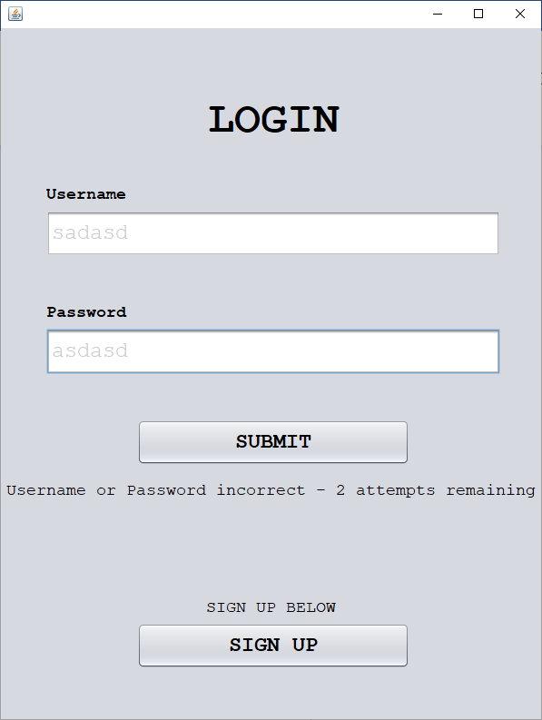

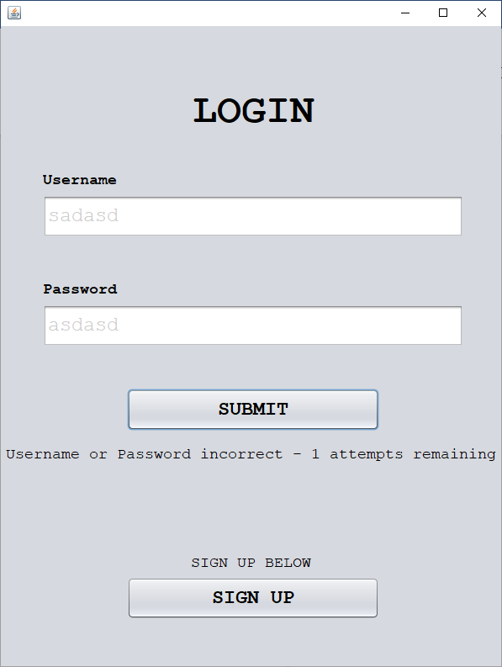

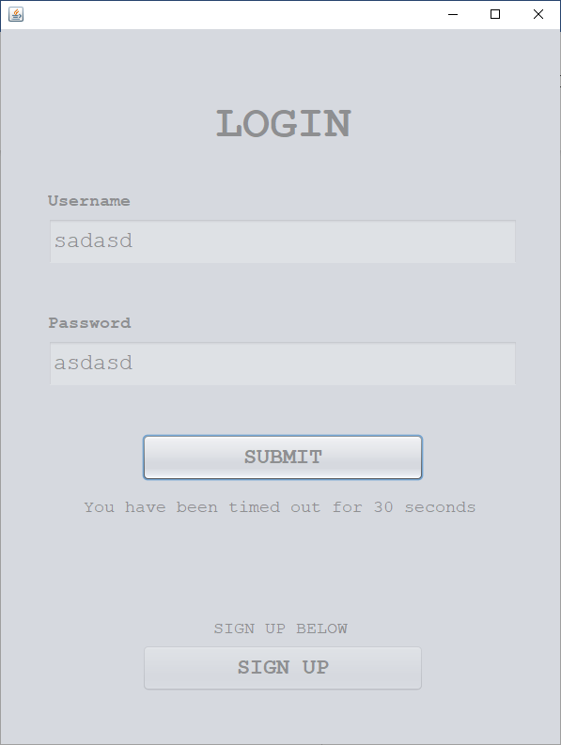

The program correctly times out on the third attempt

#### Errors & Fixes

##### Test #6 Fix

|  |  |  |  |  |  |
| --- | --- | --- | --- | --- | --- |
| Test | Test description | Input | Expected outcome | Type of test | Passed Test? |
| 6 | Test for clicking the associated sign-up button | Button click with the intent to sign up | User is redirected to the sign-up page | Normal |  |

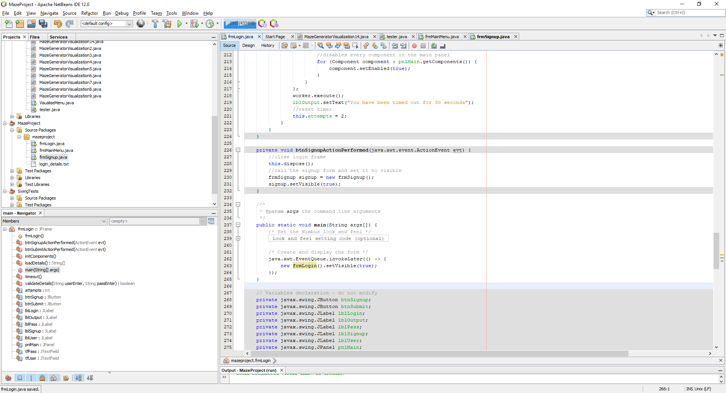

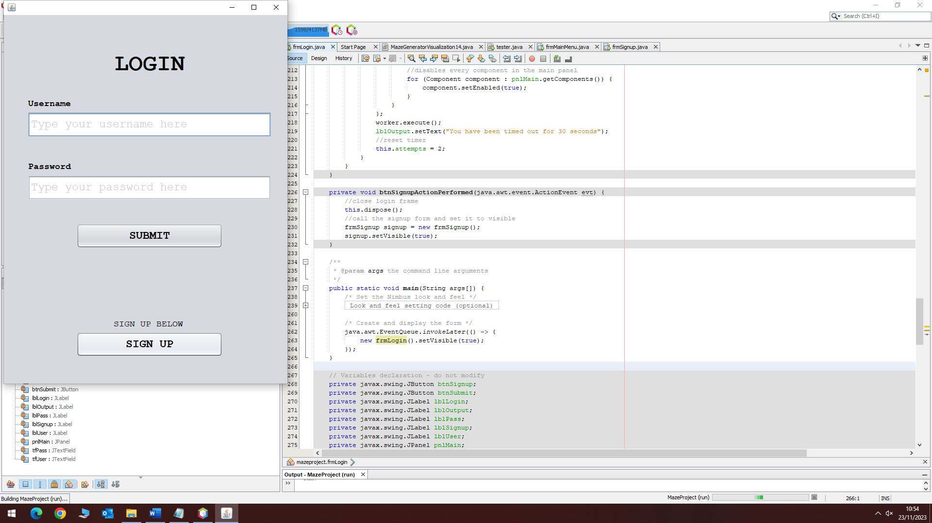

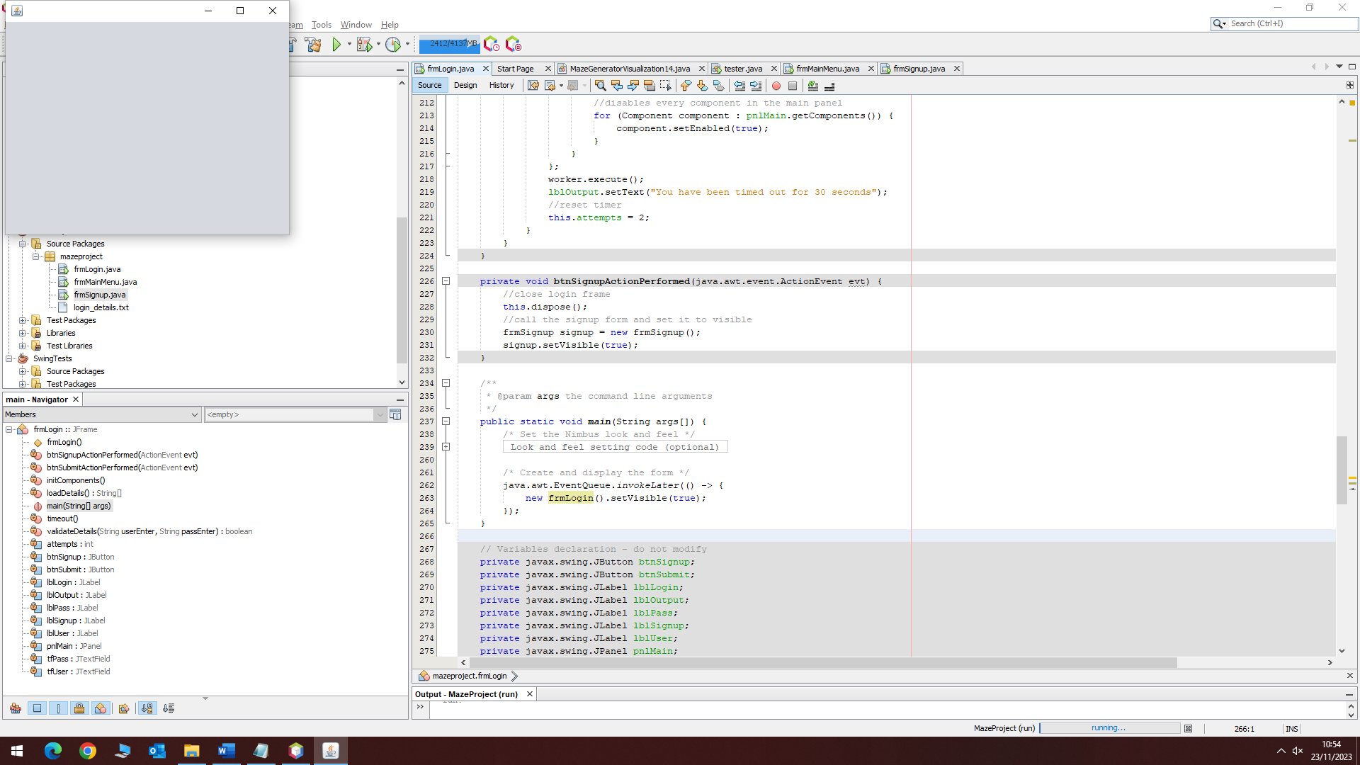

Now the code correctly displays a sign-up form when the sign-up button is clicked.

##### Test #8 Fix

|  |  |  |  |  |  |
| --- | --- | --- | --- | --- | --- |
| Test | Test description | Input | Expected outcome | Type of test | Passed Test? |
| 8 | Test for entering blank details | No input into the text box | The user should be told that either the username or password is blank, and an attempt is not used | Normal |  |

Validation must be implemented when passing through text that halts the selection process if blank data is detected.

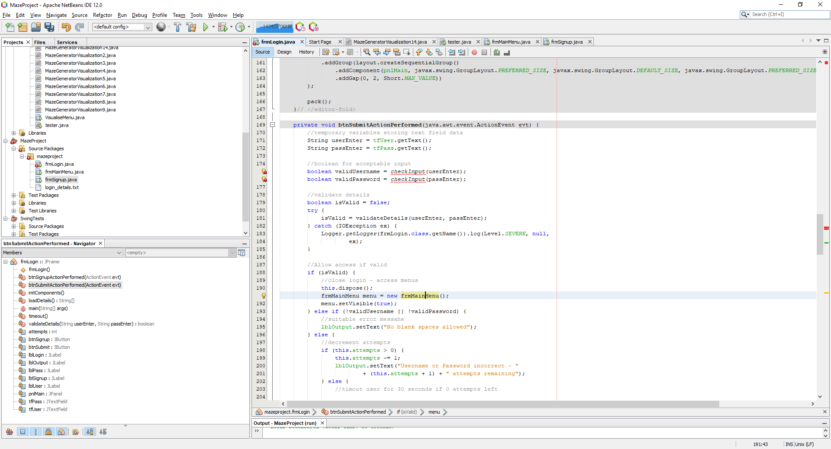

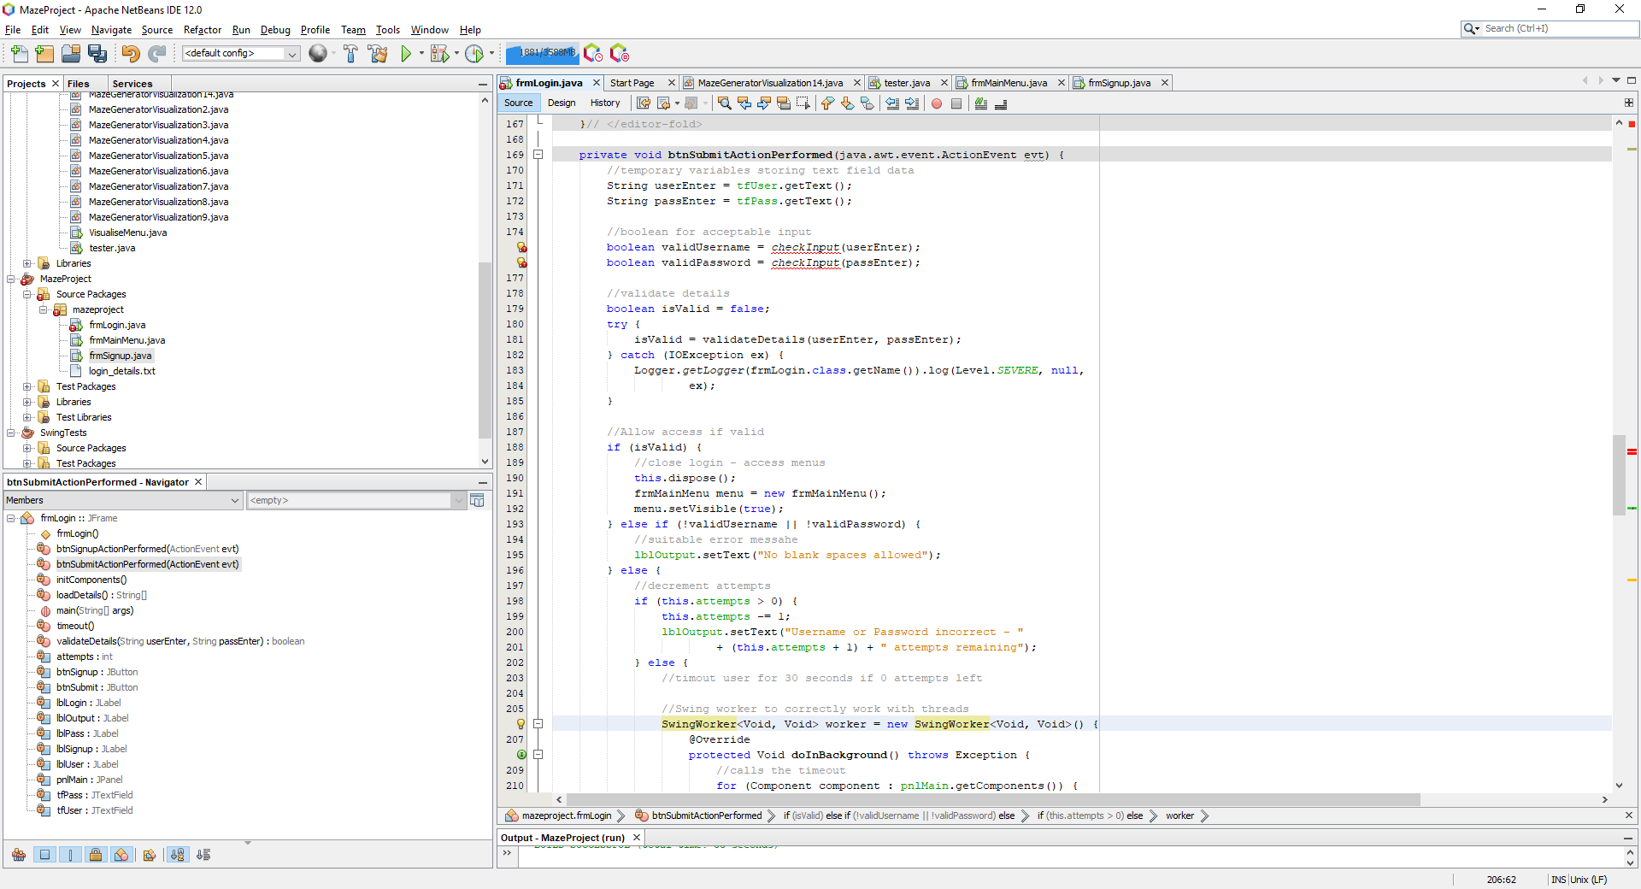

Now I have the blueprint for the code to work, I will develop the code to correctly validate the input.

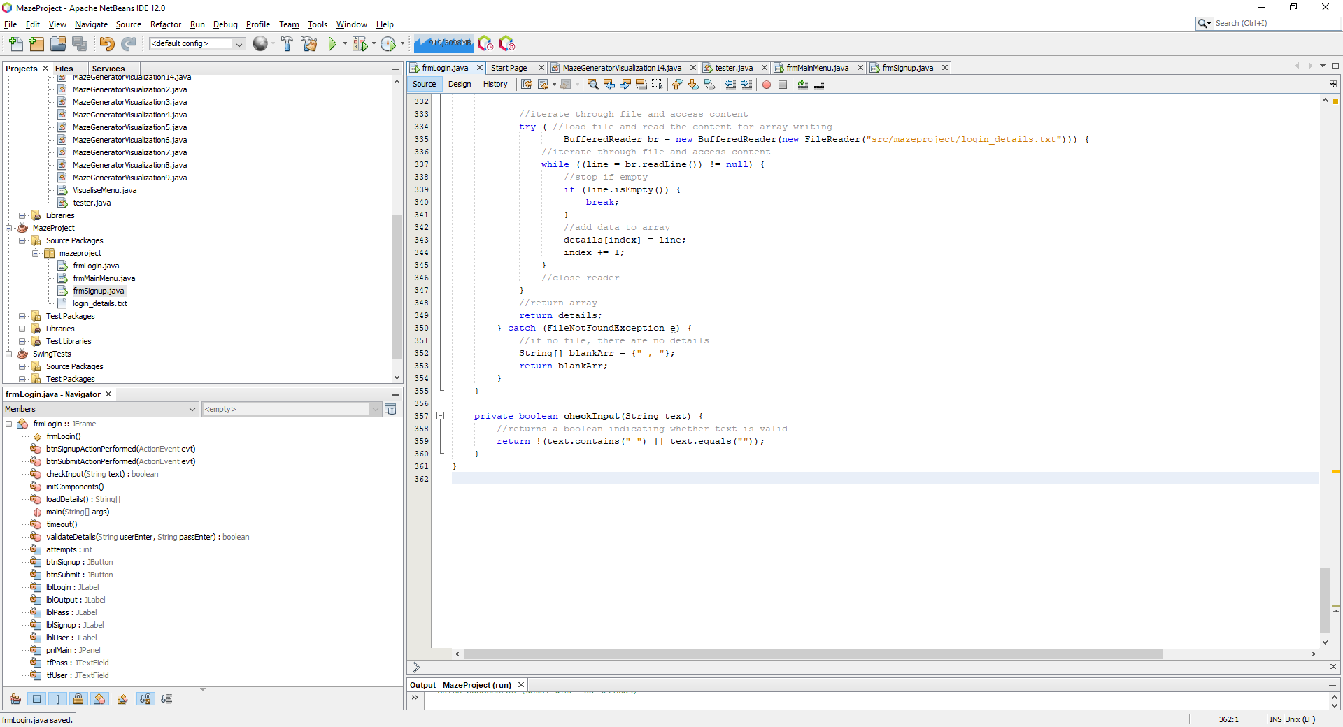

Now when entering blank input, the program correctly identifies the blank space and does not use an attempt.

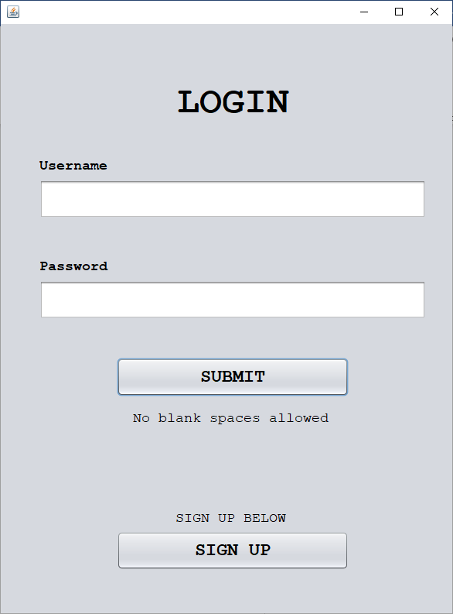

#### Conclusion

Ultimately, this **current** **prototype** of the login form represents a **significant starting point,** showing fundamental features and a smooth user interface. After extensive testing and improvement, the form can now be relied upon to **generate legal results** for any combination of inputs. Implementing appropriate validation methods and enforcing a three-attempt restriction before a timeout guarantees a **safe and intuitive** login procedure.

Although the current prototype is a great place to start, there's also a note that it will be **improved** much further in later development cycles. In the following cycle, the emphasis will be on creating a registration form, which will allow **further quality of life** features to be included into the product.

**Three errors** were identified during the development process, two of which were **successfully fixed**. In particular, the choice for delaying fixing **test #7's error**, the tip text on a text box, is to give this prototype's essential features priority. Future cycles of development will integrate this feature and other quality-of-life improvements into the finished product.

The primary focus is on **continuous improvement** and only implementing essential features in reference to the what the cycle intends to achieve. The integration of new features and a balance between the login and register forms, as the project develops, will result in a **reliable authentication system**.

## Cycle 3 – Register Form GUI

### Design

#### Decomposition & Overview

The alternative option for users is the register section where users can sign up to create **details** that are registered by the system. The layout would consist of a **username**, password and **confirm password** text field. The first function to be created should be the validation where users should have a unique username and a password that is at least 8 characters in length, contains at least **1 special character** and at least **one number**. In addition to this, after the validation process passes, the confirmed password should then be compared to the original password.

Upon registering, a recovery code is generated which can then be used to recover/ change any password on the system. This generated **code will be of length 12** of a random mixture of letters and numbers. This creates an extra layer of security and can be used as a form of verification as opposed to email or **SMS** authentication.

After developing the main body and functionality of the register frames, the design prototype from cycle 1 will be applied to boost aesthetics and apply the **usability features** previously discussed.

#### Validation

The registration form will have a **more rigorous validation** scheme as it is vital that correct and valid details are stored onto the system. The details must pass all these conditions:

* Username is unique.
* Password is at least 8 characters in length.
* Password contains at least one special character.
* Password contains at least one number.
* The password and confirmed password must both be equal.

As well as these **static forms of validation**, a dynamic idle validation will be applied through an action listener that monitors character input. This updates any values as a character is input onto the screen so that live feedback on the format is displayed.

#### Pseudocode

procedure btnSubmit()

//get text box values

userEnter = ""

passEnter = ""

passConfirm = ""

userEnter = tfUser.getText()

passEnter = tfPass.getText()

passConfirm = tfPass.getText()

//call validate functions

isUniqueUser = checkUniqueUser(userEnter)

isUserFormat = checkUserFormat(UserEnter)

isPassFormat = checkPassFormat(passEnter)

isPassEqual = checkEqual(passEnter, passConfirm)

//hierarchy of validation

if isUniqueUser then

if isUserFormat then

if isPassEqual then

if isPassFormat then

//write details to file

writeToFile(userEnter + "," + passEnter + "\n")

//output success and return to main menu

tfOutput.setText("Successfully registerd!")

FrmRegister.close()

FrmLogin logn = new FrmLogin()

else

//output

tfOutput.setText("Passwords are not correctly formatted!")

endif

else

//output

tfOutput.setText("Passwords not equal!")

endif

else

//output

tfOutput.setText("Username of incorrect format!")

endif

else

//output

tfOutput.setText("Username already taken!")

endif

endProcedure

//vailidate username

function checkUniqueUser(user)

//load all details

details = loadDetails()

for i=0 to storedDetails.length

//split details into user AND password

splits = storedDetails[i].split(",")

//compare stored values

if (user == splits[0]) then

//returns false if username in array

return false

endif

next i

//returns true if not in array

return true

endfunction

function checkUserFormat(username)

//converts username to lowercase

username = username.toLower()

//check at least 5 char

if (username.length() < 5 then

return false

for i=0 to username.length()-1

if (NOT username[i].isDigit() OR asc(username[i])<97 OR asc(username[i])>122) then

return false

endif

next i

//return true if end reached

return true

endfunction

function checkPassFormat(pass)

//track booleans

special = false

number = false

//password must be 8 in length

if pass.length()<8 then

return false

endif

//check for special char and number

for i=0 to pass()-1

if pass[i].isSpecial() then

special = true

else if pass[i].isDigit() then

number = true

endif

next i

//if password contains both special AND num

if number AND special then

return true

return false

endfunction

function checkEqual(str1, str2)

//check equal

return str1 == str2

endfunction

function loadDetails()

//open file in read mode

myFile = openRead("login_details.txt")

lineNum = 0

//get number of lines

while NOT myFile.endOfFile()

lineNum = lineNum + 1

endwhile

//store all lines in an array

array details[lineNum]

index = 0

while NOT myFile.endOfFile()

details[index] = myFile.readLine()

index = index + 1

endwhile

return details

endfunction

procedure writeToFile(str)

//open file in write mode

myFile = openWrite("login_details.txt")

//write to and close file

myFile.write(str)

myFile.close()

endprocedure

#### Variable Table

|  |  |  |
| --- | --- | --- |
| Key Variables | Data Type | Justification |
| userEnter | String | This is the temporary variable within a button function that fetches the string from the user text box and stores the username. |
| passEnter | String | This is the temporary variable within a button function that fetches the string from the user text box and stores the password. |
| isUniqueUser | Boolean | This holds a Boolean value that determines whether the username is unique. |
| isUserFormat | Boolean | This Boolean determines if the username is of correct format – holds the returned value from a validation function. |
| isPassFormat | Boolean | Holds a Boolean value needed for assessing password format. |
| isPassEqual | Boolean | Boolean value that signifies whether the 2 input passwords are equal. |
| passConfirm | String | This is the string fetched from the text box that asks the user to confirm the previously entered password |
| special | Boolean | Boolean indicating whether the password contains a special character. This variable has a local scope specific to the validate password function |
| number | Boolean | Boolean indicating whether the password contains a number. This variable has a local scope specific to the validate password function |
| storedDetails | Array | All comma separated details are stored in this array with a new index representing a new login/ line in the external file. |
| splits | Array | A sub array of stored details that temporarily stores the split values from a certain index in the array. These splits contain values such as username and password. This is needed so that the program can correctly distinguish between the username and login from the text file. |
| myFile | File | This is the file that has all login details stored. This file is read from in the login stage. In the registration section, the file is written to and read from. |

#### Test Table

|  |  |  |  |  |
| --- | --- | --- | --- | --- |
| Test | Test description | Input | Expected outcome | Test type |
| 1 | Test for entering a username that contains characters other than letters or numbers | Invalid username with characters other than letters or numbers | The user is told that the username must only contain letters and numbers and is not allowed to register | Erroneous |
| 2 | Test for entering a username that contains only letters but is not unique | A valid username that has already been registered | User is informed that the username is taken, and the account cannot be created | Normal |
| 3 | Test for entering a username that isn’t in the accepted length range | Username with a length of less than 4 letters | User is told that the username must be inclusively between 4 and 10 characters. | Boundary |
| Username with a length of more than 10 characters |
| 4 | Test for a password that isn’t at least 8 characters | Password with a length less than 8 characters | Password is not accepted, and the user should be told the password must be at least 8 characters in length | Boundary |
| 5 | Test for a password that does not have at least one special character | Password not containing any special characters | Password is not accepted, and the user is told that the password should contain at least one special character | Erroneous |
| 6 | Test for a password that does not have at least one number | Password not containing any numbers | Password is not accepted; user is informed that there should be at least one number within the password | Erroneous |
| 7 | Test for entering a correctly formatted first password but a different confirmed password | Formatted correct password, incorrect confirmed password | User is told before submission that the two passwords are not matching and should not be allowed access | Erroneous |
| 8 | Test for entering an incorrectly formatted first password and a different confirmed password | Incorrectly formatted password and non-matching passwords. | User should only be told that the password is of incorrect format before any other warning, so this is what is corrected first | Erroneous |
| 9 | Test the input of a correctly formatted password and a correctly confirmed password, non-unique username | Correctly formatted password and correct confirmed password, non-unique username | User can not submit their details and is notified once again that their password should be unique | Erroneous |

#### Usability Features

Layout

The layout will be comprised of a username, password and confirm password text box in that order as this is the most logical approach to signing up to a program. There will be a button to return to the login menu if the user wishes to login rather than sign up – this can be due to accidental clicks.

Style

Following the theme, the user will be presented with large, readable text of font Courier New and there will be no ambiguity between the style and function. Each will have their own respective purpose independent of each other.

#### Validation

The register form has the biggest validation proportions within the entire product as **all** input is validated to **ensure only legal data** is allowed onto the system. The username will be format checked – only numbers and letters are allowed and then it is checked if it is unique. Similarly with the password, it will first be format checked to a stricter standard. The password must be at least **8 characters** in length, contain a **special** character and at least one **number**. After passing these checks, the password is then compared to the confirmed password as a final check. Only after passing these validation checks will the user be able to log on with the registered details.

### Coding and Testing

#### Iterative Development and Testing

##### Prototype #1

Much like the login phase, I must start with a single form that has no current functionality to work around:

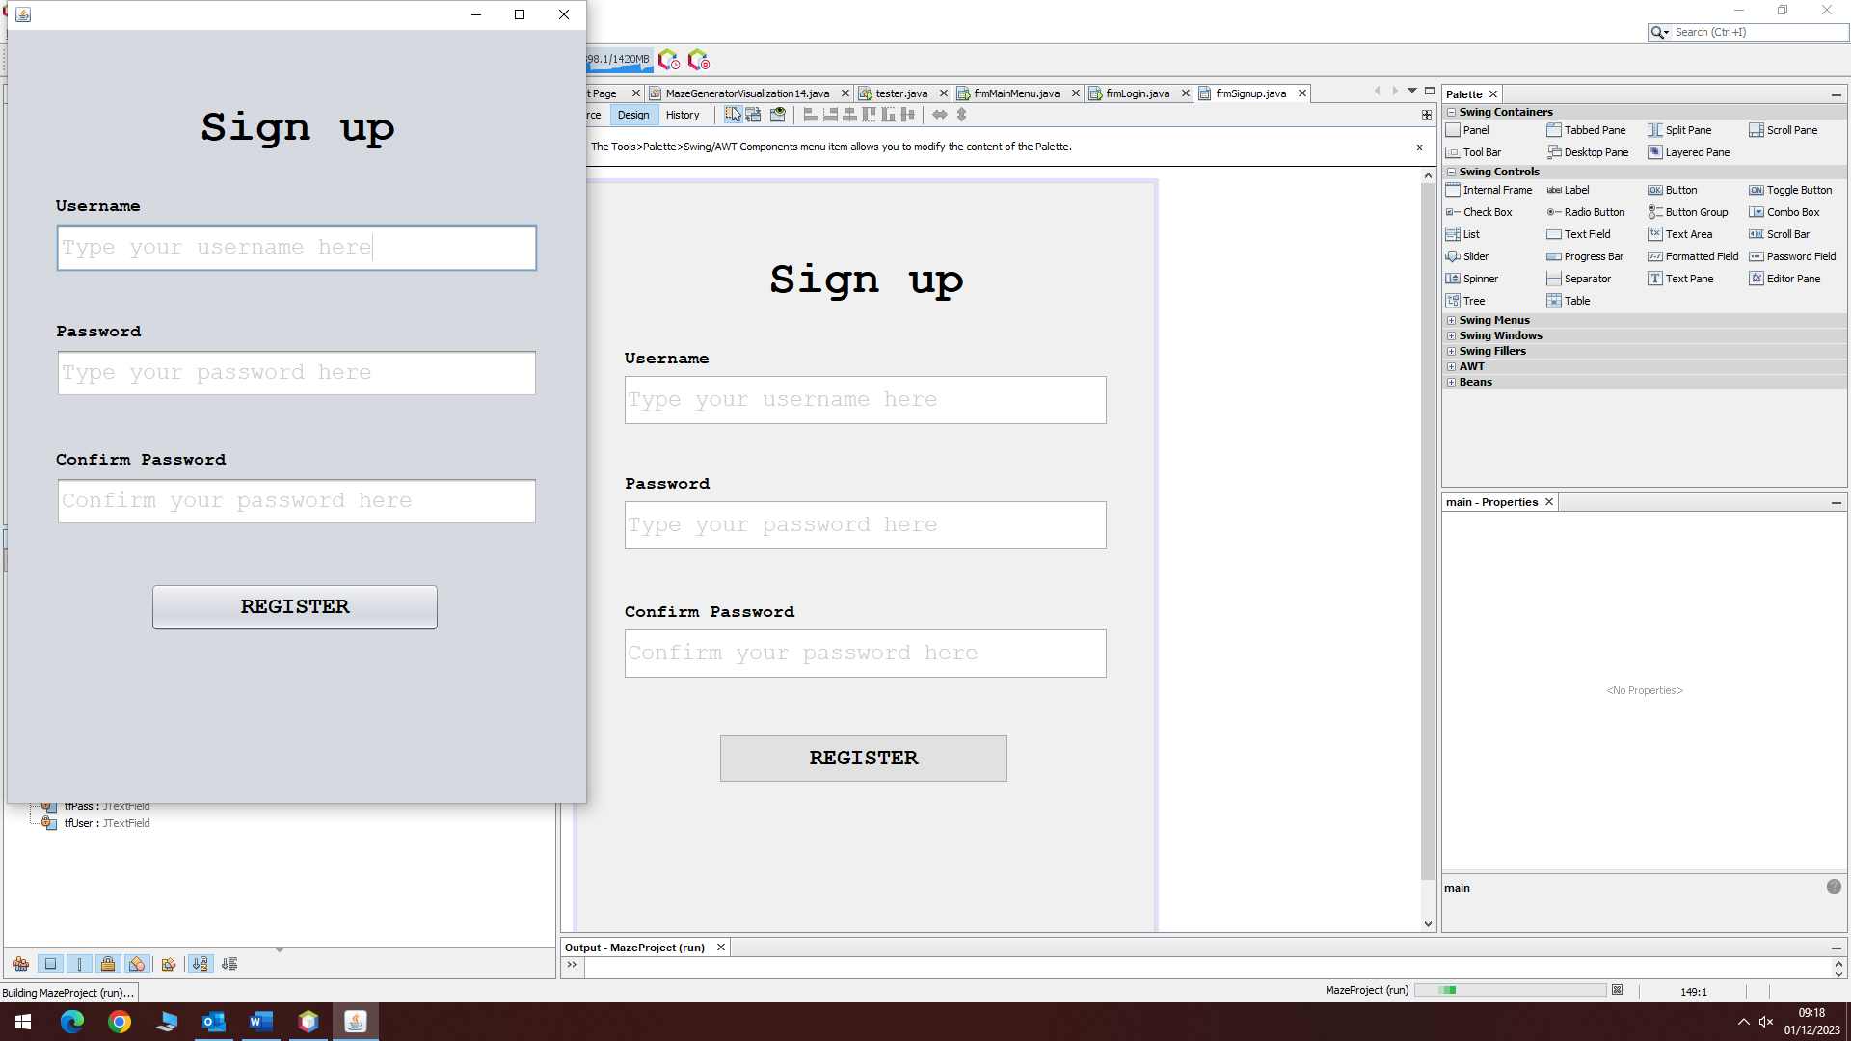

Currently, there is no button to return to the login page, but this will be added within a later prototype. This prototype has all the text boxes needed without the final graphics. A working prototype is needed before graphics are developed.

##### Prototype #2

Developing the btnRegister function blueprint

Following the planned psuedocode, I will write the outline of the function that handles the registered button clicks. The functions that are yet to be coded will be written after the main outline has been developed. This button will validate the input details and only allow correctly formatted, secure data onto the system.

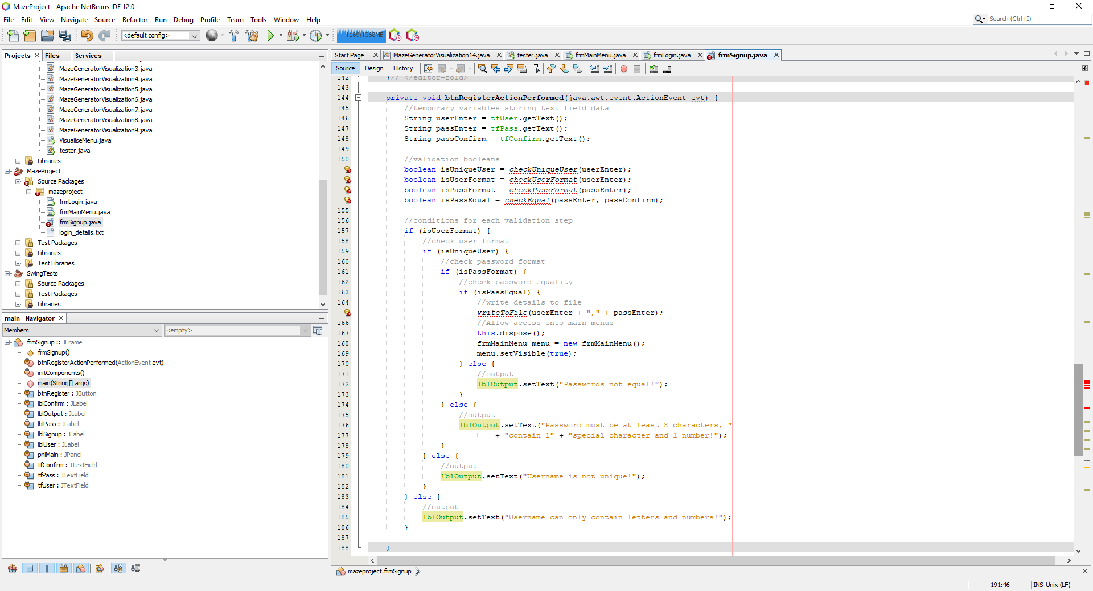

Now that I have developed the blueprint for the register button with all the associated validation, I can focus on implementing the functions that have not been written yet. I have re organised the order of the selection where I first check the format as a password will never need to be unique if it is not correctly formatted first. This is also the same for password as there is no need to check if the passwords are equal if the first one is not correctly formatted yet.

Developing the check unique user function

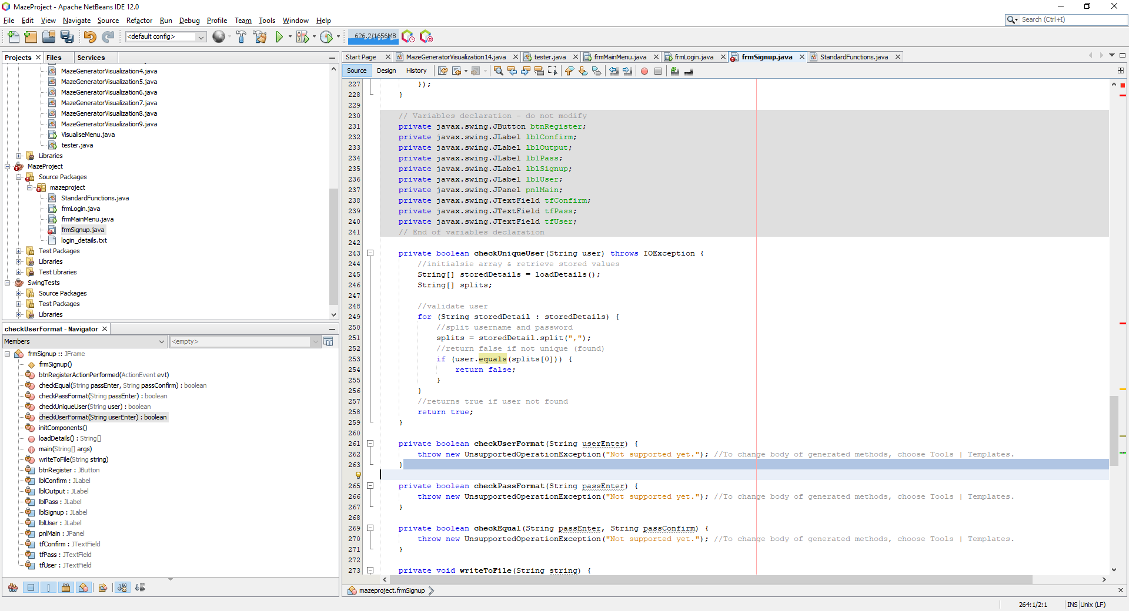

Here the loadDetails function is currently just a a copy and paste function from my login class. In a future cycle, to promote modularity, I will separate this into a class so the code can be reused to call the login details.

Developing check user format

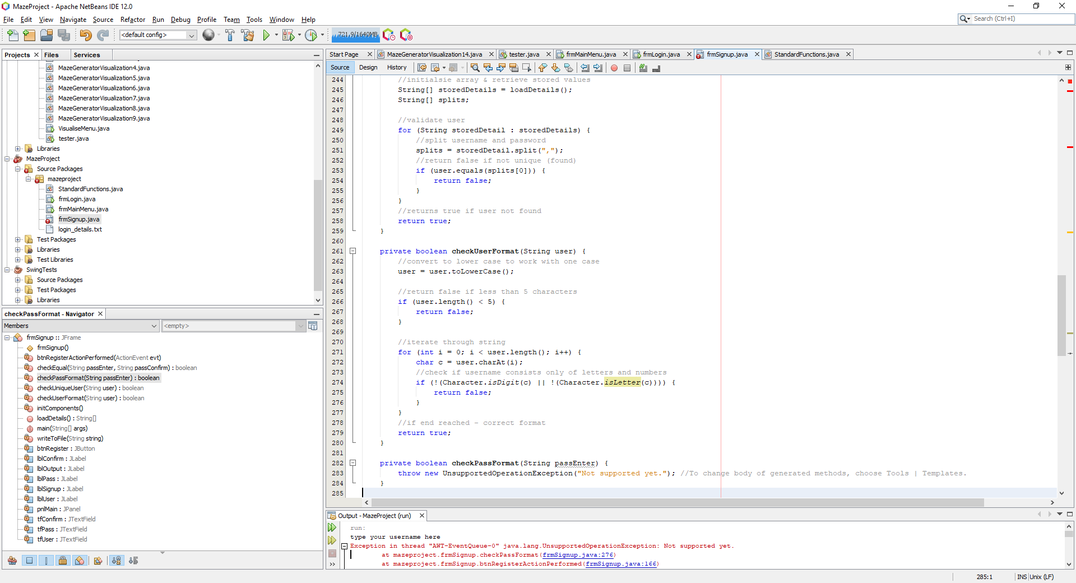

To pass a format check, the username must only be letters or numbers and be 5 characters in length. After implementing the code above, I must test if this section actually functions correctly:

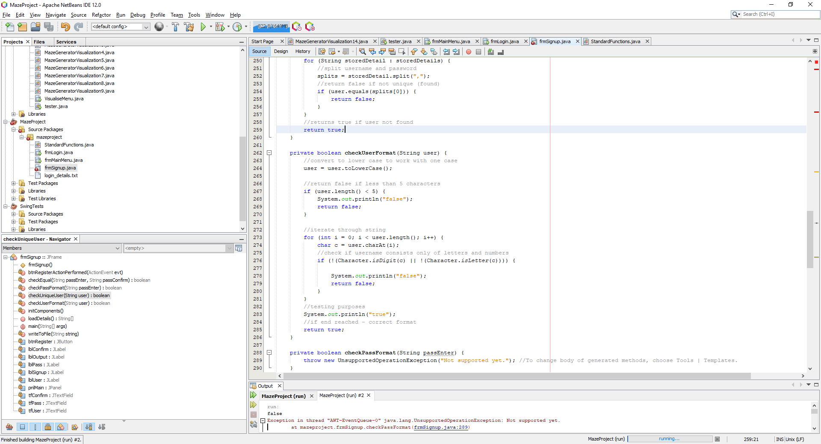

Here, I will simply print true if the password is correctly formatted and false on any case where there is incorrect format. I will input jaivir123 and the console should print out true.

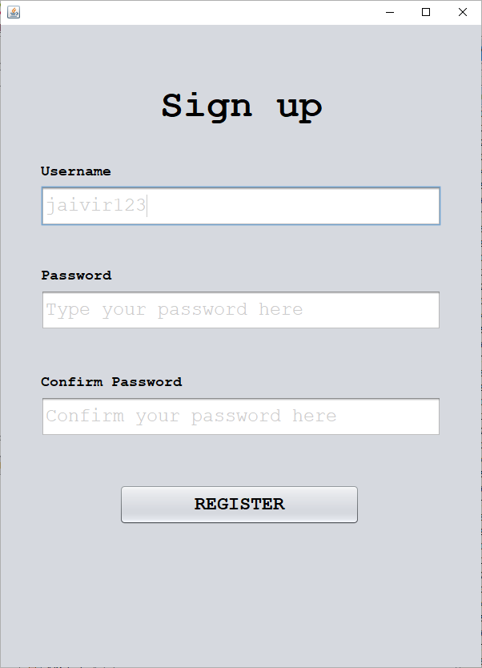

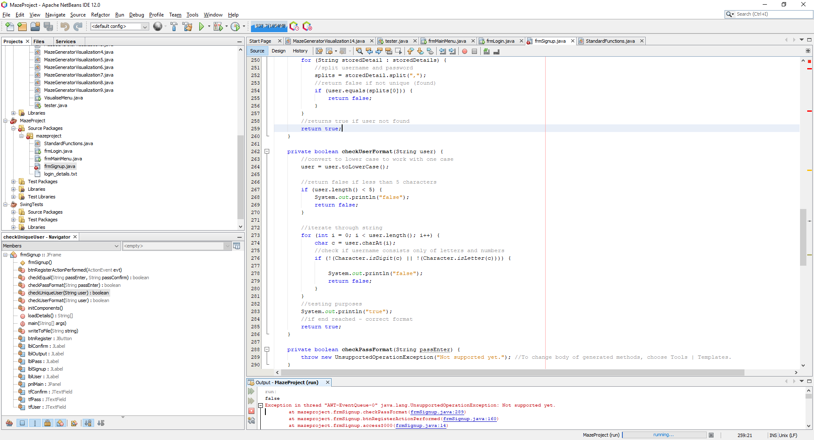

Here the output is false so there must be an error in logic within my format check function.

Identifying the error, the problem is within the line that checks for digits and characters. On line 276, the logic says **not character and not digit** – this is **wrong**. It should be not(character or digit) to correctly include all cases:

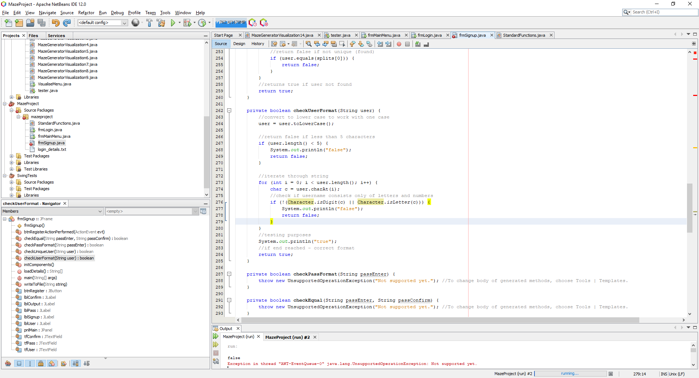

Now when inputting the details, the program correctly identifies correct format.



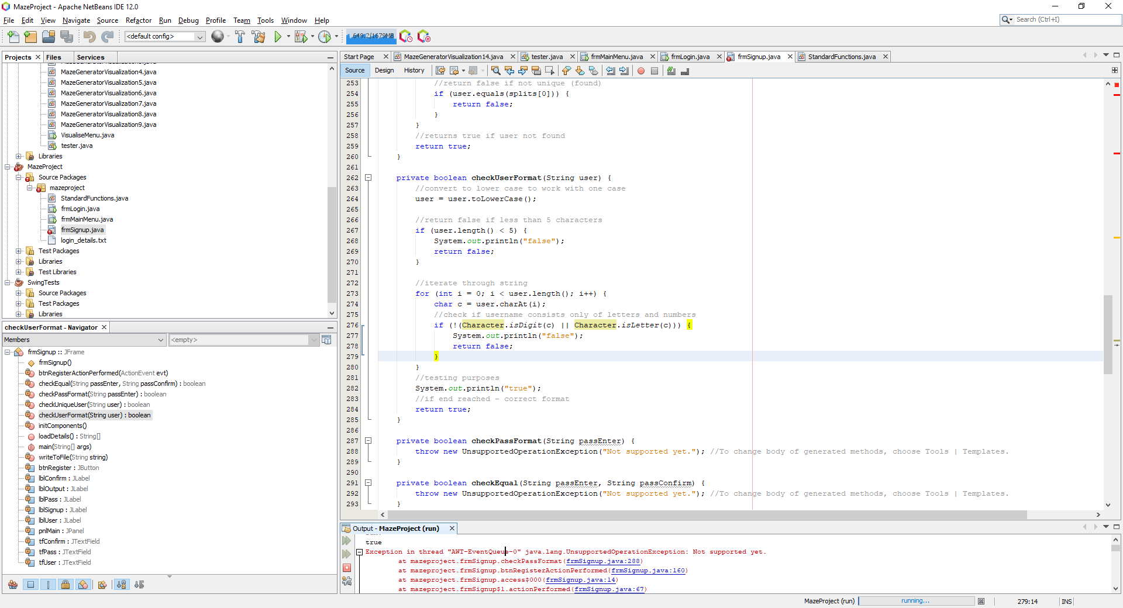

The unsupported error is only a placeholder for the code that has not been implemented yet for password validation

Now I should test incorrect input:

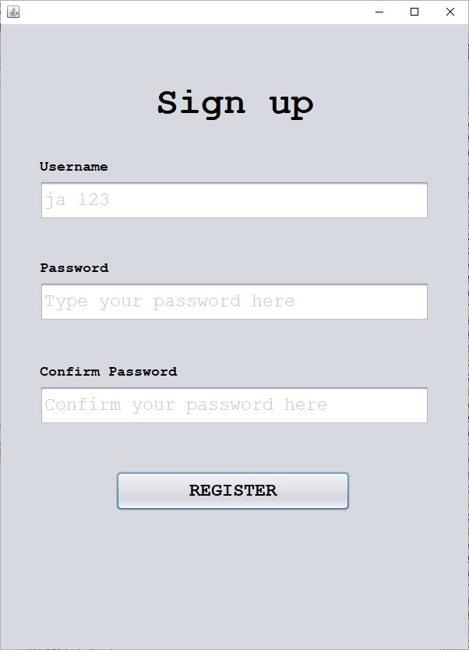

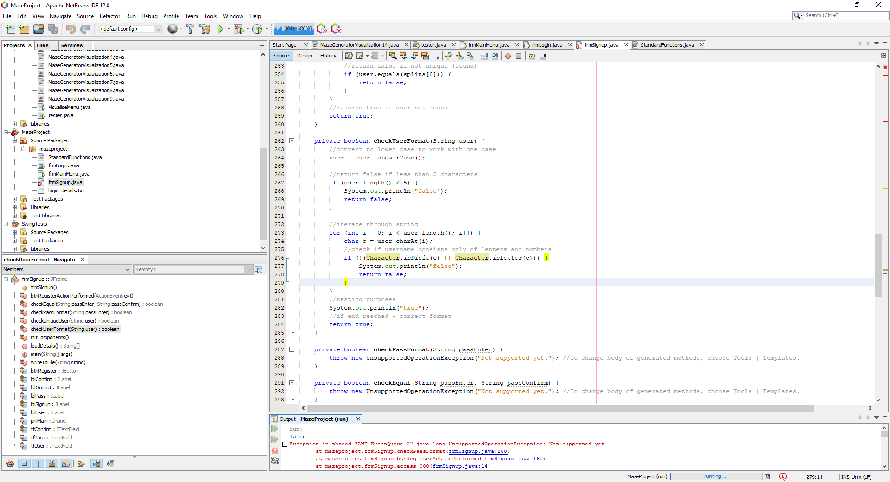

The program now correctly works and identifies usernames that are correctly formatted as well as being unique (from the previous function)

Developing the password format check

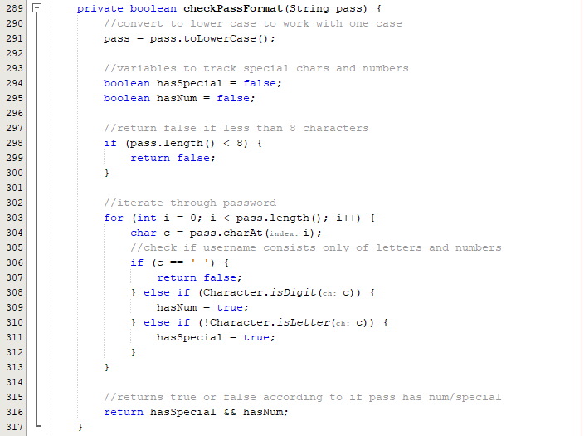

This function is similar to the check user format except there are additional constraints added to make sure acceptable passwords are submitted onto the application. Now its time to test formatted passwords – for testing purposes I will add console commands:



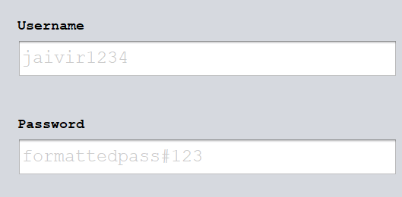

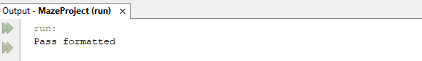

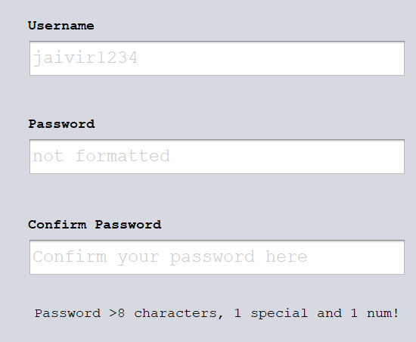

Here we can see the program correctly identifies whether a password is formatted correctly or incorrectly.

Developing the check passwords are equal function.



This simple fucntion simply returns whether the two text box values are equal

##### Protoype #3

Now that all the validation functions have been developed – we can move onto a new protoype that starts writing correct data to the file and adds a button to return to login

Developing the write to file function.

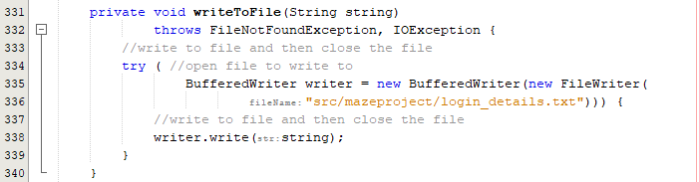

Here the function handles the errors and opens the file in write mode to add a passed string.

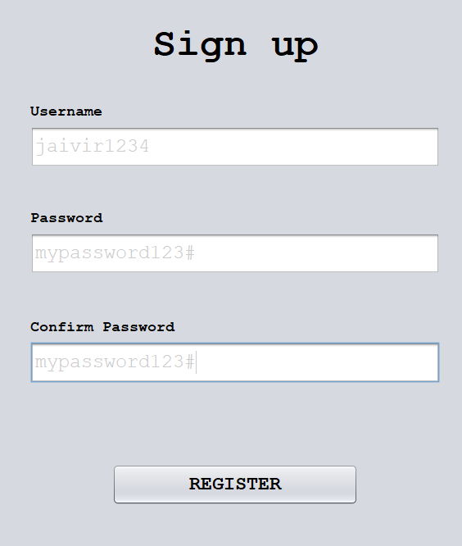

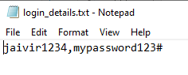

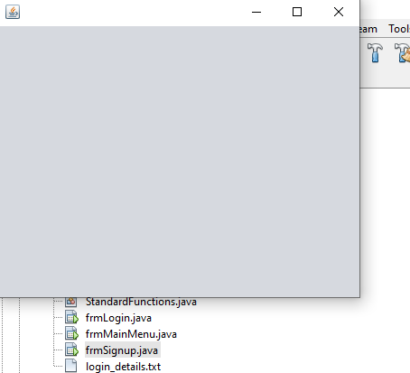

The password and username is correctly written to the file and the main menu (a dummy form) is opened.

However doing this overrides the file instead of appending a new password onto the end.

Fixing the write to file function error.

The problem was not indicating the file writer is opened in append mode – a fix is to pass the boolean true through the parameters as shown in the screenshot below:

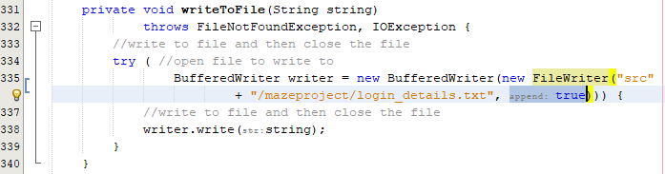

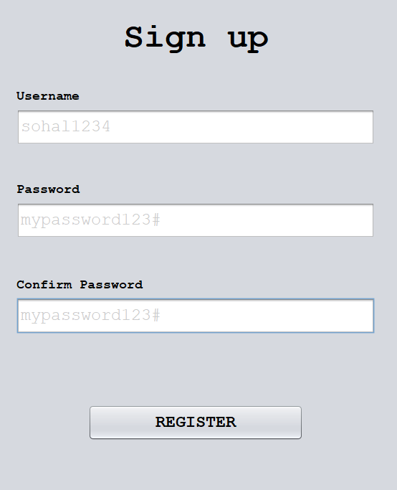

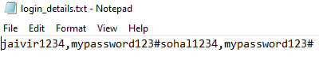

Now the file writes in append mode but there is an error where the program is not writing the text onto a new line

Fixing the new line error.



This is a simple fix and now the code writes to new lines. Using new input, we can see the appended text is now on a new line:

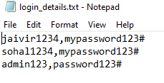

Developing the return to login button.

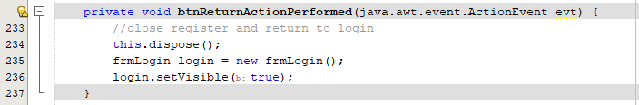

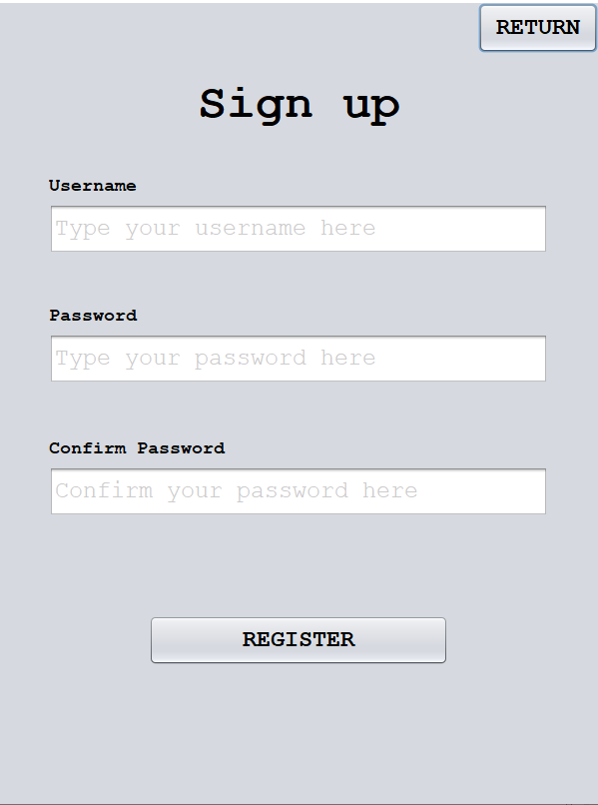

This button addition now allows the user to switch between the login menu and the sign up menu indefinitely.

#### Final Cycle Code

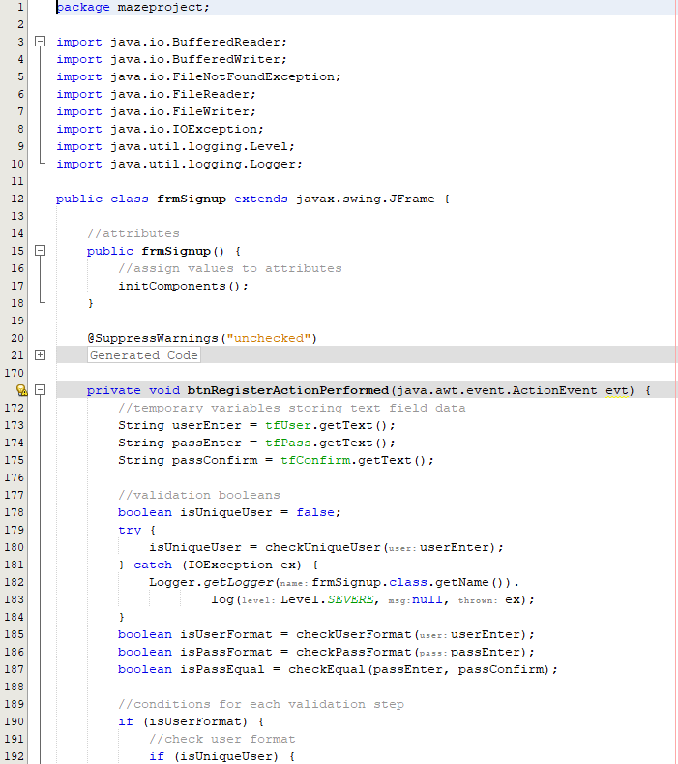

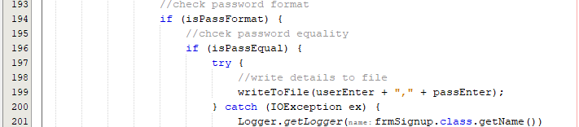

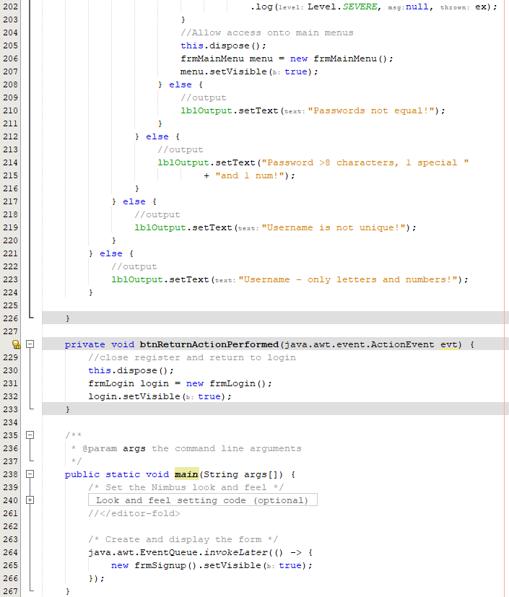

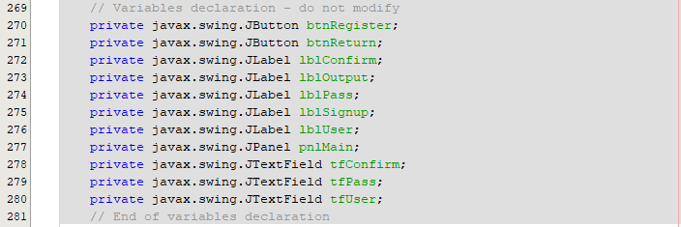

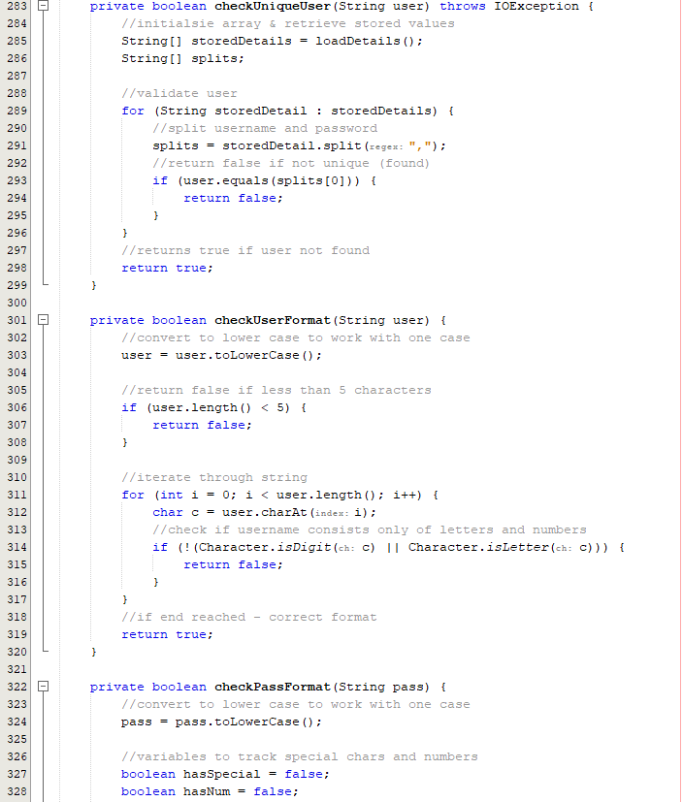

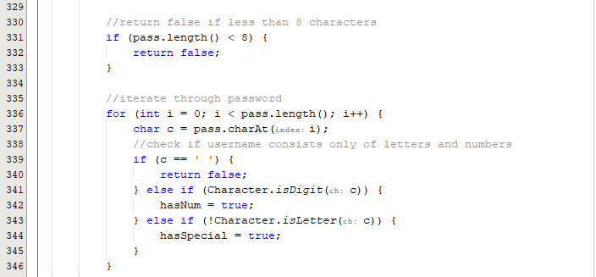

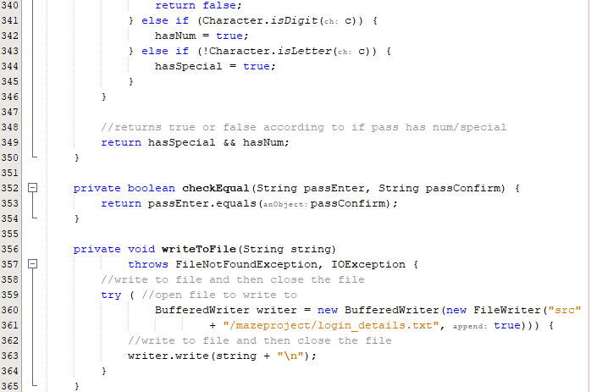

### Review

#### Final testing

|  |  |  |  |  |  |
| --- | --- | --- | --- | --- | --- |
| Test | Test description | Input | Expected outcome | Type of Test | Passed test? |
| 1 | Test for entering a username that contains characters other than letters or numbers | Invalid username with characters other than letters or numbers | The user is told that the username must only contain letters and numbers and is not allowed to register | Erroneous |  |
| 2 | Test for entering a username that contains only letters but is not unique | A valid username that has already been registered | User is informed that the username is taken, and the account cannot be created | Normal |  |
| 3 | Test for entering a username that isn’t in the accepted length range | Username with a length of less than 4 letters | User is told that the username must be inclusively between 4 and 10 characters. | Boundary |  |
| Username with a length of more than 10 characters |
| 4 | Test for a password that isn’t at least 8 characters | Password with a length less than 8 characters | Password is not accepted, and the user should be told the password must be at least 8 characters in length | Boundary |  |
| 5 | Test for a password that does not have at least one special character | Password not containing any special characters | Password is not accepted, and the user is told that the password should contain at least one special character | Erroneous |  |
| 6 | Test for a password that does not have at least one number | Password not containing any numbers | Password is not accepted; user is informed that there should be at least one number within the password | Erroneous |  |
| 7 | Test for entering a correctly formatted first password but a different confirmed password | Formatted correct password, incorrect confirmed password | User is told before submission that the two passwords are not matching and should not be allowed access | Erroneous |  |
| 8 | Test for entering an incorrectly formatted first password and a different confirmed password | Incorrectly formatted password and non-matching passwords. | User should only be told that the password is of incorrect format before any other warning, so this is what is corrected first | Erroneous |  |
| 9 | Test the input of a correctly formatted password and a correctly confirmed password, non-unique username | Correctly formatted password and correct confirmed password, non-unique username | User can not submit their details and is notified once again that their password should be unique | Erroneous |  |

##### Test #1

|  |  |  |  |  |  |
| --- | --- | --- | --- | --- | --- |
| Test | Test description | Input | Expected outcome | Type of Test | Passed test? |
| 1 | Test for entering a username that contains characters other than letters or numbers | Invalid username with characters other than letters or numbers | The user is told that the username must only contain letters and numbers and is not allowed to register | Erroneous |  |

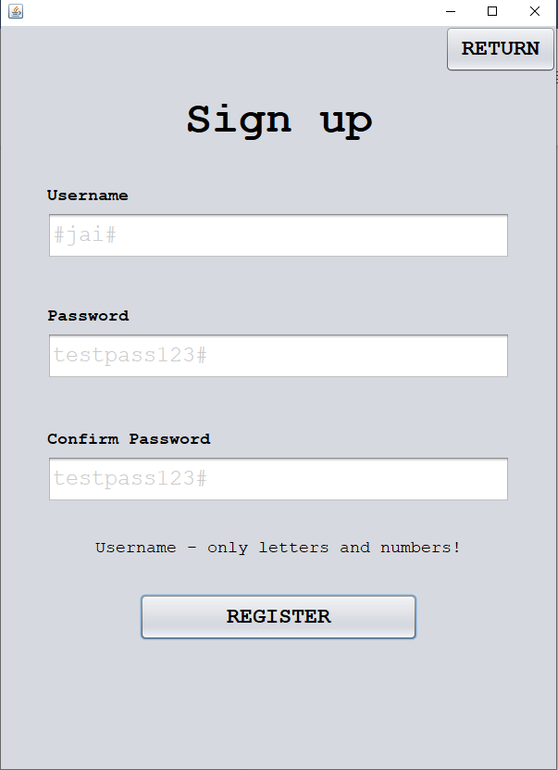

##### Test #2

|  |  |  |  |  |  |
| --- | --- | --- | --- | --- | --- |
| Test | Test description | Input | Expected outcome | Type of Test | Passed test? |
| 2 | Test for entering a username that contains only letters but is not unique | A valid username that has already been registered | User is informed that the username is taken, and the account cannot be created | Normal |  |

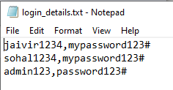

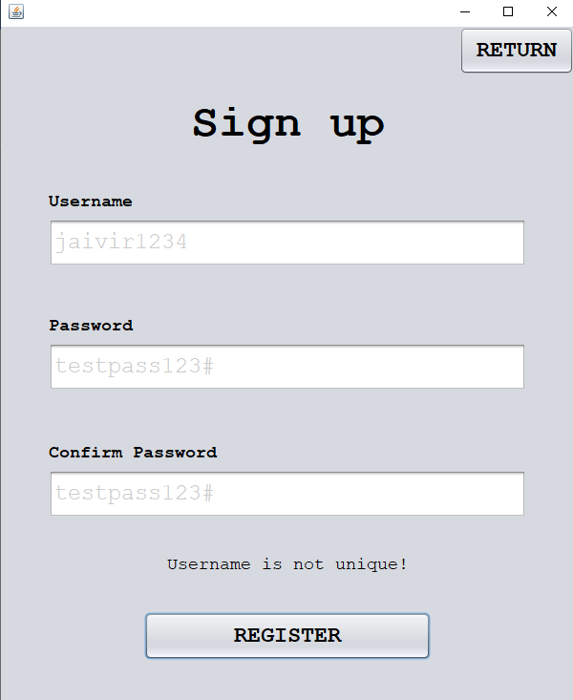

##### Test #3

|  |  |  |  |  |  |
| --- | --- | --- | --- | --- | --- |
| Test | Test description | Input | Expected outcome | Type of Test | Passed test? |
| 3 | Test for entering a username that isn’t in the accepted length range | Username with a length of less than 4 letters | User is told that the username must be inclusively between 4 and 10 characters. | Boundary |  |
| Username with a length of more than 10 characters |

Test for less than 4 characters:

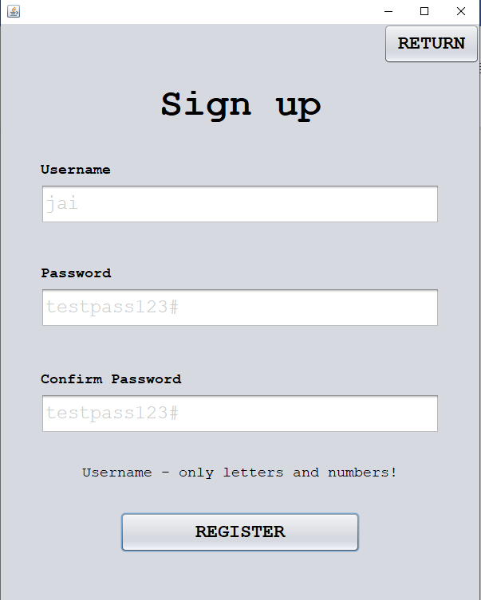

The user is not told that the username is less than 4 characters, and this is a failed test as the user must be informed of the error.

Testing for more than 10 characters:

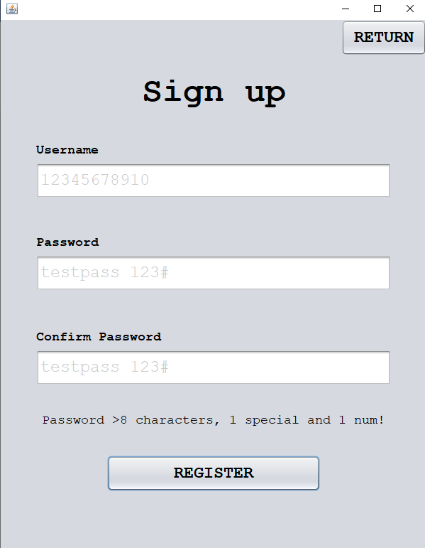

There is currently no detection for more than 10 characters therefore the input is allowed therefore going further into the nested if statements where the password is assessed. This is a failed test as a username of length greater than 10 should not pass validation.

##### Test #4

|  |  |  |  |  |  |
| --- | --- | --- | --- | --- | --- |
| Test | Test description | Input | Expected outcome | Type of Test | Passed test? |
| 4 | Test for a password that isn’t at least 8 characters | Password with a length less than 8 characters | Password is not accepted, and the user should be told the password must be at least 8 characters in length | Boundary |  |

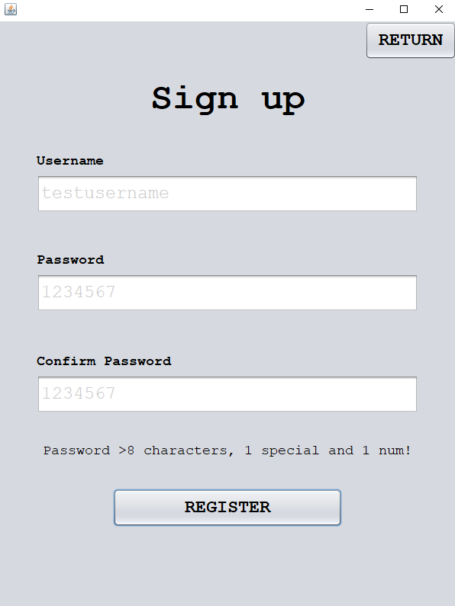

The prototype correctly does not validate a password that does not have a length greater than 8.

##### Test #5

|  |  |  |  |  |  |
| --- | --- | --- | --- | --- | --- |
| Test | Test description | Input | Expected outcome | Type of Test | Passed test? |
| 5 | Test for a password that does not have at least one special character | Password not containing any special characters | Password is not accepted, and the user is told that the password should contain at least one special character | Erroneous |  |

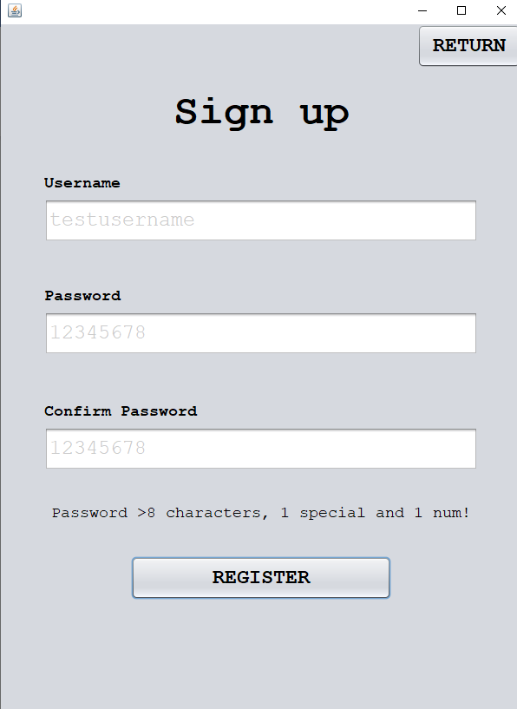

Here we can see the password is 8 characters in length but does not have any special characters and therefore does not pass validation leading to a successful test.

##### Test #6

|  |  |  |  |  |  |
| --- | --- | --- | --- | --- | --- |
| Test | Test description | Input | Expected outcome | Type of Test | Passed test? |
| 6 | Test for a password that does not have at least one number | Password not containing any numbers | Password is not accepted; user is informed that there should be at least one number within the password | Erroneous |  |

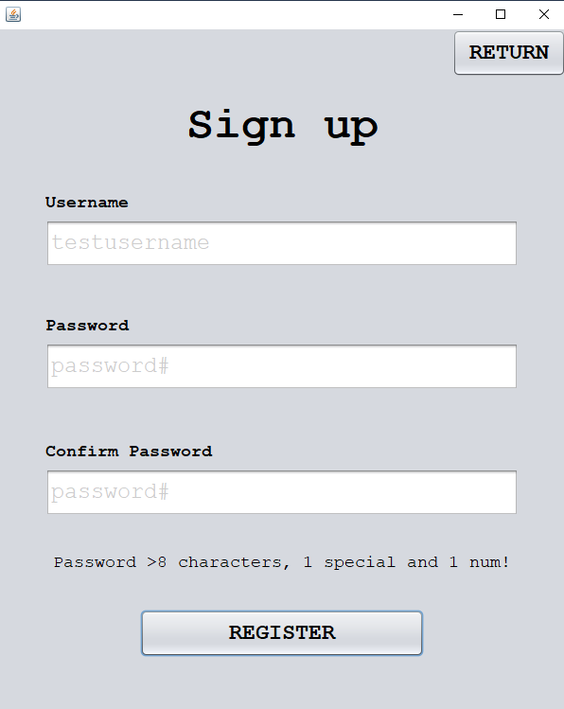

Here the user is met with an error message as the password does not contain any numbers but meets the other requirements.

##### Test #7

|  |  |  |  |  |  |
| --- | --- | --- | --- | --- | --- |
| Test | Test description | Input | Expected outcome | Type of Test | Passed test? |
| 7 | Test for entering a correctly formatted first password but a different confirmed password | Formatted correct password, incorrect confirmed password | User is told before submission that the two passwords are not matching and should not be allowed access | Erroneous |  |

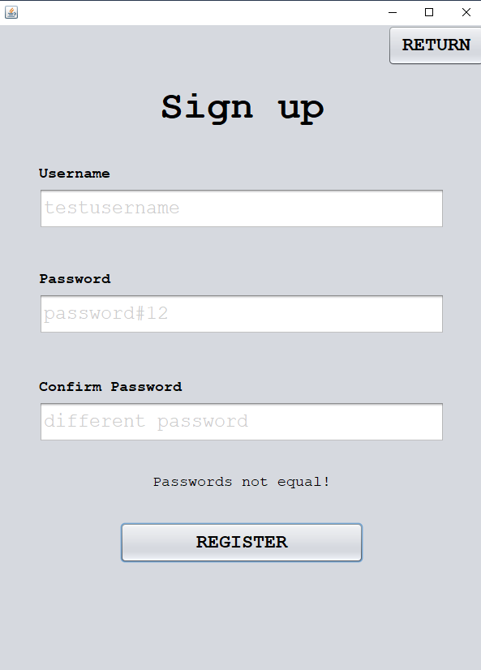

Here the user does not pass validation as the passwords do not match.

##### Test #8

|  |  |  |  |  |  |
| --- | --- | --- | --- | --- | --- |
| Test | Test description | Input | Expected outcome | Type of Test | Passed test? |
| 8 | Test for entering an incorrectly formatted first password and a different confirmed password | Incorrectly formatted password and non-matching passwords. | User should only be told that the password is of incorrect format before any other warning, so this is what is corrected first | Erroneous |  |

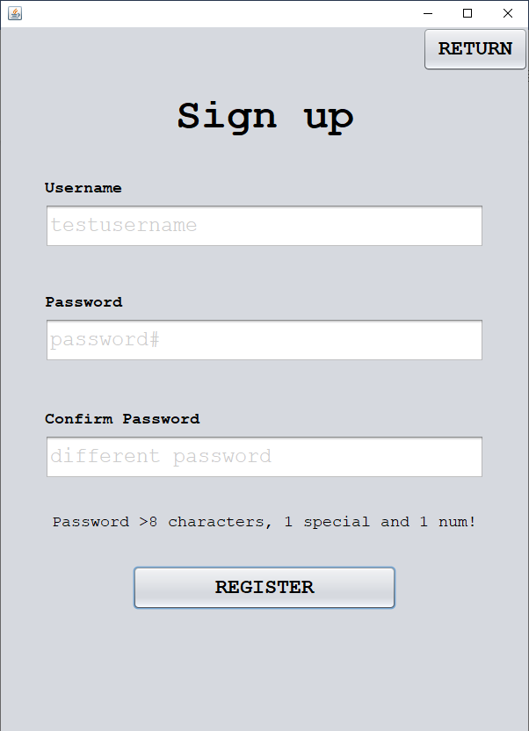

This output passes the test as the user is first informed that the password is incorrectly formatted rather than being told the passwords do not match.

##### Test #9

|  |  |  |  |  |  |
| --- | --- | --- | --- | --- | --- |
| Test | Test description | Input | Expected outcome | Type of Test | Passed test? |
| 9 | Test the input of a correctly formatted password and a correctly confirmed password, non-unique username | Correctly formatted password and correct confirmed password, non-unique username | User can not submit their details and is notified once again that their password should be unique | Erroneous |  |

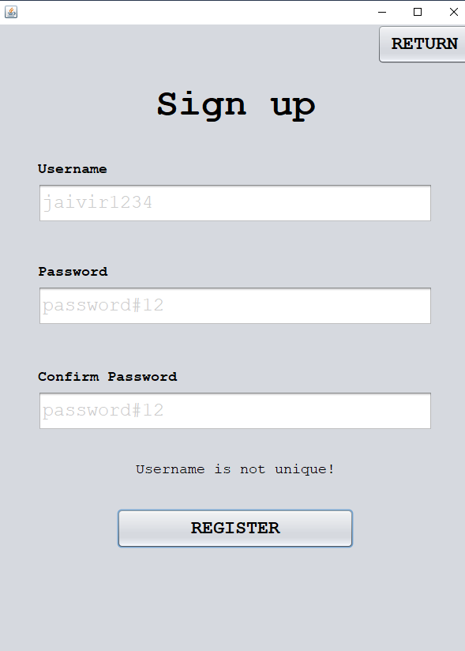

The password is correctly formatted, but the username is not unique, so the user is denied access and the test is passed.

#### Errors & Fixes

##### Test #3 Fix

|  |  |  |  |  |  |
| --- | --- | --- | --- | --- | --- |
| Test | Test description | Input | Expected outcome | Type of Test | Passed test? |
| 3 | Test for entering a username that isn’t in the accepted length range | Username with a length of less than 4 letters | User is told that the username must be inclusively between 4 and 10 characters. | Boundary |  |
| Username with a length of more than 10 characters |

A condition needs to be added in the check user format function to simply check if the username is greater than 10 characters.

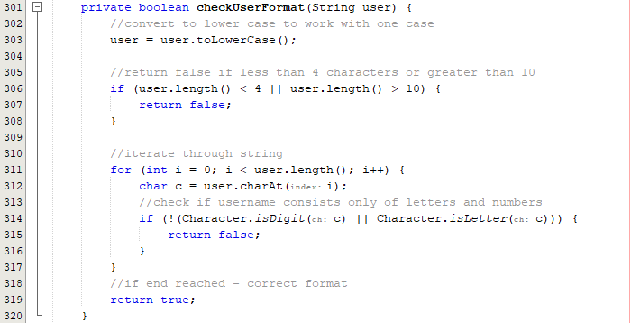

The user must also be informed of a length error rather than a general message:

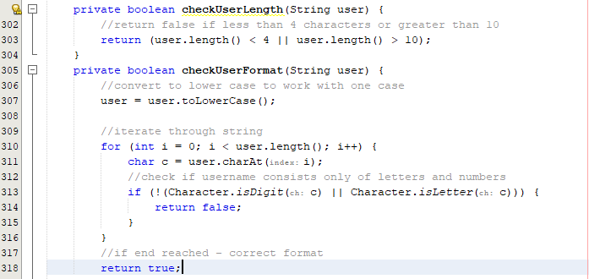

A simple fix for this is splitting this into another function and checking this independently when the register button is clicked.

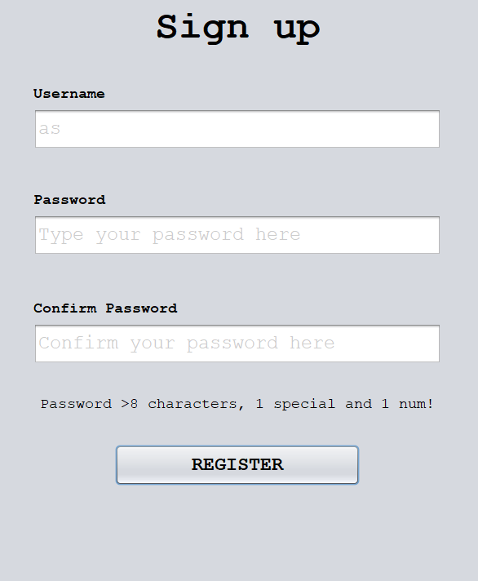

When running the code, this input passes the user length check therefore there must be a logical error somewhere. The code returning the length check in the function should be negated as it is returning the opposite Boolean value currently:

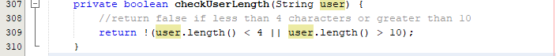

Now that the logical error is corrected, the code should work as intended:

|  |  |
| --- | --- |
|  |  |

Here both cases are now correctly being identified and the code now passes test #3

##### Adding password functionality

Upon reviewing the code that assesses the usernames length, it would be beneficial to replicate this feature for the password so that it cannot exceed 20 characters and include a separate error message for this case.

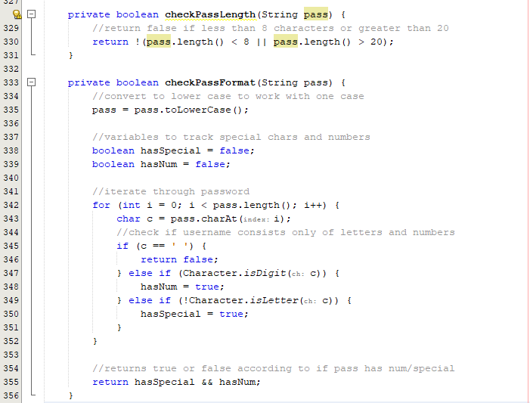



Label output needs to be tweaked to allow for password length checks:



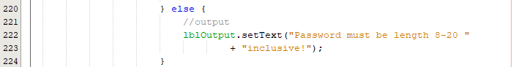

|  |  |
| --- | --- |
|  |  |

Now the cases where the passwords are outside of the accepted range are flagged and not accepted.

#### Conclusion

In conclusion, the main prototype's completion sets the stage for the next phase, which will concentrate on **improving the graphical design**. Future iterations will **polish** elements that were first created in the first cycle, such as the button arrangement and general appearance. This intentional separation of tasks guarantees that the product's **functionality** is established before focusing on its aesthetic elements.

The feature that allowed users to **register details** in the system was added in the most recent cycle. Before being stored permanently, this process requires that usernames and passwords be validated. Although this functionality **worked as intended**, there was one significant flaw that showed up during testing - a length check failure. This specific test failure was caused by a lack of code—the prototype was not coded with **the upper bound.**

This was a great opportunity to also **improve password validation** after seeing the error. Instead of just fixing the length check, the method was improved by breaking down the password validation into **separate tasks**. Two new functions were produced - a symbol function and a length function. The benefits of this method are that there is much more **targeted feedb**ack that users receive when their password entry is not in the correct format. Now that the error is made clear to users, the system is both more **informative and user-friendly**.

With the emphasis on graphical design and UI enhancements, the next cycles are expected to **improve the overall user experience** while maintaining the functionality that was established in the current prototype.

## Cycle 4 – Standard Functions Class

### Design

#### Decomposition & Overview

Currently, when considering and **object-oriented programming** approach to developing the product, classes should entirely be **independent** of each other and only contain information that is **directly linked** to the purpose of the class. Despite the loading detail’s function being relevant to the sign-up form, it would be better suited to a **standard functions** class as a **reusable component**. Currently the load detail’s function appears in both the login form and the sign-up form which is **inefficient** and should be revised.

#### Test Table

|  |  |  |  |  |
| --- | --- | --- | --- | --- |
| Test | Test description | Input | Expected outcome | Type of Test |
| 1 | Test for details correctly loading from file in the register form | Non unique username (valid username already registered) | User is told the username is not unique which must mean the data is correctly read form the file | Normal |
| 2 | Test for writing login details to a file in the register form | Valid username, valid password, and a correctly confirmed password | The registered details are written to the file on a new line | Normal |
| 3 | Test for loading details correctly in the login form | Valid username and valid password | Access to the main menu is granted | Normal |

Here, there will only be two tests available as only two functions are being migrated from the forms into a standard functions class – the load details and write details functions.

#### Usability Features

This cycle is purely backend development to **promote modularity** withing the products source code. The usability in this case is not for users but for the developers as it will be **easier to reuse functions** from the standard functions class as the product is being developed.

### Coding and Testing

#### Iterative Development and Testing

##### Prototype #1

Load detail’s function:

This is the current load detail’s function that is being used in both the sign-up form and the login form:

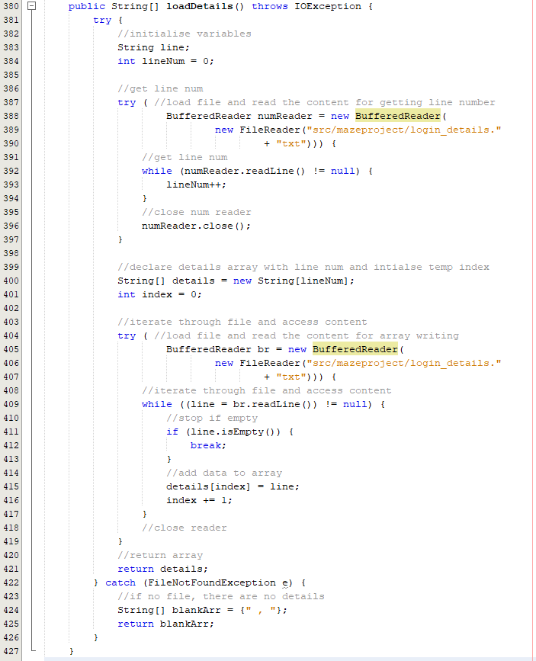

To edit this, it must be transferred to the Standard functions class and have the file name passed through the parameters so that this function works for any specified file:

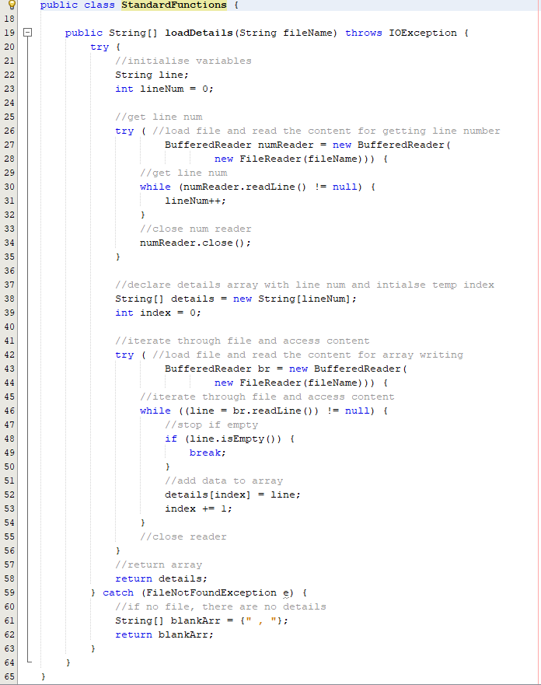

Now that I have this function in a separate class, I have to create an instance of the Standard Functions class in the constructor of my sign-up and login forms before I call the load detail function.

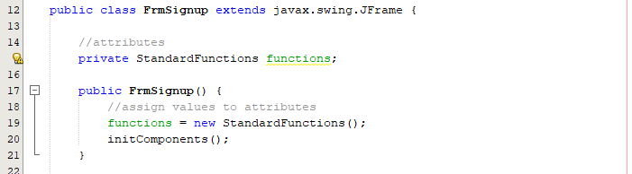

Now there is an instance of the Standard Functions class, I can now call the load function using this instance:

Changing register form check unique user:

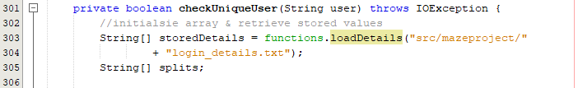

Changing login form validate details:

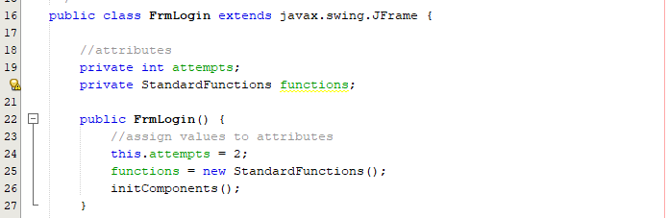

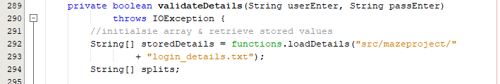

##### Prototype #2

Write to file function:

Original code:

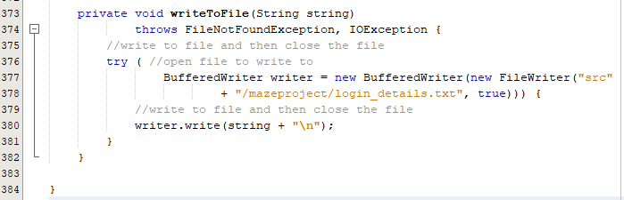

New code in standard functions class:

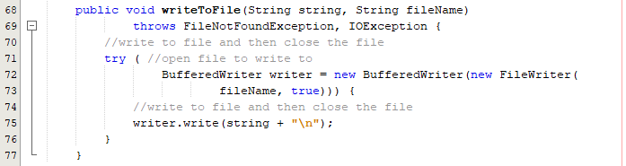

As the filename is called multiple times, it is better suited to be a global variable and assigned a value in the constructor.

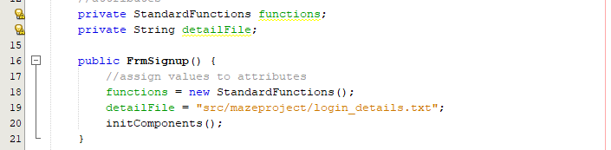



#### Final Cycle Code

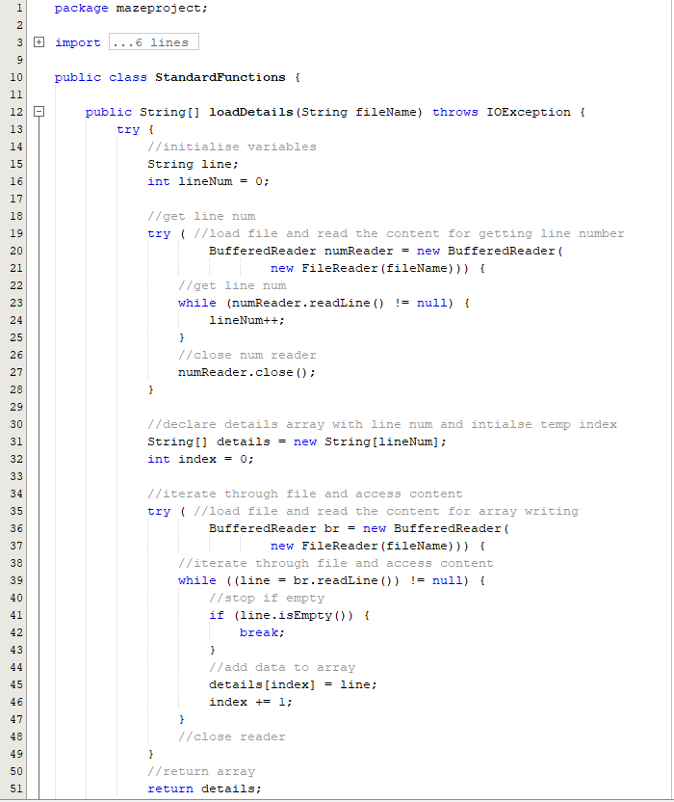

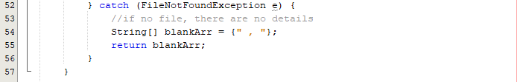

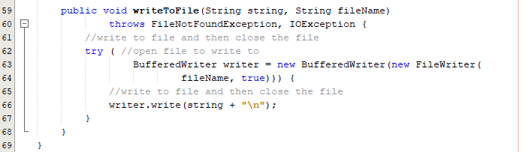

### Review

#### Final testing

|  |  |  |  |  |  |
| --- | --- | --- | --- | --- | --- |
| Test | Test description | Input | Expected outcome | Type of Test | Passed test? |
| 1 | Test for details correctly loading from file in the register form | Non unique username (valid username already registered) | User is told the username is not unique which must mean the data is correctly read form the file | Normal |  |
| 2 | Test for writing login details to a file in the register form | Valid username, valid password, and a correctly confirmed password | The registered details are written to the file on a new line | Normal |  |
| 3 | Test for loading details correctly in the login form | Valid username and valid password | Access to the main menu is granted | Normal |  |

##### Test #1

|  |  |  |  |  |  |
| --- | --- | --- | --- | --- | --- |
| Test | Test description | Input | Expected outcome | Type of Test | Passed test? |
| 1 | Test for details correctly loading from file in the register form | Non unique username (valid username already registered) | User is told the username is not unique which must mean the data is correctly read form the file | Normal |  |

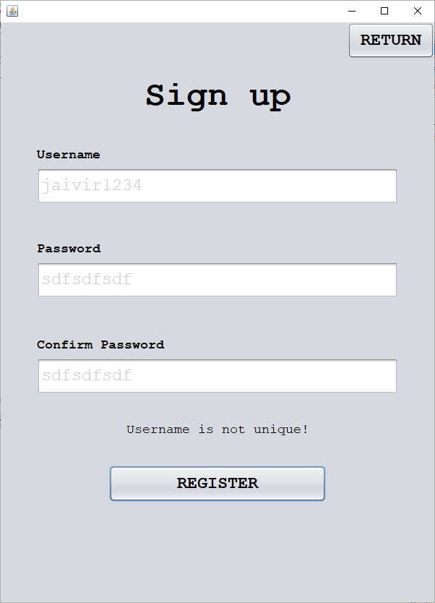

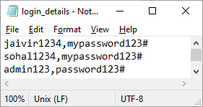

The sign-up form correctly loads details as it detects that this username is not unique and there does not pass validation – passing the test.

##### Test #2

|  |  |  |  |  |  |
| --- | --- | --- | --- | --- | --- |
| Test | Test description | Input | Expected outcome | Type of Test | Passed test? |
| 2 | Test for writing login details to a file in the register form | Valid username, valid password, and a correctly confirmed password | The registered details are written to the file on a new line | Normal |  |

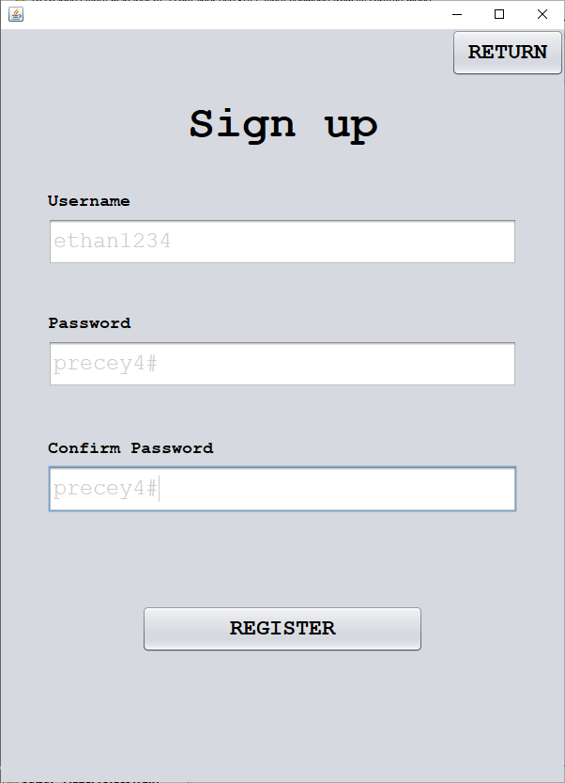

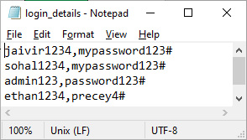

##### Test #3

|  |  |  |  |  |  |
| --- | --- | --- | --- | --- | --- |
| Test | Test description | Input | Expected outcome | Type of Test | Passed test? |
| 3 | Test for loading details correctly in the login form | Valid username and valid password | Access to the main menu is granted | Normal |  |

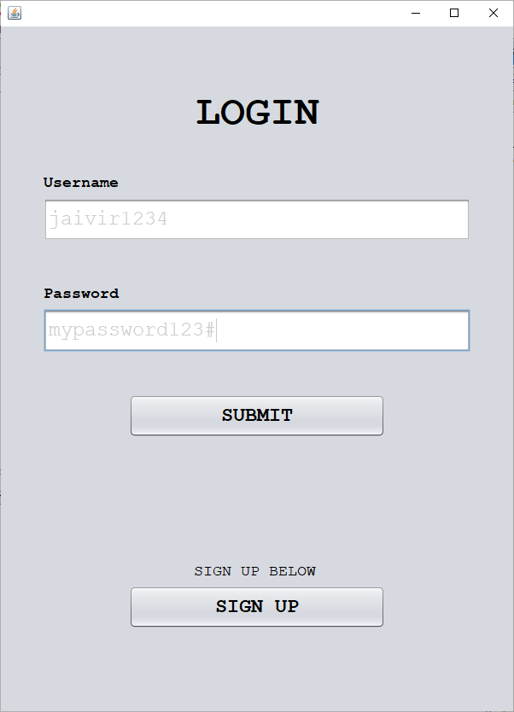

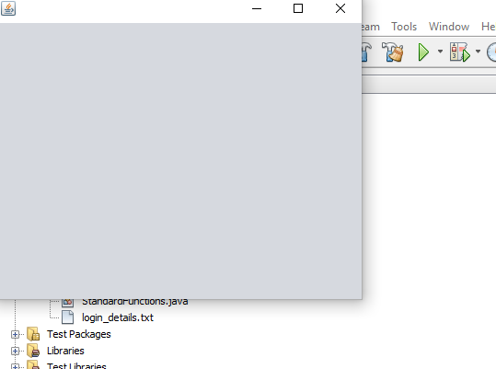

Dummy form is opened therefore the code passes the test.

#### Conclusion

I have **improved** the overall program's design in this cycle, by increasing **modularity**. The strategy was to **separate functions** from their initial positions so that each class could become more specialised for its intended use. This change makes the source code **cleaner and more efficient**, making maintenance and scalability easier.

In the future, this modular approach will be expanded by adding functions to this shared **library** that don't correctly fit into a certain class. This method not only makes the code even more **efficient**, but it also sets up the programme to **easily adapt** to changing needs. The project is kept **flexible** and prepared to accept new features in later development cycles due to the emphasis on **customisation** and **adaptability**.

## Cycle #5 – Revising the Login Form

### Design

#### Decomposition & Overview

Currently, the login form prototype **lacks quality of life features** and the majority of usability features as previously discussed in the **design phase**. The current login form is plain and has the main features such as **validating details**, having **3 attempts** and allowing the user to be **timed** **out** after using all these attempts. This product could benefit from extra features that allow **better interaction** between the user and the program.

Functions & features to be added into the cycle:

* Hint text – When **hovering** over the text field or whilst there is no input in the text box, there will be greyed out **hint** text that **informs the user** of the intended input for this section. For example, in the username text field, the hint text would be ‘**Type your username here’** and provides the user with extra details. When selecting the text to initially write into the box, the text will either be fully selected or **disappear** entirely.
* Dynamic timer – currently when the user is timed out after three attempts, it simply states there will be a **30 second timeout** but there is no timer that counts down to flow. This is why there needs to be extended functionality within the timeout function to update the screen **in real time** as the program is timed out.
* Form location – instead of the login form opening in the top right of the screen, the form should be positioned to the **centre** of the screen as the form is loaded up.
* Graphics – As proposed in cycle #1, the UI will be getting an **overhaul** that correctly fits the client’s specification. The **colour scheme and layout** will be tweaked to give a **cleaner** and more **professional** feel.
* Text colour - The **error** **text** will also now be **red** rather than the standard black so that it can **correctly be identified** as an error to provide further clarity. The text within the text box will also now be black rather than grey as this was originally grey for testing purposes.
* Fixing timeout text – the current timer function does not clear the ‘You’ve been timed out’ text after thirty seconds so this should be revised so that a **fresh screen is provided** to the user after they have waited the full 30 seconds.
* Attempt wiping – After each incorrect attempt, the text boxes should be wiped so that the user does not have to select the text and **manually** delete it. The entirety of this process will be automated, contributing to a more **seamless** login process.

#### Pseudocode

procedure timeout()

//set tfOutput colour to red

tfOutput.setTextColour(red)

//repeat for an n number of seconds

for i=0 to time

//dynamically update the output

tfOutput.setText("You have been timed out for " + str(time-i) + " seconds")

//start a 1 second timer

Timer timer = new Timer(1000)

timer.start()

next i

//clear the output text after finished

tfOutput.setText("")

endprocedure

//validate submitted details

procedure btnSubmit()

//get text box values

userEnter = ""

passEnter = ""

userEnter = tfUser.getText()

passEnter = tfPass.getText()

//set tfOutput colour to red

tfOutput.setTextColour(red)

//validate details

isValid = validateDetails(userEnter, passEnter)

if isValid then

//close login and allow access into menus

FrmLogin.close()

FrmMainMenu menu = new FrmMainMenu()

else

if attempts > 0 then

attempts = attempts - 1

tfOutput.setText("Username or Password incorrect - " + attempts + " attempts remaining")

else

//timeout user for 30 seconds if 0 attempts then reset attempts

timeout()

attempts = 3

endif

endif

//clear details once finished ready for next attempt

tfUser.setText("")

tfPass.setText("")

endprocedure

procedure selectAllOnClick()

//add mouse listeners to monitor mouse clicks

tfUser.addMouseListener()

tfPass.addMouseListener()

//select all text in the username box

if (mouseClicked(tfUser)) then

tfUser.selectAllText()

endif

//select all text in the password box

if (mouseClicked(tfPass)) then

tfPass.selectAllText()

endif

endprocedure

This pseudocode created a **separate timeout functi**on that **dynamically** edits the timer each second to provide the user with more insight into how long let the user has before they are **granted access back** onto the system.

In the button submit procedure, the output text is now correctly being set to red as well as the text fields being wiped after use. It is **sufficient** to add the code to wipe the text boxes at the **end of the procedure** as this code will only ever be reached upon a failed attempt.

To tackle the problem about the hint text, **mouse listeners** that can be utilised in java swing can be used to listen for a mouse click onto the text box and if a click is detected, then all the **text will either be selected or just deleted entirely** (will be decided as the code is being developed).

#### Variable Table

|  |  |  |
| --- | --- | --- |
| Key Variables | Data Type | Justification |
| time | Integer | This is a constant variable that signifies how long the user is timed out after all three attempts are used. This variable is global so it can be accessed throughout the file and easily edited. |
| mouseClicked | Boolean | Simplified version of an action listener that simply holds a value corresponding to whether the mouse has been clicked. This is to configure when to select all text within the text field |

#### Test Table

|  |  |  |  |  |
| --- | --- | --- | --- | --- |
| Test | Test description | Input | Expected outcome | Test type |
| 1 | Test for all text being selected upon click of any text box | Clicking into the username text field and the password text field | All text within the text box is selected so that it can easily be deleted | Normal |
| 2 | Test for the timer correctly decreasing in intervals of 1 second | 3 incorrect attempts at logging in. | Timer counts down from 30 seconds and decreases in increments of 1 second. | Normal |
| 3 | Test for opening the login form | Opening the login form | The login window opens up in the centre of the user’s screen | Boundary |
| 4 | Test for correct layout after the incorrect attempt’s timer finishes | Timer after incorrect attempts expires | The text in the output text field is then deleted after the 30 seconds is up | Normal |
| 5 | Test for text fields correctly wiping after an attempt is made | Incorrect login attempt (either incorrect password or incorrect username) | After an incorrect attempt, the username text field and the password text field should be wiped. | Normal |
| 6 | Test for valid login after all the changes have been implemented | Valid password and valid username | The details are validated, and the user is allowed access onto the system | Normal |

#### Usability Features

* Hint text (engagement) – having hint text that will describe to the user how to **interact** with the program as initially developed in a previous cycle a great usability feature. To extend this further, when the user interacts with the form currently - the user must **manually delete** all the text, and this can be quite **laborious**. This is why adding a small feature that will **remove all text at once** will greatly improve **quality of life** and the overall experience.
* Dynamic timer (engagement) – when timed out, having a timer that counts down in real time (**dynamically**) rather than statically with no updates provides the user with significantly more information, **reducing ambiguity** and increasing engagement.
* Text colour – fixing the text colour so that the **output text is coloured red** will now **correctly outline to** **users** that the suggestions are error messages e.g., an incorrectly formatted error message will now be coloured red to signify that it is an error and not a regular statement. This is to further **reduce confusion** when interacting with the login form.

#### Validation

The sole validation added within this cycle would be through the automated **event** **handling** in Java Swing through **action listeners**. I will be validating **user clic**ks and **key presses** to manipulate **text colour** (after a key is pressed) to change the colour to black after being greyed out. There will **two forms of click validation**; one that clears the **hint text** on click and one that only allows all the text to be selected once so that users can access individual characters without selecting all the text constantly.

### Coding and Testing

#### Iterative Development and Testing

##### Prototype #1

Developing the dynamic timer feature

The current code for the timeout function as shown below simply locks all components for 30 seconds:

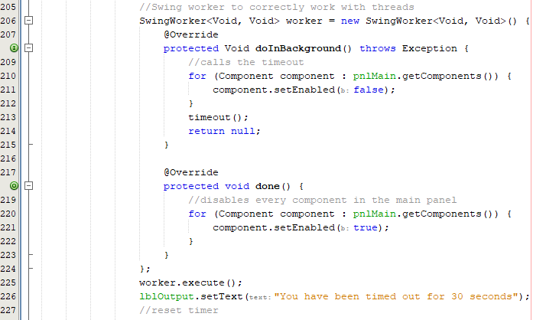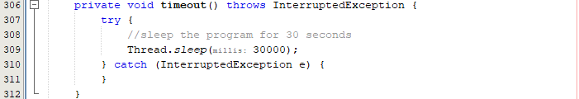

My first thought to tackle this problem would simply be looping the function 30 times with the timeout function being changed to 1 second rather than 30. This why the label can constantly change every 30 seconds:

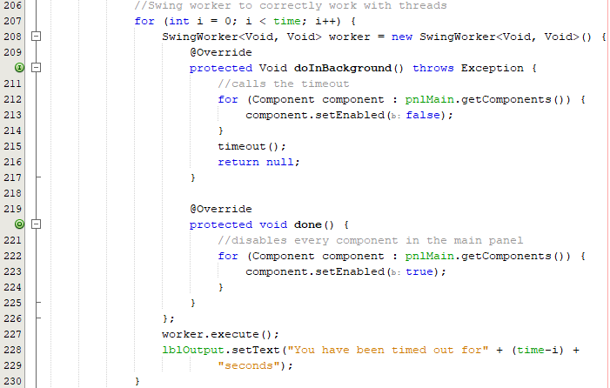

However, when running this code, the swing worker performs all iterations at once meaning there is only a 1 second timeout overall and a new strategy must be devised to implement this.

My new approach would consist of not changing the current swing worker and instead changing the timeout function so that the label is updated within the timeout rather than within the swing worker. Having a global time variable allows the time to dynamically change in the function as the local ‘i’ variable cannot be accessed.

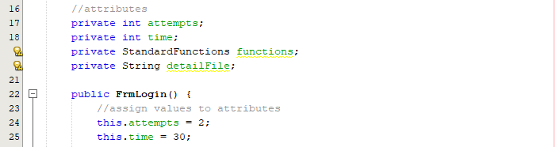

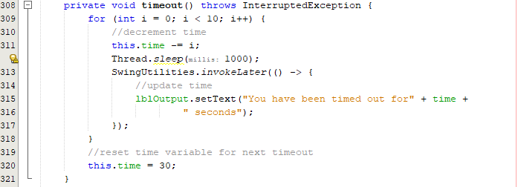

When running this code, it does successfully last 10 seconds (a reduced timer for testing purposes) but the label does not decrease in increments of 1 and instead in increments of an increasing amount e.g., 2 then 3 then 4 etc.

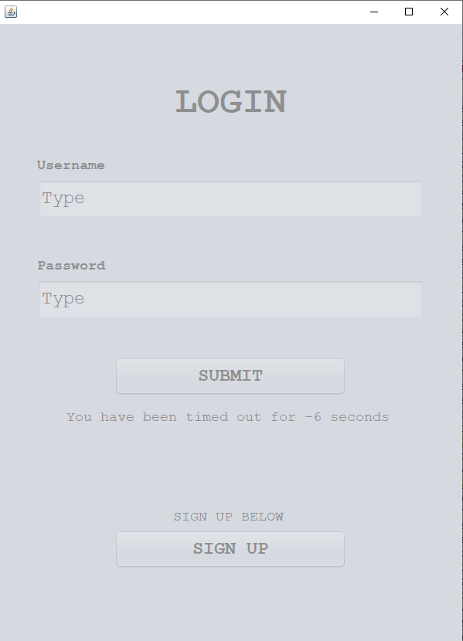

This leads to a negative time. A simple fix to mend the logic error where time should be decremented by 1 and not ‘i’ as shown on line 311.

Fixing label time error

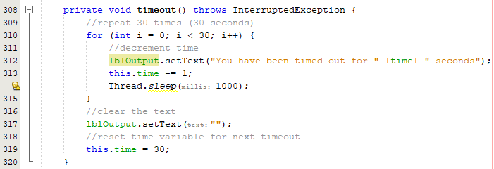

When implementing the simple change of decrementing by 1, it became apparent to me that I did not need to utilise swing utilities and could shorten my code entirely. I also added code to wipe the label text once complete so that there is a seamless transition into a new cycle of attempts.

|  |  |
| --- | --- |
|  |  |
|  |  |

The timer correctly counts down now from 30 seconds and once the timer reaches 0, the label text is cleared, attempts are reset, and the user can interact with the screen again. At the end of the first prototype of this cycle, I have now implanted a dynamic timer which marks the start of a new prototype that will include the addition of the hint text improvement.

##### Prototype #2

In this prototype, I will be considering how the user interacts with the text boxes. This includes wiping text boxes after attempts and removing hint text on click. This can be simply added by adding action events to each text field.

Developing functions to wipe hint text.

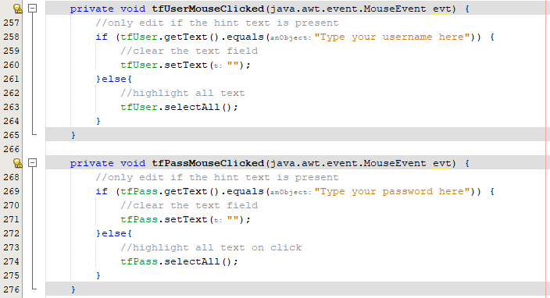

This code simply checks whether there is hint text and if there is, it will wipe it on click. Otherwise, it will select all text on click, this greatly improves quality of life as the user does a lot less work to make changes to the username or password. When loading up the form, the user is automatically clicked into the first text field so I must call the select all text for tfUser so that the user can simply backspace to get rid of it.

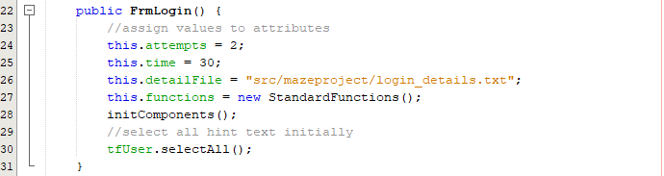

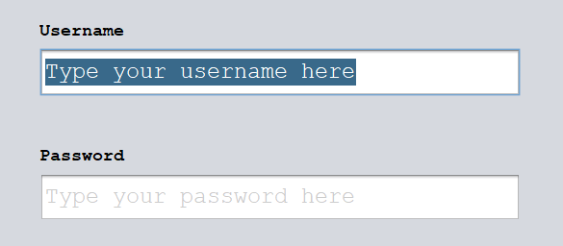

As shown above, when running the program, the user text box is automatically selected.

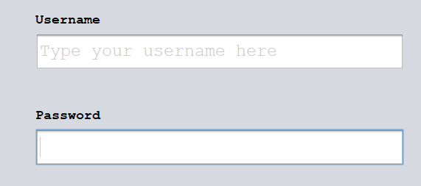

When clicking into the password box, the hint text is removed and therefore full functionality is present. However, when a user clicks to see their password or username typed and wants to click into the middle of the username, the user cannot do this as it constantly selects all text.

A way to fix this is keep track of a variable that only allows this to be clicked once and then reset once the user leaves the text box.

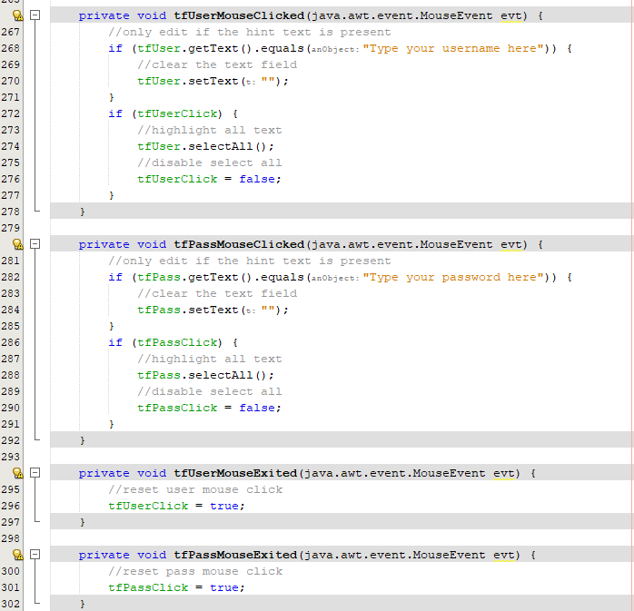

With the implementation of this code, the hint text issue is completely resolved and the extra addition of selecting all text improves the program to a higher standard than originally planned.

Wiping text boxes after attempt.

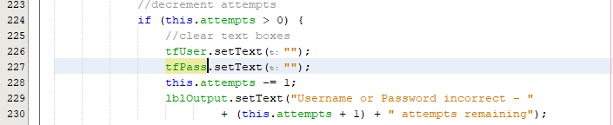

|  |  |
| --- | --- |
|  |  |

After each attempt, each field is now wiped for convenience. As all intended features for this prototype have been added, the next prototype that focuses entirely on upgrading graphics.

##### Prototype #3

This prototype is purely focused on upgrading the colour changes after interactions, static colour and overall GUI look to make it match the initial cycle design. Up until this point, the focus was on developing the functionality and now that it has all been upgraded, the aesthetics can be enhanced.

Setting a centre position

Setting a centre position is carried out by calling a null position in the constructor:

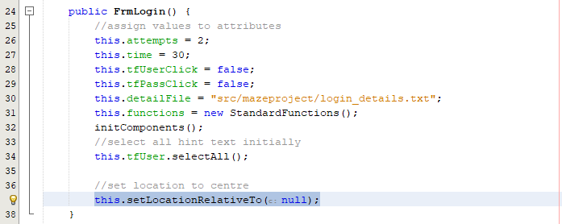

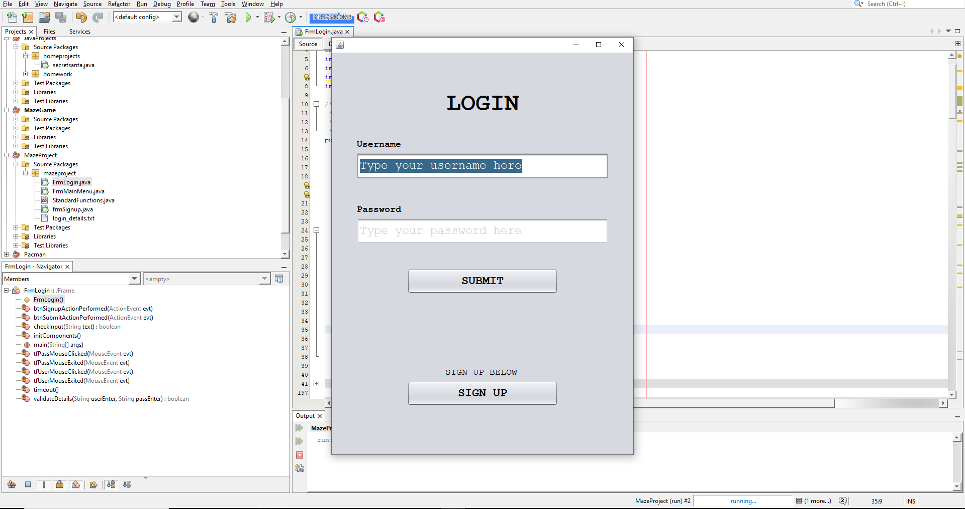

The form is correctly opening up in the centre of the screen after this change.

Changing output text colour:

Output text colour must be changed to red to indicate it is an error message. Here a custom red colour will be used rather than the standard red colour provided by Java Swing.

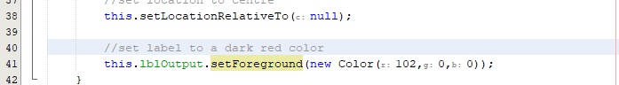

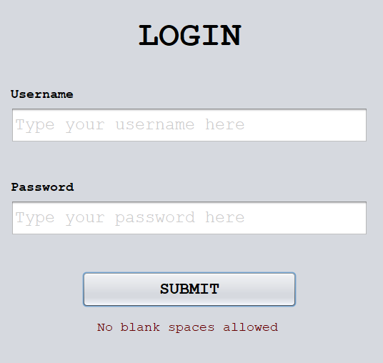

Changing typed text colour:

After the hint text is removed, any new text that is typed into the box should be typed as black text rather than greyed out text. An easy way to do this is to add a key listener that changes the text colour when a key is typed into any text box.

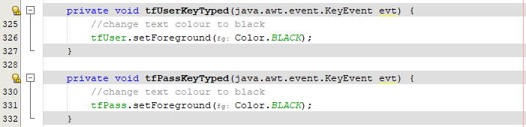

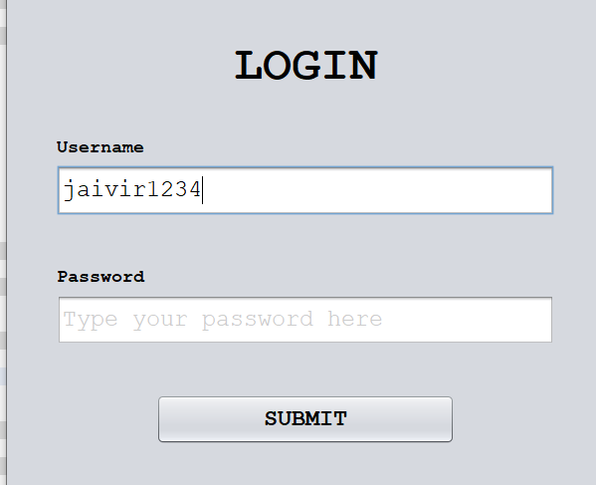

Improving graphics:

Reference image as designed in Cycle #1:



This is the product after transferring the icons from the PowerPoint version over to the code through Java Swing’s built in icon manipulation. Currently the buttons do not highlight when hovering over them and this is due to the button simply being a static image but the button still works when clicked.

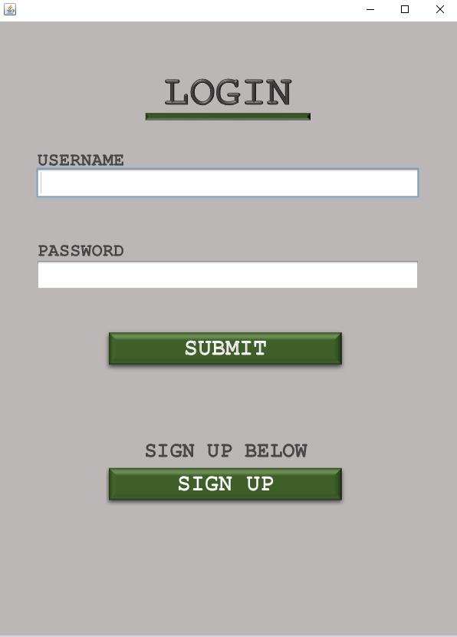

Next the text box borders need to be replicated and this can be done through a compound border of an etched border and a line border of thickness 2 and the text box size needs to be reduced horizontally:

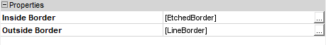

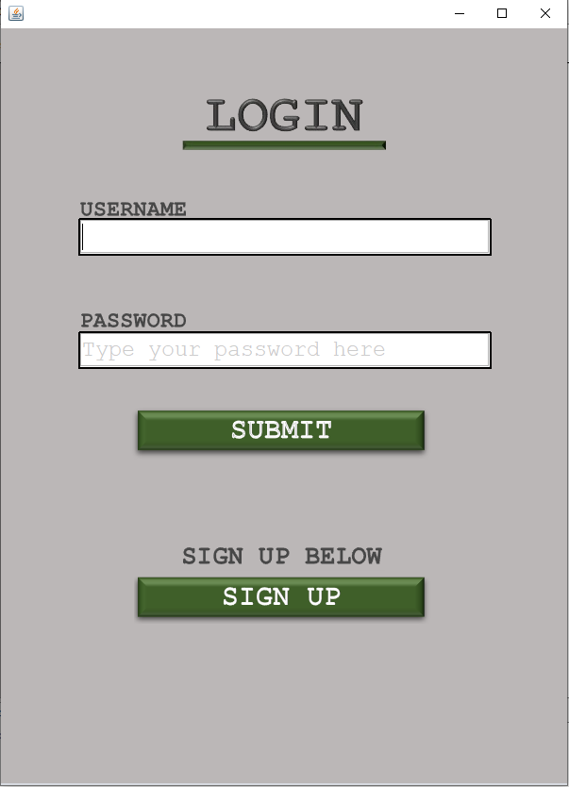

Next there must be some sort of background overlay to implement the raised backdrop with the bolted black screws.

To add this background, main panel can have an absolute layout so that overlays are allowed, and an icon can be added to a background label, this option was made apparent to me through this stack overflow post [25]:

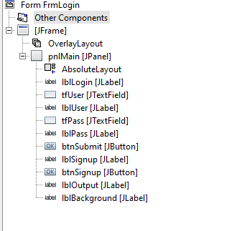

After resizing the background to fit, the login form is now the same as the proposed cycle.

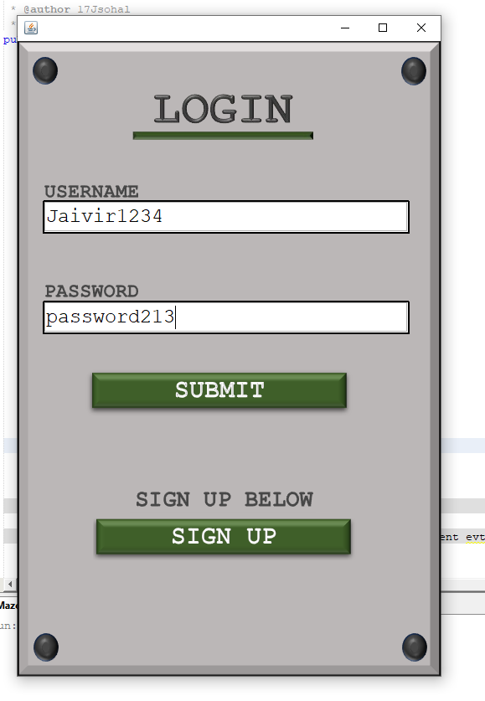

However currently, the button does not change colour and the error message needs to be resized so that it does not go off of the screen as shown below:

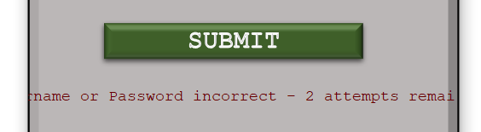

Fixing the text wrap:

To fix this problem, I can add a html tag within the long text to make sure it wraps when going over the width limit. I also made the text bold so that it stands out further:



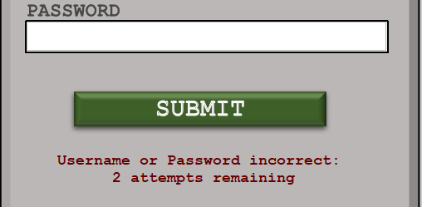

When being timed out, as the background is not grey, I will make the timeout text not disabled by simply creating an if statement that excludes the output label:

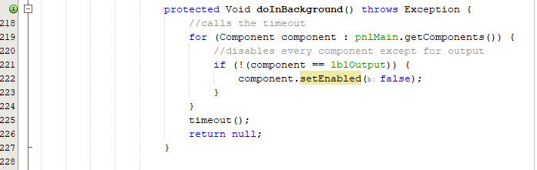

|  |  |
| --- | --- |
|  |  |

Changing the cursor icon:

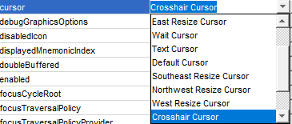

Now that most of the graphics have been overhauled, I can work on handling multiple icons for the buttons if the user hovers over area. This can be handled through key listeners and usually the target area for a buttons colour to change is smaller than the button itself. Therefore, I will create a separate overlay label over the button that acts as a target area that will monitor the mouses movement. This label will also be smaller than the button itself.

Fixing the button highlight:

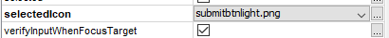

When hovering over the button, I implemented a feature where it changes the icon to a saved image that has a slightly lighter green hue. However, my current image file also changes the colour of the grey background, and a smooth transition is not made:



To edit this, I must only change the green hue in photoshop and only edit the colour of the highlighted square.



Repeating this for the signup button, both buttons now correctly highlight on hover:







Final graphics for prototype #3:

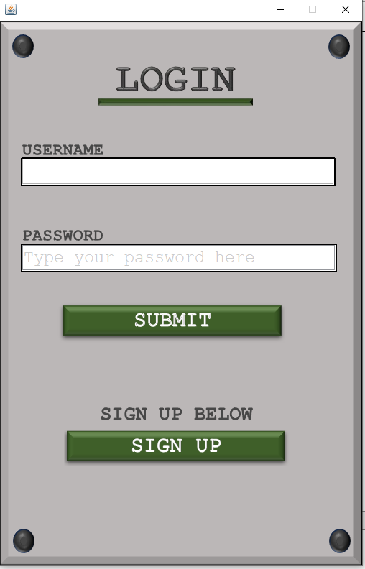

After this prototype, all key graphical features have been implemented such as the coloured buttons, bevelled edges, and coloured borders. As custom button icons were being used, a dual icon system was used that changes the icon to a different image to a lighter version each time. Now that the login form has been completely overhauled, the current product matches the client’s specification. Moving on to the next prototype, any last features will be implemented such as password security.

##### Prototype #4

Hiding information in the password text box is essential when working with passwords to maximise security in the case that anyone was viewing the screen at the time. Luckily, Java Swing has a built-in object called password field that allows passwords to be hidden by ‘*’ symbols as intended. I became aware of this through this stack overflow post: [26].

Converting text field to password field:



Using this object, all key listeners must be reimplemented as they were deleted when converting this field to a password field. Furthermore, the password field does not user the function getText but uses getPassword instead so all instances of this must be altered.

This getPassword function returns a character array so this must be converted to a string on initialisation:

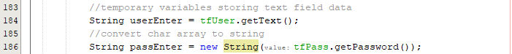

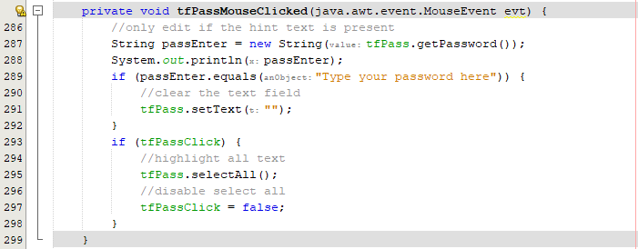

When implementing the remaining action listeners, I must add code to hide the text as soon as a key is typed. I must also not hide the text when the program starts so that the user can see the hint text – located in the constructor:



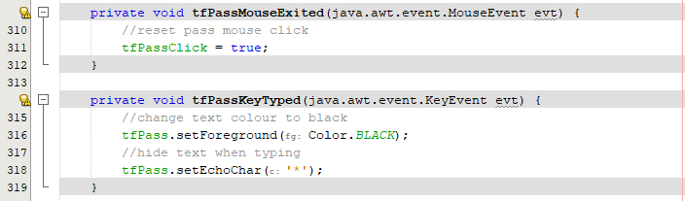

|  |  |
| --- | --- |
|  |  |

Now the password is hidden as it is being typed into the text field correctly but it would be great to have the ability to toggle the visibility of the password.

In cycle #1, I added an icon to the side of the text box that would allow the user to see the password:



This can be added into java by having a transparent label on the edge of the text field with this icon.

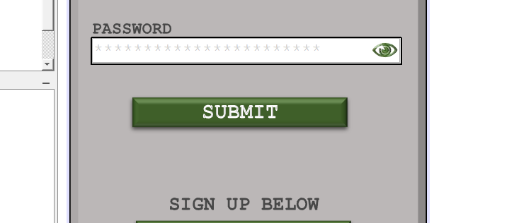

Now the icon is here, I can develop the toggle function:

To make this toggle function, I must have a global variable that tracks the state of the toggle. When true, the text will be visible and when false the text will be hidden.

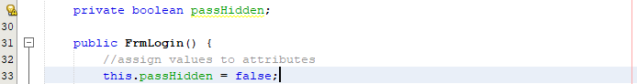

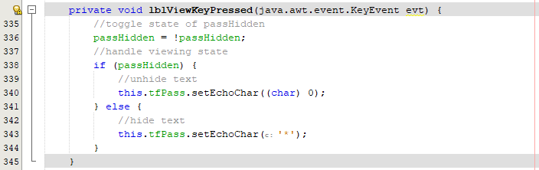when implementing this code, nothing happens when the label is clicked. To test this, I can print text to the console to see if the label is activated:



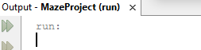

Nothing is output to the console therefore I must move the label so that it can be clicked as currently the password field is being clicked.



Even after moving this label, the error persists so it may be useful trying to change this icon from a label into a button.



When clicked, the text is successfully revealed:



Now the icon can be applied to the button:



Now to add another icon for hovering over this icon:





Editing font:

Currently the font of the text boxes is not bold and tweaking this slightly so that the text is now bold improves the overall aesthetics:

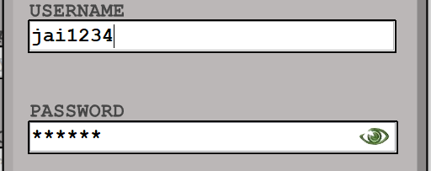

The error text should also be increased from font size 18 to font size 24 to compliment the text box size and make the error text more visible to the user:

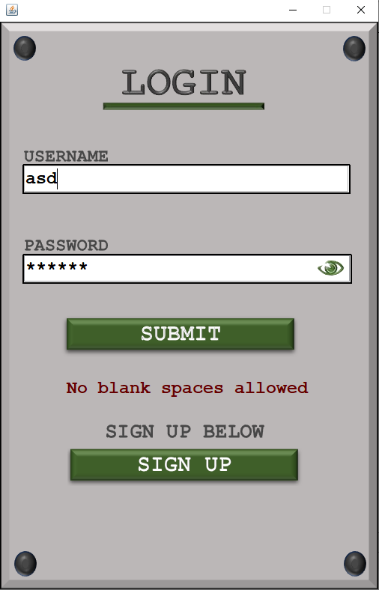

When hovering over this, the shade is slightly greener, this usability feature where the colour changes make the user aware of this eye being a button that can be clicked to allow the suer to view the password.

Now that this feature has been implemented, the objective of prototype #4 is complete and the entire login form has been fully developed with all quality-of-life features successfully included. Within this prototype, I had to edit my approach midway by changing the type of component used for the visibility toggle where it was shifted from a label to a button to fix the error of clicks not registering.

#### Final Cycle Code

Final graphics:

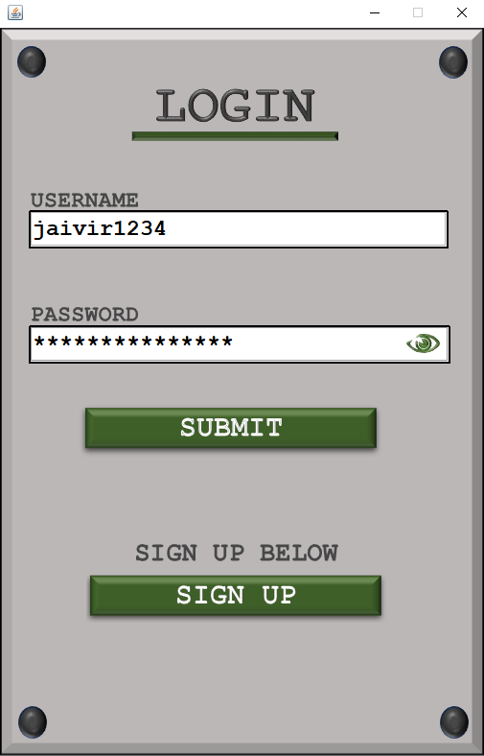

Final login code (FrmLogin):

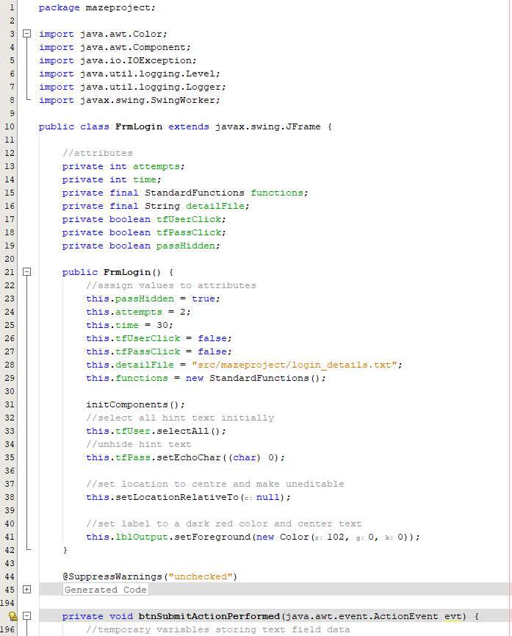

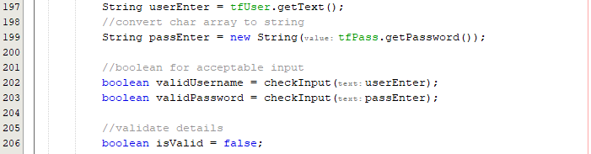

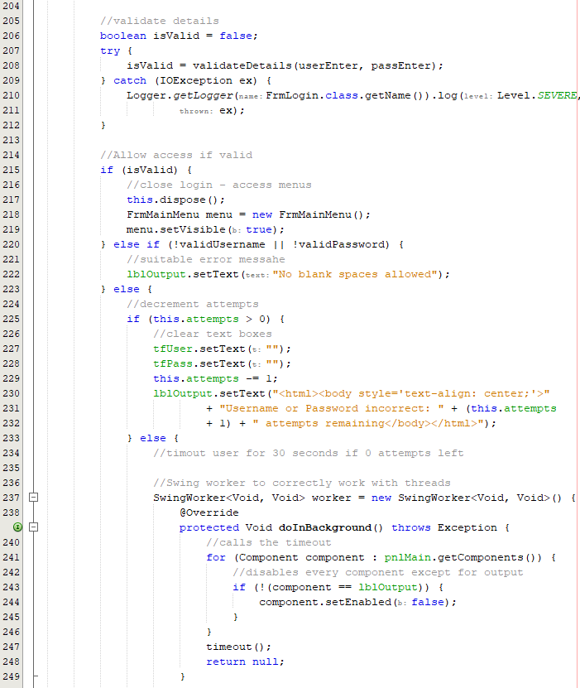

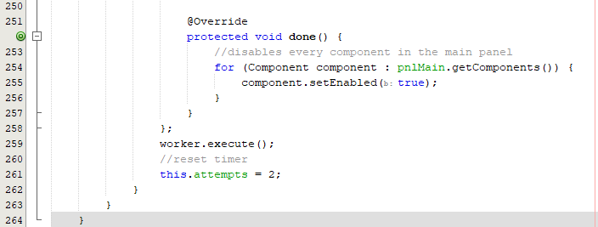

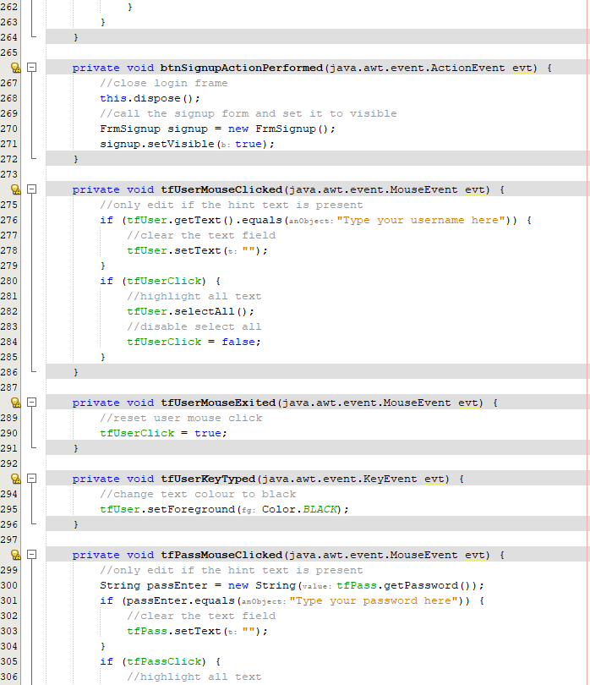

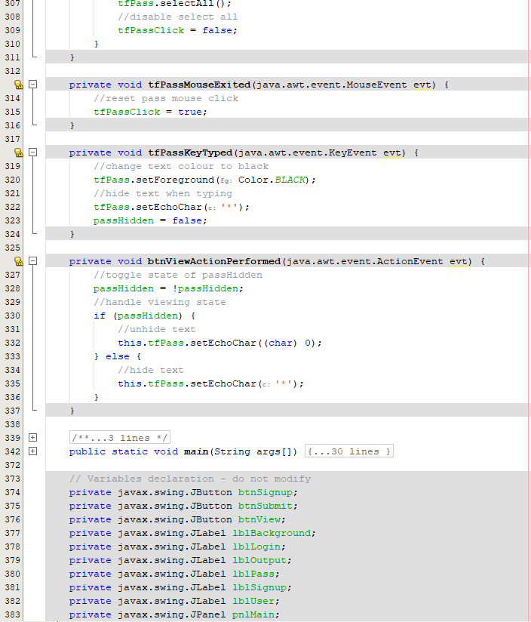

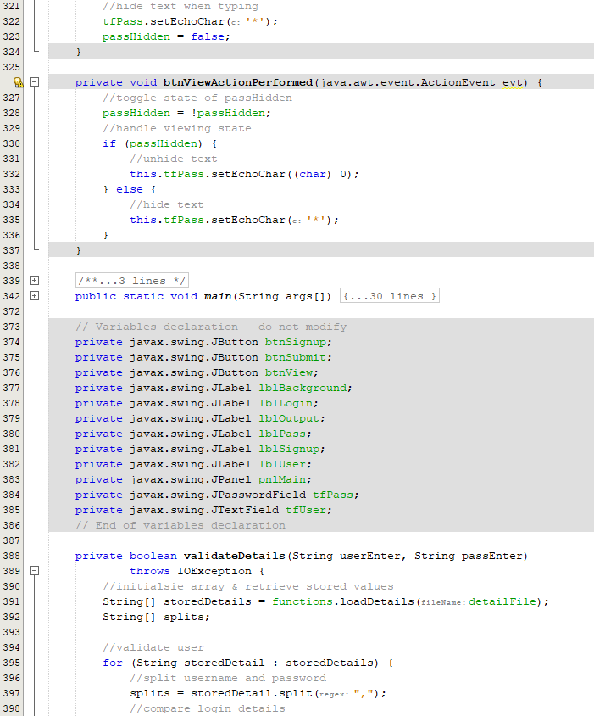

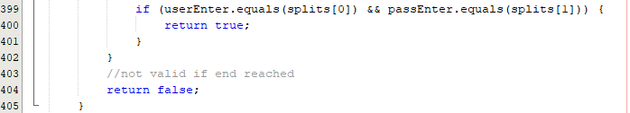

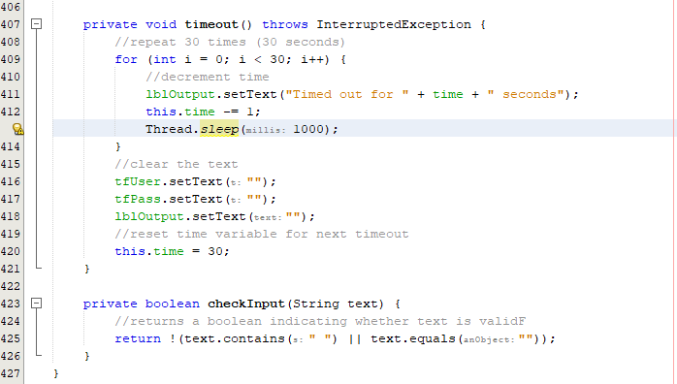

### Review

#### Final testing

|  |  |  |  |  |  |
| --- | --- | --- | --- | --- | --- |
| Test | Test description | Input | Expected outcome | Test type | Passed test? |
| 1 | Test for all text being selected upon click of any text box | Clicking into the username text field and the password text field | All text within the text box is selected so that it can easily be deleted | Normal |  |
| 2 | Test for the timer correctly decreasing in intervals of 1 second | 3 incorrect attempts at logging in. | Timer counts down from 30 seconds and decreases in increments of 1 second. | Normal |  |
| 3 | Test for opening the login form | Opening the login form | The login window opens in the centre of the user’s screen | Boundary |  |
| 4 | Test for correct layout after the incorrect attempt’s timer finishes | Timer after incorrect attempts expires | The text in the output text field is then deleted after the 30 seconds is up | Normal |  |
| 5 | Test for text fields correctly wiping after an attempt is made | Incorrect login attempt (either incorrect password or incorrect username) | After an incorrect attempt, the username text field and the password text field should be wiped. | Normal |  |
| 6 | Test for valid login after all the changes have been implemented | Valid password and valid username | The details are validated, and the user is allowed access onto the system | Normal |  |

##### Test #1

|  |  |  |  |  |  |
| --- | --- | --- | --- | --- | --- |
| Test | Test description | Input | Expected outcome | Test type | Passed test? |
| 1 | Test for all text being selected upon click of any text box | Clicking into the username text field and the password text field | All text within the text box is selected so that it can easily be deleted | Normal |  |

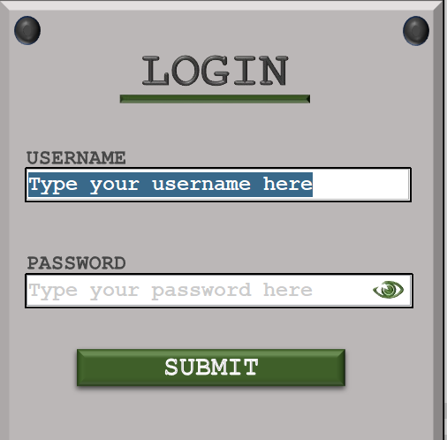



When clicking into a box, the text is automatically selected and to enhance usability, if the text is selected again, I have introduced code to not select again. This is so users can access individual characters within the text and this feature resets when the user’s crosshair exits the box and re-enters.

##### Test #2

|  |  |  |  |  |  |
| --- | --- | --- | --- | --- | --- |
| Test | Test description | Input | Expected outcome | Test type | Passed test? |
| 2 | Test for the timer correctly decreasing in intervals of 1 second | 3 incorrect attempts at logging in. | Timer counts down from 30 seconds and decreases in increments of 1 second. | Normal |  |

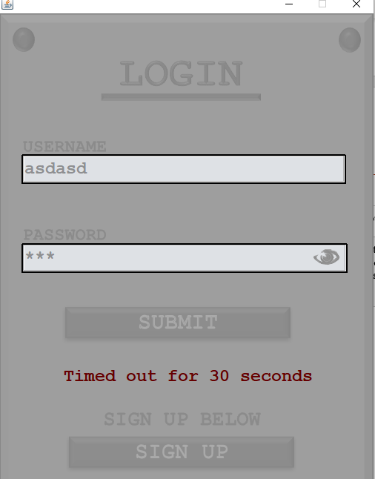

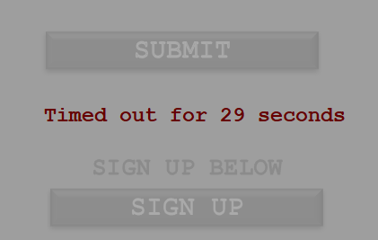

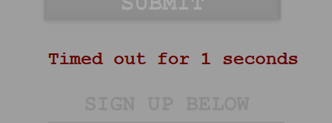

As shown above, the timer correctly decreases in intervals of 1 second until the timer reaches 0 seconds and the form is re-opened for another 3 attempts before being locked again.

##### Test #3

|  |  |  |  |  |  |
| --- | --- | --- | --- | --- | --- |
| Test | Test description | Input | Expected outcome | Test type | Passed test? |
| 3 | Test for opening the login form | Opening the login form | The login window opens in the centre of the user’s screen | Boundary |  |

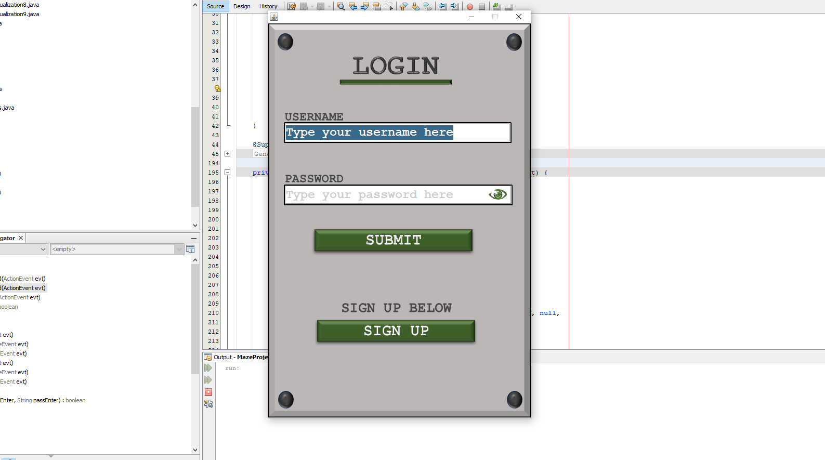

##### Test #4

|  |  |  |  |  |  |
| --- | --- | --- | --- | --- | --- |
| Test | Test description | Input | Expected outcome | Test type | Passed test? |
| 4 | Test for correct layout after the incorrect attempt’s timer finishes | Timer after incorrect attempts expires | The text in the output text field is then deleted after the 30 seconds is up | Normal |  |



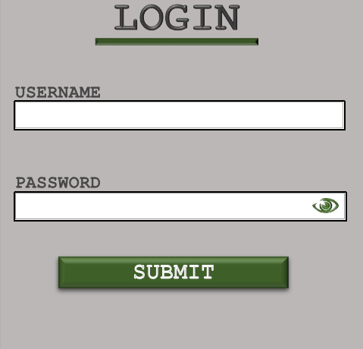

The text boxes are successfully cleared after the timer runs out, ready for the next cycle of attempts therefore passing test #4.

##### Test #5

|  |  |  |  |  |  |
| --- | --- | --- | --- | --- | --- |
| Test | Test description | Input | Expected outcome | Test type | Passed test? |
| 5 | Test for text fields correctly wiping after an attempt is made | Incorrect login attempt (either incorrect password or incorrect username) | After an incorrect attempt, the username text field and the password text field should be wiped. | Normal |  |

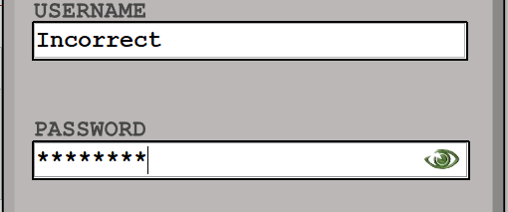

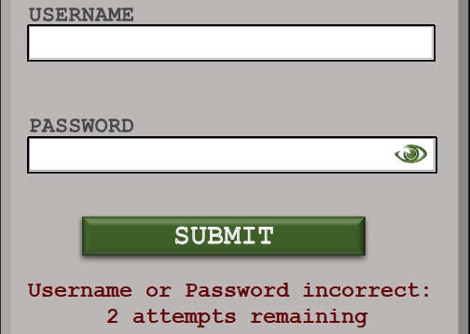

After this incorrect login, the text fields are wiped and the correct error text is displated to the user.

##### Test #6

|  |  |  |  |  |  |
| --- | --- | --- | --- | --- | --- |
| Test | Test description | Input | Expected outcome | Test type | Passed test? |
| 6 | Test for login validation after all the changes have been implemented | Valid password and valid username | The details are validated, and the user is allowed access onto the system | Normal |  |

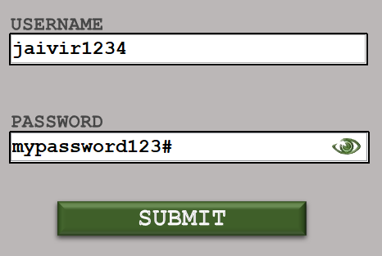

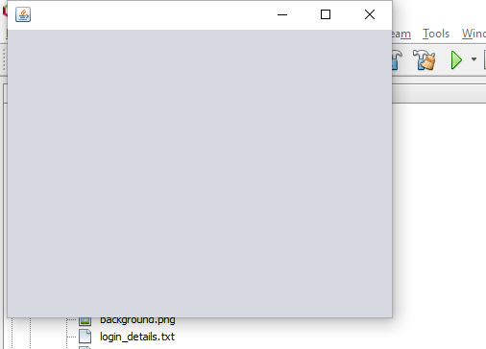

After all the changes, inputting this correct combination into the login form successfully opens the dummy form and passes all validation checks within the system.

#### Clients Feedback on final login form

Layout & Aesthetics

When presenting the login form to my client Mr Murray, there were many features that were found desirable that fit into to the initial specification and contribute to a great overall aesthetic.

* **Left Align** - The client found the username and password labels that were left aligned on the text box complimented the layout and were placed in a great position:

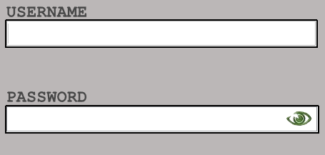

* **Text box length** – The length of the boxes seemed to be the perfect length in terms of allowing room for lengthy passwords and is not short such that an average length username/password will not fit:

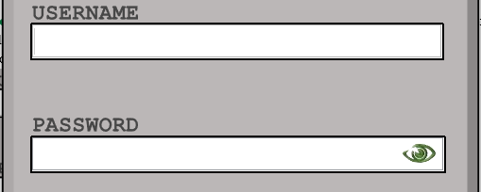

**Button icons** – The client found the buttons to be visually appealing and appreciated the forest green hue as well as the associate Courier New font. The highlighting of the buttons was also viewed in positive light: 

* **Centre align** – The entire form with all buttons and labels being centre aligned adds to the aesthetic and was the initial feature the client had raised as being desirable:

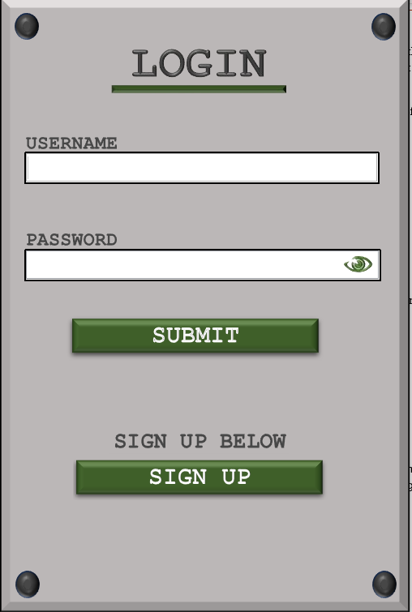

* **Spacing between text boxes** – The client has raised the suggestion that the vertical gap between the username and password could be shorter to reduce grey space between the two boxes and allow space for instructions:



* **Instructions for form** – It was also suggested that the submit button could be lowered so that instructions could be added on how to use the form. When asking the client on the preference for implementation – an information button seemed to be the best option where a small window will pop up explaining how to use the form.



Labels

* **Removal of hint text** – When clicking onto a box, the client found it useful that the hint text clears on click so that the details can be typed immediately rather than having to manually delete the previous text.

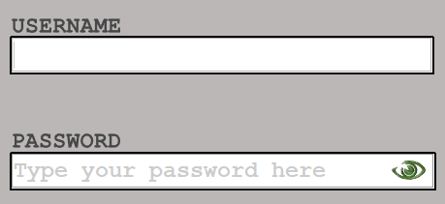

* **Selection of text** – When clicking onto the text already present in the box, all the text is automatically highlighted and allows access to a specific index on a seconds click due to validation that keeps track of selection.

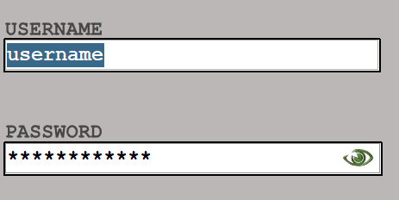

* **Ambiguous register label** – The client suggested the register label should contain extra information such as ‘No account?’ so that it is more accessible.



* **Attempts label syntax** – When the user has 1 attempt remaining to enter the password, the text should switch from ‘attempts’ to ‘attempt’, this error was pointed out by my client and should be edited. The client also did not like the colon at the end of the text and wished for it to be removed.

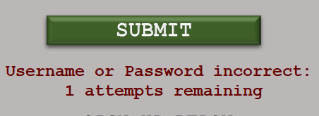

* **Timer label syntax error** – The same error as the attempts label is present when the user has been timed out. The client raised awareness to the fact that the screen says ‘1 seconds remaining’ rather than ‘1 second remaining’/

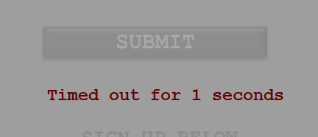

* **Increasing timer** – The client requested that after a timeout, there is a nonlinear increase in time before you can submit any attempts again. Currently it is 30 seconds every time and in doing this, the level of security will be increased.

##### Implementing Client’s suggestions

Attempts label.

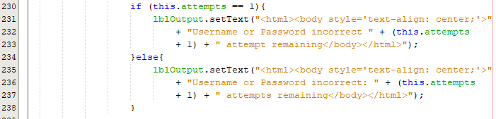

Extra selection to add case for 0 attempts:

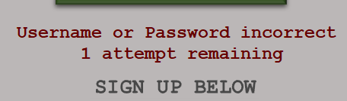

Timer label.

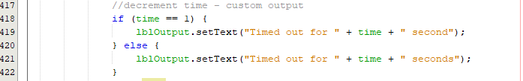

Now when there is 1 second remaining the timer should say ‘second’ rather than ‘seconds’:

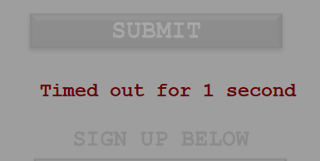

Non-linear timeout increase.

To implement this, I must keep track of how many times the user has been timed out. To achieve this, I simply must keep track of a global variable that increments each time out. I will then multiply this by the time in the timeout function.

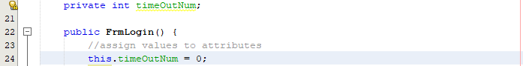

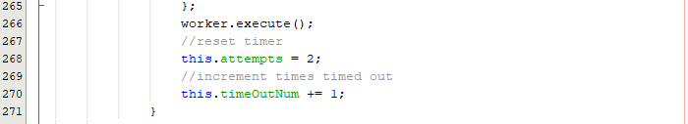

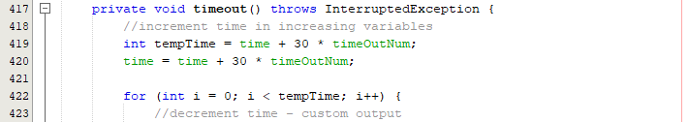

When implementing this code, the timeout function starts at 60 seconds when it should be starting at 30 seconds:

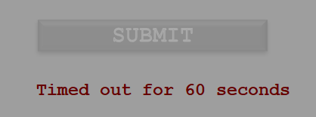

Fixing timer logical error.

To fix this, timeOutNum should be started at -1 to fix this logical issue on line 24.

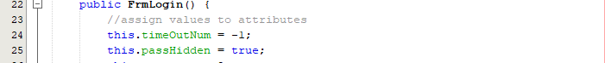



Now that this error has been fixed, we need to check if the timeout increases at a non-linear rate:

On the second timeout:

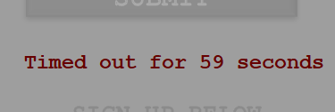

On the third timeout:

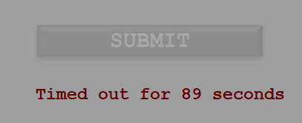

The time seems to be linear so there is clearly an error within the logic.

Fixing the linear logic.

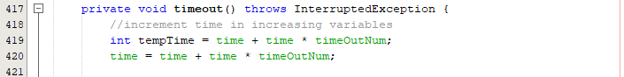

I believe the error was on lines 419 and 420 where now they it is time * timeOutNum rather than 30 * timeOutNum:

On the first timeout:

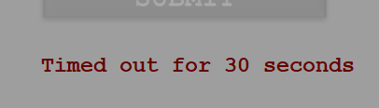

On the second timeout:



On the third timeout:



The error persists so a different view must be considered. In this case I believe timing out the user each by a scale factor is a better option and the time out number should begin from 0:

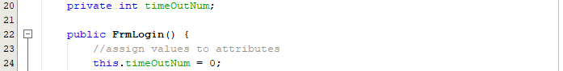

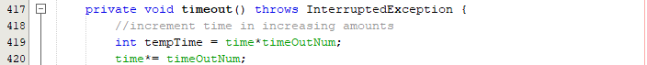

The logic error was on line 428 where the time would actually decrease back down as I decrement it:



This can be edited by having a new variable called display time:

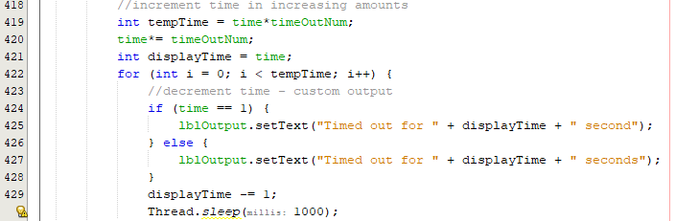

On first timeout:

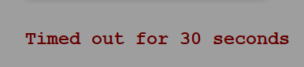

On second timeout:

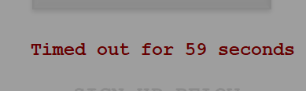

On third timeout:

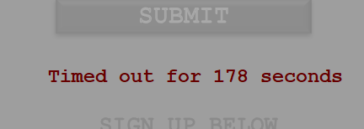

Now the timer logic is successfully working and increases at a non-linear rate.

Layout Corrections

Correcting sign up label:



Fixing spacing of labels – moving sign up options down and moving password/username text fields closer:



Adding a border to the output text so the users understand this is an area where text will be displayed:



Adding instructions:



Here I will have a button that simply toggles some hint text. I must design the button icon before hand and overlay this as the button icon:



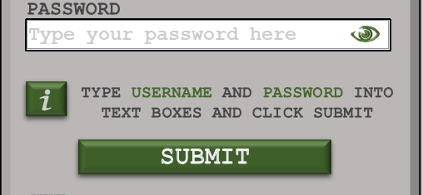

Add hover functions so that the text is only visible when hovering over the icon:

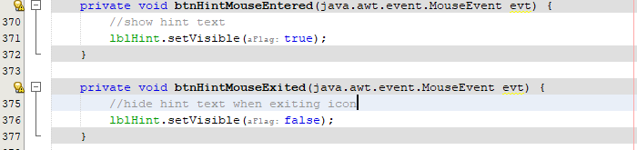



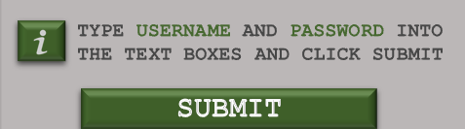

##### Final Login Form

|  |  |
| --- | --- |
|  |  |

#### Conclusion / Evaluation

From the beginning of this cycle to the end, the main purpose was to **improve quality of life**, and this was greatly enhanced. **Many errors** were encountered throughout the development process such as trying to **manipulate threads** to display a dynamic timer. There were also many **logic errors** throughout this cycle linked to the timer and the action listeners responsible for button clicks and the removal/selection of text within boxes. However, these **errors were quickly found** through **debugging** and then resolved as I **planned a fix** and then implemented it.

After creating a final login form that I believed fit the **initial requirements** from the client, I was able to present a **finished prototype** to my **client** in hopes of gaining critical feedback. After a showcase to my client, I documented and noted down everything that was well received and any **feedback** that I could use to revise the login form. After receiving this feedback, I **implemented** all the respective **changes** and was left with a fully **functional login form** with **maximised aesthetics**.

## Cycle #6 – Revising the Register From

### Design

#### Decomposition & Overview

Now, much like the login form before cycle #5, the register from **lacks all usability / quality of life features** that were initially proposed in the **design phase**. The register form is extremely hard to work with currently with there being no instructions and no visual appeal. Features such as **live validation** and features that were implemented in the login form need to be added to the sign-up form in this cycle. As many features were already developed in the login form, it is as simple as **transferring over these modules** to this separate class to re-use these functions.

Functions & features to be added into the cycle:

* Hint text – In the sign-up form, there will be **hint text** in each respective box but as implemented in the login form, the user will be able to **clear the text** with a **single click**. Any attempt to click into the box after this will **highlight** all the text within the box.
* Form location – instead of the login form opening in the top right of the screen, the form should be positioned to the **centre of the screen** as the form is loaded up.
* Graphics – As done within cycle #5, the graphics will be overhauled and enhanced to the initially proposed standard where all the associated icons and backgrounds will be introduced.
* Text colour - The error text will also now **be red** rather than the standard black so that it can correctly be identified as an error to provide **further clarity**. The text within the text box will also now be black rather than grey as this was originally grey for testing purposes.
* Live Validation – Instead of the previous validation where the user was informed of the outcome after the button is pressed, the plan is to add action listeners so that user will be told **in real time**.
* Open login after registration – Currently, the main menus are opened straight away but it would be more beneficial to **return to login menus** after a complete registration so that the user can login with the new details, adding a layer of **security** and **validation**.

#### Usability Features

* Secure password typing - **Passwords** willalso **be** **hidden** when typing it into the text so that no one can see what you have entered if there are people viewing your screen.
* Live validation – The user **does not want to wait** until clicking the submit button before finding out the two passwords do not match, or they are not of the correct format. There will **be live validation** by adding action listeners onto the text box to constantly provide the user with feedback on the password. They will be **told instantly** on the screen if passwords are weak or do not match. This can be implemented through a traffic light system that colours in boxes according to the strength of the password.

#### Validation

The main form of validation being introduced within this cycle is the **real time validity** check where as soon as a user type edits the text field – this can be **typing** keys or **removing** characters which will then run a function that **will validate the current user and password.**

This function runs similarly, if not **identically** to the **current validation** but it will run this validation check constantly. This feature will hopefully **improve usability** as well as decreasing overall time taken to register **valid details** onto the system. Validation will be **output one at a time** and not all at once so that users can focus on fixing one detail.

#### Pseudocode

Within this section of pseudocode, the submit button code was **re arranged** so that the **specific output** texts are now in their **respective functions** so that when the validation is called for the action listener, the **output is correct**.

procedure btnSubmit()

//call function to check if details are valid

valid = checkAllValid()

if valid then

//write details to file

writeToFile(userEnter + "," + passEnter + "\n")

//output success and return to main menu

tfOutput.setText("Successfully registerd!")

FrmRegister.close()

FrmLogin login = new FrmLogin()

else

tfOutput.setText("Check incorrect details")

endProcedure

//check all are valid:

function checkAllValid()

//get text box values

userEnter = ""

passEnter = ""

passConfirm = ""

userEnter = tfUser.getText()

passEnter = tfPass.getText()

passConfirm = tfPass.getText()

//call validate functions

isUniqueUser = checkUniqueUser(userEnter)

isUserFormat = checkUserFormat(UserEnter)

isPassFormat = checkPassFormat(passEnter)

isPassEqual = checkEqual(passEnter, passConfirm)

//check all validation

return isUniqueUser AND isUserFormat AND isPassFormat AND isPassEqual

endprocedure

//vailidate username

function checkUniqueUser(user)

//load all details

details = loadDetails()

for i=0 to storedDetails.length

//split details into user AND password

splits = storedDetails[i].split(",")

//compare stored values

if (user == splits[0]) then

//returns false if username in array

return false

endif

next i

//output for username

tfUserOut.setText("Username already taken!")

//returns true if not in array

return true

endfunction

function checkUserFormat(username)

//converts username to lowercase

username = username.toLower()

//check at least 5 char

if (username.length() < 5 then

return false

for i=0 to username.length()-1

if (NOT username[i].isDigit() OR asc(username[i])<97 OR asc(username[i])>122) then

return false

endif

next i

//output for username

tfUserOut.setText("Username of incorrect format!")

//return true if end reached

return true

endfunction

function checkPassFormat(pass)

//track booleans

special = false

number = false

//password must be 8 in length

if pass.length()<8 then

return false

endif

//check for special char and number

for i=0 to pass()-1

if pass[i].isSpecial() then

special = true

else if pass[i].isDigit() then

number = true

endif

next i

//if password contains both special AND num

if number AND special then

return true

//output for password

tfPassOut.setText("Passwords are not correctly formatted!")

return false

endfunction

function checkEqual(str1, str2)

//check equal

if (str1 == str2) then

return true

else

//output for password

tfPassOut.setText("Passwords not equal!")

return false

endif

endfunction

#### Variable Table

|  |  |  |
| --- | --- | --- |
| Key Variables | Data Type | Justification |
| isHidden | Boolean | This Boolean value is added because as the user clicks the icon to view the hidden password, there must be a variable to keep track of the toggle value. |

As this cycle mainly focuses on the graphics / aesthetics as well as re shuffling the code to manipulate the output, there are not many new variables being introduced within this cycle.

#### Test Table

After implementing all of the changes, the register form must pass all of the previous tests as it is necessary to ensure any new changes have not broken any features that were already present in the program.

These tests will be testing the live validation implemented within this cycle

|  |  |  |  |  |
| --- | --- | --- | --- | --- |
| Test | Test description | Input | Expected outcome | Test type |
| 1 | Test for entering a username that contains characters other than letters or numbers | Invalid username with characters other than letters or numbers | The user is told that the username must only contain letters and numbers and is not allowed to register | Erroneous |
| 2 | Test for entering a username that contains only letters but is not unique | A valid username that has already been registered | User is informed that the username is taken | Normal |
| 3 | Test for entering a unique username that isn’t in the accepted length range | Username with a length of less than 4 letters | User is told that the username must be inclusively between 4 and 10 characters. | Boundary |
| Username with a length of more than 10 characters |
| 4 | Test for a password that isn’t at least 8 characters | Password with a length less than 8 characters | Password is not accepted, and the user should be told the password must be at least 8 characters in length | Boundary |
| 5 | Test for a password that does not have at least one special character | Password not containing any special characters | Password is not accepted, and the user is told that the password should contain at least one special character | Erroneous |
| 6 | Test for a password that does not have at least one number | Password not containing any numbers | Password is not accepted; user is informed that there should be at least one number within the password | Erroneous |
| 7 | Test for entering a correctly formatted first password but a different confirmed password | Formatted correct password, incorrect confirmed password | User is told before submission that the two passwords are not matching and should not be allowed access | Erroneous |
| 8 | Test for entering an incorrectly formatted first password and a different confirmed password | Incorrectly formatted password and non-matching passwords. | User should only be told that the password is of incorrect format before any other warning, so this is what is corrected first | Erroneous |
| 9 | Test the input of a correctly formatted password and a correctly confirmed password, non-unique username | Correctly formatted password and correct confirmed password, non-unique username | User can not submit their details and is notified once again that their password should be unique | Erroneous |
| 10 | Test for all hint text being wiped upon click of any text box | Clicking into the username text field, the password text field and confirm text field | All text within the text box is selected and wiped on click | Normal |

### Coding and Testing

#### Iterative Development and Testing

##### Prototype #1

Converting text fields and adding action listeners:

In this prototype, the action listeners and action listeners developed from the login cycle will be copied over as all components have already been developed and simply need to be re-used.

Changing the password text field to a JPasswordField:





The action listener code must be implemented also:

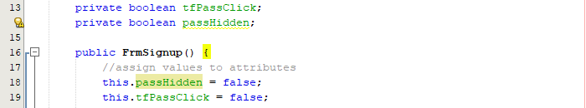

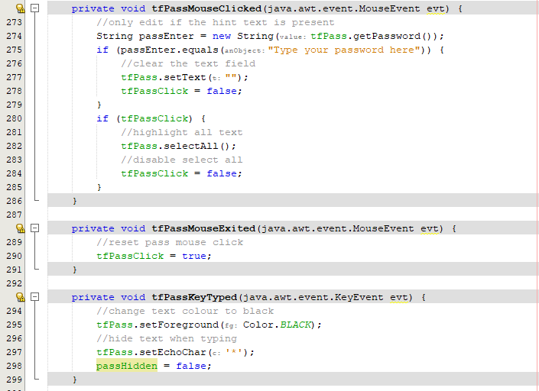

Repeating the password field for confirm password:





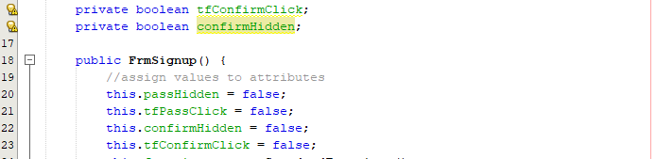

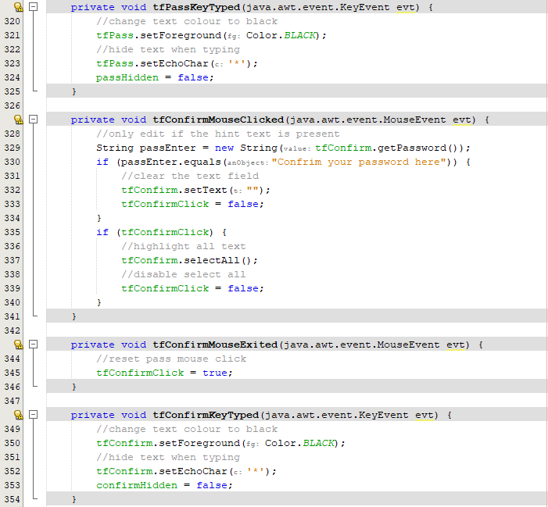

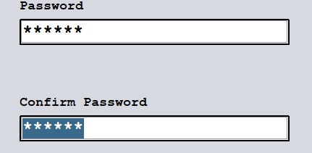

Converting to new user text field:

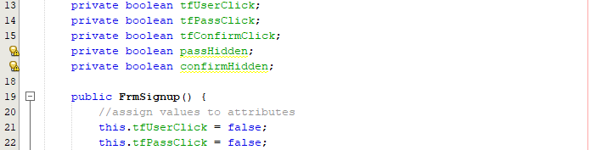

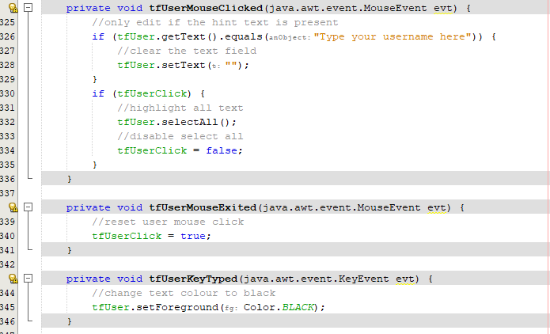

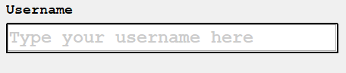

Now that the text fields have been transferred from FrmLogin to FrmSignup, I can now focus on implementing the graphics.

##### Prototype #2

This prototype will now implement the proposed graphics from cycle #1 onto the register form. This process can now be completed at an efficient rate due to the experience gained from doing this process for the login menu.

Applying label graphics:

Text field labels:

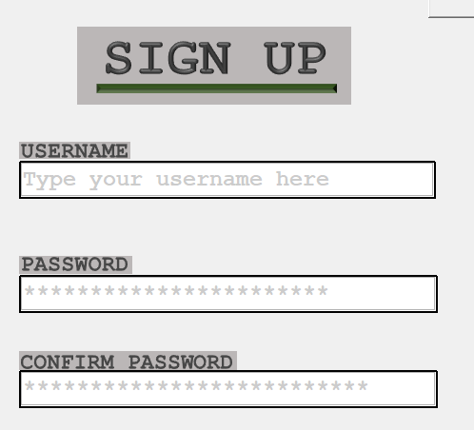

Reducing the gap between confirm and password:

Before:



After:



Adding code so the form opens relative to the centre:



Adding the background:

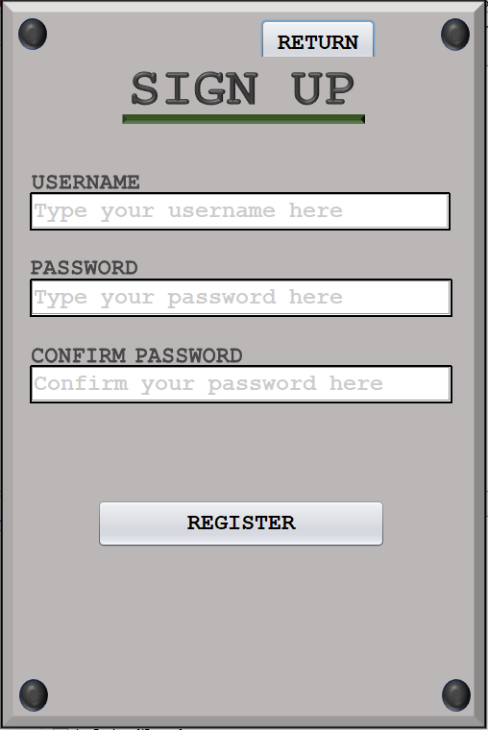

Adding the register button icon:



Highlighted button:



Adding the return button:

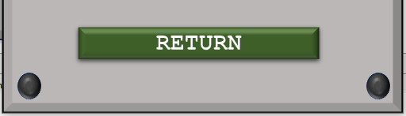

Adding the view hidden password for each password text field:



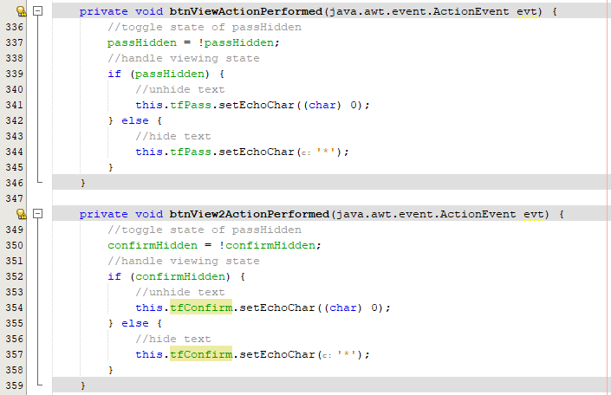

Final graphics for prototype 2:

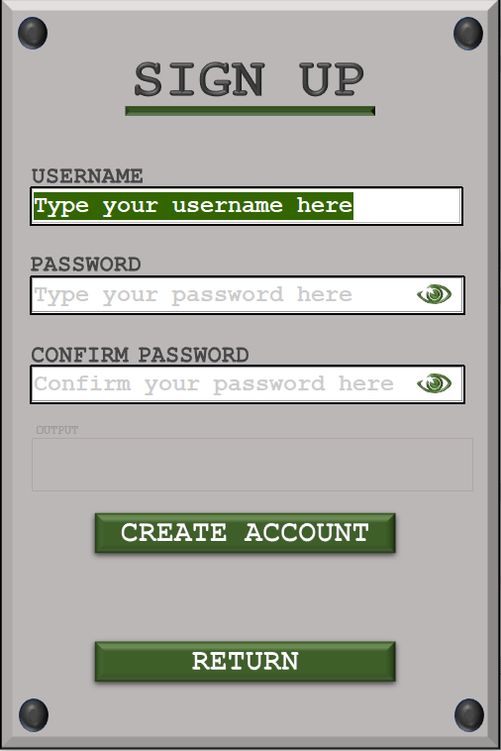

As well as implementing the graphics for all the buttons and labels, I have changed the highlighted text colour to a forest green to match with the rest of the form. All that is left now is to develop the live validation on key presses for the username and password form.

##### Prototype #3

This prototype should be the last prototype for the register form where live validation is implemented so the user can receive tailored feedback in real time.

Implementing live validation:

The first strategy is to split the register function into separate function so that a separate subroutine handles all validation processes. As a result of this, the register button has a more unique and less dense purpose. I will also be spreading the validation process and outputs across the different validation functions so that the text can display accurately.

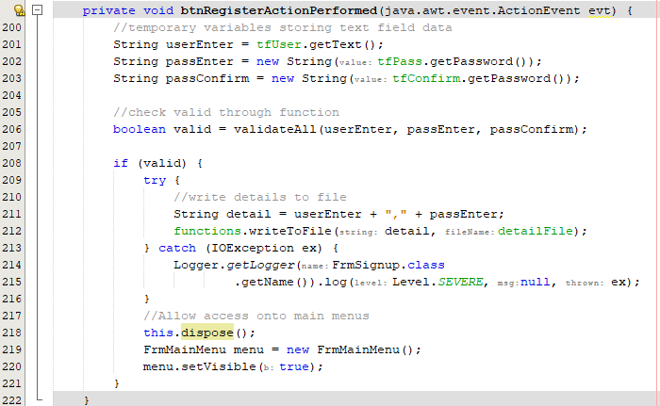

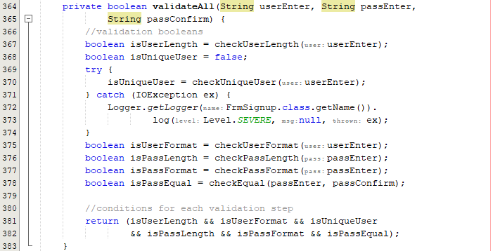

Creating respective output functions:

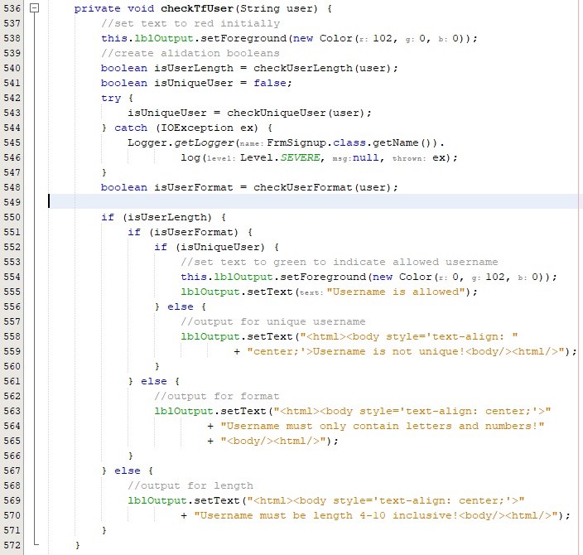

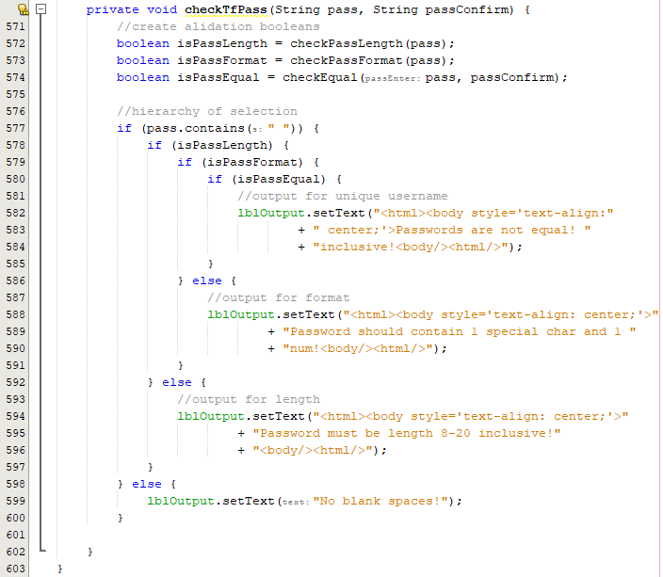



Add action listeners to call these functions on every key press:

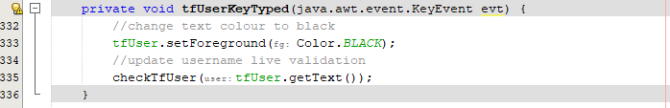

Testing username validation:

|  |  |
| --- | --- |
|  |  |

Here the username is clearly unique, yet it displays a message informing the user that it is. This is due to the logic error on line 552, where the output text is set to a non-unique label.

Fixing the label output logic error 

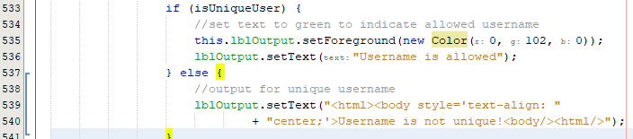

Now the error should be fixed, and the user is told the username is allowed if it passes all checks. If all these checks are passed, the output text is green. The output text is set to red at the start of every check.

When inputting jaivir1234 which is currently not a unique username, this input is allowed when it should not be. This is a clear logic error.

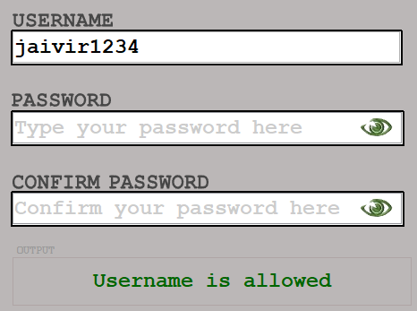

Fixing the logic error for unique usernames:

When typing into the text box, there seems to be a delay in the text being retrieved in the box. I found this out by printing out the value retrieved by the press:



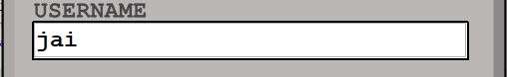

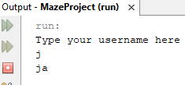

To fix this, I must have an action listener that views the text after the text is written. This will be the key released action listener rather than the key typed action listener.

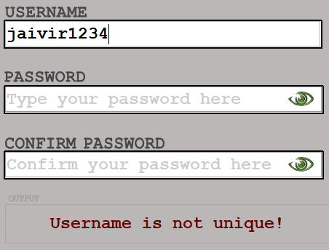

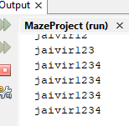

As shown above, the key listeners now correctly retrieve the text in the field when the username is input into the box. Now, I just have to repeat this procedure with the password text fields.

Password text field key listeners:

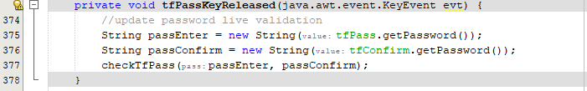

The confirm password should be updated and as the only change you can have is an equal check, it will have the same code as the first password field. This is so users make changes to the first password.

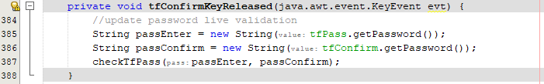

The output should also be updated when clicking into the box so that the associated output is displayed for the field the user is clicking into.

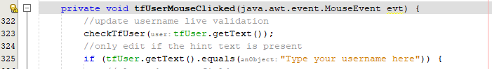

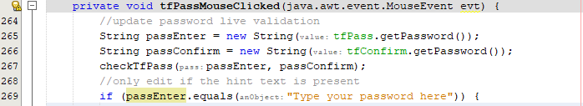

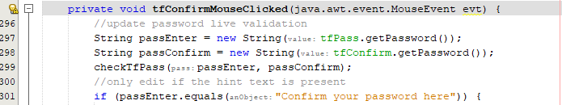

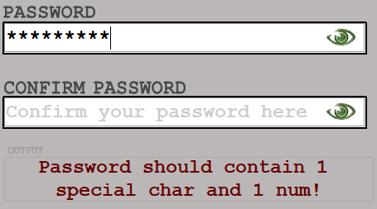

Adding tick icons to indicate completion:



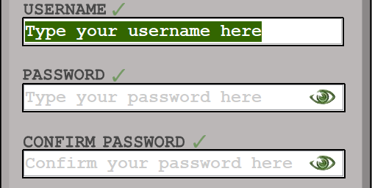

Adding text to toggle icon:

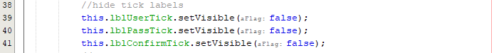

Hide on initial check:



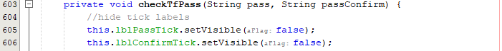

Set visible on valid check:

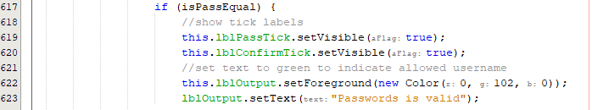

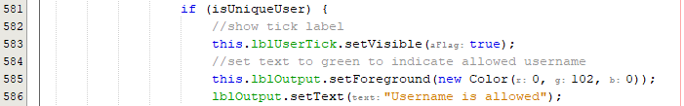

Check disabled initially:

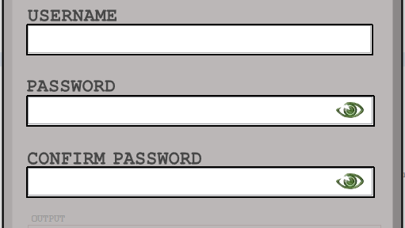

The ticks are disabled initially which passes the criteria. Now I must check for when the username is valid:

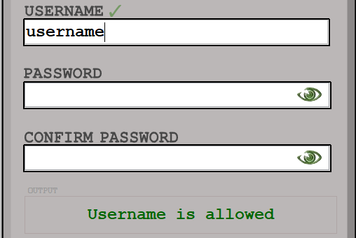

Check for password:

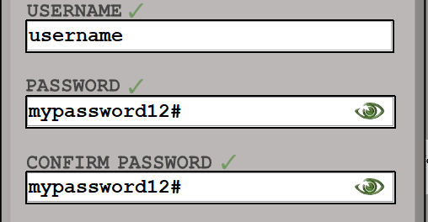

At the end of this prototype, the final login form has been developed. This prototype focused on the implementation of live validation, and I have extended this further to show ticks when the text in the field the user is typing in is fully validated. Key listeners and splitting the validation function allowed bespoke input on every key press and button click into the text fields.

#### Final Cycle Code

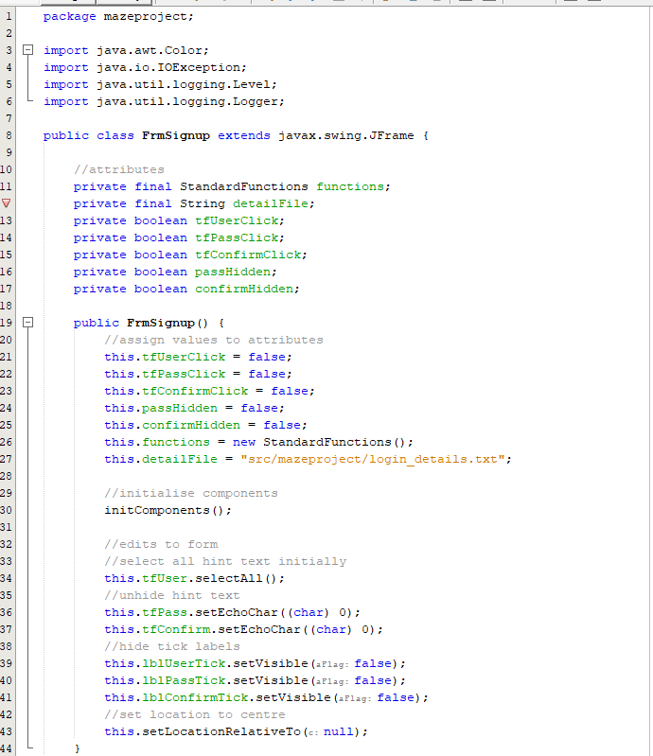

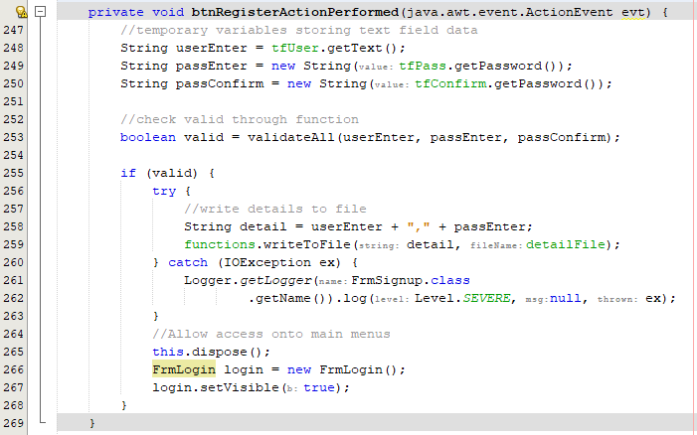



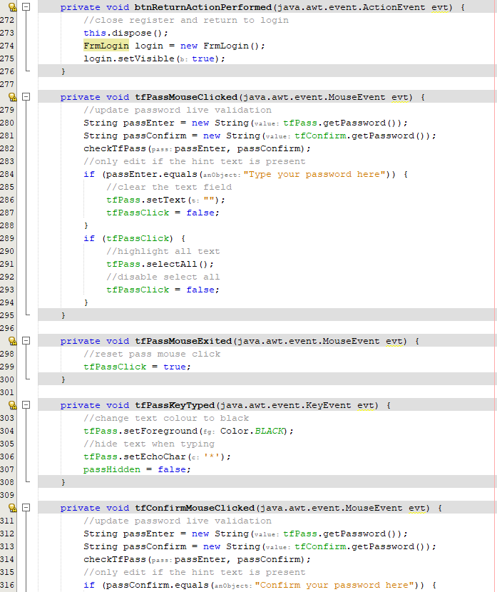

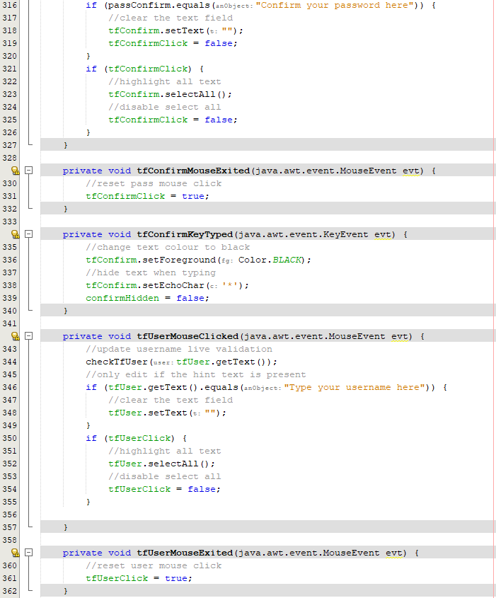

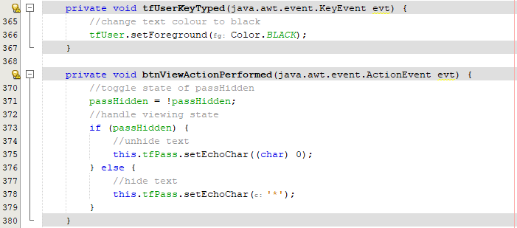

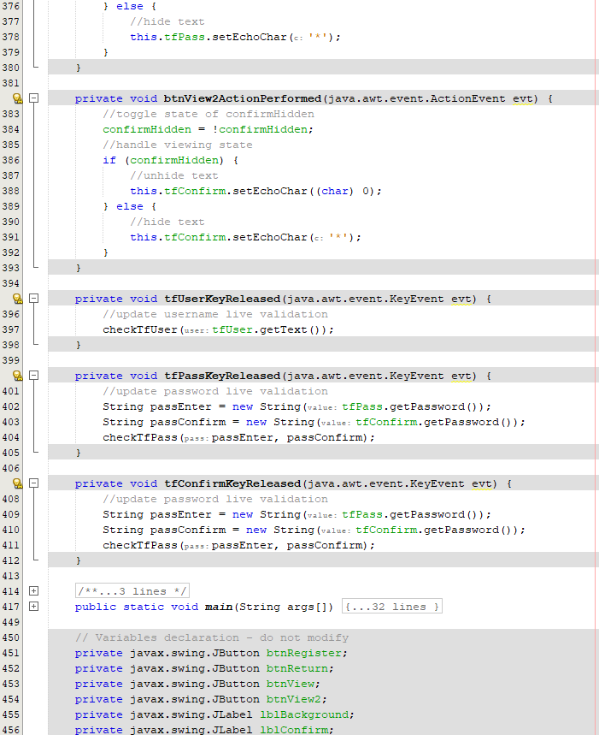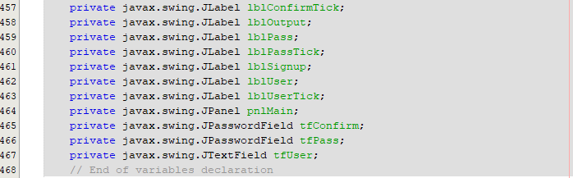

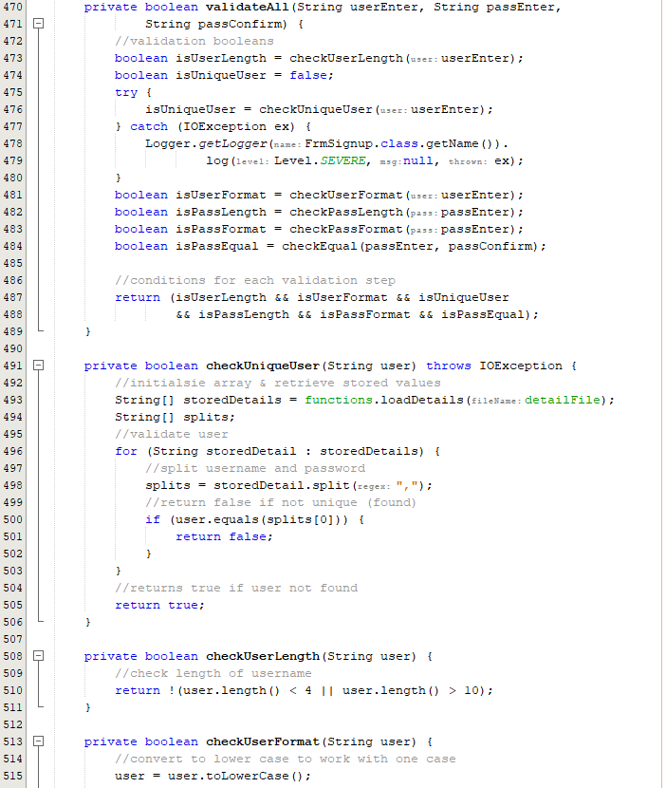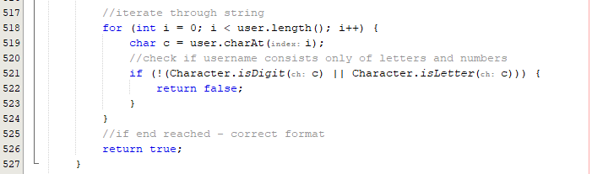

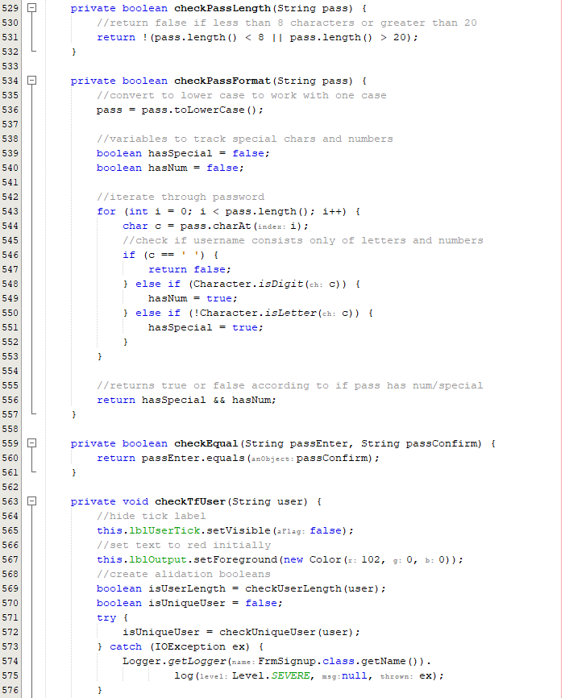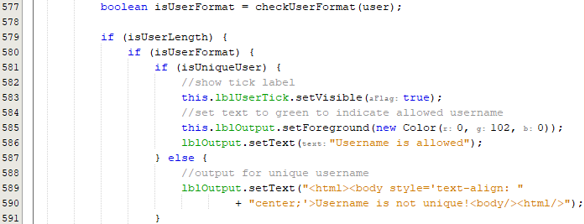

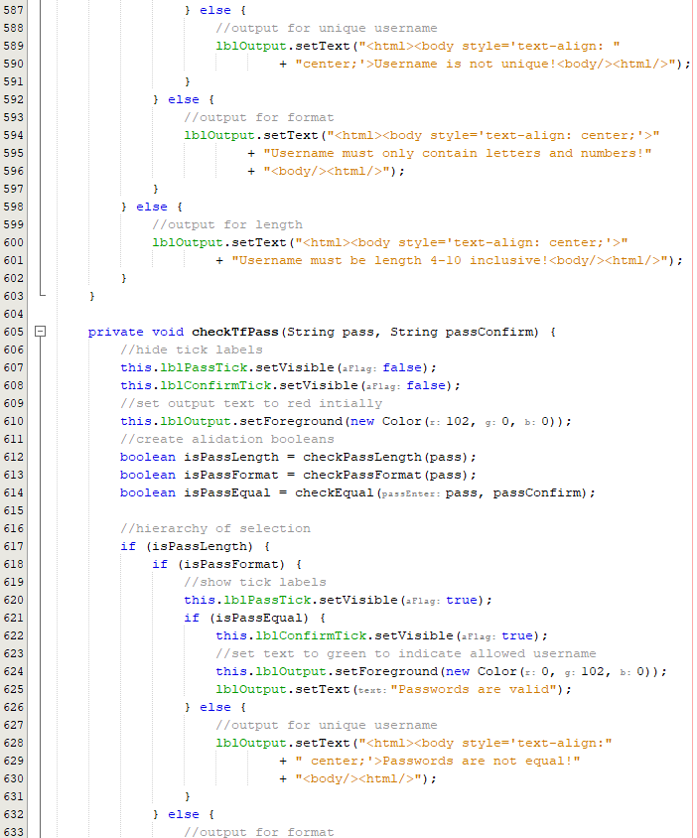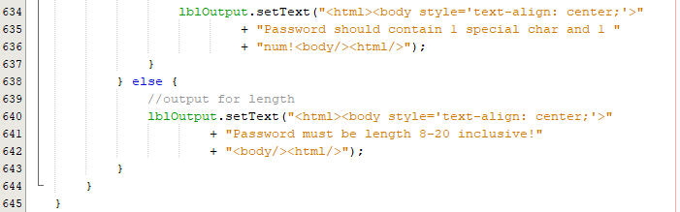

### Review

#### Final testing

|  |  |  |  |  |  |
| --- | --- | --- | --- | --- | --- |
| Test | Test description | Input | Expected outcome | Test type | Test Passed? |
| 1 | Test for entering a username that contains characters other than letters or numbers | Invalid username with characters other than letters or numbers | The user is told that the username must only contain letters and numbers and is not allowed to register | Erroneous |  |
| 2 | Test for entering a username that contains only letters but is not unique | A valid username that has already been registered | User is informed that the username is taken | Normal |  |
| 3 | Test for entering a unique username that isn’t in the accepted length range | Username with a length of less than 4 letters | User is told that the username must be inclusively between 4 and 10 characters. | Boundary |  |
| Username with a length of more than 10 characters |
| 4 | Test for a password that isn’t at least 8 characters | Password with a length less than 8 characters | Password is not accepted, and the user should be told the password must be at least 8 characters in length | Boundary |  |
| 5 | Test for a password that does not have at least one special character | Password not containing any special characters | Password is not accepted, and the user is told that the password should contain at least one special character | Erroneous |  |
| 6 | Test for a password that does not have at least one number | Password not containing any numbers | Password is not accepted; user is informed that there should be at least one number within the password | Erroneous |  |
| 7 | Test for entering a correctly formatted first password but a different confirmed password | Formatted correct password, incorrect confirmed password | User is told before submission that the two passwords are not matching and should not be allowed access | Erroneous |  |
| 8 | Test for entering an incorrectly formatted first password and a different confirmed password | Incorrectly formatted password and non-matching passwords. | User should only be told that the password is of incorrect format before any other warning, so this is what is corrected first | Erroneous |  |
| 9 | Test the input of a correctly formatted password and a correctly confirmed password, non-unique username | Correctly formatted password and correct confirmed password, non-unique username | User can not submit their details and is notified once again that their username should be unique | Erroneous |  |
| 10 | Test for all hint text being wiped upon click of any text box | Clicking into the username text field, the password text field and confirm text field | All text within the text box is selected and wiped on click | Normal |  |

##### Test #1

|  |  |  |  |  |  |
| --- | --- | --- | --- | --- | --- |
| Test | Test description | Input | Expected outcome | Test type | Test Passed? |
| 1 | Test for entering a username that contains characters other than letters or numbers | Invalid username with characters other than letters or numbers | The user is told that the username must only contain letters and numbers and is not allowed to register | Erroneous |  |

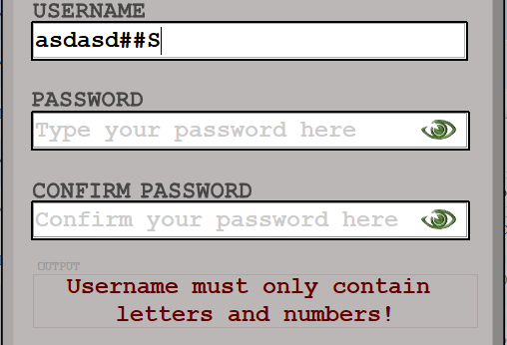

##### Test #2

|  |  |  |  |  |  |
| --- | --- | --- | --- | --- | --- |
| Test | Test description | Input | Expected outcome | Test type | Test Passed? |
| 2 | Test for entering a username that contains only letters but is not unique | A valid username that has already been registered | User is informed that the username is taken | Normal |  |

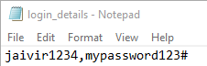

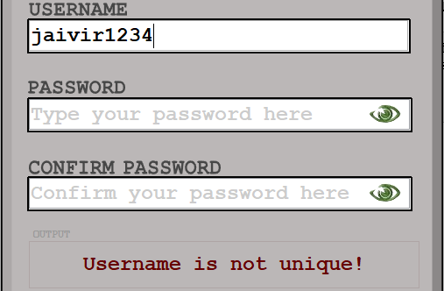

##### Test #3

|  |  |  |  |  |  |
| --- | --- | --- | --- | --- | --- |
| Test | Test description | Input | Expected outcome | Test type | Test Passed? |
| 3 | Test for entering a unique username that isn’t in the accepted length range | Username with a length of less than 4 letters | User is told that the username must be inclusively between 4 and 10 characters. | Boundary |  |
| Username with a length of more than 10 characters |

|  |  |
| --- | --- |
|  |  |

##### Test #4

|  |  |  |  |  |  |
| --- | --- | --- | --- | --- | --- |
| Test | Test description | Input | Expected outcome | Test type | Test Passed? |
| 4 | Test for a password that isn’t at least 8 characters | Password with a length less than 8 characters | Password is not accepted, and the user should be told the password must be at least 8 characters in length | Boundary |  |

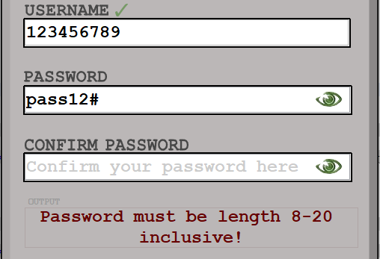

##### Test #5

|  |  |  |  |  |  |
| --- | --- | --- | --- | --- | --- |
| Test | Test description | Input | Expected outcome | Test type | Test Passed? |
| 5 | Test for a password that does not have at least one special character | Password not containing any special characters | Password is not accepted, and the user is told that the password should contain at least one special character | Erroneous |  |

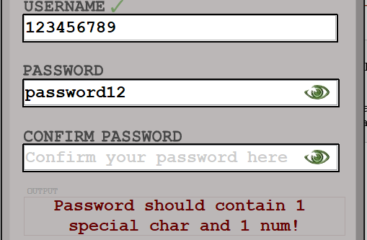

##### Test #5

|  |  |  |  |  |  |
| --- | --- | --- | --- | --- | --- |
| Test | Test description | Input | Expected outcome | Test type | Test Passed? |
| 5 | Test for a password that does not have at least one special character | Password not containing any special characters | Password is not accepted, and the user is told that the password should contain at least one special character | Erroneous |  |



##### Test #6

|  |  |  |  |  |  |
| --- | --- | --- | --- | --- | --- |
| Test | Test description | Input | Expected outcome | Test type | Test Passed? |
| 6 | Test for a password that does not have at least one number | Password not containing any numbers | Password is not accepted; user is informed that there should be at least one number within the password | Erroneous |  |

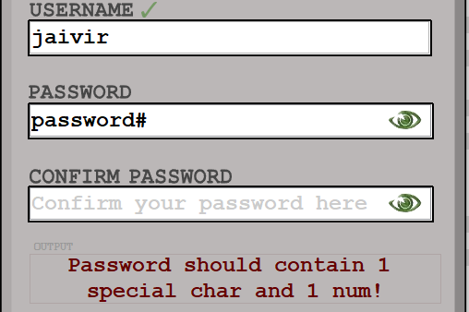

##### Test #7 & #8

|  |  |  |  |  |  |
| --- | --- | --- | --- | --- | --- |
| Test | Test description | Input | Expected outcome | Test type | Test Passed? |
| 7 | Test for entering a correctly formatted first password but a different confirmed password | Formatted correct password, incorrect confirmed password | User is told before submission that the two passwords are not matching and should not be allowed access | Erroneous |  |
| 8 | Test for entering an incorrectly formatted first password and a different confirmed password | Incorrectly formatted password and non-matching passwords. | User should only be told that the password is of incorrect format before any other warning, so this is what is corrected first | Erroneous |  |

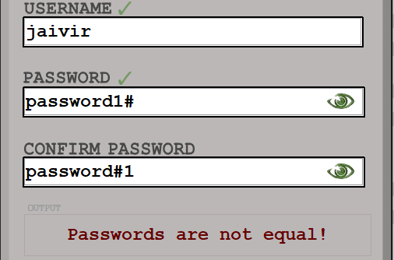

##### Test #9

|  |  |  |  |  |  |
| --- | --- | --- | --- | --- | --- |
| Test | Test description | Input | Expected outcome | Test type | Test Passed? |
| 9 | Test the input of a correctly formatted password and a correctly confirmed password, non-unique username | Correctly formatted password and correct confirmed password, non-unique username | User can not submit their details and is notified once again that their username should be unique | Erroneous |  |

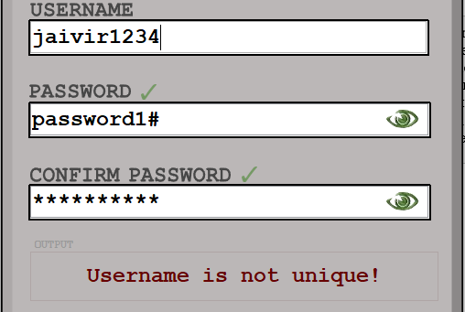

##### Extra Test

Testing all valid details:

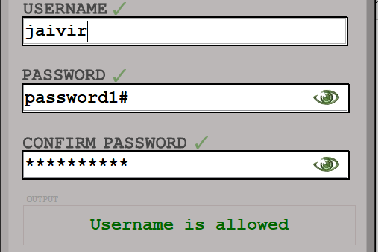

#### Conclusion

The aim of this cycle was to **revise the register form** by adding all the **extra validation** for usability and adding the proposed graphics. All these tasks were successfully carried out and by the end of this cycle, there were **no errors in final testing** meaning the register form works as intended and it maintained all previous functionality from cycle #3.

The largest **error** encountered was **mid development** and this was the logic for the label output. The branch of selection responsible for the username validation was displaying the final output text **incorrectly**. This was due to the **code missing one final else** **statement** that would separate conditions and successfully inform the user that username is valid on completion. Apart from this, this **cycle has been smooth** as it re used many components from the **login form** as both pages are very **similar in nature** and in **function**.

Now the login and register form are **both complete,** the main game and visualiser can be developed as the user can successfully access the system. This cycle was extremely **successful** and allows a smooth transition into creating the Maze Class using **Prim’s algorithm**

## Cycle #7 – Developing the Maze Class

### Design

#### Decomposition & Overview

Before developing the main products maze visualiser / maze player features there must be a separate Maze class with all the associated functions responsible for creating a maze and manipulating a maze. This maze class will be called withing the separate classes for the visualise and play mode and heavily promotes object-oriented programming where this maze entity is separate from the rest of the program with its corresponding attributes.

Outlining the Maze Class through object-oriented programming principles:

* Attributes – the attributes of the maze class are initialised within the constructor and a few of these variables will vary depending on what values are passed through the parameters on instantiation.
  + **X value** – This determines the length of the maze.
  + **Y value** – This determines the width of the maze.
  + **2D array maze** – 2D integer array to hold all cells of the maze – each cell is either a 1 or a 0 and this represents a wall or a path.
* Constructor– within the constructor, any attributes will be assigned corresponding values whether through parameters or in the program.
  + **X value** – this is set to the value passed through the parameter and cannot be changed.
  + **Y value** – this is also set to the value passed through the parameter and will not be changed through the entirety of the program.
  + **2D array maze** - A 2D maze is created with the X value and the Y value, all values initially are 0s as this is the Java standard when creating blank integer arrays.
* Getter – When accessing an instance of the Maze class it will be useful in the future to get access to the integer values of the maze.
  + **getMaze()** - this function returns the current state of the maze class through #
* Other functions– any other functions that will benefit the development of the maze class.
  + printMaze() – at this stage a print maze function is mandatory and will greatly help testing purposes to view the state of the maze.

Method of implementation:

Prim’s algorithm is a minimum spanning tree andbuilds a tree one vertex at a time [22],

1. Start with a grid of walls.
2. Choose a random cell and mark it as part of the maze, add the walls of the cell to the wall list.
3. Whilst there are walls in the list:
   1. Pick a random wall, if only one of the cells that the walls divides is visited then:
      1. Remove the wall between the cells and mark the unvisited cell as part of the maze.
      2. Add the neighbouring walls of the cell to the existing wall list.
   2. Remove the wall from the list.
4. After the while loop finishes, the maze will be fully generated.

Java implementation:

As within Prim’s algorithm I will be focusing on adjacent paths to create a stream of connected paths, a useful data structure to use will be the LinkedList data structure [27]. This structure allows reference to the next node which is perfect for prims algorithm due to the nature of the maze creation.

The Linked List in Java is a linear data structure, and each element is separate (can be referred to as a node) and this is useful as additions can be made easily to create chains of nodes to be checked in a connected pathway. When checking all the edges of a vertex, it can be removed from the previous list easily as items are shifted. This is why it is much more useful than an Array List in Java.

#### Pseudocode

procedure generateMaze(maze)

//initialize the maze as a grid filled with walls

for i=0 to maze.length

for j=0 to maze[i].length

//set each cell to be a wall

maze[i][j] = 1

next j

next i

//initialise a linked list to store the potential paths

potentialPaths = ()

//random co ords

start = random(maze.length)

end = random(maze[i].length)

//start with a single path at a random location

//random starting and end reference

potentialPaths.append({start, end, start, end})

//iterate until all cells are in the maze

while potentialPaths.length != 0

//remove random path from the list

path = remove(potentialPaths, random(potentialPaths.length))

//assign co ordinates from current removed path

x1 = path[0]

y2 = path[1]

x2 = path[2]

y2 = path[3]

//if the cell is a wall, carve a path and add new potential paths

if maze[x2][y2] == 1 then

//carve a path - 0 is a path

maze[x1][y1] = maze[x2][y2] = 0

//check the four directions around the cell

if x2 >= 2 AND maze[x2 - 2][y2] == 1 then

//add new connected potential path to the north

potentialPaths.append({x2 - 1, y2, x2 - 2, y2})

endif

if y2 >= 2 AND maze[x2][y2 - 2] == 1 then

//add new connected potential path to the west

potentialPaths.append({x2, y2 - 1, x2, y2 - 2})

endif

if x2 < maze.length - 2 AND maze[x2 + 2][y2] == 1 then

//add new connected potential path to the south

potentialPaths.append({x2 + 1, y2, x2 + 2, y2})

endif

if y2 < maze[i].length - 2 AND maze[x2][y2 + 2] == 1 then

//add connected new potential path to the east

potentialPaths.append({x2, y2 + 1, x2, y2 + 2})

endif

endif

endwhile

//return the generated maze after potential paths is empty - (complete maze)

return maze

endfunction

#### Variable Table

|  |  |  |
| --- | --- | --- |
| Key Variables | Data Type | Justification |
| maze | 2D Array | This is the 2D integer array assigned by the x value and y value input by the user. This is an integer array so that walls and paths can be represented by 0s and 1s |
| x | Integer | This attribute of the Maze class determines the number of rows of the maze – parsed through user input |
| y | Integer | This attribute of the Maze class determines the number of columns of the maze – parsed through user input |
| potentialPaths | List | This list keeps tracks of any paths that can be connected to the main maze. This is needed to assess adjacent cells for Prim’s algorithm follows. |

#### Test Table

|  |  |  |  |  |
| --- | --- | --- | --- | --- |
| Test | Test description | Input | Expected outcome | Test type |
| 1 | Test for a fully encased maze | Any size maze | The maze is encased by walls to make a grid and is full of paths inside. | Normal |
| 2 | Test for producing a solvable maze | Maze of size 20x20 | A maze grid that has a path from the first square to the final square | Normal |
| 3 | Test for a maze working at least 5 different sizes | Mazes of any size e.g., 8x8, 12x12, 16x16 | On each maze size, there is a path from the starting square to the final square. | Normal |
| 4 | Test to reach any point in the maze | Start at any point in a maze | From starting point, any point in this maze can be reached –successful application of prim’s algorithm | Normal |

### Coding and Testing

#### Iterative Development and Testing

##### Prototype #1

Developing the blueprint of the maze is the current priority where I must outline the attributes and then assign values to attributes. When calling this maze class, the user will define the maze dimensions so the x value and y value of the 2D array must be passed through so that the array can be made with these restrictions:

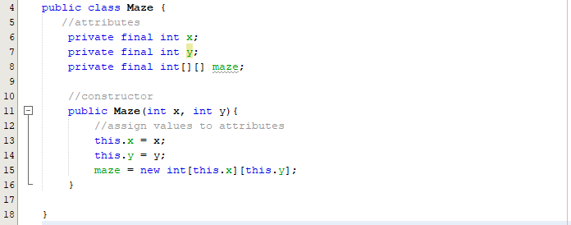

To test that the maze is correctly being represented as a grid, I can implement a print maze procedure that prints the current maze state to the console:

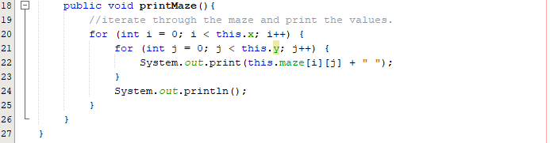

For testing purposes, I will create a class called Tester to check if the 2d array is being assigned correctly; I will create a 10x10 maze and print the maze to the console:

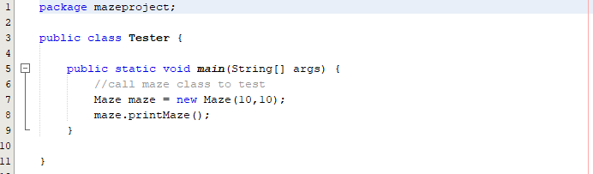

Output of maze:

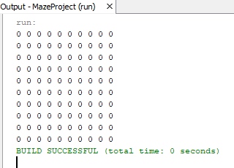

As seen above, there is clearly an empty maze represented by 0s being output to the console.

##### Prototype #2

Now that I have the maze blueprint, I can start generating the maze using Prim’s algorithm.  
Adapting the pseudocode to Java:

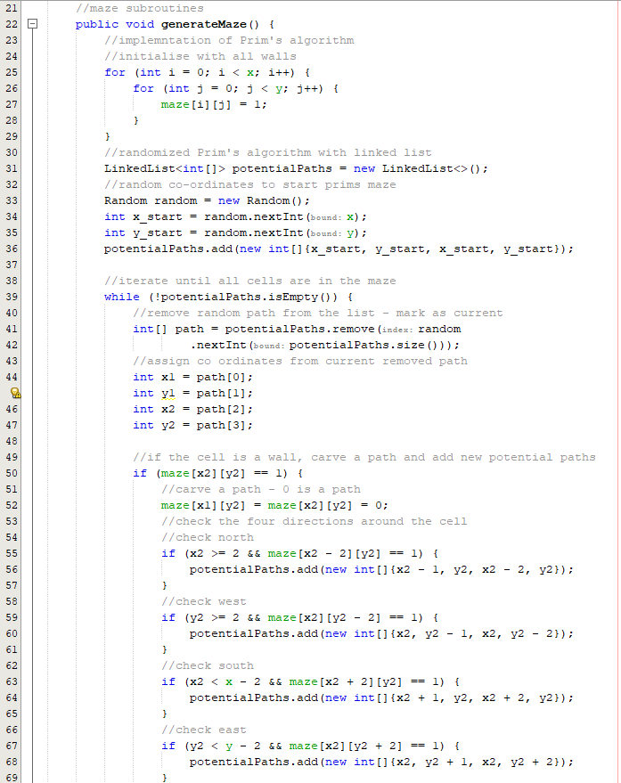

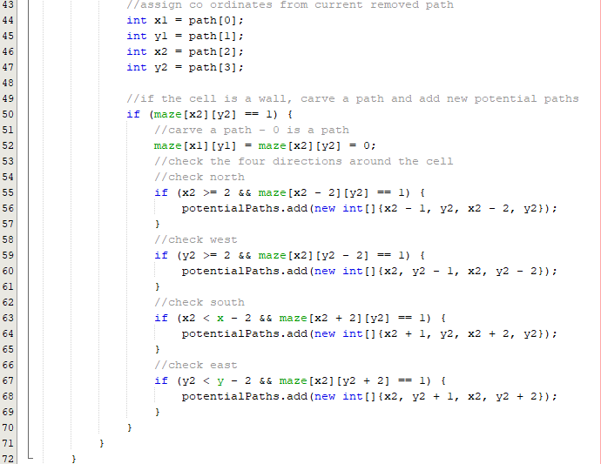

Now the code is developed, I can text if a correct maze is being output to the screen:

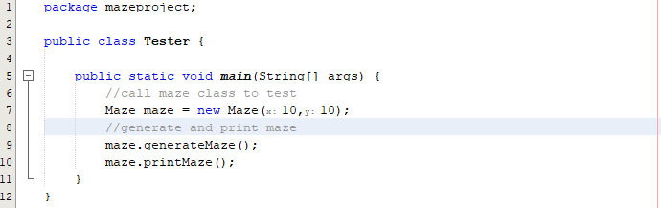

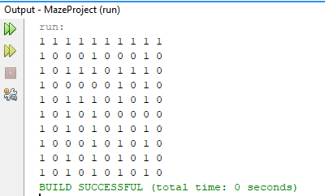

This current maze build is definitely incorrect just by looking at the edges as there is clearly 2 missing wall encasings on the east side and west side. However, this is a great start for the first implementation of Prim’s algorithm as a correct maze was partially made. To make this clear, I will draw on the output to show the maze:

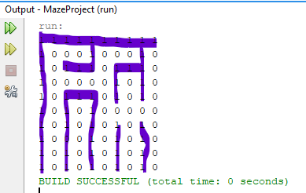

As you can see above, this is actually a solvable maze that is only missing the encasing on the southeast corner.

To save myself the hassle of continuously drawing over this maze to view the structure, I will develop a temporary Java Swing frame that displays this through labels.

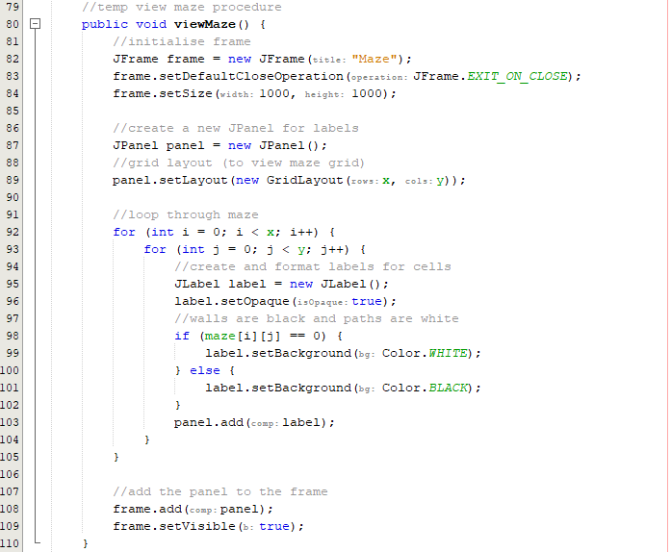

Test the view maze by calling it in the tester:

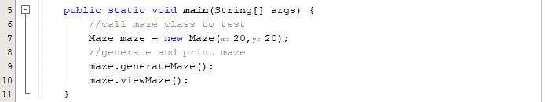

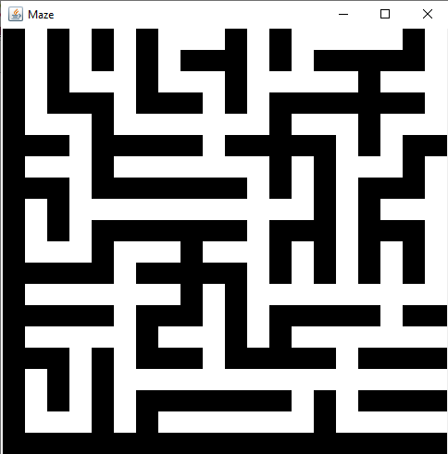

As shown above, the maze can now be viewed easily. To assess the shape of a 20x20 maze and the encasing I will run the maze a few times:

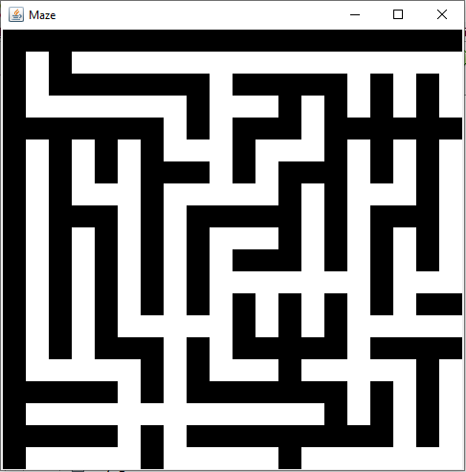

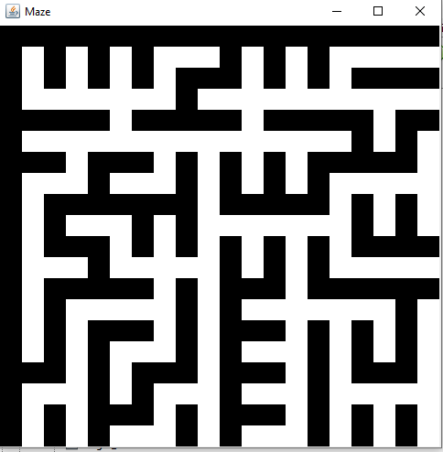

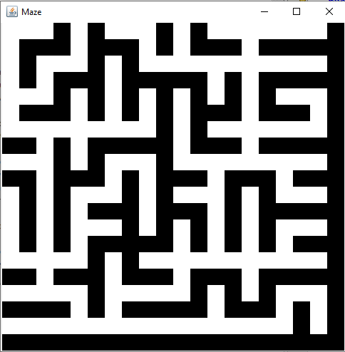

From running this a few times, I can see that the encasing is random, and this is very likely to be due to the random starting positions that are generated each turn.

The next step is to test with a maze created by odd numbers for the x and y:



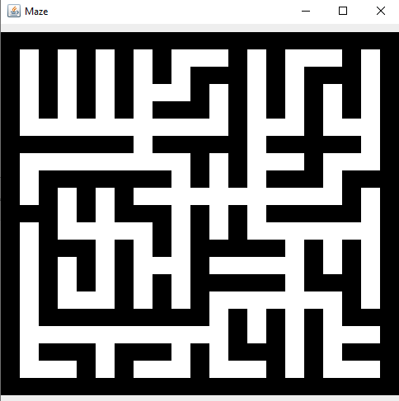

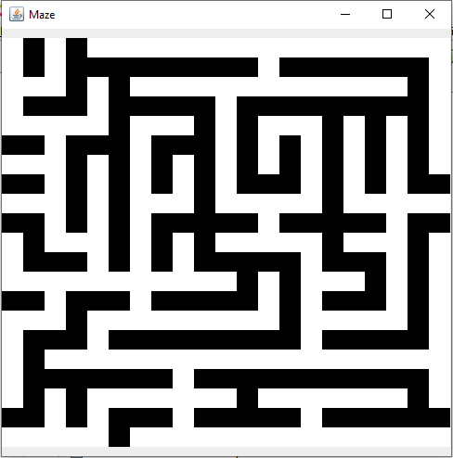

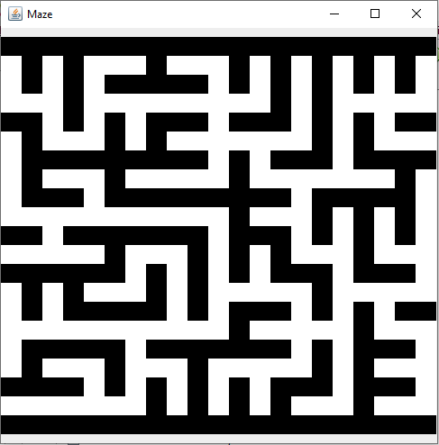

When working with odd numbers, there are many different encasing cases – sometimes it is full whereas sometimes there is no encasing or just on 2 sides. For simplicity sakes, I will be focusing on even maze shapes as this will be what my maze parameters will be in the future.

Fixing the encasing error:

My first thought would be to encase this maze in a new one that is larger by one size:

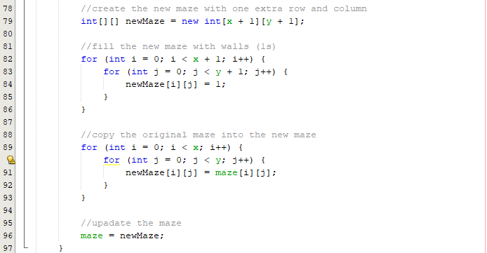

Testing by generating mazes:

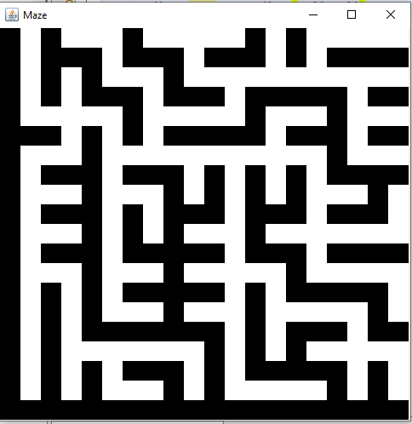

With this code, it seems like no change is being made therefore I must change my strategy. I think adding detection is the first step so I will try to add detection for which side of the maze is encased.

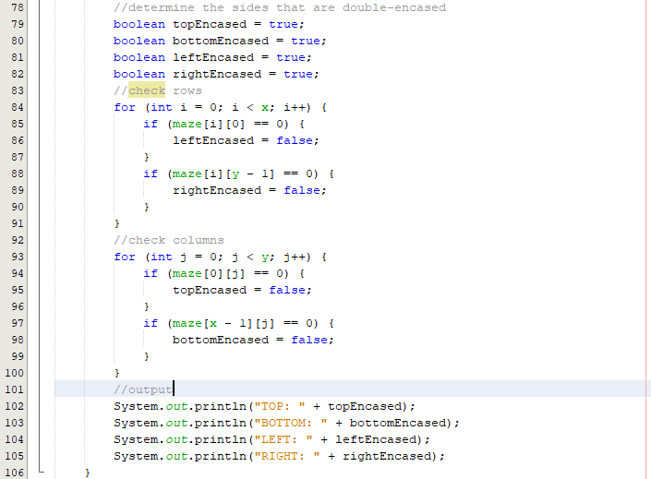

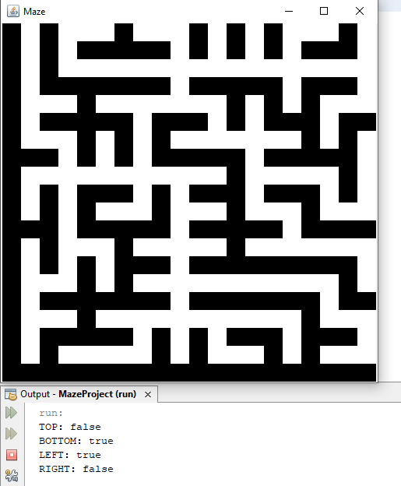

Here the code correctly identified that the bottom left was encased as bottom and left were output as true.

The next step is to add detection to encase the maze based on these variables. For example, if bottom left encased, place the maze in the bottom left of the new maze of a larger size:

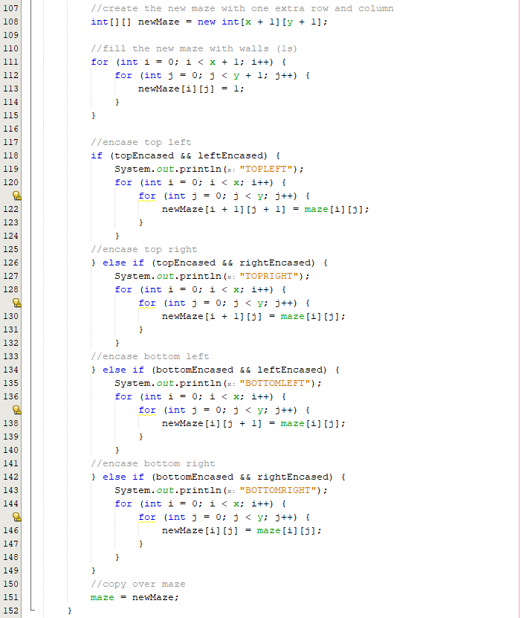

I have included the print statements for testing purposes. Now it is important to test a few more maze prints:

|  |  |
| --- | --- |
|  |  |
|  |  |

Here we can see that the mazes are not being created correctly and are encasing twice on the same side. However, some sides are not being double encased, therefore creating a multitude of error cases. To attempt a fix, I must change the code for each encasing case, I will consider copying to rows and columns:

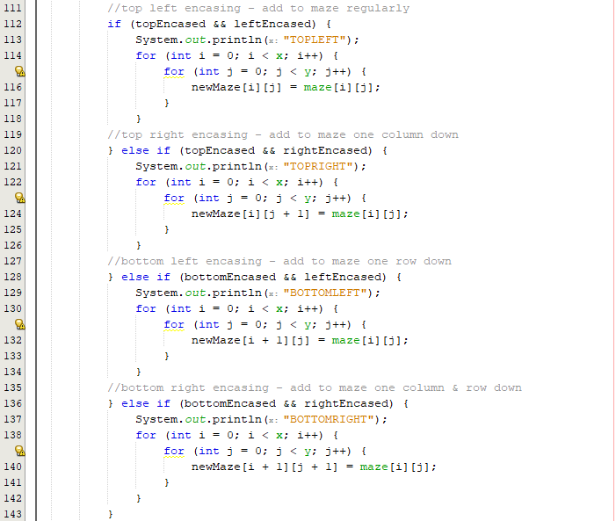



View maze logic error:

It also came to my attention that, the view maze was not printing out the mazes correctly as it was only calling the rows of the original length – not the new maze length. To change this, when iterating with a for loop I can use maze length rather than x and y.:

Before:



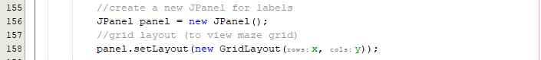

After:



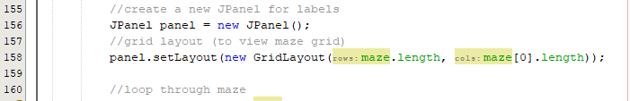

Testing mazes:

|  |  |
| --- | --- |
|  |  |
|  |  |
|  |  |

Now I have successfully generated fully encased mazes. However, I am not satisfied with this result. The only maze that seems proper is the bottom left print screen. This is because this was top left encasing where it does not cut off any white squares. The other 3 mazes have cut off corridors, so they look incomplete or malformed on one certain corner.

Fixing the malformed corner:

The best choice right now is to restart from the original maze as I must reconsider my logic to formulate a better fix that produces aesthetic mazes. Right now, I want a result that is constant. For example, a constant encasing each time. This way I can always have the same encasing for each iteration. I’m aiming to get top left encasing to produce visually pleasing mazes such as the one in the bottom right within the set of screenshots above.

A thought that comes time to mind is to alter the starting position of the generation. Maybe if I start a set square each time rather than a random starting position, I can keep achieving a constant encasing. The maze will always be random in paths, but the encasing could theoretically be constant this way:

Before:



After:



Running the code:

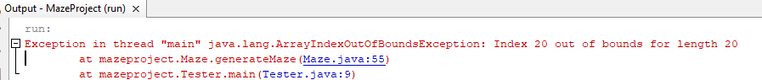

This error is present due to an index out of bounds. This is because I have overlooked the fact that the length of the maze should be 1 less to correctly match the 2D array index system:

Fix:



Running mazes:

|  |  |  |
| --- | --- | --- |
|  |  |  |

As shown above, this simple edit now correctly develops mazes that Always have a top left encasing. Now I just need to add this into a maze that is bigger in length by one row and one column:

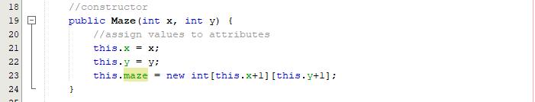

Testing mazes:

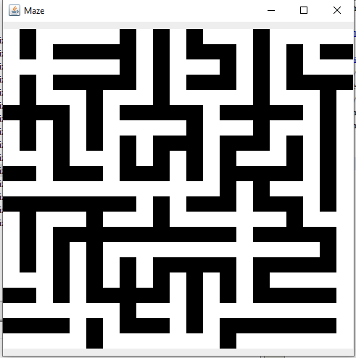

Now after this test, I’m missing all encasing.

Fixing no encasing logic issue:

To fix this issue, it will be better to work with x’s and y’s so I should change all of these first:



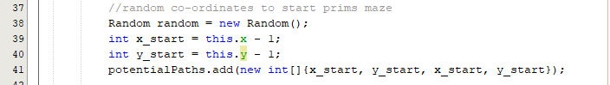

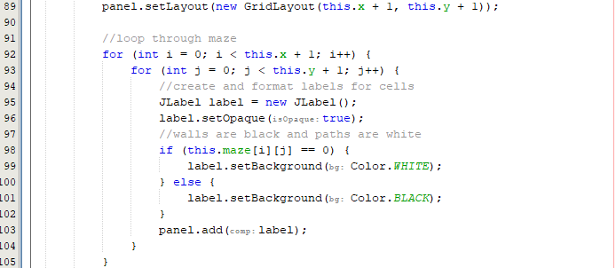

Now that the x’s and y’s are in use rather than checking the current maze length, I can run my maze.

Testing mazes:

|  |  |
| --- | --- |
|  |  |
|  |  |

After running all of these tests, I now finally have mazes that are always fully encased an no paths are being cut off due to forced encasing. Now that I have these mazes, I can clean up the Maze class and add a getter function that will return the current maze state:

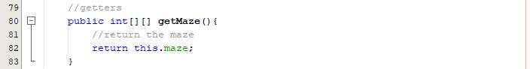

#### Final Cycle Code

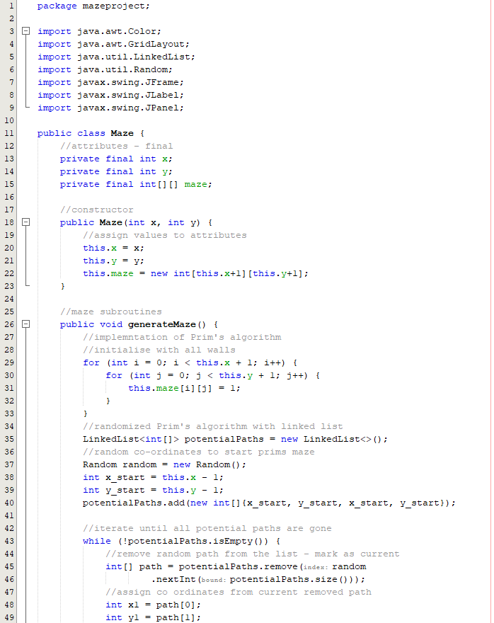

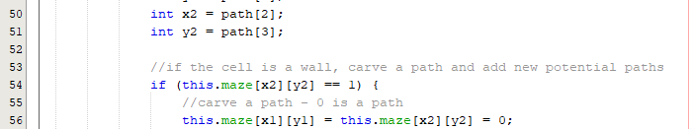

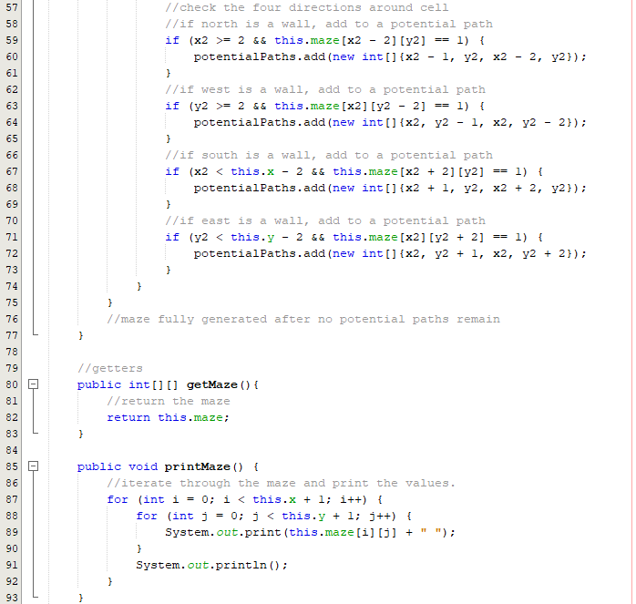

### Review

#### Final testing

|  |  |  |  |  |  |
| --- | --- | --- | --- | --- | --- |
| Test | Test description | Input | Expected outcome | Test type | Test passed? |
| 1 | Test for a fully encased maze | Any size maze | The maze is encased by walls to make a grid and is full of paths inside. | Normal |  |
| 2 | Test for producing a solvable maze | Maze of size 20x20 | A maze grid that has a path from the first square to the final square | Normal |  |
| 3 | Test for a maze working at least 3 different sizes | Mazes of any size e.g., 8x8, 12x12, 16x16 | On each maze size, there is a path from the starting square to the final square. | Normal |  |
| 4 | Test to reach any point in the maze | Start at any point in a maze | From starting point, any point in this maze can be reached –successful application of prim’s algorithm | Normal |  |

##### Test #1

|  |  |  |  |  |  |
| --- | --- | --- | --- | --- | --- |
| Test | Test description | Input | Expected outcome | Test type | Test passed? |
| 1 | Test for a fully encased maze | Any size maze | The maze is encased by walls to make a grid and is full of paths inside. | Normal |  |

60x60 maze:

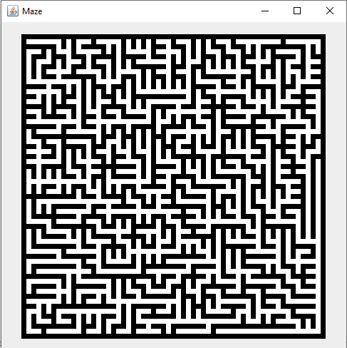

The maze has full enclosure and can be regarded as a completed grid.

##### Test #2

|  |  |  |  |  |  |
| --- | --- | --- | --- | --- | --- |
| Test | Test description | Input | Expected outcome | Test type | Test passed? |
| 2 | Test for producing a solvable maze | Maze of size 20x20 | A maze grid that has a path from the first square to the final square | Normal |  |

|  |  |
| --- | --- |
|  |  |
|  |  |

In these 4 iterations, it is evident that every maze is solvable with a unique solution from the starting square to the final square, therefore passing the test.

##### Test #3

|  |  |  |  |  |  |
| --- | --- | --- | --- | --- | --- |
| Test | Test description | Input | Expected outcome | Test type | Test passed? |
| 3 | Test for a maze working at least 3 different sizes | Mazes of any size e.g., 8x8, 12x12, 16x16 | On each maze size, there is a path from the starting square to the final square. | Normal |  |

Testing 4 sizes, 10, 20, 30, 40:

|  |  |
| --- | --- |
|  |  |
|  |  |

All of these sizes produce working mazes that are fully encased and have a unique solution.

##### Test #4

|  |  |  |  |  |  |
| --- | --- | --- | --- | --- | --- |
| Test | Test description | Input | Expected outcome | Test type | Test passed? |
| 4 | Test to reach any point in the maze | Start at any point in a maze | From starting point, any point in this maze can be reached – indicates successful application of prim’s algorithm | Normal |  |

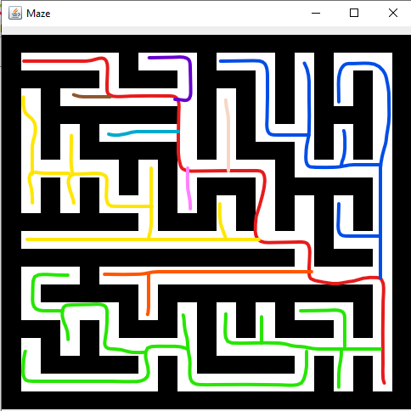

Every branch that comes off the main path (red) explores every path. This geometrically shows that any path coming off the solution which is the red path is connected to all the other paths coming off the main path. This shows that any point can reach another from any point within the maze.

#### Conclusion

After finishing this maze cycle, I have **successfully** been able to create a program that outputs fully **solvable mazes** through the process of **Prim’s algorithm**. The program picks a starting point for the generation (I have chosen the bottom right square for a more stable generation) and then searches for **potential paths** where it will then begin to fill in these paths as the algorithm progresses. As adjacent cells are checked, it is ensured that a **fully solvable maze** is generated, and a full path is present from the starting point to the end point.

Currently, the maze class contains functions that allow the user to access the current state of the maze in the form of a **2D integer array**. This will be useful as after the maze is generated, the visualiser class can create a maze and display this to the screen using the array. The visualiser class which will be the next cycle will contain an **update panel** function that documents the maze generation process in detail **in real time** to the user. The play class where the user can play a generated maze will also use these methods to generate the maze the user will be working for.

The main error encountered during the final prototype was the **encasing issue**. This error stems from my **adaptation of Prim’s** algorithm, I believe the error arrived from a **potential path** being located on the **edge** square which will lead to a **chain of paths** along an edge side. To fix this problem, extra validation could have been implemented but it would have been greatly time consuming, and an easier fix was to create a state of **stable encasing** where the pattern was **constant** and then place this maze onto a larger one by 1 square to fix the encasing. This way, the maze would always be encased whilst fully working and this fix would be **sufficient** for my program.

Overall, this maze produced highly **successful** results and after the errors were fixed, the maze generation turned out better than originally expected and they highlight the randomness of Prim’s algorithm. Now the visualisation aspect can be focused on with the use of timers and threads.

## Cycle #8 – Developing the Visualiser

### Design

#### Decomposition & Overview

The maze **visualiser** is an important aspect of the program where the user can view the features of certain **pathfinders** such as **depth** first search, **breadth** first search and the **A\*** search algorithm. The goal is to have speed sliders so that the user can edit the generation speed so that if requested, the user can see how the certain algorithm unfolds in **real time.**

Visualiser Class:

**Attributes:**

* X – this integer indicates the number of **rows** in the maze.
* Y – this indicates the number of **columns** in the maze.
* Start – this integer array indicates the **starter** **co-ordinates** of the pathfinder.
* End – this integer array indicates the **end** **co**-**ordinates** of the pathfinder.
* genTime – this dynamic integer is responsible for the **generation time** of the maze via **Prim’s** algorithm as developed in the previous cycle.
* solveTime – another dynamic integer that indicates the **speed** of the pathfinder **solver**.

**Subroutines:**

* intialisePanel()– this panel **initialises the frame** by adding all of the associated display labels, buttons and sets the dimensions for the class.
* generateMaze() – this function will be responsible for generating the **starting** and **end** square and calling the maze class to generate the maze.

Pathfinder Class:

**Attributes:**

* StartX – this integer indicates the **row** value of the **starting** co-ordinate.
* StartY – this integer indicates the **column** value of the **starting** co-ordinate.
* EndX – this integer indicates the **row** value of the **ending** co-ordinate.
* EndY – this integer indicates the **column** value of the **ending** co-ordinate.
* solveTime –integer that indicates the **speed** of the pathfinder solver.

**Subroutines:**

* solveDFS() – this subroutine takes the solve time, starting and end co-ordinates and the maze as a parameter and performs a visual **depth first search** on the maze.
* solveBFS() – this subroutine also takes the solve time, starting and end co-ordinates and the maze as a parameter and performs a visual **breadth first search** on the maze.
* solveAStar() – this subroutine takes the solve time, starting and end co-ordinates and the maze as a parameter and performs a visual the **A* search algorithm** on the maze.

Panel Class:

**Subroutines:**

* updatePanel() – This procedure is responsible for **updating the frame in real time** so that every small change is documented to the screen. This code simply updates the status of the maze to the labels and any change will be evident. This function can be called wherever a **visual** change is necessary.
* delay() – This procedure is similar to update **subroutine** but this is a simple **thread delay** that handles the **error exceptions**.

The **combination** of all these functions and procedures should allow me to have a class that represents each pathfinding process **visually** along with the generation of the maze.

The Java data structures for each search will be varying for each search algorithm:

* For depth first search, I will use a stack as it will continue a path until a dead end is reached then it back tracks (pops the previous values on the same path level).
* A queue will be used for breadth first search as all neighbour nodes need to explore before carrying on.
* A priority queue can be used for A Star search as the compare node’s function will utilise heuristics to compare two nodes before carrying on. A Euclidean distance operator will be cast and allows the algorithm to make smarter decisions with the goal of reaching the target node quicker [14].

#### Pseudocode

procedure DFS(maze, startX, startY)

//initialize the visited array and the stack

visited = arr[maze.length][maze[0].length]

stack = []

//push the start point onto the stack

stack.push([startX, startY])

//while the stack is not empty

while stack.length != 0

//pop and retrieve cell from the stack

[currentX, currentY] = stack.pop()

//check if the cell is valid and unvisited

if currentX >= 0 and currentX < maze.length and currentY >= 0 and currentY < maze.length and current != visited[currentX][currentY] then

//mark the cell as visited

visited[currentX][currentY] = true

//try move all possible directions (up, down, left, right)

foreach direction in {{-1, 0}, {1, 0}, {0, -1}, {0, 1}}

newX = currentX + direction[0]

newY = currentY + direction[1]

//if new cell valid, unvisited, push it onto the stack

if newX >= 0 and newX < maze.length and newY >= 0 and newY < maze[0].length and new != visited[newX][newY] then

stack.push([newX, newY])

endif

next direction

endif

endwhile

//return the visited array (solved)

return visited

endprocedure

procedure BFS(maze, startX, startY)

//initialize the visited array and the queue

visited = arr[maze.length][maze[0].length]

queue = []

//enqueue the start point into the queue

queue.enqueue([startX, startY])

//while the queue is not empty

while queue.length != 0

//dequeue and retrieve cell from the queue

[currentX, currentY] = queue.dequeue()

//check if the cell is valid and unvisited

if currentX >= 0 and currentX < maze.length and currentY >= 0 and currentY < maze[0].length and current != visited[currentX][currentY] then

//mark the cell as visited

visited[currentX][currentY] = true

//try move all possible directions (up, down, left, right)

foreach direction in {{-1, 0}, {1, 0}, {0, -1}, {0, 1}}

newX = currentX + direction[0]

newY = currentY + direction[1]

//if new cell valid, unvisited, enqueue it into the queue

if newX >= 0 and newX < maze.length and newY >= 0 and newY < maze[0].length and new != visited[newX][newY] then

queue.enqueue([newX, newY])

endif

next direction

endif

endwhile

//return the visited array (solved)

return visited

endprocedure

procedure AStar(maze, startX, startY, goalX, goalY)

//initialize the visited array, the priority queue and costs

visited = arr[maze.length][maze[0].length]

queue = PriorityQueue()

gScore = {}

hScore = {}

fScore = {}

//set actual cost of start to 0 and calculate heuristic cost

gScore[[startX, startY]] = 0

hScore[[startX, startY]] = heuristic(startX, startY, goalX, goalY)

fScore[[startX, startY]] = gScore[[startX, startY]] + hScore[[startX, startY]]

//enqueue start point into queue

queue.enqueue([startX, startY], fScore[[startX, startY]])

//while the queue is not empty

while not queue.isEmpty()

//dequeue and retrieve cell from the queue

[currentX, currentY] = queue.dequeue()

//check if the cell is valid and unvisited

if currentX >= 0 and currentX < maze.length and currentY >= 0 and currentY < maze[0].length and current != visited[currentX][currentY] then

//mark the cell as visited

visited[currentX][currentY] = true

//if the current cell is the end, stop the search

if currentX == endX and currentY == endY then

break

endif

//try move all possible directions (up, down, left, right)

foreach direction in {{-1, 0}, {1, 0}, {0, -1}, {0, 1}}

newX = currentX + direction[0]

newY = currentY + direction[1]

//if new cell valid, unvisited, calculate its new score

//cost of moving to a neighbouring cell is 1

newGScore = gScore[[currentX, currentY]] + 1

if newX >= 0 and newX < maze.length and newY >= 0 and newY < maze[0].length and new != visited[newX][newY] then

if new not in gScore or new not in newGScore < gScore[new] then

//update the scores

gScore[new] = newGScore

hScore[new] = heuristic(newX, newY, endX, endY)

fScore[new] = gScore[new] + hScore[new]

//enqueue the new cell into the queue

queue.enqueue([newX, newY], fScore[new])

endif

endif

next direction

endif

endwhile

//return the visited array (solved)

return visited

endprocedure

//define the heuristic function

function heuristic(x1, y1, x2, y2)

//use manhattan distance as the heuristic – for pseudocode purposes

return abs(x2 - x1) + abs(y2 - y1)

endfunction

#### Validation

The following search algorithms must have **validation** to ensure that only **valid paths** and moves are being made. Each search is coded in a similar way and will **share** validation techniques.

* Boundary Check - Before performing any operation, each algorithm checks whether the current position is within the boundaries of the maze. For instance, in the pseudocode the condition:

currentX >= 0 and currentX < maze.length and currentY >= 0

ensures that the current position is within the maze boundaries so that the code does not reach an index out of bounds error.

* Visited Node Check - All algorithms keep track of the nodes that have already been visited. They check if a node has been visited before adding it to the queue or stack. For example, the condition:

maze[currentX][currentY]!= visited[currentX][currentY]

ensures that a node is not visited again.

#### Variable Table

|  |  |  |
| --- | --- | --- |
| Key Variables | Data Type | Justification |
| visited | Array | This keeps track of all cells/nodes that have already been visited by the pathfinder. This is essential for validating new cells as they must not be in this visited array |
| StartX | Integer | This integer signifies the starting X co-ordinate of the pathfinder. This is needed for the starting condition. |
| StartY | Integer | This integer signifies the starting Y co-ordinate of the pathfinder. This is needed for the starting condition. |
| endX | Integer | This integer signifies the ending X co-ordinate of the pathfinder. This is needed for the ending condition that halts the program. |
| endY | Integer | This integer signifies the ending Y co-ordinate of the pathfinder. This is needed for the ending condition that halts the program. |
| newX | Integer | An integer X co-ordinate is necessary after applying the direction mid process. For example, the x co-ordinate will change if moving to the right direction and needs to be redefined for the pathfinder. |
| newY | Integer | An integer Y co-ordinate is necessary after applying the direction mid process. For example, the y co-ordinate will change if moving to the down direction and needs to be redefined for the pathfinder. |
| stack | Array | This data structure will be necessary to perform a depth first approach as all cells in a certain path are exhausted before moving on. |
| queue | Array | The breadth first search requires a queue to check all adjacent neighbours in all four directions simultaneously and one after another. |
| height | Integer | This integer is necessary for setting the height of the panel and JFrame that the maze visualiser will be running in. |
| width | Integer | Necessary integer for setting the width of the panel and JFrame that the maze visualiser will be running in. |
| genTime | Integer | There must be an integer to indicate how fast the maze will generate via Prim’s algorithm |
| solveTime | Integer | An integer that will determine how fast the pathfinder will unravel the solution. This can be changed dynamically mid process using threads. |

#### Test Table

|  |  |  |  |  |
| --- | --- | --- | --- | --- |
| Test | Test description | Input | Expected outcome | Test type |
| 1 | Test for generating a maze in the visualise section | User clicks button | Click the generate maze should generate the maze slowly at a speed that the user can follow | Normal |
| 2 | Test for generating a solvable maze in the visualise section | Users click – algorithmic process called upon click | Once the maze is generated, there must be a path from the start of the square to the finish | Normal |
| 3 | Test for 3 different generation times | User clicks different speed options | Each generation speed has a different time to generate the maze. Change in speed must feel natural. | Normal |
| 4 | Test for 3 different solve times | User clicks different speed options | Each solve speed has a different time to generate the maze. Change in speed must feel natural. | Normal |
| 5 | Test for visibility of final and starting squares | User has the option to toggle the starting squares and end squares for the pathfinder | On click, the user can see the starting squares. On the second click the square are not visible. The squares are not visible on start. | Normal |
| 6 | Test to check whether depth first search correctly identifies the solution | User selects the depth first search mode | Once the algorithmic process has ended, the maze should be solved with the pathfinder marker on the final square | Boundary |
| 7 | Test to check whether breadth first search correctly identifies the solution | User selects the breadth first search mode | Once the algorithmic process has ended, the maze should be solved with the pathfinder marker on the final square | Boundary |
| 8 | Test to check whether A Star first search correctly identifies the solution | User selects the A Star first search mode | Once the algorithmic process has ended, the maze should be solved with the pathfinder marker on the final square | Normal |
| 9 | Test for shortest path viewer | User waits for pathfinder to finish | Shortest path is revealed in colour | Normal |

### Coding and Testing

#### Iterative Development and Testing

##### Prototype #1

Before developing any pathfinder algorithms, I must first create a panel that I can display my maze onto. This can then develop into a procedural generation where each step is displayed. This is going to be the main goal of this prototype where future prototypes can focus on the algorithms that will solve the maze.

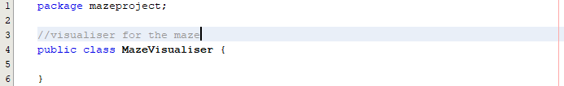

I need to start off with an empty class where I can then initialise the panel and call the maze onto the screen. I should first worry about static display before dynamic display.

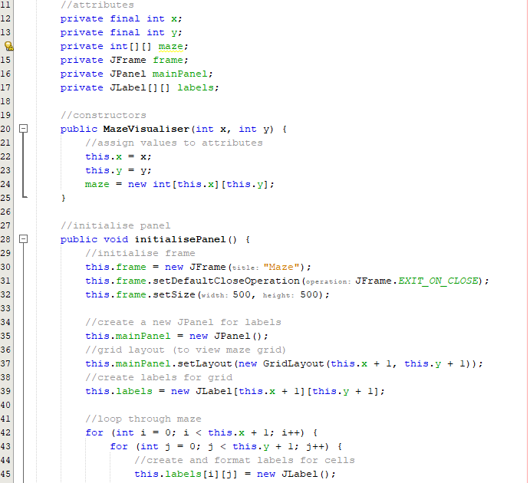

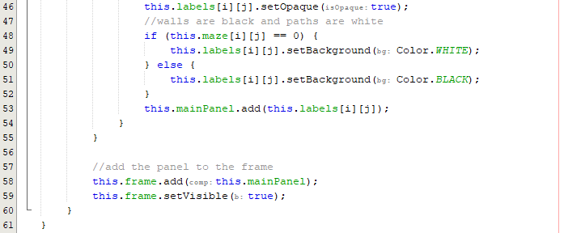

This initialise panel is simply an adaptation of the viewMaze function from the previous cycle. The frame and panel are made global variables so they can be dynamically updated throughout the program. The only change is that I am now keeping track of the labels through a 2D label array where I can access the values whenever needed. One change that can be made is passing parameters through this (x and y) so that I don’t have to add 1 to the co-ordinates each time:

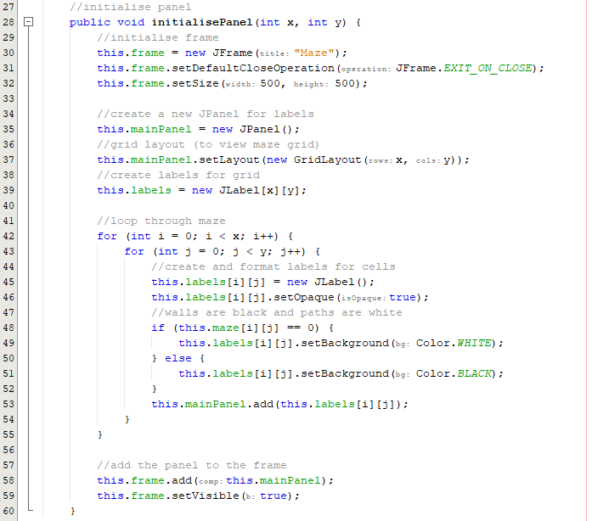

Now that I have a function to view the panel, I can import the maze and try to display it onto the screen by calling the maze generator and getting the value:

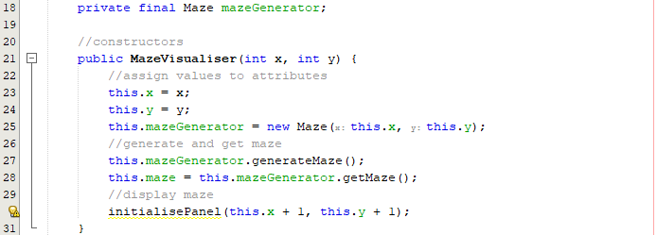

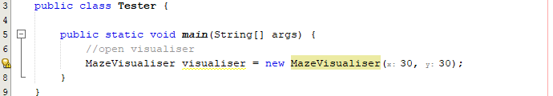

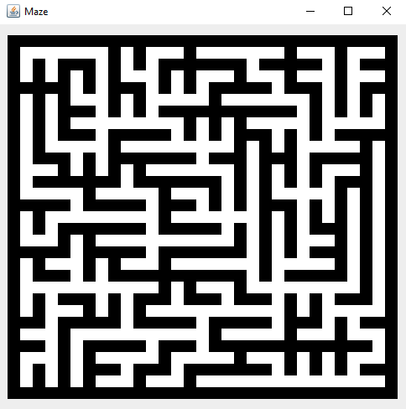

The maze is correctly displaying to screen after implementing these functions.

Adding real time generation:

The first change is to use the object-oriented principle encapsulation to make the initialise panel function private as it should only be accessible inside the visualiser class:



The approach I need is to have a function available called updatePanel that will update the panel with the current state of the maze.

A delay is needed, and a smooth process will be displayed. This is because every change will only make one singular change, the whole maze will not have to be re shown as the computer will remember this position so only the change takes time to show.

The first step is to create a new Panel class as this maze will be called inside the Maze generator class. This panel will take a maze, a time and the labels as parameters.

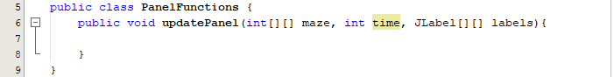

Now a timeout is needed:

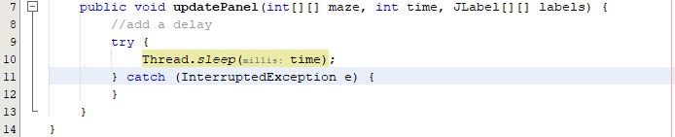

After this, I need to update the label colours – I can remove this from the initialise panel function:

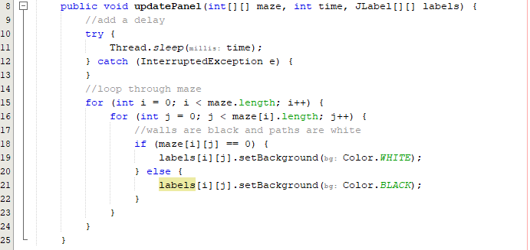

Adding polymorphism to the maze generator

Now I need to add this update panel function to the maze generator. I will also be renaming the Maze class to MazeGenerator as this is more appropriate. I will be using polymorphism to have a generate maze function that is identical but with an extra parameter to accept a time. Accepting a time will automatically let the program be aware that the new generate maze function will be used.

Adding a panel functions instance:

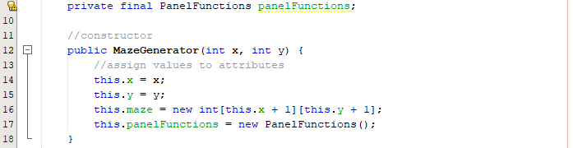

New generator:



Adding the update panel to key changes:

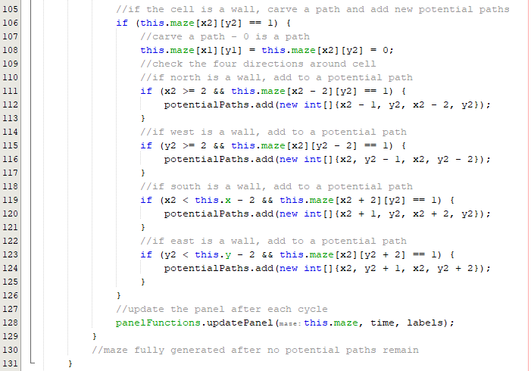

Now I must call add the parameters when generating the maze in the visualiser and add a generation time:

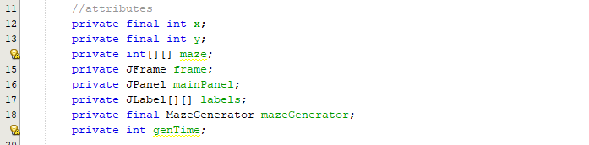

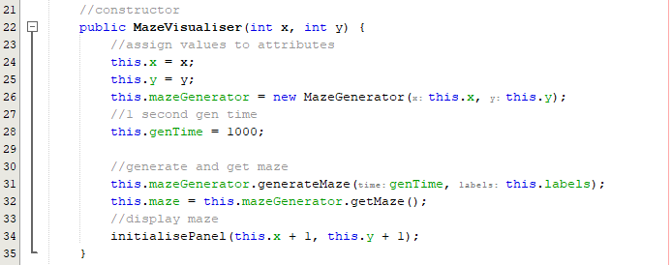

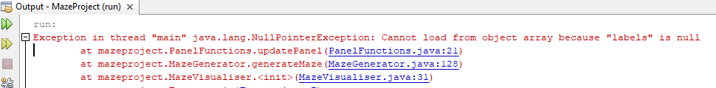

I am getting an error when running the code so I must have a logic error present.

Fixing the null error logic

I have a null labels error as I initialise the panel after generating the maze whereas it should be done before so that the labels have a value.

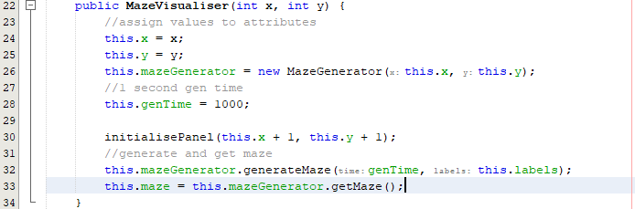

Now when I run this, I should have a maze displayed in real time:

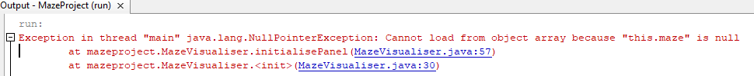

I am getting this issue when running the code as the maze does not exist when I am trying to run the initialise panel code. The constructor has not assigned a value to the maze yet.

Fixing the maze null logic

To fix this, I simply need to instantiate the maze. I will also create a new function that will generate the maze when called by accessing the maze generator class.

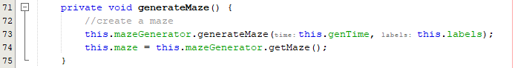

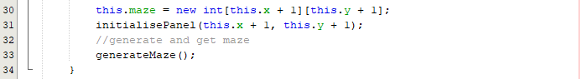

Running the code:

|  |  |
| --- | --- |
|  |  |
|  |  |

The maze now successfully displays in real time and starts the generation from the bottom left corner. However, at the start, as shown in the top 2 screenshots, the maze labels suddenly switch from white to black and the computer makes this jump which skews the screen. To fix this I can initialise the panel with all the labels being black:

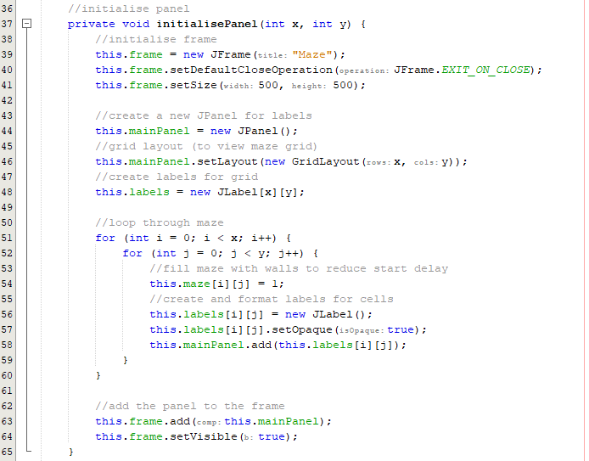

On line 54, the maze is now started with black cells.

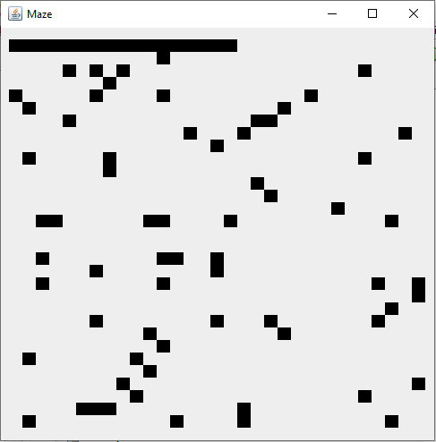

The error is still present so I must update the panel immediately after with a 1ms delay (fast update) so the user does not notice this swift update:

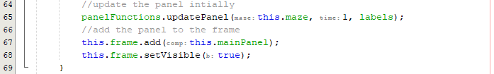

Running the fix:

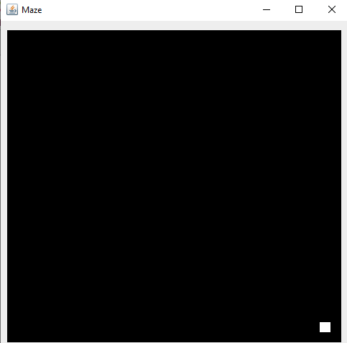

Full process of a maze generating:

|  |  |
| --- | --- |
|  |  |
|  |  |
|  |  |
|  |  |

The code now instantly starts on a black grid that is filled in gradually: Now that this prototype can gradually display a maze being generated, I can move onto the process of displaying the path of a solver.

##### Prototype #2

This prototype will be responsible for developing and displaying depth first search onto the screen. After having developed a successful update panel function there is no need to worry about display and the focus can be on developing a successful depth first search.

Making the Pathfinder class:

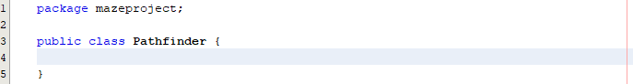

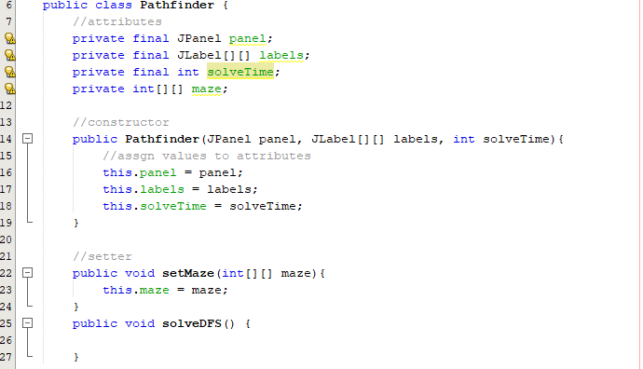

Here I have made the attributes the labels, panel, solve time and the maze so that I can pass these through in the constructor of the visualiser. The depth first search function is currently blank and will be developed next. I need to create an instance of the pathfinder in the visualiser class:

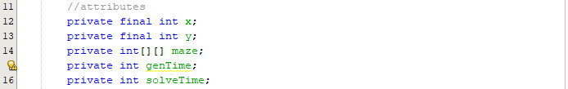

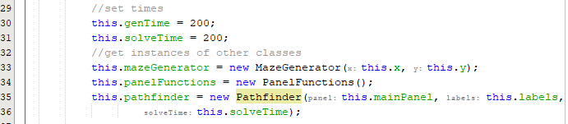

I should add a function to update the pathfinder details for smooth transitions. I have also realised that it is not necessary to pass the panel through the pathfinder as only the labels are changing.

In the Pathfinder Class:

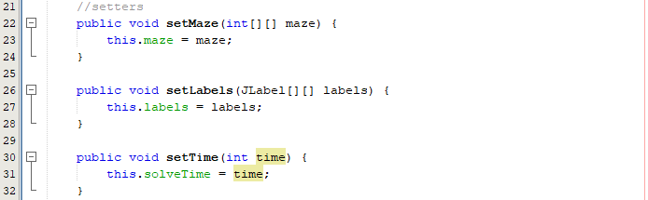

In the Visualiser class:

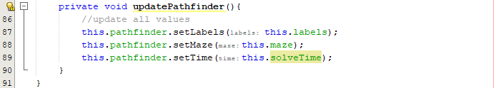

Now before every pathfinder performance, I can update these values so there is a smooth display.

Running my code to see if the code still works:

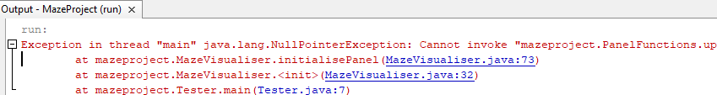

There is now an error message when running that says panel functions does not exist, this is my current code in the constructor:

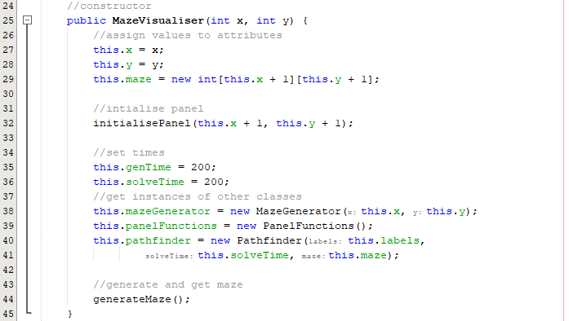

I must reorder the code so that the panel is initialised after panel functions is created:

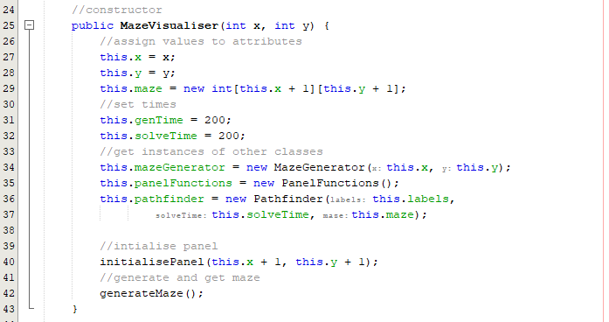

Running the code:



A maze is successfully displayed onto the screen, so the error has been fixed.

Developing depth first search:

When a path is created, I will be making the value a number 2 in a maze. I will have the path a green so I must add code for this in the update panel function:

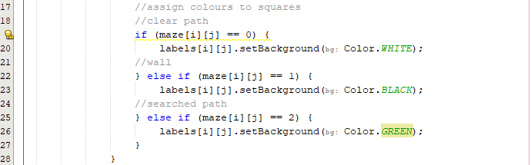

Convert pseudocode into Java:

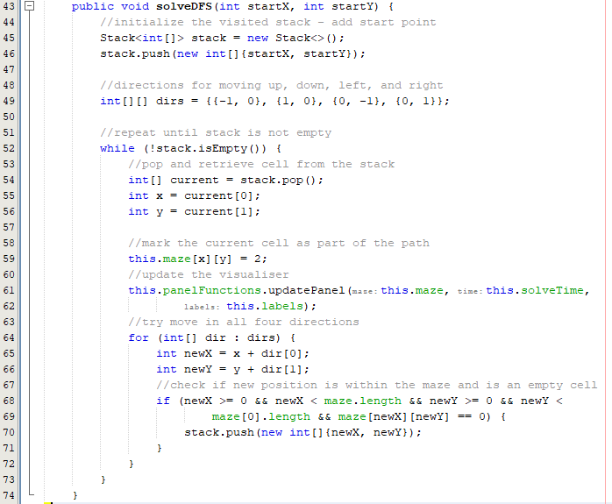

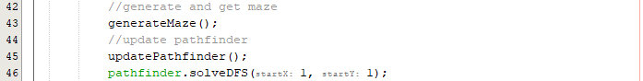

Right now, the code only has a starting point and will keep going until the target node is reached as shown above where the pathfinder only takes the starting co-ordinates through as parameters. The expected outcome from running the visualiser would be the maze solves itself and exhausts all paths until there are no paths left. The entire maze should be green by the end of the solver:

|  |  |
| --- | --- |
|  |  |
|  |  |

The code successfully searches the entire maze through depth first principles and stops once the entire maze has been searched. The next step is to add an end point so that the solver can end at a requested end point. For now, ill set the end point as the final square in the maze.

Adding an end point to the solver:

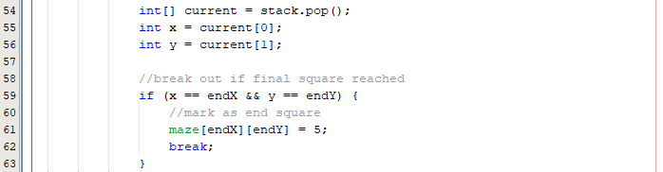



I have the end point as the regular x and y as the maze is of size that is one bigger that the current x and y. Therefore, x and y signify the last cell in the maze.

Running to see if the pathfinder stops at the end square:

|  |  |
| --- | --- |
|  |  |

The pathfinder does not stop when the ending point is reached on the maze and the logic must be broken somewhere.

Fixing the logic for the pathfinder end condition:

Before I fix this, I will make the end square red by setting its value to 4 and having this relate to a red colour in the update panel function:

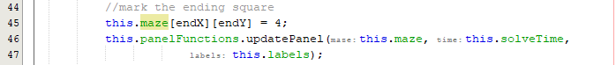

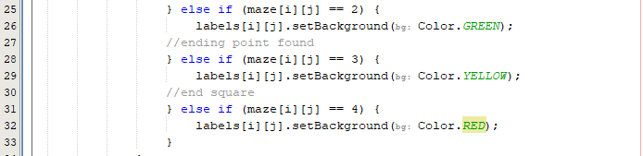

I made number 3 yellow, and this will be useful for showing the pathfinder has found the endpoint. To fix the problem, the pathfinder could not detect the end point simply because it was not recognised as a path as it was a 4. To change this, I can add an or statement that will allow the end square to be checked.

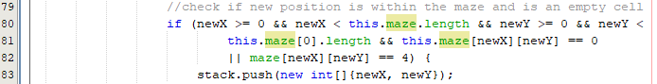



Running the maze:

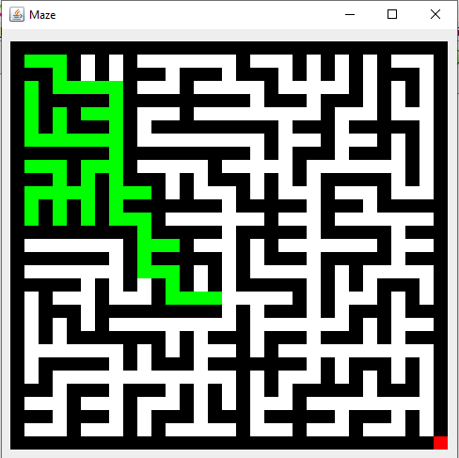

As shown above, the end square is being identified in the wrong place which is the root of the issue. It should be one less in each space.



Running the code:

|  |  |
| --- | --- |
|  |  |
|  |  |

After this addition, the pathfinder now successfully ends when the final square is reached. Another addition that would show the process of depth first search better would be to highlight the junctions another colour to show all the decisions made.

Add junction highlighting:

I simply need to update the panel with a new key inside the code where a new cell is being pushed to the stack:

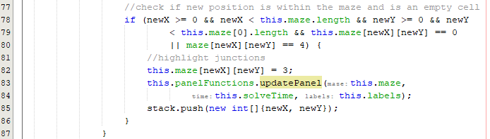

I set the value to 3 so that the paths can show up as yellow.

Running the visualiser:

|  |  |
| --- | --- |
|  |  |
|  |  |

Making the end square orange:







This addition greatly improves the visual aspect of the solver as it shows how the pathfinder is thinking and how it backtracks through each junction is a depth first manner. When viewing this in a slow speed, it provides great insight into how a depth first solver works.

##### Prototype #3

Now that depth first search has been implemented successfully, I can implement breadth first search. Breadth first search should be simple to implement now that DFS has already been developed, I can make the edit where a queue is used rather than a stack. This simple change will convert the code unto breadth first search.

Adapting DFS into BFS:

All I need to do is change the stack into a queue. Instead of pushing to a stack, I will be offering to a queue. Instead of popping from a stack, I will be polling from a queue.

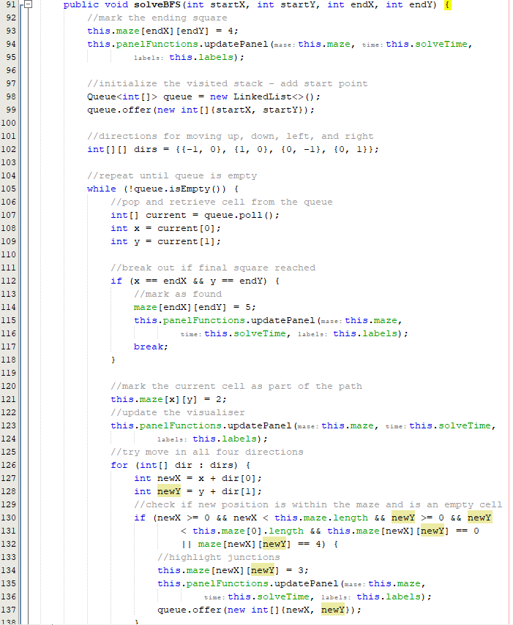

Running the solver:

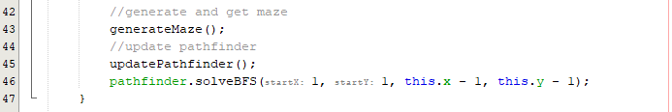

|  |  |
| --- | --- |
|  |  |
|  |  |

As shown above, as a queue is used, the searched cells pulsate out in a breadth first manner in hopes of reaching the target square. As I had fully developed the breadth first search, this was a simple change and marks the end of this prototype. The next prototype will focus on implementing the A Star algorithm.

##### Prototype #4

This prototype is responsible for adding the A Star algorithm. The A star algorithm is an upgraded breadth first search that uses heuristics to find a solution to the maze. Right now, my depth and breadth first searches use stacks and queues respectively, but I can implement the A start algorithm using a priority queue. This queue will allow me to use heuristics to calculate distances between cells. In my pseudocode I used Manhattan distance and the priority queue within Java also uses a cost operator. This cost can be calculated in many ways e.g., Euclidean distance operators to compare cells but I will be sticking with Manhattan distance where the absolute distance between X’s and absolute values between Y’s are added together to calculate the cost [15].

Changing queue to priority queue and adding heuristics:

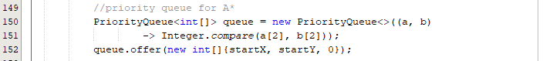

This code instantiates the priority queue and adds the starting square with a 0 cost as this is the starting square.

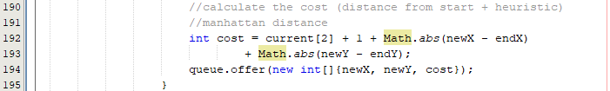

Here the cost is calculated through the Manhattan heuristic cost.

Full A star code:

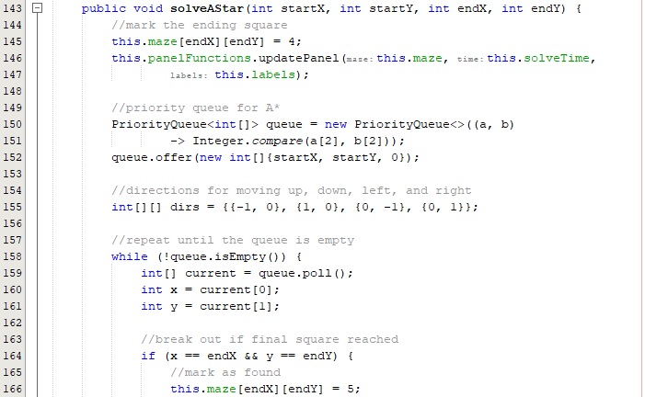

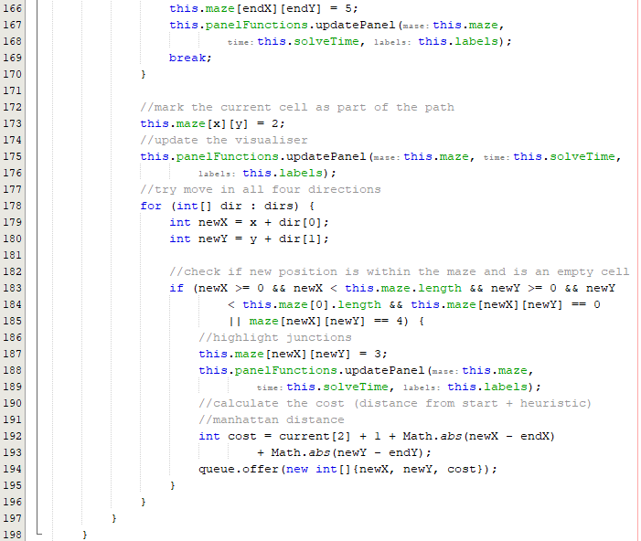

Running the A star code:

|  |  |
| --- | --- |
|  |  |
|  |  |

I ran this code on a 50x50 maze, and it is evident that the A start heads straight towards the end point but also expands out to try trial as many paths along the way as possible.

As I will be running multiple pathfinders on the same maze, I will need to pass a copy of the maze into the pathfinder rather than through the update function:



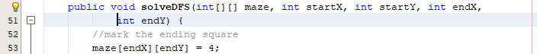

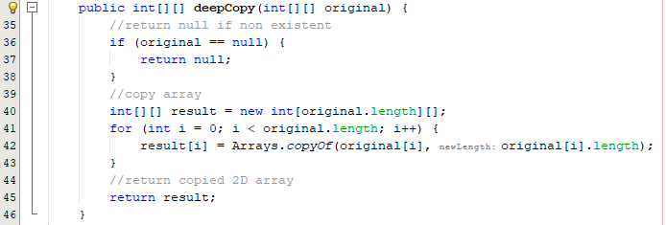

This is repeated for all pathfinders. I must also include a deep copy function that will copy over the maze. This is because if I did a simple re-assign it would point to the location of the original maze, so a deep copy is necessary:

After this prototype, I now have three pathfinders to display on my program, however the shortest path has not been revealed yet despite the solver finding the square. The next prototype will develop a backtracker that will highlight the shortest path.

##### Prototype #5

Current display:

|  |  |  |
| --- | --- | --- |
| **Depth first search** | **Breadth first search** | **A Star search** |
|  |  |  |

Here is the current search interface and these searches were run on the same maze. On this iteration the depth first search was the quickest with the least searches due to the luck of how the maze was generated and the fact that the end square is not randomly generated yet. However, all these searches lack the display of the shortest path.

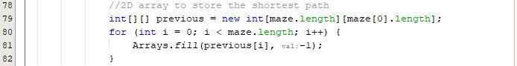

First, I created a path full of -1s that indicate a path that isn’t part of the shortest path, I will then add a path to the this array where the pathfinder makes a decision (a junction) so that the shortest path is revealed.

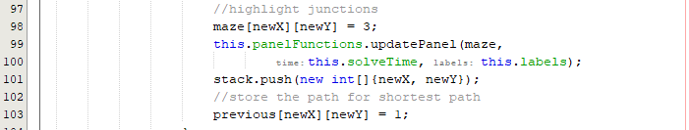

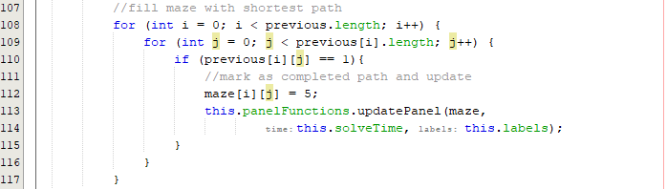

Now I can check whether the shortest path is revealed:

|  |  |
| --- | --- |
|  |  |

The logic here must be incorrect as the entire maze is being highlighted orange (shortest path colour) rather than a singular path.

Fixing the backtracker logic:



Here I’m storing the x and y value as a single number that I can then break down after using integer division and the modulus function.

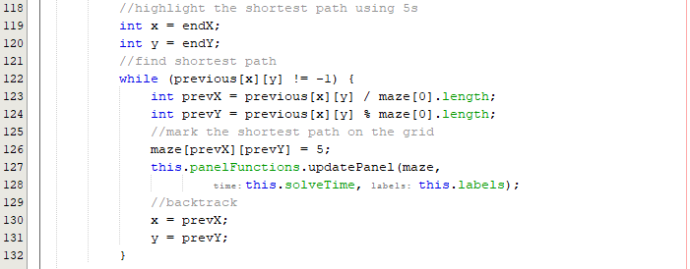

I have re developed the backtracker to correctly backtrack through the maze and calculating the shortest path along the way through integer division and remainder calculation.

Now I can run the code to test if the pathfinder correctly displays the shortest path to the screen.

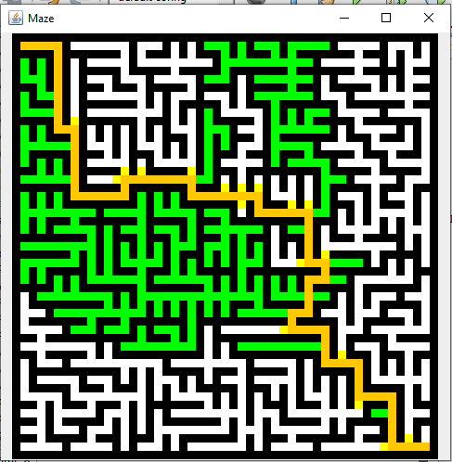

The code now successfully displays the shortest path after performing the shortest path calculations. Now I simply must repeat this code for the other 2 pathfinders.

Running all 3 pathfinders on the same maze to see if the same shortest path is revealed:

|  |  |  |
| --- | --- | --- |
| **Depth first search** | **Breadth first search** | **A Star** |
|  |  |  |

Here the correct shortest path is being displayed for each solver. I now must develop a function that scales with the number. For example, if a the solve time is really high and slow, I don’t want to scale it that high but if its smaller I want it scaled more.

Developing the scalar function:

My initial thoughts for a scalar function would be a logarithmic scalar. I will first create a static method in my tester to test a few values.

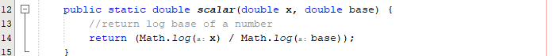This method returns the log of a number with a certain base. In Java, the log function is the natural log therefore this method finds the log with any base.

If I have a log base of 500 to indicate this as a maximum speed, I can then divide my regular time by this value obtained to achieve a time that is larger than the original time.

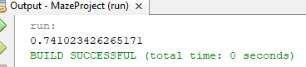

Dividing by this number would increase the time.

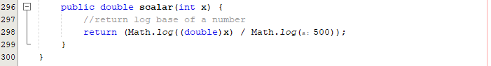

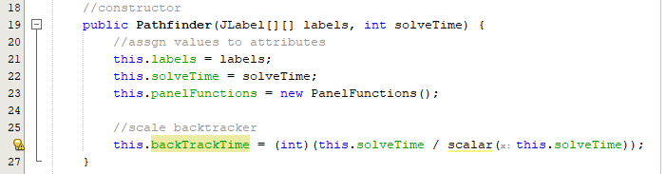

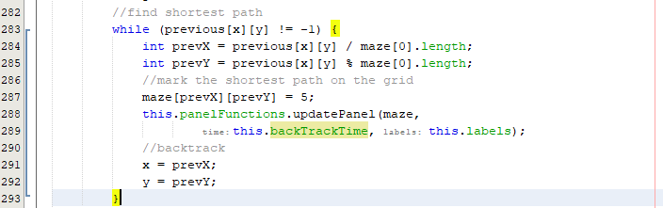

**Showing the backtracker on A Star:**

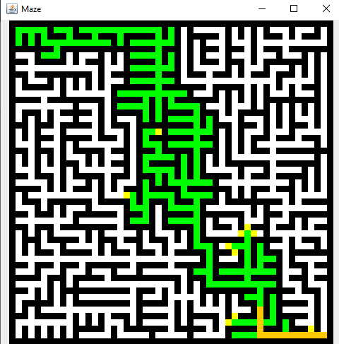

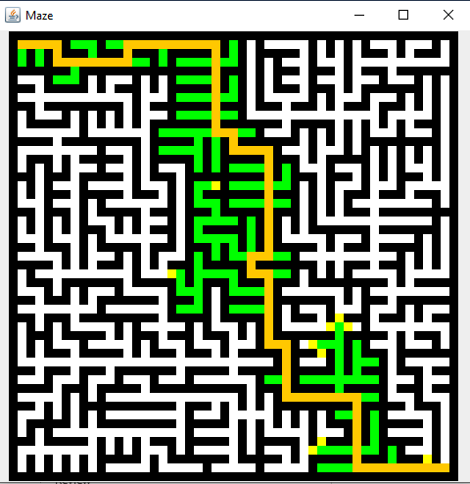

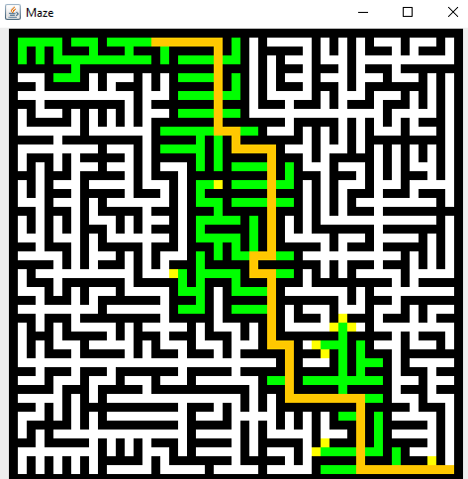

Now the backtracker is successfully working and scales correctly to the solve time and reveals the shortest path in real time. Now that the shortest path is revealed for every pathfinder, I can develop the buttons, enhance the UI and choose more appropriate colours for the pathfinder.

##### Prototype #6

The focus of this prototype is to implement buttons so that the user can interact with the screen and generate mazes or apply pathfinders to the maze. I will enhance the aesthetics so that the usability of my program is increased. First I need to have a function that randomly generates a random ending square.

Random ending point:

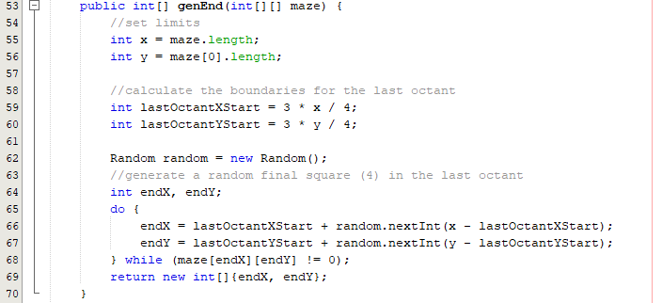

This code will randomly generate a square in the final octant of the maze. This will allow a better visual sample when running pathfinders.

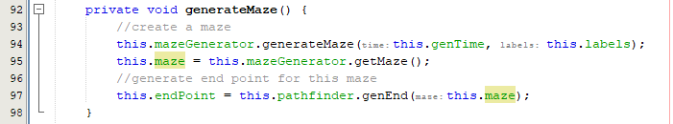

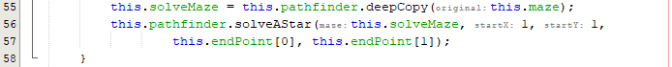

As shown below, the end point (red) is randomly placed in the last octant of the maze.

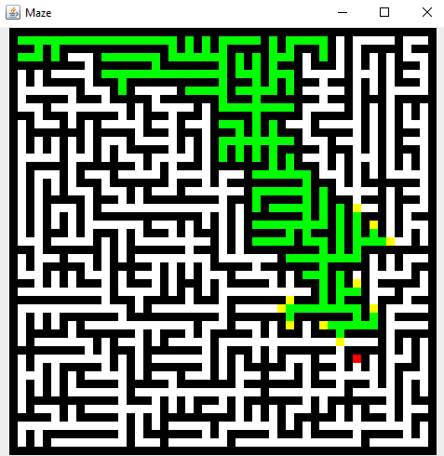

Adding buttons to the frame:

In initialise panel:



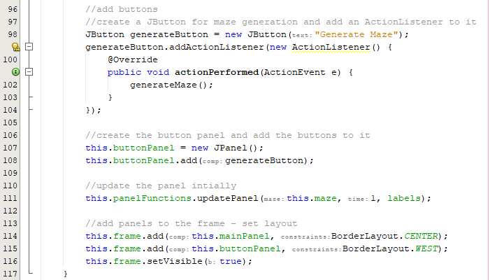

Here I have created a button with an action listener that calls the generate maze button upon click. I have also created a new panel for the buttons.

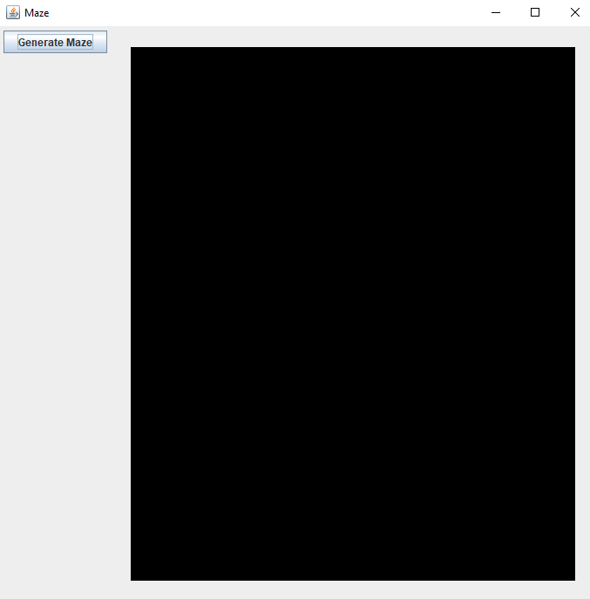

This is what the panel currently looks like. The maze panel has become rectangular due to it being squashed.

Clicking generate maze:

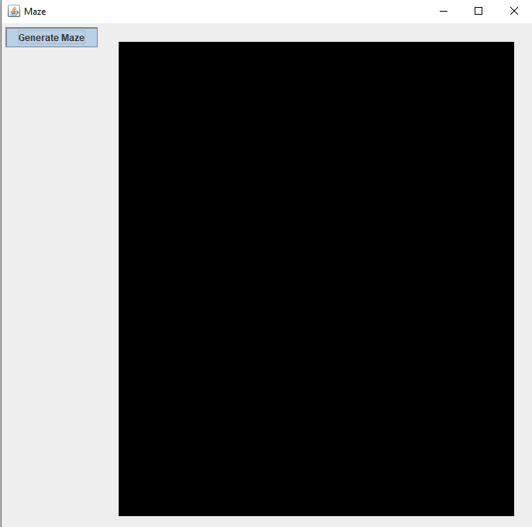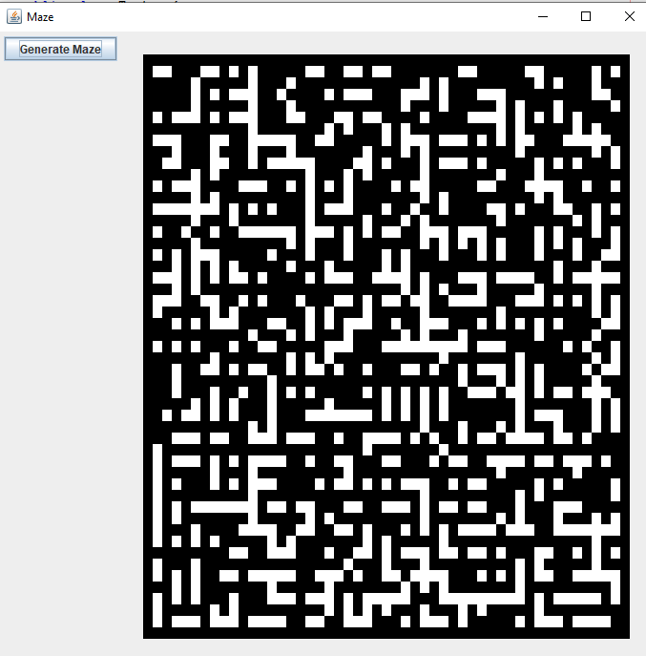

As shown above, the button does not work well with the thread delay and waits for the entire time to pile up before the maze is generated. This way, the maze just generates instantly and the graphics cannot handle it and it looks like it is being dissolved as it is generated due to the instant update

Fixing the button thread issue:

To fix this issue, I can use swing worker functions that allow tasks to be executed in the background of the program:

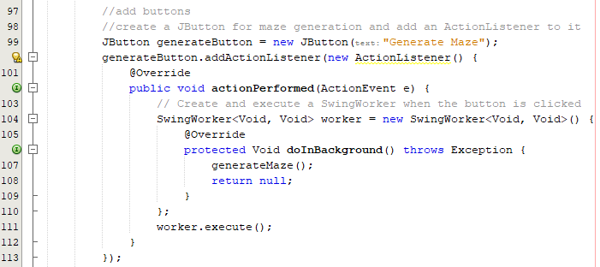

Here the generate maze function is called in the background function.



The button panel is now a box layout so that the main panel can remain square. Running the code:

|  |  |
| --- | --- |
|  |  |

Now that the button is carried out in the background, the maze is successfully displayed in real time. The next step is to add the rest of the buttons to the button panel to call the pathfinder functions.

Adding all the buttons:

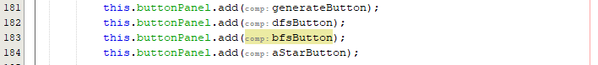

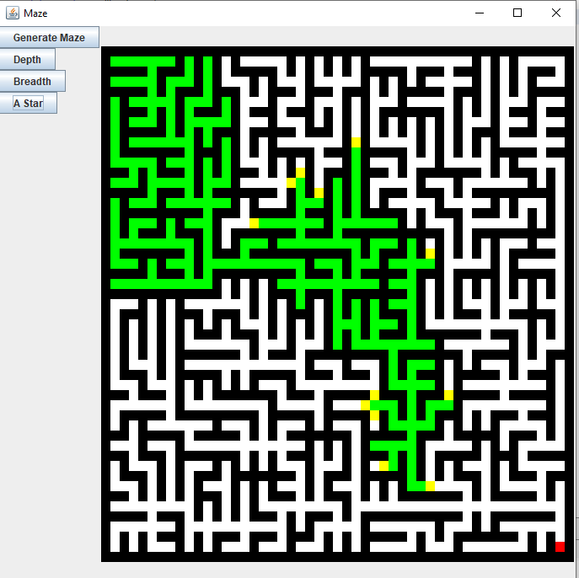

Now that all buttons are implemented, they can be called one after another and all updates happen in real time with no errors. The only error would occur when clicking multiple buttons twice at the same time during the same process.

The first issue is the button sizing and format, I need to add some code that will fix the layout of this vertically:

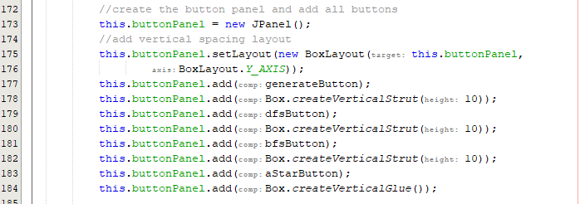

In the section of code, I have added vertical spacing through the Box library, and I found this layout after reading an article online on how to achieve this effect [28].

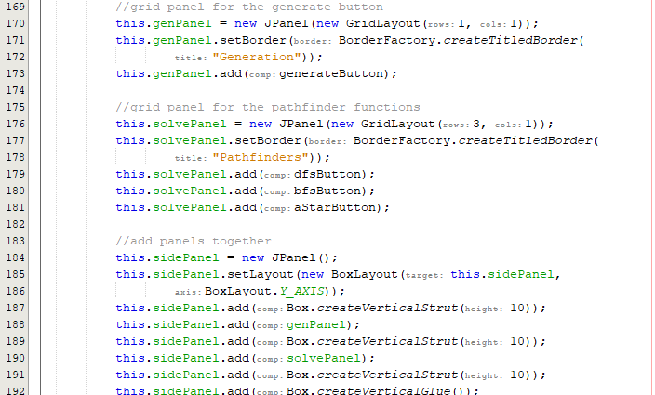

Here I have separated panels so that each major section has its own panel. As each panel has a grid layout, the buttons are automatically formatted.

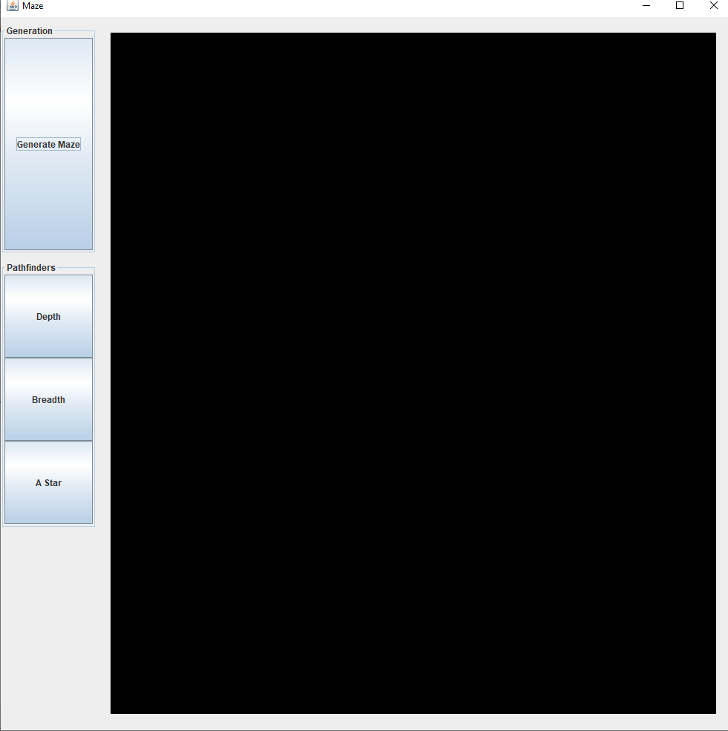

When regenerating a maze currently, the maze has the same dissolve effect. I need to add a condition that clears a maze in a longer time after the first maze is generated to get a smoother effect:

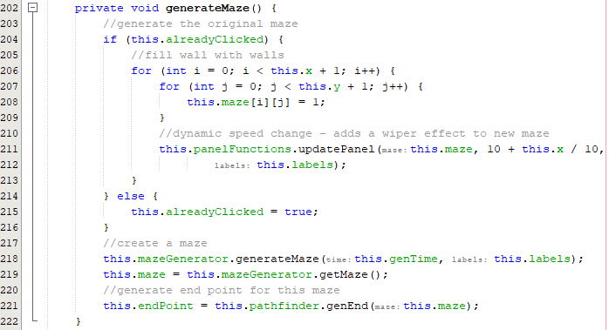

In this code, I have a global Boolean called already clicked – this checks whether a maze is already generated, if it has been generated already then it wipes the maze in real time to provide a wiper effect. This updates every row to produce this effect.

Effect:

|  |  |
| --- | --- |
|  |  |
|  |  |

Adding buttons to change time dynamically:

I need to add buttons that will allow the user to change how fast the mazes generate or how fast the pathfinder solve the maze.

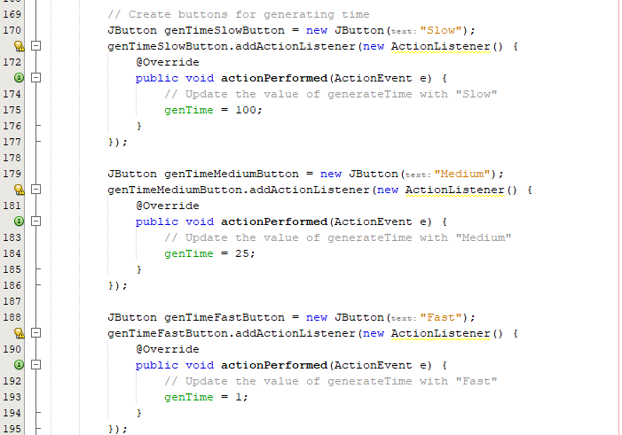

These values are not set in stone yet and will be adapted soon to match the maze size.

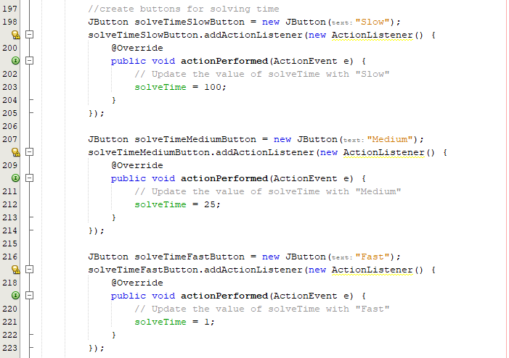

Adding these buttons to panels:

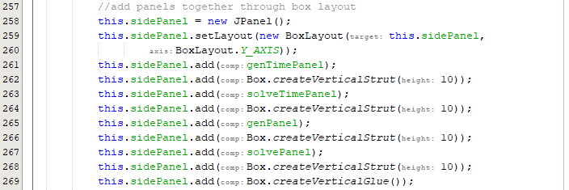

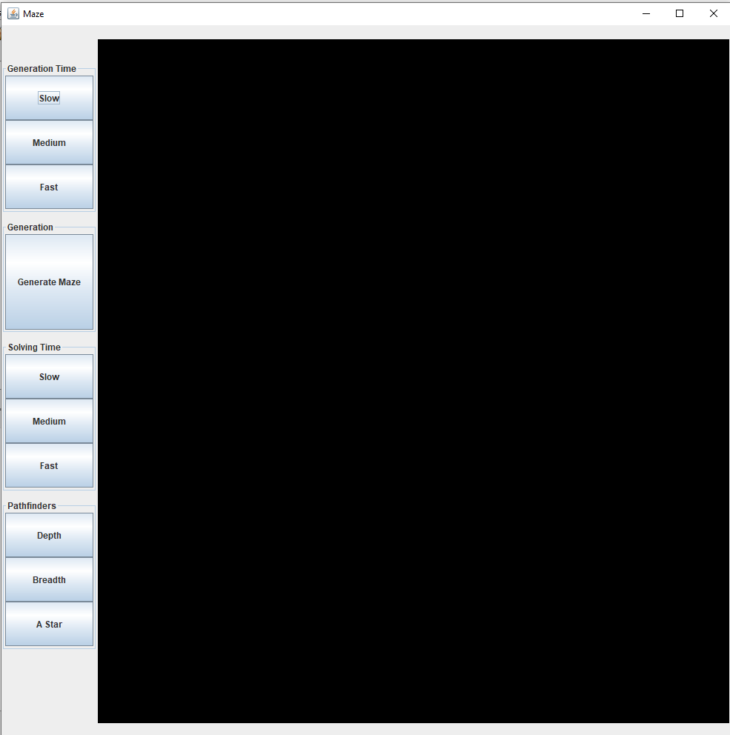

This is what the current screen looks like after adding the new buttons. The addition of the generation times should allow the user to change the speed dynamically. For example, mid maze generation if the user clicks fast speed when previously on a slow speed, the maze will speed up mid generation.

However, on the current implementation, the speed does not change dynamically.

Fixing dynamic speed logic error:

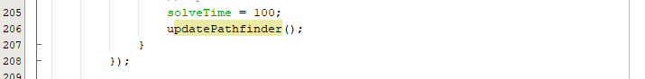

The pathfinder must be updated mid generation for the speed to change, this was what was causing the issue.

Running breadth first search:

After 5 seconds on slow:

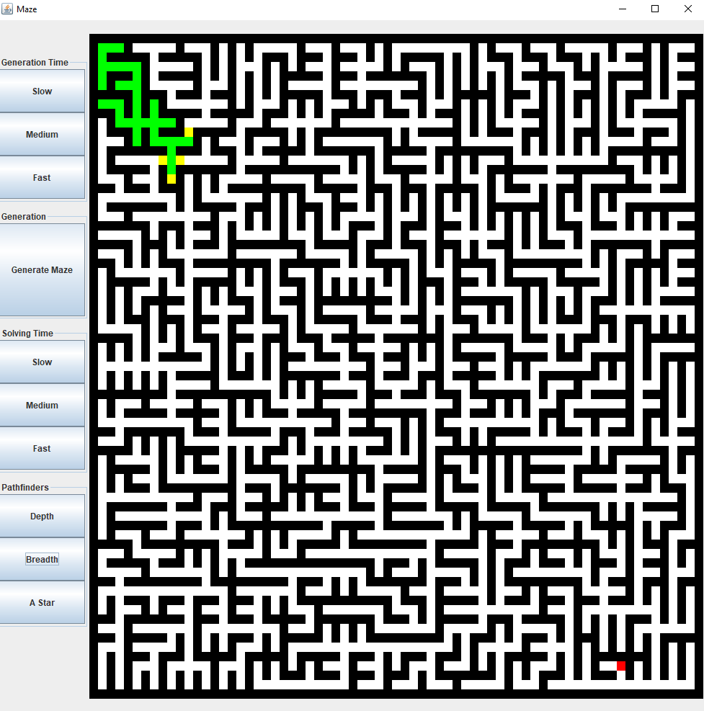

After 5 seconds switching to medium:

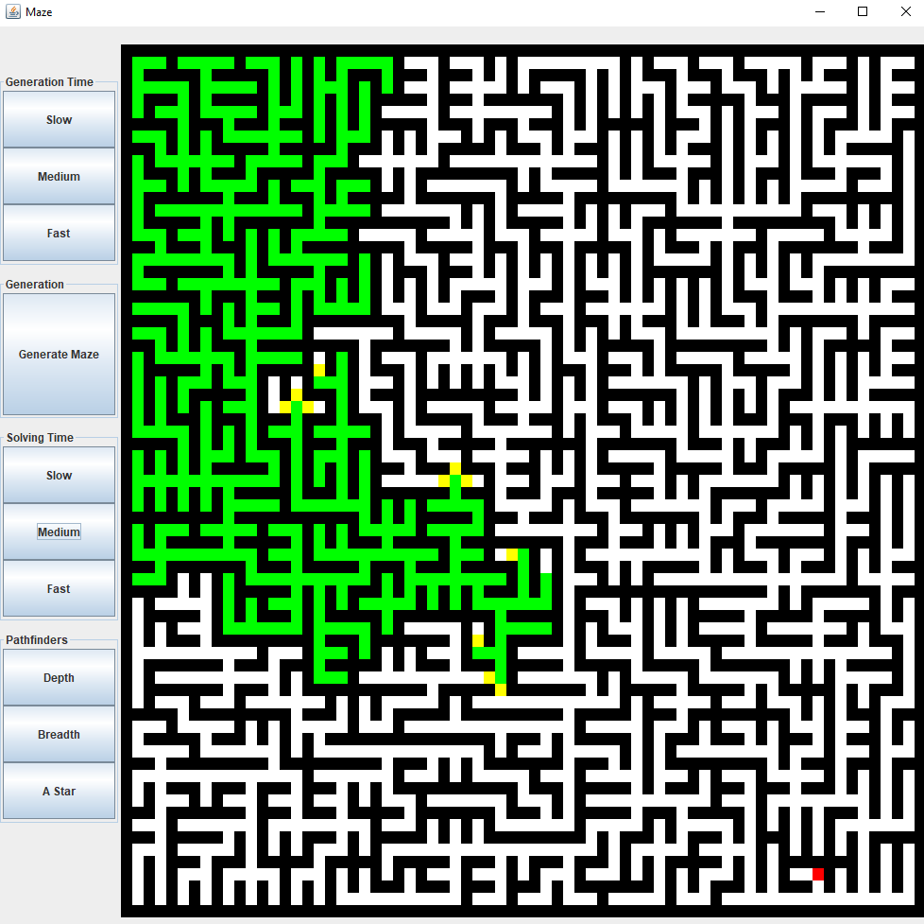

Fixing generation time:

I must add an update maze function that mimics the pathfinder update function.

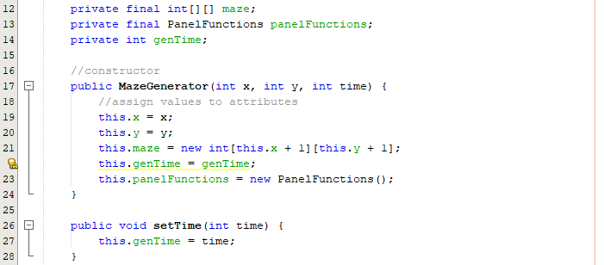

In the visualiser:

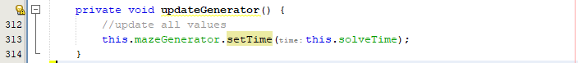

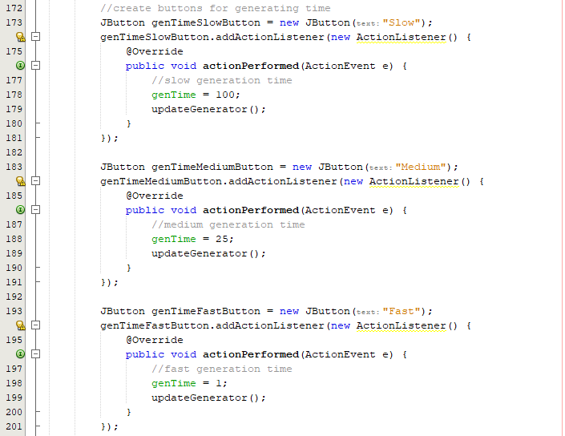

After this implementation the code does not work, and the speed does not change so a logic error must be present.

Fixing the time logic:

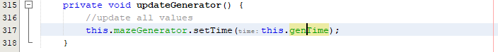

This code previously was setting the speed to the solve time rather than the generation time which would cause a logic issue when the buttons were clicked. After this resolution I will test the maze generation:

After 5 seconds on slow generation:

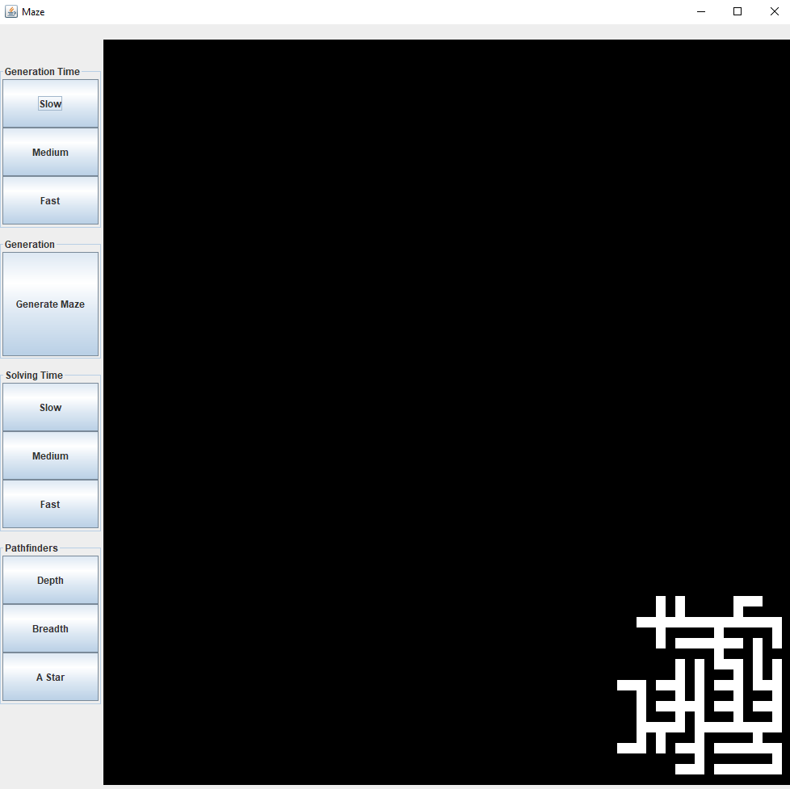

After 5 seconds on medium generation:

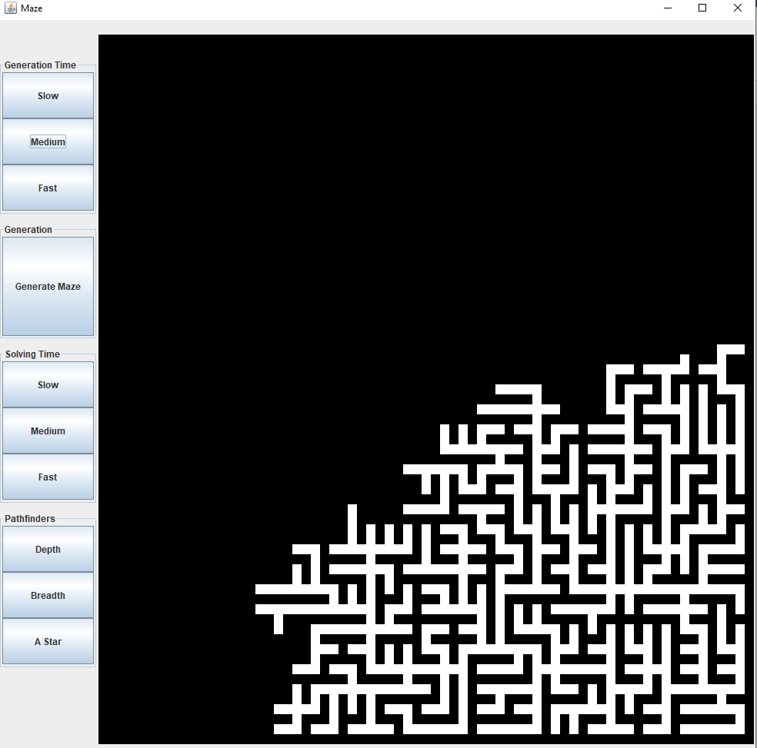

The dynamic timer function now works correctly, and I can move onto the next task which would be disabling other buttons in relevant processes and fixing the colours.

Fixing the colour scheme:

I would prefer a darker green for the paths, a light green for junctions and a dark red the shortest path found.

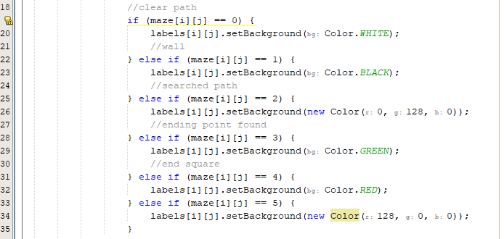

|  |  |
| --- | --- |
|  |  |

After making this change, I prefer a red colour for potential paths:

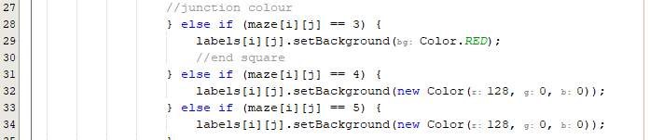

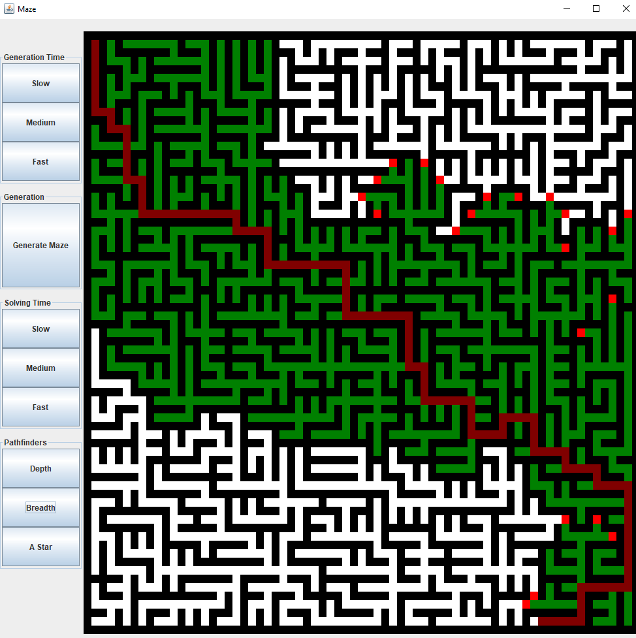

Disabling buttons on other processes:

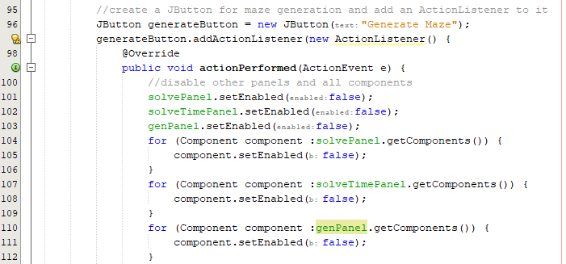

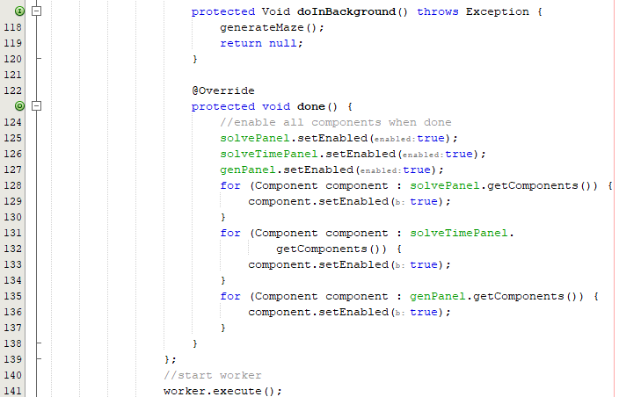

The done function will execute the code inside once finished. Whilst the maze is generating, the components in the selected panels are disabled so that the program cannot break. When done, all components are re enables.

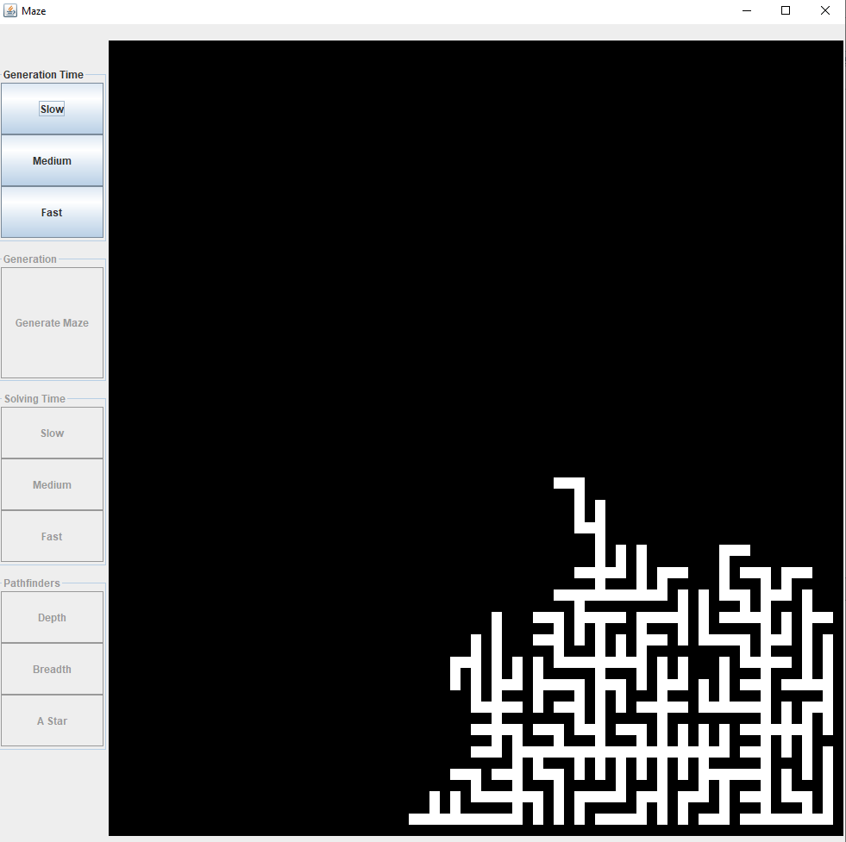

As shown above all other buttons except generation time are disabled when running.

Repeating for other buttons:

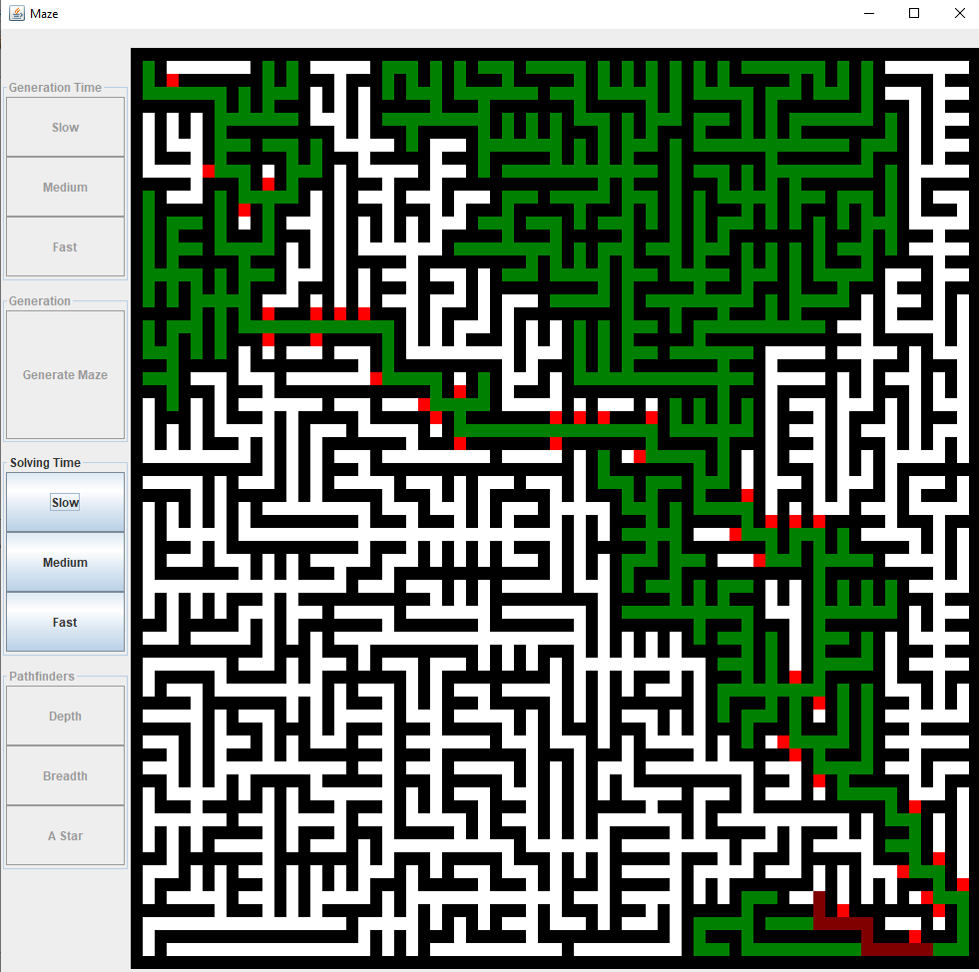

The code was repeated for all buttons and now and as shown above, whilst a solver is being carried out, all buttons except for the solve time are disabled. This is so that the user can still change the solve time dynamically mid solve.

I must also disable the pathfinders and the solve times on initialisation:

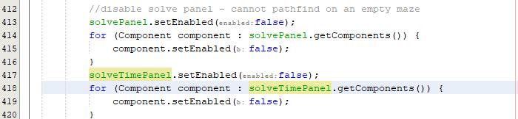

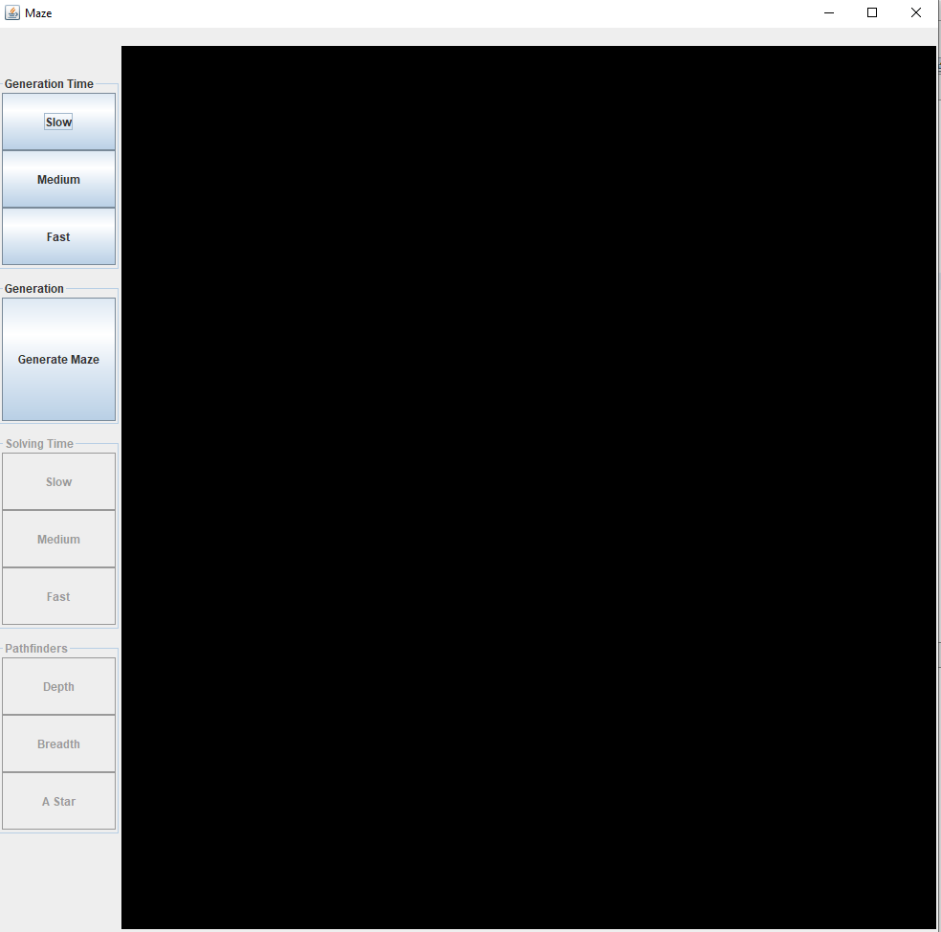

As shown above, the pathfinder options are disabled when the program is opened.

Improving the aesthetics of the visualiser:

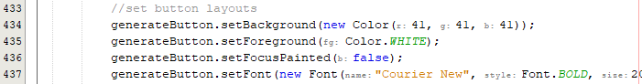

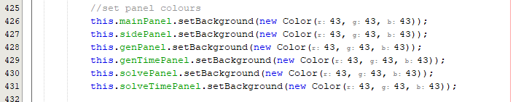

I can convert this button class into a subroutine so that each button can use the same module of code.

In Panel Functions:

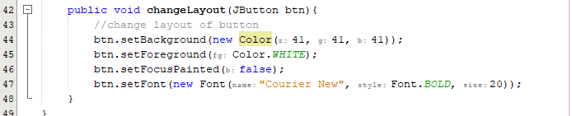

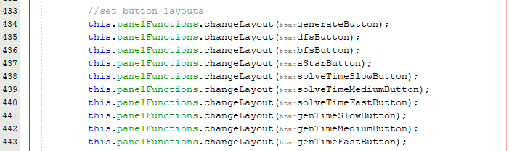

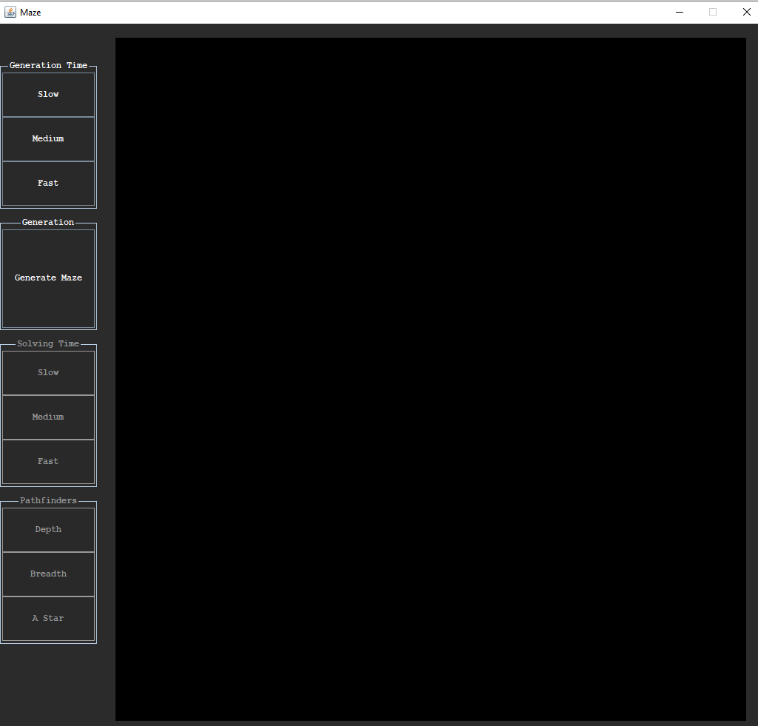

Right now, the buttons are not horizontally aligned, to fix this I can increase the font of the buttons:



Adding a return to menu button:

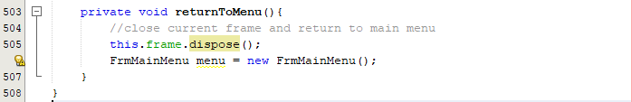

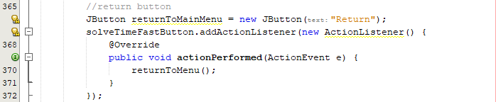

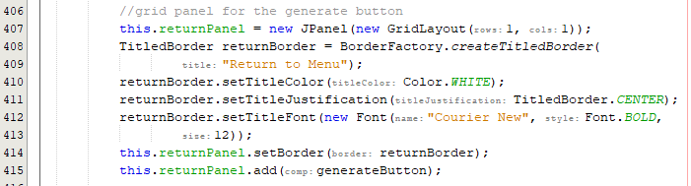





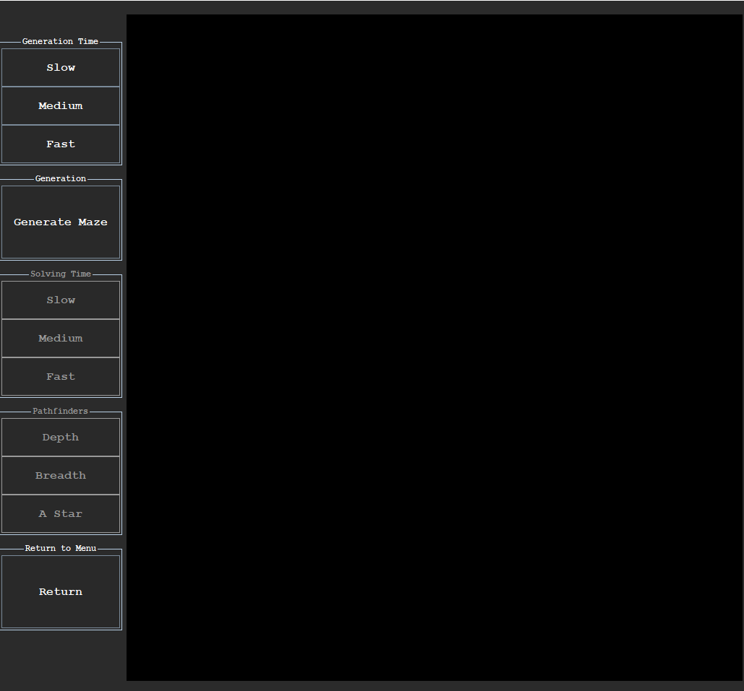

When clicking the return to menu button, nothing happens so there must be a logic error somewhere within the code.

Fixing the return to menu button:



On line 366, I did not add the action listener to the correct button:



Now the code successfully runs, and the user is redirected to the main menu

Fixing the buttons:

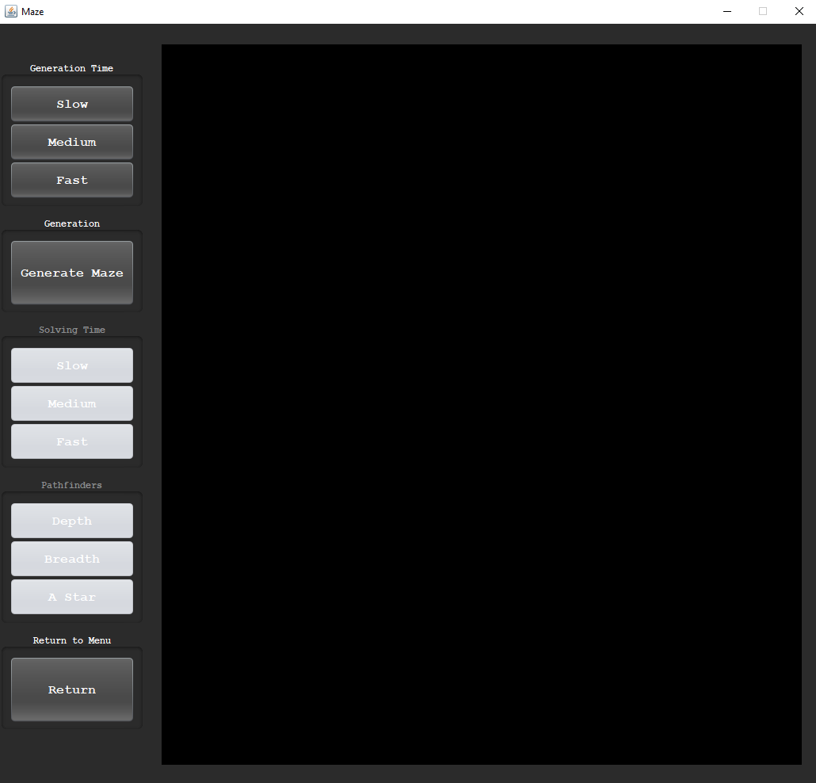

Fixing the speeds:













These speeds are the most beneficial for an 80x80 maze.

Fixing the final square error:

On few occasions, the red final square will get covered by a junction square and the finish cannot be seen to the user. Also, if the junction colours are red, the user will find it hard to distinguish between this and the final square. For this reason, I will change the junction colours to cyan:



Fixing the final square:

I simply need to add detection to ignore changing the colour if the square is a final square:

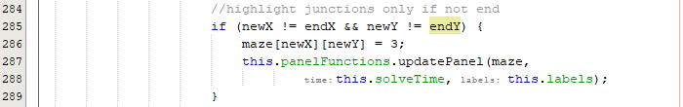

Current UI:

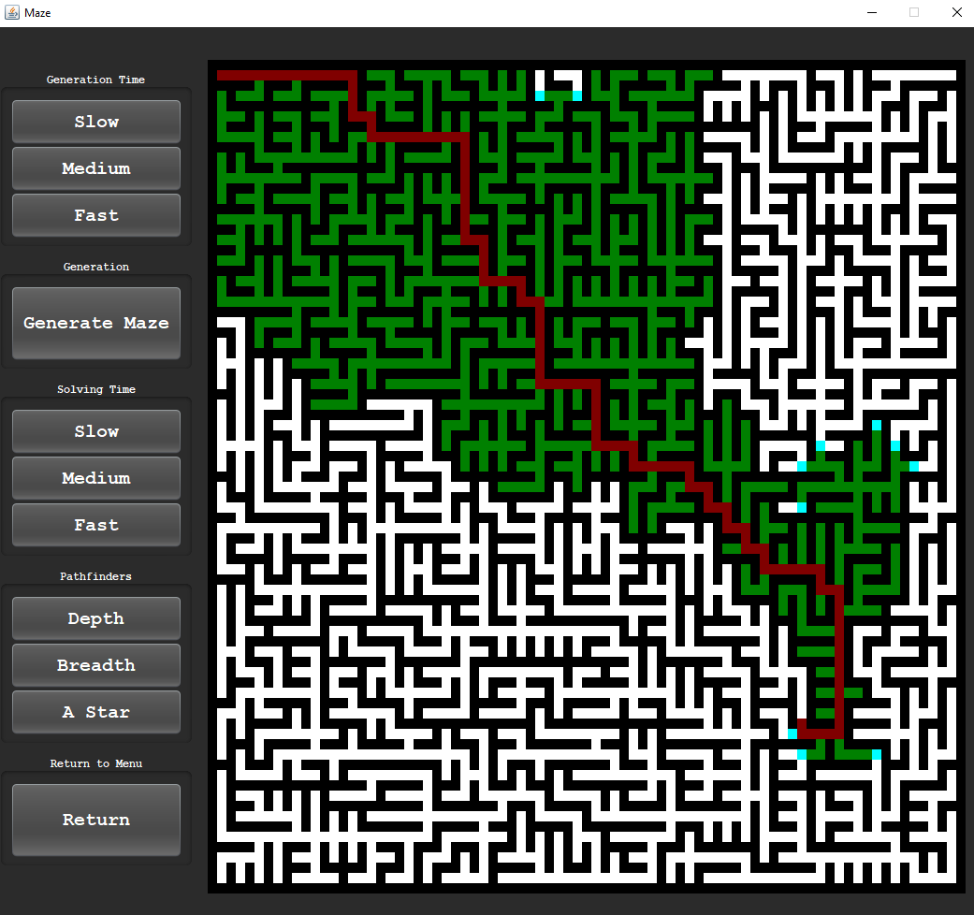

Adding currently selected buttons:

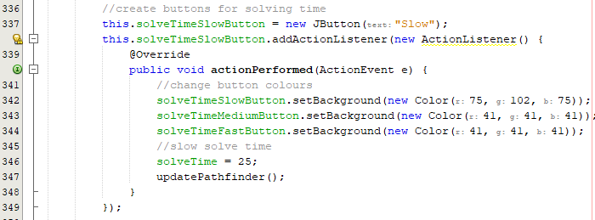

I made the buttons global variable so that they can be accessed from within the action listener. I repeated this for all button to achieve a light green currently selected colour.

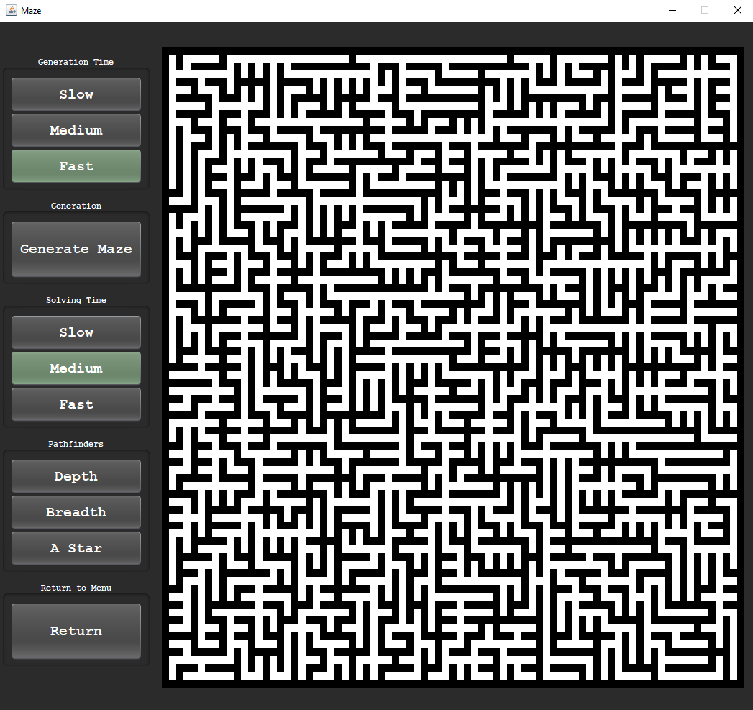

I now need to set the fast generation time and medium solving time to green on initialisation to green as this is the default mode. To achieve this, I can accept a new parameter for the button layout:

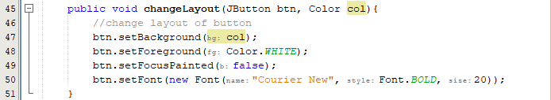

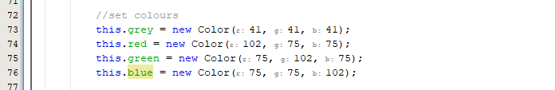

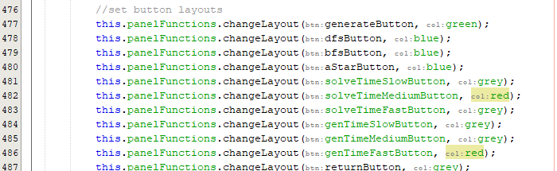

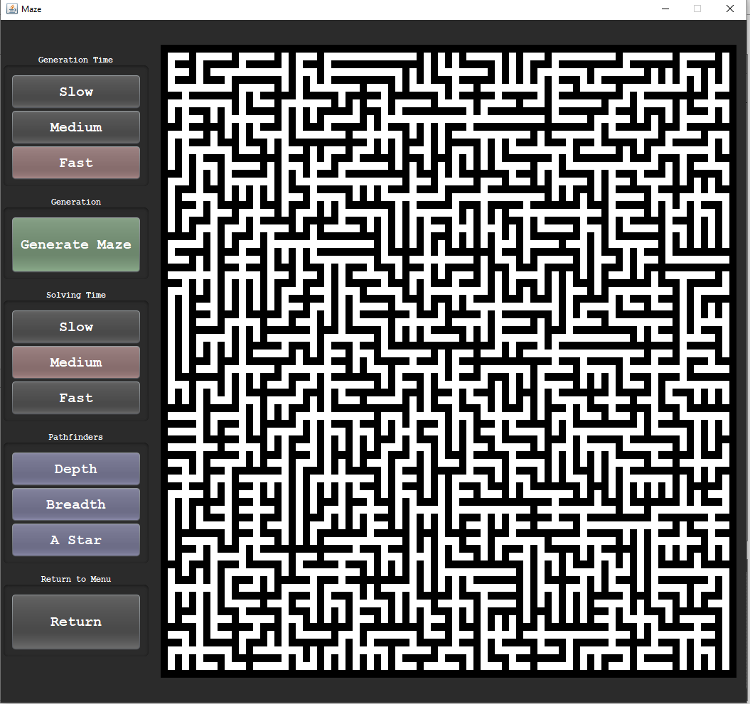

Adding information for usability:

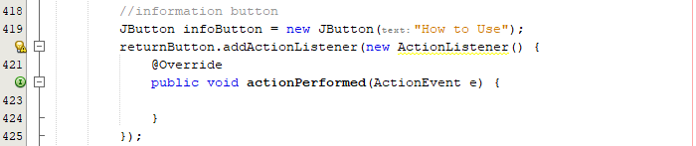

Currently, there is no code for the information button whilst the UI is being developed.

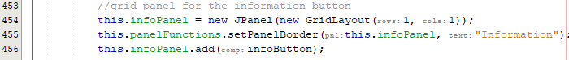





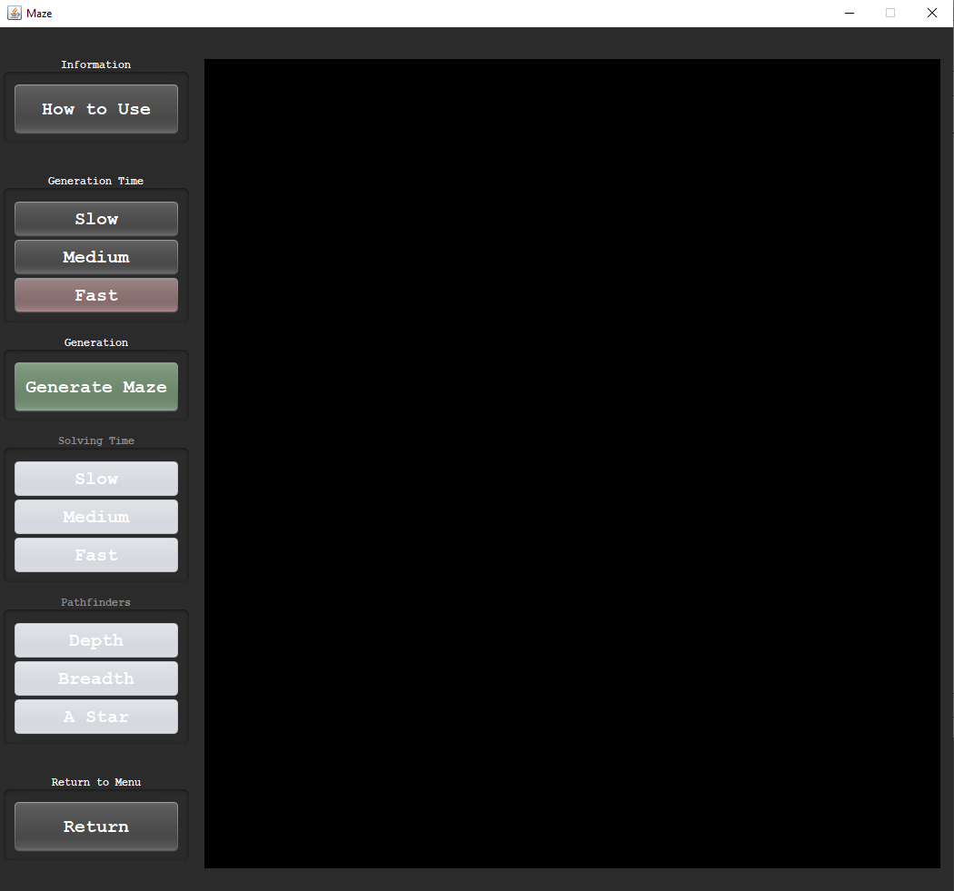

Creating the pop-up message:

I must first design the layout of the new message pop up in PowerPoint:

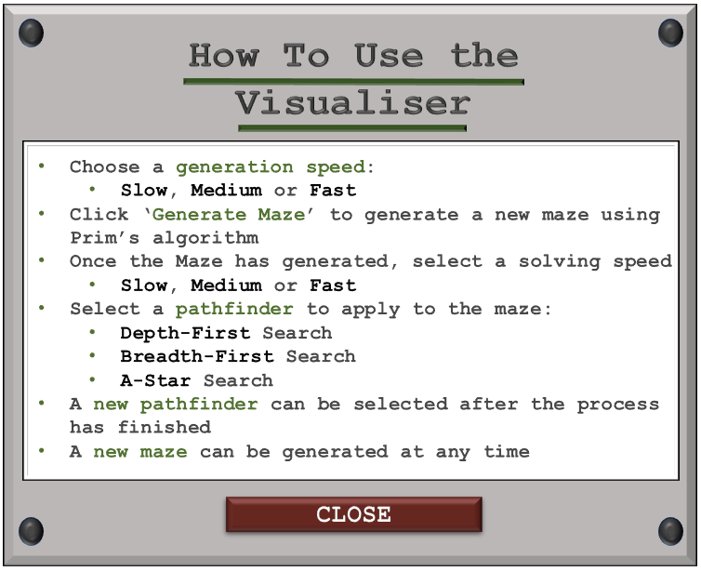

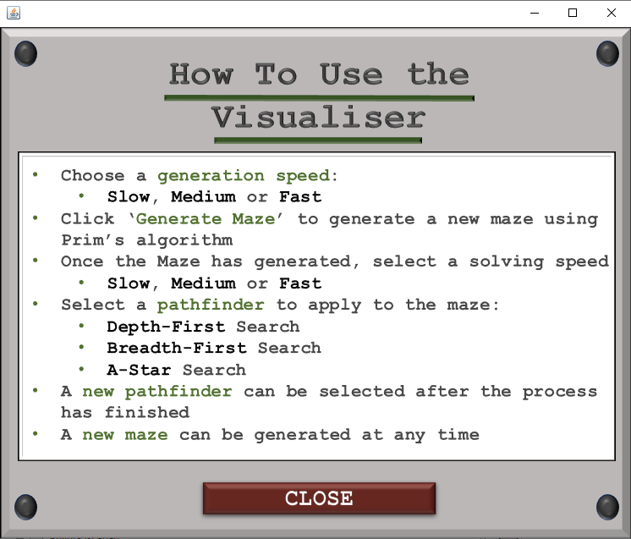

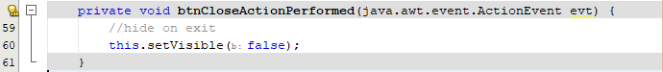

Instead of disposing of the frame, I will hide it so that I only have one instance of this frame. When the button is clicked inside the visualiser, it will make it visible again.



The frame should be invisible on initialisation.

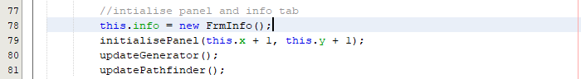

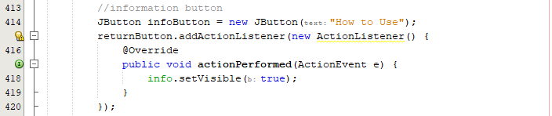

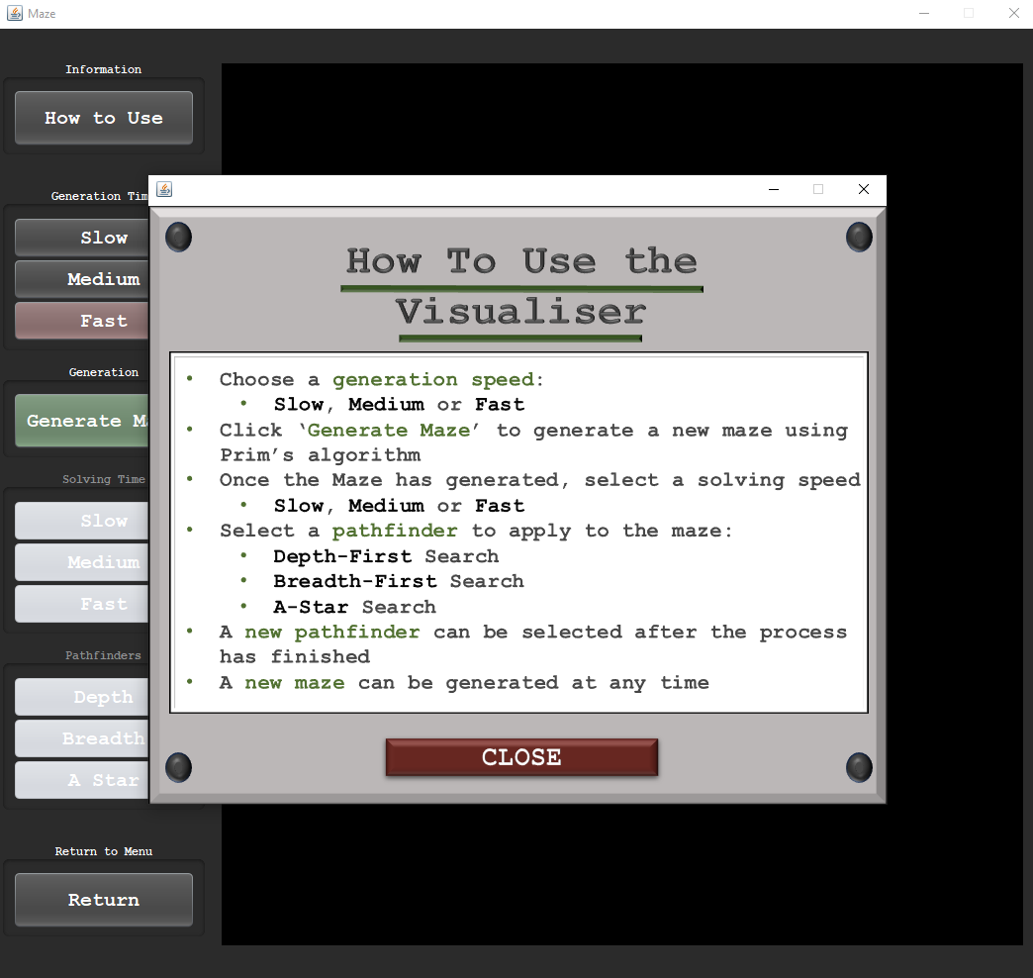

Right now, the code is fully working with the how to use toggling the visibility but if chose to exit the info top right, the visualiser closes too.

Fixing the chain close error:



To remove the exit bar at the top, I can remove call this function so that the user can only close the application through the close button.

Repeating for the visualiser:



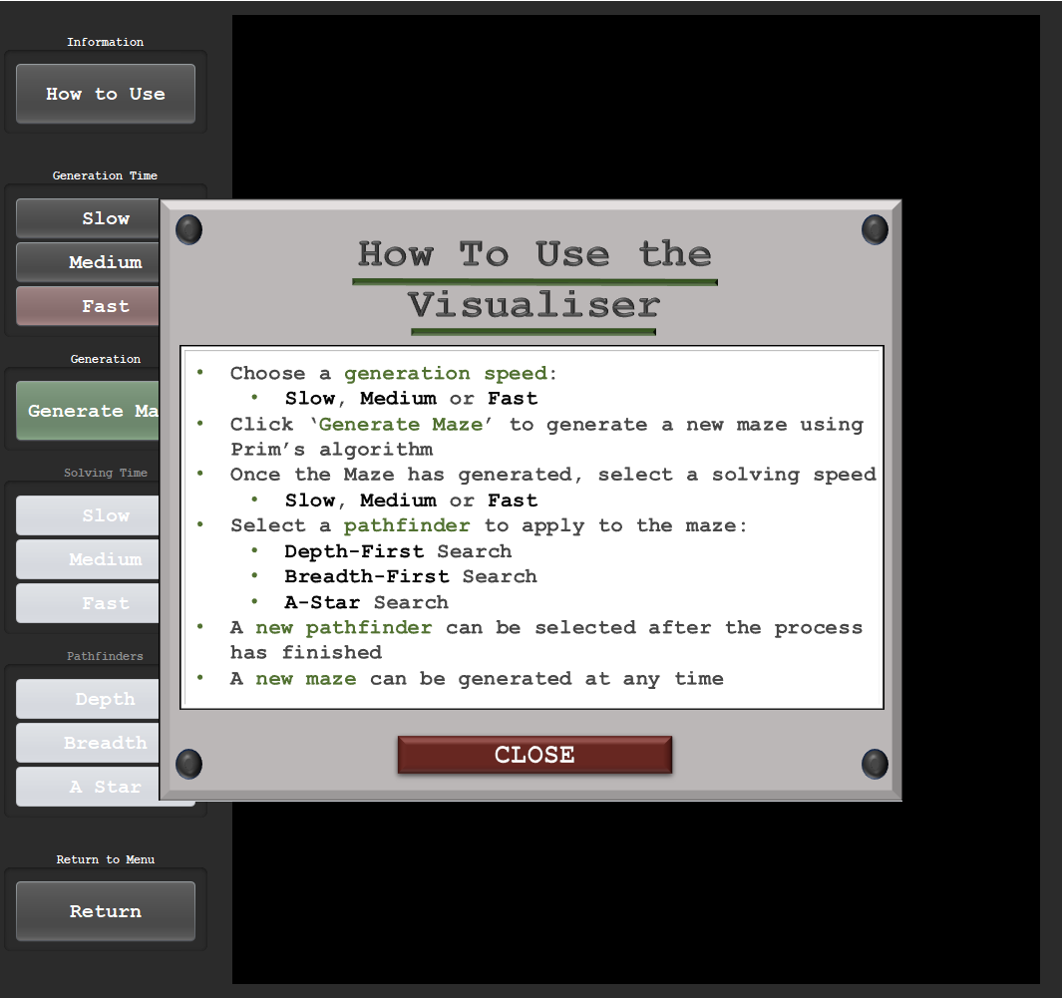

The program looks much cleaner now that the top bars have disappeared. I must add a close button to the visualiser to fully close the program now that the option has disappeared.

Now that the frame title is removed, the sizing has been skewed and stretched.

Fixing the sizing error:

Current maze:

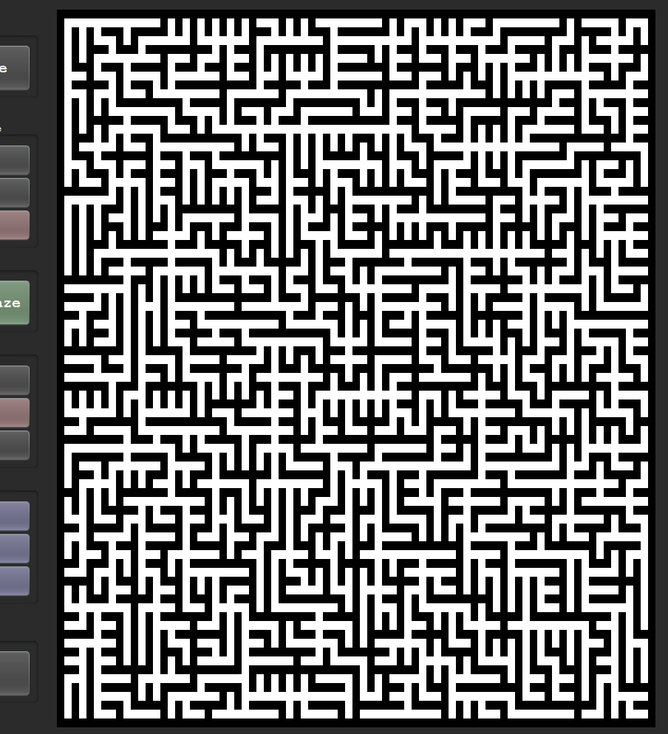

To accommodate for the sizing error, I will reduce the height of the frame:



Reducing the height of the frame allows the maze to retain its square shape:

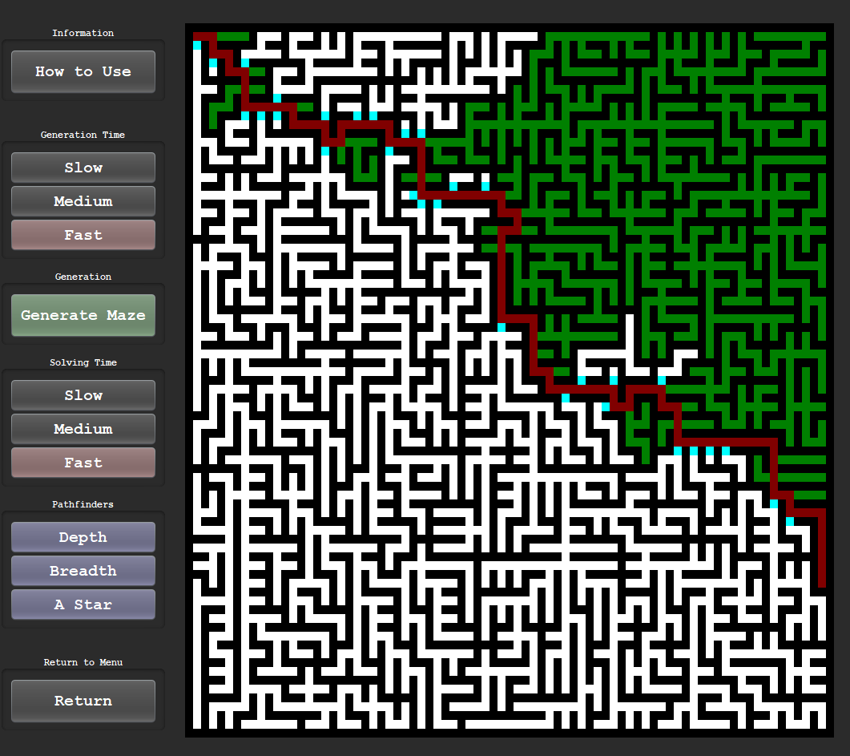

Capitalising the information title:

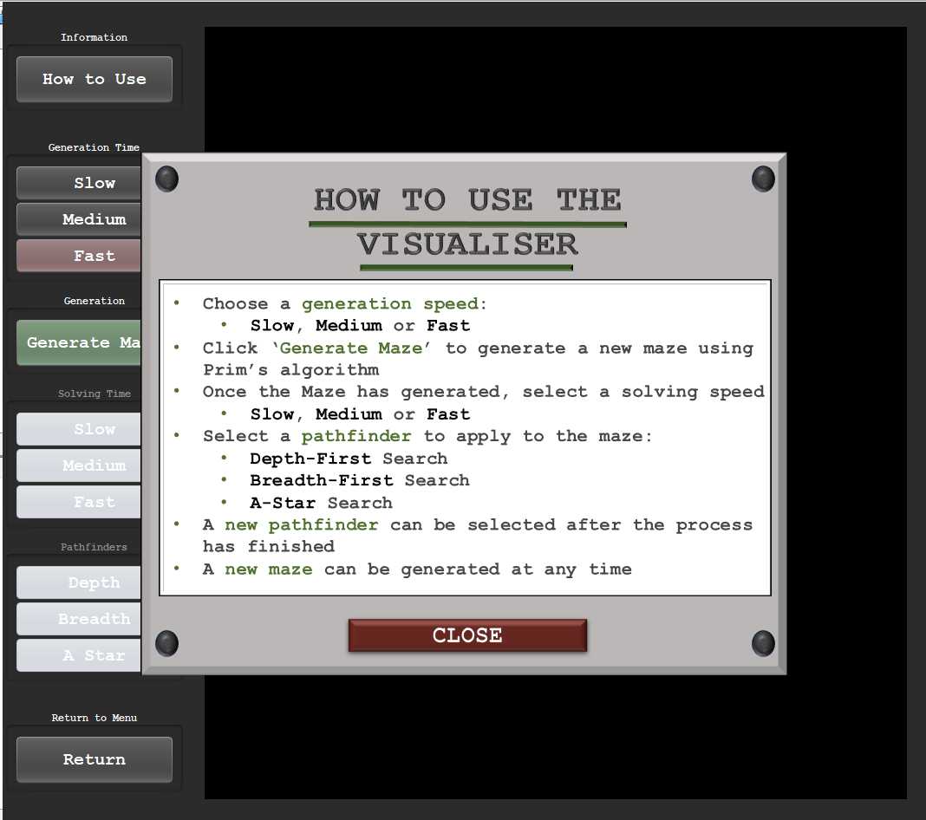

Adding tooltip text:

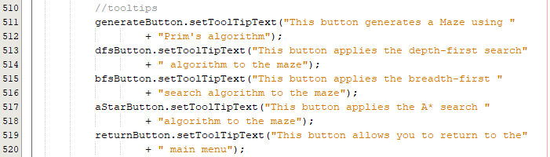

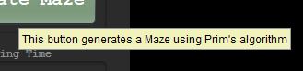

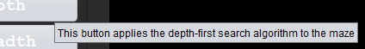

Adding the close program button:

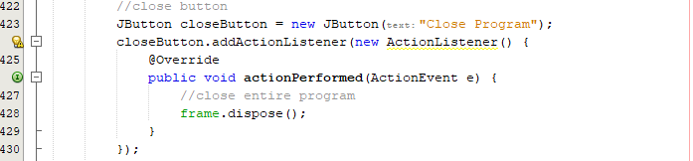

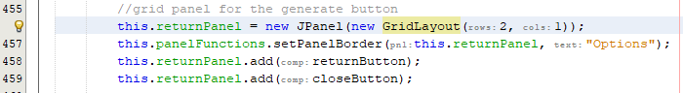

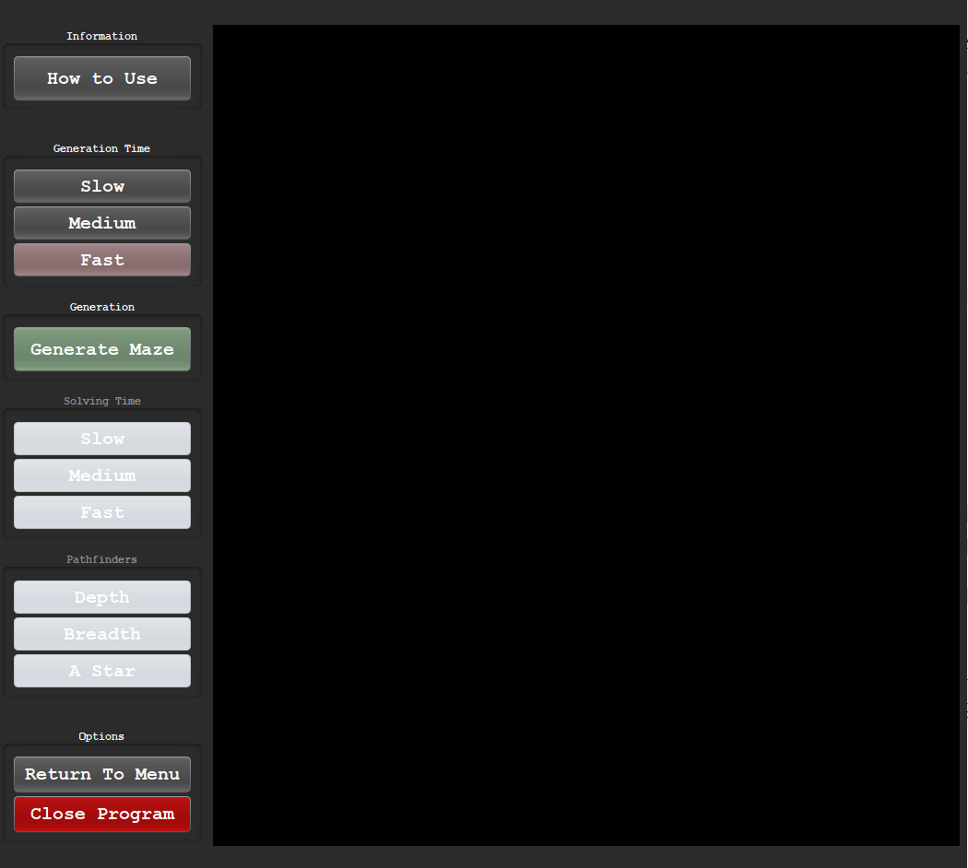

Right now when clicking close program, the program still runs but the frame closes:



Fixing the frame still running logic error:

The program still runs because the information screen is still open. I must also dispose this frame:

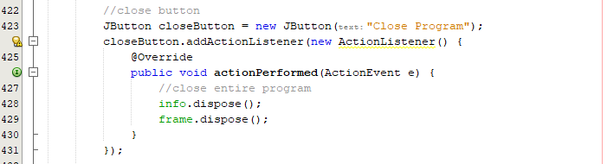

Clicking close program button:



The button now successfully works and ends the entire program.

Final Prototype UI:

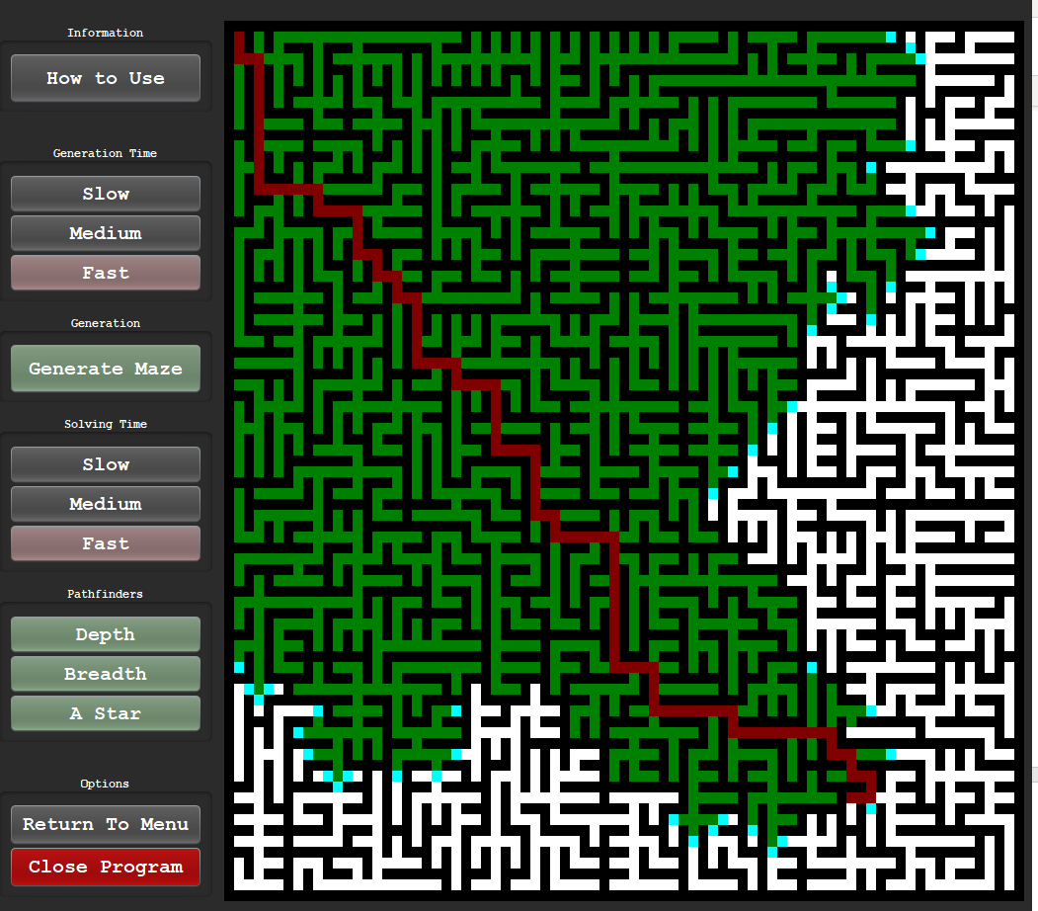

This prototype has been successful in displaying the maze in an aesthetic manner, allowing the user to fully customise maze generation and maze solvers. There is now a full working UI with instructions and options to close/ run the visualiser.

#### Final Cycle Code

##### Visualiser Class Code

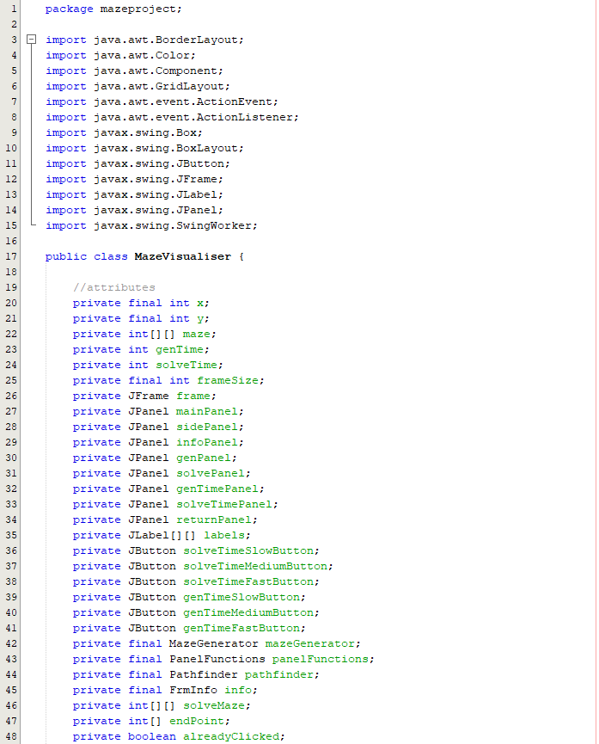

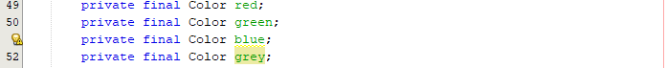

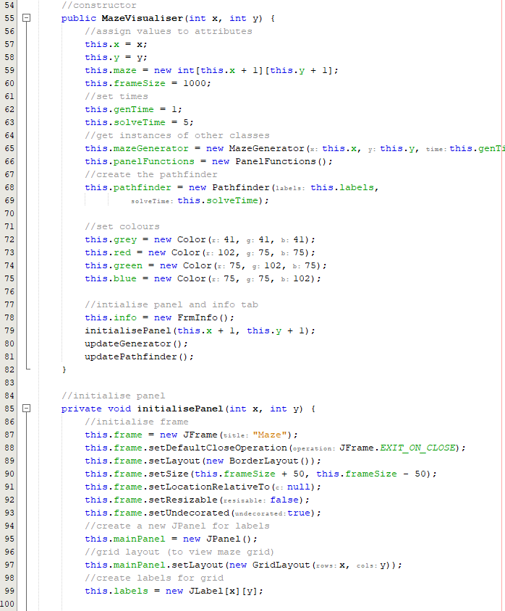

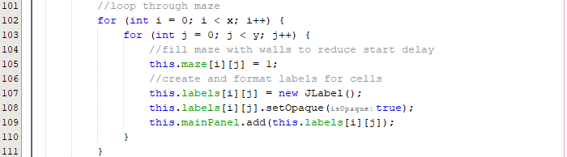

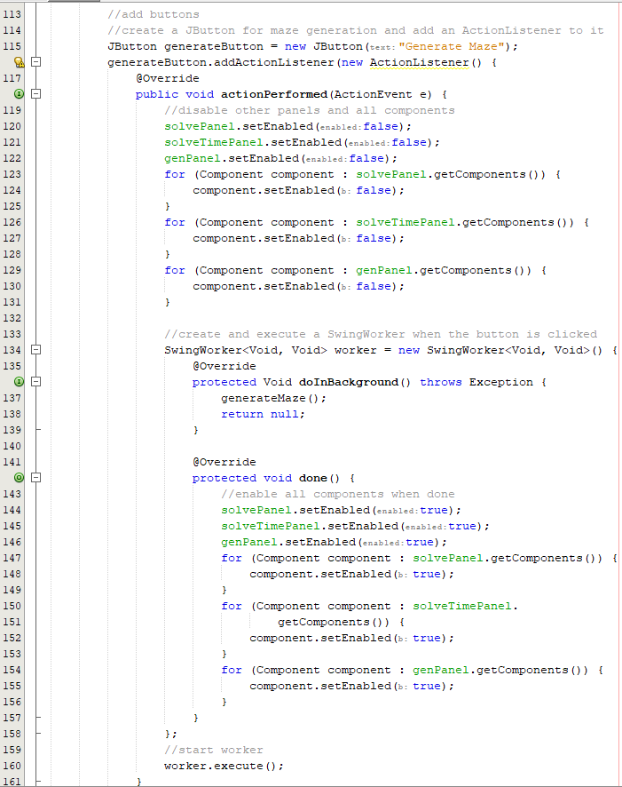

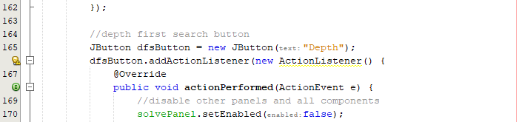

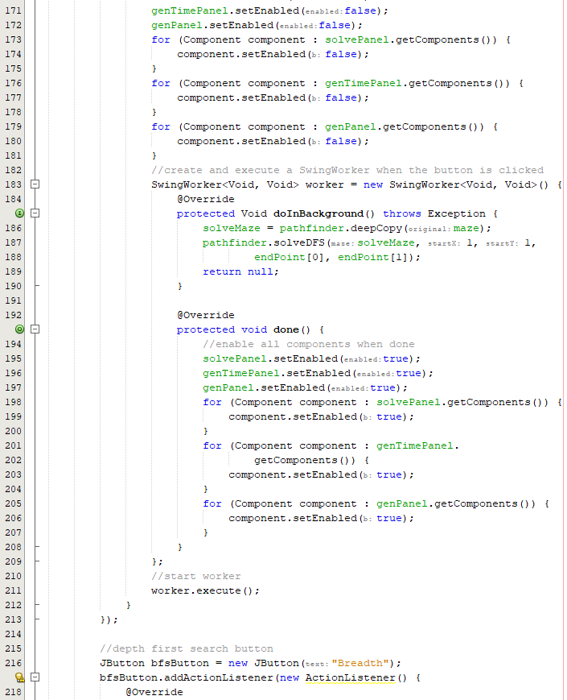

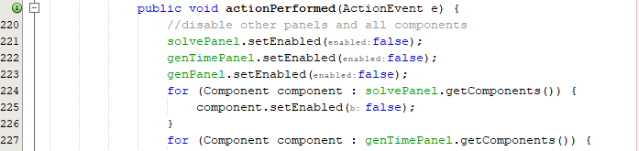

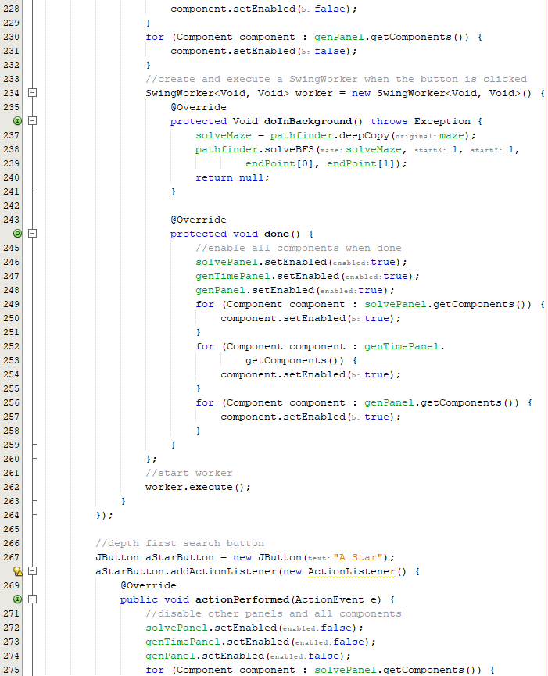

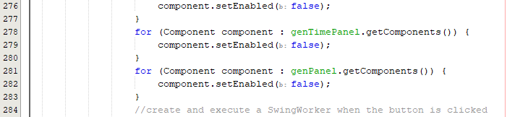

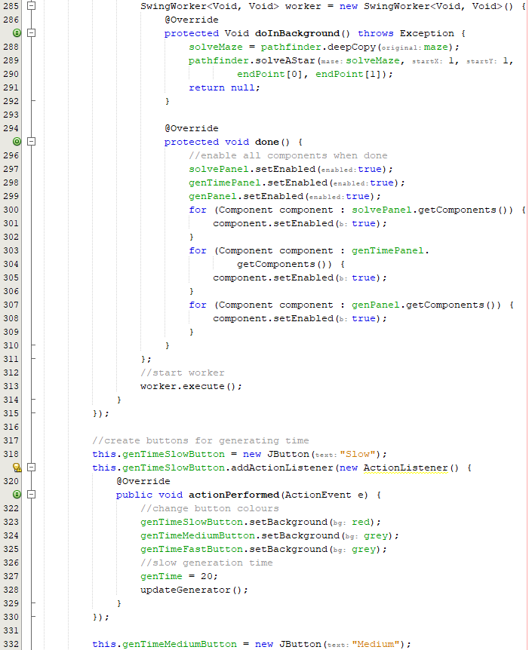

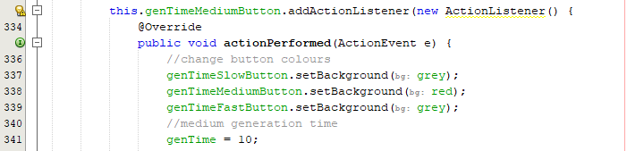

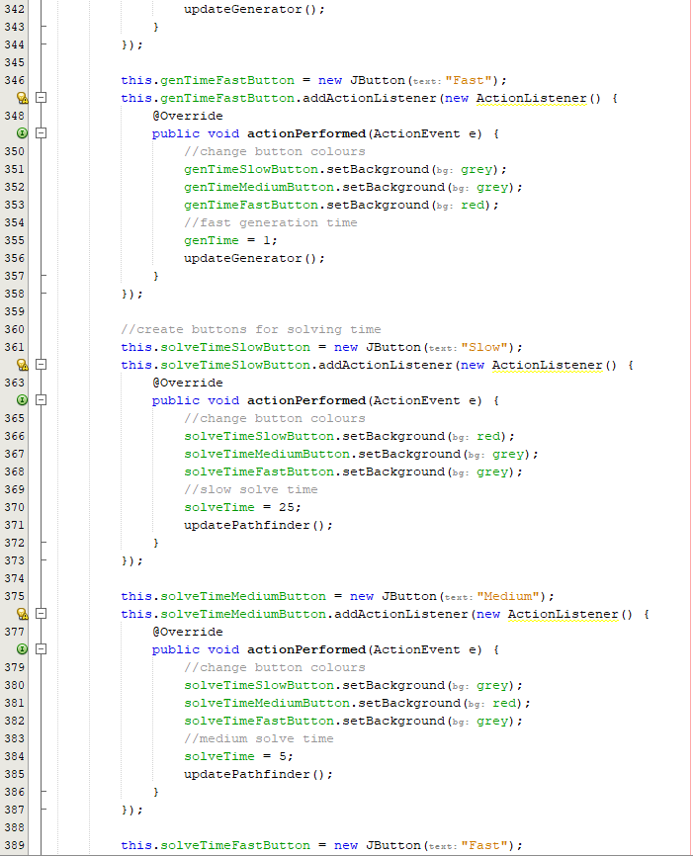

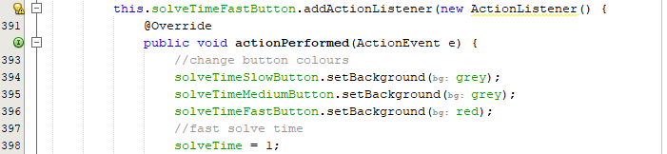

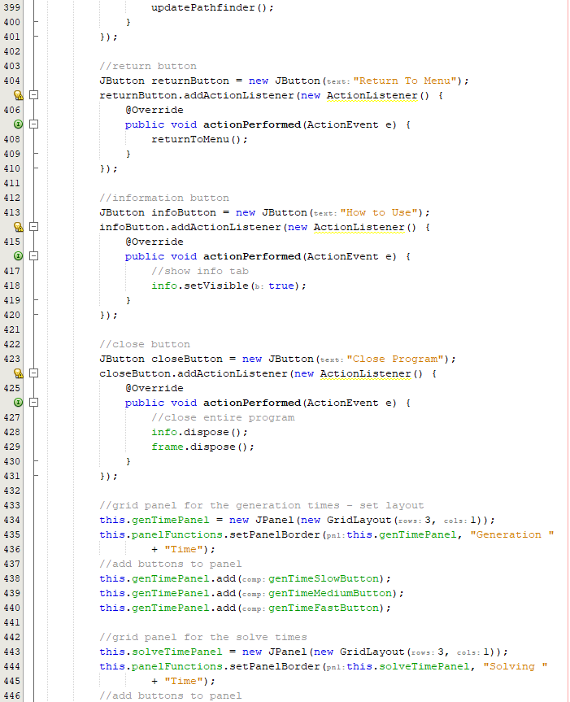

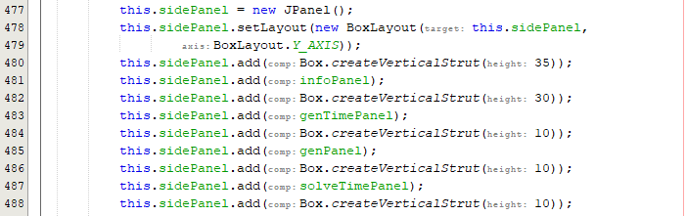

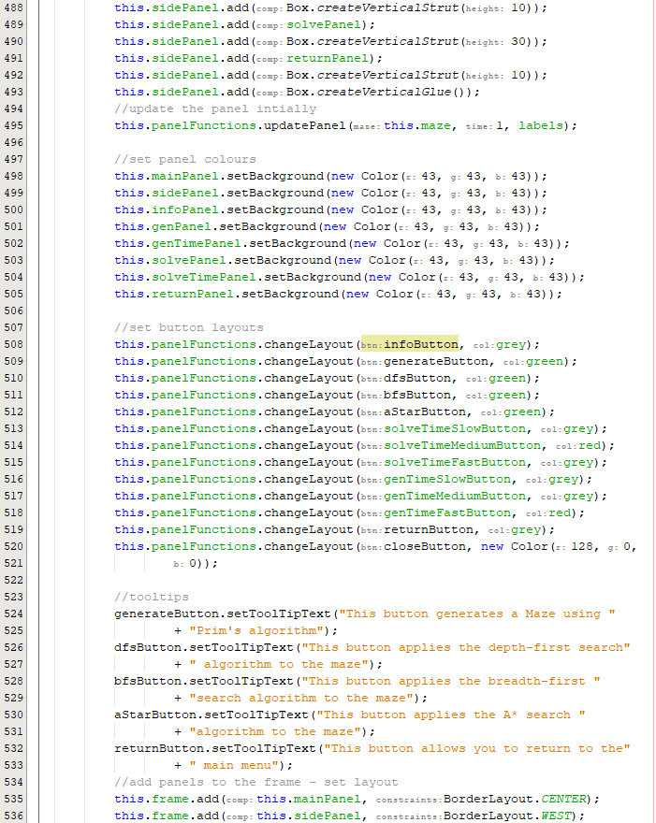

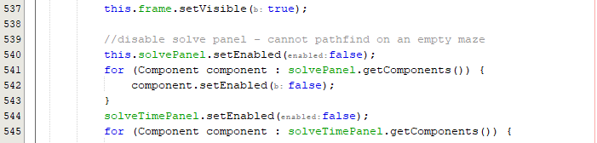

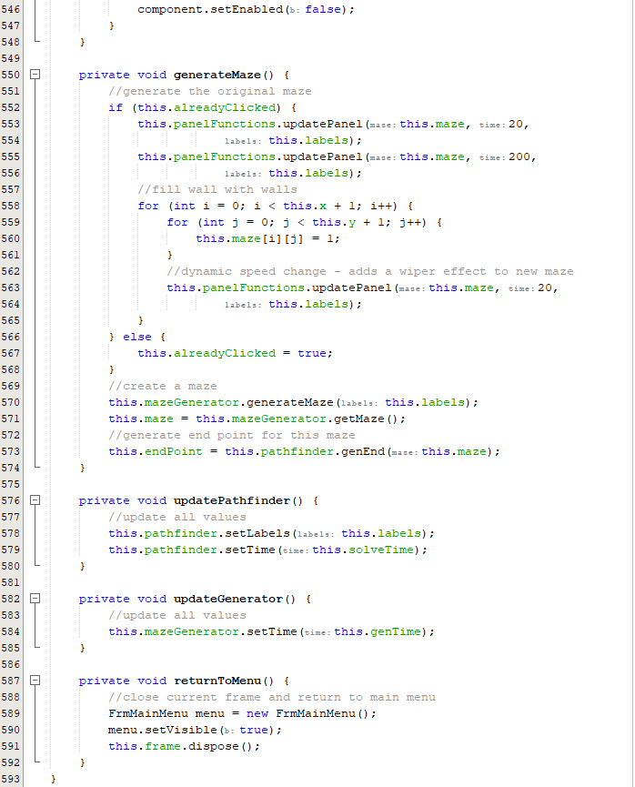

##### Pathfinder Class Code

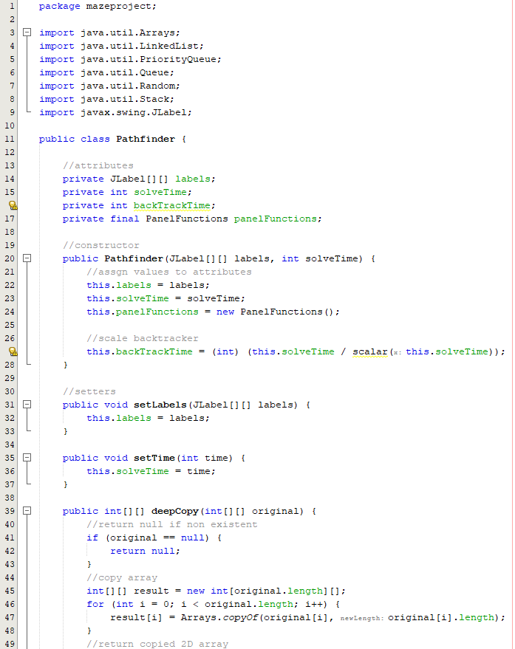

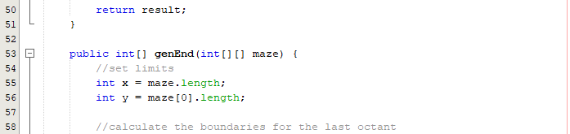

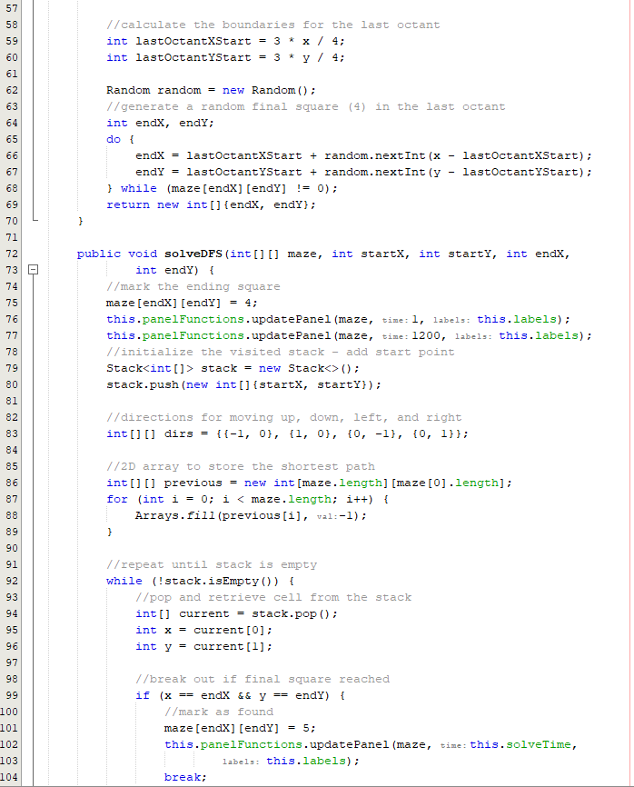

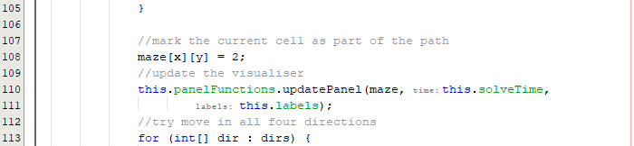

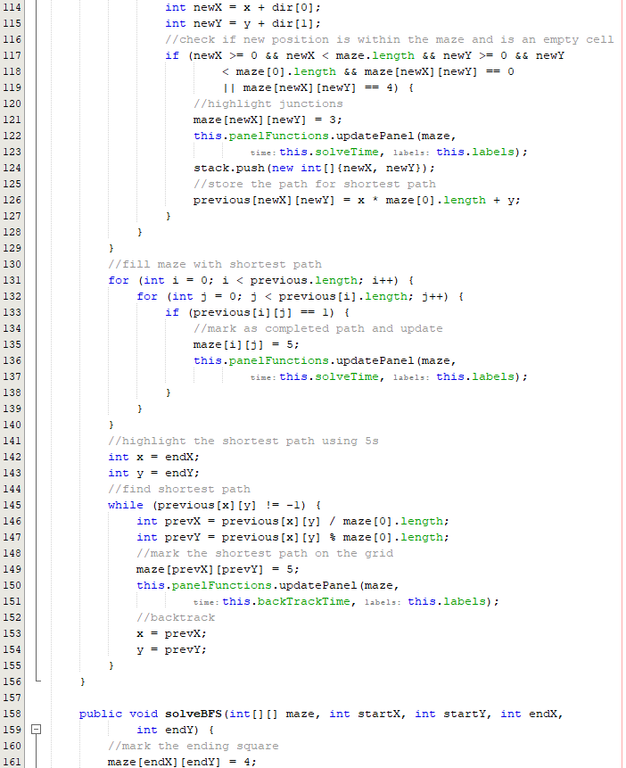

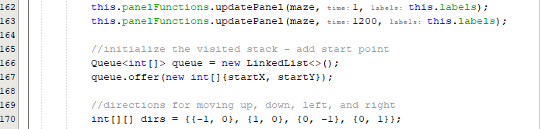

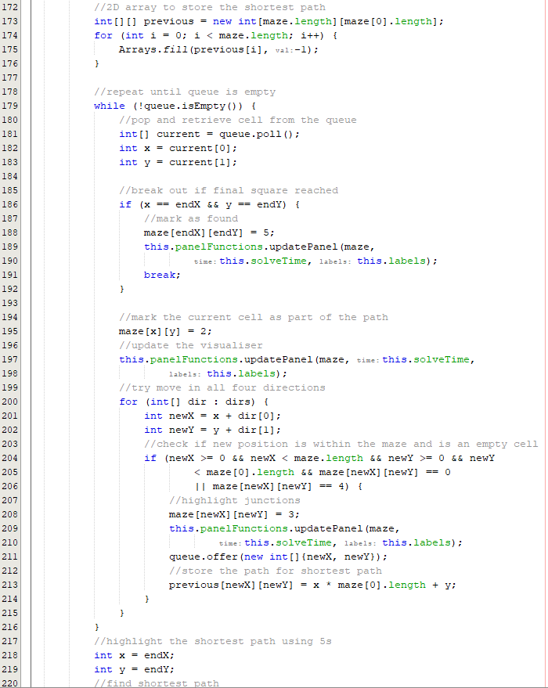

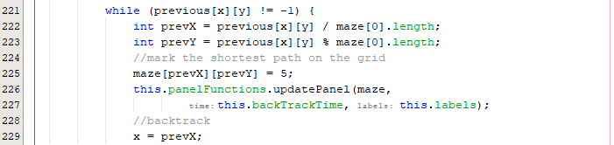

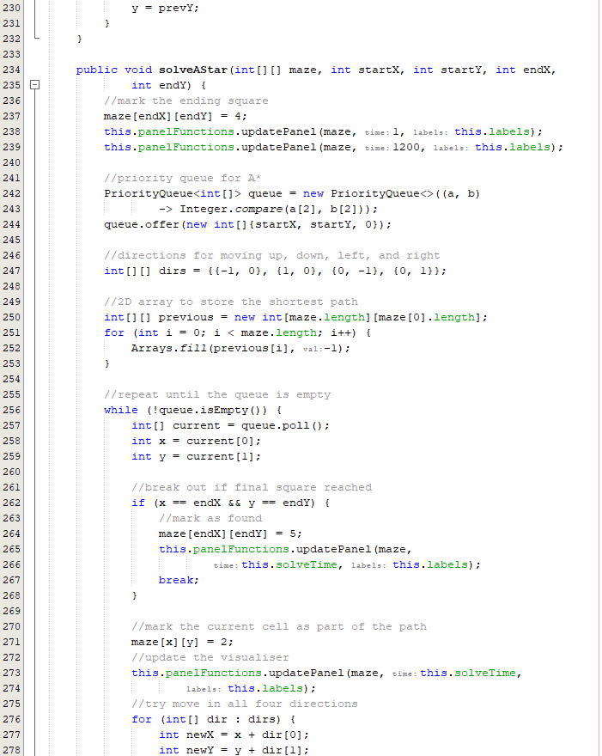

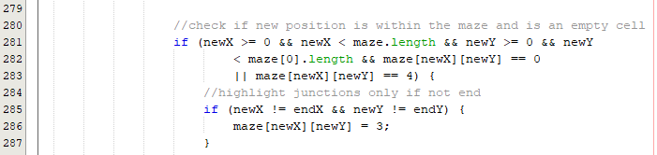

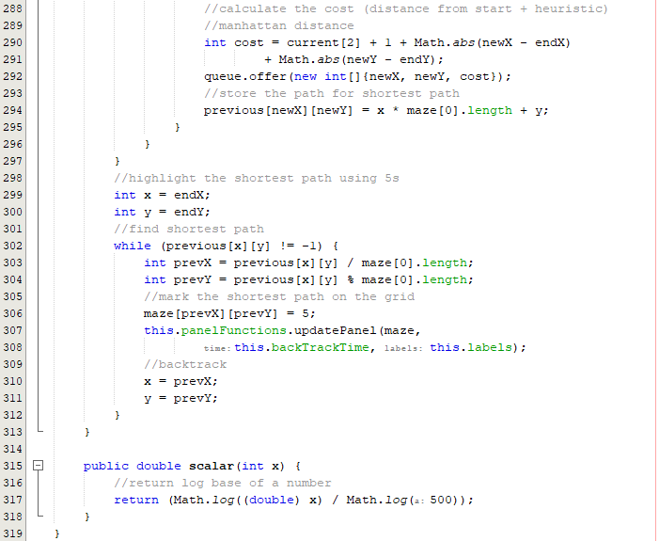

##### FrmInfo Class Code

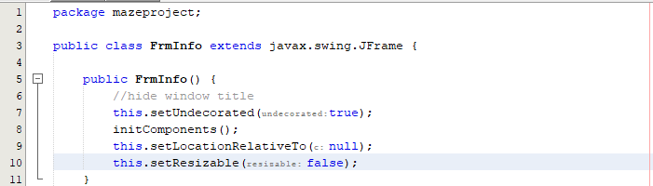

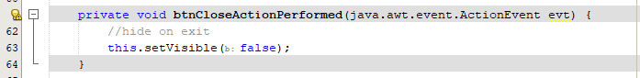

##### PanelFunctions Class Code

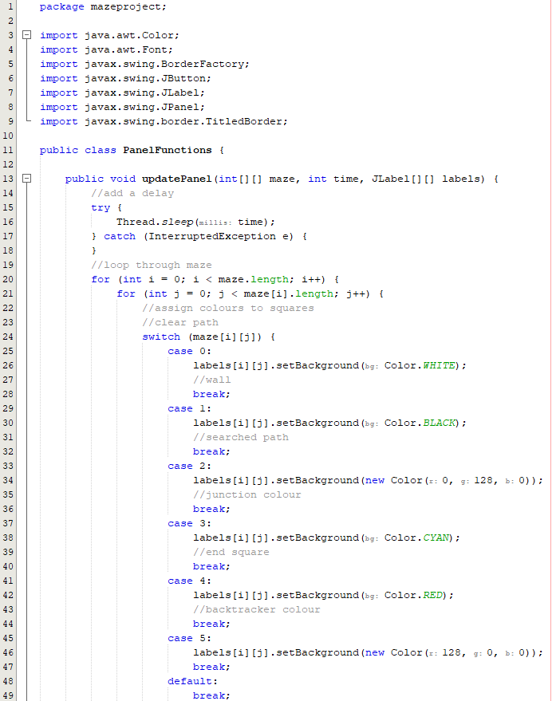

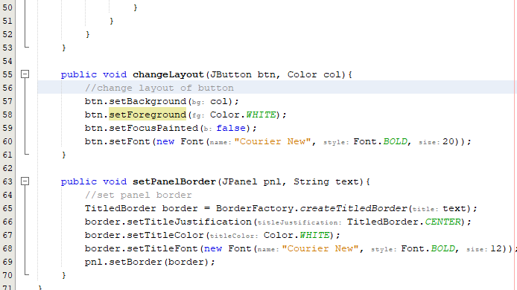



### Review

#### Final testing

|  |  |  |  |  |  |
| --- | --- | --- | --- | --- | --- |
| Test | Test description | Input | Expected outcome | Test type | Passed test? |
| 1 | Test for generating a maze in the visualise section | User clicks button | Click the generate maze should generate the maze slowly at a speed that the user can follow | Normal |  |
| 2 | Test for generating a solvable maze in the visualise section | Users click – algorithmic process called upon click | Once the maze is generated, there must be a path from the start of the square to the finish | Normal |  |
| 3 | Test for 3 different generation times | User clicks different speed options | Each generation speed has a different time to generate the maze. Change in speed must feel natural. | Normal |  |
| 4 | Test for 3 different solve times | User clicks different speed options | Each solve speed has a different time to generate the maze. Change in speed must feel natural. | Normal |  |
| 5 | Test for visibility of final and starting squares | User has the option to toggle the starting squares and end squares for the pathfinder | On click, the user can see the starting squares. On the second click the square are not visible. The squares are not visible on start. | Normal |  |
| 6 | Test to check whether depth first search correctly identifies the solution | User selects the depth first search mode | Once the algorithmic process has ended, the maze should be solved with the pathfinder marker on the final square | Boundary |  |
| 7 | Test to check whether breadth first search correctly identifies the solution | User selects the breadth first search mode | Once the algorithmic process has ended, the maze should be solved with the pathfinder marker on the final square | Boundary |  |
| 8 | Test to check whether A Star first search correctly identifies the solution | User selects the A Star first search mode | Once the algorithmic process has ended, the maze should be solved with the pathfinder marker on the final square | Normal |  |
| 9 | Test for shortest path viewer | User waits for pathfinder to finish | Shortest path is revealed in colour | Normal |  |

##### Test #1

|  |  |  |  |  |  |
| --- | --- | --- | --- | --- | --- |
| Test | Test description | Input | Expected outcome | Test type | Passed test? |
| 1 | Test for generating a maze in the visualise section | User clicks button | Click the generate maze should generate the maze slowly at a speed that the user can follow | Normal |  |

|  |  |
| --- | --- |
|  |  |
|  |  |

The maze was generated in ‘slow’ mode and the user could have chosen to increase the speed to medium or fast. The maze is gradually created and displayed, and the generation starts from the top left corner.

##### Test #2

|  |  |  |  |  |  |
| --- | --- | --- | --- | --- | --- |
| Test | Test description | Input | Expected outcome | Test type | Passed test? |
| 2 | Test for generating a solvable maze in the visualise section | Users click – algorithmic process called upon click | Once the maze is generated, there must be a path from the start of the square to the finish | Normal |  |

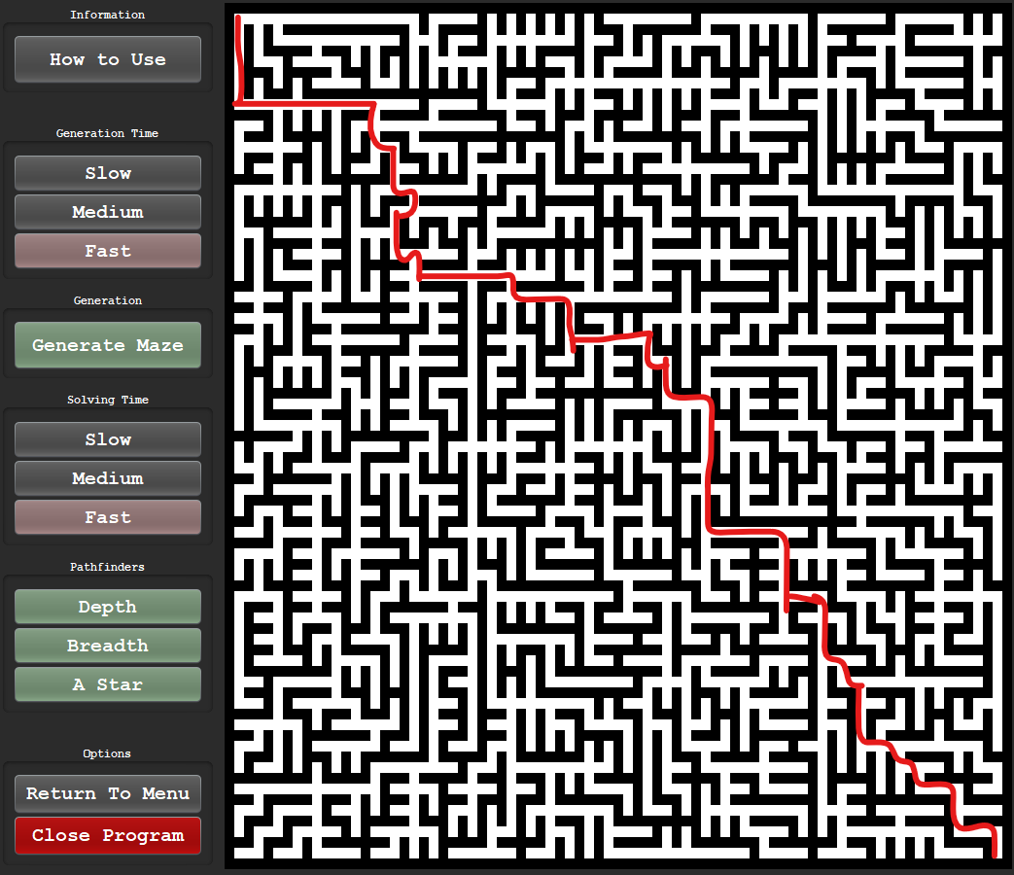

The maze generator above has a path from the starting square to the end square therefore being solvable. Due to the nature of Prim’s algorithm, this also shows that every point in the maze can reach another if connected to this solution path.

##### Test #5

|  |  |  |  |  |  |
| --- | --- | --- | --- | --- | --- |
| Test | Test description | Input | Expected outcome | Test type | Passed test? |
| 5 | Test for visibility of final and starting squares | User has the option to toggle the starting squares and end squares for the pathfinder | On click, the user can see the starting squares. On the second click the square are not visible. The squares are not visible on start. | Normal |  |

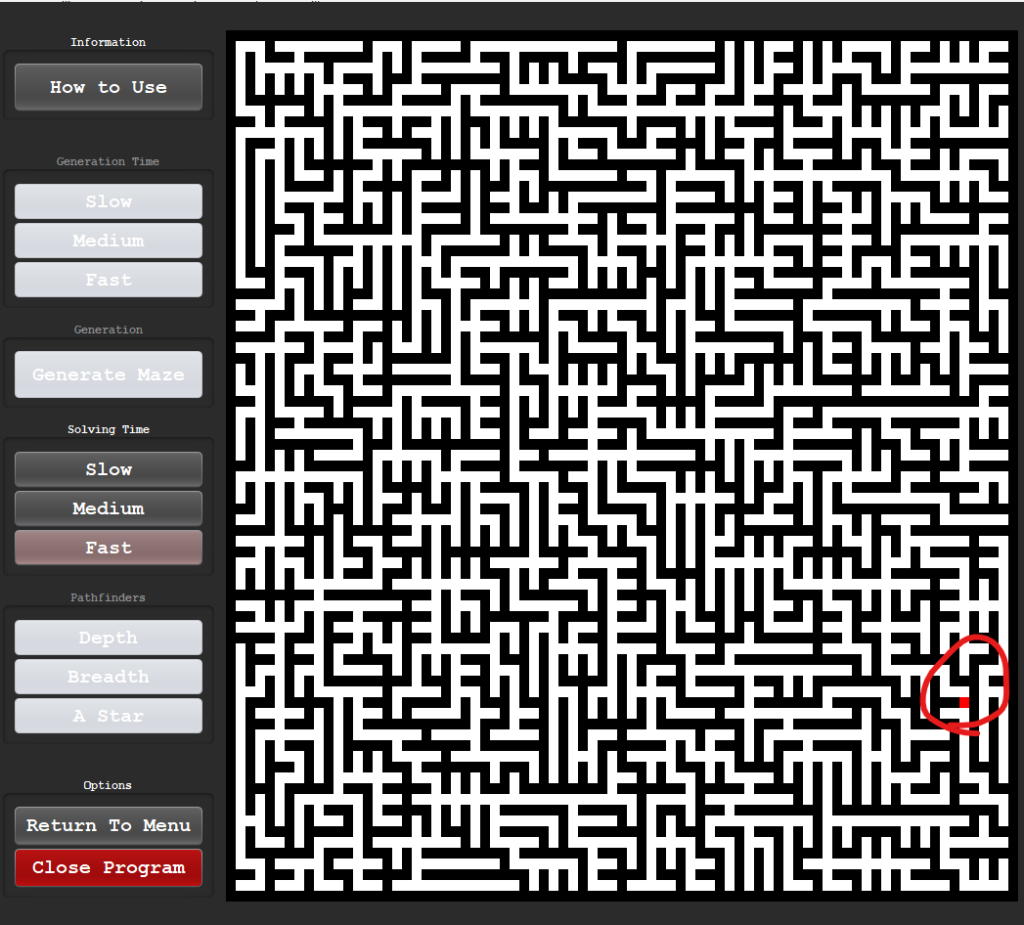

As shown above only the end square is visible and not the starting square. The pathfinders will always start from the beginning so the highlighting of the initial square would be pointless.

##### Test #6

|  |  |  |  |  |  |
| --- | --- | --- | --- | --- | --- |
| Test | Test description | Input | Expected outcome | Test type | Passed test? |
| 6 | Test to check whether depth first search correctly identifies the solution | User selects the depth first search mode | Once the algorithmic process has ended, the maze should be solved with the pathfinder marker on the final square | Boundary |  |

Running depth-first search:

|  |  |
| --- | --- |
|  |  |
|  |  |

As shown above, the maze fills the depth of the maze from top to bottom before eventually finding the end point and highlighting the shortest path, therefore passing the test as the search stops once the end point is found.

##### Test #7

|  |  |  |  |  |  |
| --- | --- | --- | --- | --- | --- |
| Test | Test description | Input | Expected outcome | Test type | Passed test? |
| 7 | Test to check whether breadth first search correctly identifies the solution | User selects the breadth first search mode | Once the algorithmic process has ended, the maze should be solved with the pathfinder marker on the final square | Boundary |  |

|  |  |
| --- | --- |
|  |  |
|  |  |

As shown above the searcher radiates outwards therefore successfully showing the breadth first search working. The solver also stops working when the end square has been reached and the shortest path is revealed.

##### Test #8

|  |  |  |  |  |  |
| --- | --- | --- | --- | --- | --- |
| Test | Test description | Input | Expected outcome | Test type | Passed test? |
| 8 | Test to check whether A Star first search correctly identifies the solution | User selects the A Star first search mode | Once the algorithmic process has ended, the maze should be solved with the pathfinder marker on the final square | Normal |  |

|  |  |
| --- | --- |
|  |  |
|  |  |

As shown above, the A Star algorithm was more efficient than the breadth first search due to the added heuristics and less searches were needed. The solver stopped and revealed the shortest path when the end point is released.

##### Test #9

|  |  |  |  |  |  |
| --- | --- | --- | --- | --- | --- |
| Test | Test description | Input | Expected outcome | Test type | Passed test? |
| 9 | Test for shortest path viewer | User waits for pathfinder to finish | Shortest path is revealed in colour | Normal |  |

|  |  |  |
| --- | --- | --- |
| **Depth-first search** | **Breadth-first search** | **A-Star search** |
|  |  |  |

When running the same maze for all of these searches, all of the had revealed the shortest path in a dark red colour. In all 3 cases, the shortest path is consistent with one another.

#### Conclusion

Overall, this cycle has produced a **fully functioning visualiser** mode for the product and includes a fully functioning user interface that accommodates **custom settings** such as the **speed** of **generation** or the **speed** of **traversal** for the pathfinder. Each previous step is highlighted in a **green** tone and any possible step (a **junction**) is highlighted in a **blue** tone. This process repeats until the **end square is reached** where the shortest path that was calculated during the process is gradually revealed in a **red** tone.

The **usability** of the program was enhanced through the instructions form and the colours remaining **consistent** throughout the **UI**. Speed controls are red, maze controls are green. A great addition in this cycle that will be soon added to the other forms is the **undercoating** of the window. This allows the title bar at the top to be removed to add a **clean fe**el to the program. To facilitate this change, a close program button was created and added to the bottom to allow full **termination** of the program.

This implementation was **smooth** with any errors being resolved instantly, test #5 did **not pass** as I have chosen **not to highlight** the starting square to remove **ambiguity**. The solvers will always start at the beginning so there is no point in highlighting this square each iteration and adding unnecessary confusion. Another error that halted progress for a while was the use of **threads with buttons**. To tackle this problem, I employed **swing workers** to call the threads in the background as a separate process entirely. The entire structure of this visualiser was made through **object-oriented** programming where **encapsulation** and **polymorphism** were used most frequently.

The next steps are to create a **main menu** and develop a game mode for the user to play the maze. The class to do this will use the **current frame settings** and the **Maze** class.

## Cycle #9 - Developing the Main Menu

### Design

#### Decomposition & Overview

The main menu is the **first** **form** the user sees after being **allowed to access** the system. The form should be easy to use with **minimal ambiguity**. The main menu should consist of **3 main buttons**:

* Visualise – This mode allows the user to apply certain **pathfinders** such as depth first search, **breadth** first search and **A** **Star** search onto a maze generated through **Prim’s** algorithm.
* Play – This mode will allow the user to **solve a maze** that has also been generated through prim’s algorithm but there is **no visual creation**. There will be an option of **three** differentmaze **sizes** and a timer will be displayed above the maze.
* Statistics – here there will be a **leaderboard** that displays the **quickest** times for the three different maze sizes. The username will be displayed and the time the user has achieved will be adjacent.

Designing the main menu in PowerPoint:

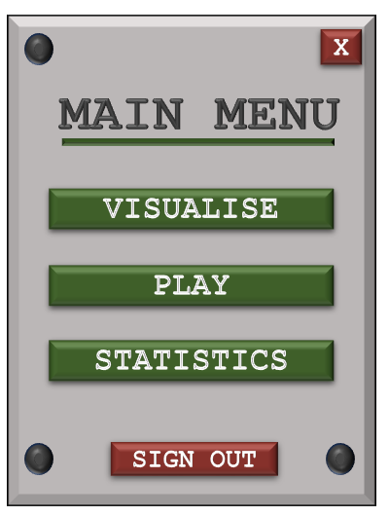

Here I have included an **exit button** in the **top right** due to the plan to remove the title bar as discussed in the previous cycle. I will also give the user the option to sign out and return to the login form.

#### Usability Features

The only usability feature to discuss in this cycle is **accessibility** (how easy it is to use the menu). This will be achieved through the layout and aesthetic.

I have chosen a **centre lining** for all components; the buttons are aligned with equal spacing and there is not much empty space within this form. The exit and sign out options are **red** to indicate **termination** with the remaining buttons being green with the same **aesthetic** as the login and register form.

#### Test Table

|  |  |  |  |  |
| --- | --- | --- | --- | --- |
| Test | Test description | Input | Expected outcome | Test type |
| 1 | Test for exiting the entire program | User clicks top right button | The program stops running and is terminated | Normal |
| 2 | Test for signing out | User clicks the sign out button at the bottom of the form | Current form closes and the user is returned to the sign-up form. | Normal |
| 3 | Test for clicking visualiser | User clicks the visualiser button | Current form closes and the user is redirected to the visualiser form | Normal |
| 4 | Test for clicking play | User clicks the play button | Current form closes and the user is redirected to the play form (currently a dummy form) | Normal |
| 5 | Test for clicking statistics | User clicks the statistics button. | Current form closes and the user is redirected to the statistics form (currently a dummy form) | Normal |

### Coding and Testing

#### Iterative Development and Testing

##### Prototype #1

Adding the background:

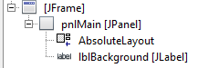



Setting frame properties:

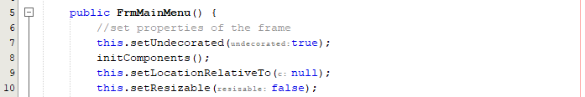

Adding the buttons:

Exit button:



Game mode buttons:

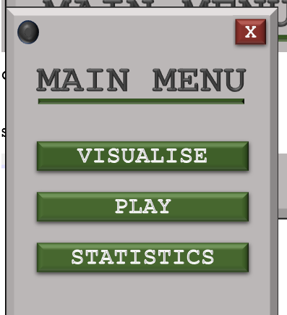

Sign out button:



Full UI:

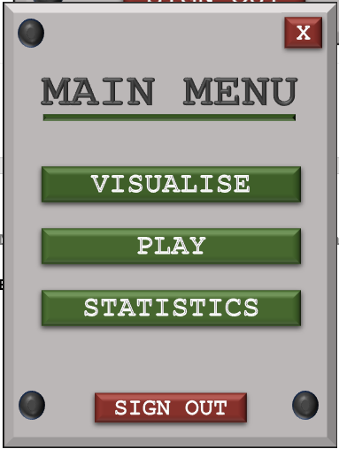

Adding button functionality:

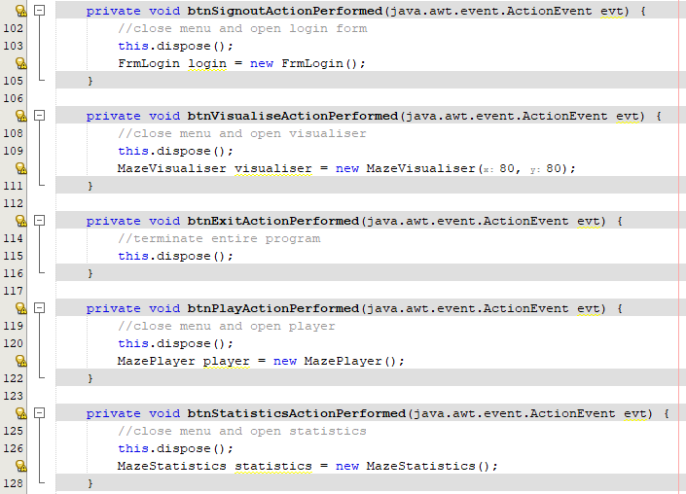

Login form not opening when sign out error:

The login form currently does not open as it is not set to visible:

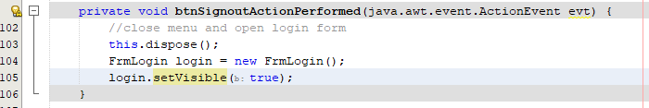

Final UI:

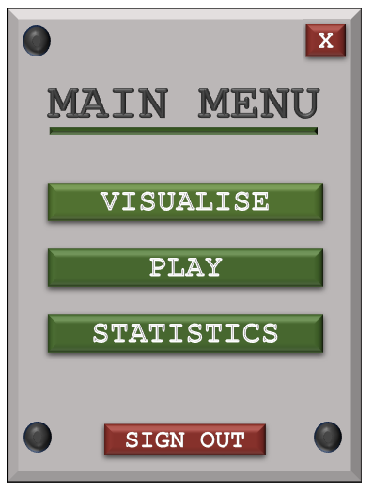

#### Final Cycle Code

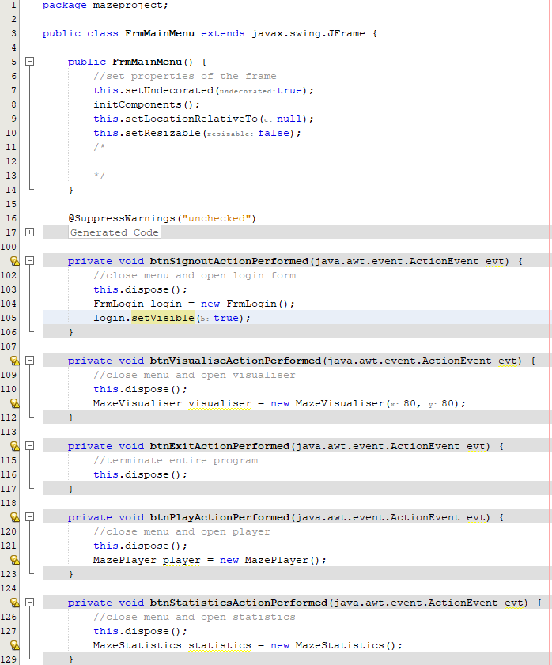

### Review

#### Final testing

|  |  |  |  |  |  |
| --- | --- | --- | --- | --- | --- |
| Test | Test description | Input | Expected outcome | Test type | Passed test? |
| 1 | Test for exiting the entire program | User clicks top right button | The program stops running and is terminated | Normal |  |
| 2 | Test for signing out | User clicks the sign out button at the bottom of the form | Current form closes and the user is returned to the sign-up form. | Normal |  |
| 3 | Test for clicking visualiser | User clicks the visualiser button | Current form closes and the user is redirected to the visualiser form | Normal |  |
| 4 | Test for clicking play | User clicks the play button | Current form closes and the user is redirected to the play form (currently a dummy form) | Normal |  |
| 5 | Test for clicking statistics | User clicks the statistics button. | Current form closes and the user is redirected to the statistics form (currently a dummy form) | Normal |  |

##### Test #1

|  |  |  |  |  |  |
| --- | --- | --- | --- | --- | --- |
| Test | Test description | Input | Expected outcome | Test type | Passed test? |
| 1 | Test for exiting the entire program | User clicks top right button | The program stops running and is terminated | Normal |  |

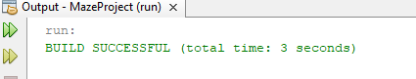

As show above, the program stops running when the exit button is clicked.

All other tests are simple and documenting the process of showing redirection would not be necessary.

#### Conclusion

This cycle was **short in nature** and implemented purely **graphics** to a few button presses. The game now has 3 mode options with the visualiser already having been **implemented**. The addition of this menu fits **perfectly** into the **general aesthetic** as it **reuses** the layout from the login form. The main menu has an option to exit the entire program top right as the window bar was removed and another option to **sign out** of the account where the user will go back onto the login screen.

Now that this form has been developed, a clear **outline** of what remains for the program is available. The **Play** mode and **Statistics** mode remain to implemented and after developing the visualiser, the play mode can re-use this form but with **JButtons** rather than **JLabels** and the entire process should be shorter than the Cycle #8 as the **modules** can be reused from the **visualiser** class and the **maze generator** class.

## Cycle #10 – Developing the Play mode

### Design

#### Decomposition & Overview

When designing the play game mode, I do not need to worry about **display**, initialising the frame or developing the UI graphics as this was **already done** when developing the visualiser. This class will be an **abstraction** of the visualiser as it will have the same functions e.g. **return to menu**, **close** program, and an **information** tab.

The main process of this game can be broken down:

* Access - Upon clicking the visualise button on the main menu, a function will call a form that will prompt a user to generate a maze, solve a maze and display statistics.
* Size - The user is asked to select between **3 size options** which will be set during development.
* Generation - A maze is built through **Prim’s algorithm**, and this will be called from the maze generator class where the interface is update through the update panel subroutine in the panel functions class.
* Start & End - The starting point will always be the first square and the ending point will always be the last square. This is to keep the game fair and avoid luck-based times when storing these times to be displayed on a leaderboard.
* Win Detection – Once the user reaches the end square, the maze is locked, and the key listeners will be removed. After this a pop-up menu will be displayed where the user can choose to start a new game, return to the main menu, and display the win statistics.

#### Validation

* Legal Move – Every key press, the program will **validate** what key is **pressed** and **attempt a move** in that direction. I do not need out of bounds validation as my maze is encased by walls therefore **out of bounds will never be reached**. Each move in a direction will validate whether the user is moving onto a wall, if it is not a wall then the user can make a move into that direction where the current cell is updated, and the **process is repeated**.

#### Usability Features

* Play experience – After selecting the size of the maze, the user **will know how** to **navigate** through the maze instantly, this is because the controls will be located on the screen with a description just before starting the game. There will only be one goal during this; use the controls to navigate form the starting square to the finishing square. Too many **different functions will obscure** the objective.
* Instructions – Similar to the maze visualiser, the play interface will have a form that will explain **how to use the mode**. This will explain that the **arrow keys** can be used to navigate through the maze where the process will be timed. The user can return to the menu or start a new game **at any point,** but the time will only be stored if the game is **completed**.

#### Pseudocode

procedure keyPressed()

//case for each key press

switch (keyEvent):

//up arrow press

case KEY.up:

//set directions

i = currentCell[0] - 1

j = currentCell[1]

//check if maze location is not a wall

if maze[i][j] != 1 then

//mark as explored

maze[i][j] = 2

//update current cell

currentCell = {i, j}

endif

//down arrow press

case KEY.down:

//set directions

i = currentCell[0] + 1

j = currentCell[1]

//check if maze location is not a wall

if maze[i][j] != 1 then

//mark as explored

maze[i][j] = 2

//update current cell

currentCell = {i, j}

endif

//left arrow press

case KEY.left:

//set directions

i = currentCell[0]

j = currentCell[1] - 1

//check if maze location is not a wall

if maze[i][j] != 1 then

//mark as explored

maze[i][j] = 2

//update current cell

currentCell = {i, j}

endif

//up arrow press

case KEY.right:

//set directions

i = currentCell[0]

j = currentCell[1] + 1

//check if maze location is not a wall

if maze[i][j] != 1 then

//mark as explored

maze[i][j] = 2

//update current cell

currentCell = {i, j}

endif

default:

//handle error

print("error")

endswitch

endprocedure

#### Variable Table

|  |  |  |
| --- | --- | --- |
| Key Variables | Data Type | Justification |
| hasWon | Boolean | This Boolean is mandatory for indicating whether the maze has been solved. This value is true if the current cell is the end cell and is false otherwise. The variable will help signify whether or not the win menu is displayed. |
| displayTime | String | This time is displayed as a string on a label and the integer value is incremented every second that goes by. The integer value of this string is stored on a text file when saving the statistics. |
| currentX | Integer | This integer signifies the current X co-ordinate of the user. This is needed to keep track of the path and determine if a move is legal. |
| currentY | Integer | This integer signifies the current Y co-ordinate of the user. This is needed to keep track of the path and determine if a move is legal. |
| isLegal | Boolean | This Boolean value signifies whether a move a user is making is a legal move (is not a wall). If it is, the process of updating the current cell is carried out. |

#### Test Table

|  |  |  |  |  |
| --- | --- | --- | --- | --- |
| Test | Test description | Input | Expected outcome | Test type |
| 1 | Test to check if the maze on ‘play’ mode generates a solvable maze | User selects the size of the maze | After the size is selected, a complete maze should be created with that dedicated size | Normal |
| 2 | Test for interaction /playability | User clicks a cell on the grid or arrow key pressed adjacent to current square | Label should be able to be clicked or accessed if it is adjacent to the current square and is then highlighted | Normal |
| 3 | Test for selecting non-current cells that have not been highlighted previously | User clicks or tries to access a cell that is not the current cell and has not been highlighted before | Nothing happens, the square is not highlighted, and the input is ignored | Normal |
| 4 | Test for deselecting non-current cells that have been highlighted previously | User clicks or accesses a highlighted label that isn’t the current label | The cell is not deselected, and the input is ignored | Normal |
| 6 | Test for menu after win detection | User navigates to the final square | As soon as the final square is reached, a menu is displayed after the win is detected | Boundary |
| 7 | Test for returning to main menu after playing a game on the win menu | Button click | Upon clicking return to main menu, the old form is removed, and the main menu is now displayed | Boundary |
| 8 | Test for the ability to play another game on the win menu | Button click | User can successfully play a game one after another. Game loads after click and removes the previous game | Normal |
| 9 | Test for instructions on the play mode | Clicking how to use | A form should pop up that informs the user how to use this section of the program | Normal |
| 10 | Test for paths to be highlighted in a darker colour if going over them multiple times | Re tracing previously explored paths | The cell becomes a tint darker when re traced | Normal |

### Coding and Testing

#### Iterative Development and Testing

##### Prototype #1

This prototype’s purpose is to transfer the UI from the visualiser and remove any unneeded variables and components so that it is tailored to this certain game mode. By the end of this prototype, there should be a working frame that displays the maze to the user but the associated buttons to visualiser should be removed.

Converting the code

Keep generate maze and return to menu subroutines:

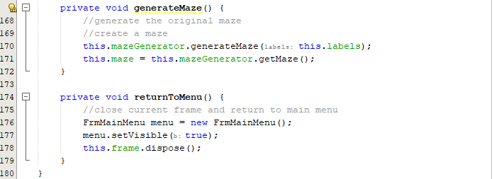

I must remove all the buttons associated with the visualiser as well as the panels to hold these:

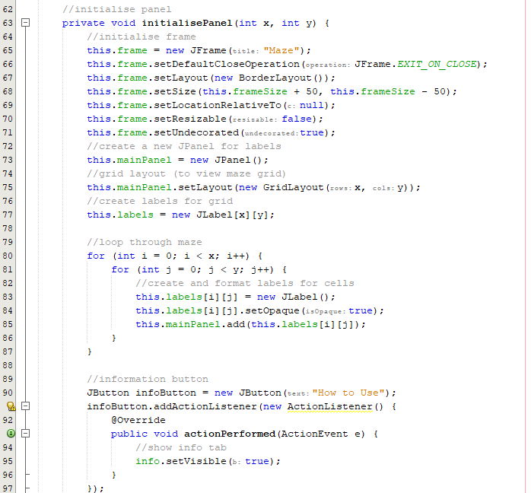

Keeping these buttons:

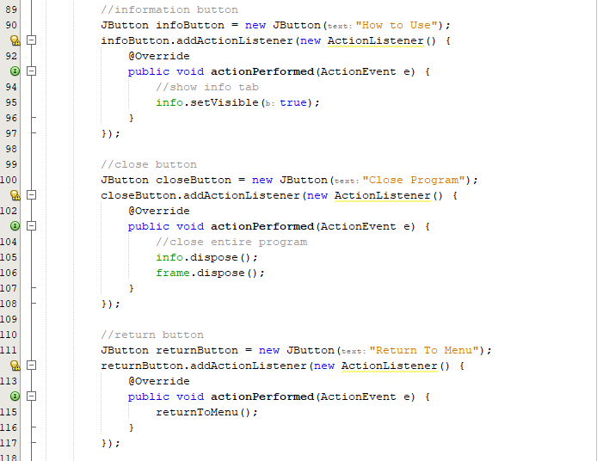

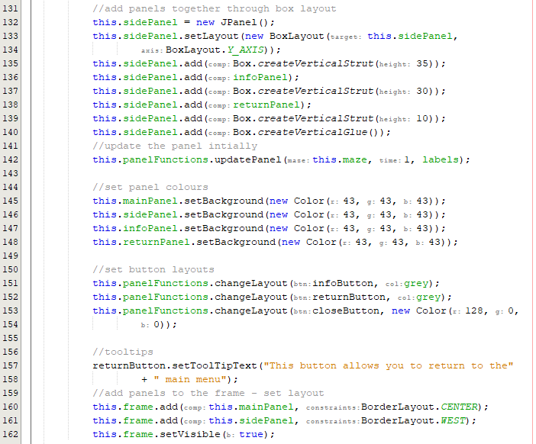

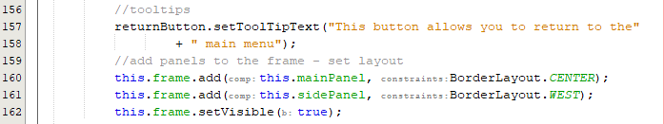



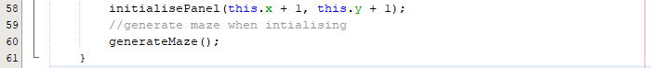

Testing the current menu:

In the main menu:

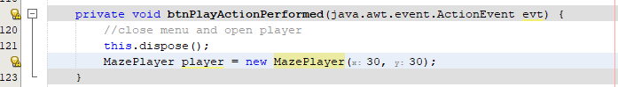

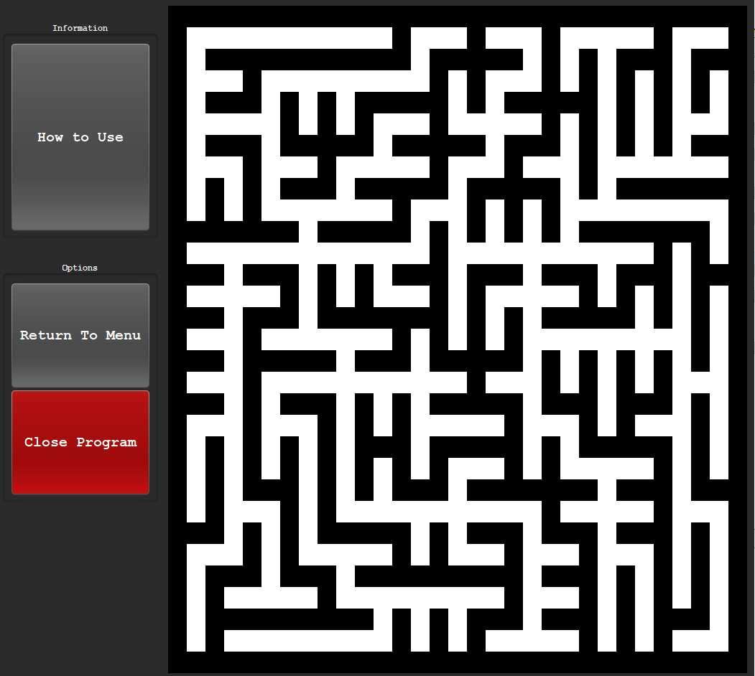

This prototype has been successful in generating a maze whilst keeping original format.

##### Prototype #2

Now that the maze has been developed and displayed, I will now begin to add key listeners so that the user can interact with the screen and solve the maze. This prototype will be responsible for allowing the user to interact with the maze and detecting a win.



This code adds a key listener to the entire frame and monitors clicks. Now I must handle each button press:

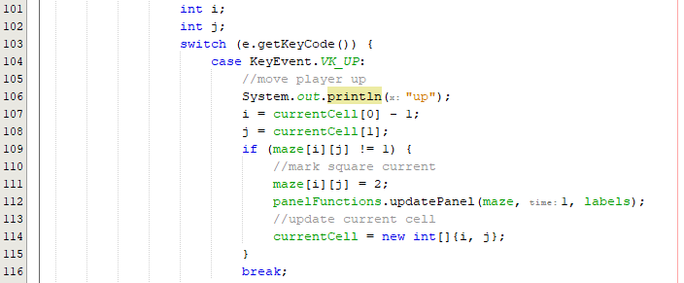

With this code, I have added I and J variables that correspond to position in the maze. The code checks the code above and if it is not a wall then it allows this to become the current square. Now I must repeat this for the other directions:

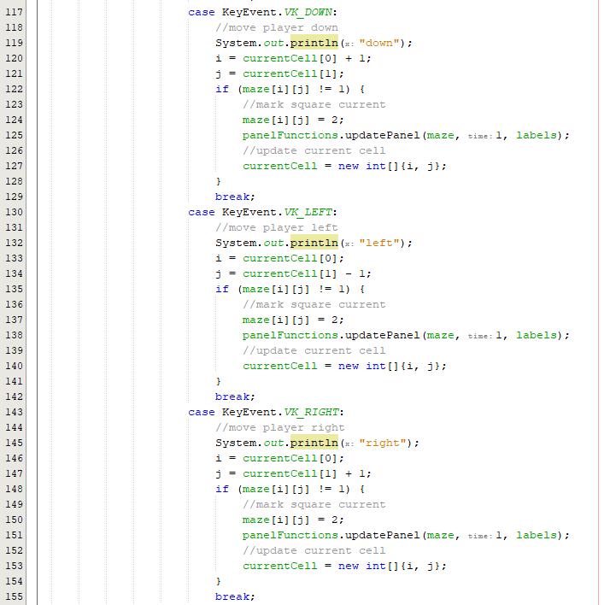



On each case, I have console output to test if the button is being pressed. Clicking the up button, I should expect the console to output ‘up’.

Running the listeners:

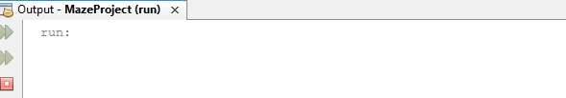

When clicking a button, the code is not correctly registering this key press.

Fixing the key listener logic:

When reviewing the documentation for key adapters and listeners, I found that the frame must request focus so that the key press can correctly be associated with the frame:

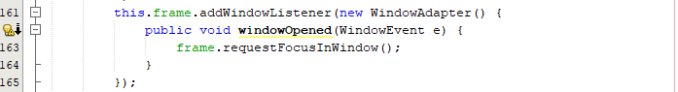

Here I have added a function that adds an additional listener to allow the user to request focus into the frame.

Running the listeners and attempting to move through the maze:



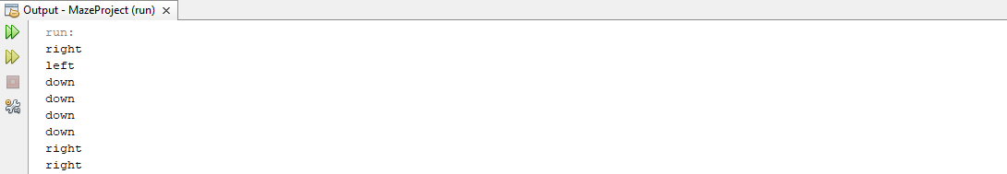

The code now successfully works and allows the user to use the keys to traverse the maze. Currently there is no starting square so the user cannot see where they are headed and can get lost in their previous tracks.

Adding a current square highlighter:

To achieve this, I must optimise my variables for easy implementation. The I and J variables should indicate the current square, and this will allow easier highlighting.

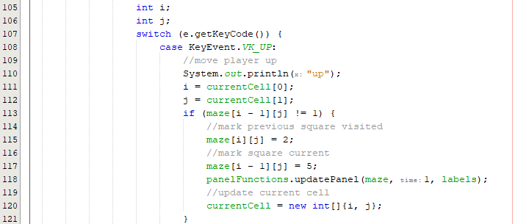

Now the current square code is more optimised and tailored. When running this, the current square should be highlighted:



There must be a bug when highlighting squares or when I changed my I and J variables as the code is incorrectly highlighting and updating. There should only ever be one red square.

Fixing the logic for current square:

When reviewing the change, on line 120, I did not update the current cell correctly, it should be I – 1 for the up direction. This should be changed and accounted for in all directions. When fixing this, the current square should be correctly highlighting:

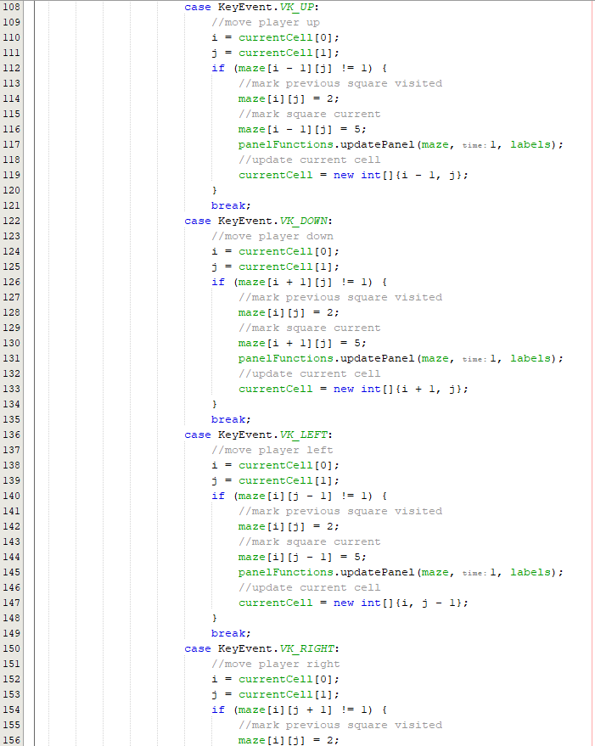

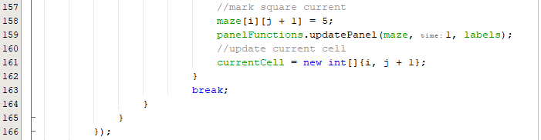

Running the code after implanting the changes:

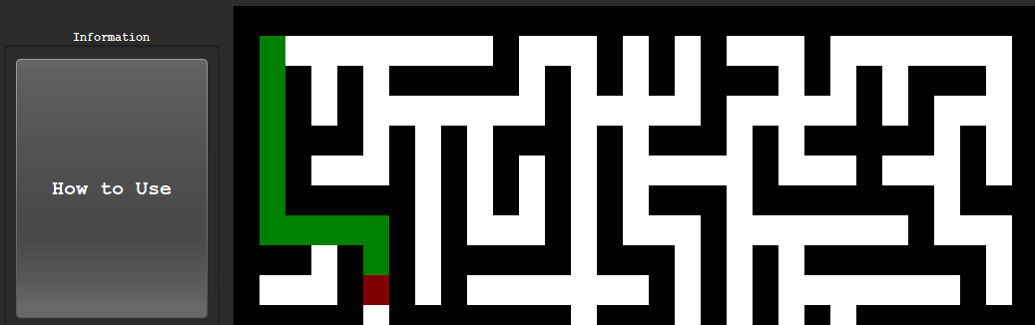

Backtracking:

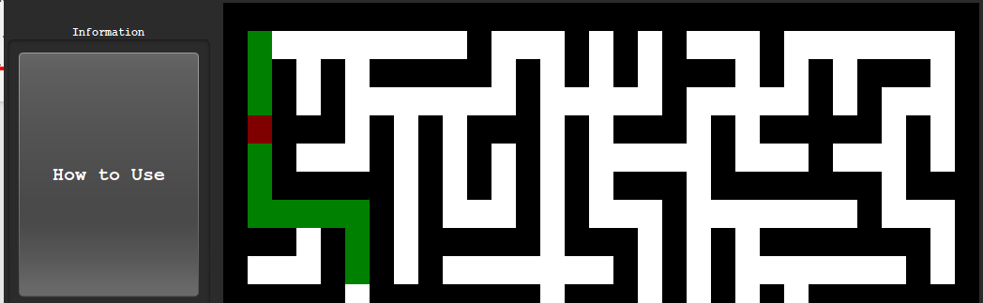

The current square highlighter now successfully shows the user what square the user is currently on. The next task is to add win detection to the maze, it will check if the last square has been reached and if it has then the key listeners will be removed, at a later point, the frame will be disabled after a win menu is displayed.

Adding Win Detection:

I need to add code that only checks for key presses if the current square is not the final code. I can achieve this by adding a condition before the key press validation:

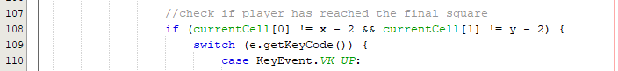

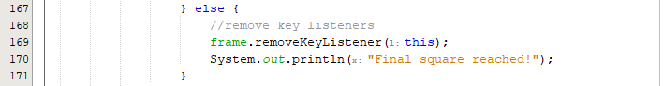

The position is x – 2 and y – 2 as the maze is generated in 1 extra size so the final square will be another cell inwards in the maze.

I have added a console output in the else statement for the condition to see if the code correctly identifies the final square at the correct point.

Running the code:

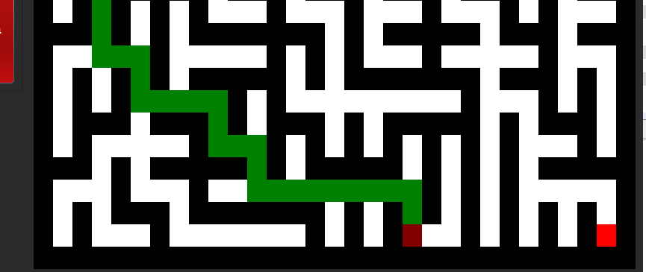

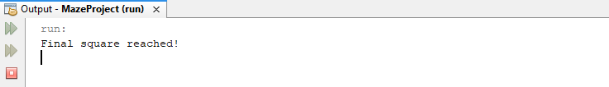

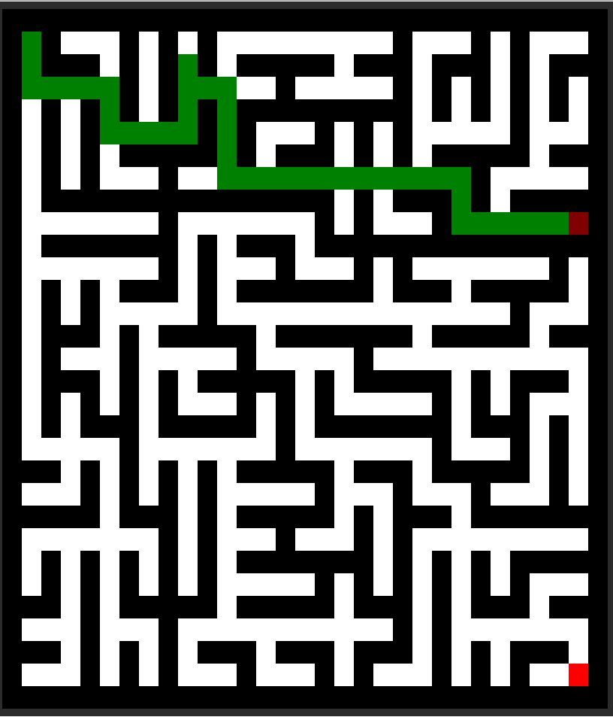



The code clearly is not identifying the final square and instead seems to end the program as soon as the current square reaches on of the shared edges.

Fixing the win detection logic:

The error is derived from the condition where an and statement is used rather than an or statement:



An Or statement is needed as I have used not equal to operators where I must negate the and sign according to De Morgan’s laws [29].

Running the fix:

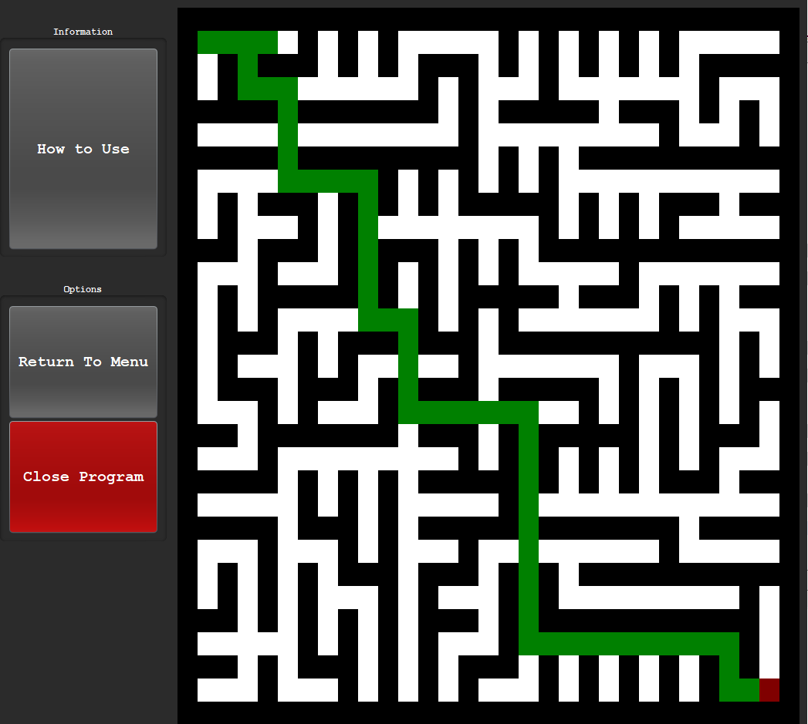

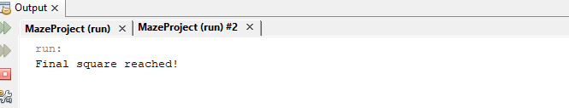

Now that the code correctly identifies a win on the final square and disables the key listeners so that the user cannot re-interact with the maze, this prototype has successfully fulfilled its task, The next task is to add a timer that times how quickly the user was able to solve the maze.

##### Prototype #3

The purpose of this prototype is to add a timer and then stop this timer when the user reaches the end. This end value is stored to later be revealed in the statistics tab. Currently, this value can be printed to the console.

Creating the panel for the timer:

Attributes:





In the constructor:



In the initialise frame function: 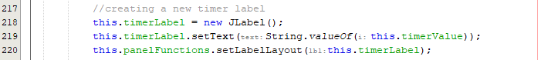

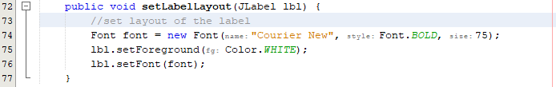

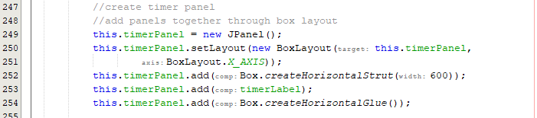

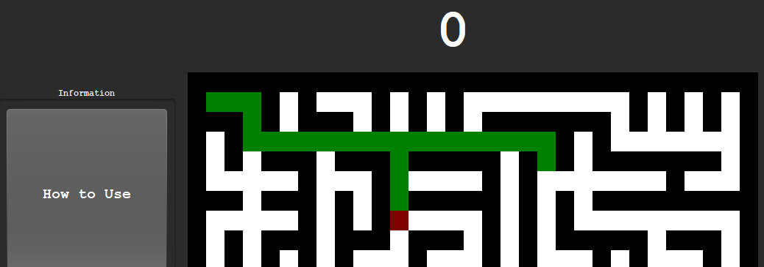

Creating the timer code:

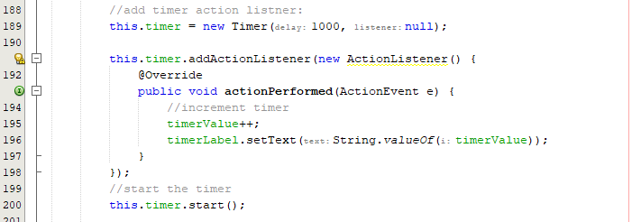

Here the timer action lister starts and can be stopped if the function is called.

Testing to see if the timer increments:

|  |  |
| --- | --- |
|  |  |

The timer correctly increments and increases in value over time.

Formatting the timer:

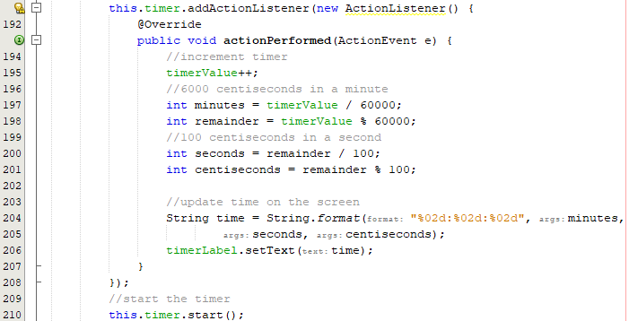

|  |  |
| --- | --- |
|  |  |

Now the timer correctly increments in a formatted manner where it increases in centi-seconds as milliseconds would strain the program too much. However, when closing the program, the timer isn’t ending, and this leads to the program still running:

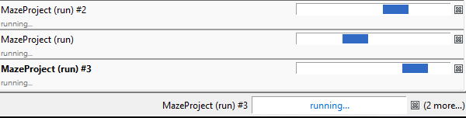

Fixing the running program issue:

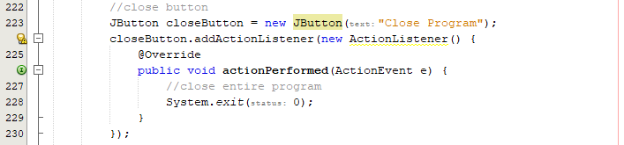

This code handles the close program where all processes are now terminated instead of individually. However, when returning to the main menu I must also stop the timer.

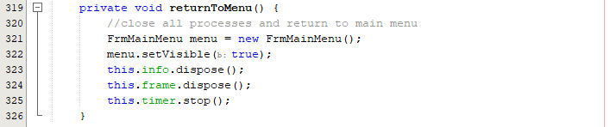

Now the builds correctly stop when the associated buttons are pressed.

Getting the final time:

Instead of storing the formatted string version of the time each time, it is best to recalculate this as soon as the end square is reached to make the program more efficient.

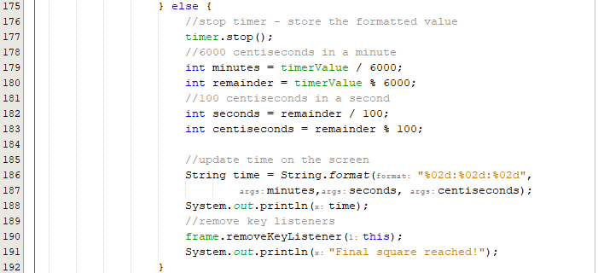

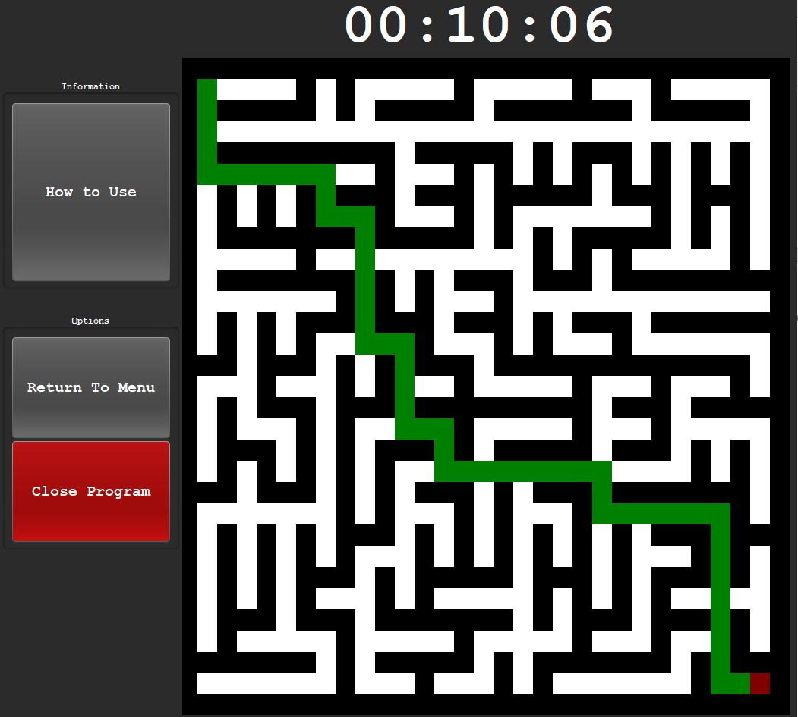

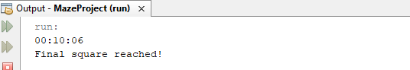

Currently, I have realised that the timer only stops if another button is pressed after the final square is reached due to a logic issue. Up until this point, this has remain hidden as if I would try to press again I could not move and would not be aware of this issue.

Fixing the win detection timer logic error:

The problem is that the code does not update until the next cycle so a new cycle must occur before the code updates and stops the timer. I can achieve this by altering the final else statement into an if statement so that it performs the check each move rather than only if the first if statement fails.

Previous code:



New code (De Morgan’s negation of previous statement):

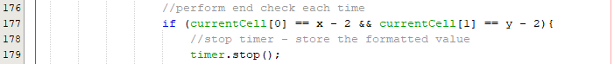

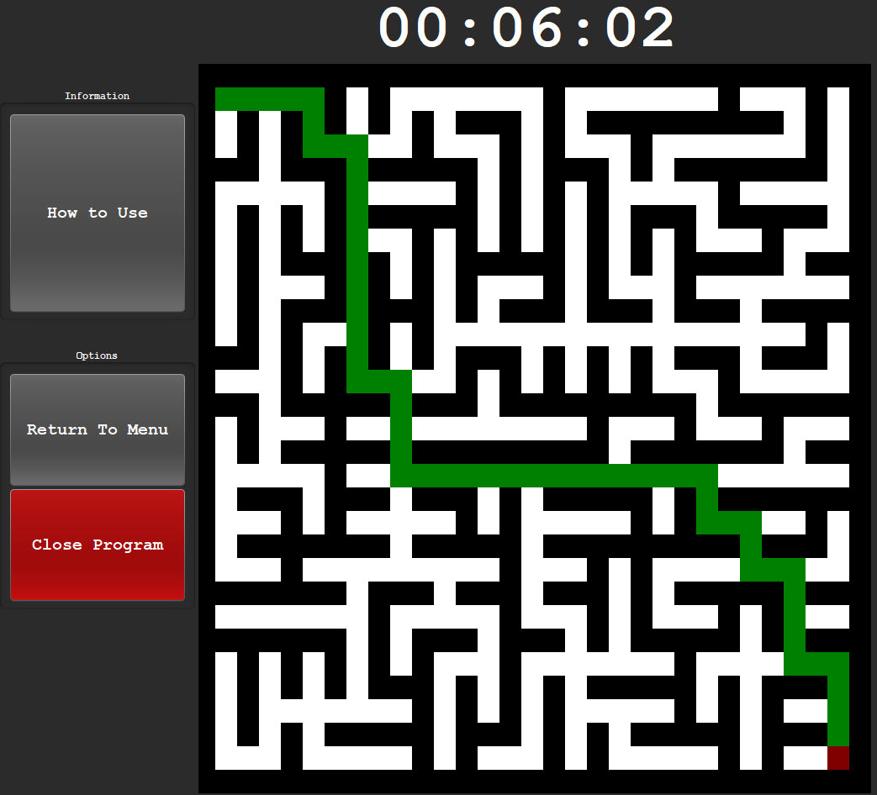

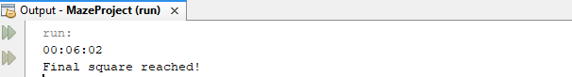

The code successfully ends as soon as the final square is reached. Now that the time is successfully output and the timer stopped on a win, this prototype has been successfully, and the win menu can be developed. Before developing this win menu, the first menu where the user can decide the maze size should be developed.

##### Prototype #4

This prototype is solely responsible for the selection menu where the user can choose the maze size of a new game. This menu will also have a return to menu button, an exit button and information tab where the user can view how to play the game.

Design:

New Game:

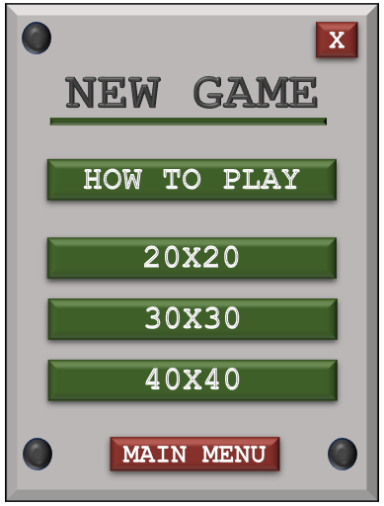

How to Play:

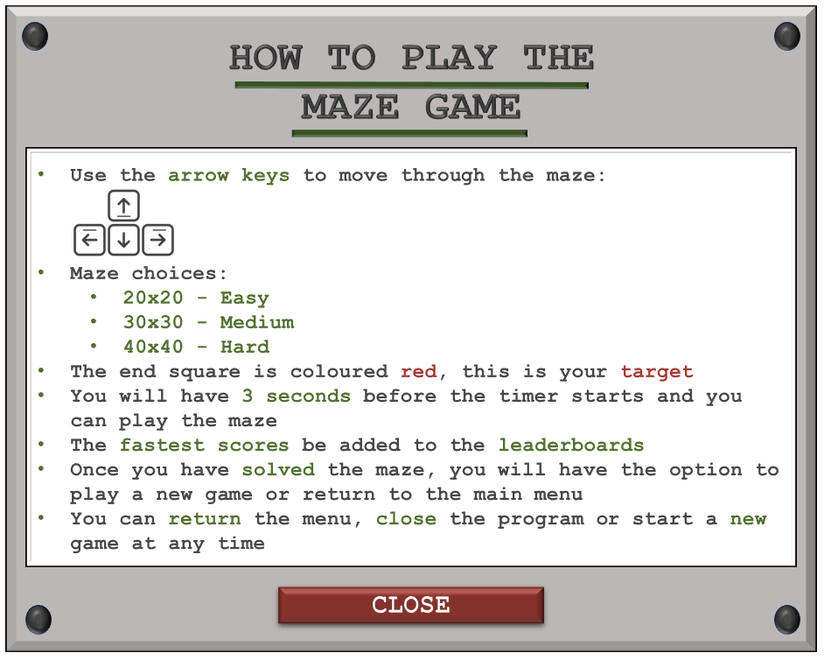

Win Menu:

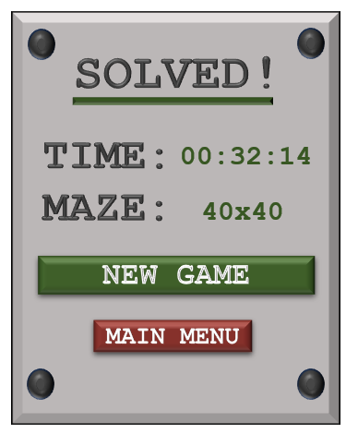

Adding to Java:

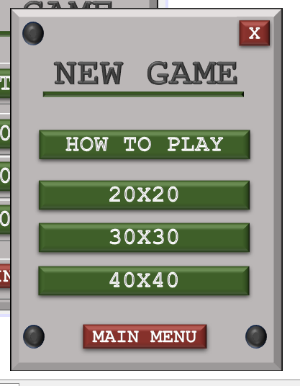

Adding button functions:

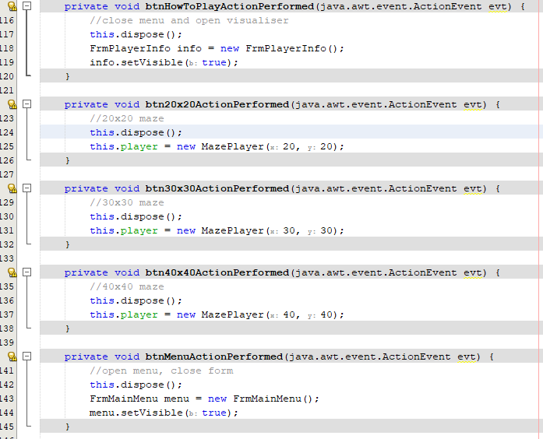

Adding the information tab:

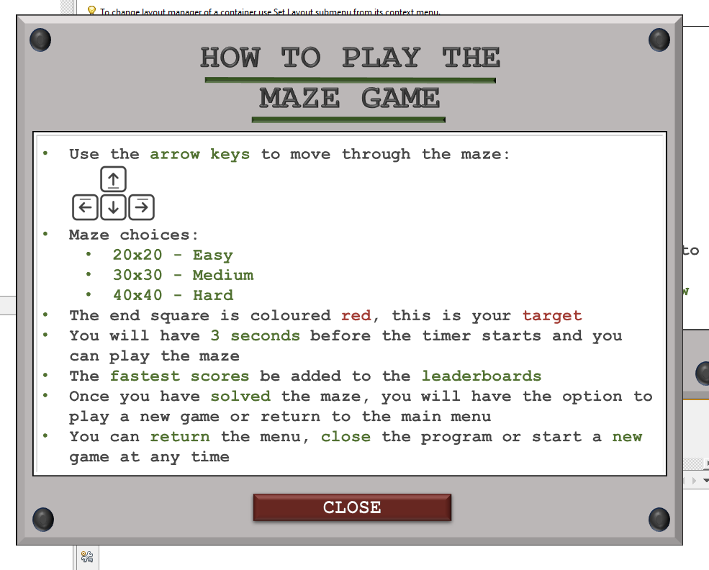

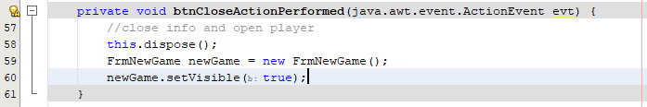

Win Menu:

Text is a sample and feature not implanted yet:

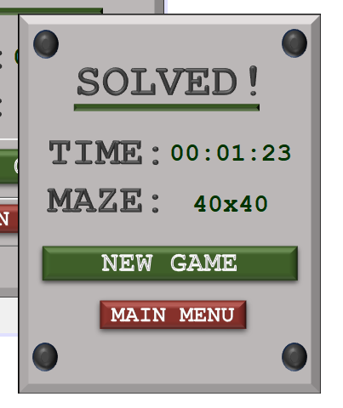

Now that all the menus have been developed and added to Java, the prototype is complete, and we can move on to the final prototype where the play mode implements these menus and saves the users data to a text file.

##### Prototype #5

This prototype will be responsible for fixing the play game layout, adding a timer delay to the game, and saving the users game data to a file.

Adding the win menu to the game, I must pass the maze type and maze time through the parameters:

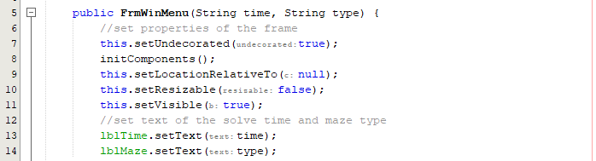

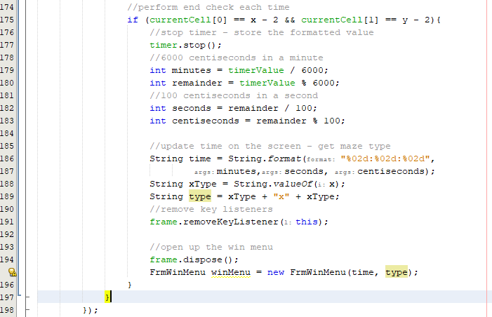

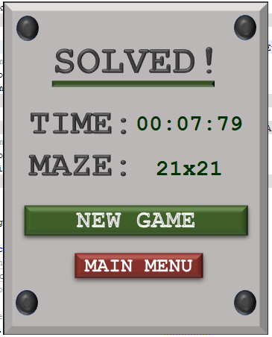

The text currently says a maze size that is one larger due to the maze generation.

Fixing the maze text:



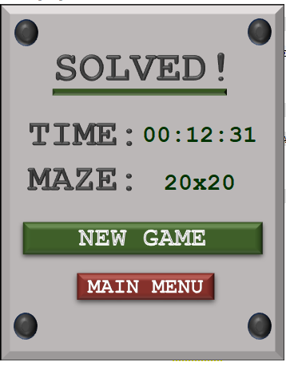

Fixing button layout:

Removing the how to use button and adding a new game button:

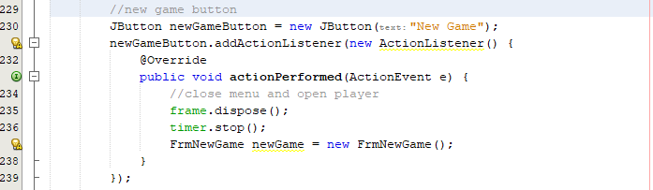

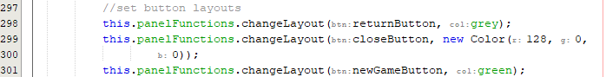

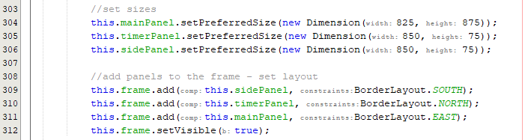

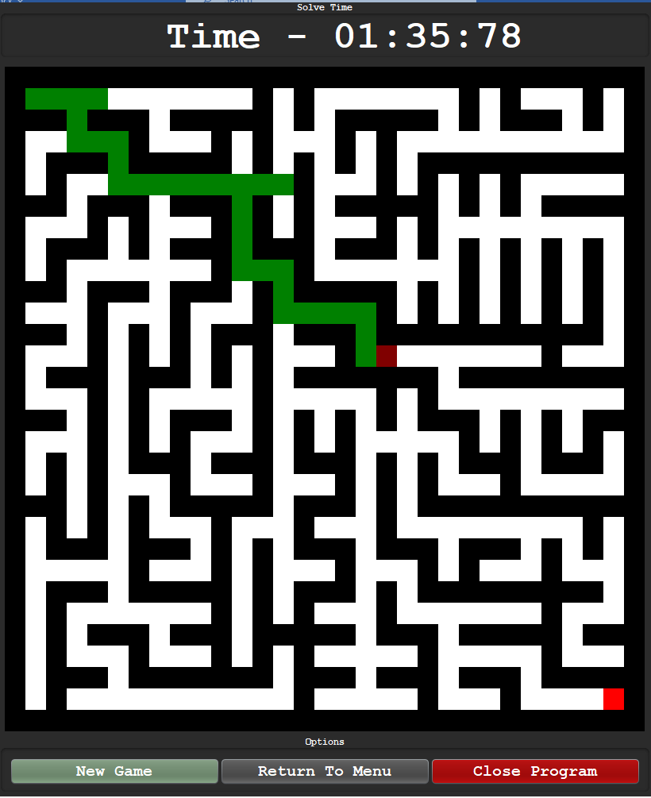

Highlighting the starting square initially:

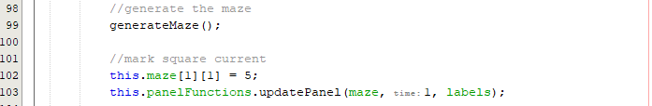



Storing the username, maze type and time to a text file:

I have already developed a write to file function in my standard functions class, so I just need to create an instance of this class and call the function.





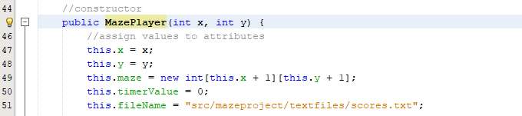

Passing the username through the classes:

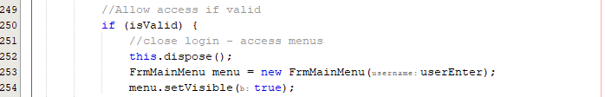

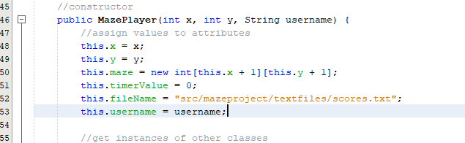

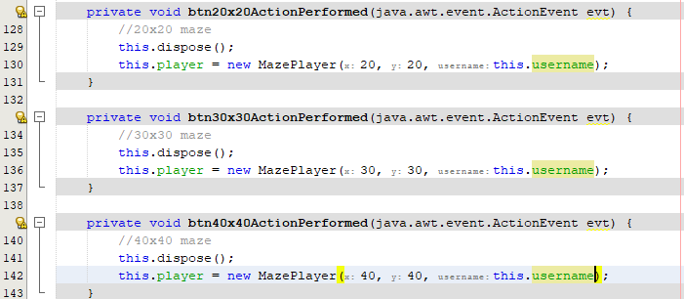

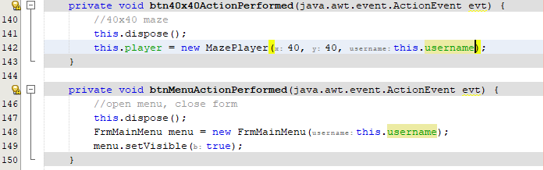

Writing to the file:

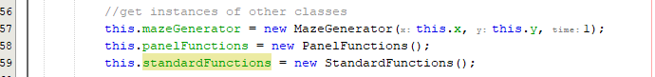

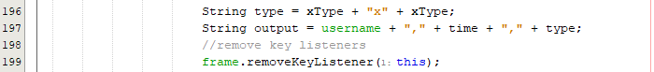

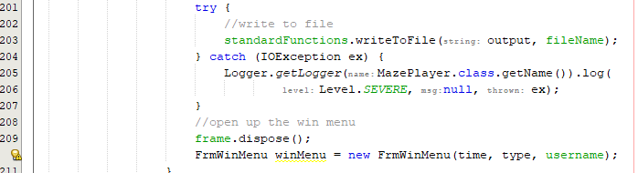

The code should successfully write to the file, testing the code by logging in as ‘jaivir’:

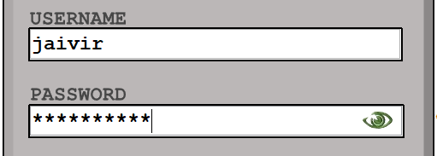

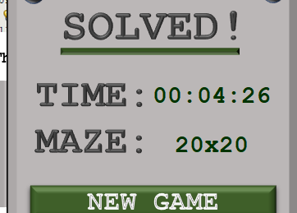

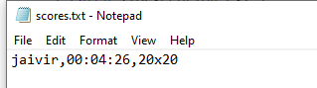

The text file successfully stored my score in the file where the username, time and maze type being separated by commas.

Adding path darkening:

A way to enhance the aesthetics is to add darkening when going over a square already highlighted. To achieve this, I can have another maze that solely holds the number of times that maze has been traversed over:







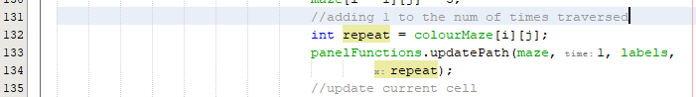

Running the code:





As shown above, the entire path gets updated when this code is carried out.

Fixing the darkening logic:

I must edit the number for each value and have the default switch case to account for this change within the original maze class.

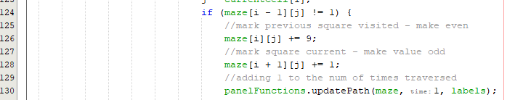

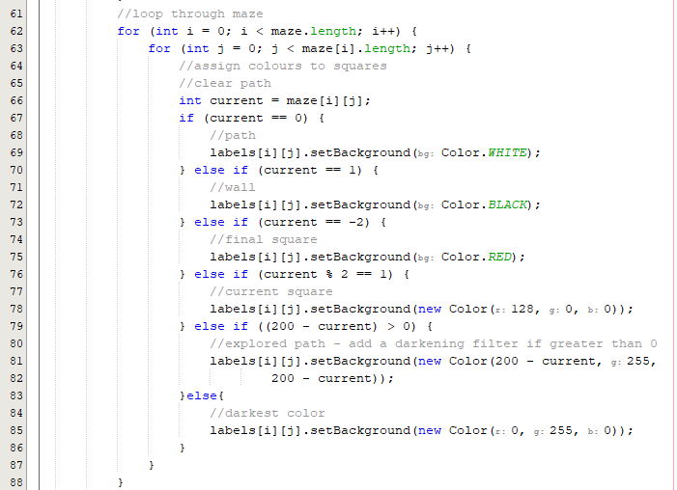

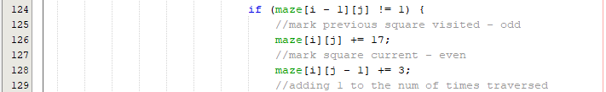

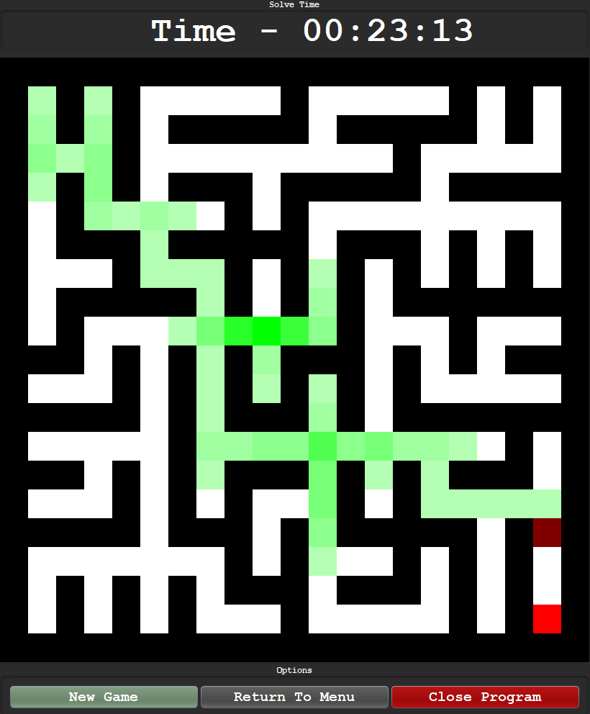

This code highlights the square in a fading green colour.

Changing difficulty sizes:

The jump between 20, 30, and 40 seemed too easy and linear, this is why I have chosen to make the sizes 20, 40 and 80 to add a greater challenge.

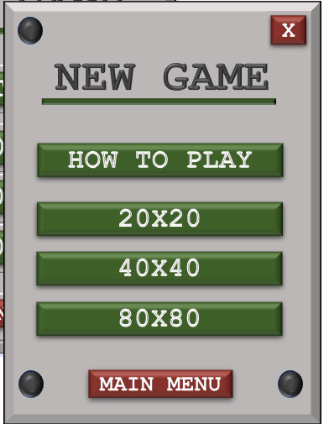

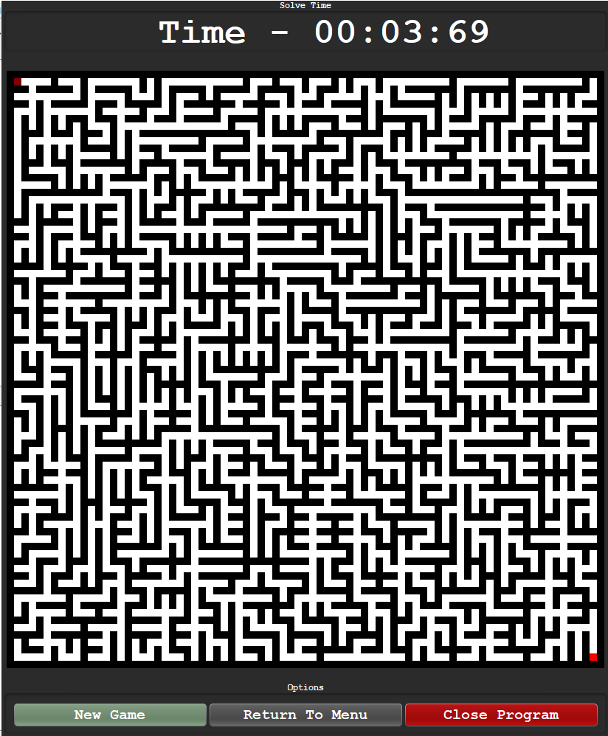

Adding the 5 second delay:

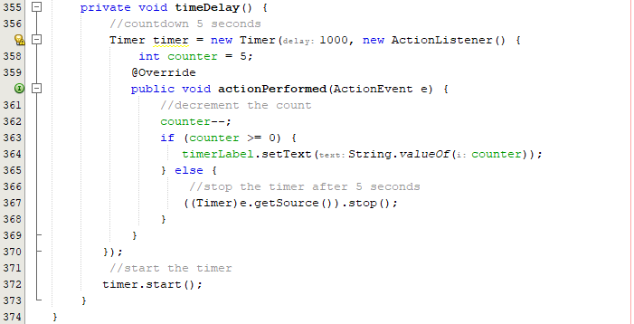





Even though the timer now successfully has a delay, the user can still use the frame. I must disable the key listeners during this time:

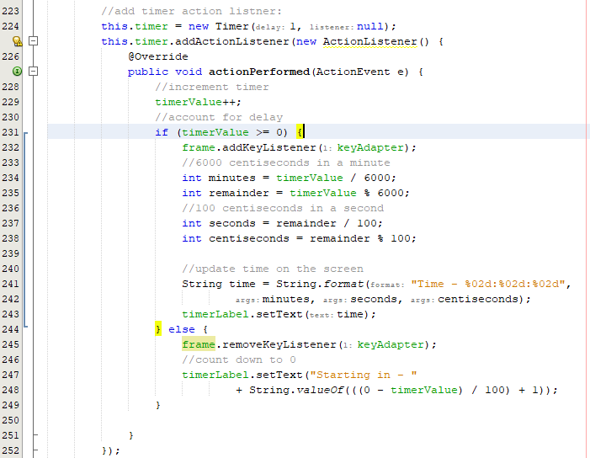

This seems to add too many key listeners as one move registers as hundreds – one press

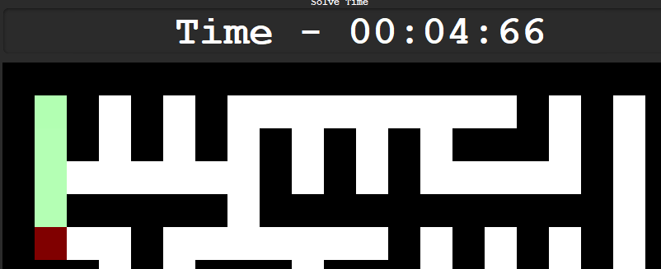

To fix this I can add a condition that only adds this on one occasion:

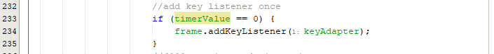



As shown above, the code now correctly moves one square at a time after the waited time.

Final game GUI:

|  |  |
| --- | --- |
|  |  |

|  |  |
| --- | --- |
|  |  |

#### Final Cycle Code

Final UI’s

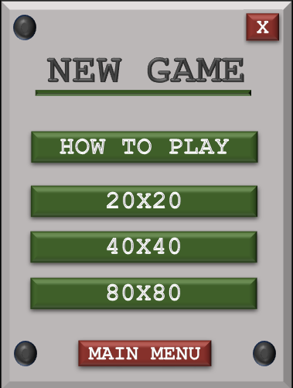

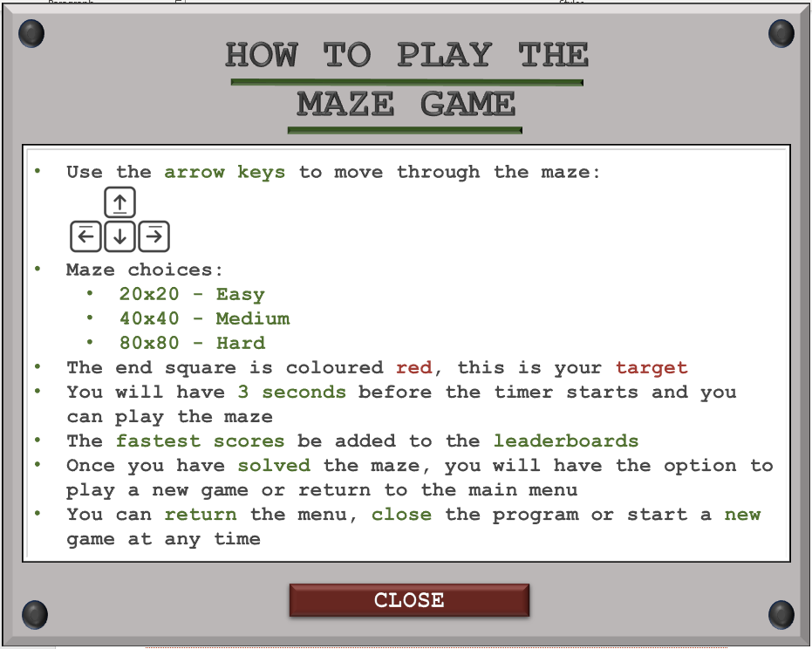

|  |  |
| --- | --- |
| **20x20** | **40x40** |
|  |  |

|  |
| --- |
| **80x80** |
|  |

##### Maze Player Class

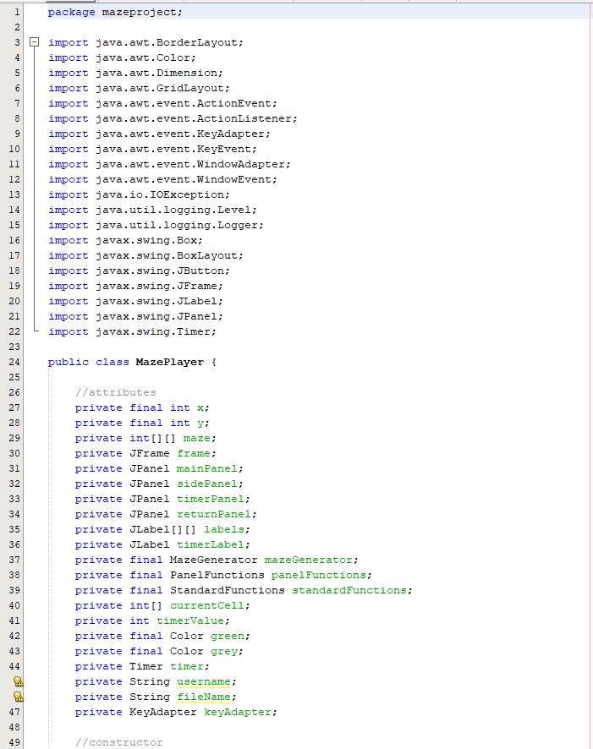

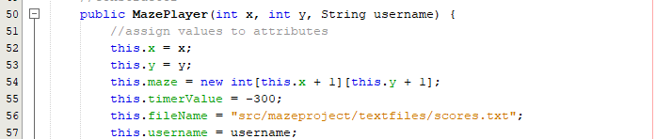

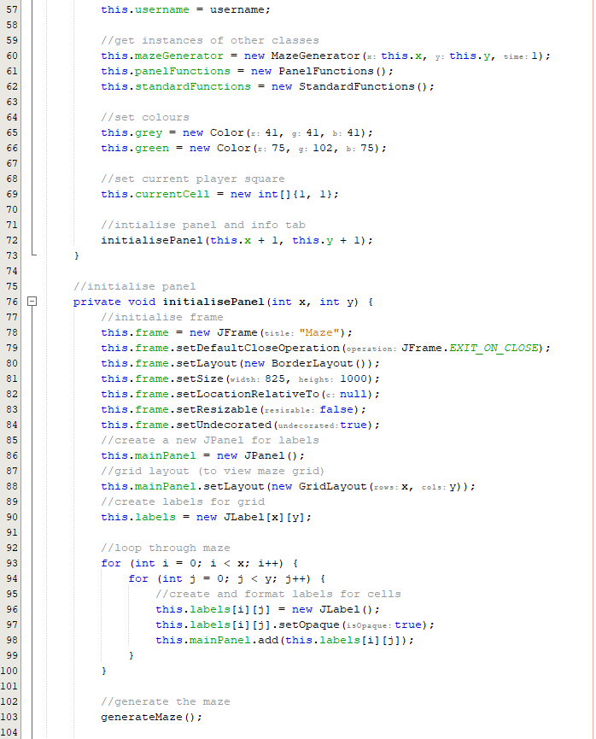 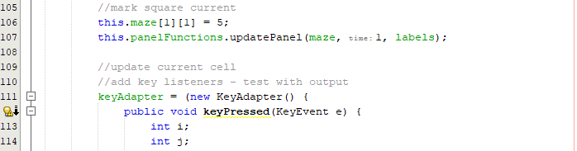

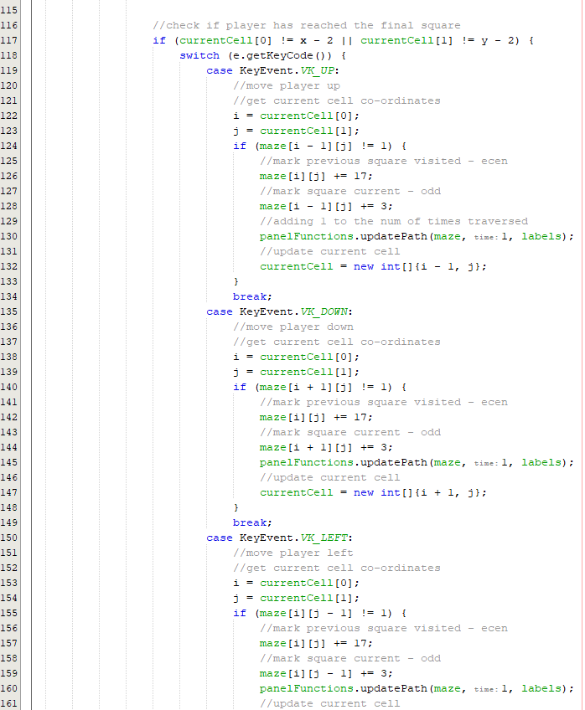 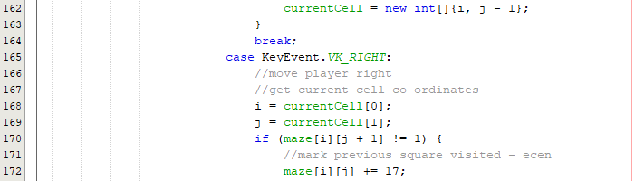

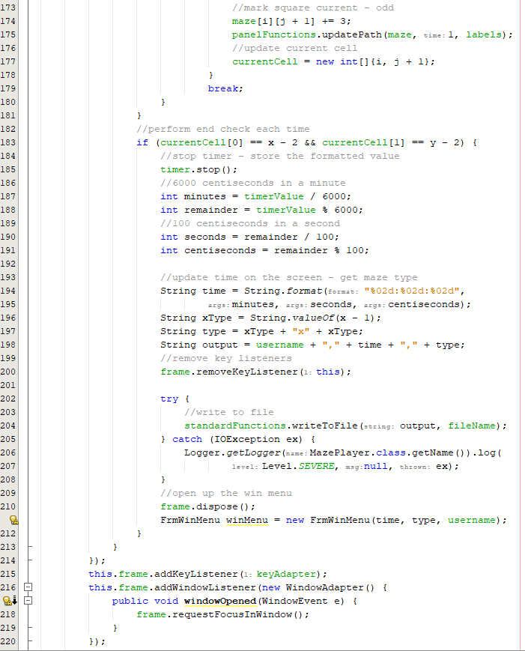 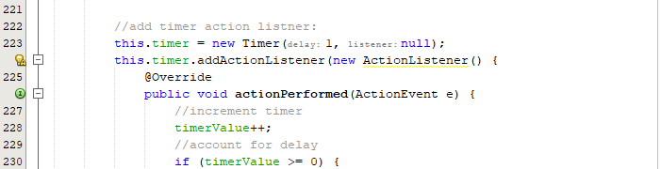

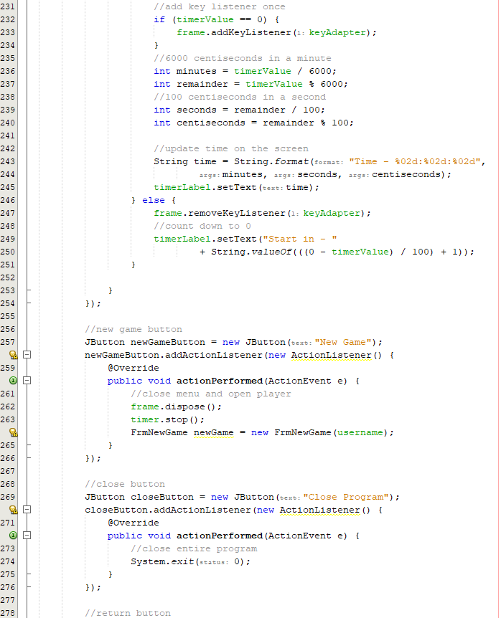 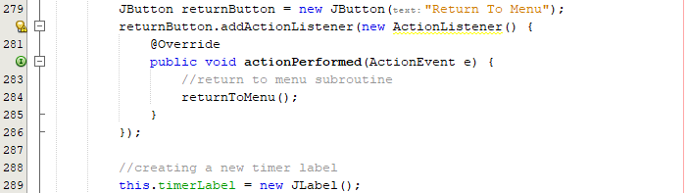

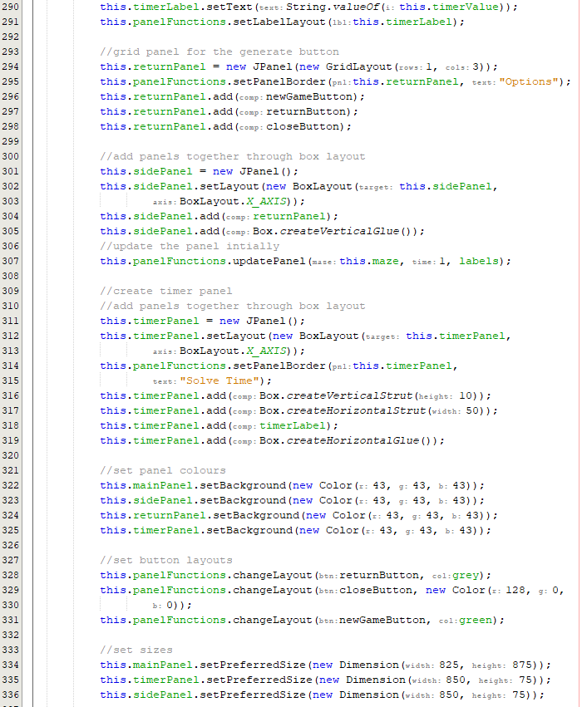 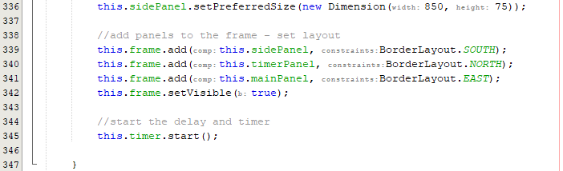

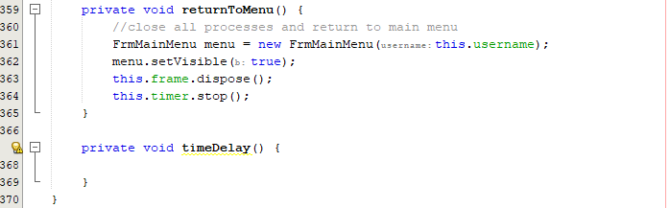

##### New Game Class

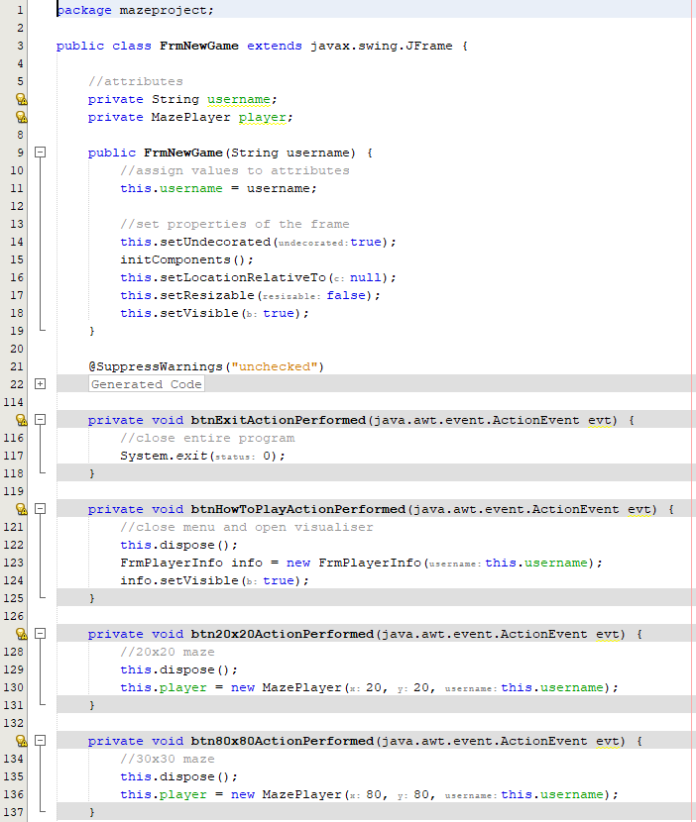

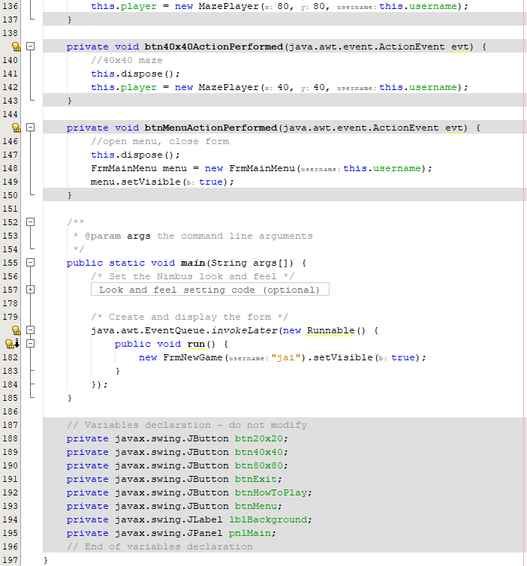

### Review

#### Final testing

|  |  |  |  |  |  |
| --- | --- | --- | --- | --- | --- |
| Test | Test description | Input | Expected outcome | Test type | Passed Test? |
| 1 | Test to check if the maze on ‘play’ mode generates a solvable maze | User selects the size of the maze | After the size is selected, a complete maze should be created with that dedicated size | Normal |  |
| 2 | Test for interaction /playability | User clicks a cell on the grid or arrow key pressed adjacent to current square | Label should be able to be clicked or accessed if it is adjacent to the current square and is then highlighted | Normal |  |
| 3 | Test for selecting non-current cells that have not been highlighted previously | User clicks or tries to access a cell that is not the current cell and has not been highlighted before | Nothing happens, the square is not highlighted, and the input is ignored | Normal |  |
| 4 | Test for deselecting non-current cells that have been highlighted previously | User clicks or accesses a highlighted label that isn’t the current label | The cell is not deselected, and the input is ignored | Normal |  |
| 6 | Test for menu after win detection | User navigates to the final square | As soon as the final square is reached, a menu is displayed after the win is detected | Boundary |  |
| 7 | Test for returning to main menu after playing a game on the win menu | Button click | Upon clicking return to main menu, the old form is removed, and the main menu is now displayed | Boundary |  |
| 8 | Test for the ability to play another game on the win menu | Button click | User can successfully play a game one after another. Game loads after click and removes the previous game | Normal |  |
| 9 | Test for instructions on the play mode | Clicking how to use | A form should pop up that informs the user how to use this section of the program | Normal |  |
| 10 | Test for paths to be highlighted in a darker colour if going over them multiple times | Re tracing previously explored paths | The cell becomes a tint darker when re traced | Normal |  |

##### Test #1

|  |  |  |  |  |  |
| --- | --- | --- | --- | --- | --- |
| Test | Test description | Input | Expected outcome | Test type | Passed Test? |
| 1 | Test to check if the maze on ‘play’ mode generates a solvable maze | User selects the size of the maze | After the size is selected, a complete maze should be created with that dedicated size | Normal |  |

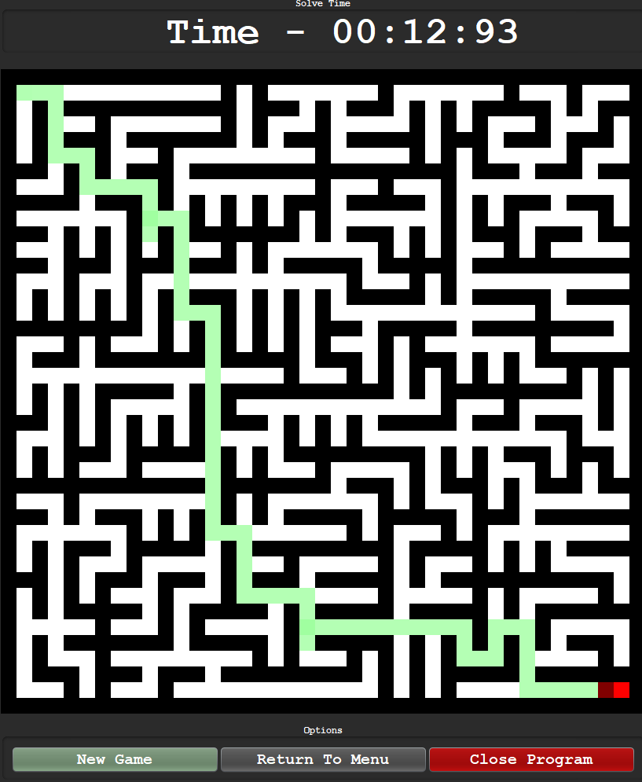

As shown above there is a clear path from the starting point to the end point. This test was a 40x40 maze and passes the criteria. This result is consistent with all sizes.

##### Test #4

|  |  |  |  |  |  |
| --- | --- | --- | --- | --- | --- |
| Test | Test description | Input | Expected outcome | Test type | Passed Test? |
| 4 | Test for deselecting non-current cells that have been highlighted previously | User clicks or accesses a highlighted label that isn’t the current label | The cell is not deselected, and the input is ignored | Normal |  |

This test failed because rather than deselecting squares, I have decided to improve the functionality by allowing squares that have been traversed over multiple times to become a darker shade of green each time. This will be shown in test #10

##### Test #6

|  |  |  |  |  |  |
| --- | --- | --- | --- | --- | --- |
| Test | Test description | Input | Expected outcome | Test type | Passed Test? |
| 6 | Test for menu after win detection | User navigates to the final square | As soon as the final square is reached, a menu is displayed after the win is detected | Boundary |  |

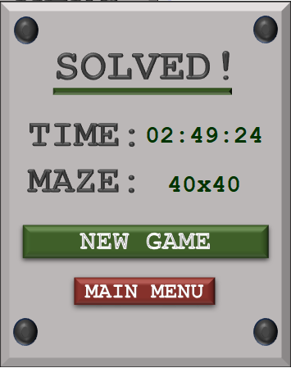

##### Test #9

|  |  |  |  |  |  |
| --- | --- | --- | --- | --- | --- |
| Test | Test description | Input | Expected outcome | Test type | Passed Test? |
| 9 | Test for instructions on the play mode | Clicking how to use | A form should pop up that informs the user how to use this section of the program | Normal |  |

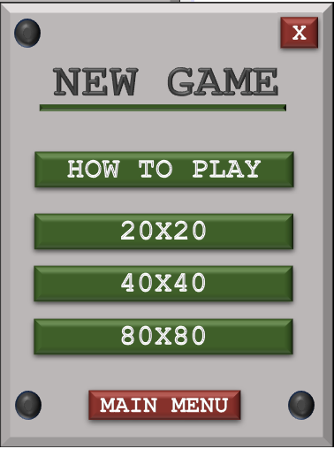

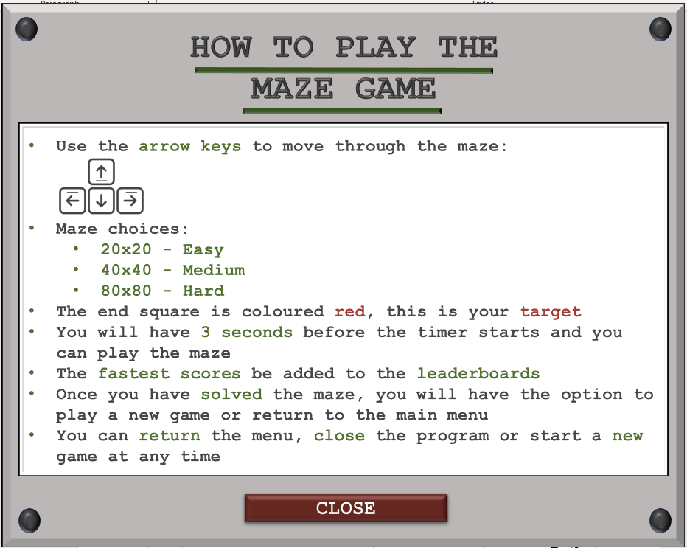

After clicking the how to play button, the menu to the right pops up and when the close button is pressed, the user is returned to the main menus.

##### Test #10

|  |  |  |  |  |  |
| --- | --- | --- | --- | --- | --- |
| Test | Test description | Input | Expected outcome | Test type | Passed Test? |
| 10 | Test for paths to be highlighted in a darker colour if going over them multiple times | Re tracing previously explored paths | The cell becomes a tint darker when re traced | Normal |  |

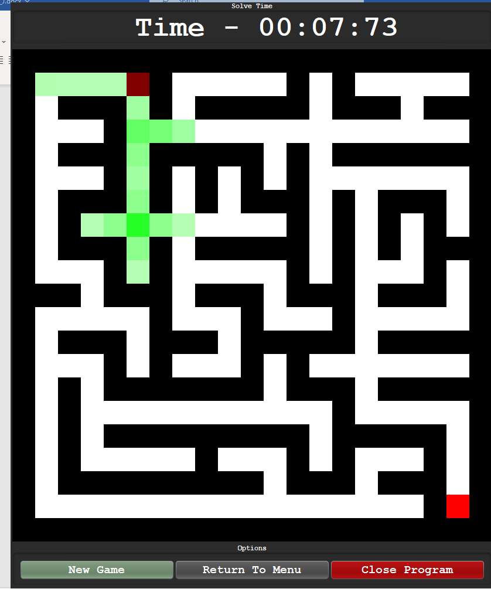

Above shows how squares that have been travelled over multiple times will have a darker shade of green. Usually, the junctions will have the darkest shades of green as they are passed through multiple times. This test therefore passes.

### Conclusion

The initial proposal of this cycle was to add the **functionality** of the ‘play’ mode located within the main menu. The main goal was to just add **win detection** on a maze that allows **interaction** to reach an end point and this cycle was **successful** in this regard. Not only was this functionality introduced, it was also **expanded** upon where the users have 3 seconds before the maze is **unlocked** and then a timer that updates every **centi-second** is present. The statistics are also **displayed** and **saved** after a win is detected so that the user can view the **leaderboard** once the statistics are **developed** in the next cycle.

There were **few errors** encountered in this cycle as the form layout was transferred from the maze visualiser and the file functions were already developed in a **previous** cycle. There were errors when trying to develop the **path darkening** and a few issues with win detection but after reviewing the **logic** and justifying the fix, the problems were resolved quickly.

The next goal is to develop the **statistics** tab where a menu will be present that allows the user to select between viewing the **3 maze** **size** statistics. Each leaderboard will display the **top 5** times for each maze.

## Cycle #11 Developing the Statistics

### Design

#### Decomposition & Overview

The statistics section is the **final** part of the product and will allow the user to view the **fastest** solve times any user has ever submitted. This cycle will purely focus on **global** statistics rather than **local** account statistics.

The main structure of the statistics would stem from clicking the associated option in the **main menu**. From this screen, the user will be able to select from **20x20, 40x40** and **80x80** leaderboards as each **individual** game mode will have allocated statistics.

This cycle is **not lengthy** and will purely focus on the **one function** that displays the statistics to the screen and the general **graphical appeal** to the user.

#### Pseudocode

procedure filterStats(fileName, boardSize)

//load all score details

details = loadDetails(fileName)

//array of variable names

usernames = ["lblUser1", "lblUser2", "lblUser3", "lblUser4", "lblUser5"]

times = ["lblTime1", "lblTime2", "lblTime3", "lblTime4", "lblTime5"]

//filter data

for i=0 to details.length - 1

splits = details[i].split(",")

if splits[2] == boardSize then

//dynamically change variable name label

usernames[i].setText(splits[0])

times[i].setText(splits[1])

endif

next i

endprocedure

#### Variable Table

|  |  |  |
| --- | --- | --- |
| Key Variables | Data Type | Justification |
| highScores | Integer Array | This array of integers is responsible for holding the values of the five fastest times for each respective leaderboard. This value is an array as it has a fixed length of five that will not be changed |
| line | String | This variable will represent a line from the scores file. Each induvial String line is necessary as it holds each score. In this line, there will be the username, time achieved and maze type. |
| splits | String Array | This array of strings will be the subsets of each line. This is mandatory to access each induvial detail about the score line. The data will be separated and split by commas. |

#### Test Table

|  |  |  |  |  |
| --- | --- | --- | --- | --- |
| Test | Test description | Input | Expected outcome | Test type |
| 1 | Test to check if each leaderboard button opens the respective leaderboard | 20x20, 40x40 and 80x80 button | Each respective button opens the correct statistics associated to the size | Normal |
| 2 | Test for the top 5 scores in a leaderboard appearing on the form | User opens any of the three leaderboards | The top 5 scores in the category (lowest times) are displayed to the screen. | Normal |
| 3 | Test for updating the 20x20 leaderboard | User obtains a high score and then opens the leaderboard for the 20x20 maze size | Score appears in the correct position on the leaderboard | Normal |
| 4 | Test for updating the 40x40 leaderboard | User obtains a high score and then opens the leaderboard for the 40x40 maze size | Score appears in the correct position on the leaderboard | Normal |
| 6 | Test for updating the 80x80 leaderboard | User obtains a high score and then opens the leaderboard for the 80x80 maze size | Score appears in the correct position on the leaderboard | Normal |

### Coding and Testing

#### Iterative Development and Testing

##### Prototype #1

This prototype is responsible for the design of the leaderboard menus. The program will re-use components such as the buttons that say 40x40 etc.

Adding the selection menu:

Design:

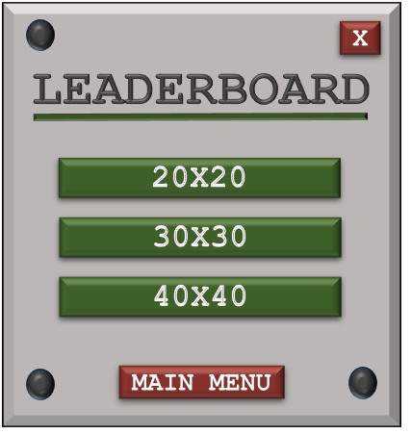

Adding to Java:

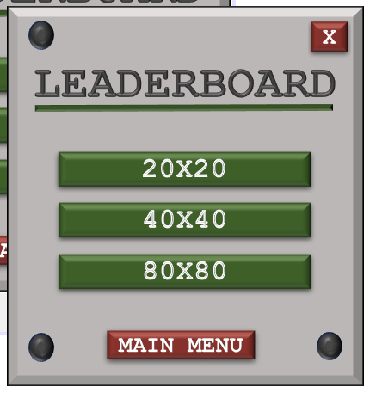

Designing the leaderboard visual:

Initial design:

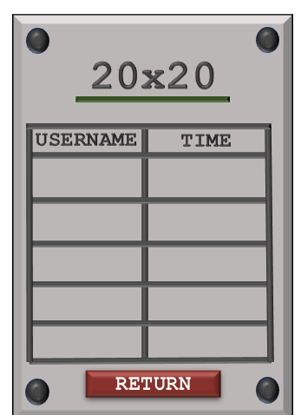

Revised design:

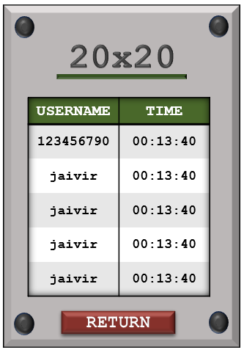

Max username length is 10 so I must make sure the font size is correct for this table. The font size for this table is 12.

##### **Prototype #2**

Developing into Java

The focus of this prototype is to develop a working leaderboard in java. By the end of this prototype, all cycles of the program should be completed.

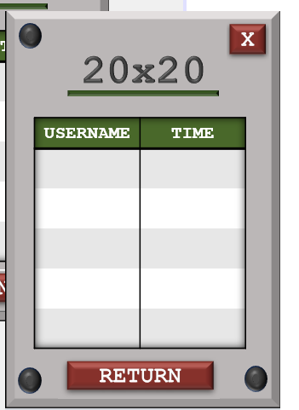

Adding labels:





Repeating for all labels:

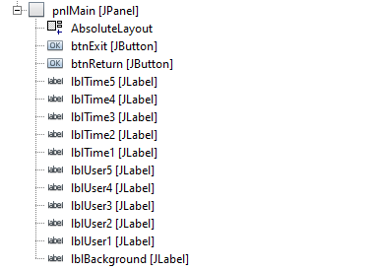

Now that the main design is created and will be repeated for the other sizes, the code can be developed to read the text file for the related scores.

Adding the code to file read:

The code to load details has already been developed in the standard files class and returns an array of comma separated values.

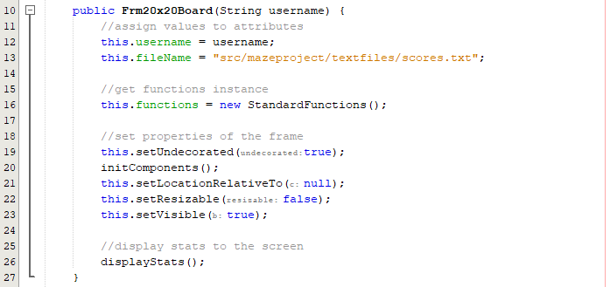

Developing the display stats function:

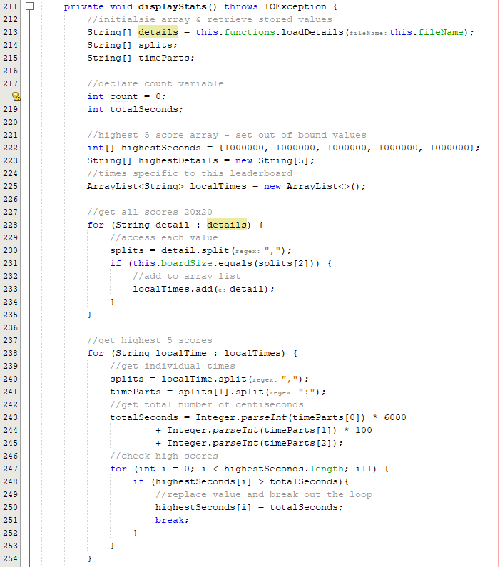

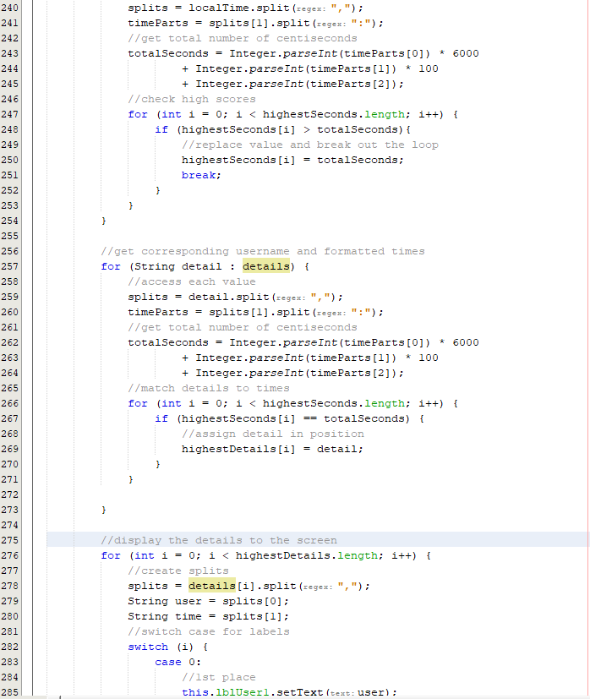

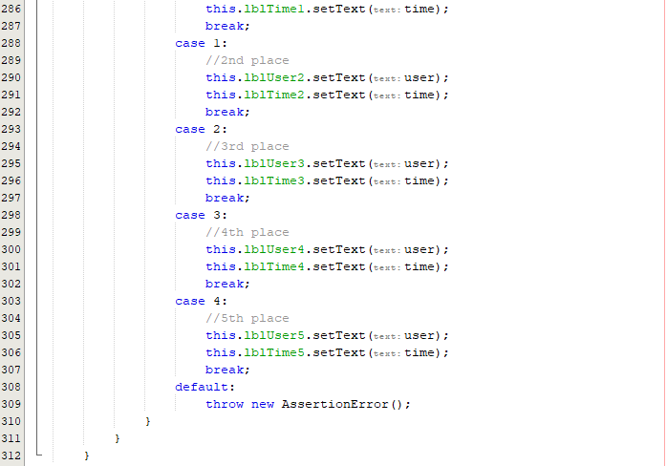



The code I implemented first gets all of the data and stores it within an array list as the size is unknown, after this, the program calculates raw time by converting the formatted time into seconds. Once the raw time is calculated the highest 5 scores are stored in array (lowest times) and then the corresponding username line is added. After this, the code should output the scores to the labels using a switch case.

When developing the pseudocode, I have realised that I had overlooked the fact that I must have a condition to ensure that all values are checked so that a top 5 can be created.

Expected result:

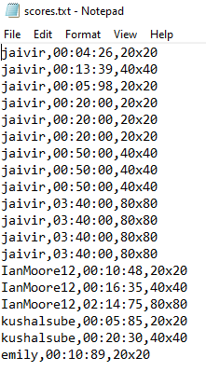

The expected result should be the top 5 scores from this list (lowest times)

Running the code:

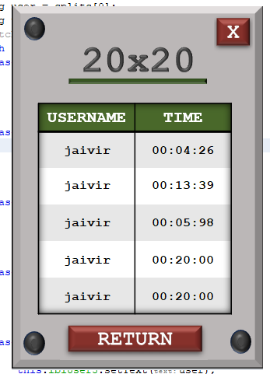

The code seems to have read the first 5 lines of the file rather than the top 5.

Fixing the leaderboards statistics logic error:

The error is on line 278 where the original details are being split and the first five are being output.



To fix this, I must change this to the highest score array.

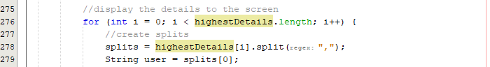

Runing the fix:

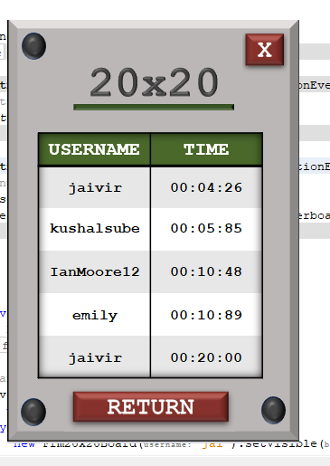

The code now correctly outputs the correct times and high scores. The bottom score is a placeholder score to fill the spaces in the table.

Repeating for other maze sizes:

40x40:

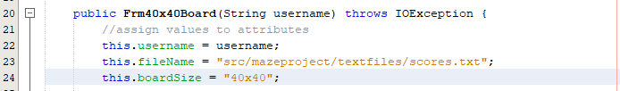

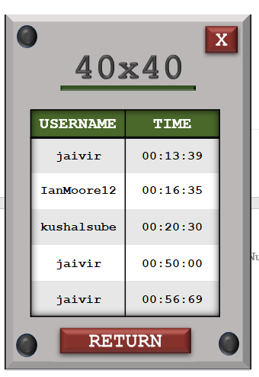

80x80:

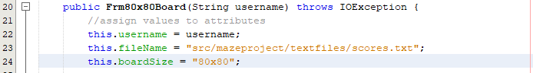

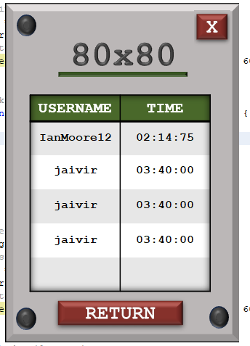

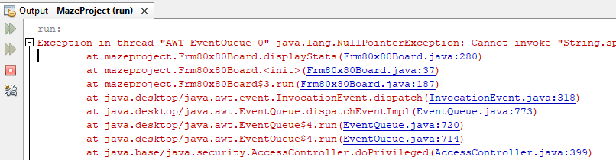

Within this code, there is an error that does not allow the code to fully display the leaderboard times.

Fixing the leaderboard logic issue:

Locating the issue:

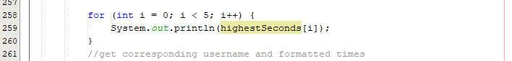

Checking if there are 5 times:

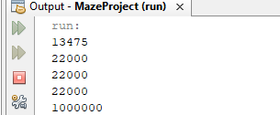

Here only 4 times are being recorded as the last value of 1 million is the default value. The error in the code must be before this logic.

Checking the comparisons between values:

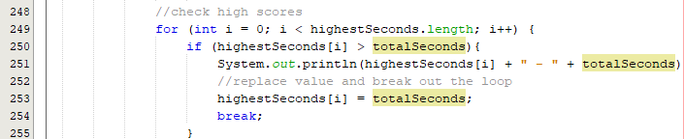

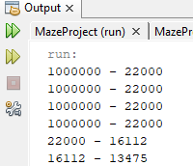

Here the code clearly finds more than 4 values that are candidates for the leaderboard. The error is in line 253 where the first instance is replaced rather than the largest distance. To tackle this, I can sort the array in descending order so the top value is always edited first:

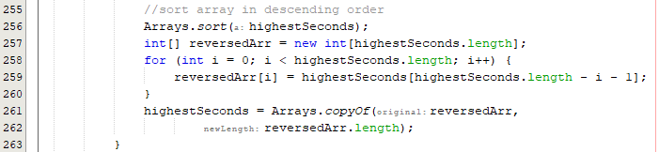

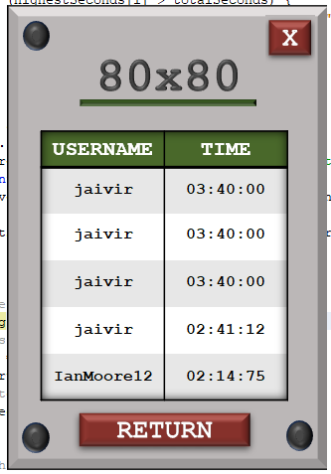

This process outputs with no errors but the final leaderboard is reversed so I mist reverse the array again. I can make this into a subroutine as the reverse code will be repeated.

In standard functions:

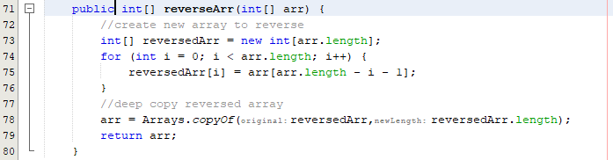

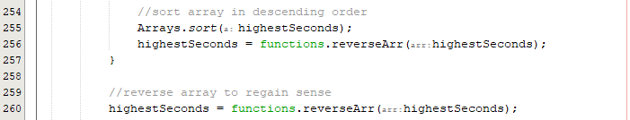

Running the code:

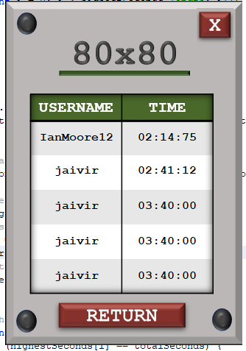

The code now correctly displays the leaderboard correctly and the issue is fixed.

Testing a new leaderboard score:

|  |  |
| --- | --- |
|  |  |

As shown above, the leaderboard correctly updates when a new high score is created. Now that a working leaderboard is present and users can view their scores, this prototype has been successful in reaching its goal.

#### Final Cycle Code

Final Leaderboard UIs:

|  |  |
| --- | --- |
|  |  |
|  |  |

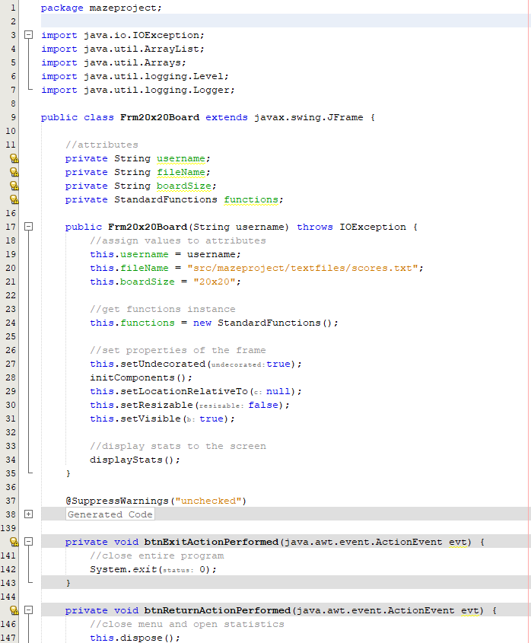

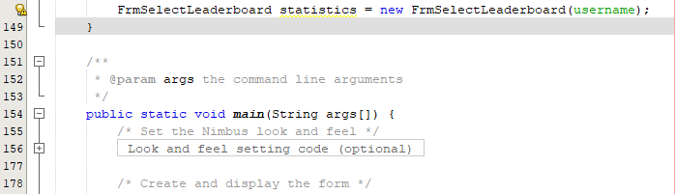

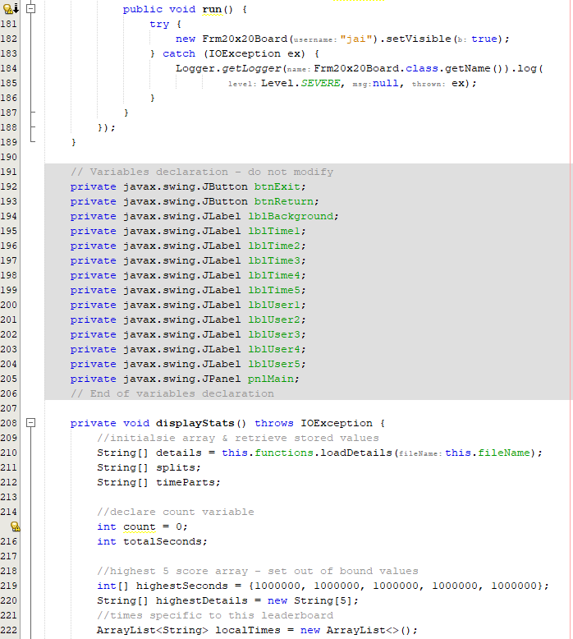

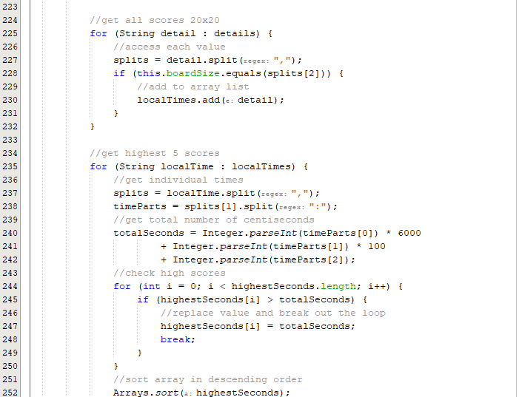

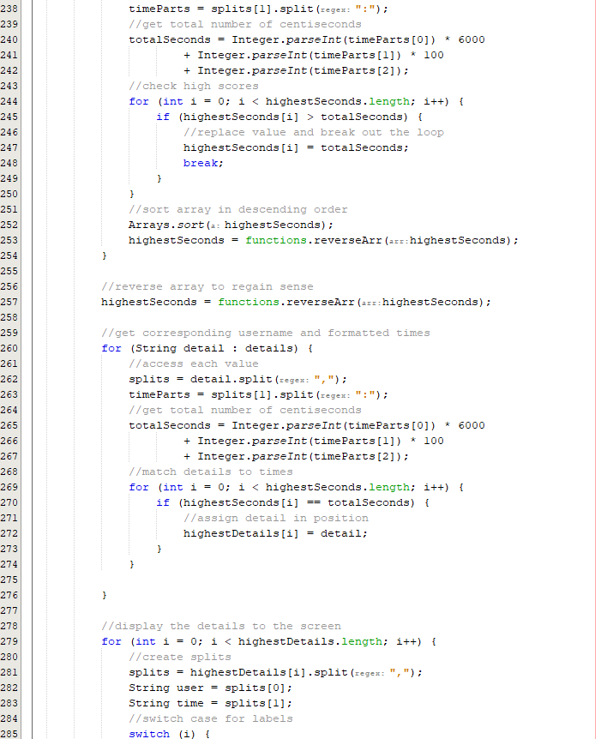



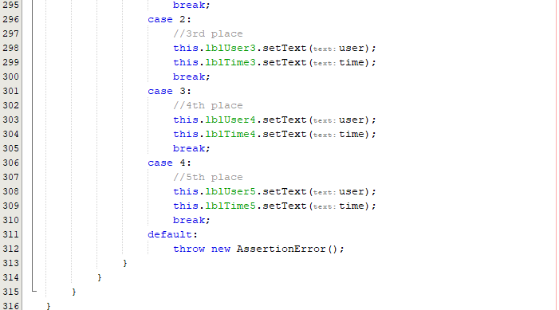

Code is repeated for 40x40 and 80x80 but with different board sizes.

### Review

#### Final testing

|  |  |  |  |  |  |
| --- | --- | --- | --- | --- | --- |
| Test | Test description | Input | Expected outcome | Test type | Passed test? |
| 1 | Test to check if each leaderboard button opens the respective leaderboard | 20x20, 40x40 and 80x80 button | Each respective button opens the correct statistics associated to the size | Normal |  |
| 2 | Test for the top 5 scores in a leaderboard appearing on the form | User opens any of the three leaderboards | The top 5 scores in the category (lowest times) are displayed to the screen. | Normal |  |
| 3 | Test for updating the 20x20 leaderboard | User obtains a high score and then opens the leaderboard for the 20x20 maze size | Score appears in the correct position on the leaderboard | Normal |  |
| 4 | Test for updating the 40x40 leaderboard | User obtains a high score and then opens the leaderboard for the 40x40 maze size | Score appears in the correct position on the leaderboard | Normal |  |
| 6 | Test for updating the 80x80 leaderboard | User obtains a high score and then opens the leaderboard for the 80x80 maze size | Score appears in the correct position on the leaderboard | Normal |  |

##### Test #1

|  |  |  |  |  |  |
| --- | --- | --- | --- | --- | --- |
| Test | Test description | Input | Expected outcome | Test type | Passed test? |
| 1 | Test to check if each leaderboard button opens the respective leaderboard | 20x20, 40x40 and 80x80 button | Each respective button opens the correct statistics associated to the size | Normal |  |

|  |  |  |
| --- | --- | --- |
| **20x20** | **40x40** | **80x80** |
|  |  |  |
|  |  |  |

##### Test #2

|  |  |  |  |  |  |
| --- | --- | --- | --- | --- | --- |
| Test | Test description | Input | Expected outcome | Test type | Passed test? |
| 2 | Test for the top 5 scores in a leaderboard appearing on the form | User opens any of the three leaderboards | The top 5 scores in the category (lowest times) are displayed to the screen. | Normal |  |

Testing the 40x40 table – the green values should appear on the table:

|  |  |
| --- | --- |
|  |  |

As shown above, all of the green values that are highlighted in the scores file are displayed onto the leaderboard therefore passing this test.

##### Test #3

|  |  |  |  |  |  |
| --- | --- | --- | --- | --- | --- |
| Test | Test description | Input | Expected outcome | Test type | Passed test? |
| 3 | Test for updating the 20x20 leaderboard | User obtains a high score and then opens the leaderboard for the 20x20 maze size | Score appears in the correct position on the leaderboard | Normal |  |

Current leaderboard:

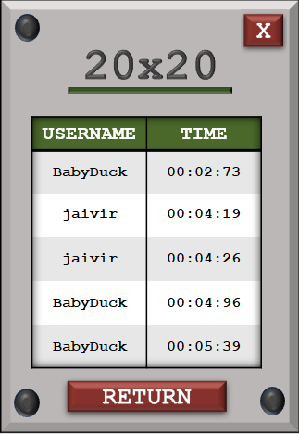

Score & leaderboard update:

|  |  |
| --- | --- |
|  |  |

The score achieved appears in the leaderboard therefore passing this test.

##### Test #4

|  |  |  |  |  |  |
| --- | --- | --- | --- | --- | --- |
| Test | Test description | Input | Expected outcome | Test type | Passed test? |
| 4 | Test for updating the 40x40 leaderboard | User obtains a high score and then opens the leaderboard for the 40x40 maze size | Score appears in the correct position on the leaderboard | Normal |  |

Current leaderboard:

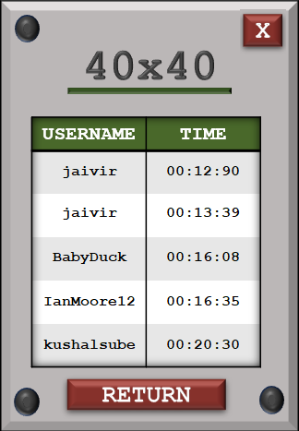

Score & leaderboard update:

|  |  |
| --- | --- |
|  |  |

The score achieved appears in the leaderboard therefore passing this test.

##### Test #5

|  |  |  |  |  |  |
| --- | --- | --- | --- | --- | --- |
| Test | Test description | Input | Expected outcome | Test type | Passed test? |
| 6 | Test for updating the 80x80 leaderboard | User obtains a high score and then opens the leaderboard for the 80x80 maze size | Score appears in the correct position on the leaderboard | Normal |  |

Current leaderboard:

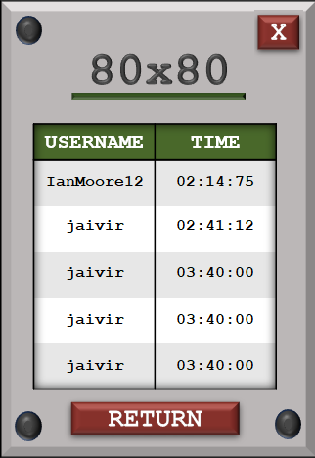

Score & leaderboard update:

|  |  |
| --- | --- |
|  |  |

The score achieved appears in the leaderboard therefore passing this test.

### Conclusion

The statistics cycle was **short in nature** but was one third of the products functionality. This cycle was straightforward as the only code developed in this cycle was the **filtering** of data that is read from the score file. The logic had to be tweaked a few times so that the **top five** scores are correctly displayed but it was **fully working** after a few fixes. The menus were first designed in PowerPoint and then transferred over to Java much like the previous cycles.

The user can select a **20x20, 40x40** and **80x80** leaderboard where the data is **filtered** from the scores file and then **filtered** further to sort the values by time. After the sorting process, the **corresponding** **usernames** are found and output to the screen via Java Swing labels.

Overall, this cycle and its associated **prototypes** were all **successful** in achieving what was initially proposed. Now that the statistics section has been fully developed, the product has been **fully developed** and can be tested for **robustness**, **usability** and **functionality** where it will then be evaluated based on the respective outcomes.

# Section 4 – Evaluation

## Final Testing

### Function Testing

The program will be tested under the initially proposed final test table and then any extra tests will be carried out. This is to ensure the function of the program is correctly assessed and compared to the initial success criteria.

#### Final Test table

|  |  |  |
| --- | --- | --- |
| **Pass** | **Changed Feature** | **Fail** |
|  |  |  |

|  |  |  |  |  |  |  |
| --- | --- | --- | --- | --- | --- | --- |
| Test | Test description | Input | Expected outcome | Type of test | Relative Success Criteria | Passed Test? |
| 1 | Test for the user’s ability to interact with the login form and enter details | Any username and password (both strings) | Data should be evaluated and an appropriate response output | Normal | 1 |  |
| 2 | Test to see the outcome of inputting the correct username and the correct password | Correct username and password both of type String | User is allowed access and is redirected to the main menu form | Normal | 1 |  |
| 3 | Test for inputting the incorrect username, correct password | Incorrect username, correct password | User is denied access but is only told that the details are incorrect, not specifically the username | Normal | 1 |  |
| 4 | Test for inputting the correct username, incorrect password | Correct username, incorrect password | User is denied access but is only told that the details are incorrect, not specifically the password | Normal | 1 |  |
| 5 | Test for inputting the incorrect username, incorrect password | Incorrect username, incorrect password | User is denied access and is told that the details are not correct, not specifically that both are incorrect | Normal | 1 |  |
| 6 | Test for entering a username that contains characters other than letters or numbers | Invalid username with characters other than letters or numbers | The user is told that the username must only contain letters and numbers and is not allowed to register | Erroneous | 2 |  |
| 7 | Test for entering a username that contains only letters but is not unique | A valid username that has already been registered | User is informed that the username is taken, and the account cannot be created | Normal | 2 |  |
| 8 | Test for entering a username that isn’t in the accepted length range | Username with a length of less than 4 letters | User is told that the username must be inclusively between 4 and 10 characters. | Boundary | 2 |  |
| Username with a length of more than 10 characters |
| 9 | Test for a password that isn’t at least 8 characters | Password with a length less than 8 characters | Password is not accepted, and the user should be told the password must be at least 8 characters in length | Boundary | 3 |  |
| 10 | Test for a password that does not have at least one special character | Password not containing any special characters | Password is not accepted, and the user is told that the password should contain at least one special character | Erroneous | 3 |  |
| 11 | Test for a password that does not have at least one number | Password not containing any numbers | Password is not accepted; user is informed that there should be at least one number within the password | Erroneous | 3 |  |
| 12 | Test for entering a correctly formatted first password but a different confirmed password | Formatted correct password, incorrect confirmed password | User is told before submission that the two passwords are not matching and should not be allowed access | Erroneous | 3 |  |
| 13 | Test for entering an incorrectly formatted first password and a different confirmed password | Incorrectly formatted password and non-matching passwords. | User should only be told that the password is of incorrect format before any other warning, so this is what is corrected first | Erroneous | 3 |  |
| 14 | Test the input of a correctly formatted password and a correctly confirmed password, non-unique username | Correctly formatted password and correct confirmed password, non-unique username | User can not submit their details and is notified once again that their username should be unique | Erroneous | 3. |  |
| 15 | Test the input of a correctly formatted password and a correctly confirmed password, unique username | Correctly formatted password and correct confirmed password, unique username | User passes all validation checks and is allowed access onto the system | Normal | 3. |  |
| 16 | Test when all inputs are left blank | No input | User cannot submit their details and is informed that text fields must not be blank | Erroneous | 3. |  |
| 17 | Test when at least one input is left blank |
| 18 | Test for generating a maze in the visualise section | User clicks button | Click the generate maze should generate the maze slowly at a speed that the user can follow | Normal | 9, 10 |  |
| 19 | Test for generating a solvable maze in the visualise section | Users click – algorithmic process called upon click | Once the maze is generated, there must be a path from the start of the square to the finish | Normal | 4. |  |
| 20 | Test to check whether pathfinder correctly identifies the solution | User selects the pathfinding mode | Once the algorithmic process has ended, the maze should be solved with the pathfinder marker on the final square | Normal | 11, 12 |  |
| 21 | Test to see if the pathfinder displays each step of the process on the screen | User confirms pathfinding choice | Each step of the solver will be overlayed onto the maze and the steps until completion are displayed gradually | Normal | 12 |  |
| 22 | Test for a 10x10 generated maze | User selects 10x10 maze | A maze that has 100 cells (10 by 10) is generated | Normal | 7 |  |
| 23 | Test for a 20x20 generated maze | User selects 20x20 maze | A maze that has 400 cells (20 by 20) is created | Normal | 7 |  |
| 24 | Test for a 30x30 generated maze | User selects 30x30 maze | A maze that has 900 cells (30x30) is created | Normal | 7 |  |
| 25 | Test to check if the maze on ‘play’ mode generates a solvable maze | User selects the size of the maze | After the size is selected, a complete maze should be created with that dedicated size | Normal | 4 |  |
| 26 | Test for starting square generation on 10x10 | No input | User should start on a square located bias to the top left of the first maze quadrant | Boundary | 5 |  |
| 27 | Test for starting square generation on 20x20 |  |
| 28 | Test for starting square generation on 30x30 |
| 29 | Test for target square generation | No input | A square should be generated bias to the bottom right of the fourth quadrant | Boundary | 5 |  |
| 30 | Test for starting square random generation | Re generated maze | Starting square should generate randomly but with little deviation | Normal | 5 |  |
| 31 | Test for target square random generation | Re generated maze | Final square should generate randomly but with noticeable deviation | Normal | 5 |  |
| 32 | Test for intractability /playability | User clicks a cell on the grid or arrow key pressed adjacent to current square | Button should be able to be clicked or accessed if it is adjacent to the current square and is then highlighted | Normal | 6 |  |
| 33 | Test for selecting non-current cells that have not been highlighted previously | User clicks or tries to access a cell that is not the current cell and has not been highlighted before | Nothing happens, the square is not highlighted, and the input is ignored | Erroneous | 6 |  |
| 34 | Test for deselecting non-current cells that have been highlighted previously | User clicks or accesses a highlighted button that isn’t the current button | The cell is not deselected, and the input is ignored as only the current square can be deselected | Erroneous | 6 |  |
| 35 | Test for deselecting a current cell | User clicks on the current cell | The input is accepted, and the square is deselected. The previous square now becomes the current square. | Normal | 6 |  |
| 36 | Test for menu after win detection | User navigates to the final square | As soon as the final square is reached, a menu is displayed after the win is detected | Normal | 8, 15 |  |
| 37 | Test for returning to main menu after playing a game on the win menu | Button click | Upon clicking return to main menu, the old form is removed, and the main menu is now displayed | Normal | 13, 15 |  |
| 38 | Test for the ability to play another game on the win menu | Button click | User can successfully play a game one after another. Game loads after click and removes the previous game | Normal | 15 |  |
| 39 | Test for the game pausing after transition menu selected | Transition menu selected in the game menu | Once the menu is clicked, the user should not be able to interact with the game and only the menu | Normal | 14 |  |
| 40 | Test for returning to menu after transition menu selected | Visualise section | After selecting return to main menu on the transition menu, the menu should close as well as the form currently open and then display the main menu | Normal | 14 |  |
| Play section |
| Statistics section |
| 41 | Test for resuming after transition menu selected | Visualise section | After selecting the transition menu, if resume is collected, the transition menu is closed, and everything returns to normal | Normal | 14 |  |
| Play section |
| Statistics section |
| 42 | Test for displaying correct stats after a win is called | User completes a maze and reaches the finish | Upon winning a game, the user should be shown the total time taken to solve | Normal | 8, 16 |  |
| 43 | Test for displaying top 10 scores for a 10x10 maze with at least 10 pieces of total data | Selection of the 10x10 statistics | Top 10 scores of all time for the 10x10 game mode will be recalled and output on the screen to see | Normal | 17, 18 |  |
| 44 | Test for displaying top 10 scores for a 10x10 maze with less than 10 pieces of data | All scores recorded for the 10x10 will be output onto the screen as there cannot be a ranking if there are less than 10 total items of data |
| 45 | Test for displaying top 10 scores for a 20x20 maze with at least 10 pieces of total data | Selection of the 20x20 statistics | Top 10 scores of all time for the 20x20 game mode will be recalled and output on the screen to see | Normal | 17, 18 |  |
| 46 | Test for displaying top 10 scores for a 20x20 maze with less than 10 pieces of data | All scores recorded for the 20x20 will be output onto the screen as there cannot be a ranking if there are less than 10 total items of data |
| 47 | Test for displaying top 10 scores for a 30x30 maze with at least 10 pieces of total data | Selection of the 30x30 statistics | Top 10 scores of all time for the 30x30 game mode will be recalled and output on the screen to see | Normal | 17, 18 |  |
| 48 | Test for displaying top 10 scores for a 30x30 maze with less than 10 pieces of data | All scores recorded for the 30x30 will be output onto the screen as there cannot be a ranking if there are less than 10 total items of data |

##### Test #1

|  |  |  |  |  |  |  |
| --- | --- | --- | --- | --- | --- | --- |
| Test | Test description | Input | Expected outcome | Type of test | Relative Success Criteria | Passed Test? |
| 1 | Test for the user’s ability to interact with the login form and enter details | Any username and password (both strings) | Data should be evaluated and an appropriate response output | Normal | 1 |  |

|  |  |
| --- | --- |
|  |  |

As shown above the user can input details and in this case the details were wrong, so the form tells the user that the username or password is wrong which is the correct response to the combination of inputs. The choice of not informing the user which username and password is incorrect for security purposes.

##### Test #2

|  |  |  |  |  |  |  |
| --- | --- | --- | --- | --- | --- | --- |
| Test | Test description | Input | Expected outcome | Type of test | Relative Success Criteria | Passed Test? |
| 2 | Test to see the outcome of inputting the correct username and the correct password | Correct username and password both of type String | User is allowed access and is redirected to the main menu form | Normal | 1 |  |

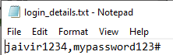

|  |  |
| --- | --- |
|  |  |

As shown, the details input onto the form are valid as they are located within the permanent login storage. When clicking submit, the user is allowed access onto the main menu.

##### Test #3

|  |  |  |  |  |  |  |
| --- | --- | --- | --- | --- | --- | --- |
| Test | Test description | Input | Expected outcome | Type of test | Relative Success Criteria | Passed Test? |
| 3 | Test for inputting the incorrect username, correct password | Incorrect username, correct password | User is denied access but is only told that the details are incorrect, not specifically the username | Normal | 1 |  |

|  |  |
| --- | --- |
|  |  |

The details are not accepted as the username is incorrect.

##### Test #4

|  |  |  |  |  |  |  |
| --- | --- | --- | --- | --- | --- | --- |
| Test | Test description | Input | Expected outcome | Type of test | Relative Success Criteria | Passed Test? |
| 4 | Test for inputting the correct username, incorrect password | Correct username, incorrect password | User is denied access but is only told that the details are incorrect, not specifically the password | Normal | 1 |  |

|  |  |
| --- | --- |
|  |  |

As the password is incorrect (missing the #) the details are not accepted and the test passes.

##### Test #5

|  |  |  |  |  |  |  |
| --- | --- | --- | --- | --- | --- | --- |
| Test | Test description | Input | Expected outcome | Type of test | Relative Success Criteria | Passed Test? |
| 5 | Test for inputting the incorrect username, incorrect password | Incorrect username, incorrect password | User is denied access and is told that the details are not correct, not specifically that both are incorrect | Normal | 1 |  |

|  |  |
| --- | --- |
|  |  |

Both details are incorrect, the user is denied access, and the test is passed.

##### Test #6

|  |  |  |  |  |  |  |
| --- | --- | --- | --- | --- | --- | --- |
| Test | Test description | Input | Expected outcome | Type of test | Relative Success Criteria | Passed Test? |
| 6 | Test for entering a username that contains characters other than letters or numbers | Invalid username with characters other than letters or numbers | The user is told that the username must only contain letters and numbers and is not allowed to register | Erroneous | 2 |  |

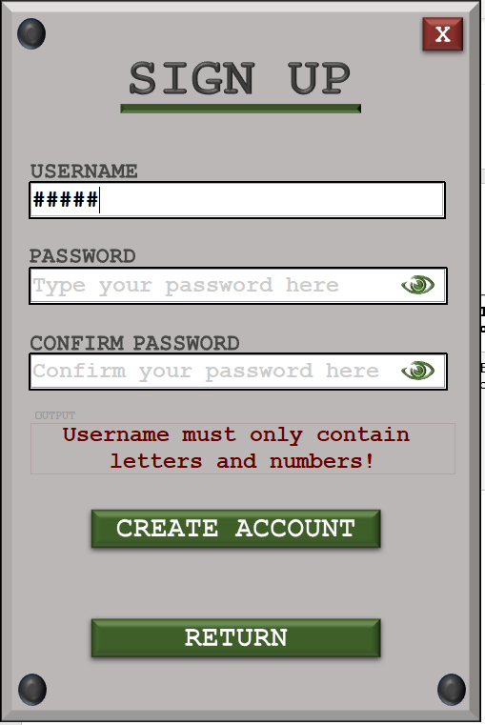

Inputting hashtag symbols for the username is illegal and the user is told that the username can only be letters and numbers therefore the test passes.

##### Test #7

|  |  |  |  |  |  |  |
| --- | --- | --- | --- | --- | --- | --- |
| Test | Test description | Input | Expected outcome | Type of test | Relative Success Criteria | Passed Test? |
| 7 | Test for entering a username that contains only letters but is not unique | A valid username that has already been registered | User is informed that the username is taken, and the account cannot be created | Normal | 2 |  |

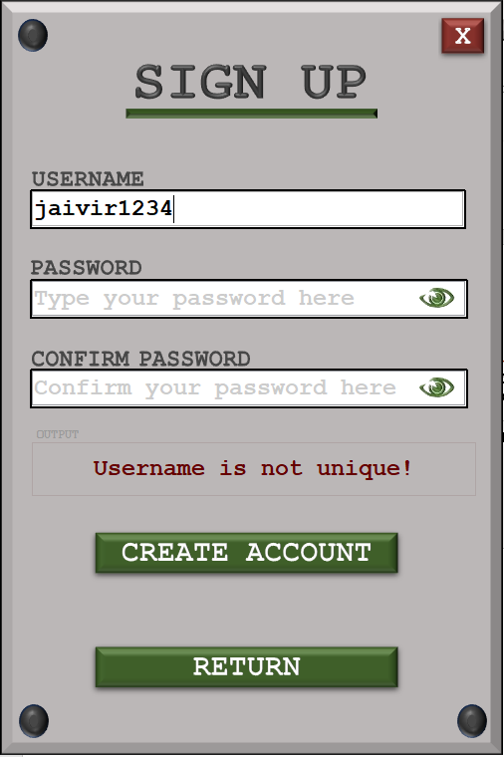

The username is checked after each key press, so the user was informed instantly that the username is not unique, therefore passing the test.

##### Test #8

|  |  |  |  |  |  |  |
| --- | --- | --- | --- | --- | --- | --- |
| Test | Test description | Input | Expected outcome | Type of test | Relative Success Criteria | Passed Test? |
| 8 | Test for entering a username that isn’t in the accepted length range | Username with a length of less than 4 letters | User is told that the username must be inclusively between 4 and 10 characters. | Boundary | 2 |  |
| Username with a length of more than 10 characters |

|  |  |
| --- | --- |
|  |  |

The left screenshot shows a username of length 3 being invalid and the right screenshot shows a username that is greater than 10 characters. Both variations are not accepted by the program and therefore the product passes this teste successfully.

##### Test #9

|  |  |  |  |  |  |  |
| --- | --- | --- | --- | --- | --- | --- |
| Test | Test description | Input | Expected outcome | Type of test | Relative Success Criteria | Passed Test? |
| 9 | Test for a password that isn’t at least 8 characters | Password with a length less than 8 characters | Password is not accepted, and the user should be told the password must be at least 8 characters in length | Boundary | 3 |  |

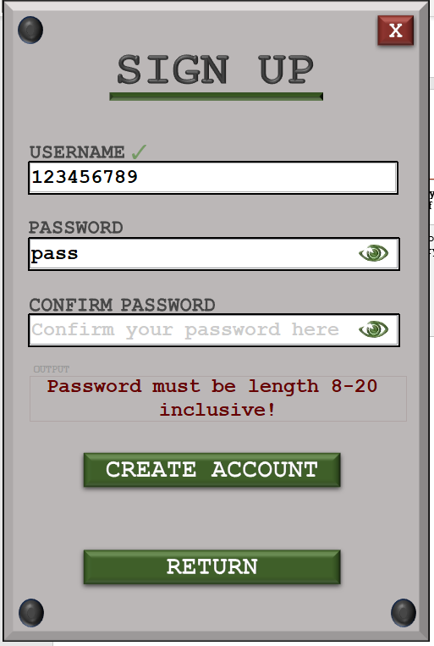

Password is four characters and the program correctly check password length first as there is no need to check for special characters or numbers if the length is incorrect, passing this test.

##### Test #10

|  |  |  |  |  |  |  |
| --- | --- | --- | --- | --- | --- | --- |
| Test | Test description | Input | Expected outcome | Type of test | Relative Success Criteria | Passed Test? |
| 10 | Test for a password that does not have at least one special character | Password not containing any special characters | Password is not accepted, and the user is told that the password should contain at least one special character | Erroneous | 3 |  |

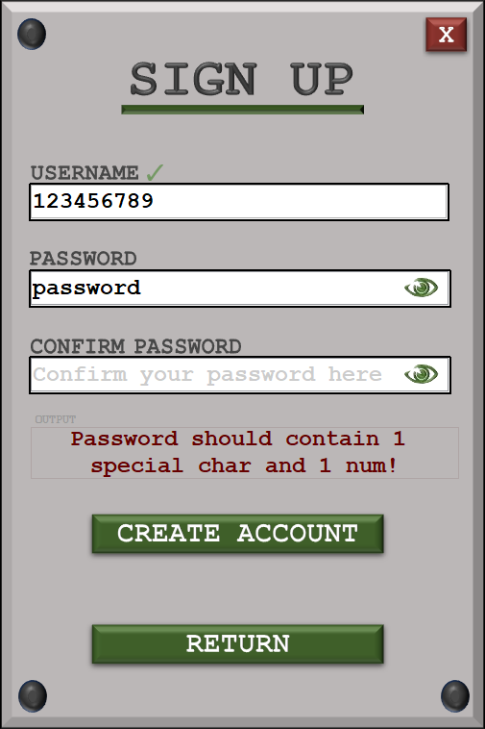

The password does not have a special character and is informed of this. The input is grouped with the number as they both come under special addition requirements.

##### Test #11

|  |  |  |  |  |  |  |
| --- | --- | --- | --- | --- | --- | --- |
| Test | Test description | Input | Expected outcome | Type of test | Relative Success Criteria | Passed Test? |
| 11 | Test for a password that does not have at least one number | Password not containing any numbers | Password is not accepted; user is informed that there should be at least one number within the password | Erroneous | 3 |  |



The password does not have any numbers and is informed of this. The input is grouped with the special character validation as they both come under special addition requirements.

##### Test #12

|  |  |  |  |  |  |  |
| --- | --- | --- | --- | --- | --- | --- |
| Test | Test description | Input | Expected outcome | Type of test | Relative Success Criteria | Passed Test? |
| 12 | Test for entering a correctly formatted first password but a different confirmed password | Formatted correct password, incorrect confirmed password | User is told before submission that the two passwords are not matching and should not be allowed access | Erroneous | 3 |  |

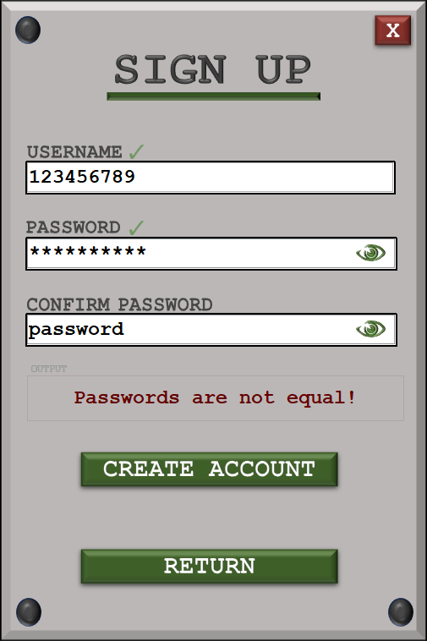

##### Test #15

|  |  |  |  |  |  |  |
| --- | --- | --- | --- | --- | --- | --- |
| Test | Test description | Input | Expected outcome | Type of test | Relative Success Criteria | Passed Test? |
| 15 | Test the input of a correctly formatted password and a correctly confirmed password, unique username | Correctly formatted password and correct confirmed password, unique username | User passes all validation checks and is allowed access onto the system | Normal | 3. |  |

|  |  |
| --- | --- |
|  |  |

As shown above, the passwords are correctly formatted and equal whilst the username is unique. On clicking create account, the user is redirected to the login page for security reasons so that they can now input their valid details and be allowed onto the system.

##### Test #16 & 17

|  |  |  |  |  |  |  |
| --- | --- | --- | --- | --- | --- | --- |
| Test | Test description | Input | Expected outcome | Type of test | Relative Success Criteria | Passed Test? |
| 16 | Test when all inputs are left blank | No input | User cannot submit their details and is informed that text fields must not be blank | Erroneous | 3. |  |
| 17 | Test when at least one input is left blank |

|  |  |
| --- | --- |
|  |  |

Any combination of blank inputs does not allow the user to input any details. This also does not use up an attempt and passes the test successfully.

##### Test #18

|  |  |  |  |  |  |  |
| --- | --- | --- | --- | --- | --- | --- |
| Test | Test description | Input | Expected outcome | Type of test | Relative Success Criteria | Passed Test? |
| 18 | Test for generating a maze in the visualise section | User clicks button | Click the generate maze should generate the maze slowly at a speed that the user can follow | Normal | 9, 10 |  |

|  |  |
| --- | --- |
|  |  |
|  |  |

The maze is generated from the top left corner and procedurally shows each path and the decisions Prim’s algorithm. Once the maze has been generated, the user is allowed to apply pathfinding algorithms but during generations, the buttons are disabled. The speed is variable and can be chosen by the user.

##### Test #19

|  |  |  |  |  |  |  |
| --- | --- | --- | --- | --- | --- | --- |
| Test | Test description | Input | Expected outcome | Type of test | Relative Success Criteria | Passed Test? |
| 19 | Test for generating a solvable maze in the visualise section | Users click – algorithmic process called upon click | Once the maze is generated, there must be a path from the start of the square to the finish | Normal | 4. |  |

|  |  |
| --- | --- |
|  |  |
|  |  |

In these 4 iterations, it is evident that every maze is solvable with a unique solution from the starting square to the final square, therefore passing the test.

##### Test #20

|  |  |  |  |  |  |  |
| --- | --- | --- | --- | --- | --- | --- |
| Test | Test description | Input | Expected outcome | Type of test | Relative Success Criteria | Passed Test? |
| 20 | Test to check whether pathfinder correctly identifies the solution | User selects the pathfinding mode | Once the algorithmic process has ended, the maze should be solved with the pathfinder marker on the final square | Normal | 11, 12 |  |

|  |  |  |
| --- | --- | --- |
| **Depth-first search** | **Breadth-first search** | **A-Star search** |
|  |  |  |

When running the same maze for all of these searches, all of the had revealed the shortest path in a dark red colour. In all 3 cases, the shortest path is consistent with one another. This shows shortest path validation for all three mazes is identical as the same path is revealed.

##### Test #21

|  |  |  |  |  |  |  |
| --- | --- | --- | --- | --- | --- | --- |
| Test | Test description | Input | Expected outcome | Type of test | Relative Success Criteria | Passed Test? |
| 21 | Test to see if the pathfinder displays each step of the process on the screen | User confirms pathfinding choice | Each step of the solver will be overlayed onto the maze and the steps until completion are displayed gradually | Normal | 12 |  |

Running depth-first search:

|  |  |
| --- | --- |
|  |  |
|  |  |

As shown above, the maze fills the depth of the maze from top to bottom before eventually finding the end point and highlighting the shortest path, therefore passing the test as the search stops once the end point is found.

Running breadth-first search

|  |  |
| --- | --- |
|  |  |
|  |  |

The searcher radiates outwards therefore successfully showing the breadth first search working. The solver also stops working when the end square has been reached and the shortest path is revealed.

Running the more efficient A* Star search algorithm:

|  |  |
| --- | --- |
|  |  |
|  |  |

All algorithms display the steps periodically with junctions/decisions being blue.

##### Test #22 & 23 & 24

|  |  |  |  |  |  |  |
| --- | --- | --- | --- | --- | --- | --- |
| Test | Test description | Input | Expected outcome | Type of test | Relative Success Criteria | Passed Test? |
| 22 | Test for a 10x10 generated maze | User selects 10x10 maze | A maze that has 100 cells (10 by 10) is generated | Normal | 7 |  |
| 23 | Test for a 20x20 generated maze | User selects 20x20 maze | A maze that has 400 cells (20 by 20) is created | Normal | 7 |  |
| 24 | Test for a 30x30 generated maze | User selects 30x30 maze | A maze that has 900 cells (30x30) is created | Normal | 7 |  |

Test #22 and #24 partially passed as I chose to change the default sizes of maze to accommodate the change in difficulty for usability as users would prefer a bigger jump in size. This is why I chose to have 20x20, 40x40 and 80x80.

|  |  |
| --- | --- |
|  | **20x20** |
|  |
|  |  |
|  |  |
| **40x40** | **80x80** |
|  |  |

##### Test #29

|  |  |  |  |  |  |  |
| --- | --- | --- | --- | --- | --- | --- |
| Test | Test description | Input | Expected outcome | Type of test | Relative Success Criteria | Passed Test? |
| 29 | Test for target square generation | No input | A square should be generated bias to the bottom right of the fourth quadrant | Boundary | 5 |  |

|  |  |
| --- | --- |
|  |  |

##### Test #30

|  |  |  |  |  |  |  |
| --- | --- | --- | --- | --- | --- | --- |
| Test | Test description | Input | Expected outcome | Type of test | Relative Success Criteria | Passed Test? |
| 30 | Test for starting square random generation | Re generated maze | Starting square should generate randomly but with little deviation | Normal | 5 |  |

|  |  |
| --- | --- |
|  |  |
|  |  |

The feature to have a random starting square was removed so that only one feature of the pathfinder’s parameters was random.

##### Test #31

|  |  |  |  |  |  |  |
| --- | --- | --- | --- | --- | --- | --- |
| Test | Test description | Input | Expected outcome | Type of test | Relative Success Criteria | Passed Test? |
| 31 | Test for target square random generation | Re generated maze | Final square should generate randomly but with noticeable deviation | Normal | 5 |  |

|  |  |
| --- | --- |
|  |  |
|  |  |

As shown above, the ending square is generated somewhere in the last 16th (octant) of

the maze, therefore passing the test.

##### Test #32

|  |  |  |  |  |  |  |
| --- | --- | --- | --- | --- | --- | --- |
| Test | Test description | Input | Expected outcome | Type of test | Relative Success Criteria | Passed Test? |
| 32 | Test for intractability /playability | User clicks a cell on the grid or arrow key pressed adjacent to current square | Button should be able to be clicked or accessed if it is adjacent to the current square and is then highlighted | Normal | 6 |  |

Down arrow pressed:

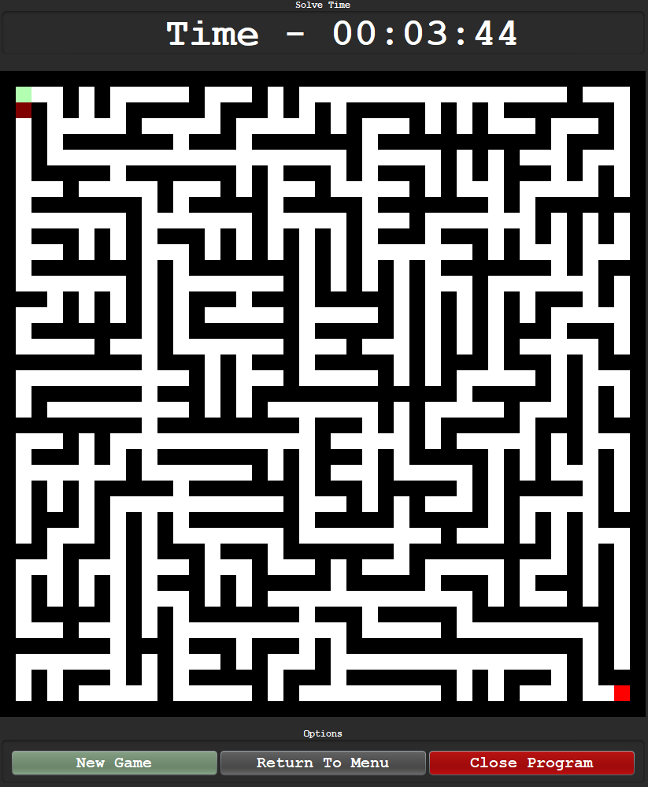

The user can interact with the maze using the arrow keys therefore the test is passed

##### Test #33 & #34 & #35

|  |  |  |  |  |  |  |
| --- | --- | --- | --- | --- | --- | --- |
| Test | Test description | Input | Expected outcome | Type of test | Relative Success Criteria | Passed Test? |
| 33 | Test for selecting non-current cells that have not been highlighted previously | User clicks or tries to access a cell that is not the current cell and has not been highlighted before | Nothing happens, the square is not highlighted, and the input is ignored | Erroneous | 6 |  |
| 34 | Test for deselecting non-current cells that have been highlighted previously | User clicks or accesses a highlighted button that isn’t the current button | The cell is not deselected, and the input is ignored as only the current square can be deselected | Erroneous | 6 |  |
| 35 | Test for deselecting a current cell | User clicks on the current cell | The input is accepted, and the square is deselected. The previous square now becomes the current square. | Normal | 6 |  |

As only arrow inputs are used, the feature to deselect squares has been removed.

##### Test #36

|  |  |  |  |  |  |  |
| --- | --- | --- | --- | --- | --- | --- |
| Test | Test description | Input | Expected outcome | Type of test | Relative Success Criteria | Passed Test? |
| 36 | Test for menu after win detection | User navigates to the final square | As soon as the final square is reached, a menu is displayed after the win is detected | Normal | 8, 15 |  |

|  |  |
| --- | --- |
|  |  |

The moment the user reaches the final square, the win menu pops up and displays the solve time as well as the type of maze. The user is then allowed to start a new game or return to the main menu.

##### Test #37

|  |  |  |  |  |  |  |
| --- | --- | --- | --- | --- | --- | --- |
| Test | Test description | Input | Expected outcome | Type of test | Relative Success Criteria | Passed Test? |
| 37 | Test for returning to main menu after playing a game on the win menu | Button click | Upon clicking return to main menu, the old form is removed, and the main menu is now displayed | Normal | 13, 15 |  |

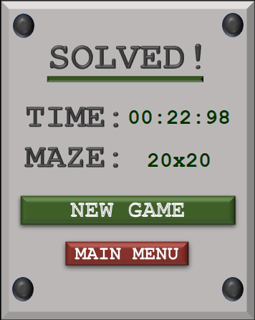

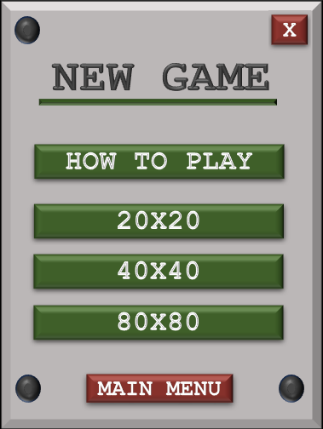

On click of the new game button, the correct menu is displayed.

##### Test #38

|  |  |  |  |  |  |  |
| --- | --- | --- | --- | --- | --- | --- |
| Test | Test description | Input | Expected outcome | Type of test | Relative Success Criteria | Passed Test? |
| 38 | Test for the ability to play another game on the win menu | Button click | User can successfully play a game one after another. Game loads after click and removes the previous game | Normal | 15 |  |



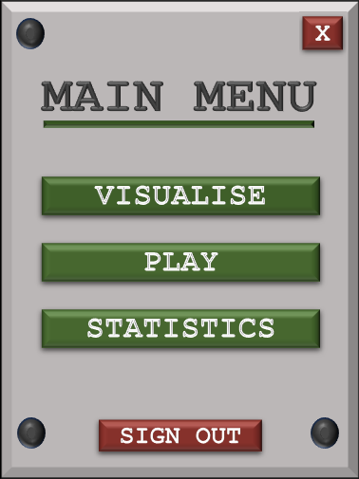

On click of the new game button, the correct menu is displayed.

##### Test #39 & #40 & #41

|  |  |  |  |  |  |  |
| --- | --- | --- | --- | --- | --- | --- |
| Test | Test description | Input | Expected outcome | Type of test | Relative Success Criteria | Passed Test? |
| 39 | Test for the game pausing after transition menu selected | Transition menu selected in the game menu | Once the menu is clicked, the user should not be able to interact with the game and only the menu | Normal | 14 |  |
| 40 | Test for returning to menu after transition menu selected | Visualise section | After selecting return to main menu on the transition menu, the menu should close as well as the form currently open and then display the main menu | Normal | 14 |  |
| Play section |
| Statistics section |
| 41 | Test for resuming after transition menu selected | Visualise section | After selecting the transition menu, if resume is collected, the transition menu is closed, and everything returns to normal | Normal | 14 |  |
| Play section |
| Statistics section |

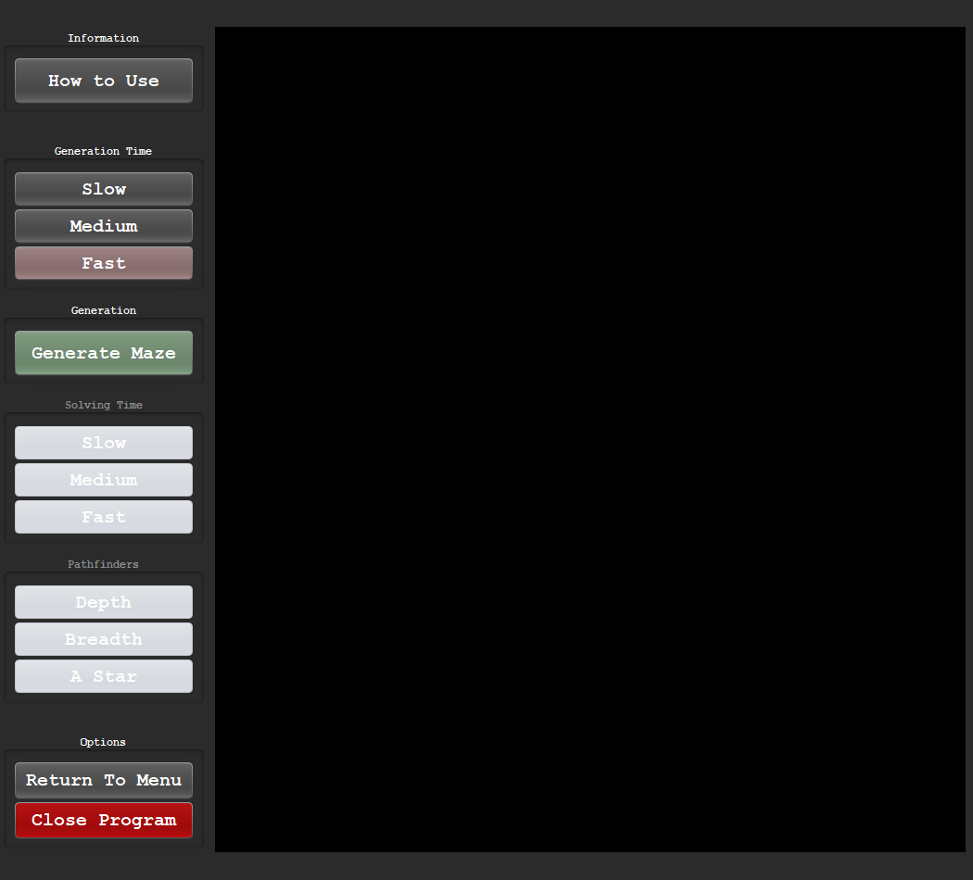

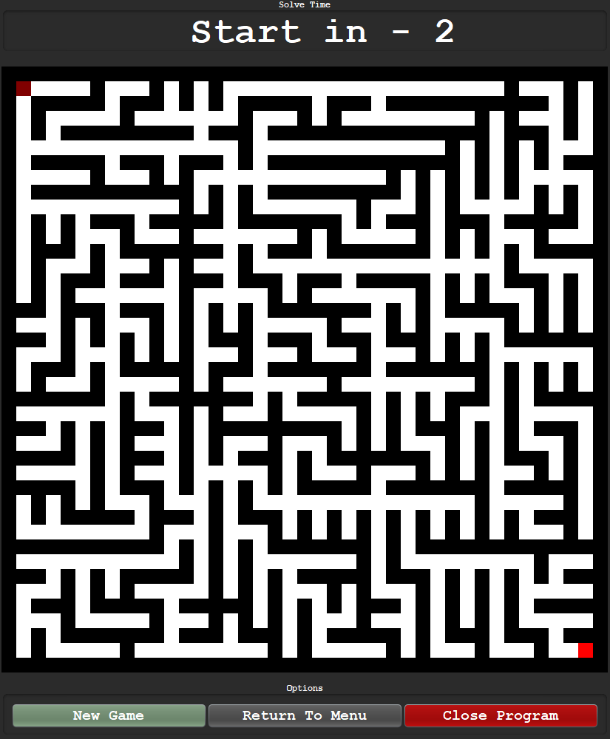

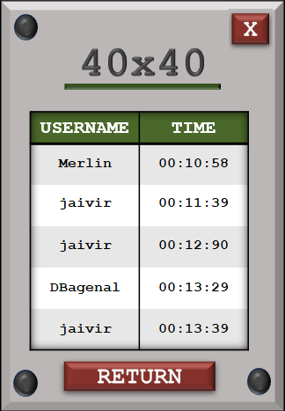

As shown above there is no transition menu for any of the game modes, therefore the test fails.

##### Test #42

|  |  |  |  |  |  |  |
| --- | --- | --- | --- | --- | --- | --- |
| Test | Test description | Input | Expected outcome | Type of test | Relative Success Criteria | Passed Test? |
| 42 | Test for displaying correct stats after a win is called | User completes a maze and reaches the finish | Upon winning a game, the user should be shown the total time taken to solve | Normal | 8, 16 |  |

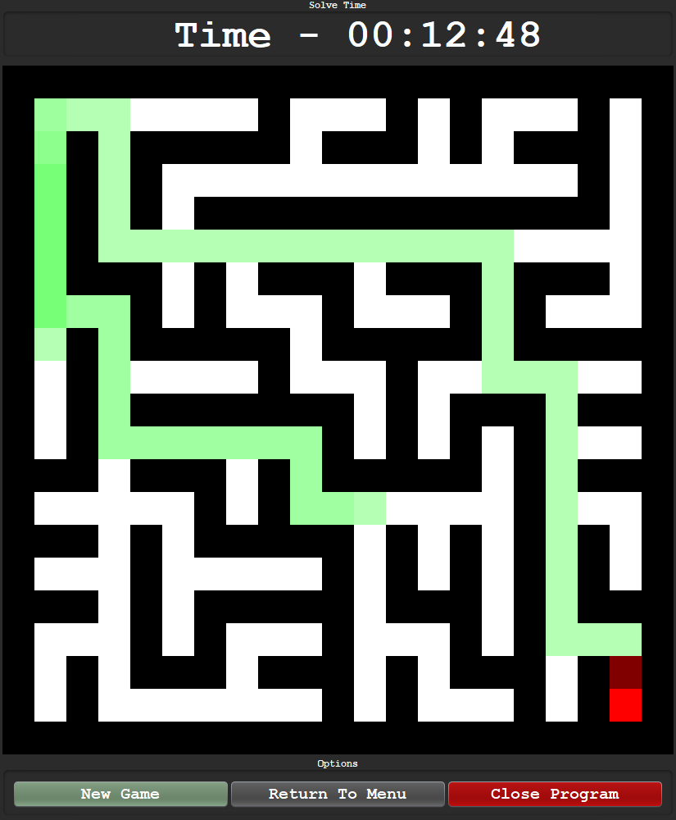

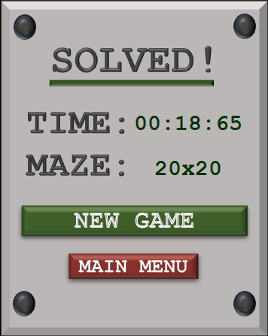

As shown above, the user is informed of the solve time after the win is detected.

##### Test #43 & #44

|  |  |  |  |  |  |  |
| --- | --- | --- | --- | --- | --- | --- |
| Test | Test description | Input | Expected outcome | Type of test | Relative Success Criteria | Passed Test? |
| 43 | Test for displaying top 10 scores for a 10x10 maze with at least 10 pieces of total data | Selection of the 10x10 statistics | Top 10 scores of all time for the 10x10 game mode will be recalled and output on the screen to see | Normal | 17, 18 |  |
| 44 | Test for displaying top 10 scores for a 10x10 maze with less than 10 pieces of data | Selection of the 10x10 statistics | All scores recorded for the 10x10 will be output onto the screen as there cannot be a ranking if there are less than 10 total items of data | Normal | 17, 18 |  |

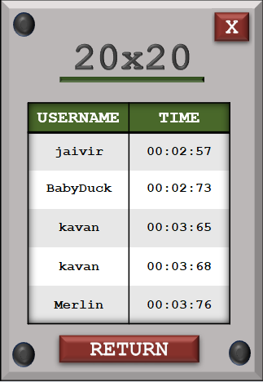

Rather than having top 10, I chose 5 scores, so this feature has been edited. The test still passes but fewer data items are output to the user.

##### Test #45 & #46

|  |  |  |  |  |  |  |
| --- | --- | --- | --- | --- | --- | --- |
| Test | Test description | Input | Expected outcome | Type of test | Relative Success Criteria | Passed Test? |
| 45 | Test for displaying top 10 scores for a 20x20 maze with at least 10 pieces of total data | Selection of the 20x20 statistics | Top 10 scores of all time for the 20x20 game mode will be recalled and output on the screen to see | Normal | 17, 18 |  |
| 46 | Test for displaying top 10 scores for a 20x20 maze with less than 10 pieces of data | Selection of the 20x20 statistics | All scores recorded for the 20x20 will be output onto the screen as there cannot be a ranking if there are less than 10 total items of data | Normal | 17, 18 |  |

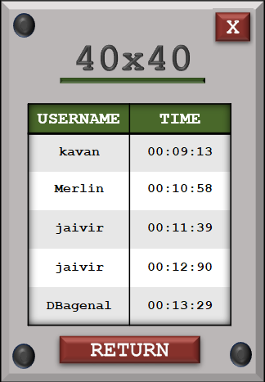

Rather than having top 10, I chose 5 scores, so this feature has been edited. The test still passes but fewer data items are output to the user.

##### Test #47 & #48

|  |  |  |  |  |  |  |
| --- | --- | --- | --- | --- | --- | --- |
| Test | Test description | Input | Expected outcome | Type of test | Relative Success Criteria | Passed Test? |
| 47 | Test for displaying top 10 scores for a 30x30 maze with at least 10 pieces of total data | Selection of the 30x30 statistics | Top 10 scores of all time for the 30x30 game mode will be recalled and output on the screen to see | Normal | 17, 18 |  |
| 48 | Test for displaying top 10 scores for a 30x30 maze with less than 10 pieces of data | Selection of the 30x30 statistics | All scores recorded for the 30x30 will be output onto the screen as there cannot be a ranking if there are less than 10 total items of data | Normal | 17, 18 |  |

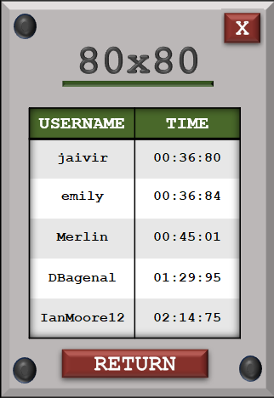

Rather than having top 10, I chose 5 scores, so this feature has been edited. The test still passes but fewer data items are output to the user.

#### Extra testing

##### Live validation

Unique username:

|  |  |
| --- | --- |
|  |  |

Password:

|  |  |
| --- | --- |
|  |  |

##### Timeout login

|  |  |
| --- | --- |
|  |  |
|  |  |

The timeout follows a polynomial increase in time to penalise successive timeouts.

##### Changing speed mid generation

After 3 second intervals:

Slow:

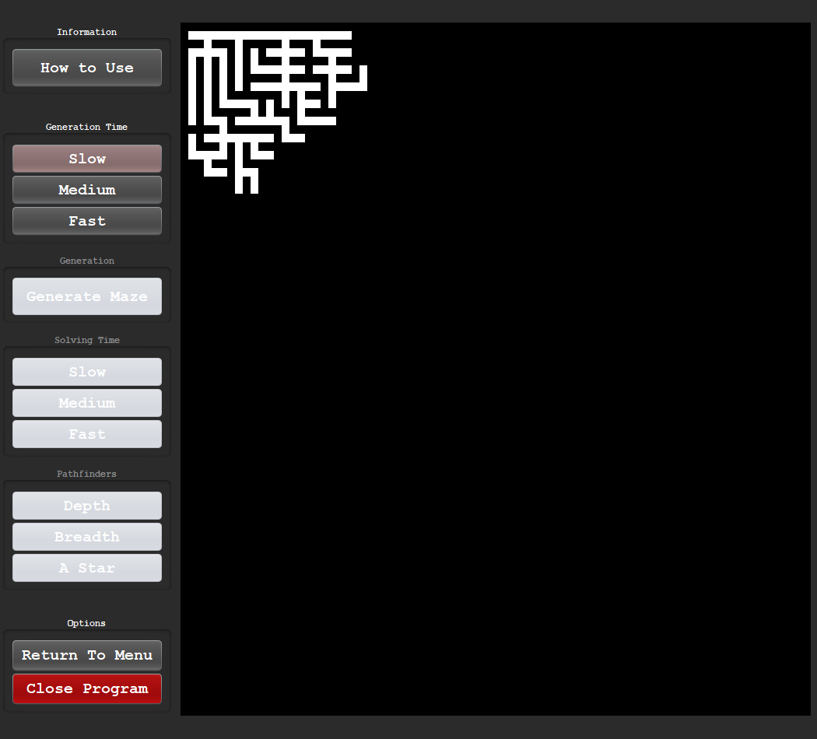

Fast:

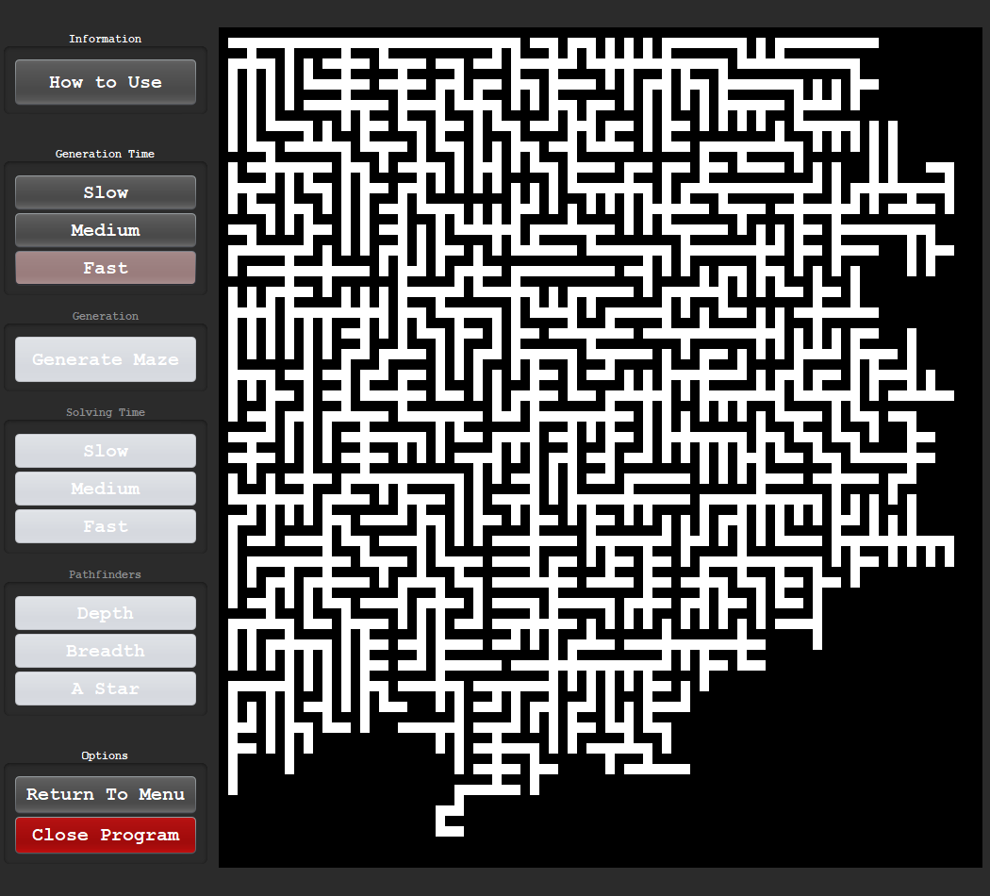

##### Junction highlighting

A Star search:

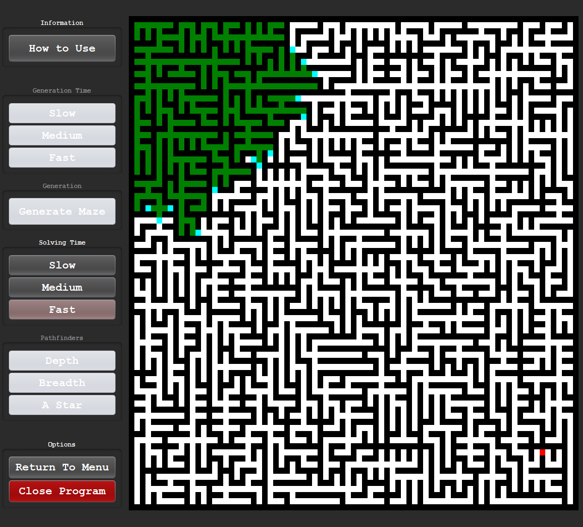

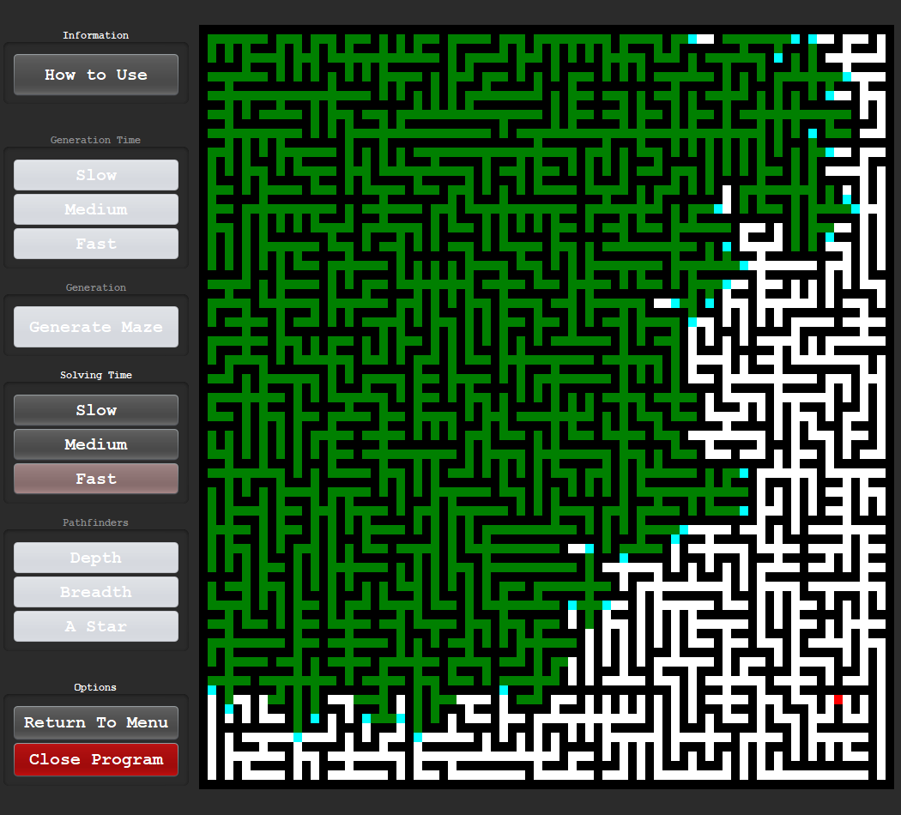

The code successfully highlights the junctions in a light blue colour. This square indicates a decision and allows the user to follow the pathfinder in real time.

##### Path darkening

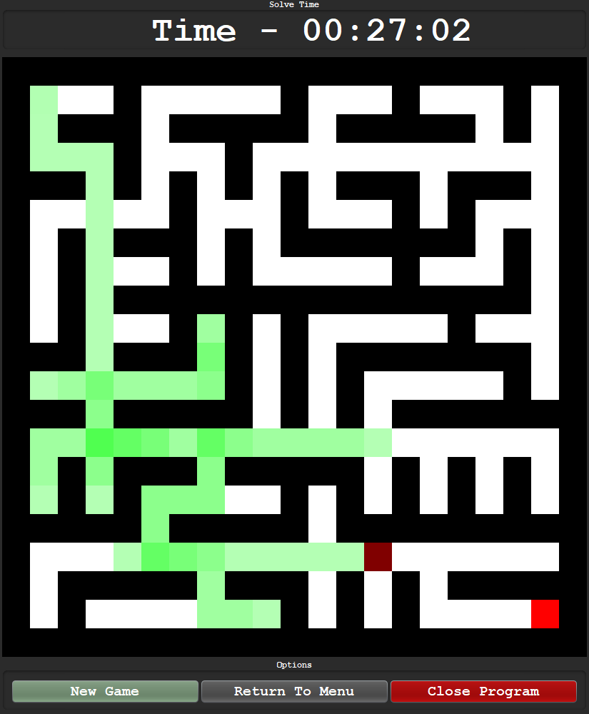

As shown above, there is code that keeps track of each paths step count. Therefore, when re tracing over a cell that has already been explored, the visualiser will display a progressively darker path.

### Robustness Testing

Robustness testing is necessary to assess the quality and reliability of the product. Exceptional inputs and stress testing will be carried out to see if the product can handle these extreme cases.

#### Login and Register Form

Spam clicking the submit button on blank input:

|  |  |
| --- | --- |
| **Robustness Test passed?** |  |

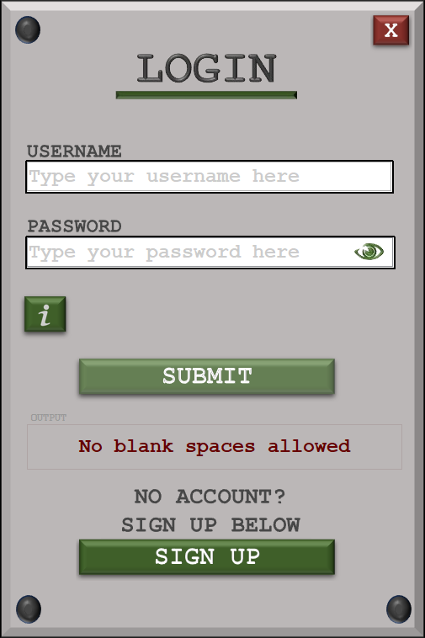

When spamming the button with blank input, the user is simply told there can be no blank input and attempts are not used. Spamming the button on this case, does not break the program as there are measures in place to prevent this.

Spam clicking the submit button on valid input:

|  |  |
| --- | --- |
| **Robustness Test passed?** |  |
|  | |  |
|  | |  |

After the initial error message, the no blank space message returns and gives the same result as the previous robustness test.

Continuously typing into a password field that has been unhidden:

|  |  |  |
| --- | --- | --- |
| **Robustness Test passed?** |  | |
|  | | |  | |

When typing into a password field that has been unhidden, the password becomes hidden the moment new text is added which results in a failed test as password should be still unhidden.

Spam clicking view password:

|  |  |
| --- | --- |
| **Robustness Test passed?** |  |









Spam clicking sign up and return to login:

|  |  |  |
| --- | --- | --- |
| **Robustness Test passed?** |  | |
|  | | |  | |

As I have removed the window undercoating title bar, the login and register forms load up extremely quickly and instantly. This means when spam clicking the buttons that are relatively in the same location, the program does not break and loads up the next page instantly.

Testing the time out screen

|  |  |
| --- | --- |
| **Robustness Test passed?** |  |

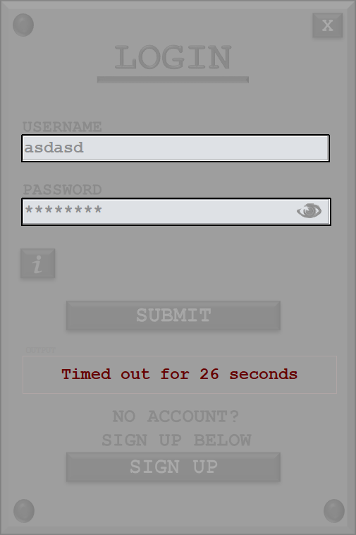

When the user is timed out of the form, the entire frame is completely disabled so the user cannot physically alter any process on the screen as the interaction is removed. Any click will be ignored during this period.

#### Visualise Mode

Applying a pathfinder to an empty maze (pre generation)

|  |  |
| --- | --- |
| **Robustness Test passed?** |  |

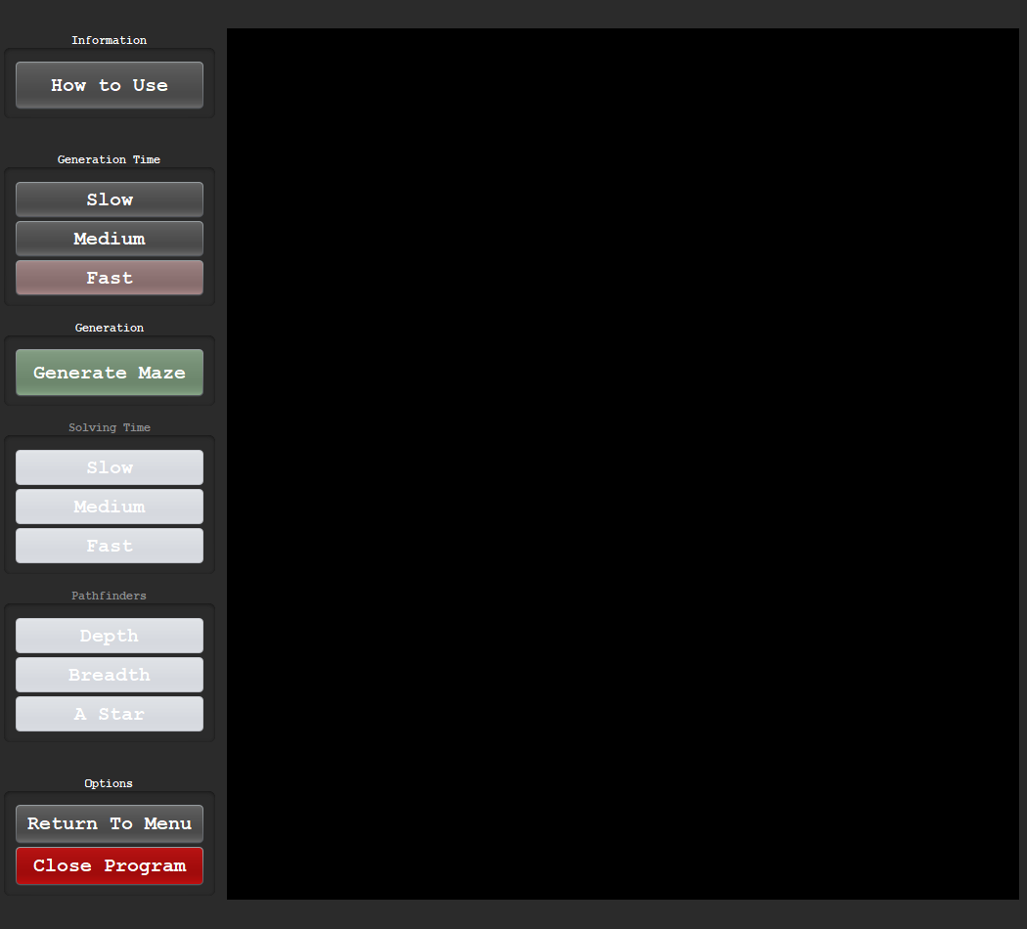

Before generating a maze, the button to apply pathfinders are disabled so there is no possible input that can break the state of the program as an empty maze cannot run a pathfinder.

Checking if another process can start during maze generation:

|  |  |
| --- | --- |
| **Robustness Test passed?** |  |

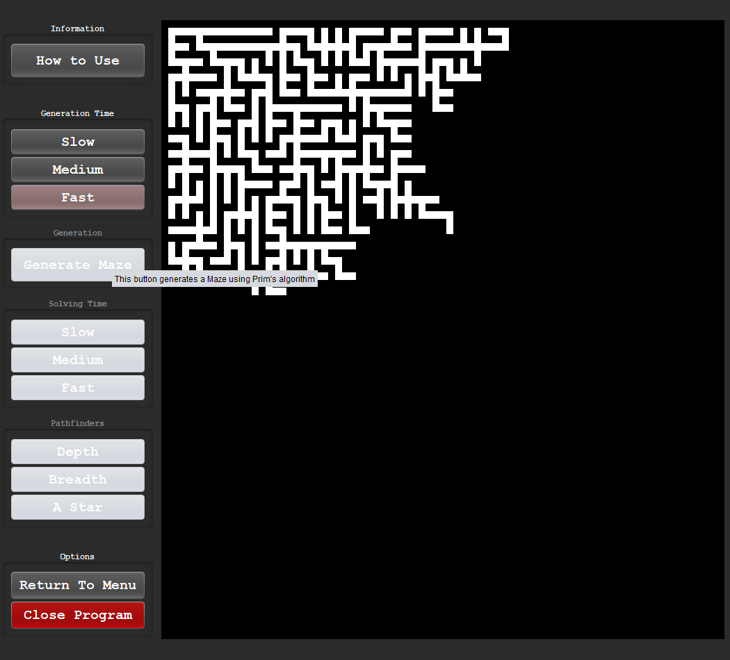

The instant a maze starts to generate, the user cannot start a new process. The buttons to generate and apply a pathfinder are only enabled one the generation has finished. The only buttons the user can click is to terminate/ exit or view the how to use info.

#### Play mode

Repeating random input before allowed to play:

|  |  |
| --- | --- |
| **Robustness Test passed?** |  |

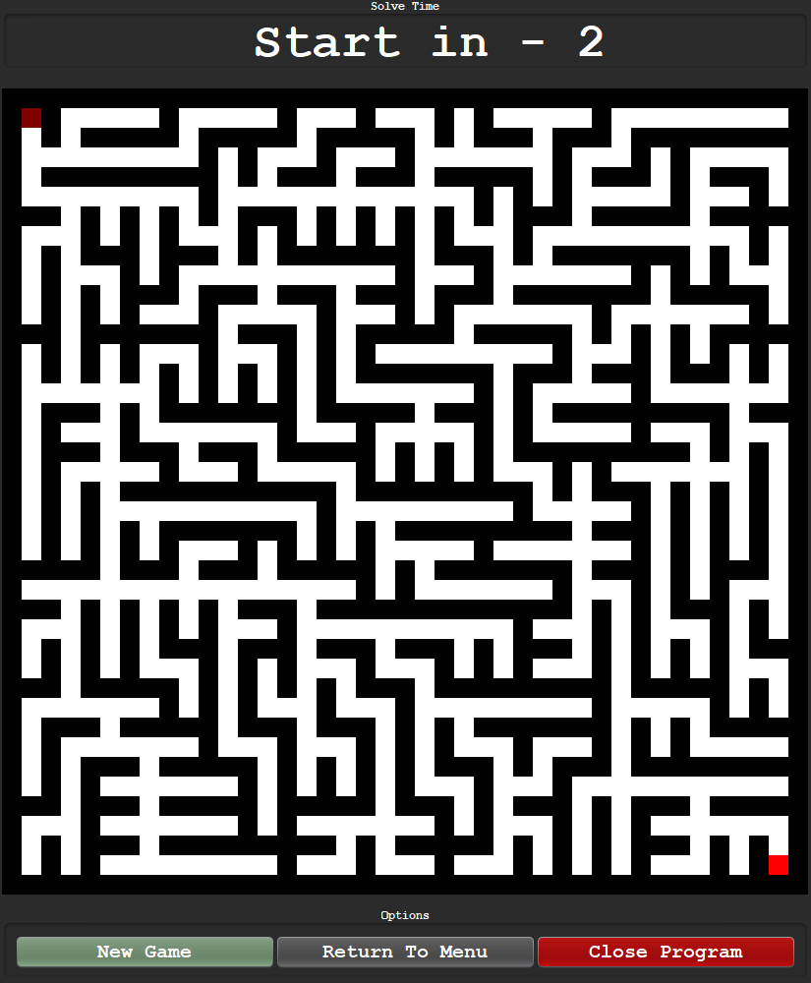

Any combination of input is ignored, and no move can be made before the timer reaches 0.

Reaching the darkest path colour:

|  |  |
| --- | --- |
| **Robustness Test passed?** |  |

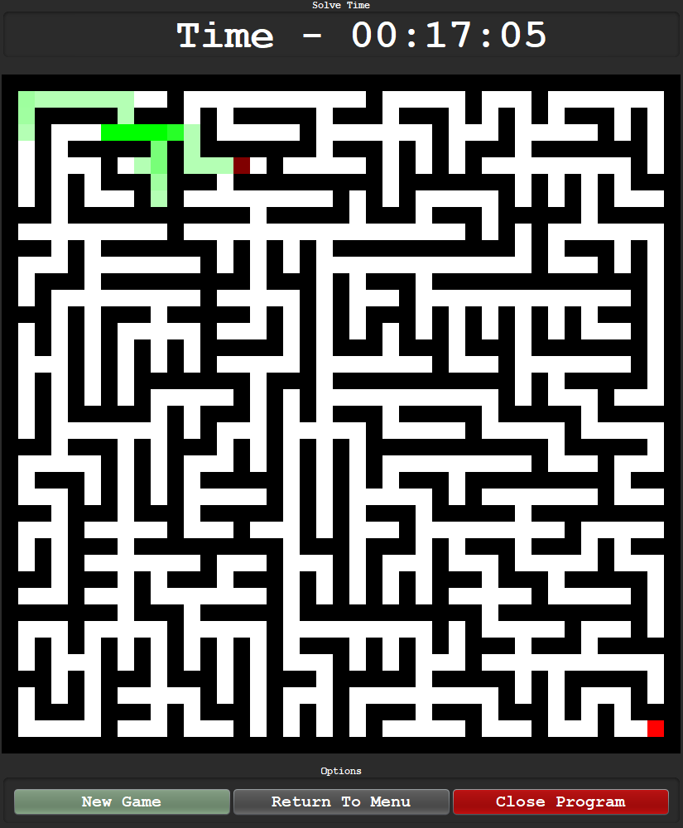

When going over the same point, the darkest green reached is (0, 255, 0) and the product does not break when this limit is reached.

Continuing input after a win is reached:

|  |  |
| --- | --- |
| **Robustness Test passed?** |  |

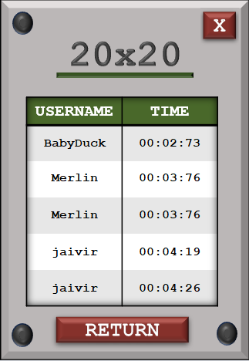

A logic flaw is present in the program as a certain combination of inputs or perhaps an extra click as soon as the final square is reached sometimes results in a double score being recorded as shown above in the statistic section.

### Usability Testing

Usability testing is crucial in testing how usable the final product is. The usability features implemented throughout all the development cycles are tested by the client, stakeholders, test users and end users.

#### Creating a usability form

A usability form must be created so that the users experience can be expressed through ratings and comments. Not only should there be a form, but there should also be an option to leave comments for each major section of the program (visualise, login etc.)

First the user is asked to provide their name to identify what type of person is answering the questionnaire (client, end user etc.)

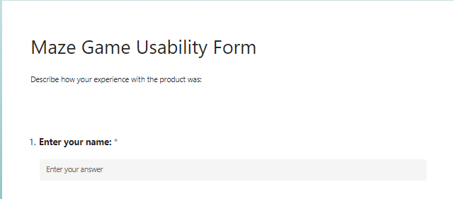

Login section:

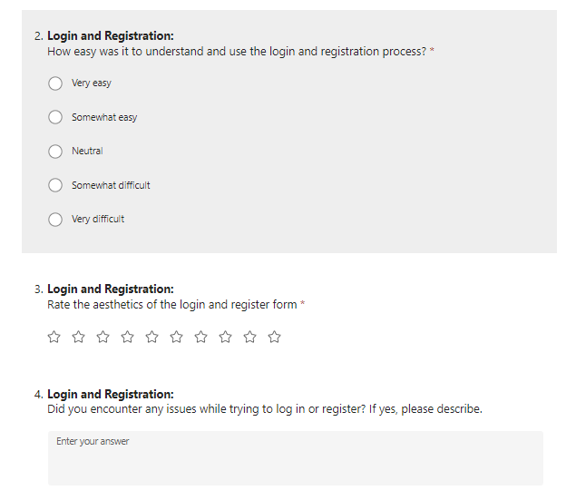

Main Menu:



Visualise Section:

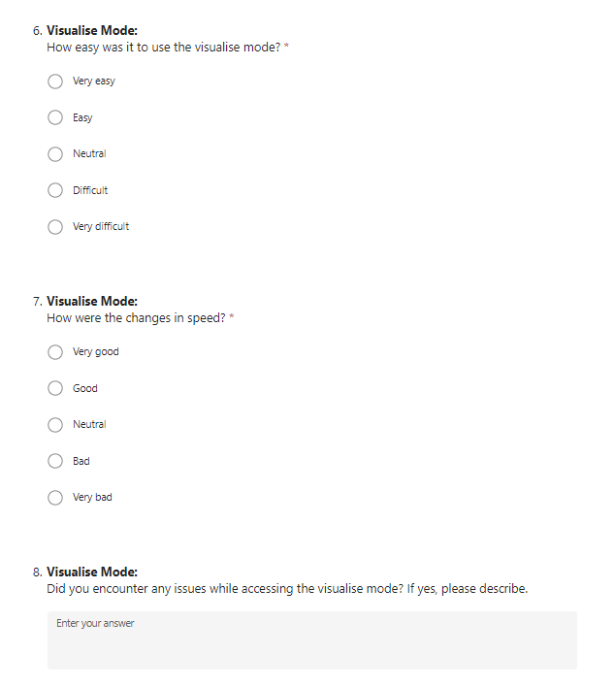

Play mode:

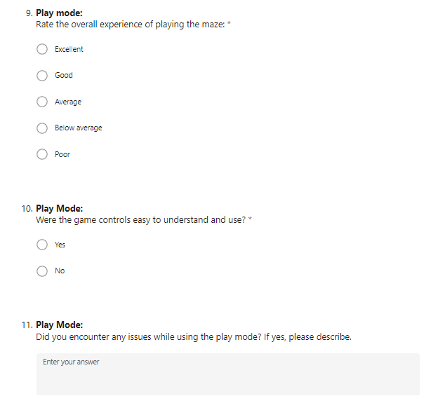

Statistics:

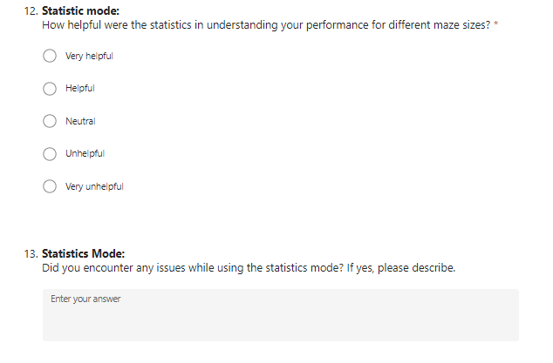

Overall:

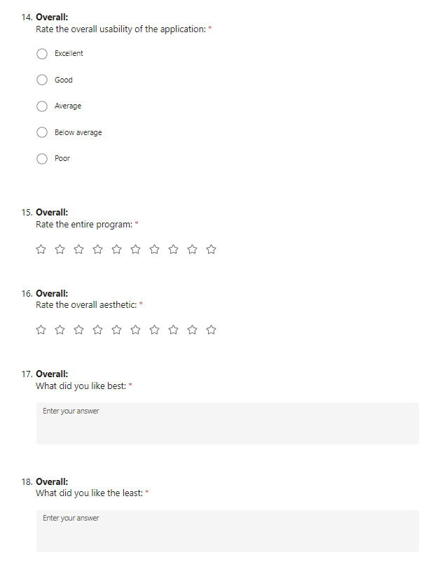

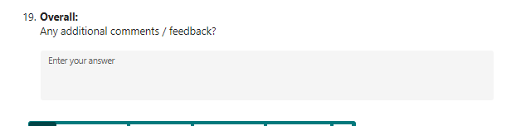

#### Login and registration



 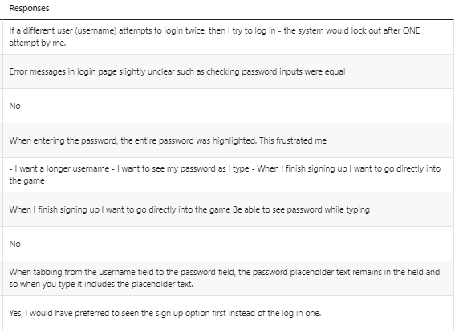



#### Main Menu



#### Visualise Mode

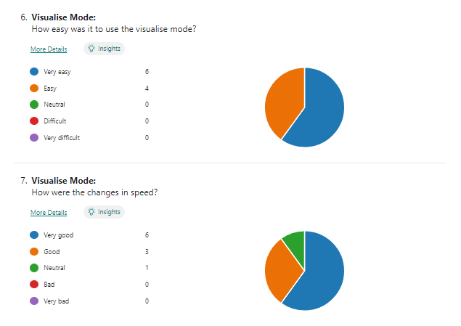



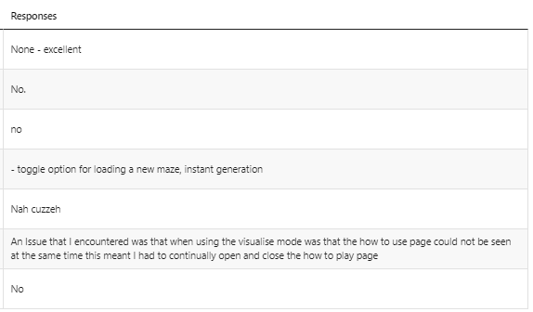

#### Play mode

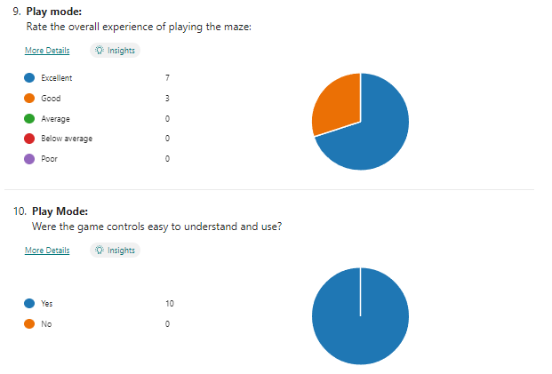



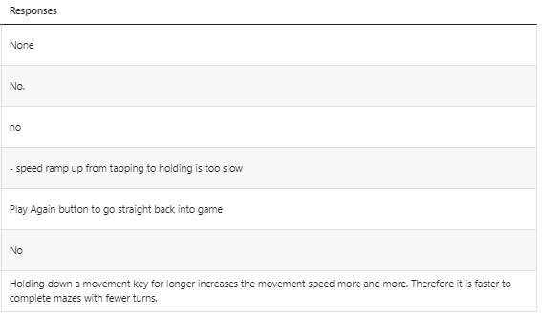

#### Statistics mode

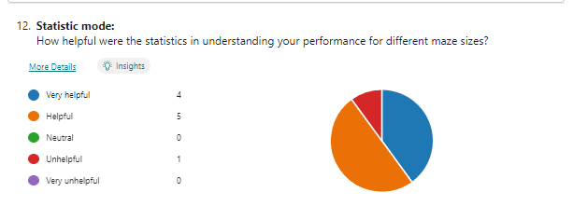

 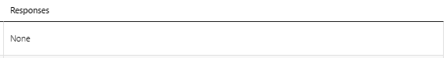

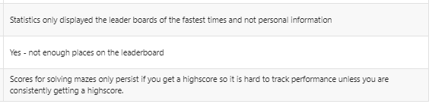

#### Overall

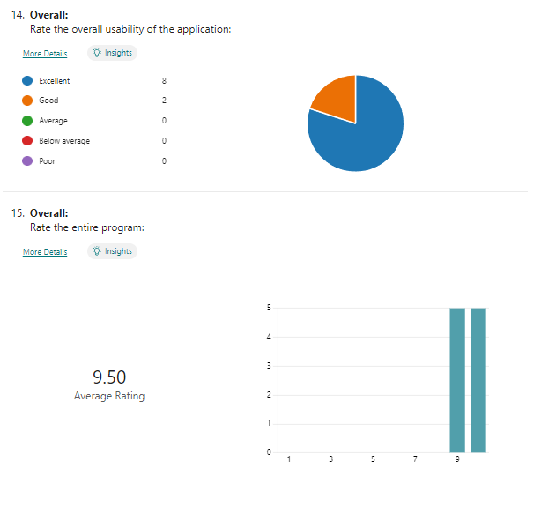

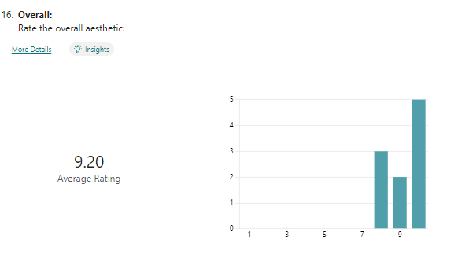



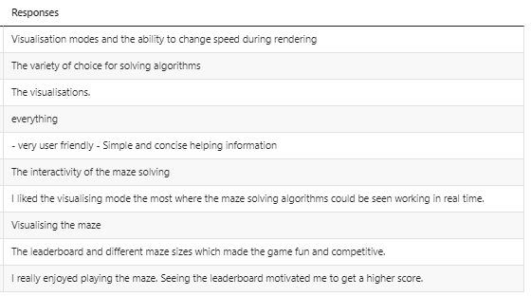



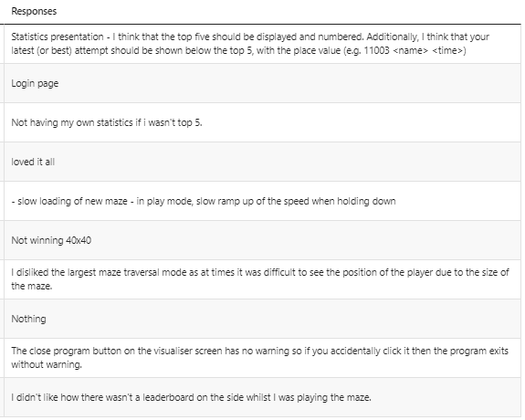



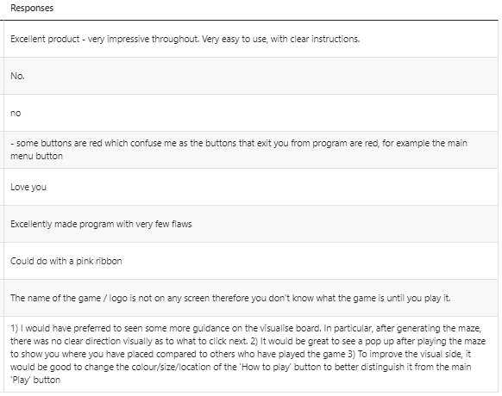

Overall, the usability of the program was well received with all average ratings being greater than 9. This reflects that the planned features during development to enhance usability were successful. Using these comments for each individual section, I can evaluate my findings compared to the success criteria, function tests and initial design.

## Success of the solution

### Concluding Success Criteria

|  |  |  |
| --- | --- | --- |
| **Pass** | **Partial Pass** | **Fail** |
|  |  |  |

1. Log in
   1. Users will be able to interact with a login screen and type their existing username and password to access the application.
   2. This ensures that only authorised users are permitted to use the application and can have all local data stored on one account. This allows the separation of data and provides the user with a personalised experience.
2. Register
   1. Users that do not have existing details to sign up with should be able to interact with a form that allows them to register a unique username and a strong password. The register form should be easy to locate.
   2. An option to register allows a new user to create a way to securely access the application and have relevant data stored locally A registration form that is easy to locate will enhance user friendliness.
3. Register validation
   1. User passwords must meet a specific criterion when registering. The password must at least 8 characters, have 1 special character and have 1 number.
   2. Password validation enhances security by forcing users to have a complex password. This reduces the possibility of passwords and account details being breached and unauthorised access.
4. Maze generation
   1. The application must generate solvable mazes that have at least one path for the user or pathfinding algorithm to navigate through. A maze is defined as solvable if you can navigate to the finish from any point in the maze.
   2. Having solvable mazes adds functionality to the game and allows users to interact with a working product. Pathfinding algorithms can only be applied to mazes that are solvable therefore this feature is mandatory.
5. Start and finish squares
   1. Every maze in ‘play’ mode must have a starting square that the player starts on and a finish square that the player must reach. These must be randomly generated by an appropriate algorithm.
   2. Clear starting and finishing points are essential for creating a structured and solvable maze. Random generation ensures diversity in maze layouts and provides the user with a different experience each time. A maze without starting or finishing squares cannot be played.
6. Interaction and playability
   1. Users must be able to interact with the maze and complete it by displaying an appropriate completion screen upon reaching the finishing square.
   2. This creates the base functionality for the product and adds clarity so the user can understand what their actions lead to and can identify when they have successfully completed a maze.
7. Maze size selection
   1. The user must be able to choose between three predetermined maze sizes when choosing to play.
   2. This removes the user not being able to decide what size is best and instead gives them a pointer to difficulty. E.g., 10x10 is the easiest, 20x20 is medium difficulty and 30x30 is the hardest.
8. Win Detection
   1. There must be detection in place to recognise when a user completes a maze.
   2. The detection makes sure there is no game that lasts for ever and allows users to play mazes one after another.
9. Maze generation algorithm
   1. The product must have at least one maze generation algorithm for the user to select in ‘visualise’ mode.
   2. There should be at least one way for a maze to be generated as this is the primary function of the product. Before pathfinding, a maze must be generated visually.
10. Maze generation visualiser
    1. A gradual creation of a maze must be displayed visually that highlights each step of the maze generation algorithm.
    2. Maze generation visualisation provides users with insights into how mazes are created. It is an educational and entertaining aspect of the application which in turn enhances the entre experience.
11. Maze pathfinding algorithm
    1. There must be at least one choice and code for a pathfinding algorithm to apply onto the generated maze in ‘visualise mode’.
    2. Having at least one algorithm is the bare minimum for the visualise section to be functional. It can be called and applied to generated mazes.
12. Maze pathfinding visualiser
    1. Once a choice is selected, the maze must display every step of the pathfinding algorithm with a coloured path that traces through the maze until the end point is reached.
    2. Allowing the user to see the path being traced and visually seeing the algorithms decisions can be insightful and develops greater understanding for how the algorithm functions.
13. Working main menu
    1. The menu should offer options to choose between playing mazes, visualising solutions to mazes and exiting the form.
    2. A well-structured main menu improves user navigation and experience. It provides clear choices for users and makes sure they can easily access the intended features.
14. Transition Menu
    1. A perpetual menu will be located top right during all game modes and allows the user to pause, resume and return to main menu.
    2. The transition menu adds convenience to the user experience by allowing easy access back to the main menu and can be resumed at any time.
15. Win Menu
    1. After the user navigates to the final square, a menu should appear to inform the user of the win and present the options associated with a win.
    2. This removes ambiguity after a win and gives users a clear blueprint on what to do after a win.
16. Solve statistics.
    1. After a maze is completed, the time taken to solve the maze should be displayed to the user.
    2. The user can compare previous scores to current scores to monitor progress and improvement.
17. Visualise statistics.
    1. The relative data after solving a maze with the selected pathfinding algorithm should be output to the user on the screen.
    2. The chosen pathfinding algorithm is compared against other algorithms to outline the efficiency when compared against similar algorithms.
18. Leaderboard
    1. Users should be able to open a leaderboard and see their local data compared against other statistics.
    2. After completing a maze, the user should see their local stats to track progression and monitor improvement.

### Assessing Success Criteria

#### Success Criteria #1

Log in

* 1. Users will be able to interact with a login screen and type their existing username and password to access the application.
  2. This ensures that only authorised users are permitted to use the application and can have all local data stored on one account. This allows the separation of data and provides the user with a personalised experience.
* Tests associated with criterion: (1-5)

Ensuring that only authorised users can access the system by entering their correct username and password combination is the main focus of the success criteria outlined for the application's login functionality. This protects the user's data's security and privacy.

This success criteria simply states that the user will be allowed to log onto the system after already having registered details. My first login prototype had already achieved this success criteria with the inclusion of a simple blank form with no extra usability. This is why I decided to include extra features such as hint text, extra aesthetics, view password and automatic highlighting. When considering a visualiser, the product must be easy to use with the usability being a high priority. These improvements may help to improve the application's overall usability by making the login procedure more straightforward and user-friendly.

In test #1, #2, #3, #4 and #5, most combinations were tested to show that the authorisation was of the correct standard. All possible tests were not identified as the general functionality could be represented using fewer tests. For example, a correct username with an incorrectly formatted password (no special char) is a different case to a correct username with an incorrect formatted password (no number) but can be represented by the same test.

#### Success Criteria #2

Register

* 1. Users that do not have existing details to sign up with should be able to interact with a form that allows them to register a unique username and a strong password. The register form should be easy to locate.
  2. An option to register allows a new user to create a way to securely access the application and have relevant data stored locally A registration form that is easy to locate will enhance user friendliness.
* Tests associated with this criterion: (6-8)

This section handles the registering aspect rather than the validation process. This includes the storing of details onto the system after the validation has passed. The ability to interact with the form is also assessed for example in the tests referenced above, the fields must not be left blank and if they are, an attempt is not used. This all fits under the criteria of a successful registration process.

This section focuses on the registration aspect, encompassing the storage of user details upon successful validation. In addition to validation, the user's ability to effectively interact with the registration form is evaluated. For instance, tests (6-8) ensure that all required fields are filled out, preventing submission attempts with incomplete information. Successful completion of these tests indicates a robust registration process, where user data is securely stored and accessible by the program.

#### Success Criteria #3

Register validation

* 1. User passwords must meet a specific criterion when registering. The password must at least 8 characters, have 1 special character and have 1 number.
  2. Password validation enhances security by forcing users to have a complex password. This reduces the possibility of passwords and account details being breached and unauthorised access.
* Tests associated with this criterion: (9-17)

This success criteria handles the registering of the login information the user provides. This registered information is what is passed through the login form therefore the entire validation process must be done at this stage and is tested through this certain success criteria.

By creating an account on the application, new users can verify their identity in the system and get customised features and services. Upon registering, users can gain secure access to the application and have their specific information saved locally, guaranteeing a smooth and customised interaction with the platform every time.

Unlike the login stage, the implantation was not straightforward as all validation procedures must be designed and implemented onto the form to sanitise and confirm the data that enters the system. The extra usability features were an extension to this criterion as the live validation was not an added feature but more of a refined feature.

#### Success Criteria #4

Maze generation

* 1. The application must generate solvable mazes that have at least one path for the user or pathfinding algorithm to navigate through. A maze is defined as solvable if you can navigate to the finish from any point in the maze.
  2. Having solvable mazes adds functionality to the game and allows users to interact with a working product. Pathfinding algorithms can only be applied to mazes that are solvable therefore this feature is mandatory.
* Tests associated with this criterion: (19, 25)

When developing a product centred entirely around the generation of mazes, there must be a set of rules to pass regarding maze creation that can be the building blocks for future success criteria such as the game win detection of visualising pathfinders. The maze was generated through Prim’s algorithm (a minimal spanning tree) as referenced through the development phase. Tree graphs are a series of connected nodes so a path to the root (the starting square for generation) is guaranteed.

As shown in test 19 and from the maze cycle mid development:



Any point in the maze can be reached from another random independent and singular cell in the maze. This is a consequence of the tree style creation as mentioned above.

#### Success Criteria #5

Start and finish squares

* 1. Every maze in ‘play’ mode must have a starting square that the player starts on and a finish square that the player must reach. These must be randomly generated by an appropriate algorithm.
  2. Clear starting and finishing points are essential for creating a structured and solvable maze. Random generation ensures diversity in maze layouts and provides the user with a different experience each time. A maze without starting or finishing squares cannot be played.
* Tests associated with this criterion: (26 - 31)

For the play mode on the final product, there must be a starting point and an end point for the user to follow to create a winning path. The initial proposition was to randomise both the starting and ending square but through iterative testing mid development, I had found that the optimal method was to only randomise the ending square. I began with a random starting square, but this removed part of the skill as adding an extra random variable added another form of luck.

After rigorous testing, I settled on keeping the starting square on the first cell. To extend this further, I decided to only keep the random end square algorithm for the visualiser and always keep the target square to the far bottom right cell. This exclusion now leads to the only form of random behaviour being the generation of the maze. I believe that this lead to a better playing experience and this is why this success criteria has partially passed.

Example of the starting and end square in the play mode of the program.



#### Success Criteria #6

Interaction and playability

* 1. Users must be able to interact with the maze and complete it by displaying an appropriate completion screen upon reaching the finishing square.
  2. This creates the base functionality for the product and adds clarity so the user can understand what their actions lead to and can identify when they have successfully completed a maze.
* Tests associated with this criterion: (32 - 35)

The purpose for this success criteria is to assess if the product can be used and played. When looking with a general view, the user can interact with the program and utilise the play mode to play a certain maze. The user can interact with the visualiser using the interactive buttons that allows generation and solving of mazes. In the play section, the user can choose their size and then navigate through the maze with the arrow keys.

When designing the tests for this criterion, I had planned for the user to be able to navigate through the maze using both the mouse and the arrow keys on the keyboard. However, after assessing the problem at hand, I had found that it was beneficial to keep consistent controls as it may add ambiguity and confusion if there were multiple ways to use product. It may also be argued that the program would be more usable if there were multiple controls but for my client, I decided to keep the arrow keys. In the end, the criteria were met, and the product was still functional.

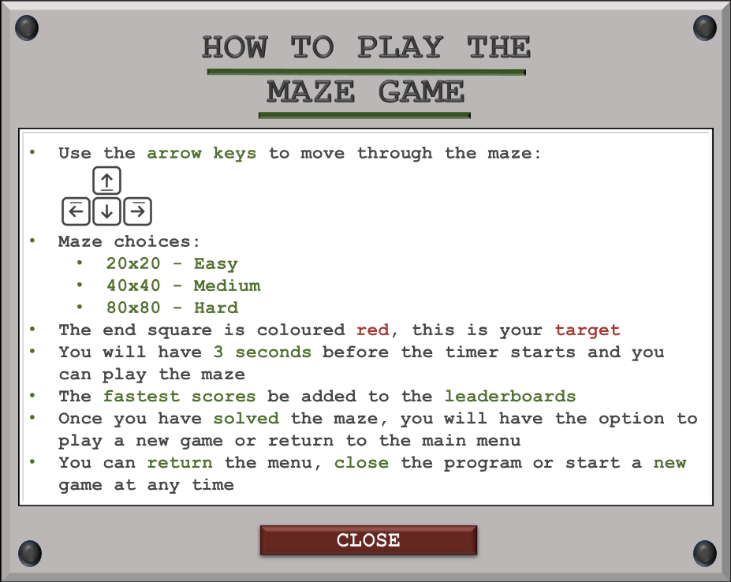

#### Success Criteria #7

Maze size selection

* 1. The user must be able to choose between three predetermined maze sizes when choosing to play.
  2. This removes the user not being able to decide what size is best and instead gives them a pointer to difficulty. E.g., 10x10 is the easiest, 20x20 is medium difficulty and 30x30 is the hardest.
* Tests associated with this criterion: (22 - 24)

This criterion is a core feature of the play mode where the user must have an option to select the size of the maze. As initially planned, there are 3 modes which are easy, medium, and hard. After rigorous testing documented in the development phase, I settled on doubling the maze sizes for each increase in difficulty as this proved to be the most usable combination of sizes. The sizes of 20x20, 40x40 and 80x80 were best when regarding usability.



|  |  |  |
| --- | --- | --- |
|  |  |  |

#### Success Criteria #8

Win Detection

* 1. There must be detection in place to recognise when a user completes a maze.
  2. The detection makes sure there is no game that lasts for ever and allows users to play mazes one after another.
* Test associated with this criterion: (42)

For a working maze game mode, there must be an ending condition. This works well with success criteria #5 as reaching the ending square is the condition required to complete a game. This win condition stops the game process and outputs an appropriate win menu to congratulate the user on finishing the game. The product has a menu in place to correctly notify the user of the outcome and presents the solve time therefore passing this specific criterion. During the development phase, there were errors implementing this feature, but these were tackled swiftly.





#### Success Criteria #9

Maze generation algorithm

* 1. The product must have at least one maze generation algorithm for the user to select in ‘visualise’ mode.
  2. There should be at least one way for a maze to be generated as this is the primary function of the product. Before pathfinding, a maze must be generated visually.
* Test associated with this criterion: (18)

This criterion is necessary for many other success criteria as a maze must be generated before playing or visualising. As shown in test #18, the maze is periodically generated with the whole process being visualised. Furthermore, every test shows a solvable maze which is evidence of a working algorithm. In this case, I have chosen Prim’s algorithm to generate a maze using a minimal spanning tree. This is because when using trees, there is always a guaranteed path back to the root node (the starting point).

Below is the main section of code for the logic behind Prim’s algorithm and refer to test 18 to see the evidence for the maze produced using this algorithm.

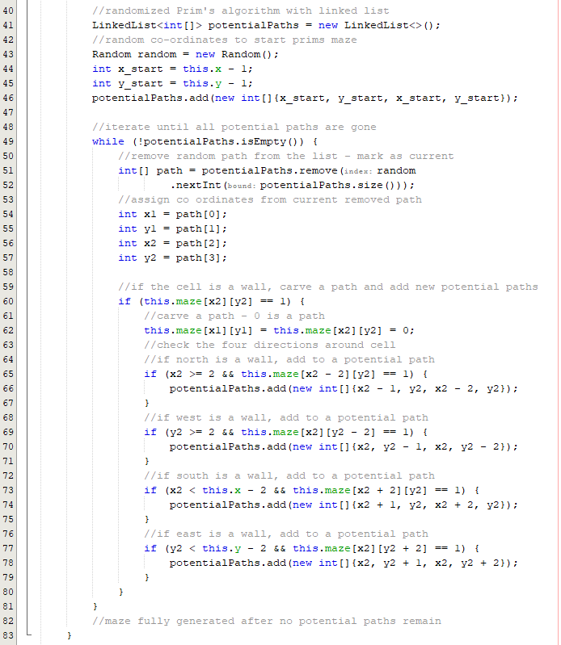

#### Success Criteria #10

Maze generation visualiser

* 1. A gradual creation of a maze must be displayed visually that highlights each step of the maze generation algorithm.
  2. Maze generation visualisation provides users with insights into how mazes are created. It is an educational and entertaining aspect of the application which in turn enhances the entre experience.
* Test associated with this criterion: (18)

As shown in test #18, the maze is procedurally generated as the first step in the visualise section. The speed can be adjusted mid generation with the choices being between slow, medium, and fast. Each step is shown, and the process of Prim’s algorithm is displayed where new nodes are constantly added to the tree.

Maze visualiser interface:

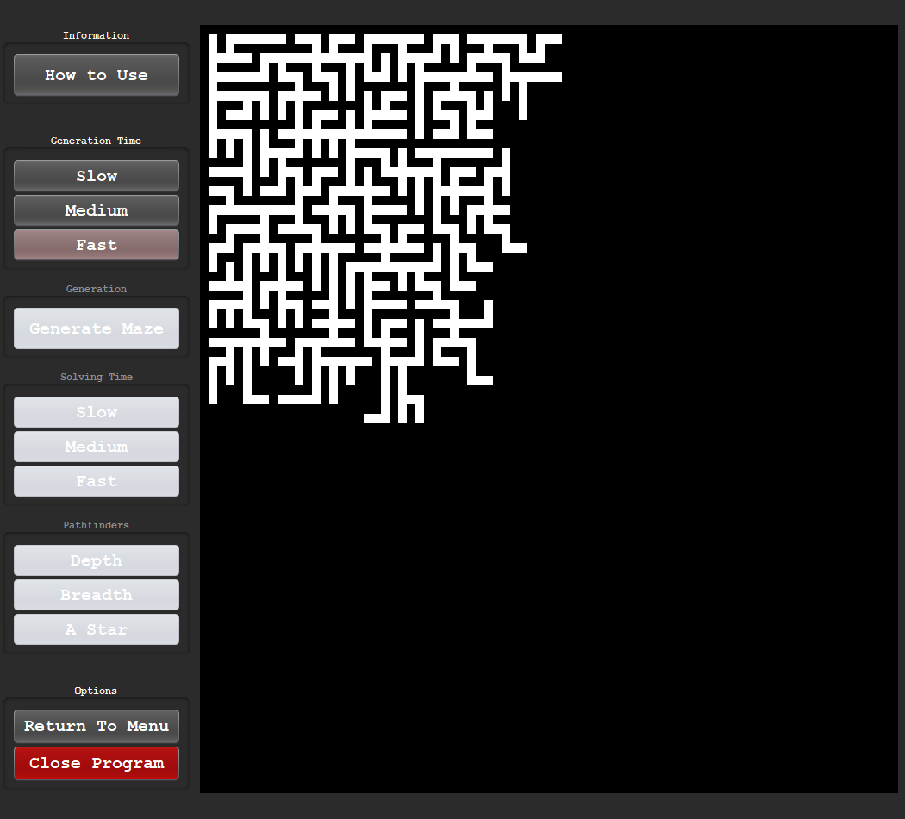

#### Success Criteria #11

Maze pathfinding algorithm

* 1. There must be at least one choice and code for a pathfinding algorithm to apply onto the generated maze in ‘visualise mode’.
  2. Having at least one algorithm is the bare minimum for the visualise section to be functional. It can be called and applied to generated mazes.
* Test associated with this criterion: (20)

For maze pathfinding the product must have at least one algorithm implemented that allows a solution to be found. After analysing the problem in the analysis section of this document, I had found 4 potential algorithms that could be implemented into the program. These were: breadth-first search, depth-first search, A*-search and Dijkstra’s algorithm. All but Dijkstra’s algorithms were implemented as I believed demonstrating one algorithm with heuristics (A* search) was sufficient for the time available for the products development phase.

|  |  |  |
| --- | --- | --- |
| **Depth-first search** | **Breadth-first search** | **A-Star search** |
|  |  |  |

As shown above and in test #20, each algorithm finds the same solution and the searchers display the steps taken to find the target square.

#### Success Criteria #12

Maze pathfinding visualiser

* 1. Once a choice is selected, the maze must display every step of the pathfinding algorithm with a coloured path that traces through the maze until the end point is reached.
  2. Allowing the user to see the path being traced and visually seeing the algorithms decisions can be insightful and develops greater understanding for how the algorithm functions.
* Tests associated with this criterion: (20, 21)

As shown in the previous success criteria and tests #20 and #21, the visualiser procedurally displays each step of the selected algorithm whether it is a maze generator or a maze pathfinder. Therefore, this criterion is passed as the visualiser stops once the end point is reached whilst also leaving a coloured search trail behind.

#### Success Criteria #13

Working main menu

* 1. The menu should offer options to choose between playing mazes, visualising solutions to mazes and exiting the form.
  2. A well-structured main menu improves user navigation and experience. It provides clear choices for users and makes sure they can easily access the intended features.
* Test associated with this criterion: (37)

Upon registration or login, the user should be greeted with an appropriate screen. Not only does the criterion require the presence of such a menu, but it also must be well structured in nature. The main menu created for this product was well received by my client and other test users as shown in the usability testing section. These comments will be further evaluated.

This menu consists of 5 buttons: 3 buttons are used to select the different modes (visualise, play and statistics) whilst the other 2 are for exiting the program and signing out.

Main Menu for the product:



#### Success Criteria #14

Transition Menu

* 1. A perpetual menu will be located top right during all game modes and allows the user to pause, resume and return to main menu.
  2. The transition menu adds convenience to the user experience by allowing easy access back to the main menu and can be resumed at any time.
* Tests associated with this criterion: (39 - 41)

The option to pause the game and view a menu was first proposed to allow the user to halt any currently running processes and either return to the menu or resume to previously running application. As I had planned many features to implement into the product, I placed this certain aspect as a lower priority compared to the other tasks. This is because the buttons that would be located on this transition menu could be added onto the frame rather than developing a new menu. As I prioritised other features, this addition would be unnecessary and only add obscurity to application.

#### Success Criteria #15

Win Menu

* 1. After the user navigates to the final square, a menu should appear to inform the user of the win and present the options associated with a win.
  2. This removes ambiguity after a win and gives users a clear blueprint on what to do after a win.
* Tests associated with this criterion: (36 - 38)

There must be an appropriate win menu after the win detection. This criterion is an extension of the previous win detection criteria but after the detection, a menu must pop up to inform the user. The product successfully achieved this and as shown in the referenced tests.

Win menu:

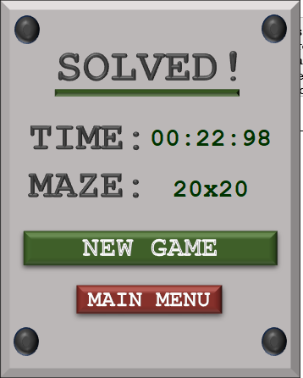

#### Success Criteria #16

Solve statistics.

* 1. After a maze is completed, the time taken to solve the maze should be displayed to the user.
  2. The user can compare previous scores to current scores to monitor progress and improvement.
* Test associated with this criterion: (42)

Another extension of the win detection is the information displayed on the win menu. The criteria states that the time taken to solve the maze should be displayed. The product does include this feature and reminds the user of the maze type they achieved this score on – refer to test #42 to see the solve statistics.

#### Success Criteria #17

Visualise statistics.

* 1. The relative data after solving a maze with the selected pathfinding algorithm should be output to the user on the screen.
  2. The chosen pathfinding algorithm is compared against other algorithms to outline the efficiency when compared against similar algorithms.
* Tests associated with this criterion: (43 - 48)

In the design phase, I proposed that I would include a section that displayed the relevant and relative statistics for each pathfinder. Despite being possible to log the relative time for each pathfinding algorithm, I found that running the product on different hardware produced different results. This was because some processors carried out the required operations quicker than others. This lead to a variation in data collected and I concluded that it would be more beneficial to allow users to see the differences between the searchers for themselves in the visualise section.

#### Success Criteria #18

Leaderboard

* 1. Users should be able to open a leaderboard and see their local data compared against other statistics.
  2. After completing a maze, the user should see their local stats to track progression and monitor improvement.
* Tests associated with this criterion: (43 - 48)

The leaderboard should consist of two different subsections: local and global statistics. With the allocated time and size of my product, I settled on global statistics with the choice of displaying the top 5 scores for each respective maze size. This is why the success criteria has been partially met. There is a leaderboard but no local data specific to each account. In the usability evaluation, I will discuss further of how this could have been improved or edited.

## Describe the final product

### Evaluating functionality

Once the success criteria have been evaluated, the overall functionality and additional features can be assessed. Successes and shortcomings will be addressed for each significant section, with any failures being explained with appropriate reasoning.

#### Login & Register

##### Successes

The proposed solution has many successful features for the maze-solving game. First, it includes a login function that compares user information with externally stored values, ensuring secure user login. Additionally, to maintain security and prevent abuse, the system is designed not to accept blanks in login and registration menus, prompting users to enter their information correctly and it uses a timeout feature to enhance security measures by limiting access after three incorrect login attempts. The timeout increases with each invalid attempt, preventing unauthorised login attempts from causing long wait times for multiple invalid cases.

Also, the system has an information hover button in the login interface, so that users can easily get instructions on how to navigate and use the login menu effectively. For user registration, the system forces appropriate data verification systems and user account prestige. The system checks the uniqueness of the username during registration and the password must be at least eight characters long, containing both special characters and numbers for security. Additionally, live verification is included during registration, with a tick-like visual that will appear once in the field is validated. Real-time access to information on registration information improves accuracy and completeness. These features combine to enhance the user experience, safety, and efficiency of the maze-solving game, making it a comprehensive and user-friendly solution though develop intellectual agility and critical thinking.

The product is not limited to a simple game involving a maze solving; there is a set of features to make the system easier for end-users, secure, and more efficient. The logins are not only are safe but also friendly to users, and they are secured while at the same time making the game easy to access to users and their information protected. Through prompting users to ensure that their details are correctly entered and introducing a penalty with the time out feature, the system discards unauthorised access attempts making it a secure environment for users to players with the game.

The built-in live check that is a part of the registration raises the level of user experience by delivering the feedback about the correctness of the details immediately. This feedback mechanism’s immediate response guarantees that the users only provide accurate information, but at the same time, it gives users the satisfaction that their data is securely handled. The user-specific designing features all-inclusively construct the maze-solving game as an all-encompassing and solid tool for mental sharpness and critical thinking skill development.

##### Failures

In the development of the maze-solving game, the functionality related to login and register processes has been implemented seamlessly without any failures. The login interface allows users, including Mr Murray and other test users to securely access the game, while the register feature enables new users to create accounts easily.

The login functionality has been thoroughly tested to ensure that users can enter their credentials without encountering any issues. This includes providing feedback for incorrect login attempts, ensuring password security, and handling any potential errors gracefully. The registration process is user-friendly, guiding new users through the account creation steps without minimal technical glitches or obstacles. The only error that many users encountered was when using the tab key to switch between text fields. My code removes hint text on mouse clicks and not tab clicks so if the user clicks tab to switch into the menu, they will have to manually delete the hint text.

Furthermore, the login and register functionalities have been designed with data security in mind, protecting user information and ensuring privacy. The system is robust against common vulnerabilities like unauthorised access, data breaches, and account manipulation. Overall, the implementation of the login and register functionalities in the maze-solving game has been successful, with almost no reported failures or issues.

#### Visualise Mode

The visualise mode showed exceptional results in terms of improved user experience and critical thinking skills. Firstly, the Prim's algorithm to generate mazes makes sure there is at least one solution that leads to the end square, so the users can finish the puzzle without getting stuck or having to restart it. The strategic choice to block the pathfinder buttons before the generation of a maze is solely for robustness and will be evaluated further in the robustness section.

The maze preparation phase also enables the pathfinder buttons to be activated after the process has finished. Then, the users use various solvers to see and learn different pathfinding algorithms. The visualise mode is highly effective in developing an interactive and informative environment that allows both entertainment and knowledge on the operations of maze-solving and pathfinding algorithms.

The diversity of the algorithm set includes three functional solvers - breadth first search, depth first search, and A Star search - enables users to select different algorithms to work with and learn objectives suiting their needs and preferences. In addition, the possibility to call an alternative pathfinder after completing the first pathfinder routine offers a smooth transition between different algorithms. The introduction of a maze generation option with a visual wiper effect introduces a fun way to reset mazes. The program further provides easy entry/exit return options, which users will find very useful in navigating the interface and improving on program usability and satisfaction as a whole.

In conclusion, the visualise mode has many successful functions. Prim's algorithm which is used to create the mazes ensures that there is always a path that the user can take from the beginning square to the end square. The strategic option to disable the pathway buttons before setting up the maze removes trial and error attempts at solving the maze. After the maze forms, the highlighting of the pathfinder buttons gives users an option to apply various solvers such as breadth-first search, depth-first search, and A* search in an effective manner. The fact that users can hit the pathfinder button again after the first pathfinder is finished makes the program user-friendly and flexible. The feature that creates a new maze with a sweeping effect combines to make the game eye-catching with visual effects. The flexibility to adjust the playing speed and visualisation to users accommodates any preferred tastes. Finally, the exit options that the program provides allow users to smoothly exit the program or come back to the menu whenever they choose.

#### Play Mode

The maze-solving game presents a user-friendly menu that offers three maze sizes (20x20, 40x40, and 80x80) for selection, allowing for customization. While the choice of three predefined sizes simplifies the decision-making process and reduces confusion, a potential improvement could be to provide an option for users to input custom sizes for a more personalized experience.

Navigating through the maze using arrow keys enhances simplicity. Although the removal of the mouse navigation option may improve the gameplay, offering both arrow key and mouse navigation as alternative controls could cater to different user preferences and enhance accessibility.

The feature where the path colour darkens when backtracking provides valuable visual feedback to users, allowing them to track their movements and paths traversed multiple times effectively. This visual aids in navigation through the maze and enhances the overall user experience.

The win detection functionality effectively determines when a user reaches the final square. However, the instant appearance of the win menu upon reaching the end may prevent users from visually witnessing their successful completion of the maze. Delaying the win menu display slightly to allow users to witness their final steps and experience the sense of accomplishment firsthand could enhance user satisfaction and engagement with the game.

#### Statistics

The development of a leaderboard within the product proved to be a successful feature and served as a source of motivation for many users. Despite the decision to prioritise other functionalities over the statistics section, the leaderboard implementation was well-received. The inclusion of a global leaderboard displaying the top 5 scores for each maze size was a safe choice, providing users with a sense of competition and achievement.

However, the absence of a local leaderboard within the program is a drawback. The local leaderboard, tailored to individual accounts, would have offered users the ability to track their personal progress and compare their performance over time. This feature would have enhanced the personalised experience of the game and added value to users looking to monitor their own improvement.

Furthermore, while the global leaderboard's size limitation to display only the top 5 scores for each maze size was justified given time constraints, expanding this feature to accommodate an indefinite size would have provided users with a more comprehensive view of the competition. Allowing users to scroll through a larger global leaderboard could have further engaged a wider group of users.

In conclusion, while the statistics section may have seen reduced functionality due to priority, the implementation of the leaderboard was a success. Moving forward, the addition of a local leaderboard and the expansion of the global leaderboard size could further enhance the user experience and promote engagement with the game.

### Evaluating usability

#### Login & Register

##### **Aesthetics & Layout**

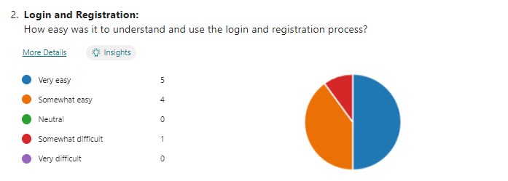

The layout of the maze was well-received, as the majority of users found it to be very easy or somewhat easy to navigate, with only one outlier selecting somewhat difficult. This indicates that the buttons were arranged in an appropriate manner for smooth interaction. The placement of the text boxes first with guiding hint text is a user-friendly approach that helps users navigate through the process seamlessly. Additionally, I placed the sign-up button at the bottom to acknowledge that most players will likely be logging in rather than signing up - enhancing the overall user experience.

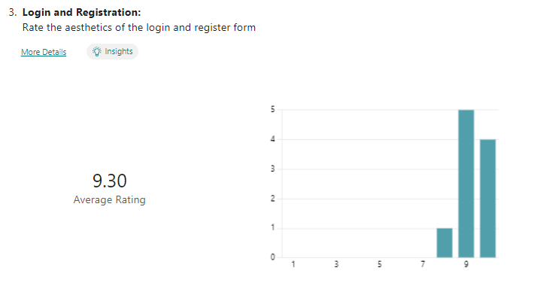

The aesthetics scored a 9.3/10 overall indicating that the efforts to enhance the aesthetics through UI design were successful. The retro feel and green colour palette were good additions and added to the overall appeal of the game. This positive feedback suggests that the visual aspects of the game were engaging and contributed to a good user experience.

##### **Interaction & Issues**

The addition of an information hover button within the login interface further aids users in navigating the system effectively, providing guidance when needed. This feature enhances the overall usability of the game by offering support and instructions directly within the interface. Moreover, the validation procedures during user registration ensure that data integrity is maintained, and user accounts are secure. By checking for unique usernames and enforcing strong password requirements, the system prioritises security without compromising user experience.

The user is informed if there are blank spaces in their input - a helpful feature for ensuring completeness and accuracy in data entry. The inclusion of a visual tick when the text meets the requirements for a valid username or password during registration is a user-friendly touch that enhances the user experience by providing immediate feedback.

The slight colour change of buttons when hovering over them not only adds an interactive element but also improves user engagement and intuitiveness by indicating the button can be clicked. The locked menu prevents accidental movement, ensuring that users can navigate the interface without unexpected disruptions, enhancing overall usability and preventing frustration.

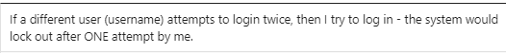

The suggestion to have a different number of login attempts for each user is an interesting feature that my client suggested, as it adds an extra layer of security to the system. By resetting the login attempts for each new user, the system can effectively manage and track login activities. Using a hash map to keep track of users and their corresponding login attempt values is a practical and efficient approach. This method ensures that each user's login attempts are uniquely monitored and managed. Overall, implementing this feature would enhance the user experience as each user is given the appropriate number of attempts and they do not feel penalised by previous users.



The system lacks error handling for certain input combinations during the sign-up process, which could lead to confusion for users. It is essential to include conditions for all possible input combinations to ensure a seamless user experience. The feedback provided to users after entering matching passwords and a correct username is unclear and there should be a message output to the screen to avoid ambiguity. By implementing an additional output combination, users can be informed about the accuracy of all details entered during the sign-up process, enhancing the overall usability of the system.

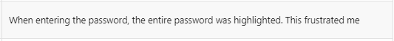

The addition of code to differentiate between a user's first time entering the box and subsequent attempts is a feature I created in hindsight for usability. By highlighting the entire text on the first click and selecting individual characters on successive attempts, it enhances usability and provides a convenient way for users to delete their password with one click.

While it is noted that the test user did not particularly like this feature, overall, it was well received. It is important to consider individual user preferences and feedback to refine the feature further. However, the positive reception from the majority of users indicates that this addition has added value to the system and improved the user experience.

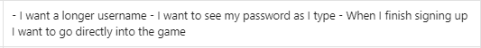

The user expressed a desire for longer usernames beyond the current limit of 10 characters. While accommodating longer usernames may increase user satisfaction, it is crucial to maintain uniform username lengths to ensure consistency and readability on the leaderboard. The decision for a username between 4 and 10 characters was what I believed was the perfect balance.

For password visibility, the system currently reverts to hiding the password whenever any modification is made such as adding a character. This behaviour although intended for security, has been mentioned many times for users who cannot simultaneously edit and view their passwords. This usability issue which was created from a design choice made during development is a feature I would change in future development.

Furthermore, the user suggested direct access to the game after registration which bypasses the login menu for convenience. However, redirecting users to the login menu post-registration is as an added security measure. This ensures that users re-verify their credentials before accessing the game.

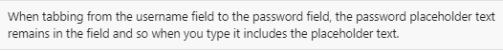

The program's design prioritizes user clicks over keyboard shortcuts. The inclusion of a tab shortcut for easy navigation between text boxes promotes efficiency but I did not include code to handle these cases. The issue of hint text not being removed upon tabbing could disrupt user flow. To address this, implementing additional validation measures for improved usability or disabling the tab shortcut altogether could be beneficial. These adjustments would further refine the program's usability and allow users to only user the product in the intended manner.

#### Main Menu

##### **Aesthetics & Layout**

Successes

The main menu of the product is a showcase of usability, user interaction and functionality. Firstly, all buttons are interactive within the main menu, enabling users to use whichever features they prefer in an easy way. This shifts the user experience toward easier navigation, which is achieved by featuring clear and simple options.

Another huge aspect is the addition of the “x” button at the top right corner of the menu. This characteristic lets the users quit the whole program with a single click, thus allowing an easy, quick, and efficient way of leaving the application.

Moreover, the last of options left for users to click is the red sign out button. This aspect, apart from guaranteeing privacy and security of the user, also takes the user back to the login page. Thus, the implementation of this function allows the prioritisation of user experience, and the program gives the opportunity for users to control sessions for themselves.

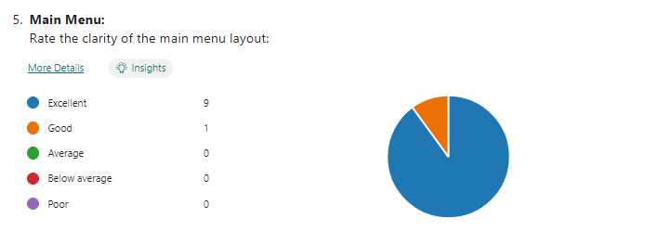

The main menu was ranked excellent 9 out of the 10 times with the other option being good. This set of results indicate this menu was a strong in being user friendly and all usability features embedded into the layout were successful.

Overall, the main menu is a good place to interact with all features of the system, has a set of exit options, and prompts for fast and easy log out of the system. These functions serve to build upon the user experience as they also display how user oriented the program is.

Failures

The main menu of the game can be considered a success due to its simplicity and focus on usability over complex functionality. It serves as the gateway to all the game's features and acts as a navigational hub for users.

One of the reasons for the main menu's success is its intuitive design. It presents clear options for users such as visualiser, play mode, and statistics. This straightforward layout makes it easy for users to understand and access the various functionalities of the game without any confusion.

The main menu prioritises usability by providing easy access to essential features. It focuses the user experience by presenting only buttons and eliminating unnecessary clutter. This ensures that users can quickly navigate the game and focus on solving mazes and improving their mental skills without being overwhelmed by complex menu structures.

Furthermore, the main menu's simplicity enhances the overall user experience by allowing users to focus on the primary purpose of the game - improving mental agility and critical thinking skills. By keeping the main menu straightforward and user-friendly, the game maintains its educational value.

#### Visualise Mode

##### **Aesthetics & Layout**

The login page and menus of the application are designed with a visually appealing forest green/grey layout created using drag and drop Java Swing components. This design choice enhances the overall aesthetics of the application and facilitates easy customisation which allows for improved usability and a more engaging user experience.

In contrast, the visualise mode within the application is developed using pure code following object-oriented principles. While this approach presents challenges for enhancing graphics as each change must have unique code, it allows for greater control and flexibility in implementing advanced visual features such as dynamic frame sizes.

To maintain consistency in design across different components of the application, a dedicated GUI design class was introduced. This class ensures uniformity in button layouts, colour schemes, and overall visual elements, contributing to a professional look and feel throughout the user interface.

Through thorough testing and refinement of the layout code, the resulting graphics in the application have been optimised to be not only functional and user-friendly but also aesthetically pleasing and provides a visually satisfying experience for the user.

##### **Interaction**

The visualise mode is created for its emphasis on usability and interaction. The primary goal of this mode is to create a visually engaging experience by generating mazes and displaying the shortest solution in a visual manner.

During the development process, I paid close attention to planning the usability aspects of the visualise mode. I wanted to ensure that users could easily navigate through the features and find it straightforward to generate mazes. By focusing on usability, I aimed to make the entire interaction process smooth and user-friendly.

To guarantee a good user experience, I made sure to thoroughly test each feature that was implemented. With this I could identify any potential issues or glitches and resolve them before the mode became available to users. This comprehensive testing process helped me ensure that each feature worked flawlessly and contributed to the overall usability and interactivity of the visualise mode.

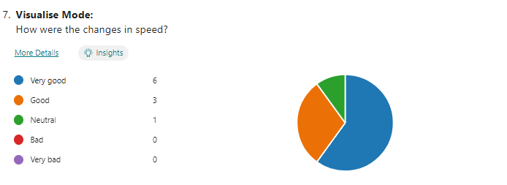

When reviewing the changes in speed, the feedback received was mostly positive. Out of the 10 responses collected; six were voted very good, three were categorized as "good," while one response remained neutral. The absence of any negative feedback signifies that the speed testing conducted during the development phase was successful. Both test users and the client positively received this feature.

Out of the 10 responses, only two people encountered an issue; this response reflects the efforts I had made to ensure the usability was enhanced to a level where most users cannot encounter an issue and only use the program the intended way.



One user made a great suggestion about the addition of a toggle option for loading a new maze. The suggestion was to include the option to toggle instant generation, as the current fastest speed is not instantaneous. If implemented, this toggle option would provide an additional speed setting for generating mazes.

As the visualiser primarily focuses on displaying the maze generation process, I decided to remove this feature. By removing the instant generation option, the visualizer ensures that users can always witness the step-by-step process of Prim's algorithm. However, it's important to consider as the toggle option could still be beneficial for users who have already observed the algorithm's process multiple times.

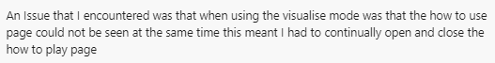

Another user encountered an issue with using the hint feature while simultaneously accessing the section on how to use the visualiser. Due to the disabling of window moving for usability and prevention of accidental movement, the how-to page remained covered when clicking off. The user suggested that it would be beneficial to have the information form be movable, allowing users positioning it to the side for easier access.

The issue highlights the inconvenience of essential information being obstructed by the visualiser's interface. By allowing users to relocate the information form to a more suitable position like the side, users would have the flexibility to reference it without obstruction.

Overall, the visualise mode was developed with usability and interaction in mind. By prioritising user-friendly design and conducting extensive testing, I have created an immersive page where users can easily generate mazes and visualise the shortest solution.

#### Play Mode

##### **Aesthetics & Layout**

I used the visualise mode as a template for the implementation of my layout. By following this approach, I was able to ensure that my interface maintained aesthetic consistency with the visualise mode, as all graphical elements were hard coded to match its style and design rather than added using Java Swing’s drag and drop.

Strategic placement of buttons played a crucial role in enhancing user experience. For example: positioning the timer at the top of the interface ensured its visibility without obstructing the central maze, allowing users to easily track their progress while navigating through the maze. Additionally, placing the exit and new game buttons at the bottom of the interface was purposeful in consideration of human behaviour patterns. Studies have shown that people often scan interfaces from top to bottom, with attention drawn to elements positioned towards the lower portion last.

Ultimately, the central maze frame is the focal point for visibility. By prioritising its location within the layout and ensuring that peripheral elements are visible but not eye catching the program will not detract from the user's engagement with the maze

##### **Interaction**

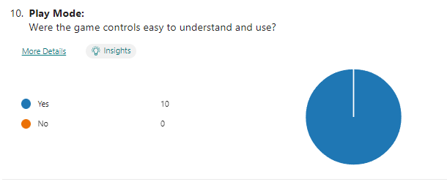

All 10 test users unanimously voted that the game controls were easy to understand and use. This suggests that the usability of the play mode is exceptional and highlights the success of the features implemented to ensure a user-friendly experience.

A major decision that added to this outcome was the choice to limit controls to just the arrow keys. This simplification was a smart decision and enhanced usability. By providing a single method of control that is mentioned in the how to use information, users were able to navigate through the game without the need to learn complex control schemes. This approach also eliminated potential confusion or frustration that might be present from having multiple control options.

Furthermore, by focusing solely on the arrow keys, the game interface remained uncluttered and intuitive. Users quickly grasp the mechanics and dive into gameplay without any barriers. This emphasis on simplicity contributed to the overall ease of use and enhanced the accessibility of the game by ensuring that players of all skill levels could enjoy it without feeling overwhelmed or intimidated by intricate controls.



Currently, the option for re playing a maze was a simple green button but this green button calls an instance of the new game menu. This gives the user a choice to re select the maze size. However, this user found it unsatisfactory to choose again and would prefer another button that loads the same size maze game. This eliminates any extra hassle needed to choose the same option again. The addition of an extra button would fit smoothly into the potential features that would be added in the future to improve the usability.





Two out of the three users encountered the same issue regarding speed ramping up within the game. This problem arises when holding down a movement key and noticeable in mazes with long corridors where the speed accelerates rapidly.

The users pointed out that this reliance on luck in long corridor mazes distracts the users from the gameplay experience. They suggested implementing a constant speed to reduce the element of luck which is a valid suggestion. By maintaining a consistent speed regardless of corridor length, I can create a more balanced and skill-based gameplay.

Addressing this issue aligns with principles of fair game design and enhances player satisfaction. Implementing a constant speed mechanism will dampen the impact of luck and ensure a more consistent and enjoyable experience for all players.

#### Statistics

##### **Aesthetics & Layout**

For the product, maintaining consistency in aesthetics across different menus was a key aspect, and this was successfully achieved in the statistics leaderboard. By once again using Java Swing's drag and drop functionality, I replicated the visual style of the other menus and this approach saved development time.

The exit button at the top right corner of the leaderboard mirrors its position from other menus. This design choice enhances user familiarity and ease of navigation, allowing users to access menu options without having to reorient themselves. The return button also allows users to return to the menu with ease.

In terms of visual aesthetics, attention was given to leaderboard's table design aligns with the overall theme of the application. The use of alternating fill colours enhances the readability of the statistics and adds visual interest, making the leaderboard visually appealing and engaging for users.



##### **Interaction**

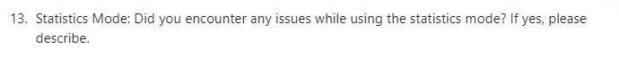



In the development of the project, the statistics mode fell short of fully implementing all the planned features as other features were prioritised. The global leaderboard was meant to provide users with a comprehensive overview of their performance relative to others. However, only 5 places were displayed instead of the initially proposed 10. While this limitation may impact the depth of competition showed, it still provides users with valuable insight into their standing among other players.

Another feature that was missed in implementation is the local leaderboard, which would have stored and displayed information specific to each user account. This feature would have been useful as it allows users to track progress over time and compare their performance to previous sessions.

The addition of the local leaderboard would have significantly enhanced the user experience by providing a personalised element to the statistics mode. Moving forward, incorporating this feature could be a priority to further engage users and encourage continued usage of the application.

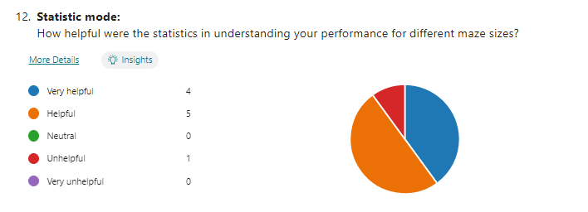

In evaluating user feedback, a lot of responses (nine out of ten) were positive, indicating a generally good reception of the application. However, more users voted for the "helpful" option rather than "very helpful." This trend can be due to the fact that while the application provided useful statistics, users couldn't access their personal stats when not achieving a high score.

While the provided statistics were informative and served their purpose well, the inability to access personal stats may have hindered users from fully appreciating the product’s entire utility.

I could fix this limitation by allowing users to access their personal stats that are independent to high scores and could upgrade the usability of the application. By providing users with more comprehensive feedback on their performance, the application can better meet the needs and expectations of its users, leading to higher levels of engagement.

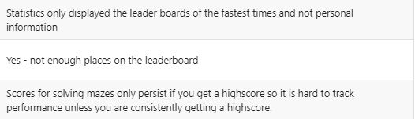 

As mentioned before, the application's limitation of only tracking top scores leaves users in a challenging position regarding progress tracking. This restricts users to only viewing their best performances and will not accurately reflect their overall progress or skill development.

A significant drawback is that users are compelled to consistently achieve high scores to gauge their progress, which is an unrealistic expectation. This narrow focus on top scores can fail to provide a reliable view of progress but also places pressure on users to continually outperform themselves.

This product can also be an effective tool for progress tracking and skill improvement but a more personal approach to tracking progress is needed. By expanding the tracked statistics beyond the top 5 scores, users can gain a more bespoke understanding of their performance over time. This could include tracking average scores, completion times, or other relevant information to provide users with a broader view of their progress and skill development.

#### Overall

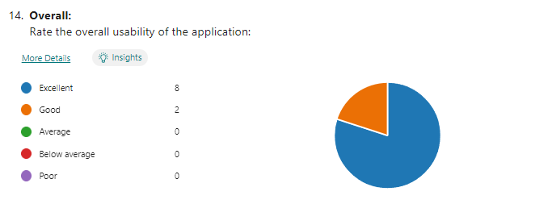

In reviewing the overall statistics, 80% of users rated the usability of the application as excellent, while the remaining 20% ranked it as good. This complete positive feedback reflects the success of the development phase. The majority of users rating the usability as excellent indicates that the application effectively meets and may exceed user expectations in terms of ease of use and navigability.

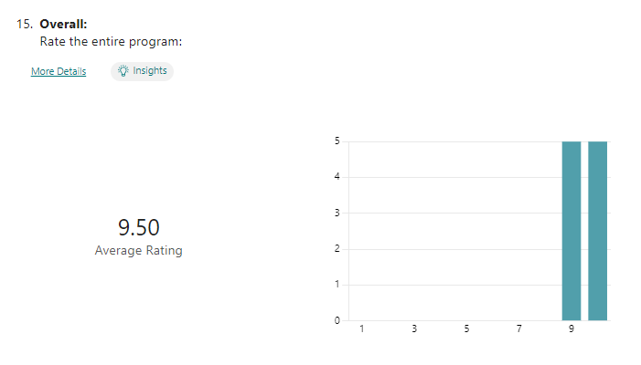

The 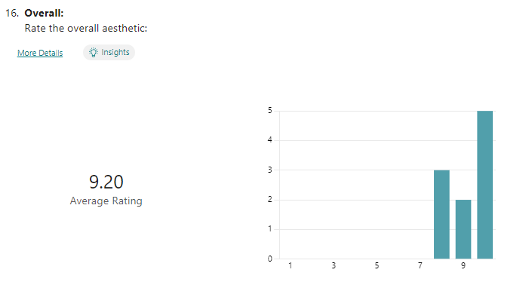

The entire program was rated a 9.5 with the aesthetics being a 9.2. These results indicate that the designing of the UI in each cycle proved to a successful task as all users rated this highly.

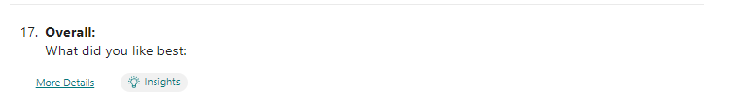

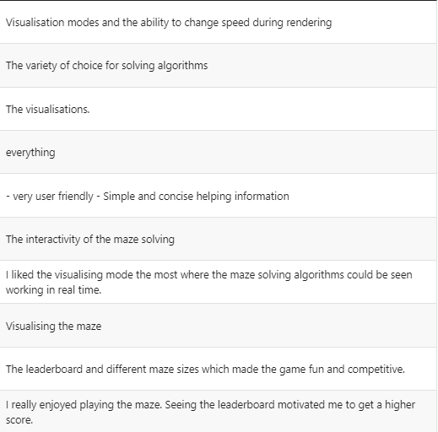

The feedback from users indicates that the usability and interactivity of the application was very well-received. The visualiser mode received the best and required the most development time. This correlation suggests that the time and effort invested in developing this mode were well spent and the positive response to the visualiser mode validates the decision to allocate additional time to its development.

Additionally, the fact that all modes were mentioned in user responses indicates that the product was successful across all aspects. This suggests that each mode offered unique value and catered to different user preferences. The diversity of modes provided users with options to engage with the application in ways that suited their individual preferences and interests and ultimately enhances user satisfaction.



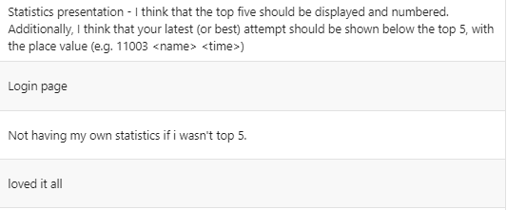

The statistics feature was the least favoured among the users. My client suggested to improve the usability of the statistics by numbering the entries as this change could enhance clarity and organisation within the feature. Additionally, my client recommended expanding the leaderboard to accommodate more entries, as the current size limit of five entries may be too restrictive to provide a better overview of user performance. Furthermore, my client proposed displaying the last score achieved alongside other entries in the leaderboard. This addition would enable users to make direct comparisons between their current performance and their previous scores.

## Maintenance and Development

### Evaluating maintenance

The process of UI adjustments is necessary for maintaining the effectiveness and usability of the product. As users interact with the interface and provide feedback, suggestions for improvements will always arise. This loop is important to the iterative nature of software development and makes sure that the application evolves to meet the changing needs and preferences of my client and other users. However, the UI has already been heavily designed to a point where there is little need for any change.

Furthermore, addressing any other usability issues as they arise is a perfect way to provide a positive user experience. By actively listening to user feedback and promptly implementing necessary adjustments, developers can enhance the usability of the application and minimize user frustration.

Users may also request additional features or suggest improvements to existing ones based on usage patterns and needs. This feedback is invaluable as it provides insights into areas where the product can be further developed to better meet user expectations and requirements. Ongoing development work would be needed to add new functionality or enhance existing ones. I would aim to ensure that any change remains relevant and valuable to users, so no further maintenance issues are created. Enhancements based on user input will improve the user experience and show a commitment to meeting needs and expectations.

I understand that despite thorough testing during development, bugs and glitches may still occur. These issues can be due to various factors such as untested interactions between different components or compatibility issues with external systems. The first bug fix would be to fix the hint text bug mentioned previously where the user tabs onto the next text field. However, it is mandatory that it is heavily tested as a bug fix should not implement any further issues.

Regular maintenance of the application involves identifying and fixing these issues promptly to ensure the application functions smoothly. The process begins with testing and debugging to identify the root cause of the problem. Once the issue is identified, appropriate fixes are implemented, and the application is tested again to verify that the problem has been resolved and that no new issues have been introduced.

Another concern is the possibility of slow loading times that is evident when loading large maze sizes within the play mode. To remove this, regular optimisation efforts are needed to keep optimal performance levels. As more features are implemented, the product will run slower so all code must be as efficient as possible. Many methods could be used like code optimisation to enhance efficiency or implementing caching mechanisms to reduce computational stress. Data compression can be used to minimize file sizes and by regularly monitoring performance, any future issues can be fixed quickly.

### Evaluating limitations

The main limitation identified in user feedback is the leaderboard feature. Users expressed concern that the current implementation limits their ability to do self-analysis as there is no indication of how their performance has evolved over time. To address this limitation, it would be good to add an average rate of performance increase over time for completion times on each maze size.

By including an average rate of increase over time users can view performance trends across different maze sizes. This would provide users with a quantitative measure of improvement or regression and allows them to track their progress more accurately. For example, if a user consistently achieves faster completion times on larger maze sizes over time, they can tell that their skills are improving as the scores are saved.

This enhances the functionality of the leaderboard and drives users to engage in more self-assessment and goal setting when improving critical thinking. By providing users with a dynamic and personalised performance mode the application can develop a greater motivation for improvement.

A user mentioned the difficulty in seeing the player on the largest maze size due to the dark red colour. However, altering the maze size is not feasible as it is limited by solving time and would change the step up in difficulty so alternative solutions must be considered. One option to correct this issue is to change the colour of the player marker to a brighter hue. By selecting a brighter colour that contrasts well with the black walls of the maze, the player's position can become more visible to users even on the largest maze size.

Implementing this change preserves the structure of the play mode while improving the visibility of the player indicator therefore strengthening the overall user experience. Selecting a brighter colour for the player indicator ensures that it remains visible and prominent across different maze sizes and backgrounds. The timer on the play mode can max be 99 minutes before the program displays incorrect formatting. As a user should have a maze completed by this time, I did not address this issue, but it is a limitation for when a game lasts longer than 99 minutes.

Some users were confused by the "return to menu" and "exit" buttons, due to the placement in the top right corner. This highlights a usability issue that is limiting the overall experience. To address this limitation and prevent accidental exits from the application, implementing a confirm close menu can be an effective solution.

The confirm close menu would be a safeguard against unintended exits by prompting users to confirm their decision before exiting the application. By introducing this confirm close menu, users are provided with an extra layer of protection against unintentional actions and removes any associated frustration. This solution maintains the current button placement while addressing the limitation. An example of code optimisation was with my play mode timer; I had kept the raw time (without format) and only recalculated this time once at the end when the player has won. This removes thousands of formatting decisions.

## Conclusion

### Further features

After evaluation and the feedback from users, many features could be added to improve the product. Firstly, the addition of an ending option to allow users to save or print the generated maze would greatly enhance usability, particularly for those who wish to attempt solving the maze manually on paper before applying a pathfinder algorithm. This feature would provide users with greater flexibility and control over their interactions with the application and will cater to a wider range of users.

Additionally, implementing the option to change the maze generation corner would add a new dimension to the user experience. Allowing users to observe the maze generating from different viewpoints could enhance engagement and help students understand the maze generation process quicker. This feature would enhance visual appeal and offer a better educational value.

Furthermore, the introduction of a custom size sandbox mode would be a great opportunity. Enabling users to input their own settings for playing the game would give the user a highly customisable experience and promote users to tailor their gameplay experience to suit their specific needs.

The misleading time format in the leaderboard needs to be addressed by changing hundredths of seconds to milliseconds and adding a key would enhance clarity to prevent confusion. By making this adjustment and providing a clear explanation of the time format, users will have a more accurate understanding of the leaderboard data.

Implementing a simple greeting message for users upon logging into the system adds a personal feel to the user experience. A "hello" message, accompanied by the username will create a welcoming atmosphere and allows a positive interaction between the user and the application.

Introducing an admin login and password for maintenance is a strategic move to enhance the functionality of the application. This feature can unlock additional features or customisation options for users with administrative privileges and will provide them with greater control or flexibility over the application's settings and functionality. Implementing this as a hidden menu or within a separate admin dashboard ensures that it remains accessible only to authorised users whilst maintaining security and integrity.

In conclusion, incorporating these suggested features and improvements aligns with enhancing usability, personalisation, and functionality within the application. By focusing on user feedback and implementing these enhancements, the application can continue to evolve and offer an enhanced user experience for its users.

### Evaluation Summary

Based on the extensive function testing conducted on the maze-solving game, it can be concluded that the proposed solution has been successful in meeting the identified objectives. The game effectively exercises and improves mental agility and critical thinking skills and addresses the problem of deteriorating mental skills during breaks. The computational approach chosen has proven to be efficient, precise, scalable, flexible, and visually engaging.

Furthermore, the stakeholder, Mr. C Murray, has found the solution suitable for teaching pathfinding algorithms to his students and for maintaining mental agility during breaks, aligning well with his needs, and providing educational value. The detailed research on both non-computational and computational methods has informed the development of the game, ensuring a robust and effective solution.

The analysis of online products has also contributed to understanding essential features required for the game, such as the login interface, main menu, maze generation, pathfinding algorithms, visualizer, play mode, and statistics. Overall, the maze-solving game has demonstrated success in addressing the identified problem and providing a valuable solution for enhancing mental skills.

The general success of function testing and usability testing indicates that the product has been thoroughly developed and validated, with any identified issues either justified or addressed through discussion and fixes. This demonstrates a robust development process, where potential problems were proactively identified and resolved, ensuring that the product functions as intended. The inclusion of all main sections and the addition of extra features in most of them highlights a successful iterative approach to product development. By going beyond the basic requirements and adding additional functionalities, the product offers extended value to users.

Overall, the successful testing outcomes and the educational nature of the product indicates a high level of quality and attention to detail in the product’s development. Moving forward the product will have continued monitoring, increased feedback gathering, and iterative improvements to maintain the product's success and meet evolving client expectations.

# Bibliography

1. Peter Kirsch 1, Stefanie Lis, Christine Esslinger, Harald Gruppe, Peter Danos, J. (2006). Brain activation during mental maze solving. [Online]. National Library of Medicine. Last Updated: September 11 2006. Available at: https://pubmed.ncbi.nlm.nih.gov/16966840/ [Accessed 12 May 2023].
2. Gareth Halfacree. (2023). Brian Haidet Puts Electricity to Work Finding the Shortest Route Through a Maze. [Online]. hackster. Last Updated: 1 April 2023. Available at: https://www.hackster.io/news/brian-haidet-puts-electricity-to-work-finding-the-shortest-route-throug [Accessed 16 May 2023].
3. Clay Dillow. (2011). A Memristor-Based Processor Solves Mazes, Using the Power of Parallel Computing. [Online]. Popular Science. Last Updated: 4 March 2011. Available at: https://www.popsci.com/science/article/2011-03/memristor-processor-solves-simple-maze-marking-breakt [Accessed 16 May 2023].
4. Bergman Joe. (2022). Water maze simulation. [Online]. Tik Tok. Available at: https://www.google.com/url?sa=i&url=https%3A%2F%2Fwww.tiktok.com%2F%40bergmanjoe%2Fvideo%2F710909851 [Accessed 22 May 2023].
5. Steve Mould. (2023). Can water solve a maze?. [Online]. Youtube. Last Updated: 31 March 2023. Available at: https://www.youtube.com/watch?v=81ebWToAnvA [Accessed 16 May 2023].
6. Luciano Cosmo. (2023). 123RF. [Online]. Illustration Of The Human Body Stomach Maze. https://www.google.com/url?sa=i&url=https%3A%2F%2Fwww.123rf.com%2Fphoto_53498222_illustration-of-the [Accessed 22 May 2023].
7. Ciprian Stremtan. (2023). thinking brain. [Online]. Shutterstock. Available at: https://www.shutterstock.com/image-vector/thinking-brain-166501700 [Accessed 22 May 2023].
8. Albert Lee. (2014). How the Brain Makes Sense of Spaces, Large and Small. [Online]. Howard Hughes Medical Institute. Last Updated: 25 August 2014. Available at: https://www.hhmi.org/news/how-brain-makes-sense-spaces-large-and-small [Accessed 22 May 2023].
9. National Geographic. (2023). Lungs. [Online]. National Geographic. Available at: https://www.nationalgeographic.com/science/article/lungs?loggedin=true&rnd=1685899592112 [Accessed 4 June 2023].
10. pbs.. (2020). Secret Mind of Slime. [Online]. NOVA. Available at https://www.pbs.org/video/secret-mind-of-slime-oa3w89/. [Accessed 4 June 2023].
11. Chris R Reid, Tanya Latty, Audrey Dussutour, Madeleine Beekman. (2012). Slime mold uses an externalized spatial "memory" to navigate in complex environments. [Online]. PubMed. Last Updated: 8 October 2012. Available at: https://pubmed.ncbi.nlm.nih.gov/23045640/ [Accessed 4 June 2023].
12. The Action Lab. (2021). Self-Assembling Wires That Can Solve a Maze!. [Online]. YouTube. Last Updated: 18 April 2021. Available at: https://www.youtube.com/watch?v=rKbOVkVC15Y [Accessed 4 June 2023].
13. Nils Berglund. (2022). Solving a maze with waves. [Online]. YouTube. Last Updated: 11 Oct 2022. Available at: https://www.youtube.com/watch?v=GjQ1zNCSWUQ [Accessed 13 June 2023].
14. Wikipedia. (2022). Euclidean distance. [Online]. Wikipedia. Last Updated: 8 May 2023‎. Available at: https://en.wikipedia.org/wiki/Euclidean_distance#:~:text=In%20mathematics%2C%20the%20Euclidean%20dis [Accessed 16 June 2023].
15. Wikipedia. (2021). Taxicab geometry. [Online]. Wikipedia. Last Updated: 28 May 2023. Available at: https://en.wikipedia.org/wiki/Taxicab_geometry [Accessed 16 June 2023].
16. Wikipedia. (2020). Great-circle distance. [Online]. Wikipedia. Last Updated: 25 January 2023. Available at: https://en.wikipedia.org/wiki/Great-circle_distance [Accessed 16 June 2023].
17. Isaac Computer Science. (2023). A* search algorithm. [Online]. Isaac Computer Science. Available at: https://isaaccomputerscience.org/concepts/dsa_search_a_star?examBoard=all&stage=all [Accessed 20 June 2023].
18. Filip Ponulak. (2013). Effects of noise on wavefront propagation. [Online]. Research Gate. Available at: https://www.researchgate.net/figure/Effects-of-noise-on-wavefront-propagation-A-A-single-wavefront-i [Accessed 20 June 2023].
19. Wikipedia. (2017). Pathfinding. [Online]. Wikipedia. Last Updated: 23 March 2023‎. Available at: https://en.wikipedia.org/wiki/Pathfinding [Accessed 20 June 2023].
20. Wikipedia. (2020). Maze generation algorithm. [Online]. Wikipedia. Last Updated: 18 June 2023. Available at: https://en.wikipedia.org/wiki/Maze_generation_algorithm [Accessed 27 June 2023].
21. Wikipedia. (2020). Kruskal's Algorithm. [Online]. Wikipedia. Last Updated: 25 June 2023‎. Available at: https://en.wikipedia.org/wiki/Kruskal%27s_algorithm [Accessed 27 June 2023].
22. Wikipedia. (2019). Prim's algorithm. [Online]. Wikipedia. Last Updated: 26 May 2023‎. Available at: https://en.wikipedia.org/wiki/Prim%27s_algorithm [Accessed 27 June 2023].
23. MathsIsFun. (2023). Mazes. [Online]. Maths Is Fun. Available at: https://www.mathsisfun.com/games/mazes.html [Accessed 11 August 2023].
24. mySteinbach. (2023). Maze game. [Online]. Mazes - Free Online Games. Available at: https://www.mysteinbach.ca/game-zone/1507/maze/ [Accessed 20 August 2023].
25. Stack Overflow. (2013). Place Jlabel over another. [Online]. Stack Overflow. Last Updated: 2015. Available at: https://stackoverflow.com/questions/18236172/place-jlabel-over-another [Accessed 01 December 2023].
26. Stack Overflow. (2013). Hide/Show Password in a JTextFIeld (Java Swing). [Online]. Stack Overflow. Last Updated: 2021. Available at: https://stackoverflow.com/questions/19755259/hide-show-password-in-a-jtextfield-java-swing [Accessed 12 December 2023].
27. Oracle. (1993). Class LinkedList. [Online]. Oracle. Available at: https://docs.oracle.com/javase/8/docs/api/java/util/LinkedList.html [Accessed 24 December 2023].
28. Fred Swartz. (2006). BoxLayout spacing. [Online]. fredosaurus. Available at: http://www.fredosaurus.com/notes-java/GUI/layouts/42boxlayout-spacing.html#:~:text=Use%20vertical%20 [Accessed 30 December 2023].
29. Wikipedia. (2022). De Morgan's laws. [Online]. Wikipedia. Last Updated: 31 December 2023‎. Available at: https://en.wikipedia.org/wiki/De_Morgan%27s_laws [Accessed 7 January 2024].